Simple glaciation models for the last 6 million years
William Neil Howell, incomplete draft 23Sep07, initial draft 14Sep07

WARNING: This is a very incomplete draft still under development.
This paper is a cross between a review and a specific model/ analysis.
(see see www.BillHowell.ca/Climate and sun/Howell - Glaciation models for the last 6 million years.pdf)

Modelling and conclusions are still being updated/ corrected, but
most work is being halted for other priorities, perhaps resuming in Q1 2008,
as part of a project on the sun, climate, and civilisations:
(see www.BillHowell.ca/Civilisations and sun/Howell - Mega-Life, Mega-Death and the Sun II,
towards a quasi-predictive model of the rise and fall of civilisations.pdf)

Abstract

Simple, naive variants of the glaciation model as proposed by Paillard & Parrenin [ref] have been applied by the author to marine isotope data [ref] over the last 6 million years Before Present (6 MyBP). The variants take into account:
- insolation by latitude (from 45 to 90 North, and 45 to 90 degrees South), and month of the year;
- possible correlations with cosmic/ galactic ray influences on cloud cover and climate, based on the models of ?Medvedev 200?, and Wickson 2007?; and
- a simple and naive ordinary differential equation formulation of ice accumulation based on assuming snow and melt rates according to solar insolation, and ice flow based on ice height only.

These models address some of the previous criticisms of the Milankovic theory of glaciation by resolving:
- the stage 11 problem of glaciation as previously addressed by Paillard & Parrenin [ref];
- why eccentricity dominates over the last 800 thousand years (0.8 MyBP), obliquity from ?3.5 to 0.8 MyBP?, and a combination of precession and obliquity from ?6 to 3.5? MyBP. However - the earliest period is not well modelled by the present paper;
- how to quantify the total ice volume variations over the last 6 MyBP.

While Paillard & Parrenin [ref] first obtained these same results, their specific approach to the longer term (to ?3.5? MyBP) was based on a model of CO2 release from a variable deep-ocean circulation. Additionally, Paillard & Parrenin have developed an excellent model for predicting the timing of transitions between glaciation and deglaciations.

In contrast to the Paillard & Parrenin model, the current paper favours the cosmic/galactic ray explanation, although no substantiation for that preference is provided by the present paper. Other suspected mechanisms for solar mediation are discussed in this paper.

1. Introduction

1.1 Astronomical theories of glaciation

1.1.1 Milankovic cycles - Earth orbit eccentricity, Earth axis obliquity and precession

The most successful models so far of the ongoing "Pleistocene? glaciation period which has dominated climate for the last 1.5-2.5 million years are based on the so-called "Milankovic cycles". These models provide a basis of predictability of glaciation periods lacking with most other explanations. The reader is referred to an excellent review by Paillard 2001 to gain a modern perspective of glaciation theories, and also to Wikipedia (?authors yr?) for excellent illustrations and a discussion of some of the "gaps and shortcomings" in Milankovic-based theories, although some of these have been addressed by Paillard's own models. Many key illustrations in this section are taken from those two references, and the reader can also refer to computer software from websites of Laskar etal and from the present author (which is merely a "port" of the Laskar etal software to the Q'Nial programming language). The three Milankovic processes usually used in modelling are illustrated well by the following figures from Wikipedia (next page).

Solar insolation values vary over the surface of the Earth (by latitude) and with time. Only very slight changes in the overall solar insolation are sufficient to drive major changes in climate, including glaciation according to the Milankovic class of glaciation models. As the Earth's orbit around the sun is slightly elliptical, at times it is closer or farther from the sun, thereby raising or lowering the amount of solar power received by the Earth. Changes in the tilt of the Earth's axis, or its orientation with respect to the sun at perihelion (when it is closest to the sun) affect how much sun is received at various latitudes during each of the seasons. This can often mean that the Southern polar regions are receiving increased insolation during summer while the Northern polar regions are receiving less, and visa versa. However, one must realize that because of the varying timing of each of the Milankovic cycles, the summer insolation can also move in the same direction (increase or decrease) at the same time. For example, look at the graph "Check on insolation interpolations data" in Appendix II.

Other "Milankovic cycles" have also been investigated, such as the change in inclination of the Earth's orbit with respect to the plane of the solar system, but these are not incorporated in the insolation models of Laskar etal. and so they are not included in the calculations of this paper. Laskar etal 2004 go into excellent detail on this subject.

Note, however, that Milankovic cycles are chaotic over time periods exceeding perhaps ?40? million years [Laskar etal, Huygens etal], so blind application of insolation values to periods beyond that is problematic.

Computer software with source code is available on the websites of Laskar and Howell:
www.imcce.fr/fr/presentation/equipes/ASD/preprints/prep.2004/La_2004_prep.pdf
www.BillHowell.ca/Climate and sun/
Figure ??: Illustration of Milankovic cycles from: www.Wikipedia.com encyclopedia

Orbit Eccentricity Earth Axis Tilt Earth axis precession
(~413 & 100 ky) (~41 ky) (~23 ky)

Figure ??: Predictible, smooth, mid-term Milankovic cycles
Reference: www.Wikipedia.com encyclopedia 65 degrees North latitude
Illustration is intentionally flipped to see time increasing to the right, as per normal convention.
This is important, as temperatures "crash up" coming out of a glaciation, and dipsey-doodle down.

Concepts have been proposed since the mid-1800's for estimating the influence of solar insolation changes on glaciations,. Figure ??, taken directly from [Paillard 2001, Figure 1], shows this evolution of astronomical theories for glaciation, up until Paillard's own model as presented in [Paillard 1998]. Note that there is a shift in emphasis with succeeding generation of models as to which aspect of the insolation changes are critical to glaciation, passing from Adhémar's 1842 early concept based on the length of the seasons, to Croll's 1875 emphasis on how cold the winters would be in each hemisphere), and Milankovic's more detailed model that showed that the critical parameter was how cold summers are at near the North pole. Typically analysis has been based on summer solar insolation at 65°N.

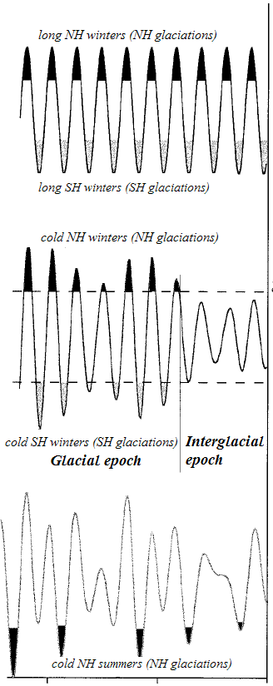

Adhémar's
Model

Croll's
Model

Milankovitch's
Model

-200 -100 0
Time (kyrBP)

From Paillard 2001. Figure 1. "... The ice ages according to Adhémar [1842], Croll [1875], and Milankovitch [1941]. Adhémar was aware only of the precession of equinoxes, and he related the glacial ages to the lengths of seasons. Croll benefited from the advances in astronomy and was aware of changes in the other astronomical parameters, though he could not compute the obliquity changes. Milankovitch was the first to integrate the effect of all astronomical parameters and to capture explicitly the insolation at the top of the atmosphere. He understood that summer, not winter, was the critical season. His insolation minima were associated with the major alpine glacier advances recorded by geological evidence. ..."]

[Didier Paillard (2001) Glacial Cycles: towards a new paradigm, Review of Geophysics, 39,3, 325-346]

[Howell - text to be expanded later (some of this is self explanatory from the figures to a limited extent)
Discussion of results of the earlier glaciation models - Calder, Imbrie, Paillard
Wikipedia discussion of Milankovic model shortcomings, and results of current models
Discussion of recent modelling efforts - Paillard, Howell, Huybers
What's missing - SOLAR VARIABILITY over all time-scales!!
]

Note that Paillard's "high" forecast (using the 0.75 cut-off) is the only forecast of all those shown in this paper that predicts a high "double-peak", implying a prolongation of the current "inter-glacial " warm period. His other "low and less probable" estimate very much resembles all other forecasts, which essentially show that the peak of this interglacial was reached ?6-8? thousand years during the "Younger Dryas" period referred to by archaeologist and paleontologists.

endpage

Time (kyrBP)

[Paillard 2001, Figure 14. "Model extrapolations for the future. The top curve is the forcing, the summer insolation at 65 °N [Berger, 1978]. The three lower curves compare the Calder, Imbrie, and Paillard models over the last million years and the next 200 kyr. The bold curve in the Paillard model corresponds to the original threshold i_{o} = -0.75, while he thin curve corresponds to i_{o} = -0.5. These thresholds are also indicated on the insolation curve. Both i_{o} values give indistinguishable results for the last million years, but very different results for the next cycle. .."]
(This figure has been flipped horizontally to show time progressing to the right.)

[Didier Paillard (2001) Glacial Cycles: towards a new paradigm, Review of Geophysics, 39,3, 325-346]

Huybers & Tziperman 2007 produced a sophisticated glaciation Energy Balance Model (EBM) which goes far beyond the model presented later in this paper. However, there is surprising agreement in some aspects of the models.

It does not appear that their model accounts for overall lower levels of solar irradiance (solar constant) such as might occur from solar variability or galactic ray variability (associated with irradiance or not).

endpage

Figure ?? - Graphs of recent glaciation models over the last 1 MyBP

a) Milankovic insolation cycles and 1 My of glaciations (global insolation values), Reference: Laskar etal, Wikipedia

b) Paillard's Milankovic threshold model for 1 My of glaciations, Reference: Frédéric Parrenin, Didier Paillard 2003

c) Howell's variant of Paillard's model for 1 My of glaciation (this paper - non-optimized results from first generation modelling)
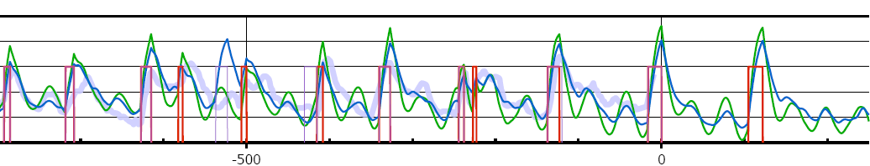
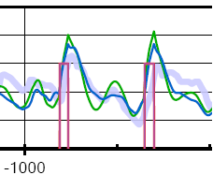
d) Tziperman, Raymo, Huybers, Wunsch 2006 - Nonlinear phase locking to Milankovitch forcing
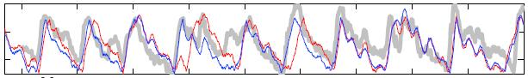

Captions for Figure ?? - Graphs of recent glaciation models over the last 1 MyBP

a) Milankovic insolation cycles and 1 My of glaciations, Reference: Laskar etal www.Wikipedia.com www.BillHowell.ca
Global average solar insolation clearly relates to glaciation trends...but the theory isn't adequate!

b) Paillard's Milankovic threshold model for 1 My of glaciations, Reference: Frédéric Parrenin, Didier Paillard 2003 http://glaciog.ujf-grenoble.fr/~parrenin/publications/download/articles/parrenin-paillard-EPSL2003.pdf Forecasts: Didier Paillard (2001)
Black curve: glaciation data, Green curve: best fit, Burgundy: Paillard 0.75 forecast, Blue: Paillard 0.50 factor
Note: Paillard used a different temperature series based on marine delta 18O, whereas that shown is from ice core data (great generalization!).
Data values hand entered from literature graph (approximate only) using Engauge digitizer software. http://digitizer.sourceforge.net/

c) Howell's variant of Paillard's model for 1 My of glaciation (this article)

d) Tziperman, Raymo, Huybers, Wunsch 2006 - Nonlinear phase locking to Milankovitch forcing
Reference: http://www.people.fas.harvard.edu/~phuybers/Doc/Phase_Locking.pdf
From Tziperman etal: "...Phase locking to Milankovitch forcing. The gray curve is the proxy d18O compilation of Huybers and Wunsch [2004]; the thin color curves are ice volume time series from different model runs using different initial conditions..."

1.1.2 Solar variability
The sunspot cycle is the most familiar form of solar variability, but sunspots cannot fully describe all the different aspects and components of solar output and variability even for the traditional Schwabe 11 year half-cycle, or 22 year Hale full cycle. Furthermore, virtually none of the solar cycles are really cyclic - they are quasi-cyclic and mathematical and statistical techniques for handling this kind of system are still being developed. Many great scientists have floundered when dealing with the sun, and lesser scientists have fared even worse. That will likely continue to be the case for sometime to come.

Typical solar cycles mentioned in the literature (see also Tim Patterson presentation 17May07) are:
- sunspots - Schwabe 11 year half-cycle, or 22 year Hale full cycle (the sun's magnetic pole flips each half-cycle)
- lunar cycle ~19? y (OK, this isn't the sun, but it's handy to know)
- Gleissberg ~87-90 y ( 75 - 90 y)
- Suess ~208 y ( 200 - 500 y)
- Bond ~1440 y (1200 - 1500 y)
- ?? ~2200-2400? ???

Notice that solar activity cycles on the scale of glaciation activity (10 ky to ~5 My) are virtually unknown, but it would be foolish to assume that they do not exist.

Therefore, a HUGE knowledge gap regarding glaciations is that we simply do not know how the sun behaves over those time-scales (actually, we can't predict it on the very short timescales either). This of course has to be a major limitation of glaciation models!!!

1.1.3 Cosmic/ galactic rays and their influence on cloud cover

In the mid-1900's, an apparent influence of galactic/cosmic rays on cloud coverage was noted by (?name date?). Too subtle to be noticed on the short term of days, over several months the "noise" in cloud coverage data tended to cancel out, leaving a galactic ray signature. This is reminiscent of the "cloud chamber" apparatus used in the early days of nuclear physics. That, plus the known nuclear reactions occurring in the upper atmosphere (for example the formation of 10Be - berylium, and 14C - carbon 14) leaves the enchanting impression that we are living in a cloud chamber!

The usual explanation for this effect is that the helio-magnetosphere (sun's magnetic field) provides a "shield" against extremely high energy cosmic/galactic particles. Variations in the helio- or geo-magnetic fields thus allow more or less rays to reach the Earth's atmosphere and thereby influence cloud coverage. For example, over a "typical" sunspot cycle, cloud cover varies by approximately 1.7%, which has approximately the same effect on climate as the UN-IPCC's estimated effect of CO2 on temperature over the last 100-150 years! Note that this author feels that the UN-IPCC effects of CO2 are exaggerated by an order of magnitude or so, as they appear to be really based on the water vapour GHG effect, and mistake CO2's real role - which is that of a time-lagged fuzzy thermometer, rather than a significant driver of temperature changes. CO2's effect on climate is probably inconsequential once it is above ~40-60 ppm in concentration in the atmosphere.

From: Bard, E. and Frank, M. 2006. Climate change and solar variability: What's new under the sun? Earth and Planetary Science Letters, v. 248, pp. 1-14.

In the last two decades observational and experimental data showing this relationship has rapidly expanded to the point that many scientists feel that galactic rays are a dominant mediator of solar insolation on Earth primarily through their influence on cloud cover. This occurs over a vast range of time scales, from monthly and decadal [Svensmark ???], through to the entire Phanerozoic era. [Shaviv & Veizer 2003]. Medvedev & Melott 2006, and Wickson 2007 have also provided interesting support for the hypothesis that galactic/cosmic rays have driven the five major mass extinctions that have occurred in the paleontological record. Illustrations on the next page from Wikipedia and [Veizer?] help to illustrate concepts for the longer-term variations in galactic ray exposure.

Figure 1: Galactic plane-bobbing, spiral jumping, and eccentricity
of our solar system in the Milky Way
Reference: Jan Veizer & Nir Shaviv, Steven Wicksonphotos:
(I couldn't find top and side photos of our Milky Way... let me know if you find some <grin>)
http://160.114.99.91/astrojan/Ngc/eso60.jpg http://www.space.com/scienceastronomy/astronomy/spiral_galaxy_011002.html
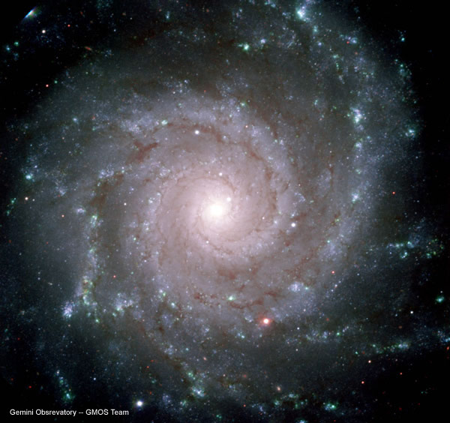
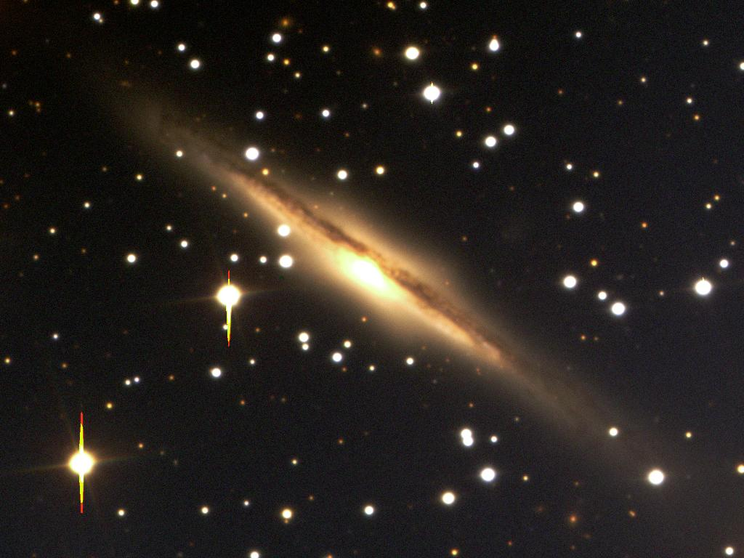
...................

Figure 2: Predictable galactic-driven climate cycles
Reference: Shaviv & Veizer

To the author's knowledge, so far the only published link between galactic rays and glaciations is a suggestive chart by Veizer (date pub?). However, the uncertainty over what drives the "switch" between glaciations and degalciations in the Milankovic-based models of glaciations, together with the suspicion that solar variability is a leading suspect for that switch, also suggests that there is a good chance that galactic rays are also a key mediator to accelerate the process of deglaciation.

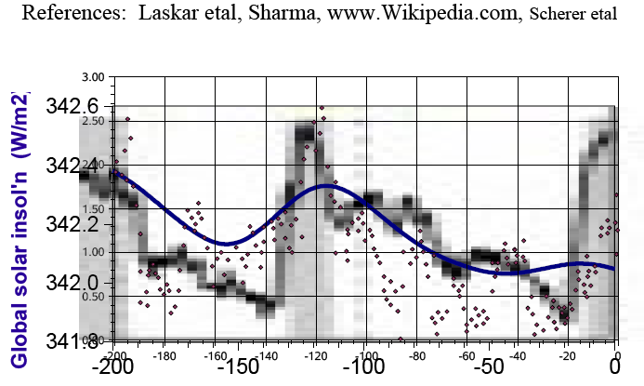
Figure ??: Milankovic insolation, Solar variability and temperatures over 200 ky

The blue curve is the global annual average solar insolation as calculated on the basis of Milankovic cycles. The brown points are solar irradiance values from Be10 measurements [based on a graph from Veizer?], and the black (low-resolution) background graph is the ice core temperature proxy trend, which is similar to the trend in marine sediment delta_O18. The spreadsheet "morphs" from Milankovic to irradiance variability.

An advantage of the cosmic/galactic ray relation to glaciation, is it predictable to the extent that the underlying moderators of galactic rays are themselves predictable (i.e. the "predictable side of" solar activity, and the solar system movements likely to affect cosmic/galactic ray exposure). The theory already has impressive (compared to most other theories) data and experimental support, and at least some support over multiple geologic time-scales (from recent glaciations to the entire Phanerozoic era going back > 500 My), through some correlation or visual relationship to glaciation data.

However, as noted in the section above on solar variability, there is also probably a huge component of unpredictable variability in galactic/cosmic rays exposure, which must be considered in modelling.

1.1.4 Planetary movements, the solar system barycenter, and their effects on solar activity and galactic rays

The possibility that the planetary motions drive solar activity cycles was central to the first quantitative theory of sunspot activity over 150 years ago [Wolf 1859 in Charbonneau 2002], and this concept has resurfaced every generation or two in a new form. As an analogy of ocean tides on Earth, it is an appealing concept, but before going further it should be stated that thus far there is not a solid statistical link between these theories and solar activity. The history is well described by [Charbonneau 2002].

With that caveat in mind, many more papers on this subject have been produced recently (Fairbridge ?year?, Mackey 2007, Bailey in Alexander etal 2007, Charvatova & Strestik 2004, Landscheidt etc etc], and if they can be developed into credible theories for solar activity cycles it would be a significant advance, and one that could well be important for estimating long-term solar activity quasi-cycles on the scale of glaciations. Perhaps these will develop into a serious basis for the "climate flipping" between glaciations and deglaciations?

Note that barycentric motions of the sun don't have to generate solar activity to be of importance. Apparently (to be confirmed?) Earth-Sun distances change to almost the same extent as with Earth orbit eccentricity. Another way to look at this is that extremely high solar activity levels, such as at the end of the last glaciation period/ Younger Dryas period, could tend to heat up the Earth's climate to one extreme, while the trend during the glaciation periods over the last million years is that continued glaciation would lead to extreme glacial coverage if it continued unabated. So the climate "teeter-totters" - drifting in one direction or another until the sun drives it the other way.

I. Charvatova 1988 "The relations between solar motion and solar variability" Bulletin Astonomical Institure of Cechoslovakia v41 (1990) pp56-59

"Solar Inertial Movement" (SIM) leads to changes in the sun-barycenter distances that are equivalent to the Earth orbit eccentricity!!

Approximate numbers:
Earth-Sun distance (average) : astronomical unit = 1.5e11 m = 1.5e8 km
solar radius (rs) : 0.02 AU = 3e9 m = 3e6 km
Earth orbit eccentricity : 0.06 max, 0.028 average
delta distance (Earth-sun) eccent : = d * e = 1.5e8 * 0.06 =9e6 km max, ~4.5e6 avg
diameter of the area in which the Sun moves around barycenter
: 4:3rs = 1.3e7 km ~= 10 % of Earth-Sun distance!!!
: approximately same as eccentricity!!!!

The key thing right now is that while many are trying to tie the "Solar Inertial Motion" (SIM - with respect to the solar system barycenter) to solar activity - sunspots AND perhaps solar minima, I think that even the positioning of the sun alone is extremely important even if no solar activity (eg sunspots) result. That is because the changes in Earth-Sun distances are comparable to the Milankovic eccentricity effects on the distance!! The complex treffoil/perimeter waltz of the sun around the barycenter has "quasi-periodicities" matching many of the key solar "cycles" (listed here according to Charvatova):
- Charvatova - two prominent periods of 7.8 and 12.8. significant periods of 6.5, 7.4, 8.4, 10.4, 12.0 and 13.8 years
- Air surface temps - ...prominent periods of 7.8 and 12.7 periods of 6.4, 7.4, 8.4, 10.4, 14.1 years. "...The significant peak lack that occurs between 8 and 10 years corresponding to that of SIM spectrum (see also in Bucha et al., 1985,Fig. 1) is clearly seen. It is here necessary to point out that no significant peak occurs near the period of 11.1 years whichis the mean period of the solar activity cycle. ..." I think one of Charvatova's papers alluded to the Gleissberg, Suess and Bond cycles as well, but I may be mixing that up right now.
Charvatova is the paper set I'm most directly using for the barycenter issue, and Landscheit's output of NASA JPL data. but many others
have looked closely at this, and it was actually the first model for sunspot activity!
The next trick would be to incorporate the sun-barycenter model INTO the Milankovic solar insolation programs, and take a look at the global average annual insolation. (This may actually be the case - but I might not have noticed it because my smallest time step in the 6 MyBP glaciation model is 1 ky.) Note that the global average annual insolation is NOT dependent on Earth axis obliquity and precession, but because of albedo (eg snow, cloud) and big seasonal differences, the actual effect of the insolation at the surface of the Earth would be somewhat dependent on Earth axis obliquity/ precession.
After that, allowance for sun-barycenter movements would allow a more accurate idea of the impacts month by month over time at any latitude - this could have very important seasonal impacts (agriculture, weather etc).
After that, then maybe get back to the possible sunspot impact of the sun's movement around the barycenter.
#**********************
# cSun_tSSB_6000y_x5d full data - each month.txt
Bill Howell, October 2007
uses Landshcheits sun-barycenter output based on NASA/JPL Ephemeris program

#*****************************
Reference

# Theodor Landscheidt
http://landscheidt.auditblogs.com/6000-year-ephemeris

Solar System Barycenter Ephemeris

I have put together an ephemeris of the relationship between the Sun and the Solar System Barycentre, starting 3000BC to 3000AD, with longitude, distance, angular momentum, and torque every 5 days for the full 6000 year period.

It is compressed in an 11.6MB ZIP file which decompresses to a 30MB tab seperated values text file - you can download it from from this file storage page or this one - you are welcome to use it for any non-commercial purpose.

The first character on each line is a ‘-’ or a ‘ ‘ (blank space), being BC or AD, immediately followed by the date in YYYYMMDD format, the next column is ecliptic longitude in degrees, then distance in solar radii, angular momentum in grams cm2 / secs, and torque as delta_angular_momentum / delta_time_seconds, which as far as I can determine should match Dr Landscheidt’s work.

The angular momentum and torque calculations were done using a simple program I wrote in THINK Pascal running in Classic mode (OS9.2.2) in OSX10.3.9 on a 400 mHz Mac G4 Sawtooth.

The Astronomical Computations for the SSB were generated by …
Solar System Dynamics Group, Horizons On-Line Ephemeris System
4800 Oak Grove Drive, Jet Propulsion Laboratory
Pasadena, CA 91109 USA
Information: http://ssd.jpl.nasa.gov/
Connect : telnet://ssd.jpl.nasa.gov:6775 (via browser)
telnet ssd.jpl.nasa.gov 6775 (via command-line)
Author : Jon.Giorgini@jpl.nasa.gov

#*****************************
http://en.wikipedia.org/wiki/Ecliptic_longitude

Ecliptic longitude
From Wikipedia, the free encyclopedia
• Find out more about navigating Wikipedia and finding information •
Jump to: navigation, search

Ecliptic longitude (solar longitude or celestial longitude) is one of the co-ordinates which can be used to define the location of an astronomical object on the celestial sphere in the ecliptic coordinate system. In this system, the celestial sphere is divided into two hemispheres by the plane of the ecliptic.

The ecliptic is the path followed by the sun across the celestial sphere during the year. It crosses the celestial equator twice during the year, once at the Autumnal equinox and once at the Vernal equinox. There is no obvious point along the ecliptic at which ecliptic longitude should be zero, and so zero is arbitrarily defined as the location of the sun at Vernal equinox. Ecliptic longitude is then the angular distance of the object eastwards along the ecliptic from this point.

Ecliptic co-ordinates are most useful for solar system objects. For example when an almanac give the longitude of the Sun, ecliptic longitude is meant.

1.1.5 Solar obliquity and precession

Changes to the sun's axis obliquity and precession should also have an effect on climate, perhaps if only for time intervals on the scale of these "cycles". That is because irradiance from the sun depends on the lattitude, and apparently for at least several solar revolutions, the longitude of the sun. Given the eccentricity of the Earth's orbit, and the changing angle of the Earth's orbit with respect to the plane of the solar system, one should expect insolation effects on Earth. Whether these are significant or not is another question.

The question arises as to whether it's feasible to build an historical basis for solar axis precession/obliquity, as I assume that relatively modern measurements are required. Whether the sun's axis has the same meaning as the Earth's, I don't know - but the asymmetry by latitude and longitude of sunspot activity is at least a "simile" if the axis of the sun doesn't behave the same (and does the axis of the faster-moving inner core/radiative zone/convection zone move relative to the photosphere or axis?).

If the Sun's axis does move in a manner that is predictable on the long term, then that would help some of the models of glaciation.

1.1.6 Other astronomical concepts for glaciation

Other astronomical concepts for glaciations include meteorite impacts [refs], and ???...
[Howell - text to be added later:
thermal inertia of oceans and time lags at varying scales (hundreds of years to 10 ky)
wind-ocean interactions
]

This particular paper by Muller & MacDonald (M&M) shows a few weaknesses of my recent work, a couple of which are even alluded to in my incomplete draft paper (I haven't even started to write out the model description/data/results/ interpretations etc):
www.billhowell.ca/Climate and sun/Howell - Glaciation models for the last 6 million years.pdf
"...Other "Milankovic cycles" have also been investigated, such as the change in inclination of the Earth's orbit with respect to the plane of the solar system, but these are not incorporated in the insolation models of Laskar etal. and so they are not included in the calculations of this paper. Laskar etal 2004 go into excellent detail on this subject...."
"Dirty snow & clouds" is one of my themes that is related to M&M's "accretion of interplanetary material: meteoroids and dust" of M&M. I mostly allude to it in my incomplete paper on civilizations, I think, but also in a point form so far in my glaciation paper:
"...1.2.3 Volcanic and seismic activity
[Howell - text to be added later:
known / potential effect of volcanic ash emission - here ALBEDO is a BIG issue!! with respect
to "climate flipping" between meta-stable states..."
How to incorporate the inclination into current software that I'm using is maybe a bit tricky - as the mechanism proposed by Muller & MacDonald is only tentative, and the issue of how to quantify it is a bit "loose" (like galactic rays at the present time).
One of the M&M comments is "strange" (appears wrong), though:
"...Since orbital inclination does not affect insolation, we must search for another mechanism relating it to climate. The only plausible one we have found is accretion of interplanetary material: meteoroids and dust...."
There is a big latitudinal asymmetry (and longitudinal asymmetry! at least over modest intervals of less than a year) variation in solar radiation, and this of course varies strongly with solar activity. This is probably quite easy to calculate "on average", but it may not be easy to estimate asymetries (and of course activities) over useful timescales for glaciation, UNLESS the solar system barycenter/ solar activity theories ultimately work out so that the activity levels are predictable (or at least are somewhat so - one problem is that even Milankovic cycles are chaotic over tens of millions of years, and barycenter motions may be chaotic over thousands of years - but I haven't seen anything to that effect in the literature).
However, in the end I am not so worried about the 100 ky periodicity - there are probably more than a dozen competing theories here, and I prefer to retain them all rather than jump to conclusions or to be restricted to one mechanism when several may come into play. My big issue is the lack of prectio of the "precession-dominated" timeframe from ?say ~3.5 or 4 MyBP to 6 MyBP (my model only considers data back to 6 MyBP).

1.2 Other influences over glaciation

1.2.1 Ocean circulation
[Howell - text to be added later:
thermal inertia of oceans and time lags at varying scales (hundreds of years to 10 ky)
wind-ocean interactions
]

1.2.2 Geomagentic influence over glaciation

The changes in the Earth's magnetic field are often described as:
- "intrinsic" - internal to the Earth - usually described in terms of the rotation of molten iron in the outer core of the Earth). As a rule of thumb this might be taken to be changes occuring over time periods greater than ~4 years (very roughly); and
- "extrinsic" - as influenced by the sun's magnetic field (helio-magnetic influence)

To the present author (non-expert in geo-magnetics), there does seem to be an influence of the sun on all time scales over the last 100 years or so. Over longer time periods, geo-magnetism goes through periods of rapid "switching" and long periods of stability, as can be seen in the graph of Gradstein etal.

However, at present no attempt is made here to cover geo-magnetism, other than posing a rhetorical question that may have been answered long ago:

Do Northern hemisphere glaciations align with the magnetic pole rather than the Earth's axis of rotation? Or is there some influence here?

1.2.3 Volcanic and seismic activity
[Howell - text to be added later:
known / potential effect of volcanic ash emission - here ALBEDO is a BIG issue!! with respect to "climate flipping" between meta-stable states
solar driver of seismic activity?
]

1.2.4 Green House Gases (GHGs) and glaciation

The over-whelmingly dominant GHG is water vapour, and for 10 to 200 years that has been very well known, and to the author's knowledge it has not been seriously challenged by any substantive work.

It seems to this author that the Paillard-Parrenin 2004 CO2-based model approach for ~3.5 MyBP really should have first accounted for the vastly dominant Green House Gas (GHG): water vapour. Water vapour is not only the dominant GHG in terms of the "cumulative GHG" effect at current atmospheric gas concentrations, it also varies far more than CO2 concentrations and does not suffer the apparent situation with CO2 of having "absorbed" most of its spectral band within a few hundred feet of the surface of the Earth [ref].

However, the present author considers the GHG effects to be at best tertiary, and prefers to first tackle:
- the only "primary climate driver" (solar power and its variability); plus
- substantive "solar mediators" (Milankovic cycles, galactic rays, land surface albedo, clouds, and ???), and
- "climate reservoirs" (oceans and their circulation, glaciers).

1.2.5 Geothermal activity and glaciation
Consideration of the influence of geothermal activity on climate is conspicuously absent from the literature, presumably because most scientists consider the magnitude and vaiations of geothermal energy to be too small to be significant.

However, that very assumption has been an ongoing reason for repeated, catastrophic failures in thinking by the scientific community regarding climate, and as with geo-magnetism one can't help think that there might eventually be something to say about this.

I wouldn't at all be surprised to see the ultimate effect of these variables to surpass that of anthropogenic GHGs!!

[Howell - text to be expanded later (important section!)
Modern detaled models of glaciers
eg Uof Calgary guy
]

1.3 Local Theories of glaciation (time, region)

[Howell - text to be expanded later (important section!)
Modern detaled models of glaciers
eg Uof Calgary guy
]

2. Howell's variant of the Paillard-Parrenin model for glaciation

2.1 The Paillard-Parrenin model for glaciation - a basis for the current work

The Paillard-Parrenin (PP) model is a great description of glaciations over the last 1 MyBP, and it is a deceptively simple framework for glaciation that avoids trapping those using it into any particular phenomenological framework at a time when it is extremely important to be aware of the very large number of factors and processes that may or may not influence glaciation. The PP model lends itself to both simple and elegant conceptual additions, and it suggests which parts of the glaciation process are "easy", and which are "critical and difficult".

2.2 Howell's variant of the Paillard-Parrenin model
(first generation linear models)

[Howell - this is in a very preliminary outline form!!]

Simple 1st order ODE's model of snow accumulation, melt, and flow, primarily influenced by insolation between 45 and 90 degrees latitude in Northern & Southern hemispheres. No account is made for altitude,

Galactic ray effect on cloud cover - primarily assuming Medvedev & Melott concept of the solar system bobbing above & below the plane of the Milky Way galaxy.

Melt versus sublimation issue
- when does sublimation kick in?
very cold air heated up just above the ice - big "under-saturation" with respect to sublimation
winds carry away moisture, perhaps best done by "cold winds"
does this create special "fogs"?

Evaporation of melt (like sublimations, sort of)

Albedo changes - as a possible mechanism for "climate switching" between states.

Future investigations:
The GHG effect of water vapour (NOT CO2 until water vapour accounted for, as it is far more important!).

Note that "arbitrary ice volumes" are used in place of the actual delta 18O data, and these volumes will not be correct. However, the models will automatically scale to better total ice volume estimates once the basic process of building and refining models

Missing concepts
phase/state switching
altitude & slope

As Jan Veizer repeats all the time, to a first approximation climate can be described as water cycles (ocean current, atmospheric evaporation, precipitation, wind-ocean oscillation & jet stream influences, glaciers, regional droughts, etc etc) given the huge heat content of water-bearing streams. In a sense the water cycles tend to stabilize temperatures. Of course this is a simplification, but it helps offset excessively temperature-centric analysis. And as you say, this certainly applies to glaciation as well - glaciers are, after all, great temperature mediators on the upside at the melting point (climate reservoirs, in a sense).
The simplest of the "simple, naive models" of glaciation do not have to rely on any specific intermediate variables (temperature, any of the water cycles, etc). As a rough approximation, they are:
- driven by solar insolation by geography;
- augmented by phase changes (one can generate as many phases of glaciations as one likes, but two is enough for the simplest of the simple) for which the drivers or 'turning points" may be implicit or explicit; and
- a very heavy application of the "Mean Value Theorem" in many dimensions.
Many of your key points have been covered in my "simple naive model", albeit in a fantastically naive, simple, averaged sense:
- precipitation and melt/sublimation are basic factors, and indeed this was one of the reasons to do my model as a variant of the Paillard-Parrenin model.
- Ice flow is included in such a primitive form it is laughable (linear function of ice height, not even a Bingham plastic, and no slopes on average) - for now it is simply a "placeholder" in which much more realistic functions can be inserted in the future.
- Temperature doesn't even appear in the descriptions, although it would be easy to stick it in as either a simple output or an intermediate variable. (I have zero interest in doing that right now).
- Albedo effects have already been incorporated as another key concept of my model - as a possible explanation for "multiple meta-stable states" of the climate. It's clear FROM THE PERSPECTIVE of these simple models that albedo could easily help drive phase changes, but the data basis to this I haven't even looked for yet (and I assume there will be a lot of guesswork and extrapolation from modern data, which will likely not cover past situations over the last 1 MyBP). I have provided anumber of suggestions as to how the albedo might change, and there are doubtless others.
- Albedo has not yet been used EXPLICITLY as a means of readjusting global temperatures - and it wouldn't make sense to do that until the models are upgraded for heat movement around the planet (which I certainly don't have time to do for the near future).
However, I have only scratched the surface, as these models do not currently incorporate detailed geography (especially altitude, land masses, ocean currents etc) and wind patterns etc etc. On a resolution of 1 degree latitude and probably 1 to 6 degrees longitude (depending on latitude), that kind of analysis require far more time than I have right now (I also have a problem with the limitations of the programming language I am using, so optimization procedures and different approaches to decomposing solutions will be needed).
My next step isn't to improve the models at all - it would be to use a level of analysis that is useful to me (the current models indicate that glaciation may be too simple to have value as a challenge in the direction I need to go with neural networks).
Other important points:
- global ice volumes and "average latitudinal ice heights" are arbitrary numbers, until I obtain real historical data. A simple scaling factor can be used to adjust them later to estimates of real ice volumes over the last 6 MyBP. For now I want to keep an arbitrary number, as some of the parameters have a "somewhat physical meaning" (again, in a very averaged sense).
- nuts, I forget what I was going to say here... maybe later. But there are a couple of other hugely misleading parts to the model if you are not aware of the arbitrary basis that was taken.
Even if these models are "simple and naive", they give rise to many "classes of glaciation behaviour" that would require regional glaciation data over time which I haven't inserted yet (back to geographical detail again as the first next step).
In spite of their "simple, naive" basis, these classes of models actually describe global glaciation data of the marine isotope type extremely well. A key here is "describe", and another is "predictability". Of course, if one wants to build a very detailed phenomenological model that does incorporate current knowledge but doesn't describe or predict glaciation well, that is still a legitimate goal. Also, no doubt something like a GCM could be used to provide better fits - these models have so many degrees of freedom that they could hardly NOT fit anything. But tellingly, I haven't seen any descriptions or predictable models to rival the simple naive models, and the latter have huge opportunities for improvement with only a few simple improvements such as those described above.
Furthermore, in line with "Ockham's razor", their very simplicity is some protection against the huge problems that face complex models. Here I am mostly worried about:
- the "small-world universal function approximation" nature of complex models
- the arbitrariness of detailed models - such as all of the assumptions that would go into wind/ocean circulations for 3 MyBP, and how air moisture is picked up and dropped off in a very different climate state. I don't have that much faith in GCMs, and even giving me one or two more parameters in such simple, naive models means the models can produce even far more scenarios that are not well constrained at all. A great example of this is the Paillard-Parrenin model for the last 3.5 MyBP which assumes that CO2 from deep ocean circulation accounts for the deglaciation transitions. The functional form of that "CO2" influence is like a continuous "Finite Impulse Response" filter. With that, any model could sing an opera. (I'm not being fair to the authors here).
- predictability becomes a matter of what scenario you want to see (look at the Paillard-Parrenin model , which is very simple and yet gives HUGE differences in outcomes and climate behaviour for modest parameter changes)
*************
As an embarassing omission, I hadn't even thought of looking at the precession/ obliquity of the sun's rotational axis. Your comments the other day made me realize this has been missing.

I doubt it's feasible to build an historical basis for solar axis precession/obliquity, as I assume that relatively modern measurements are required. Whether the sun's axis has the same meaning as the Earth's, I don't know - but the asymmetry by latitude and longitude of sunspot activity is at least a "simile" if the axis of the sun doesn't behave the same (and does the axis of the faster-moving inner
core/radiative zone/convection zone move relative to the photosphere or axis?).

If the Sun's axis does move in a manner that is predictable on the long term, then that might help some of the models.

3. Results

?To: Albert Jacobs? week of end Sep07?

- a declining overall insolation due to the galactic ray trends from "Milky Way plane-bobbing" of the solar system (and other effects) as described by Medvedev & Melott is an alternate to Paillard's "deep-ocean CO2 circulation". In the actual model shown, something like a 1.5 factor of increased solar insolation equivalent (straight line decline from 6 MyBP to 1.0 at present) was used, which is probably way too high, but much lower values could also work (just parameter trade-offs). Also keep in mind Patterson's comment - 0.1 % solar variability to give 1.7% cloud cover change. That won't scale linearly, but it just goes to show... I wish I could extract Wickson/ Medvedev's functional relationship instead of just showing a straight line - but all in due time.
- The "deglaciation " epsodes could easily be explained buy a decrease in global average ice albedo from ~0.55 to 0.51. That's a lot - but perhaps not crazy, only trouble is it should happen with every reveral, and it doesn't. Adding an additional effect from overall &/or regional water vapour GHG effect (forget CO2 until the waters taken care of), and it all starts adding up (the dirty snow and fog concept).
- Of course, the big question is whether solar activity alone could explain all of the non-Milankovic effects, and one of the papers I think that you just sent me (email CCNet or FOS extracts or something?) alludes to ?6% high activity excursions like current say a few million years ago versus 1 or 2% now? - I forget the numbers. I suspect that the deglaciation changes may be solar activity.
- Even though the solar physicisits hate it, I kind of like the solar system ?barycentre? concept for explaining high periods of solar activity, although I have to admit its mainly because the solar physicist hate it so much <grin> (just like de-rectification of sunspot data). It would probably take some time to find equations/ code for that and take a close look myself.
- My adaptation of Paillard's model does NOT explain the precession (23 ky) dominated behaviour of glaciation or snow prior to (3 - 3.5) MyBP. That could be due to parameter adjustments, but I suspect that model inadequacy is key. Perhaps a switch to seasonal coverage starts to participate then dominate ice volumes, so obliquity dominates from (1.5 - 2) to (2 - 2.5) MyBP, precession to (3 - 3.5) MyBP, and just winter snow that entirely melts away before that. (just pure speculation)...
- One of the real fun ideas would be to develop an analysis to identify time periods of Multiple Meta-Stable states and conditions for moving between them - like chemical equilibria and even more like "simulated annealing" approaches to solving spin glass problems in physics (which caused great excitement in neural networks when John Hopfield did that in the early 1980's). My gut feel is that solar activity (BIG bursts in comparison to what we see over the last 5000 years) would do the trick.

4. Discussions

Meta-stable states and climate switching

Meta-stable climate states - switching can & does occur, and is pronounced during glaciation periods ("ice houses")

switch because:
- solar "scorcher"/ "freezer"
- galactic "scorcher"/ "freezer"
- albedo changes - cloud coverage, eg snow/land, volcanic ash, melt water ponds on melting glaciers (or just wetting of ice surfaces (melt or rain) might dramatically change albedo?) - but one has to explain why ther is enough to "flip" to deglaciation.
- water vapour's GHG effect

volcanic switching
solar-seismic connection and volcanic ash? (not to mention predictability of seismic events)

Multi-stable state property of glaciations - the albedo differences between snow/ice versus water/ various land surfaces are "self-reinforcing", and likely result in multiple stable states for the same external forcings. Not only would local (latitudinal) insolation effects be affected, but the global Earth insolation balance would also be affected in a self-reinforcing manner. Thereafter, only "sufficient large or sufficiently long" insolation changes would "flip" the glaciation state. In a sense, this may "stabililize" glaciation cycles against rapid switching back and forth according to solar insolation.

Laksar etal 2004 point out that the ?yearAs mentioned by others [Mackey 2007, other refs?],

5. References

Mark A. Cane, Pascale Braconnot, Amy Clement, Hezi Gildor, Sylvie Joussaume, Masa Kageyama, Myriam Khodri, Didier Paillard, Simon Tett, Eduardo Zorita, 2006 "Progress in Paleoclimate Modeling" Journal of Climate, vol19 15Oct06 pp5031-5056

Paul Charbonneau 2002 "The rise and fall of the first sunspot model" JHA xxxiii Science History Publications Ltd. - Provided by the NASA Astrophysics data system

I. Charvatova 1988 "The relations between solar motion and solar variability" Bulletin Astonomical Institure of Cechoslovakia v41 (1990) pp56-59

Ivanka Charvatova, Jaroslav Strestik 2004 "Periodicities between 6 and 16 years in surface air temperature in possible relation to solar inertial motion" Journal of Atmospheric and Solar-Terrestrial Physics 66 (2004) pp219-227

R Ehrlich, Journal of Atmospheric and Solar-Terrestrial Phys, May 2007 - A theory is described based on resonant thermal diffusion waves in the sun that explains many details of the paleotemperature record for the last 5.3 million years. These include the observed periodicities, the relative strengths of each observed cycle, and the sudden emergence in time for the 100 thousand year cycle. Other prior work suggesting a link between terrestrial paleoclimate and solar luminosity variations has not provided any specific mechanism. The particular mechanism described here has been demonstrated empirically, although not previously invoked in the solar context. The theory, while not without its own unresolved issues, also lacks most of the problems associated with Milankovitch cycle theory.

Rhodes W. Fairbridge ?year? "The Solar Jerk, The King-Hele Cycle, and the Challenge to Climate Science" 21st Century Science and Technology magazine

A. Ganopolski, S. Rahmstorf, V. Petoukhov & M. Claussen 1998 "Simulation of modern and glacial climates with a coupled global model of intermediate complexity" NATURE, v391 n22 JANUARY 1998 p351-356

Felix M. Gradstein, editor "A Geologic Time Scale 2004" Cambridge University Press, March 2005, Poster accompaniement available from Geologic Survey of Canada http://www.stratigraphy.org/gts.htm http://www.stratigraphy.org/GTS04.pdf

Donna Howell, Neil Howell, Irene Howell, Bill Howell May07 "Mega-Life, Mega-Death, and the invisible hand of the Sun: Towards a quasi-predictive model for the rise and fall of civilisations"
www.BillHowell.ca\Civilisations and sun\Howell - Mega-Life, Mega-Death and the Sun II, towards a quasi-predictive model of the rise and fall of civilisations.pdf (draft version - this paper on glaciations was initiated as background to the historical paper)

Huybers & Curry 2006 - Links between annual, Milankovitch and continuum temperature variability 2006 doi:10.1038 nature04745 http://www.people.fas.harvard.edu/~phuybers/Doc/Annual2Milankovitch.pdf

Peter Huybers, Eli Tziperman 2007 in press "Integrated summer insolation forcing and 40,000 year glacial cycles: the perspective from an icesheet & energy-balance model" Paleoceanography, VOL. , XXXX, DOI:10.1029/

Michael Jenkins 2005 "nial Systems Limited" http://www.nial.com/

Masa Kageyama, Didier Paillard 2005 "Dansgaard-Oeschger events: an oscillation of the climate-ice-sheet system?" C. R. Geoscience 337 (2005) pp993-1000

Theodor Landscheidt "Solar System Barycenter Ephemeris - Jon Giorgini of JPL calcs" http://landscheidt.auditblogs.com/6000-year-ephemeris

J. Laskar, P. Robutel, F. Joutel, M. Gastineau, A.C.M. Correia, B. Levrard 2004 "A long term numerical solution for the insolation quantities of the Earth" Astronomy & Astrophysics manuscript no. La˙2004 May 23, 2004 http://www.imcce.fr/fr/presentation/equipes/ASD/preprints/prep.2004/La_2004_prep.pdf

J. Laskar 2003 "A comment on ‘Accurate' spin axes and solar system dynamics: Climatic variations for the Earth and Mars" Astronomy & Astrophysics manuscript no. 'comment 2003' V2 November 24, 2003 http://www.imcce.fr/fr/presentation/equipes/ASD/preprints/prep.2003/comment_2003.pdf

Richard Mackey 2007 "Rhodes Fairbridge and the idea that the solar system regulates the Earth’s climate" Journal of Coastal Research SI 50 955 - 968 ICS2007 (Proceedings) Australia ISSN 0749.0208

Mikhail V. Medvedev, Adrian L. Melott "Do extragalactic rays induce cycles in fossil diversity?" arXiv:astro-ph/0602092v1 Dept of Physics & Astronomy, Uof Kansas, 4 Feb 2006 13pp

Steve Moshier 2004 "DE118i.ARC - N-body numerical integration of the Sun, Earth, Moon, and planets" http://www.moshier.net/ssystem.html

Richard A. Muller, Gordon J. MacDonald "Origin of the 100 kyr Glacial Cycle: eccentricity or orbital inclination?" ?1999? http://muller.lbl.gov/papers/nature.html

Frédéric Parrenin, Didier Paillard 2003 "Amplitude and phase of glacial cycles from a conceptual model" Earth and Planetary Science Letters 214 (2003) 243-250 http://glaciog.ujf-grenoble.fr/~parrenin/publications/download/articles/parrenin-paillard-EPSL2003.pdf

Didier Paillard, Frédéric Parrenin 2004 "The Antarctic ice sheet and the triggering of deglaciations" Earth and Planetary Science Letters 227 (2004) 263-271
http://glaciog.ujf-grenoble.fr/~parrenin/publications/download/articles/paillard-parrenin-EPSL2004.pdf

Didier Paillard "What Drives the Ice Age Cycle?" Science Vol 313 28 July 2006, pp455-456

(Parrenin) EPICA Community Members 2006 "One-to-one coupling of glacial climate variability in Greenland and Antarctica" Nature Vol 444|9 November 2006| doi:10.1038/nature05301
http://www-lgge.obs.ujf-grenoble.fr/~parrenin/publications/download/articles/EPICA-nature2006.pdf

Nir Shaviv, Jan Veizer “Celestial driver of Phanerozoic climate?” GSA Today, July 2003, pp4-10

Scherer, Veizer, Shaviv et.al. 2006 "Interstellar-Terrestrial relations: variable cosmic environments, the dynamic heliosphere, and their imprints on terrestrial archives and climate" Kluwer Academic Publishers, Netherlands, 2006 ~163pp

Eli Tziperman, Maureen E. Raymo, Peter Huybers, and Carl Wunsch 2006 "Consequences of pacing the Pleistocene 100 kyr ice ages by nonlinear phase locking to Milankovitch forcing" PALEOCEANOGRAPHY, VOL. 21, PA4206, doi:10.1029/2005PA001241, 2006 http://www.people.fas.harvard.edu/~phuybers/Doc/Phase_Locking.pdf

Steven Wickson, 04Jul07 "A Galactic Theory of Climate" http://www.billhowell.ca/Wickson website/Wickson - Galactic Theory of Climate.pdf

Wikipedia 2007 - Milankovitch cycles.htm http://en.wikipedia.org/wiki/Milankovitch_cycles

Appendix I - High resolution timeline of glaciation model over the last 6 MyBP

NOTE: The following comments and graphs are for non-optimized models developed in the first generation of parameter setting and model adaptations.

There is no intent to improve the current model basis any time soon, however, as the priority for immediate work will be now be re-focussed towards another objective - advanced dynamical models for which the glaciation problem may not be sufficiently complex or well enough characterized. After all, the only real challenge for glaciations in the last 1 MyBP seems to be the prediction of the "finite impulse response" behaviour of the deglaciations, for which Paillard & Parrenin have a surprisingly effective model. Apart from that, regional geographical extensions (far beyond the Howell variant discussed in this paper) and shorter or longer time periods are also challenges. In fact, the author's interest in doing this 6 MyBP glaciation model was only as a background to a different paper on solar influences on the rise and fall of civilisations (see:

[Howell - the text will be expanded in the future to cover:
Issue of time lags for marine isotopic data series versus precipitation-based ice-core isotopic series...
]

endpage
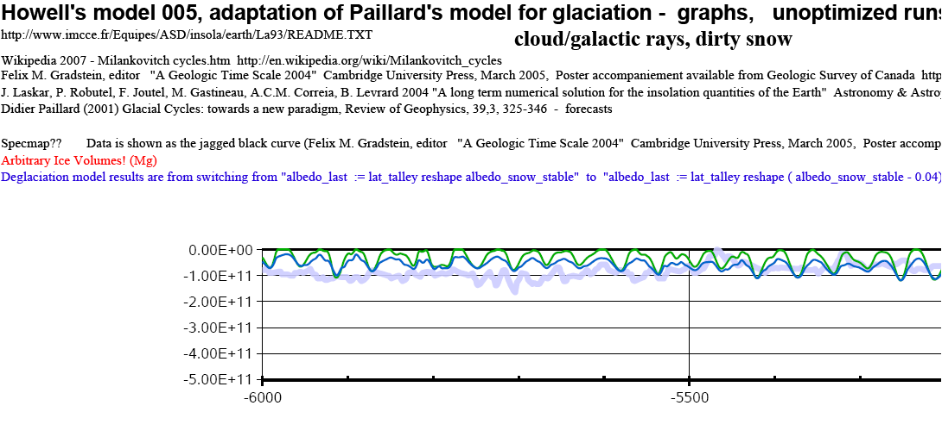

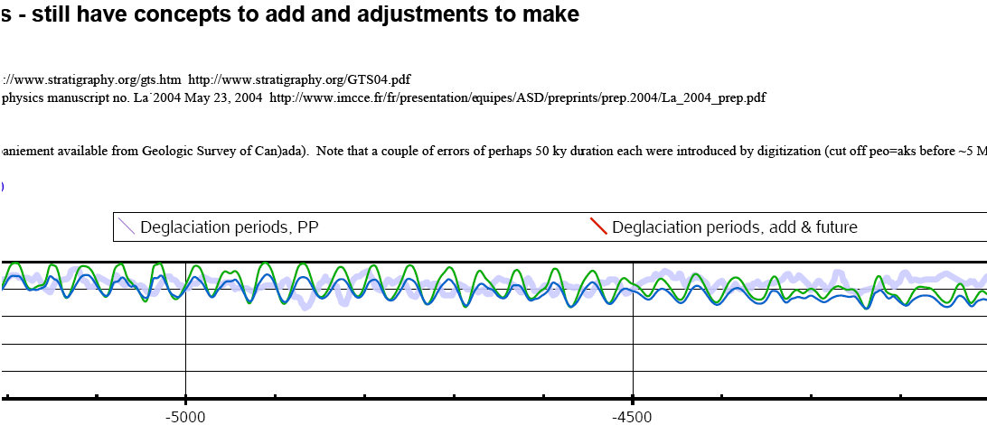

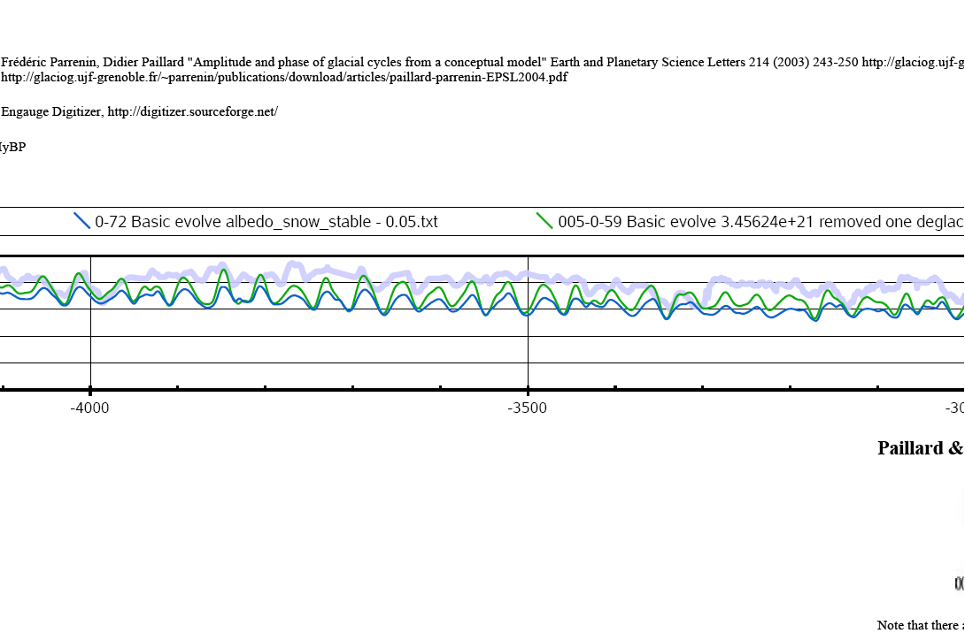
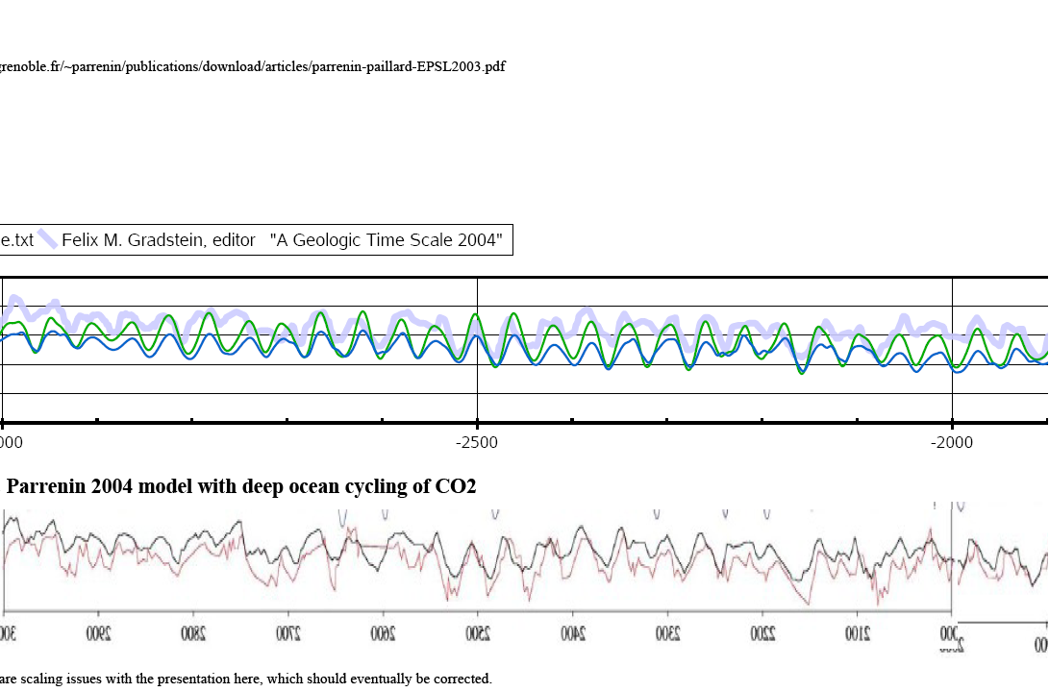
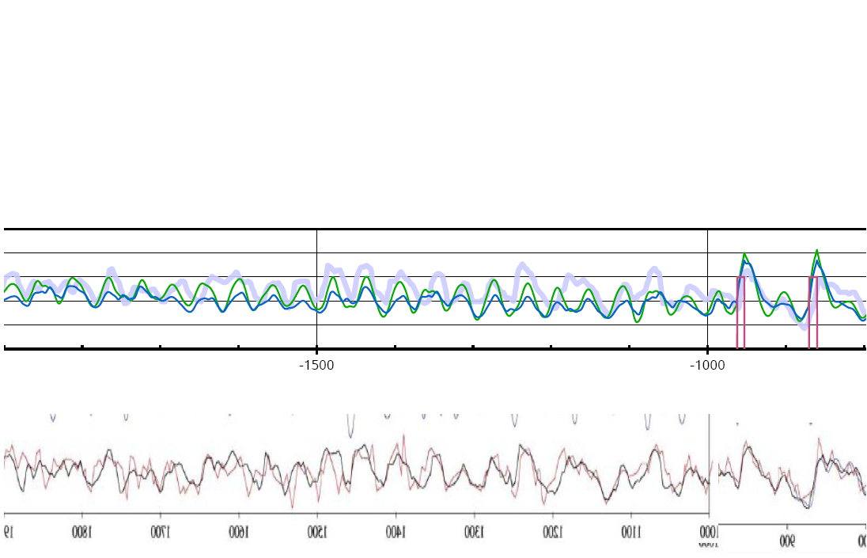

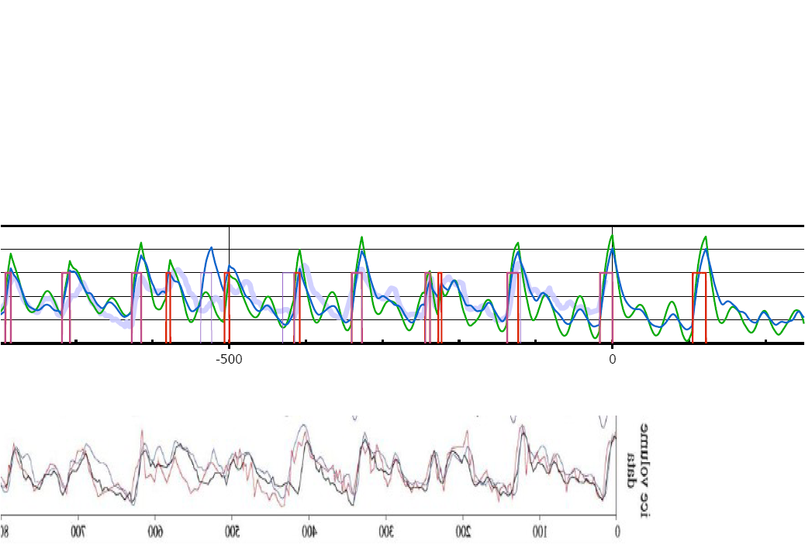

Appendix II Validation of Howell's data, models and software

Reproducing the solar insolation results of Laskar, Robutel, Joutel, Gastineau, Correia, Levrard

The solar insolation software written in the Q'Nial programming language (www.nial.com) for this paper, was verified against output of the Laskar etal program [] for latitudes 45, 65, and 80 North, from -6 MyBP to 1 My into the future, and for each of twelves months, for each ky time increment. A total of approximately 190,000 data points were thus verified.

From the table below it can be seen that the absolute errors of the current author's calculations as compare to Laskar etal were very small, and these were dependent on latitude. However, for selected data points the errors could be a large percentage deviation, as would be expected as the solar insolation goes to zero.

The conclusion is that the author's software faithfully reproduces the Laskar etal results insofar as the requirements of the glaciation model is concerned, as it is sensitive primarily to errors in the estimate of absolute solar insolation values. However, caution must be exercised for problem domains that are sensitive to near-zero solar insolation values and timing. Perhaps animal behaviour and plant physiology, and some astronomical problems would be sensitive to this, but the author has not even looked into those possibilities.

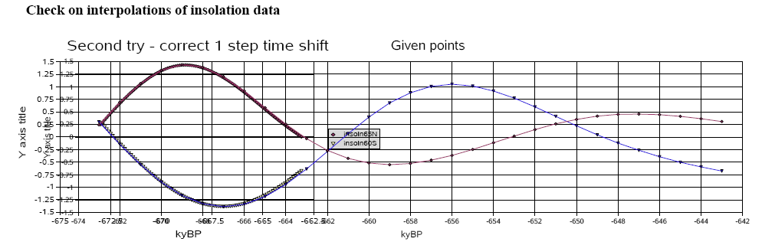

Check on Total Insolation, 65N Jun-Jul
blue - Howell - reproduction of total insolation 65N Jun-Jul using Laskar's model
orange - "Standard graph" from Wikipedia in orange (underneath)

Note that PRECESSION does not fit so well (not shown here...)!!

Reproducing the glaciation model results of Paillard & Parrenin

As a first step of confirming that the the current author's setup and programming of the glaciation model of Paillard & Parenin 2003 (PP) were correct, results were reproduced and these really should have overlapped their original results exactly. While those results are not shown here, that was not the case, indicating errors in:
- improper values for one or two variables that were not clear from the PP paper;
- the formulation of the problem on my part;
- inaccuracies in the numerical integration (Euler's method is shown); or
- errors in programming.
However, the agreement was "reasonable", and no attempt was made to improve or optimize it.

The following graphs show "enhanced reproduced" results (shown in green, two different model versions) for the PP glaciation model, placed over graphs scanned from their paper. The enhancement consists of hand adjusting several (not all) of the "deglaciations, plus adding a few extra "deglaciations" as shown in blue on the figure for "070628 10h37 No-obliq, hand-set deglace.txt". For interest sake, a deglaciation in the future was added as shown in red.

Visually speaking, the agreement is quite good, but no attempt was made to digitize the PP results and obtain quantitative measures of fit.

From working with the model, it is clear that PP have done a superb job of modeling the "deglaciation" occurrances, both by timing and duration. This is essential to the accuracy of the model, and makes it easy for other researchers to test their owns models of the onset of deglaciations with the historical data and the PP model.

As a final comment, while the PP model may be criticised because of its lack of a deep physical basis involving many climate subsystems, it does provide an excellent description of historical glacial activity, and its very simplicity makes it very robust with respect to problems that plague much more complex models, especially the "small-world universal function approximation" issue, as described elsewhere by the current author.

Digitization of the glaciation data
Note that there are many points of error. The "low points" of recent glaciations are particularly important, as the "rounding off" of these low points by the digitized data gives a mistaken impression of rising "low points" from 600 kyBP.

Glaciation modelling - techniques, challenges, and issues

Tools

Q'Nial programming language www.nial.com

Evolutionary computation
David Fogel, Kenneth de Jong
Evolving connectionist systems
Gary Marcus

Tools for non-linear dynamical systems - chaos theory, signal processing, and other

General Circulation Models (GCMs) - application to glaciation
It is the author's opinion that HUGE errors have been committed in the manipulation, misuse, and mis-representation of results from the General Circulation Models (GCMs) and their derivatives. Although ultimately, reliable tools of this sort are a very important objective, one wanders if it will be necessary to simply purge much of the community and start with new institutions, scientists, leadership, and funding organisations before any real honest and substantive progress can be made.

My own gut feel is that important advances can easily be made by simply adapting more realistic parameters and sub-system modes, even if reality forces the adoption of data that is extremely "politically incorrect". However, there is a long-term legacy in this field that screams for massive restructuring, rather than twigging of the current system.

The public deserves much better than what it has consistently been fed over the last 30 years.

Technical Issues

Hidden variables and measurement artifacts

Very sparse, incomplete, and noisy data, including proxy data sets

Small-world universal function approximation dilemma of complex models

It strikes the author that a very common failure of scientists is their faith in complex models built "from the ground up" on scientifically well-known processes.

Multiple conflicting hypothesis

In the field of Computational Intelligence it is very well established that to get the best and most reliable (or least risky) results for problems one may have to employ a "committees of experts" approach. A wide variety of approaches are available for building such systems, and for combining or selecting responses from the different models or experts

enddoc

