Svensmark’s Cosmic Theory and Cloud Cover Depictions in Little Ice Age Art.
Posted on April 24, 2014 by Anthony Watts
http://wattsupwiththat.com/2014/04/24/svensmarks-cosmic-theory-and-cloud-cover-depictions-in-little-ice-age-art/
Guest essay by Dr. Tim Ball
Correlation between sunspot numbers and global temperature was known for decades, but with no proven mechanism it was correctly set aside. That changed when Henrik Svensmark proposed his Cosmic Rays hypothesis. Figures 1 and 2 show the mechanism in two different ways. Figure 2 is from “The Chilling Stars” by Svensmark and Calder, the book that took the idea to the public.
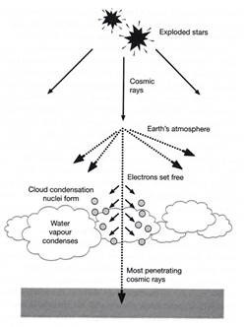

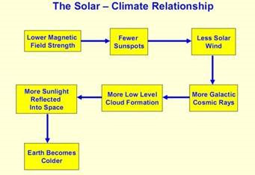
Figure 1 Figure 2
The Cosmic effect is now established through rigorous attempts to disprove it, the proper scientific method.

IPCC Challenge
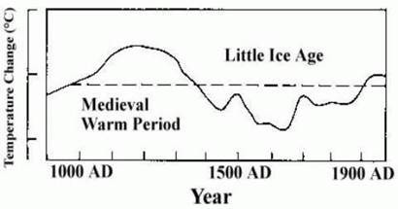
Figure 3. IPCC Figure 7c
A major objective of the 2001 IPCC Third Assessment Report (TAR) was to counter the evidence in Figure 7c from the 1990 First Assessment Report (FAR) (Figure 3). It was troubling because it showed significant variations of temperature over the last 1000 years. This appeared to contradict the IPCC claim that 20th century warming was unique and abnormal. The major focus was the depiction of the Medieval Warm Period (MWP) from approximately 950 to 1350 AD, but the cold spell from 1350 to 1850 known as the Little Ice Age (LIA) was also a concern. As Lamb noted (personal communication) the onset and termination of these periods varied regionally, sometimes by decades.
Artist’s Images Of The LIA
We all see the world through different eyes with different sensibilities and awareness. In the classic nature-nuture division most of this is nature, especially with certain abilities, such as mathematics, music or art. Artists see colour, light, and patterns of the world differently. There is a basic for landscape artists because they paint what they see before them, albeit with artistic license on occasion. Their work provides evidence of conditions such as the snow and cold of the Little Ice Age by Breughel (Figure 4) or Grifier (Figure 5). There was an exhibition of the work of Hendrick Avercamp titled the Little Ice Age at the National Gallery in Washington from March to July 2010.

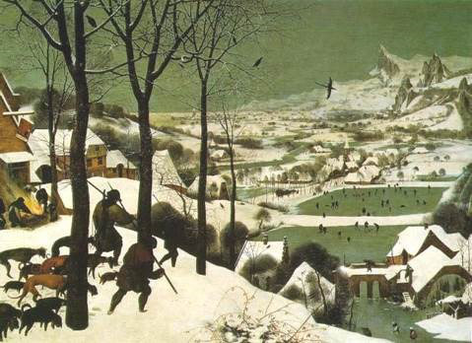
Figure 4: Pieter Breughel the Elder, Hunters in the Snow
These artists considered the conditions relatively normal, especially if their lifespans were within the LIA. However, as landscape artists they would detect changing atmospheric conditions before others and be influenced by this in their work.
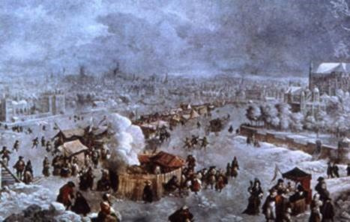
Figure 5: Jan Grifier, The Great Frost 1683 (River Thames)

Changing Skies Are Evidence of Changing Climate

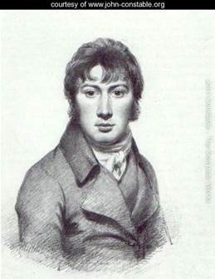
Figure 6: John Constable, English Artist
Montana is known as “Big Sky Country” so the dominant feature in images are sky and clouds. This is true of any flat region, such as Saskatchewan, or Norfolk in eastern England. Artists naturally paint these skyscapes, but few with greater awareness than John Constable (Figure 6). He became so aware of the clouds that in 1821 he produced an entire book simply depicting clouds and cloud forms (Figure 8). There are several books analyzing these depictions. One of them, John Constable’s Skies, is subtitled A Fusion of Art and Science and poses the question, “And were the skies he painted scientifically accurate?” Published in 1999 it preceded the confirmation of Svensmark’s work on sunspots and cloud cover.
Constable’s works do not, in themselves, provide support for Svensmark, but when put with a 1970 study by Neuberger (republished in Weather on 30 April 2012) it provides independent confirmation. The beauty of Neuberger’s work, Climate in Art, is that it precedes by 29 years the beginning of the sunspot temperature connection outlined in Friis-Christensen and Knud Lassen’s Science 1991 article Length of the Solar Cycle: An Indicator of Solar Activity Closely Associated with Climate.
Neuberger’s hypothesis was that,
…a statistically adequate sample of paintings executed by many painters living during a given period in a given region should reveal meteorological features significantly different from those of a similar sample of paintings produced during the same epoch in a climatically different region.
He studied over 12,000 paintings in 41 European and American art museums. The period of coverage was from 1400 to 1967. Various definitions were assigned to standardize the categories including the US airways code of four categories,
“clear (less than 10% of the visible sky covered by clouds)”,
“scattered (10 to 50% clouds)”
“broken (60 to 90% clouds)”
“overcast (more than 90% clouds)
He divided the 1400 to 1967 span into three epochs as shown in Figure 7 (Figure 12 in the original article).

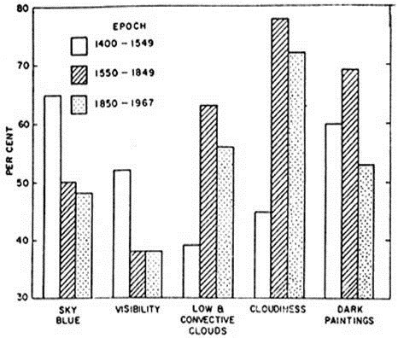
Figure 7: Neuberger’s caption, “Epochal changes of various painting features”

He labeled the epochs,
1400 – 1549 the pre-culmination period of the Little Ice Age
1550 – 1849, the culmination period which contains the “years without a summer”
1850 – 1967, the post-culmination period in which a definite retreat of glaciers and substantial atmospheric warming occurred.
When he broke this down by 50 – year epochs the percentages for average cloudiness were dramatic ranging from 29% for 1400 – 1449 to 77% for 1550 – 1599. As he noted,
The frequency of low and convective clouds also shows a sharp change from the first to the second epoch reflecting the deterioration of the weather throughout Europe.

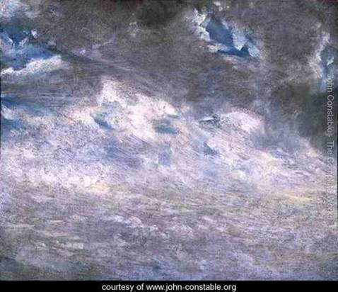
Figure 8: From a cloud study by Constable (1821).

J.M.W. Turner, a contemporary of Constable’s, also painted landscapes with extensive displays of clouds. He was more intrigued by the changing light conditions particularly after the eruption of Mount Tambora in 1815. Because of this his works are considered early English impressionism.
Conclusion
A critical part of climate reconstruction is to obtain corroborating information from different independent sources. This early empirical study by Neuberger supports Svensmark’s hypothesis that changing solar activity creates changing lower cloud cover, which causes changing temperatures.

