0_NN - interesting throughts and items
www.BillHowell.ca – ongoing lists

**********************
13Apr2014 Nik Kasabov mentioned it in an email - he may be using it
http://apt.cs.manchester.ac.uk/projects/SpiNNaker/

SpiNNaker Home Page piNNaker is a novel computer architecture inspired by the working of the human brain.
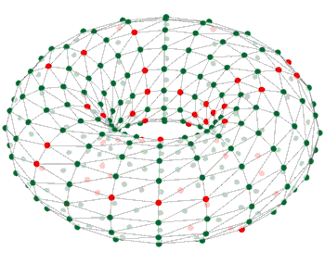
A SpiNNaker machine is a massively parallel computing platform, targeted towards three main areas of research:
Neuroscience: Understanding how the brain works is a Grand Challenge of 21st century science. We will provide the platform to help neuroscientists to unravel the mystery that is the mind. The largest SpiNNaker machine will be capable of simulating a billion simple neurons, or millions of neurons with complex structure and internal dynamics.
Robotics: SpiNNaker is a good target for researchers in robotics, who need mobile, low power computation. A small SpiNNaker board makes it possible to simulate a network of tens of thousands of spiking neurons, process sensory input and generate motor output, all in real time and in a low power system.
Computer Science: SpiNNaker breaks the rules followed by traditional supercomputers that rely on deterministic, repeatable communications and reliable computation. SpiNNaker nodes communicate using simple messages (spikes) that are inherently unreliable. This break with determinism offers new challenges, but also the potential to discover powerful new principles of massively parallel computation.
Where to go to find out more:
- Learn more about the SpiNNaker Project
- For more detail on the philosophy of the SpiNNaker Architecture
- The heart of the machine is the SpiNNaker chip
- Information on development boards and our plans to build SpiNNaker Machines
- The System Software running on the machine.
For developers:
- To try SpiNNaker on your own workstation, download our SpiNNaker emulator
- To access tools and software to run on SpiNNaker systems, see our Downloads page
- Our Support page provides white papers, documents and FAQs.
- The Publications page gives details of papers describing SpiNNaker in detail

enddoc

