Astronomical & [geology,climate,biology,psychology,health] pseudo-cycles
www.BillHowell.ca 06Mar2018 start collection from many sources based on earlier compilations - especially Hoyt & Schaten, Pandemics, Stephen Puetz etal
http://www.BillHowell.ca/

Table of Contents
Key Sources 2
?Glenn Borchardt?, Stephen Puetz, ?Andreas Prokophf?, etal 2
Paul Vaughan, Piers Corbyn 2
Nicolas Scafetta, Willie Soon, Tim Patterson, ?Ian Wilson?, ?Gary Carter?, Ian Plimer 2
Ben Davidson 2
Hoyt & Schatten (+ others where comparable) 2
Biology 3
Population dynamics 3
Forest fires vs sunspots - Canada & USA 3
Seaweed versus sunspots - Scotland 4
Lynx furs versus sunspots - Canada 1820-1957 4
Insects versus sunspots - Britain 5
Tent caterpillars versus sunspots ~1914-1942 - New Jersey 5
Human health 7
Polk 82mmdd Schumann Resonances and EEG [delta,theta,alpha,beta] bands 7
War, revolutions, conflict 8

endpage

Key Sources

It is my expereience that less that one in ten thousand [government, academic] research scientists shows the traits of a "strong thinker", and far fewer actually come up with (and fight for) insights to break apart the [great,politically-correct,mainstream] scientific religions of the day. That ability is NOT AT ALL a characteristic of scientists, and overwhelmingly will be accomplished by rare amateurs together with a very few isolated professional scientists. (see ???)

?Glenn Borchardt?, Stephen Puetz, ?Andreas Prokophf?, etal

Paul Vaughan, Piers Corbyn

Nicolas Scafetta, Willie Soon, Tim Patterson, ?Ian Wilson?, ?Gary Carter?, Ian Plimer

Ben Davidson

Hoyt & Schatten (+ others where comparable)

From Douglas V. Hoyt, Kenneth H. Schatten ?year? “The role of the sun in climate change”
(I have this book at home, bought a long time ago)

Other info/sources:
- Tapping etal – influenza pandemics since 1730
- ?? Bubonic plague 1955-1995 in ?Kazikstan? gerbil populations
- Malaria, cholera, etec but seemingly not smallpox

endpage

Biology

Population dynamics

Forest fires vs sunspots - Canada & USA

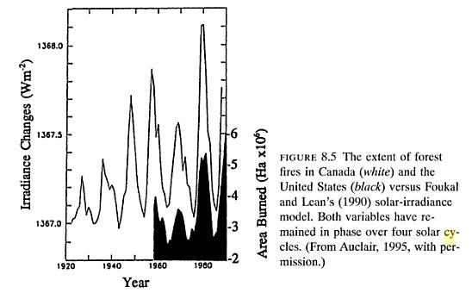

Also :

Milan M. Radovanovic, Tomislav M. Pavlovic, Gorica B. Stanojevic, Misko M. Milanovic, Mila A. Pavlovic, Aleksandar R. Radivojevic ?data? "The influence of solar activities on occurance of the forest fires in Southern Europe" http://www.doiserbia.nb.rs/img/doi/0354-9836/2014%20OnLine-First/0354-98361400036R.pdf

endpage

Seaweed versus sunspots - Scotland

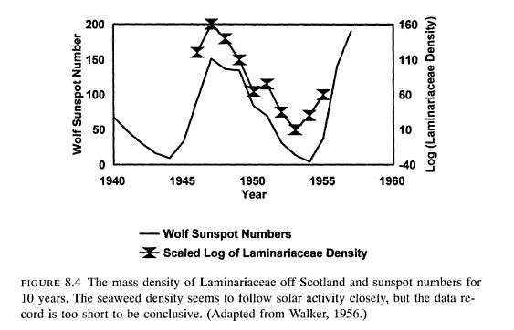

Lynx furs versus sunspots - Canada 1820-1957

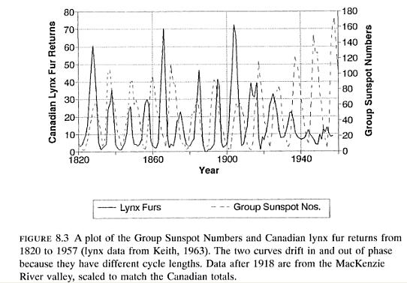

endpage

Insects versus sunspots - Britain

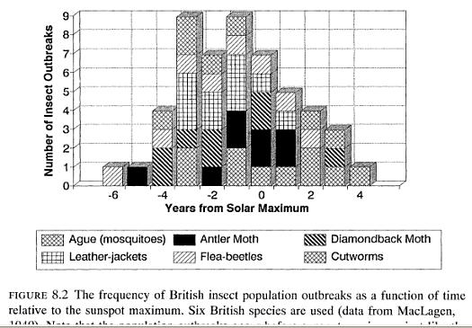

1940). Note that the population outbreaks occur before sunspot maximum, Just like the tent caterpillars in New Jersey.

Tent caterpillars versus sunspots ~1914-1942 - New Jersey

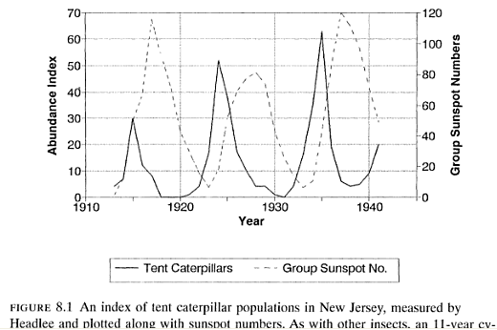
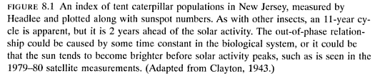

endsection

Human health

Pandemics

enbdsection

Psychology

Polk 82mmdd Schumann Resonances and EEG [delta,theta,alpha,beta] bands
in D'Amico 180228 Space Weather & Human Health

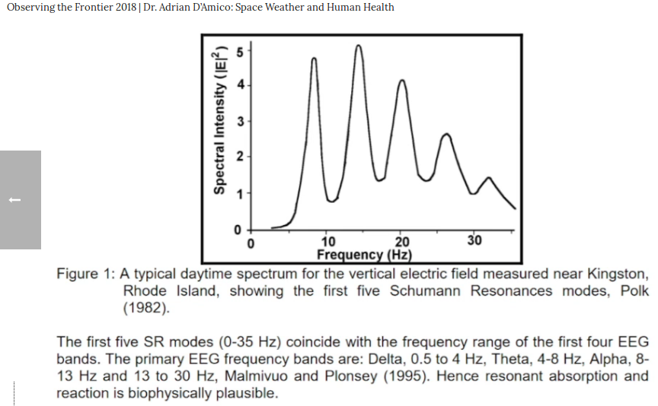

2. Neil Cherry 09Aug2001 "Schumann Resonances, a plausible biophysical mechanism for the human health effects of Solar/Geomagnetic Activity"
Polk 82mmdd Schumann Resonances and EEG [delta,theta,alpha,beta] bands, in D'Amico 180228 Space Weather & Human Health.png
- originated with German physicist W.O. Schumann, 1952
- Schumann resonances ULF/ELF radio signals trapped between ionosphere & Earth's surface
- caused by thunderstorm activity
- Cherry created multiple hypothesis "can the brain absorb, detect, and respond to extremely low intensity ULF/ELF environmental electromagnetic signals"
- Cherry didn't do primary research - meta-analysis
- Schumann student Konig = ELF brain waives may have evolved to use natural Schumann signals (Natural Zeitgeber)
- Schumann response - healthy at normal levels, extreme [intensity,frequency] alter brain waves
- polstulated melatonin/serotonin balance
- solar maximum & solar storms

https://en.wikipedia.org/wiki/Gamma_wave
Brain waves :
Delta wave – (0.1 – 3 Hz)
Theta wave – (4 – 7 Hz)
Alpha wave – (8 – 15 Hz)
Mu wave – (7.5 – 12.5 Hz)
SMR wave – (12.5 – 15.5 Hz)
Beta wave – 2. (16 – 31 Hz)
Gamma wave – (32 – 100 Hz)

endsection

War, revolutions, conflict

enddoc

