The ‘crude’ reality of what weaker oil means for Canada: CIBC

Pamela Heaven | December 16, 2014 | Last Updated: Dec 16 2:02 PM ET
New York Times
The impact on Canada's real GDP from declining oil prices is already approaching the damage inflicted by past crises.

The 40% dive in oil prices over the past four months is an unprecedented situation for Canada and its impact on the economy will be much greater than thought, CIBC economists predicted Tuesday.
In a report entitled “No barrel of fun: What weaker crude means for Canada,” the team of economists estimated that the real hit to the nation’s growth would be closer to 2%, rather than the quarter or third percentage point earlier predicted by the Bank of Canada.
In fact the dent from declining oil prices to the country’s national income is already approaching the damage inflicted by past crises, as the chart below shows.

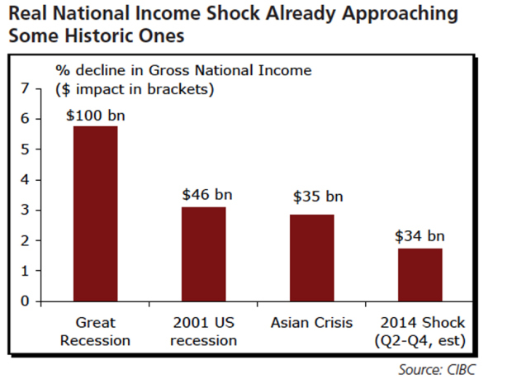
[Howell - Great Recession probably 1985/86, Asian 1997-98]
What makes this rout different, says CIBC, is that it is led by supply shock, driven by OPEC’s refusal to cut output in an oil glut, rather than the sharp declines in demand of past corrections. As well, Canada is now a much bigger exporter than it was, making it more exposed to oil’s fortunes.
The CIBC model doubles the impact to real GDP of the Bank’s quarter point to half, but says the hit to nominal GDP and net national income could be as much as 2%.

Related
- Oil’s rapid slide fuels uneasiness in Canada’s oilsands boomtown
- Oil prices are now unsustainably low: So where do we go from here?
- Canadian banks could take up to 7% earnings hit from oil exposure
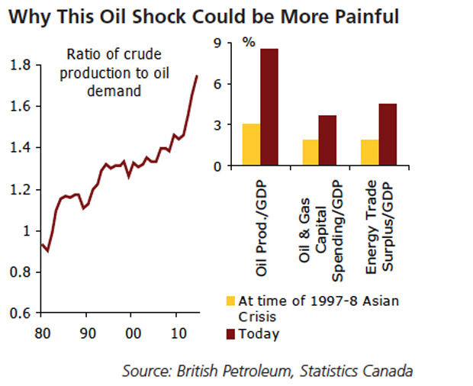
The impact for Canada’s three oil producing provinces, Alberta, Newfoundland and Labrador and Saskatchewan, will be much worse. While the energy sector accounts for 10% of Canada’s GDP, in oil producing provinces, it’s more like 25-30%. While this decline will not be as ugly as 2009 (when the WTI fell 40% year on year), it will be large enough to tip the robust GDP growth of Canada’s three oil-rich provinces into negative territory, CIBC said.

On the bright side, cheap oil prices, a low Canadian dollar and interest rates will boost Ontario’s economy to become the leader in GDP growth next year.
“The bottom line is that references to a few decimal places in real GDP miss the point,” write CIBC economists. “The value of what Canada sells to the world, not just the volumes, is what filters into wages and profits, government revenues, and economic well being.”
Even if oil hangs on to US$70 a barrel, the government sector stands to lose $10-$13-billion in revenue, with Ottawa’s share in the loss at $5-billion.
Because of falling oil prices, CIBC has pushed back its forecast on the Bank of Canada’s first rate rise to the last quarter of 2015. It also sees the loonie bottoming lower at 81 US cents, about 5% below than prior estimates.

