http://business.financialpost.com/2014/12/01/here-are-the-breakeven-oil-prices-for-every-drilling-project-in-the-world/

Here are the breakeven oil prices for every drilling project in the world
Myles Udland, Business Insider | December 1, 2014 8:40 AM ET
More from Business Insider
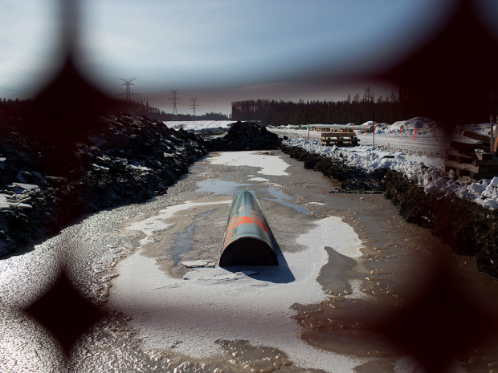
BloombergCitigroup said companies are canceling projects that require oil prices above $80 a barrel to break-even as the futures market has made hedging above that price a challenge.

Oil is getting slammed.
On Thursday, OPEC announced that it would not curb production to combat the decline in oil prices, which have been blamed in part on a global supply glut.
And now that oil prices have fallen more than 30% in just the last six or so months, everyone wants to know how low prices can go before oil projects start shutting down, particularly US shale projects.
In a note last week, Citi’s Ed Morse highlighted this chart, showing that for most US shale plays, costs are below $80 a barrel.

Related
- How Low Oil Prices Put The World Economy At Risk Over The Long Run
- This Stock Chart Perfectly Sums Up The Whole Oil Crash Story, And It Is Scary
- The Cure For Low Oil Prices

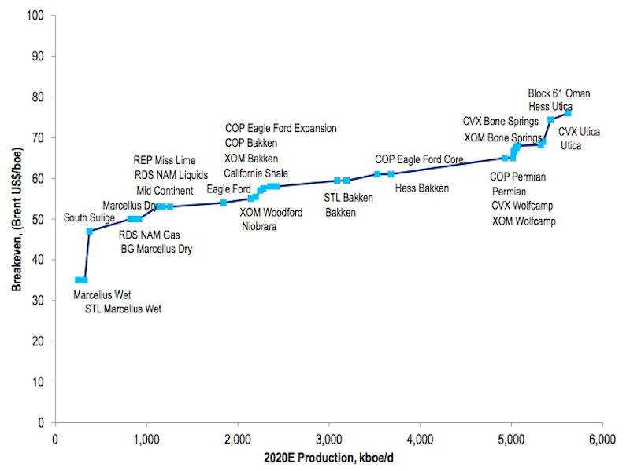
Citi
Morse writes that if Brent price move towards $60 — they’re currently around $72 — a “significant” amount of shale production would be challenged.
But Morse also highlighted this dizzying chart, listing the breakeven price for every international oil company project through 2020. (You can save it to your computer and zoom in for a closer look.)
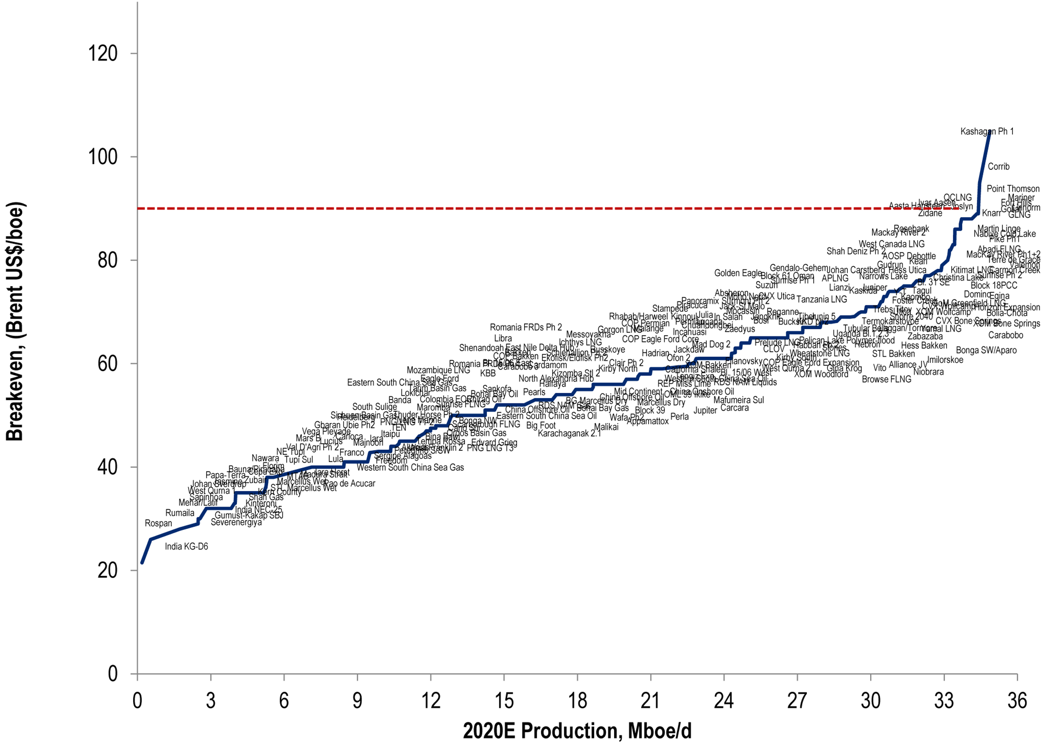
Citi
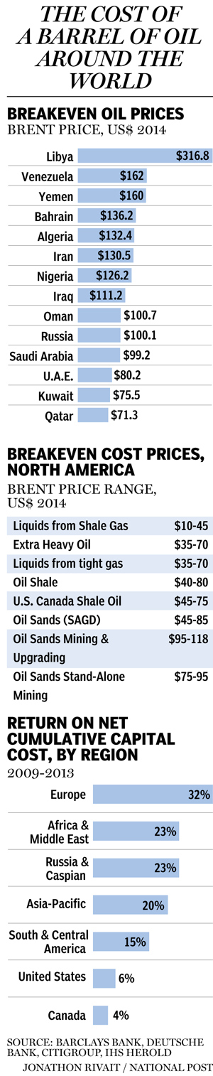
The US shale plays
Over the last few years, Morse writes that companies have been willing to consider projects if they can sell the project’s oil for $90 a barrel.
And while the chart shows that almost every project that has been considered by companies to this point has required prices less than $90 to break-even, Morse writes that companies are canceling projects that require oil prices above $80 a barrel to break-even as the futures market has made hedging above that price a challenge.
And beyond the implications for the economic feasibility of projects right now, there are also implications for future global supply.
“We think the world has plenty of oil at $90 going forward,” Morse writes, “but supply may be less adequate on a sustainable basis at prices much below $70…even though on a shorter-term basis, US shale production can continue to grow robustly even at lower prices.”
On Friday, Business Insider’s Shane Ferro also highlighted comments from analysts at Morgan Stanley, who write that while we’re focused on lower prices today shutting down projects, potentially supply shortfalls and upward price shocks in the future could be even more harmful in the future.

johnfromcanada • a day ago
And isn't that exactly what OPEC is trying to do - make a lot of the newer projects uneconomic and basically take them off-line so that when the price goes up again, it will soar to new heights? And then the cycle will start all over again.
obzabor johnfromcanada • 20 hours ago
If they do, it's a false hope. Look how quickly the projects came online - and that's when they were building new capacities. If OPEC gets all these projects to curtail (real possibility), they will be online 10 times faster when prices go back up. Trying to outpace market's ability to adjust is a losing game.
ThatBCGuy obzabor • 15 hours ago
Do you think if the Canadian oil sands "went offline" there would be any hope of getting the environmental approval to take them back online?
mossonrocks ThatBCGuy • 15 hours ago
Yup
ivanhoemy mossonrocks • 11 hours ago
no doubt when the price drops out of the bottom the Saudis' will buy them all up after all they are sitting on a trillion or so US$ and that way they could control production and profits indefinitely.
Notconradblack johnfromcanada • an hour ago
Bingo. The old supply vs demand scenario. Time tested again and again.
David • a day ago
Moral of the story; if you have an economy that depends on natural resources you'd better have some backup in value added industries.
Rock Doctor David • 20 hours ago
That sounds just like the United States. Lots of oil & gas, lots of coal and lots of research, manufacturing and service industries. Despite their fumbling government they might come out of this mess quite well.
thunderbolt Rock Doctor • 19 hours ago
Any exporting country loses from an oil price decline and any oil importing country (US) will gain as a whole. The winners and losers within each nation will change, ie. oil producers lose, consumers gain or vica versa if oil goes up.
ThatBCGuy David • 15 hours ago
So what is Canada backup plan? We have had issues with resourced based economies from coast to coast for decades and we still pin the hope of paying off our debt on them.
mossonrocks ThatBCGuy • 15 hours ago
And the Ontario premier killing jobs at a break neck speed as she send manufacturing out of province through taxation and electricity costs
No problem - Alberta will bail them out - some day
Q_Impact mossonrocks • 15 hours ago
Alberta has higher electricity costs than Ontario, but don't let facts get in the way of a good rant.
Riskybizness Q_Impact • 9 hours ago
Not if you factor in the debt used to finance the power generation. Alberta is also quickly phasing out coal for natural gas which comes at a cost.
Realistag Q_Impact • 13 hours ago
Costs per KWH or delivery?
Mark Bartlett mossonrocks • 4 hours ago
Lower oil prices combined with the lower dollar that will follow will be good for Ontario and PQ ... it mostly sucks for Alberta because they are a one trick pony.
Q_Impact • 15 hours ago
Sorry, but this article is 100% garbage. It promises to give us the break-even prices but even the highest resolution graph it offers is useless.
Stupid Q_Impact • 10 hours ago
I was going to say the same thing.... That graphic is absolute garbage.
skooter67 • 21 hours ago
When they say break even point, these graphs must be after royalties paid to the nations involved, right? I would have assumed break even in middle east is extremely low for the oil project as a whole if you see the nation as a partner. Looking up some sources, the cost of extrat oil in Saudi is actually only $1-2/bbl, and with other ancillary costs if $4-5/bbl. Not the $99.2/bbl quoted in the article. So am I right, they are factoring in royalties as 'costs' here to get these break even values?
Sontourian skooter67 • 18 hours ago
I believe the break even point shown for the Middle Eastern countries is that oil accounts for almost their entire GDP. So for all their social programs and to pay for civil servants, to welfare (if any), the break even point is basically their governments spending budget.
rpd skooter67 • 17 hours ago
They are factoring in their government budgets including social spending. Crudely, it's the price required to ensure there isn't social unrest and they keep their heads on their necks.
rpd rpd • 17 hours ago
Saudi Arabia, with debt to gdp less than 5% and a large wealth fund probably has the capacity to last most others out. The analysis at low oil prices is just as importantly about balance sheets and the funding gap. Break even doesn't mean a lot if you can't fund the budget.
Fat Freddies Cat skooter67 • 18 hours ago
Not exactly, not anymore. Kuwait is supposed to have the lowest lifting costs. Saudi Arabia's Ghawar field injects about 15 million barrels of sea water a day now, couple that with produced water and it costs to take the water out and inject it back downhole. That field alone is responsible for half of Saudi Arabia's production. That being said I would take anything you hear from the middle eastern countries with a grain of salt. This break even price though it what it takes to fund their economies. The break even price here is just that, a break even price on production.
themindfire skooter67 • 20 hours ago
Good question.
Get Conrad Black Deported NOW! • 19 hours ago
I don't believe the oil prices stated for the middle-east, they're much much lower than that. This article's data is flawed.
thunderbolt Get Conrad Black Deported NOW! • 19 hours ago
This is the price of oil that these nations need to balance their budget. The cost of taking it out of the ground in most cases is in the mid- 20's.
As well the cost for Western projects also excludes the sunk costs of developing the oil field, not the actual cost of extraction which is lower. So in most cases the oil will flow as long as a field is cash flow positive. Selling price > extraction price.
skooter67 Get Conrad Black Deported NOW! • 14 hours ago
so you agree with me then. This article is junk journalism. Has zero to do with 'break even point' for the business of oil extraction and export. Has more to do with government social welfare spending.
Africon • 13 hours ago
Look at what each of these countries have given to world:
Libya - Ghaddaffi
Venezuela - Hugo Chavez
Yemen - Osama Bin Laden
Iran - Ayatollah Khomeini and Ahmadinejad
Iraq - Sadam Hussein and ISIS
Russia - Lenin, Stalin and Putin
Saudi Arabia - Medieval dictatorship supports terrorism and beheading
And not a one of them is a friend of the west or of any "progressive fundamentals" like human rights, free speech, democracy, women's rights or gay rights. Curious how our so called progressives hate the one country the above all wish to wipe out. Lets hope that N American oil independence drives them all into bankruptcy and reality.
ianinlangley Africon • 8 hours ago
What a bizarre observation...
Israel is a rogue state.. an apartheid state.. in standing violation of multiple international laws.. run by war criminals.. its the world's leading money laundering nation as well as top in illegal arms trades.
Its most recent egregious act is to try to pass legislation that announces to the world .. as clear as day.. that it is a racist state by law. The consequences of which may force the coalition minority government to fall.. and send Israeli's to the polls early.. and we all know Israel has rarely ever had an election not preceded by a severe assault on the Palestinian civilians ... the very ones it has murdered and abused for decades.
Israel has lost the propaganda war Internationally.. its own citizens stand disgusted by its egregious acts.. it is defended primarily by unstable religious nutters and Neo-Conservatives taking part in the pillaging of American tax payers with every foreign policy and military decision taken into account on behalf of israel's interests.. as opposed to those of Americans.
I would suggest you do some reading.. such as Michael Sheuer, Norman Finkelstein and John J. Mearsheimer, to help you better understand just what Israel is all about and how American policy is set to benefit it and not Americans... but we all know reading and due diligence is something only engaged in by progressives.
Google "The USS Liberty".. see for yourself how much of a "friend" Israel is.
Save water drink beer • 14 hours ago
Ohhhh poor oil companies aren't making trillions anymore just the pesky billions rolling in. For once I'm on the same side as the Arabs , that'a boys!!
Bob Lyman • 4 hours ago
These numbers look highly suspect to me. As recently as 13 years ago, most oil production was economic at $20 per barrel. That includes both conventional and unconventional sources. Oil from Canada's oil sands region has been producing since the 1970's at prices that have moved up and down significantly through the period, and most current production is based on investments that were made a decade or more ago, so it is highly unlikely that they all require prices above $75 per barrel to sustain current production. The cost of new projects is a different matter, but that is often very much affected by the competition for scarce equipment and trained personnel when development is proceeding at a fast pace. If the pace of development were to slow down, which seems highly likely during a period of low or uncertain oil prices, then the costs of the inputs would decline, and more projects would become viable at lower prices. Further, every company faces its own cost structure.
balayogi • 4 hours ago
Modern economics is not only about politics but poly tricks to all of which individuals, business houses, nations all must be always alert with back up plans in the eventuality of things going wrong. I also like the crisp comment of David below 'Moral of the story; if you have an economy that depends on natural resources you'd better have some backup in value added industries'.
Sayer • 8 hours ago
Numbers have to be explained to make sense. Oil companies generally present their numbers on half cycle basis which is a marginal cost analysis. So they can go drill a particular well and break even at, say $70 oil. That means over time they will get back their direct costs to drill and produce the well. It doesn't include land or exploration costs or overhead like paying the rent or taxes etc. Then they present the costs for OPEC countries at over $100. Well that isn't a comparison at all. Those are the costs the country needs to balance its budget not its costs to break even on the well. The break even costs in most OPEC countries is a small fraction of the costs in North America, say $20. The point is that most OPEC countries are still highly motivated to bring on new production at $70 and most North American companies are not.
ianinlangley Sayer • 4 hours ago
The extraction/operating costs are really the only consideration for the oil company short term. Their start-up and exploration costs are front end loaded.. they may as you say offer a financial with an aggregate cost per barrel that indeed shows a break even point far above the actual current extraction costs.. but it can be misleading to use that as an indication of when and if harvesting will cease.
A company may choose to not sell its oil 'on the cheap'.. as its business model lists assets of which oil is its main asset and that asset is given a value.. continuing to operate during a slump in the market may forever alter its bottom line.. whereas stopping to do "maintenance" for example might allow its to retain the former model.
Every company is a little different.. and as the article suggests.. the smaller operators may need a certain constant revenue to keep afloat.
It hasn't been suggested anywhere that this move by the Sauds might be all about buying up some shale plays around the world etc.. or even oil sands.
If you recall.. it wasn't that long ago the Canadian dollar was tanked on purpose over the better part of a year.. in order for our resource plays.. mostly oil and gas and gold.. to be pillaged... the selling of the dollar during that time was consistent and strategic.
Dave Warren • 14 hours ago
I agree with the consensus here. I think these figures are questionable. Oil should be cheapest at the wellhead in Saudi Arabia. Much cheaper drilling and far larger resources.
Riskybizness Dave Warren • 9 hours ago
The breakeven prices shown are the prices each country (dictatorship :-) needs to balance it's budget.
theBuckWheat • 14 hours ago
Many Arab OPEC countries have a socialist economic policy that requires high oil prices to support. If oil falls too low, even Saudi Arabia will not be able to keep paying off their multitudes and the House of Saud may lose its grip on the country. ISIS covets Mecca.
ThatBCGuy • 15 hours ago
Sounds like china will be on a buying spree at these discounted prices. They have the space for storage.
ianinlangley • 16 hours ago
A wee bit misleading since infrastructure costs are front end loaded.. meaning investors front the money.. usually for shares and/or coonvertibles.
They don't stop mining it because a paper breakeven point isn't met.. they will continue as long as the extraction costs are met.
rpd • 17 hours ago
Break even is only half the story. A well might have a good break even price, but when do you get the $$ out to drill the next one? At $100 that was this year, at $70 it might be in two years. Who is going to fund the gap? The banks? Not that likely. Capital Markets? Only the strong, well capitalized ones.

enddoc

