Confabulation Theory - “Plausible next sentence” survey
Bill Howell, original 2008, cleaned up an massively shortened (last simple part only): 24 August 2011 , again 02Sep11

Summary

Confabulation is a biologically-inspired theory for cognition that was developed by Robert Hecht-Nielson of San Diego. It is described in an overview fashion in Section I, and in much greater detail in his book:

Robert Hecht-Nielson 2007 “Confabulation Theory: The mechanism of thought” ISBN 978-3-540-49603-8 Springer-Verlag Berlin Heidelberg 245pp, accompanied by computer DVD for learning

As a gross overview, Confabulation Theory assumes that information is held within roughly:
- 4,000 thalamocortical modules (carrying information about “mental object attributes” i.e “attribute classes”), each of which is roughly 200 time larger than a cortical column, and might be a collection of, as an example of a wide range, 126,008 symbols;
- 40,000 cortical knowledge bases (establishing “meaningful co-occurrences” between thalamocortical modules), establish through knowledge links or items of knowledge;
- tens of billions of knowledge links, mostly established in childhood, acquired often in excess of one link per second of life, and sometimes more than 100 per second (very high for infants!) – consolidation of this being perhaps a major reason for sleep every night!
- roughly 60 neurons per “symbol” or “attribute”

All vertebrates (and even invertebrates such as bees and octopi) are postulated to possess functionally analogous structures, albeit in smaller quantities. Confabulation is a “winner-take-all” process for coming to a conclusion (intermediate or final) , and is the only information-processing operation used in cognition. Confabulation DIFFERS from Bayes theorem in statistics, and these simple differences make confabulation a superior form of reasoning for the real world, where information is often incomplete, erroneous, or event misleading (predator – prey). It is even proposed that many supposed successes of Bayesian statistics are the result of extreme simplifications which mean that it is actually Confabulation that is being applied, without the statisticians and scientists even being aware of this important distinction!

The “Next Plausible Sentence” exercise as presented in Part II of this paper was a critically important eye-opener for me, and gives a very strong “hands on” sense that while technology has a very, very long ways to go, it is a very, very long ways further along than commonly thought.

But being a theory for cognition, Confabulation Theory goes much further than just this simple exercise, even extending into the interface and intermingling with sensory systems. It may be right, it may be wrong, or it may be irrelevant: it is still an amazingly powerful, insightful, and fun look at one concept for our “Mechanism for Thought”. As quoted in Part I of this paper, Confabulation Theory: “… presents the first concrete and detailed (and thus falsifiable) scientific theory of how thinking works. …”

This paper presents a simple exercise to illustrate semantics in a deep way. One of the more direct office applications described by Hecht-Nielson is “GhostWriter ©– a giant step beyond word processing” whereby the system presumably assists with the framework and conceptual details and flow of a document tackling a subject.

I repeat here a semi-quote of the author of the theory back in 2002:

“… Our advice to you is to start your research immediately,
To run as fast as you possibly can, and to never look back.

In a few short months, you will hear the starter’s pistol firing behind you,
Unleashing the greatest intellectual land-rush of all time. …”
[Hecht-Nielson ?2002? at the World Congress on Computational Intelligence, Hawaii]

The concept is still very new, and may hold many surprises for the future, and not just for cognition. Try the exercise on your colleagues, and have fun!

endsection

*****************************************************************************
Copyright © 2011 Content is owned as follows:
- Confabulation theory quotes and Figures: Springer-Verlag Berlin Heidelberg 2007
- Survey setup, description, results and compilation : William Neil Howell, Ottawa Canada 2007-08
- All papers cited are the property of the publisher or author as specified in the books and papers.
- All information from conversations with other individuals are potentially the property of that individual, or of third parties.

Permission must be sought from Springer-Verlag for sections of this report that fall under their copyright.

Permission is granted to copy, distribute and/or modify ONLY the non-Springer-Verlag content of this document under either:


The GNU Free Documentation License (http://www.gnu.org/licenses/); with no Invariant Sections, Front-Cover Texts, or Back-Cover Texts.


Creative Commons Attribution-Noncommercial-Share Alike 3.0 Unported License.

It is expected that users of the non-Springer Verlag content will:
- Acknowledge William Neil Howell and/or the specific author of content or images on this page as indicated, as the source of the image.
- Provide a link or reference back to this specific page.
- Allow any modifications made to the content to also be reused under the terms of one or both of the licenses noted above.
****************************************************************************

endpage

Table of Contents

Summary 1
I. Confabulation Theory background for the Game/ Exercise 5
I.1 Historical “conceptual context” 5
I.2 Confabulation Theory – an overview by quotes of the conceptual basis of this exercise 5
I.3 Cerebral Cortex and Thalamus: the seat of cognition 6
I.4 The four key elements of Confabulation Theory 8
#1: Each Thalamocortical Module Describes One Mental Object Attribute 8
#2: Knowledge links connect pairs of co-occurring symbols 9
#3: Confabulation - The information-processing operation of thought 10
#4: The Conclusion -> Action Principle – The origin of behavior 11
I.5 Extra comments on Confabulation Theory 11
Aristotelian logic 11
Bayesian Statistics 12
Mapping sensory information to symbolics 13
Watson & Jeopardy 13
Reaction of the IJCNN crowd 13
Parting inspiration 14
I.6 A brief description of the Confabulation system for “Plausible Next Sentence” 14
I.7 A brief description of Howell’s overall Confabulation survey of 2007-08 14
Part II. Exercise: “Plausible next sentence” – a linguistically-challenged respondent 17
II.1 Background 17
II.2 Initial Instructions for the “Exercisee” (the person doing this exercise) 17
The Hints - “Plausible next sentence” Exercise 24
Hint #1 following the initial form-filling 24
Hint #2 (final hint) 28
II.3 Instructions for the Organiser 29
II.4 Discussion points following completion of the Exercise 30

CAUTION: Please note that this document is largely drawn from home projects and posting of Bill Howell. It is adapted here to the context of social media as per the SPINE project at NRCan. There is therefore a strong personal bias and background perspective to this document, which limit its generality, and I am several years out of date on this subject area. The content is also NOT NRCan property, as components have been posted on my website, and pre-date SPINE by several years (in particular the section on Confabulation theory and the survey that I did in 2006-2007 based on material from 2002 and 2007).

DOUBLE CAUTION: Semantics is NOT my field, nor have I made a special effort to read into it extensively. My own exposure has come through the papers and discussions of others, primarily via computational intelligence conferences, journal papers, and emails.

Modifications:
versions sent out:
2007 Completion of survey forms (spreadsheets), interviews of respondents over 4 to 6 months
Requests of “judges” for spelling, grammar, syntax, and semantics”
New Requests of judges with an emphasis on “Semantics” for all responses
Selection of 6 respondents from 15 (selected respondents had to have answers for all 6 sentence pairs)
Partial writeup of results
2008 Further writeup of results (still very much incomplete!)
New (incomplete) responses from colleagues in Ottawa
Further writeup of the last & simplest part – identification of the “affected respondent”
19May11 1st draft based on material from home (“Semantics beyond search” parent paper, skeleton draft),
10Aug11 fleshing out of parent paper,
19Aug11 reasonably complete draft of Exercise emailed to contacts,
22Aug11 etc – clean-up..

Incomplete:
- A detailed description of the system for generating the “Next Plausible Sentence” from Confabulation Theory was NOT included. For now, it is assumed that the reader must get the book [Hecht-Nielson 2006].
- Only the very last, simplest portion of the original survey is included here, and even for that portion, only a fraction of the data and analysis is included. There is no intent to write the other material up at a later date.

*****************************************************************************
Waiver / Disclaimer

The opinions expressed in this document are NOT those of any of the author's past, present, or future employers, friends, colleagues, family, acquaintances, nor of the people who participated in the surveys and their assessments. This document has no content from any of the former list, other than from:
- acquaintances (notably Robert Hecht-Nielson and others) that I met at the World Congress of Computational Intelligence 2002 in Hawaii, the International Joint Conference on Neural Networks 2007 in Orlando, or
- acquaintances who discussed ideas with me, or whose papers I have read.
- Participants (“Exercisees”, “Respondents” and many others!) in the 2007-08 survey, plus a few others who helped verify the wording of the explanations in the survey employees. Their input provided the raw data for the original survey done in Calgary and Ottawa.

No liability will be accepted for any consequences whatsoever arising from the use of any material herein. Full responsibility for the consequences of using any information here-in rests with the reader, including the consequences of the reader passing any information herein to third parties.

Author: Bill Howell, Ottawa, 22 August 2011, and for any material added thereafter.

I. Confabulation Theory background for the Game/ Exercise

I.1 Historical “conceptual context”

An earlier predecessor of this game was “Eliza” in the mid-1960’s, which was a pattern-matching system that “conversed” with people, sometimes creating a short-lived illusion . This was as an attempt to meet the “Turing test” objective for machine intelligence (http://en.wikipedia.org/wiki/ELIZA )

The results of the current game are reminiscent of the difficulty that psychiatrists apparently had in distinguishing human from machine responses, when faced with the PARRY system, a successor to ELIZA (http://en.wikipedia.org/wiki/Turing_test ):

“… Kenneth Colby created PARRY in 1972, a program described as "ELIZA with attitude". It attempted to model the behaviour of a paranoid schizophrenic, using a similar (if more advanced) approach to that employed by Weizenbaum. In order to validate the work, PARRY was tested in the early 1970s using a variation of the Turing Test. A group of experienced psychiatrists analysed a combination of real patients and computers running PARRY through teleprinters. Another group of 33 psychiatrists were shown transcripts of the conversations. The two groups were then asked to identify which of the "patients" were human and which were computer programs. The psychiatrists were able to make the correct identification only 48 per cent of the time — a figure consistent with random guessing. …”

The big difference here is that the “Confabulation system” that the exercise is based on composes answers to real sentence pairs, and must have “extensive world knowledge” to do so, albeit still within a framework of pattern-matching. Furthermore, Confabulation is producing results that are not so clearly different from normal people. In this sense, the system performs the spelling, grammar-syntax, and semantic functions relatively well.

I.2 Confabulation Theory – an overview by quotes of the conceptual basis of this exercise

This exercise was taken from results presented in the excellent book:
Robert Hecht-Nielson 2007 “Confabulation Theory: The mechanism of thought” ISBN 978-3-540-49603-8 Springer-Verlag Berlin Heidelberg 245pp, accompanied by computer DVD for learning

I had first seen the concept of Confabulation Theory a few years earlier, during a presentation / dramatic announcement by Robert Hecht-Nielson at the Word Congress on Computational Intelligence in Hawaii, 2002. The concept was developed under funding by the US Office of Naval Research. While the book and DVD is a solid and necessary starting point for understanding Confabulation Theory, several quotes from the book are provided here as a flavour of the theory (in blue font), and to show that it is anything but trivial.

The descriptions of Confabulation Theory blow are selected and quoted directly from Hecht-Nielson’s book as cited above. While it is common practice to re-interpret material from another author, I feel that this is inappropriate, and that the reader is best served by quotes than (mis)-interpretations. (If you interpret this as laziness on my part, well that’s true too…).

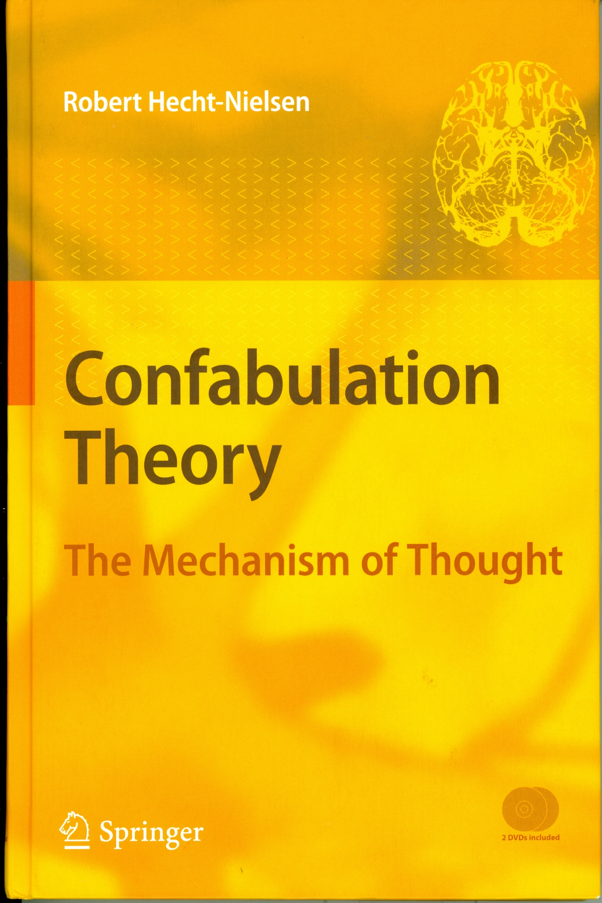
Robert Hecht-Nielson 2007 “Confabulation Theory: The mechanism of thought” ISBN 978-3-540-49603-8 Springer-Verlag Berlin Heidelberg 245pp, accompanied by computer DVD for learning

I.3 Cerebral Cortex and Thalamus: the seat of cognition

[p 5] “… This book presents the first concrete and detailed (and thus falsifiable) scientific theory of how thinking works. This confabulation theory proposes the specific neuroanatomical structures, and their functions, that are involved in human cognition.
The two main human neuroanatomical structures postulated by confabulation theory to be involved in the implementation of thought are thalamocortical modules (figure 1.1) and knowledge bases (Fig. 1.2). These structures, which constitute the “information-processing hardware” used to carry out thought, exist within the cerebral cortex and thalamus. The human brain possesses roughly 4,000 thalamocortical modules and roughly 40,000 knowledge bases. All vertebrates (and even invertebrates such as bees and octopi) are postulated to possess functionally analogous structures, albeit in smaller quantities. …”

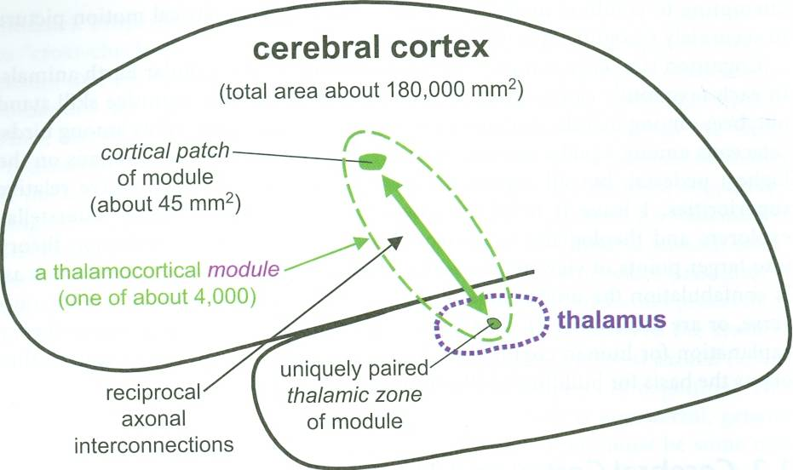
Fig. 1.1 A thalamocortical module (one of roughly 4,000 in the human brain). Each thalamocortical module is comprised of a small patch of cerebral cortex and a uniquely paired zone of thalamus. The cortical patch of each module is reciprocally axonally connected with the thalamic zone of the module. The cortical patches of different modules are largely disjoint (partial overlaps do likely occur). Similarly for their thalamic zones. The union of the cortical patches of all thalamocortical modules comprise the entire area of the cerebral cortex. However, the union of the thalamic zones of all modules do not comprise all of the thalamus.

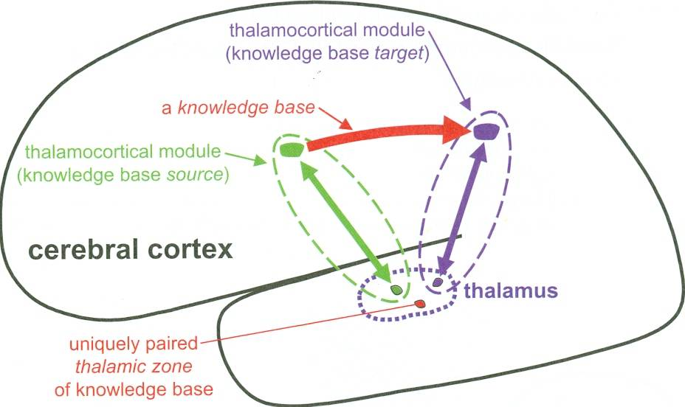

Fig 1.2 A cognitive knowledge base (one of roughly 40,000 in the human brain). Roughly 40,000 ordered pairs of thalamocortical modules (source and target modules) are selected (by genetically specified developmental processes carried out in childhood) to each have their cortical patches unidirectionally linked by a knowledge base. Each knowledge base is comprised of a large number (often millions) of individual knowledge links. Much like a thalamocortical module, each knowledge base is postulated to be paired with a unique, dedicated zone of thalamus which is postulated to be involved in that knowledge base’s enablement. The combination of the thalamic zones of the modules and knowledge bases make up the vast majority of the thalamus.

I.4 The four key elements of Confabulation Theory

[p 7] “… Today, the cognitive information-processing and cognitive knowledge acquisition, storage, and use functions of cerebral cortex and thalamus are completely unknown. Confabulation theory specifies them completely. In particular, confabulation theory postulates four key functional elements (#’s 1, 3, and 4 implemented by thalamocortical modules and #2 implemented by knowledge bases) which together comprise the neuronal information-processing “hardware” of thought. …”

#1: Each Thalamocortical Module Describes One Mental Object Attribute
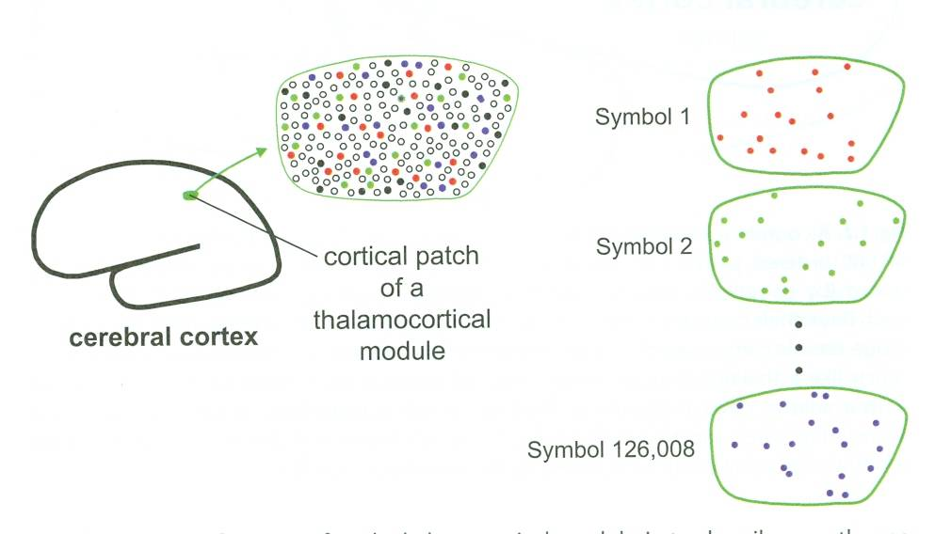
Fig 1.3 A primary function of each thalamocortical module is to describe exactly one attribute that an object of the mental universe (a sensory object, a motor process object, a thought process object, a plan object, a language object, etc) may possess. To carry out this object – attribute – description function, each module implements a large collection of symbols. When utilized for describing an object, a module typically expresses one symbol chosen from its collection (primary sensory and motor modules usually express multiple symbols). Each symbol is represented by roughly 60 neurons selected (approximately uniformly at random) from a special population of symbol-representing neurons (shown as colored dots within the enlarged depiction of the module’s cortical patch) that reside within the cortical patch of the module. Here, a module with 126,008 symbols is depicted. Each symbol’s subset of 60 neurons is shown schematically. Symbols are mostly formed in childhood and then remain stable throughout life – they are the stable terms of reference that must exist if knowledge is to be accumulated across decades. The famous binding problem (von der Malsburg 1981) does not apply to confabulation theory because each of the attribute description symbols of an object is typically linked to many of the others pairwise by knowledge links (see Sec. 1.2.2). In effect, a mental world object is any reasonably large subset of its pairwise-linked attribute description symbols. Thalamocortical module symbol sets (the collection of different descriptive terms for representing the object attribute that the module is responsible for encoding) are the first of the four key functional elements of confabulation theory.

#2: Knowledge links connect pairs of co-occurring symbols
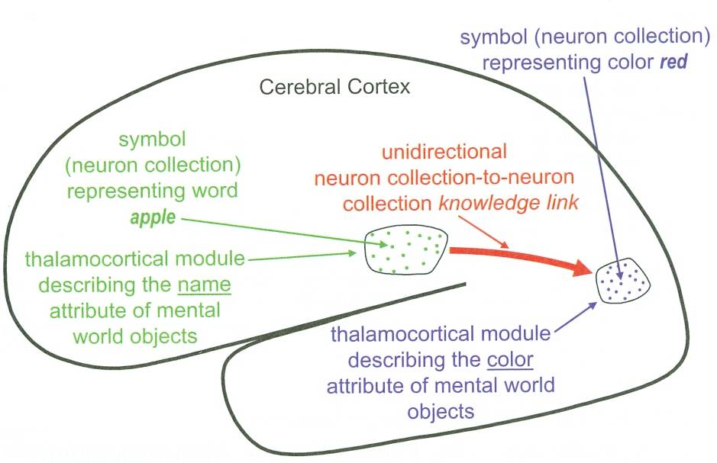
Fig 1.4 A cognitive knowledge link. Here, a human subject is viewing and considering a red apple. A visual thalamocortical module is expressing a symbol for the color of the apple. At the same time, a language thalamocortical module is expressing a symbol for the name of the apple. Pairs of symbols which meaningfully co-occur in this manner have unidirectional axonal links, termed knowledge links (each considering a single item of knowledge), established between them via synaptic strengthening (assuming that the required axons are actually present – this is determined by genetics). The average adult human has billions of knowledge links, most of which are established in childhood. The rate of human knowledge acquisition often exceeds one link per second of life.
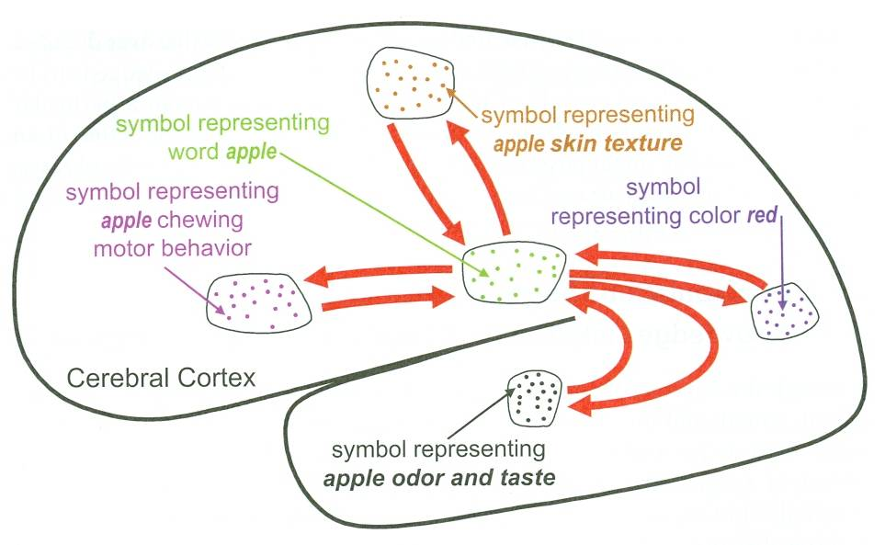

Fig 1.5 Billions of pairs of symbols are connected via knowledge links. The set of all knowledge links joining symbols belonging to one specific source module to symbols belonging to one specific target module is termed a knowledge base. In the human brain, knowledge bases take the form of huge bundles of axons termed fascicles, which together make up a large portion of each cerebral hemisphere’s ipsilateral white matter. Each module also typically has a knowledge base to its contralateral “twin” module (and perhaps to a few others near its twin) – which together constitute the corpus callosum fascicle linking the two cerebral hemispheres. Here, reciprocal knowledge links (red arrows), only some of which are shown, connect each expressed symbol representing an attribute of an apple pairwise with other such symbols. When an apple is currently present in the mental world, it is its collection of knowledge-link-connected symbols which are currently being expressed. There is no binding problem because all of these are mutually “bound” by their previously established pairwise knowledge links. Shockingly, confabulation theory contends that such knowledge links – formed exclusively on the basis of meaningful symbol pair co-occurrence – are the only type of knowledge used (or needed) in cognition! Knowledge links are the second of the four key elements of confabulation theory.

#3: Confabulation - The information-processing operation of thought

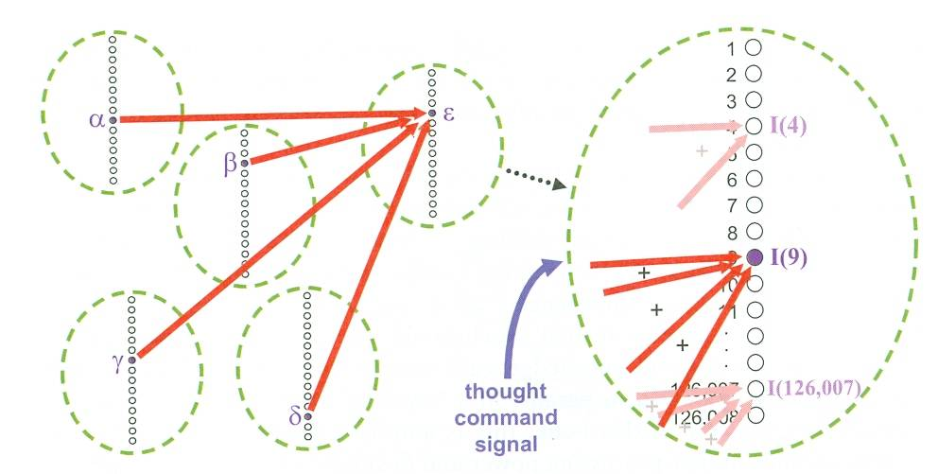

Fig 1.6 Confabulation – the only information-processing operation used in cognition. Here, a concrete example involving five thalamocortical modules is shown (for simplicity, each module is illustrated as a dashed green oval with a list of that module’s symbols inside it). See text for details. Confabulation is the third of the four key elements of confabulation theory.

#4: The Conclusion -> Action Principle – The origin of behavior

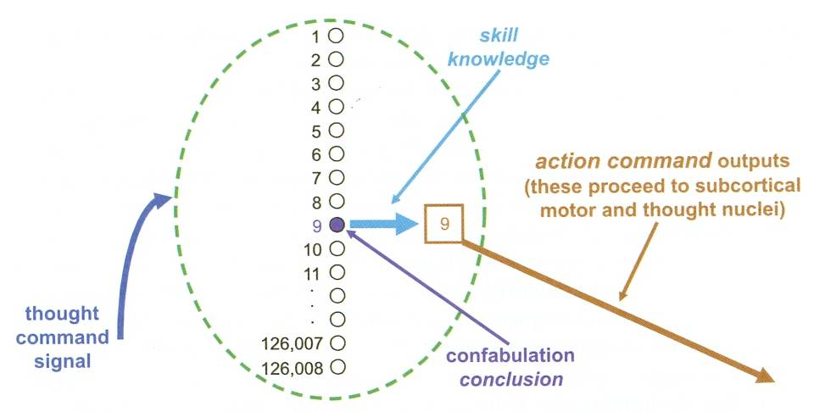
Fig 1.7 The conclusion -> action principle: hypothesized to be the origin of all non-reflexive and non-autonomic behavior. Here, a thalamocortical module (illustrated, in consonance with Fig 1.6, as an abstract “oval” structure containing a list of the module’s symbols) has successfully completed a confabulation operation (under control of its externally supplied thought-command signal) and reached a conclusion (symbol number 9 as in Fig 1.6). Whenever a module completes a confabulation and reaches a conclusion it immediately causes a set of action command outputs to be launched (these outputs proceeding to sub-cortical nuclei). The specific action command outputs that are launched are those which have been previously associated from this specific conclusion symbol via a completely separate, sub-cortically managed, skill-learning process. These action command outputs can cause behaviors to occur. The conclusion -> action principle is the fourth and last of the key elements of confabulation theory.

….
Note that it has been several years since I have looked at confabulation theory. Given that it is a fairly new concept, rapid change, or discreditation, may have occurred in the meantime. But it remains an excellent example of semantic processing!

I.5 Extra comments on Confabulation Theory

Aristotelian logic
[Hecht-Nielson 2006, p18, Chapter 4] points out that “… cogent confabulation within a logical information environment yields Aristotelian logic …”. Pretty nifty.

Bayesian Statistics
[19Aug2011 Howell - This is a pretty heavy subject, greatly challenged by the Confabulation Theory results, but I’ll need to come back to it at a later date. For now, here are a few quick points. …]

Confabulation makes for an extremely interesting and important contrast to Bayes theorem in statistics! [Hecht-Nielson p76-77] In my own clumsy way if putting it, Confabulation maximizes the expected truth of the inputs, whereas Bayes theorem maximizes the expected value of the outcome. Perhaps in an ideal sense, the two approaches would be mathematically equivalent in a roundabout fashion, but in practice there is a BIG difference. Worse, it appears that much of the success of applying Bayes theorem may be due to simplifications (“naïve Bayes formula”) that turn the Bayes approach into “cogency maximization” of Confabulation – in other words, it isn’t Bayes theorem other than in a pragmatic slang form of mathematics?

Furthermore, Bayes theorem is not well adapted to explaining biological mechanisms, according to Hech-Nielson. This is critical for anyone with a neuroscience, biology, psychology perspective!

This is part of the basis for my long-standing interest in a fun-inspired “attack on Bayes Theorem in statistics”. I have not had any success with that battle cry, at least not yet among my friends.

Along with most other areas of Computational Intelligence, this is also a basis for my strong feeling that for “complex dead systems”, that logic is an emergent property, and that [rational, logical, scientific] thinking is an inadequate approach to most real-world systems (living, human), although it might still be a somewhat useful contributing tool as long as its applications is limited and controlled. Elsewhere in this “Semantics beyond search” paper I was to address this question.

[Hecht-Nielson p76] is somewhat more forceful in his comments:
“… Since the mathematics of confabulation is simple, an obvious question is: “Why wasn’t confabulation theory discovered long ago?” A key reason is a decades-long intellectual constipation brought about by what might be called the “Bayesian religion”.

The Bayesian religion is a dogmatic belief structure (often mistakenly viewed as a set of incontrovertible facts), currently held by perhaps 100,000 researchers and practitioners worldwide, underpinned by roughly the following seductive, compelling line of arguments: .” (see Hecht-Nielson’s book for the details)

Funny, the thrust of his comments corresponds very well with my long standing interest in the “mainstream conceptual religions” of essentially all scientists (very clear with Climate Science, Special and General Relativity, Big Bang, and just about any other high-profile science issue).

All kidding aside, this is an extremely important subject area, and not one where good advise will be readily available.

Mapping sensory information to symbolics
An extremely powerful component of the thinking around Confabulation Theory lies with the manners in which a mapping of sensory information onto symbolics have been tried. I was stunned with how far that concept can be extended, even at such an early stage! But I will not review the subject here, as I merely wanted to flag it for the interested reader.

Watson & Jeopardy
One question that remains to me is whether Confabulation Theory, or something like it, was a component of IBM’s “Watson” system that defeated the best human Jeopardy players 14-16Feb2011 (http://en.wikipedia.org/wiki/Watson_(computer) ). An interesting tidbit in the Wikipedia article is that Watson relied on “… 200 million pages of structured and unstructured content consuming four terabytes of disk storage, …”. [Hecht-Nielson 2007 p113] stated that 124 million single sentences, and 70 million meaning-coherent sentence pairs were used to train their confabulation system – this would be much less than the Watson system. However, there is no indication that I can find of Confabulation in the descriptions of how Watson was built, and the following comment in the above link indicates that if confabulation is present, it is only a part of the solution: “… more than 100 different techniques are used to analyze natural language, identify sources, find and generate hypotheses, find and score evidence, and merge and rank hypotheses …”. Additionally, Confabulation theory as of 2007 was apparently slow in processing, perhaps indicating that competing in Jeopardy games would be problematic.

Reaction of the IJCNN crowd
I was very excited when I heard Hecht-Nielson’s presentation. He has a strong history in the area of neural networks, and had launched the first successful neural-network based company before resigning as Chair and returning to academia. Although usually enthusiastic, he never seemed to me to be given to exaggeration or sensationalizing things, being very firmly planted on a solid mathematical basis all the time. But he was clearly excited with his idea at the time, and was not at all shy of strong “hyperbole”. To be quite frank, right or wrong, I believe his enthusiasm was and is entirely justified – time will tell if it will work out, but confabulation is a breakthrough concept, appears to be simple and very powerful, it is fun, and it generated world-class results almost immediately.

However, many at the International Joint Conference on Neural Networks (IJCNN – part of the World Congress on Computational Intelligence) were less than enthusiastic, and that still puzzles me. For sure, confabulation theory is quite different from their own concepts and may actually contradict those. Additionally, it seems to be far too simple to have anything to do with biology, the dynamics of neural systems, and perhaps with cognition itself. Furthermore, it deals with one specific component (ort components) of cortical function, perhaps ignoring a great many other processes and functions. Fair enough, but none of that is a solid reason for not showing interest? Or, maybe I am too prone to be interested in all wild ideas? We don’t have to answer that.

Parting inspiration

“… Our advice to you is to start your research immediately,
To run as fast as you possibly can, and to never look back.

In a few short months, you will hear the starter’s pistol firing behind you,
Unleashing the greatest intellectual land-rush of all time. …”
[Hecht-Nielson ?2002? at the World Congress on Computational Intelligence, Hawaii]

I.6 A brief description of the Confabulation system for “Plausible Next Sentence”

The “builders” of Confabulation Theory built an exercise around using two sentences to generate a “third plausible sentence. The Confabulation system itself was fed ?120 million sentences and 70 million sentence pairs? from quality newspapers, magazines etc. These were “serious sentences and sentence pairs” - not jokes, plays on words or other sources that may intentionally obscure meaning. Spelling, grammar, syntax were of good quality in the information used as the basis for their system.

Several tests of the “next plausible sentence” generation by confabulation theory are provided in the book [Hecht-Nielson 2007, pp65-67], and it is from those examples that the current exercise was drawn. Note that these test sentence examples were taken randomly from quality newspapers, magazines, and similar sources. They were NOT part of the training examples for the Confabulation system. So the latter had to “invent” new responses to new questions, so to speak. Those responses also required correct spelling, grammar, syntax, which is an outcome (side effect?) of confabulation theory.

Note that the confabulation system responses are all labelled #4 in each of the tests results shown.

I.7 A brief description of Howell’s overall Confabulation survey of 2007-08

It’s important to note that the exercise in this section is only the last, simplest part of a MUCH larger survey effort that was done in 2007-08. A brief description of that larger survey is provided here, as the context is important. Otherwise Organisers and Exercisees of this section may not appreciate that a fair amount of extra work and analysis lead to the exercise as shown in this paper. However, much of the survey effort was NOT conclusive or complete, as described below.

Selection of plausible next sentences
A sampling of sentence-triplets were taken from [Hecht-Nielson 2007, pp65-69]. The first two sentences of each triplet were put on a questionnaire with instructions, including the core request:

“… Plausible next sentence - Add a third sentence to each couplet (quality newspaper or magazine style, serious - not joking, witty etc). …”

Note that “serious” and complete, well-composed answers were requested.

Sentence collection from respondents
This (serious) game/survey started off by collecting written responses by individuals, which I did in 2007. This was much harder than it seemed, as it does take time for the individuals to go through a number of questions. Furthermore, it’s not exactly a subject that interests or motivates many people. In one case it took me some time to understand that the individual I was asking was functionally illiterate, and too embarrassed to say so!

In his books, DVD and presentations, Robert Hecht-Nielson posed very interesting questions, such as (rough approximations to his questions):
- What percentage of North American adults could compose written responses with equal or greater “correctness” of spelling, grammar, and syntax? (Leave semantics aside for this question).
- What percentage of North American adults would show the same “awareness” of general world current events and issues, as Confabulation Theory seems to possess?

Sentence evaluation (spelling, grammar, syntax, semantics)
One stage of the 2007-08 survey was to assess all responses on the bases of ranking spelling, grammar, syntax, and semantics. Here we are referring to each response, without regard to the respondent or the ensemble of responses by a respondent.

Leaving semantics aside for now, the ranking of spelling, grammar, and syntax seemed obvious but it was virtually impossible to get “normal people” (as opposed to Language teachers from junior high or high school or university) to grade responses. People just weren’t confident of doing this, and the results were incomplete and not usable. Having money to pay professionals would have solved that problem.

Finally, how does one grade semantics? Obviously, part of this is world knowledge. There probably are great tools for assessing this in some domain of linguistics, but us “normal people” can only remember the coaching and motivation provided by our teachers in school. My gut feel is that one should NOT shy away for making this assessment (try telling that to your Exercisees!), and that subjective judgment is a great starting point (touchy-feely).

A lot of work went into this part of the survey, with less than satisfactory results for the reasons given above – it’s hard to grade some of this. Notice that, while we want to assess the effectiveness of Confabulation as a “machine in a human domain”, it is a real challenge for most of us to do the same of ourselves!

Rank the respondents
Identify the semantically-challenged respondent
This is the last and easiest part of the overall 2007-08 survey, and it is the focus of the exercise in this report. Generally speaking, of ~20 Exercisees to date (mostly in 2007-08), only one positively and unambiguously has selected the correct “affected respondent” #4. More importantly, no-one has stated that it was immediately and clearly obvious, within seconds of reading Question #1 and the responses, or even for the first pass of all questions, that it was obvious that #4 was the answer.

Harder still than “basics”, a clear limitation of the 2005-06 status of the Confabulation system for this exercise was the last of “variety and richness” of composition.

Evaluation of the evaluators (Exercisees)
[19Aug2011 Howell – for some later date…this is actually quite involved.]

endsection

Part II. Exercise: “Plausible next sentence” – a linguistically-challenged respondent

II.1 Background

This is the last (and easiest) part of a study of the [spelling, grammar, syntax, and semantic] flaws related to the understanding and composing of text. It relates to psychology, and more particularly to linguistics, cognition, disorders, and our perceptions of disorders.

Respondents were given a sentence pair from well-composed articles dealing with fairly well-known world or local situations and themes. Their task was to provide a “third plausible sentence” that follows the idea presented in the first two sentences, that follows the rules of [spelling, grammar, syntax] for the English language, and that “makes sense” – that is, it is a “reasonable” extension of the first two sentences. In this exercise, we are not testing the accuracy/ correctness of the response so much as the linguistic capability of respondents, and their understanding of what is written.

One of the respondents (the “affected respondent”) has problems comprehending and composing verbal and written sentences. As with many other disorders, this isn’t necessarily obvious, as this exercise demonstrates.

II.2 Initial Instructions for the “Exercisee” (the person doing this exercise)

Six sentence pairs are provided on the following pages, together with a “third plausible response” by 6 respondents. You are NOT provided with the “affected respondent” # until all three steps are completed.

- As indicated on each page, please comment on the relative strengths/weaknesses of the respondents' overall set of responses. Take into account the "context sentences" used for each response. Do the answers show an understanding of this context? Rank all six respondents from 1 (best) to 6 (worst) in the right-most column.

Only 15 minutes should be taken to do the rankings and select the “affected respondent” (30 minutes for fanatics, if you are fanatically interested). Taking too much time is counter-productive, as we’re not looking to evaluate you, but rather to get your “impressions”. It’s not whether the right “affected respondent” can be identified with effort and analysis – it’s whether if the “affected respondent” is immediately apparent within seconds of looking at the first question and its responses!!

- After completing #1 above (i.e. you have evaluated the respondents based on all six of their responses), the next step is to select WHICH RESPONDENT is the one who has a great deal of trouble understanding semantics (reading and composition) – i.e. the “affected respondent”?

What is your choice of the “affected respondent” #?: ________

- You have three tries to pick the “affected respondent”. After each pick, you will be told whether or not you were correct. If you were NOT correct, you will be given an additional clue as to the identity of the semantically-challenged “affected respondent”.

endpage
Ranking the responses

Sentence-pair #1:
- Seeing us in a desperate situation, the Lahore airport authorities switched on the runway lights and allowed us to land with barely one or two minutes of fuel left in the aircraft, he said.
- At Lahore, Pakastani authorities denied Saran's request to accept wounded passengers and women and children, but they refueled the plane.

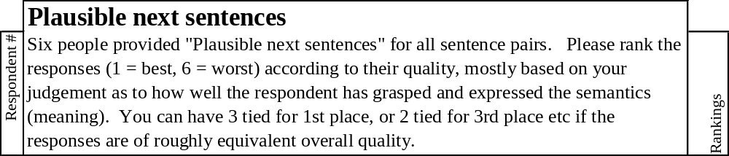

1 | I guess they had no choice.
2 | They didn't want any passengers to discuss the situation with anyone on the ground.
3 | They then allowed us to depart & continue to our destinations. A doctor on board recieved medical supplies which were necessary & used as we want. No casualties resulted & we arrived without further incident.
4 | Airport authorities said they were not consulted beforehand.
5 | This willingness to assist the aircraft and the passengers en masse, while refusing to help individuals, opens the question of depersonalization in today's technological society.
6 | After which the aircraft was sent back.

Comments:

endpage

Sentence-pair #2:
- But the constant air and artillary attacks that precede the advance of Russian troops have left civilians trapped in southern mountain villages, afraid to venture under the bombs and shells raining on the roads, Chechen officials and civilians said.
- Residents of the capital Grozny who had fled the city in hopes of escaping to Georgia, which borders Chechnya to the south, have been stuck in the villages of Itum-Kale, 50 miles south of Grozny, and Shatoi, 35 miles south of Grozny.

 | Plausible next sentences
Respondent # | Six people provided "Plausible next sentences" for all sentence pairs. Please rank the responses (1 = best, 6 = worst) according to their quality, mostly based on your judgement as to how well the respondent has grasped and expressed the semantics (meaning). You can have 3 tied for 1st place, or 2 tied for 3rd place etc if the responses are of roughly equivalent overall quality. | Rankings

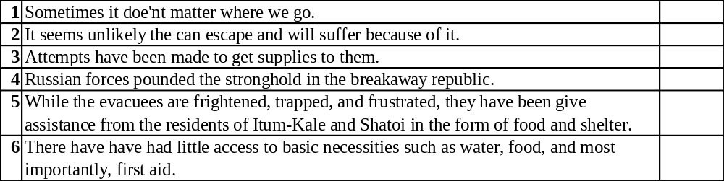

Comments:

endpage

Sentence-pair #3:
- Michelle strengthened from a category 2 to a Category 4 storm Saturday, with winds reaching 140 mph, but it was expected to weaken before it reached Florida.
- The storm or its effects could strike the Keys and South Florida tonight or early Monday, said Krissy Williams, a meteorologist at the National Hurricane center in Miami..

 | Plausible next sentences
Respondent # | Six people provided "Plausible next sentences" for all sentence pairs. Please rank the responses (1 = best, 6 = worst) according to their quality, mostly based on your judgement as to how well the respondent has grasped and expressed the semantics (meaning). You can have 3 tied for 1st place, or 2 tied for 3rd place etc if the responses are of roughly equivalent overall quality. | Rankings

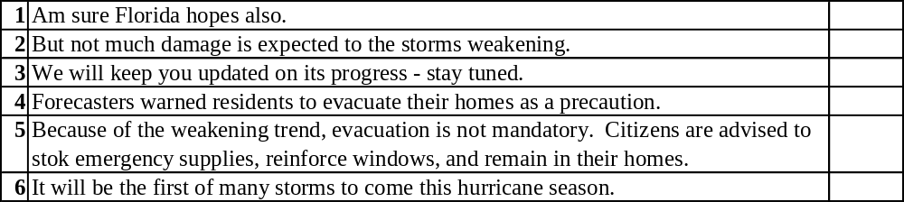

Comments:

endpage

Sentence-pair #4:
- The doctrine is frank about Russia's economic weaknesses, calling for efforts to strengthen the economy in order for the country to remain a major power.
- It acknowledges that it is in Russia's interest to maintain its economic links to the outside world, and there is no suggestion that it intends to abandon free market enterprise.

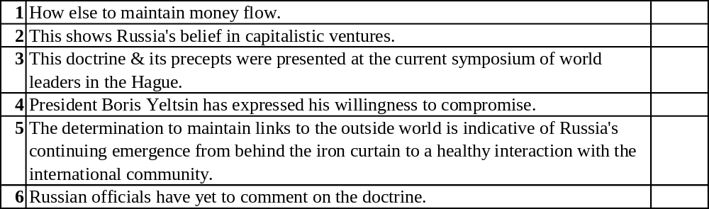

Comments:

endpage

Sentence-pair #5:
- Now, I must admit that I'm not so sure the Palestinians really wanted to reach a framework agreement, Eran said Tuesday.
- Eran wondered aloud whether the Palestinian strategy might be to negotiate as much land as possible in the remaining transfers, then declare statehood unilaterally - as the Palestinians have threatened to do before when talks bogged down.

 | Plausible next sentences
Respondent # | Six people provided "Plausible next sentences" for all sentence pairs. Please rank the responses (1 = best, 6 = worst) according to their quality, mostly based on your judgement as to how well the respondent has grasped and expressed the semantics (meaning). You can have 3 tied for 1st place, or 2 tied for 3rd place etc if the responses are of roughly equivalent overall quality. | Rankings

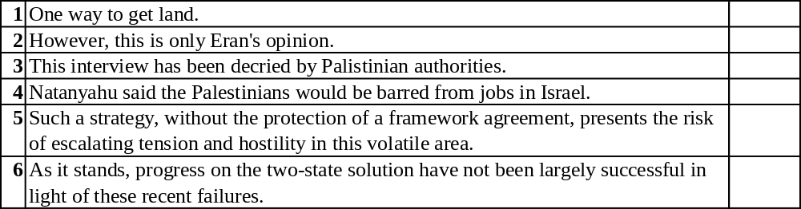

Comments:

endpage

Sentence-pair #6:
- The shortage has been attributed to rapid expansion of the prison system, low pay, a booming economy that makes the prospect of spending the day guarding convicts less attractive, and the risks of dealing with inmates who seem to be getting meaner and more violent.
- Prison officials are scrambling to keep penitentiaries staffed, recruiting at schools and from the Internet.

 | Plausible next sentences
Respondent # | Six people provided "Plausible next sentences" for all sentence pairs. Please rank the responses (1 = best, 6 = worst) according to their quality, mostly based on your judgement as to how well the respondent has grasped and expressed the semantics (meaning). You can have 3 tied for 1st place, or 2 tied for 3rd place etc if the responses are of roughly equivalent overall quality. | Rankings

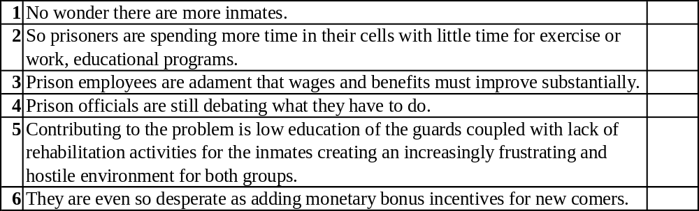

Comments:

endpage

The Hints - “Plausible next sentence” Exercise

In my experience, less than 10% of persons doing this exercise (“?exercisees?”) will identify correctly and with confidence the “affected respondent” that has a great deal of difficulty understanding and composing written text, even after two rounds of hints.

So don’t feel uncomfortable if you don’t get the right answer – it’s surprising to most of us. But there are fun lessons and concepts to learn from this simple exercise, especially about “first impressions” and “cognitive processes”. That will be discussed at the end of the exercise.

Hint #1 following the initial form-filling

In the initial instructions, it was stated that:

“… One of the respondents (the “affected respondent”) has problems comprehending and composing verbal and written sentences. …”

Actually, that respondent’s challenges are greater than one might assume from the statement above, as comprehension is severely limited.

Take another guess at who the “affected respondent” is. To help you, responses for all six questions are clustered for each respondent below. The six questions are listed on the last sheet for this Hint, for ease of reference.

What is your choice of the “affected respondent” #?: ________

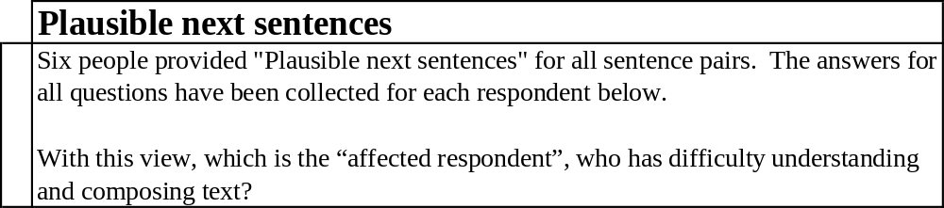

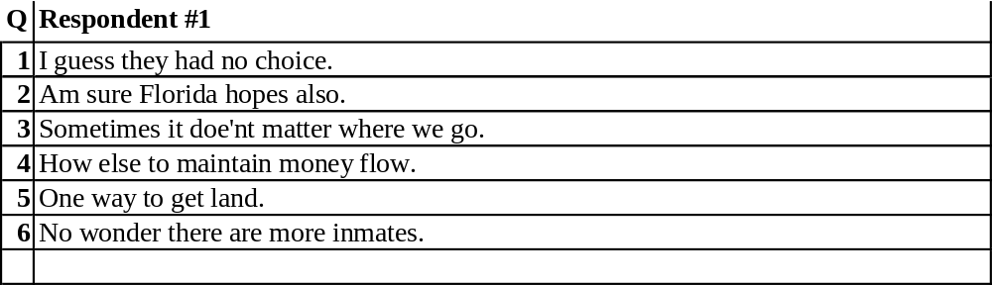

endpage

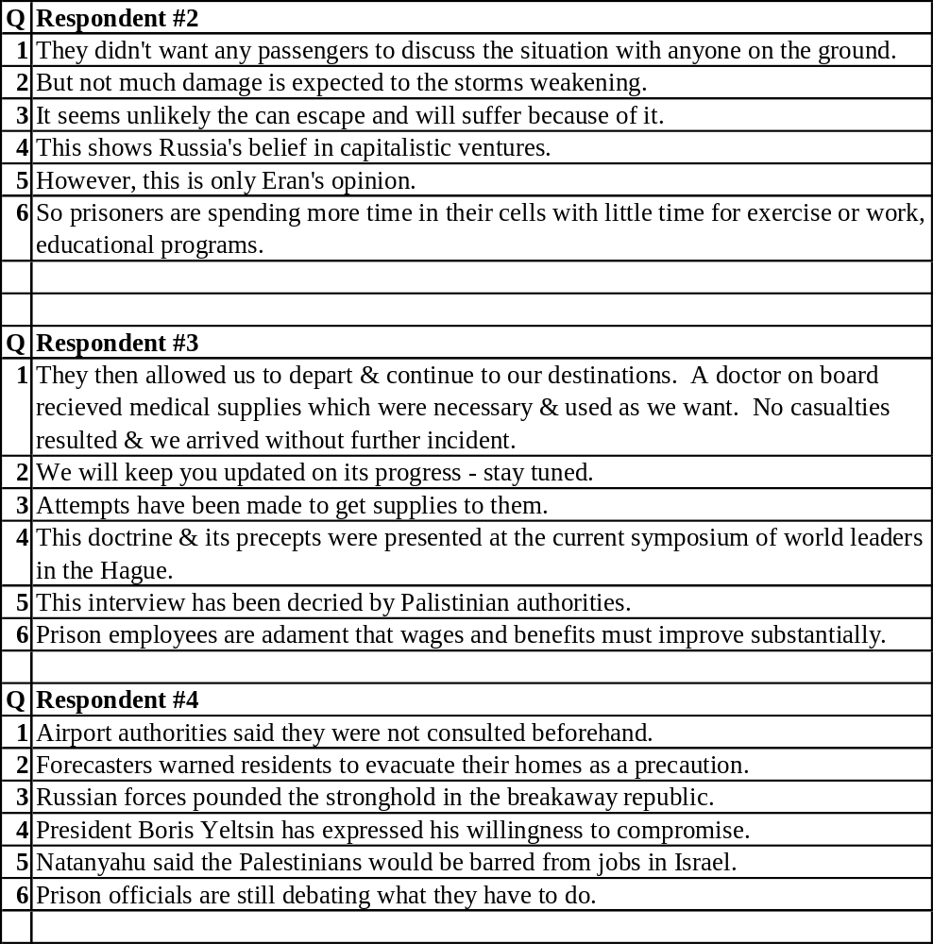

endpage

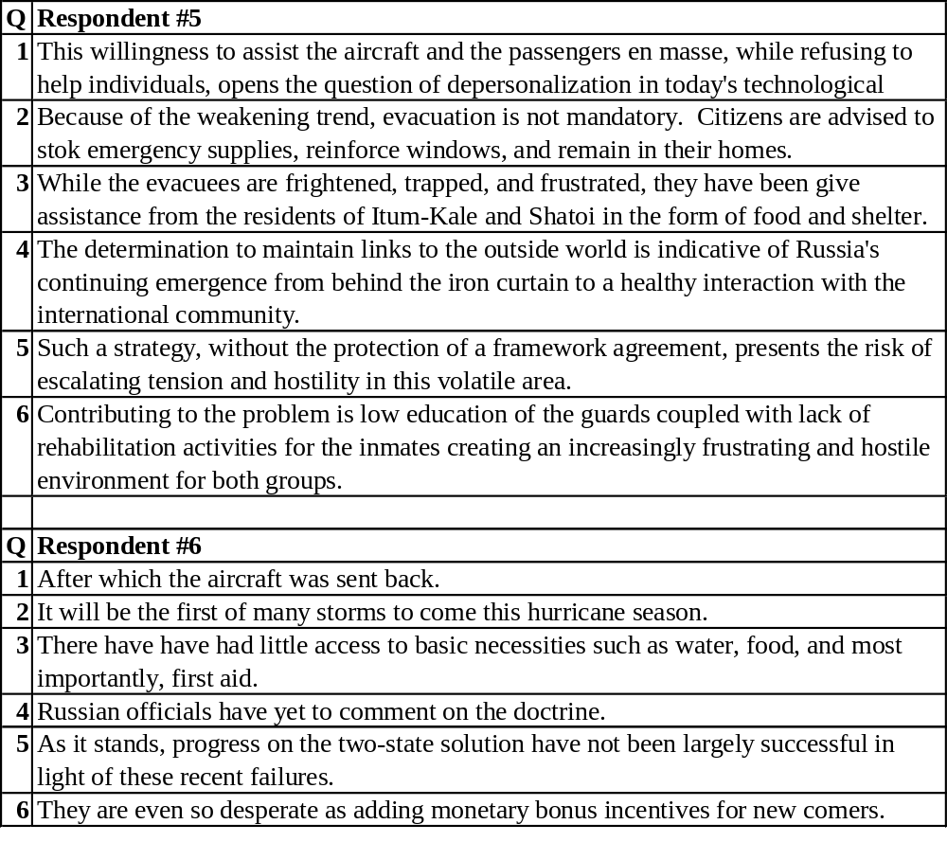

endpage

Here are the six questions, gathered together for easy reference to the respondents’ lists above.

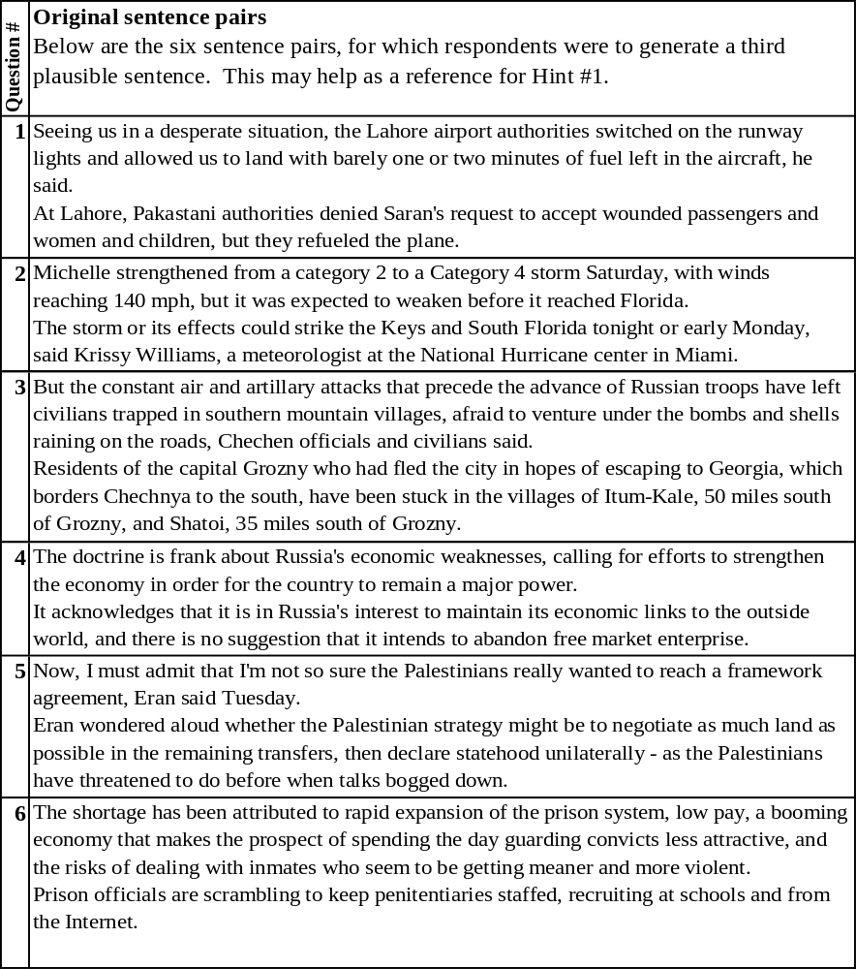

Hint #2 (final hint)

In the initial instructions, it was stated that:

“… One of the respondents (the “affected respondent”) has problems comprehending and composing verbal and written sentences. …”

In the Hint #1 this was re-emphasized:

“… Actually, that respondent’s challenges are greater than one might assume from the statement above, as comprehension is severely limited. …”

Hint #2 (the final hint) emphasizes this to an extreme! Actually, the “affected respondent” has absolutely NO COMPREHENSION at all! It is a “machine” that was trained on over 120 million sentences, and 70 million sentence pairs (if I remember this correctly) from quality newspapers, magazines etc. As the source material consisted of general topics in the news, the “machine” has “learned” to compose a reasonable answer to general questions. The concepts that gave rise to this will be discussed at the end of the exercise.

Think about it, that you may have come this far in the exercise without IMMEDIATELY (within 30 seconds!) recognizing that the “affected respondent” was a “machine” is already (to me anyways) a HUGE surprise, at least back in 2007 when I did this survey/exercise for the first time in a much more extensive and general format. As mentioned previously, the exercise in this document is the last and simplest stage of that survey.

So given this last hint as to the nature of the “affected respondent”:

What is your choice of the “affected respondent” #?: ________

II.3 Instructions for the Organiser

The intent of this section is to provide sufficient detail for an Organiser to set up and run this exercise, providing “Exercisees” (those responding to this exercise) with sufficient information to provide answers, with a minimum amount of expertise or involvement by the Organizer.

- Initial Instructions - The sheet “3 ‘Plausible next sentence’ – a linguistically-challenged respondent” should be printed together with the six following sheets (“Ranking the responses”) that show each question plus the third plausible sentences from all respondents. (NOTE: A spreadsheet-based system would be far superior both for gathering Exercisees results and for automatically collating results, but it is not ready yet.) Provide the printout to the Exercisee, and emphasize that only 15 minutes should be taken to do the rankings and select the “affected respondent” (30 minutes for fanatics, if they are fanatically interested). Taking too much time is counter-productive, as we’re not looking to evaluate you, but rather to get your “impressions”. It’s not whether the right “affected respondent” can be identified with effort and analysis – its whether if the “affected respondent” is immediately apparent within seconds of looking at the first question and its responses!!

- Collect the handouts back from the Exercisee - While the main item to look for is the Exercisee’s choice of the “affected respondent”, the rankings and comments for each question may provide a rich set of material for further discussion once the Exercisee(s) has(have) completed the full exercise.

Take notes on the Exercisee’s rational for their selection. Remember that even if they selected the correct “affected respondent”, that this will happen occasionally by random choice or a mistaken, mis-emphasized or misleading train of logic (false frameworks of logic). Right or wrong, have the Exercisee proceed with Hint #1 (then Hint #2), without revealing the correct answer. This allows you to see if they change decisions one way or another.

- Hint #1 following the initial form-filling - Hand out the four pages for “Hint #1”, and give the Exercisee a chance to revise their selection of the “affected respondent”.

As with step 2 above, take notes on the Exercisee’s rational for their selection, and if they have changed their “affected respondent” selection, get their reasoning behind the change. Again, right or wrong, have the Exercisee proceed with Hint #2 without revealing the correct answer. This allows you another chance to see if they change decisions for better or worse.

- Hint #2 (final hint) - Hand out the single page for “Hint #2”, and give the Exercisee a chance to revise their selection of the “affected respondent”.

- The Answer - Once you have the result back from Hint#2, provide the Exercisee with the answer: The “affected respondent” is respondent #4!

- End-of-exercise discussions - Provide the entire Section 1 plus 3 to the Exercisee for their reading. See the sub-section “Discussion points following completion of the Exercise” above for some points that may be of interest in live discussions with Exercisees after they’ve had a chance to look over the background material.

Endsection

II.4 Discussion points following completion of the Exercise

Here are a series of randomly selected points to help get discussions going following completion of the exercise.

- Was the “affected respondent” (#4) immediately obvious to you within seconds of having read the responses to the FIRST Question (after, of course, having read the instructions and the first sentence-pair)?

Having the “right” answer isn’t very important – the most important thing to note is that for most people (if not all) the machine doesn’t stand out like a sore thumb within seconds of starting the exercise and reading the first sentence pair and the six responses to it!

Given the sentence-pair for the first question:
“… Seeing us in a desperate situation, the Lahore airport authorities switched on the runway lights and allowed us to land with barely one or two minutes of fuel left in the aircraft, he said.
At Lahore, Pakastani authorities denied Saran's request to accept wounded passengers and women and children, but they refueled the plane. …”

What I would have expected from a machine in 2006 would have been something like one of the following examples (for a system that was provided with a spelling/ grammar/ syntax checker):
“… We are in a desperate situation in Lahore. …”
“… Saran's request to accept wounded passengers and women and children was denied. …”
Which is a safe approach, like ELIZA (see the next section), to repeat content in the question and feed it back, or perhaps simply ask very generic questions. The actual answer is a bit like that for Question 1! In 2006, I would not have been overly surprised by this.

But look at Question 2:
“… Michelle strengthened from a category 2 to a Category 4 storm Saturday, with winds reaching 140 mph, but it was expected to weaken before it reached Florida.
The storm or its effects could strike the Keys and South Florida tonight or early Monday, said Krissy Williams, a meteorologist at the National Hurricane center in Miami. …”

In this case, neither forecasters, residents, nor homes appear in the first two sentences, but are combined in a very meaningful way in the third plausible sentence:
“… Forecasters warned residents to evacuate their homes as a precaution. …”
To me, this is STILL very surprising!

- When Bill Howell ran a much moiré general series of exercises in 2007-08, only one Exercisee (out of 8 to 12 – I forget the number who did this part completely) got the correct answer with a solid line of reasoning. He was the son of a linguist, and his wife is a linguist. His tip-off was the REGULARITY of the machines sentence structures! One other person got the right answer, stating that the answers “didn’t really make much sense” (or “a bit disconnected” or something like that), a sentiment echoed by other Exercisees. Having said that, the answers weren’t so nonsensical as to allow some of them to quickly and easily make the right selection without doubting their conclusions.

- Absolutely NO rules of grammar, syntax, or spelling were provided to the machine – this was ENTIRELY EMERGENT from Confabulation Theory! Robert Hecht-Nielson, the scientist who developed Confabulation Theory, along with Zeus his cat, stated that Confabulation Theory PROVES that grammar doesn’t exist and isn’t needed! This is a great statement, right or wrong, because it forces us to think. For example:
  - Confabulation may simply “derive” spelling, grammar etc. – so it doesn’t have to be “given” such rules.
  - Perhaps there are social, or “innate” hard-core rules of spelling, grammar, syntax etc, but with a great deal of other convention simply “emergent” from that, determined more by the practical challenges of using language, than from a logic-derived mechanism. This would fit with my own belief that for “complex dead systems” (forget living or human systems – they are FAR too complex for out math!!), that “Logic is an emergent property”, not an absolute. The pre-conditions for logic are simply violated violently for these systems.
  - Maybe this explains why we all more or less “do” syntax and language, even though essentially none of us can really understand it at the most fundamental level. (Shades of Chomsky’s “Universal Generative Grammar”).

[19Aug2011 Howell 19… many more points to provide!!!! …]

[Howell - details to be added later… based on my experience several years ago when running the far more complete exercise at home]

endpage

