Astronomy, Earth sciences, Climate, and History: Data, tools, theories
Bill Howell, initial draft 10Sep2011 partly based on initial send to Yaskell of 04Sep11, 1st full, separate document sent 11Sep2011

Summary:

[11Sep2011 Howell - this is only ¼ complete, and is far too “bitter/ lunatic”.

Table of Contents

Summary: 1
1. Nomenclature to stimulate and expand, rather than imprison and poison, thinking 4
2. Stylistic line-of-argument points 6
2.1 Multiple conflicting hypothesis 6
2.2 A good question is far more powerful than a good answer. 6
2.3 It's not whether you are right or wrong, it's how you play the game 6
2.4 Who cares if its right or wrong? That's irrelevant at this point! 6
3. Theories of history 7
3.1 Ancient mythology and religions - Gods that lived in the skies, and mega-disasters never again seen (++) 7
3.2 Great chiefs, kings, human-gods (++) 7
3.3 Gibbon 1770 – Decline of the Roman Empire (++) 7
3.4 Arnold J. Toynbee - A study of history (++++) 7
3.5 Joseph Tainter - The collapse of complex societies (-----) 8
3.6 Jared Diamond – Environmental damage by societies (---) 8
3.7 No theory can work for history (0) 8
3.8 Immanuel Velikovsky - Mythology, Religion, and Science: all engines firing! (++++++++++) 8
4. Markers and Timescales for History 9
4.1 Immanuel Velikovsky's “Historical, Mythological Whoppers” of ~700 & 1500 BC (+400 – 2400 Bond, Charvatovan ) 9
4.2 Biblical 7 or so Plagues, major “solar hibernations”, and Charvatovan warm periods (200-400 years) 9
4.3 Gleissberg / Pacific Decadal Oscillation / Kondriatieff timescales (~60-100 years) 9
4.4 ?Name? (52 years) 9
4.5 Sunspot / Lunar etc (10-25 years) 9
4.6 El Nino, and MANY others (1.5 – 15 years) 9
4.7 Seasons, semi-annual and annual 9
5. Special data, themes, and theories 10
5.1 Errors, events, and uncertainties for C14 and Be10 radio-isotope series 10
5.2 Cosmic / galactic rays: Essentially ALL scientists (expert & non-expert) were wrong again (what else?) 10
5.3 The Sun – Standard models suck 10
5.4 Electric Universe - Are these lunatics right finally, after >110 years? 10
5.5 Irridium - Are the dinosaurs fooling us? 10
5.6 Anthropogenic GHGs - I'll miss the extremes of scientists' stupidity, fraud, delinquency, hypocrisy and back-stabbing! 10
6. Proxies for sun, astronomy, climate, ?and history? 11
7. Time series analysis linking sun, astronomy, climate, and history 13
7.1 Mythology, religion, historians of the day 13
7.2 Binning of events 14
7.3 Fourier series based thinking 15
7.3.1 Bubonic Plague (Black Death) 16
7.3.2 Influenza pandemics 17
7.4 Wavelet transform basis of thinking (spatio-temporal) 19
7.5 Computational Intelligence Methods 20
7.5.1 Feed-forward Neural Nets 20
7.5.2 Recurrent Neural Nets 21
7.5.3 Evolutionary Computation 21
7.5.4 Genetic specification of hybrid systems 21
7.6 Regionalism versus Global 21
7.7 “Hyper-scalar Spatio-Temporal” analysis 22
7.8 Special note on phase synchrony 24
8. Comments on: Hsiang, Meng, Cane 25Aug2011 "Civil conflicts are associated with the global climate” 25
999. Other perspectives -BROADENING, not for inclusion: 27

endpage

Copyright © 2011 All content is owned by William Neil Howell,
except when otherwise specified such as many Figures and quotes.

Permission is granted to copy, distribute and/or modify this document under either:
 | The GNU Free Documentation License; with no Invariant Sections, Front-Cover Texts, or Back-Cover Texts.
 | Creative Commons Attribution-Noncommercial-Share Alike 3.0 Unported License.
It is expected that users of this document and/or webpage will:
- Acknowledge William Neil Howell and/or the specific author of content or images on this page as indicated, as the source of the image.
- Provide a link or reference back to this specific page.
- Allow any modifications made to the content to also be reused under the terms of one or both of the licenses noted above.

Versions: (list actual documents and dates):
11Sep2011 Howell – initial draft,

endsection

1. Nomenclature to stimulate and expand, rather than imprison and poison, thinking

[11Sep2011 Howell - I haven't done this yet!! Ran out of time, need to establish a rock-hard “full” nomenclature plus practical shorthand]

Use “solar hibernation” (or “grand solar minimum”) instead of “solar minimum” to avoid confusion with 11/22 year sunspot cycle. “solar 30-100 year hibernation” makes the duration more clear to readers unfamiliar with periods, and leaves open other shorter & longer timeframes for activity levels. That is clearly NOT needed when start & stop dates are given. Furthermore, date-range nomenclature easily accomodates cascading and overlapping periodicites etc. - which cannot be handled with any degree of effectiveness by simply “naming” quasi-periods. For example:
1615-1710.y1-y2.y3-y4
might designate an El Nino event within a solar cycle within the Maunder minimum.

Use “solar hot-period” instead of “maximum” for same reasons as using “solar hibernation”. Again, “solar 30-200 year hot-period” better describes duration.

Use date ranges as names for the “solar hibernations” and NOT peoples names:
- helps reader who are not familiar to immediately have a feel for the gneeral context in history, and not to get confused with a plethora of periods
- Avoids naming conventions (people) that people (like me) strongly object to
- must also convey to the readers that the date ranges are FUZZY!!!
- “Maunder minimum” and “Medieval maximum” are fairly well known, and he temptation is to retain historical nomenclature, which I feel is not a good idea.
- Provide a “translation table” for periods in a Nomenclautre section, using multiple common phrases for each period, and perhaps describing uncertainty and disagreements on the time-period, especially for different areas (history, climate, geology, astronomy), for example:
- “?950-1250? AD solar hot-period” instead of “Medieval maximum”
- “1615-1710 AD solar hibernation” instead of “Maunder minimum”
- “?start-end?” AD solar hibernation” instead of “Tapping minimum”
- “Solanki Minimum”
- “Dalton minimum”
- “McIntyre Minimum”
- “Balyunus minimum”
- “Sporer minimum”
- “Wolf minimum”
- “???? minimum”
- Charvatovan 50 year &
- Charvatovan 350 year warm period
- If you do this, you will be one of the first to clarify nomenclature according to clear solar activity periods at multiple timescales!!! (after Charvatova, and Yaskell & Soon etc), linking sun-barycenter, climate, history, and 10 plagues!!!

However, “solar hibernation” and “solar hot-period” are only two of many “types” of quasi-periods, and actually, might not even be considered solar! Instead, “sun-barycenter ordered & disordered periods” is the ONLY independent description matching the “solar hibernations”. The sun-barycenter model this might not be a valid model, but again it is the only model that seems to fit at least somewhat. The consensus “solar dynamo” models (add-ons to the Standard Model of the sun) are fairly unconstrained, and can given any numbers you want... which is almost completely arbitrary.

[Howell broadening and clarification – see “desertification versus junglification” link]
[Howell – here I thinjk it appropriate to raise questions, as I certainly don't have a strong foundation for this. In any case, a powerful question is far more important than powerful answers.]

We are all familiar with a process that we will label “desertification” here. That is, a once fertile breadbasket becomes a barren desert, no longer able to support the fluorishing cvilisations that live there. Parts of Mesopotatmia, The Harrupans in the Induus valley of Pakistan, and many other areas of the world have sad stories such as these.

But is there also a process of the fall of societies and perhaps civilisations through “junglification”, that is the encroachment of jungles or swamps that render agriculture problematic, and big increases in temperature and humidity that hinder human thought and energy? (This is obviously a theory for Canadians who have trouble in great heatand humidity.) And if it is a measurable effect, do Angor Wat, the Mayans, and perhaps other civilisations provide examples?

endsection

2. Stylistic line-of-argument points

[10Sep11 Howell - I've added some very general points to explain my own personal stylistic approaches, as my statements probably look like an incoherent mess (they are).]

2.1 Multiple conflicting hypothesis
I find that whenever I have a “preferred hypothesis”, I magically become a proponent in the way think, even if I don't really care about a theory. Then I become blind to data and simple analysis that proves the theory can't be right, or quickly dismiss concepts that are actually quite intereesting, and have something to offer (toolsets or a way to analyse things) that might be useful in other contexts, or in the given context, even if they are wrong.

I prefer to retain at least a few diverse erroneous hypotheis / theories if there is nothing else to counter-balance a strong, lone hypothesis

Consensus thinking – is absolutely no proof of truth, but it is very important even if completely wrong – as a benchmark of thinking, reactions, and gaming.

2.2 A good question is far more powerful than a good answer.

2.3 It's not whether you are right or wrong, it's how you play the game

2.4 Who cares if its right or wrong? That's irrelevant at this point!

endsection

3. Theories of history

Here is a random and very incomplete list of theories for history. My favourite “normal” historian by far is Arnold J. Toynbee – that is, in dealing with post-686 BC history. But I may actually put Immanuel Velikovsky in first place within 2 to 5 years if my reading and results head where it looks like they do now. Velikovsky doesn't just kick historian butt, he's done a great job of showing how [dysfunctional, delinquent, dishonest, hypocritical] and especially BACK-STABBING essentially all scientists really are.

Pluses and minuses in parenthesis after each sub-section title give an indication of the relative merit of the theories TO ME. For now, comments are basically non-existent. However,, its important to state how your thinking is influenced, so others can be warned of where you come from, and protect themselves and so they can better understand your opinions.

3.1 Ancient mythology and religions - Gods that lived in the skies, and mega-disasters never again seen (++)

3.2 Great chiefs, kings, human-gods (++)

3.3 Gibbon 1770 – Decline of the Roman Empire (++)

3.4 Arnold J. Toynbee - A study of history (++++)

A “psychological” perspective of the behaviour of civilisations (not nations/ societies) – Toynbee felt strongly that history cannot be made sense of unless studied at the level of civilisations. Otherwise the variabilities and random effects obscur the picture too much.
Challenge & response
Resting on one's oars

It seems that modern historians (like Joseph Tainter, Jared Diamond, classics profs at the local university, etc) react strongly against Arnold Toynbee, whose thinking and theories have largely been discredited. Not for me – I'm still a big fan and see little if any value in modern academic thinking. As with Gibbons, in several hundred years Toynbee's name will come, long, long after ESSENTIALLY ALL modern historians are forgotten in the dustbin of cheap and broken frameworks of thinking.

3.5 Joseph Tainter - The collapse of complex societies (-----)

A favourite theory among academics for quite some time, Tainter develops a creative and interesting theory about how excessive societal complex drives to their collapse. Cute, but too bad that Tainter has no conceptual foundation for complexity (blatently unaware of whole areas of research), and no measures except for industrialised USA and perhaps some on Europe (I forget now). From there, why not apply crappy thinking to the whole of history? No wonder this worked so well with politically-correct academia!

However, I still like the complexity idea. Perhaps several have really done something with this that haven't come across...

3.6 Jared Diamond – Environmental damage by societies (---)

I call Diamond's approach in his books “Guns, germs, and steel” and “Collapse” the “saran-wrap thinking” approach. It's like you drive home one night and enter your driveway, seeing a strange sheen over the house. Getting out of the car and looking more closely, you see that the entire house is wrapped with Saran wrap. You take your pocket knife and cut through to the front door. Stepping inside the house, you look around and see that all furniture, pictures, decorations, the dog, and the cat, are all wrapped in Saran wrap as well. Your wife come to greet you, and in answer to your question explains, “Well, I bought this fantastic new Saran wrap in the superstore, and loved it so much I just couldn't help using it to preserve everything in the house.”...

Diamond misapplies a couple of simple concepts and stretches them to cover absolutely everything, until very little of his comments have anything to do with his original concepts. However, there are nice descriptions of, and information for (caveat – a bit distorted/ mis-interpreted, directed) a number of interesting historical situations, and tidbits of data.

3.7 No theory can work for history (0)

3.8 Immanuel Velikovsky - Mythology, Religion, and Science: all engines firing! (++++++++++)

Velikovsky's concepts of history are at all scales, far, far beyond the thinking of any other person I know (with the possible exception of some of his modern equivalents?). He may be completely wrong, but he could both think and imagine, and unlike all scientists, he could see what was there.

endsection

4. Markers and Timescales for History

This section provides “random, incomplete” comments on selected timescales for historical analysis. A more complete listing of “quasi-periodicities” <= 2,400 years is provided in the section on Fourier series analysis, which compares Charvatova's sun-barycentre (“Solar Inertial Momentum” - (SIM)) results to European temperature series.

[11Sep11 Howell - I don't have time to flesh this out, so I'll provide a quick list...]

4.1 Immanuel Velikovsky's “Historical, Mythological Whoppers” of ~700 & 1500 BC (+400 – 2400 Bond, Charvatovan )

4.2 Biblical 7 or so Plagues, major “solar hibernations”, and Charvatovan warm periods (200-400 years)

This includes wars!

4.3 Gleissberg / Pacific Decadal Oscillation / Kondriatieff timescales (~60-100 years)

4.4 ?Name? (52 years)

4.5 Sunspot / Lunar etc (10-25 years)

4.6 El Nino, and MANY others (1.5 – 15 years)

4.7 Seasons, semi-annual and annual

5. Special data, themes, and theories

This section provides “random, incomplete” comments on selected themes for historical analysis.

[11Sep11 Howell - As with Section 4, I don't have time to flesh this out, so I'll provide a quick list...]

5.1 Errors, events, and uncertainties for C14 and Be10 radio-isotope series

5.2 Cosmic / galactic rays: Essentially ALL scientists (expert & non-expert) were wrong again (what else?)

5.3 The Sun – Standard models suck

5.4 Electric Universe - Are these lunatics right finally, after >110 years?

5.5 Irridium - Are the dinosaurs fooling us?

5.6 Anthropogenic GHGs - I'll miss the extremes of scientists' stupidity, fraud, delinquency, hypocrisy and back-stabbing!

No fear – that kind of behaviour is associated with almost all consensus science.

endsection

6. Proxies for sun, astronomy, climate, ?and history?

In looking at how solar or astronomical factors have influenced climate and civilisations at different timescales and within different regions, we must use “proxies” (substitutes) for solar activity, as we do not have consistent, quality, unambiguous data on historical timescales. A very few of the large number of sources of proxy information sources are described below:
- Direct solar irradiance measurements - High quality F10.7 solar irradiance measurements from Penticton, BC for only 50 years. More modern measurements include the full spectrum, and are available from satellites without the interfering effects of the atmosphere.
- Sunspot cycles (Scwabe/Hale (11/22 year) - Sunspots can be used as a general indication of solar activity, although you should be aware that the fit is approximate, and difference components of the irradiance have slightly different timing. Good sunspot data goes back to the mid-1800's, and reasonable observations to ~1600 at the time of Galileo. There are sporadic observations by the Chinese back as far as ?~0? AD.
- Radio-isotopes (C14, Be10) - Prior to 1600, a typical approach is to use carbon 14 (C14) and beryllium 10 (Be10) isotope measurements as proxies for solar activity. These asily cover the Holocene period (eg certainly back to 10 ky Before Present (BP) for C14). However, C14 and Be10 levels are strongly affected by other factors such as galactic / cosmic rays, supposedly by anthropogenic burning of fossil fuels, and possibly by other processes. Note that as a very important hypothesis from perhaps the ?1950s?, and established solidly by Svensmark and team (references – eg Chilling Stars) cosmic rays have a strong influence, perhaps dominant among most factors at scales less than 200 years, on cloud cover, Cloud cover, in turn, is hugely important for climate. For the past ?15? years or so, Svensmark and team have shown impressive correlations that appear to surpass conventional hypothesis.
- Glacial ice-rafting events - Another indicator that is taken as a proxy for climate are the deposits of glacial ?till? In marine sediments, presumably carred over the seas by icebergs, which are much more frequent during cold periods. These so-called ?Haansgaard-Oscberger? ice rafting events are described below, and show a ~1,500 year Bond cycle.
- Glacial ice-core data - have been extensively used for studying the last period of glaciation and for the last 400-750 ky of multiple glaciations. It seems to me that they shouldalso be useful for the period of civilisation, but unfortunately their credibility for this purpose has been damaged by manipulations to flatten temperature series for the last 2,000 years, while introducing a fantastic “hockey stick” inflection in the last 150 years. Better to stay away from this until the scientific rot and trash is cleaned up, perhaps in 20 years, or get the raw data from non-UN-IPCC enthusiasts and do the analysis yourself. <grin>
- Marine sediments - are typically seen in longer-term times studies for millions to billions of years , but there is fine-grained information available for the period of civilisation. Papers by Tim Patterson's team for Effingen Inlet on Vancouver Island are a great example.
- Stalagmites and stalagtites - are not usually thought of for short periods like the last 7.5 ky, but as with ice core data there is information there. [Howell – comments later...]

As “proxies”, these measures should NOT be taken as pure indications of solar activity! All of these data sources, plus many others, can be used to extract information on climate cycles. Typically this has been done through Fourier analysis, as the resultant “power spectra” provide “fingerprints” that greatly help to understand and compare complex time series. From this arises the statement that various “cycles” exist in climate. Unfortunately, far too often scientists and the users of scientific results mis-understand the nature of these “cycles”, perhaps keeping the high-school notion of sinusoidal curves in their minds. But natural cycles aren't like sinusoids! They are better described as “quasi-cycles” for which the amplitude, period, and waveform doesn't repeat. Even astronomical cycles, usually taken as perfect, are like this at the extremes of accuracy. Keep in mind that many climate effects are probably third or fourth order, so “tiny squiggles” are important! This has been a constant mistake of scientists in the case of solar irradiance, which has perenially been classed as “too small a variation to account for the temperature variability observed”. This vast consensus should be enshrined as a warnign to future generations of scientists.

As a further point, please keep in mind that while Fourier series analysis is still a useful tool, it does not have anywhere close to the capablities of advanced wavelet transform analysis, and is probably inadequate for many, if not most, climate systems. For an example, see Tim Patterson's analysis for Effingen Inlet fish populations, and Willie Soon's analysis of the Arctic Oscillation (wind-ocean oscillation).

endsection

7. Time series analysis linking sun, astronomy, climate, and history

The initial intent of this Section was to simply provide one or two examples of tables and figures illustrating results in a manner that might enhance Chapter 4, both as illustrations, and as to provide a VARIETY of much more profound basis for understanding quasi-periodicities, [associates, correlates, drivers], and history. I've slightly expanded it to mention a few more basis of analysing times series, notably the sub-sections on mythology, binning, and Computational Intelligence, but I do NO explain any techniques at this point.

7.1 Mythology, religion, historians of the day

I'll skip the historical observations for now, other than to say that I think that there is a good chance that modern scientists MIGHT catch up to ancient thinking in 50 to 100 years, if we don't lose Enlightenment by then.

I will also add the name of the overwhelmingly-hated-by-scientists Immanuel Velikovsky, who combined a philological approach to interpretation of ancient sources, with a powerful cross-referencing to show similarities or exact correspondance between material from several different civilizations, and the recognition of “archetypes” and huge astronomical and geological events (catastrophism) to analyse past events and their drivers. Velikovsky died in ?~1979?, and from careful reading of his original work, it's clear that many of his opinions blew away totally all of the worlds top scientists (and mediocre scientists) in many, many areas. Of course, not all of his ideas panned out – not surprising considering how “violently different” they were from anything the herd of profeessional scientists was capable of coming up with. By reading his original work, critiques by scientists, and re-analysis of the vicious attacks on Velikovsky, this has provided a huge basis of information for one of my major themes - the catastrophic failure of [rational,logical, and scientific] thinking by essentially all scientists, ergo – all homo sapiens.
Velikovsky's name will re-appear in other themes in this “review”, as appropriate. (By the way – I'm not a “Velikovsky disciple” - but I have huge respect with what he did wit hthe information he had. He was, in my opinion, a far greater figure of philospohy and science than another scientist who argued with him over time, gradually becoming more sympathetic to at least some of Velikovsky's thoughts. When that famous scientist died, Velikovsky's book “Worlds in Collision” was on a table beside his bed, and he had been reading through it for the third time. His name was Albert Einstein. (by the way, I don't think Special Relativity ever made sense or was supported by experiments – especially the Michaelson-Morely interferometer, atomic-clocks-on-a-plane, or the GPS systems. Here there has been an enormous amount of [dysfunctional, dishonest, delinquent, and hypocritical] thinking b essentially all scientists, in my humble opinion.

My chart of C14 & Be10 folded by Charvatovan klong periods of 2.4 ky s an example of “simply plot the historical data” but there is SIMPLE FILTERING, which is “somewhat, very roughly,. In a loose sense” supported by many Fourier series analysis of many astronomical, geological, climate, and historical time series:

http://www.billhowell.ca/Civilisations%20and%20sun/Howell%20-%20radioisotopes%20and%20history.jpg

7.2 Binning of events

Example:
Solomon M. Hsiang, Kyle C. Meng, Mark A. Cane 25Aug2011 "Civil conflicts are associated with the global climate" Nature vol 476 p438-441

In their fun and informative paper, Hsiang etal rely on fairly simple statistcs applied to binning of classified data. Figure 2a is quite convincing, but there there is no description (in the paper – perhaps the Supplements get into detail) of classical time series analysis techniques,, so I assume they didn't attempt this. The binning provides a simple, robust, and “visible” method of analysng the data.

I don't want to spend more time on this right now, but its an important, practical approach to analysis, with lots of pragmatic warnings from mathematicians and scientists about how to do this and reduce the potential for getting highly erroneous and misleading results.

endsection

7.3 Fourier series based thinking

At this point, it's important to state that to my knowledge the ONLY “predictive” relation for short-to-mid-term (1.8 to 2,402.2 years) climate “quasi-cycles” is that of Ivanka Charvatova (I believe this has been reproduced by others before (to some extent) and after Charvatova). I say that in the sense that most of the major climate periodicities from >1 year to 2,400 years arise directly from Charvatova's sun-barycenter model, but also in terms of the apparent predictability of the sunspot cycles with Charvatova's model – which no-one else seems to have!

Table ?? Fourier series based thinking
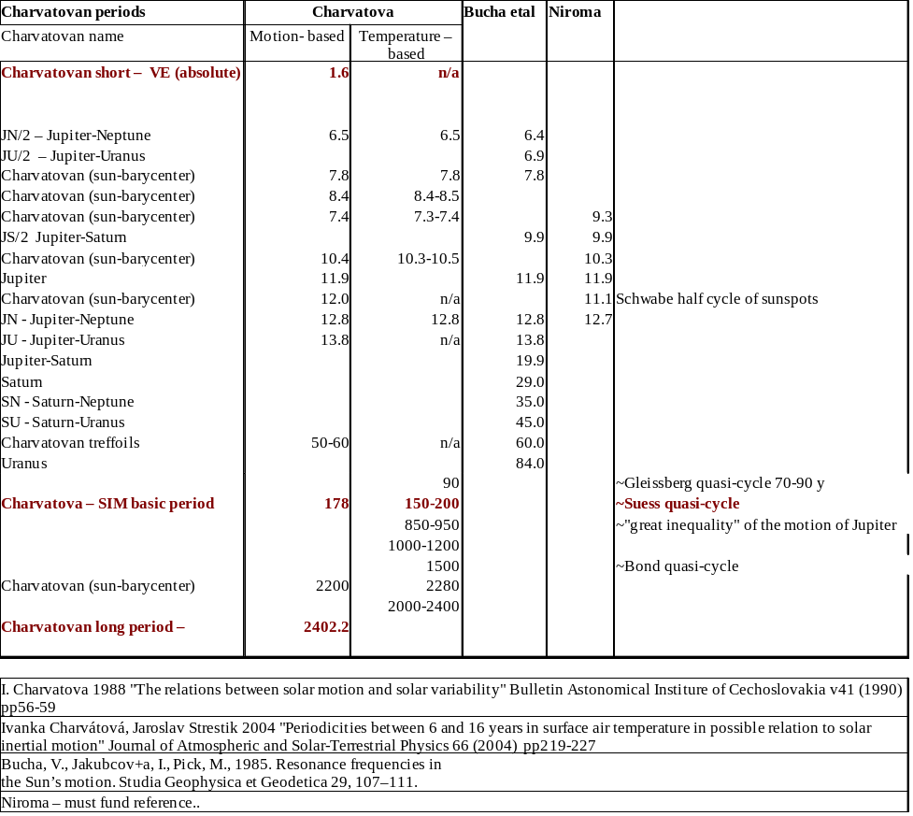
Note that there seems to be a great predictability of “corresponding” sunspot cycles using Charvatova's approach, but there are too few sunspot cycles since 1730 to really test. [Howell – I have done this for a couple of sunspot cycles!]

Note that the beloved General Circulation Models (GCMs) or “Global Climate Models” as they are sometimes referred to, not only have always failed even for periods of only 5 years prediction, but have basically NO predictive capability for quasi-cycles nor climate. In other words, like many numerical models, complex systems behaviour isn't “emergent”, instead it is observed then back-integrated into models, often with simple factors. Unfortunately, the GCM models dominate modern scientists thinking. Hopefully they will be rebuilt or better yet thrown away soon, leaving that approach to future scientists who can work free of today's peculiar environment in science.

Practically speaking, some of the best impacts of “Fourier series” type analysis are very simply and extremely simple smoothing of data with Parzen windows of varying width – picking one that tells your story best. So one doesn't even have to do optimise with a special Fourier analysis – just use commonly accepted major quasi-periodicities.

Here are two examples – pandemics: (from www.BillHowell.ca)

7.3.1 Bubonic Plague (Black Death)

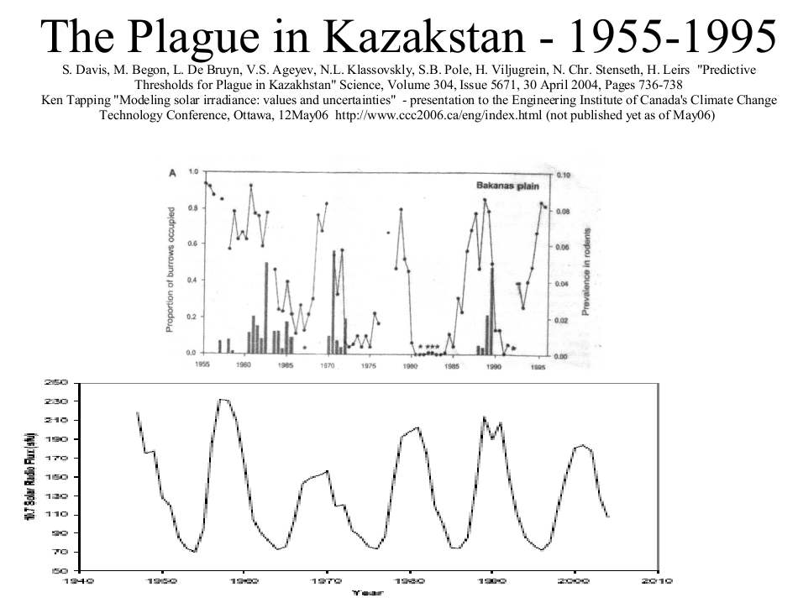

7.3.2 Influenza pandemics

K.F. Tapping, R.G. Mathias, D.L. Surkan, "Influenza pandemics and solar activity". Canadian J. Infectious Diseases, vol 12, no 1, pp 61-62, Jan-Feb 2001

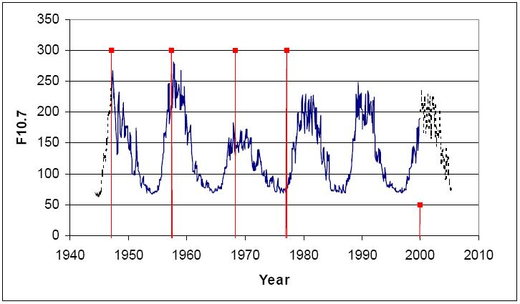
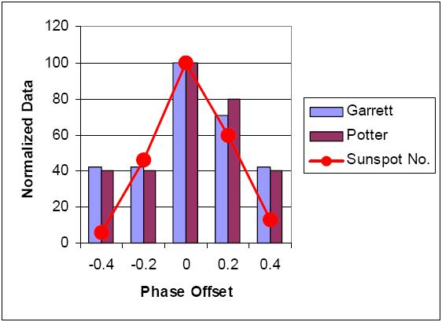
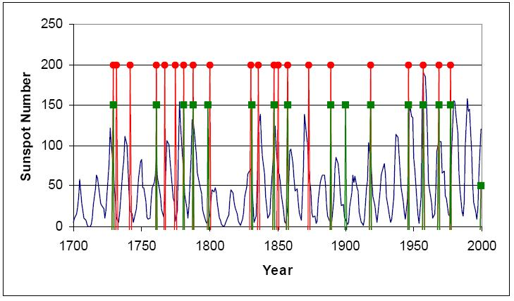

From modern times:

Leonid B. Klyashtorin 2001 "Climate Change and Long-Term Fluctuations of Commercial Catches - The Possibility of Forecasting" FAO Fisheries Technical Paper 410, Rome, 2001 Federal Institute for Fisheries and Oceanography Moscow

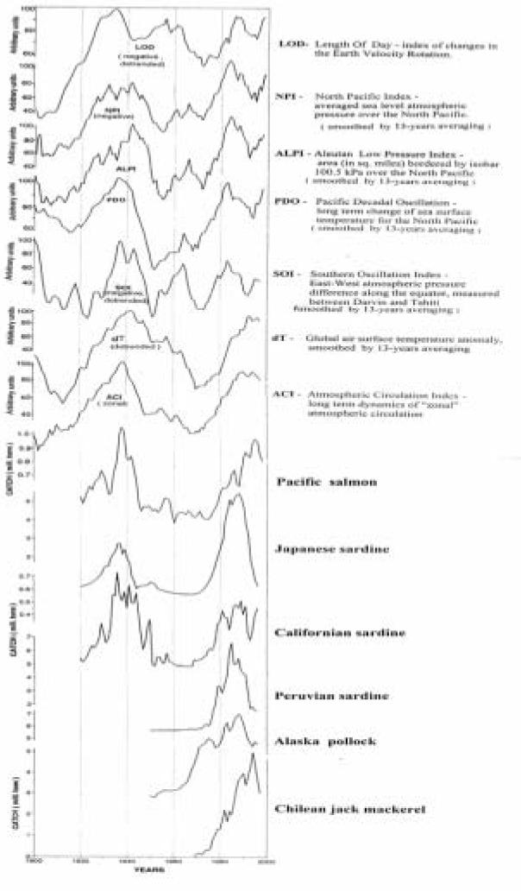
endsection

7.4 Wavelet transform basis of thinking (spatio-temporal)

See figure below - kind of a “Wavelet transform basis of thinking”
Tim Patterson's group at the University of Carleton here in Ottawa has a great series of work on geology (typical varve data (mud sediment)), climate, the sun etc. For example, varves show the sunspot cycle.
R. Timothy Patterson, Andreas Prokoph, Arun Kumara, Alice S. Chang, Helen M. Roe 2005 "Late Holocene variability in pelagic fish scales and dinoflagellate cysts along the west coast of Vancouver Island, NE Pacific Ocean" Elsevier, Marine Micropaleontology 55 (2005) 183 – 204

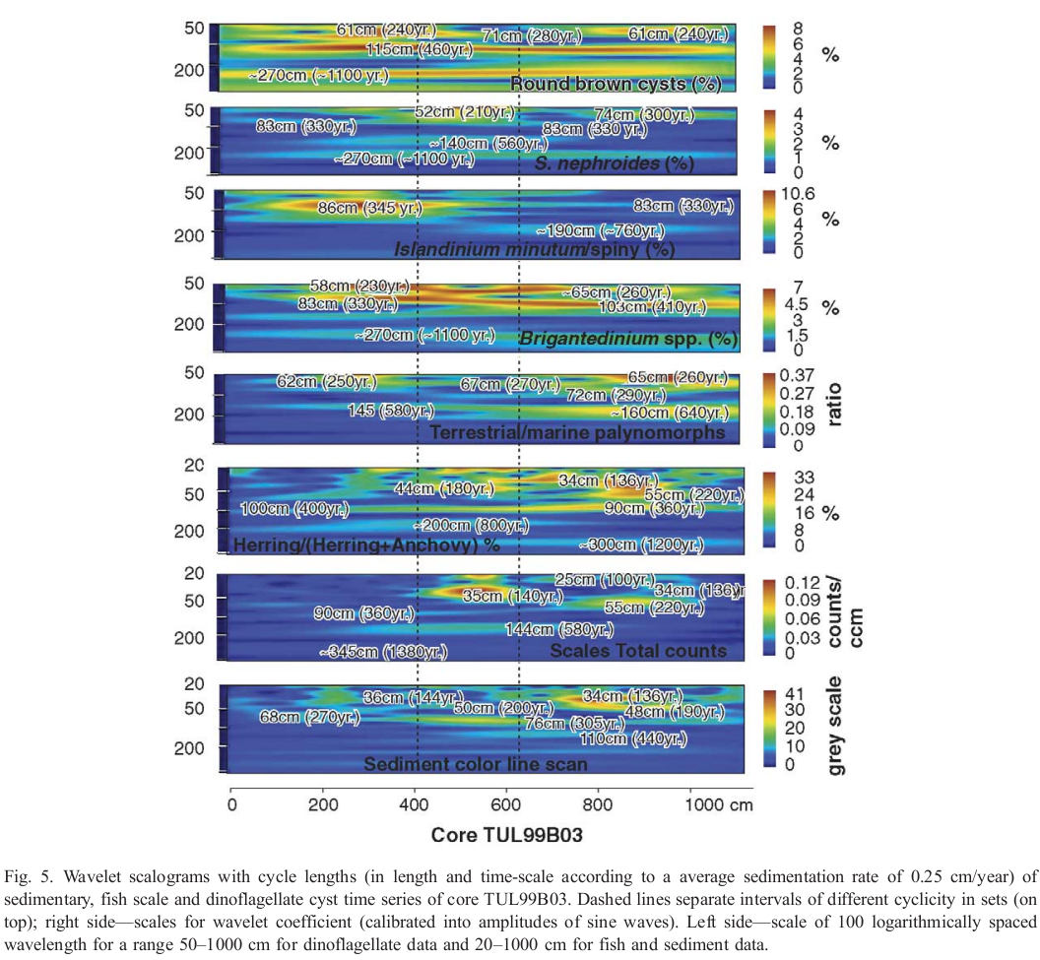
Below is a wavelet transform analysis showing herring/ anchovy populations,..

I also saw a presentation by Patterson (actually, several great presentations) at the Geological Association of Canada's Climate Symposium this last summer, showing how the fish data coincided with archeology – the abandonment of villages etc! (I don't have a copy). A similar wavelet transform graph of the ebb and flow of wars in a region would blow away anything else I've seen!

7.5 Computational Intelligence Methods

7.5.1 Feed-forward Neural Nets

Sunspot data across time!
I also have a paper from ?Eric A. Wan at Oregon Health & Science University that models modern sunspot cycles based on marine sediments from 600 My ago!!!
Eric Wan 1997 "Combining sunspot and fossil data: Committee predictions" ?Publication? (I have an electronic copy, unfortunately I'm too lazy to find the citation right now!!)
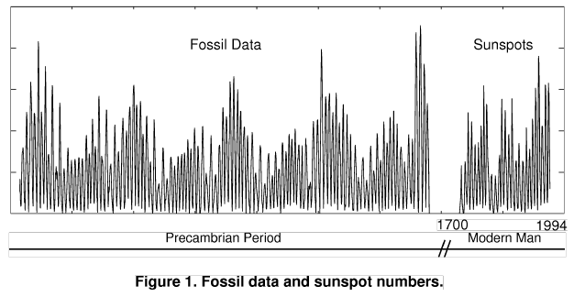
“... Conclusions: We cannot as yet draw definitive conclusions as to the relationship between the fossil data and solar activity. However, using simple committees and committee training, we were able to improve or ability to predict sunspots. Incorporating priors into the network by initially training on one series and then tuning on a second, allows for combining data which may be related but separated in time. In addition, we devised a general method for training committees of networks, which proved to be effective at improving predictions (even without the explicit use of fossil data).
Everybody whines that there just isn't enough sunspot data for proper studies. Well, Wan & colleagues only used a fraction of what was available from on rock bed! (was it 1.2 My? - I forget...) CAUTION- Planetary motions probably change, even in historical times (well beyond the Milankovic type movements – here I am speaking of “discontinuities which are significant.

7.5.2 Recurrent Neural Nets

I won't go into detail here, which is a BIG personal interest of mine!! By the way, Eric Wan is a leader in the area (which, strangely enough, is how I stumbled on the article referred to above!)

I won't put details in the next two either - suffice it to say that the power of the techniques is awesome, but they can get you into a lot of trouble.

7.5.3 Evolutionary Computation

7.5.4 Genetic specification of hybrid systems

7.6 Regionalism versus Global

Global analysis is a cute and easy starting point, but is a HUGELY INFERIOR mentality to a regional approach (and frankly is often highly misleading judging by a lot of thinking that comes out of it).

7.7 “Hyper-scalar Spatio-Temporal” analysis

I can't emphasize this theme enough, and actually should make an entire section JUST FOR THIS! This is a big source of little thinking by scientists.

Wavelets are a key modern tool for this, but we have to go much further with wavelets and other tools for this. Paul Vaughan is working towards this, as well as others, but he's the best I know of (he knows other good thinkers in this area). Willie Soon, of course, has worked on issues like this (Artic Oscillation I remember, probably other regions and maybe links to behaviours of other regions), as well as tying it in to astronomy.

Here's a really great, simple example from Ian Wilson in Australia, suggesting that the PDO is “the boss” of El Nino:

Ian Wilson Jul08 "Which came first: The chicken or the egg? (Length of Day & PDO, NAO)" lecture to the Lavoisier Group http://www.lavoisier.com.au/articles/greenhouse-science/solar-cycles/IanwilsonForum2008.pdf

CAUTION: - unpublished – get published result!?!?!!?

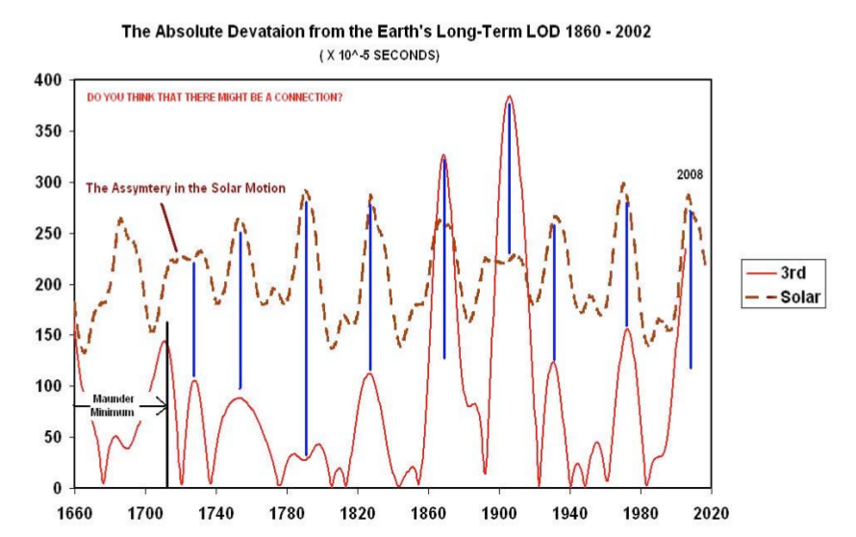
These figures give a very strong suggestion of a “flow of causality” from:

SIM → LOD → PDO → El Nino

where:
SIM = Solar Inertial Motion
LOD = Length Of Day
PDO = Pacific Decadal Oscillation
El Nino ...

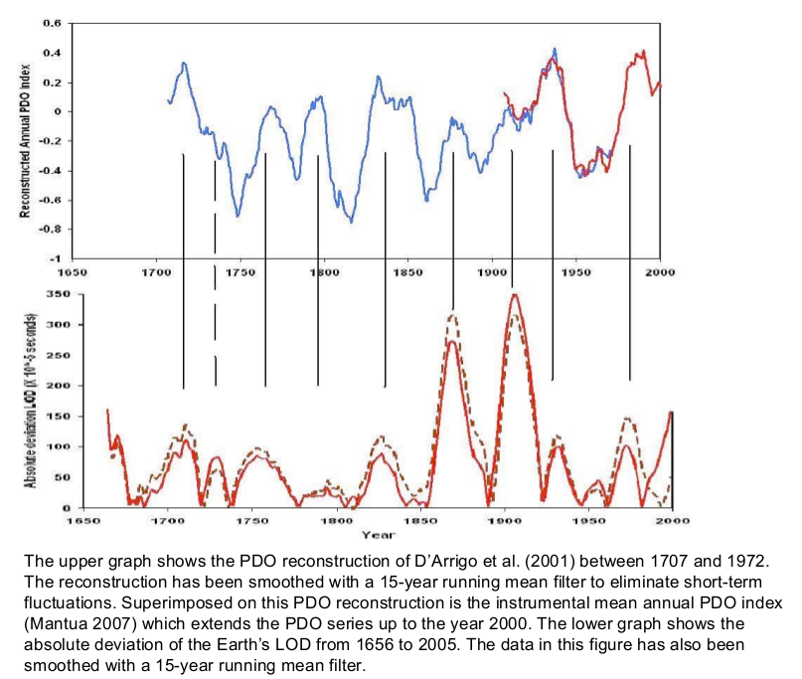
Ian Wilson Jul08 "Which came first: The chicken or the egg? (Length of Day & PDO, NAO)" lecture to the Lavoisier Group http://www.lavoisier.com.au/articles/greenhouse-science/solar-cycles/IanwilsonForum2008.pdf

CAUTION: - unpublished – get published result!?!?!!?

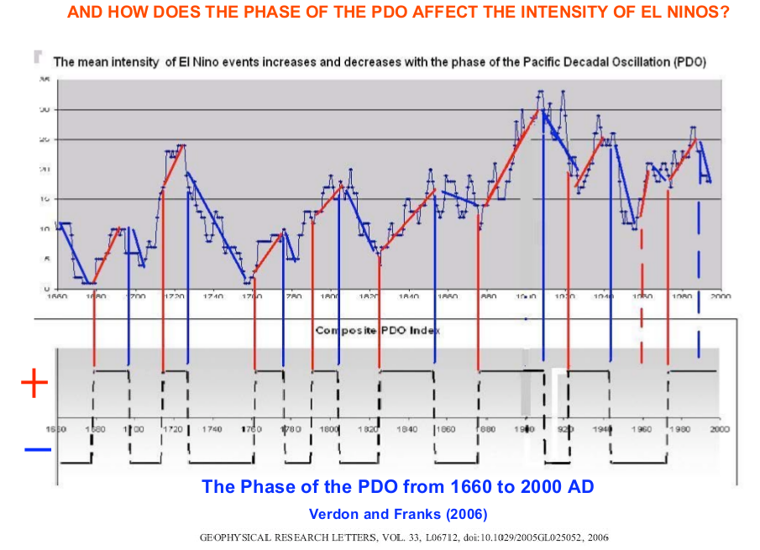

endsection

7.8 Special note on phase synchrony

From neuroscience, to climate, to other systems, phase synchrony seems to hold a great deal of potential for enormously improving our understanding of natural phenomena. One interesting climate example is the paper of Tziperman etal for glaciation. See my chart of glaciation models

“... Eli Tziperman, Maureen E. Raymo, Peter Huybers, and Carl Wunsch 2006 "Consequences of pacing the Pleistocene 100 kyr ice ages by nonlinear phase locking to Milankovitch forcing" PALEOCEANOGRAPHY, VOL. 21, PA4206, doi:10.1029/2005PA001241, 2006 http://www.people.fas.harvard.edu/~phuybers/Doc/Phase_Locking.pdf ...”

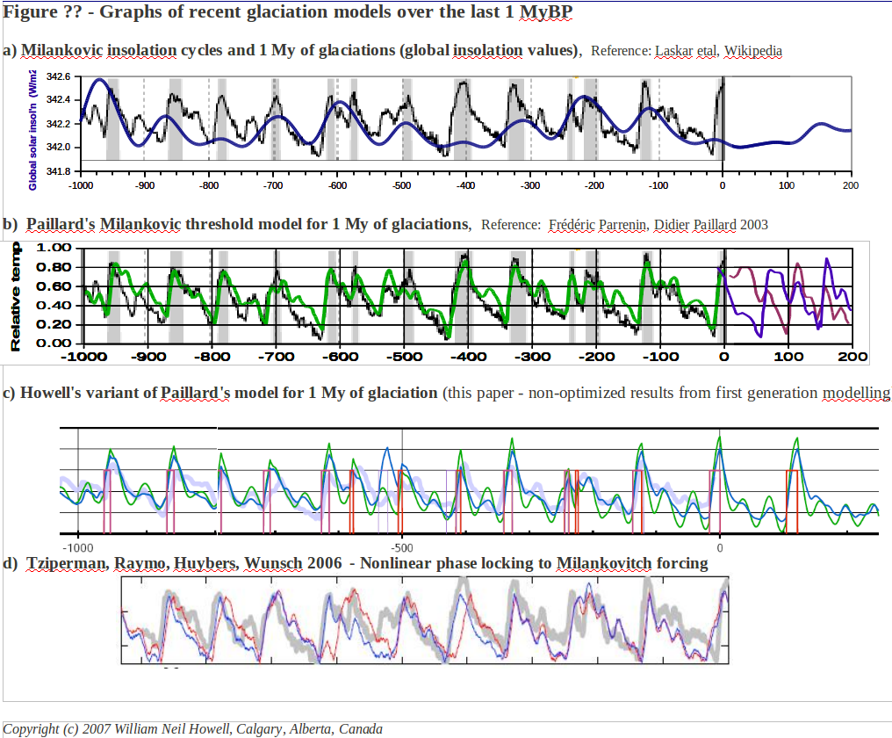
Actually, above I've labelled it “phase locking” which is not a powerful as “phase synchronisation”!

Endsection

8. Comments on: Hsiang, Meng, Cane 25Aug2011 "Civil conflicts are associated with the global climate”

Example:
Solomon M. Hsiang, Kyle C. Meng, Mark A. Cane 25Aug2011 "Civil conflicts are associated with the global climate" Nature vol 476 p438-441

In their fun and informative paper, Hsiang etal rely on fairly simple statistcs applied to binning of classified data. Figure 2a is quite convincing, but there there is no description (in the paper – perhaps the Supplements get into detail) of classical time series analysis techniques,, so I assume they didn't attempt this. The binning provides a simple, robust, and “visible” method of analysng the data.

Although my intent isn't to review or critique the article, I can't resist a few comments:
- Overall, like the article, and it is very good timing. It is easy to do far better than what they have done, but the great media / reception “establishes the theme” and prepares the ground for your book to have a much more profound impact.
- I'm not familiar with the Annual Conflict Risk ACR) data, and even if it is a gold standard in modern political science/ international conflict , I won't trust it until I have a feel for it. (Too much fluff in all areas of study, where positive, assertive statements are made on the basis of less than firm data).

- I like their:
- approach of binning areas between those “more” or “less” affected by El Nino from the climate perspective alone, and showing that the conflict results also show more effect. The obvious question is that such relations usually also require showing a quantitative (eg linear or whatever) functional relation between the variables (eg as El Nino climate impact rises or falls, so does the effect on conflict). Hsiang etal do show this (Figure 2.b), which is very good.
- Demonstration of the effect that El Nino might “displace conflict in time” rather than “create new conflict”. That point is very much like a common failure in environmental health issues – where effects kill people today who would have died tomorrow, but those promoting a cause desperately try to hide that effect (often fraudulently).
- Interesting comment on approaches to deterring conflict.

- Hsiang etal set themselves up for an easy “leap-frogging” with several flippant statements. However, I suspect that exageration has been an important part of the strong response for the article (and the subject theme is of wide interest as well):
- “... This result …. is the first demonstration that the stability of modern societies relates strongly to the global climate ...” - The authors have managed to be completely ignorant of at least 5,500 years of historical writings, and I suspect that even cave men knew that.
- The analysis is restricted to El Nino only. Why? - perhaps the data is inadequate for other major periodicities – certainly that is the case for the Gleissberg/PDO time frame and above.
- Figure 3 has barely any “extra thinking” behind it, and for sure others will run with this!. This result is reminiscent of Fareed Zhakaria's “Future of Freedom”, showing that the success of democracy is “fuzzy thresholded” by GDP/capital. Environmental performance is the same sort of result. Authors neglect to comment on the dominance of that variable 's effect (GDP) in their results.
- “... El Nino existed before the invention of agriculture ...” Oh brother, what have we here? (M-i-c-k-e-y M-o-u-s-e). Sounds like quite a bit of Jared Diamond's stuff.

I'll repeat that I think Hsiang etal's article is good news for your book. It has re-stimulated interest (and thirst) for the subject of war & climate, and their thinking and results are PUNY and naive compared to what you can do!

endsection

999. Other perspectives -BROADENING, not for inclusion:
You can't put everything in your book, and it is NOT intended that the following material be included.

What you CAN do, however, is post such comments and discussions blogs to a site that is hyperlinked in the book.

[Howell – see “broadening comments” on theories/ views of history and its drivers]

From ?ancient times? entertaining historical perspectives have included:
- Hunting, fishing, and agricultural The ancient, powerful, and capricious gods, brought favour or curse to chosen peoples or their enemies.
- “Does history make the man, or does the man make history?”
- A parent dichotomy is to contrast historical theories that emphasize the sledgehammer of nature to the
Recognizing that dichotomies are simplifications most useful for pedagogy and for promotion of concepts, the theme of this chapter is not to to be boxed in by overly simplistic contrasts such as these, but to

I

[Howell – See comments on “The full timescale – seconds to the age of the Earth” for climate, solar activity, galactic rays, ]

The glaciation cycles are VERY pertinent to your analysis of history and solar grand minima! Actually, the dominant Milankovic theory for glaciations (incomplete, doesn't fully work) is a combination of assuming constant solar insolation, but modulated by Earth orbital parameters. There is a very impressive cosmic/galactic ray hypothesis for glaciations as well, and this is at least partly non-solar-driven.

[Howell – see “broadening comments” on glaciations models (I have several graphs over 6 My)]
(I have several graphs over 6 My)

[Howell question broadening – on Bond pseudo-cycles (sometimes I say quasi-cyces)]

[Howell broadening – see “1500 & 700 BC major events”]
[Howell - It would really help if you tied a LARGE NUMBER of devastating events around the world together. This is controversial, but the proponent (Velikovsky and using similar lines of research) supports his points quite well, and much of the criticism by scientists has been, to put it politely, highly [dishonest, and/or dysfunctional and/or delinquent and/or hypocritical] - and that point is EXTREMELY well documented! ]

USELESS Comments: not for inclusion

I couldn't help commenting here an there...

[Howell – see useless titbit - “vegatative following of the ice sheets” ]
I was very surprised to see maps (every 1000 years or so) of the vegatation in North America as the ice sheets retreated. I was expecting “bands of artic through current-day vegetation” to follow the edge of the ice sheets. Ghat's not what happened – it appears that soon after land was cleared of ice sheets, the vegetation that established itself was essentiallhy the same that remained there with time (plus or minus). Maps from Geological Survey of Canada...

endsection

enddoc

