3. Grand solar phases in possible civilization-altering contexts
For considering this, a return is made to points taken up in earlier chapters on Nature and civilization. Any solar impact (for the weaker or stronger, grand or “normal”) upon humanity can be taken in two important and usual ways:
- Something Nature impresses upon the human race (Nature determines the total course).
- Something humans are always either immune or fated to, and humans ply their own total course (due to pluck, good leaders etc.) regardless of capricious Nature.
The former is classical environmental determinism. The latter is pure Plato. No claim is made here to some kind of modality or modulus compelling human behavior or temperaments into one mode or another, determined by a set geographical locations or even a set form of what could be called regular climate or socio-political conditions, laws, or wise rulers. As remarked upon in the contemplation and comprehension of deep time in Chapter 1, we knew Nature to be a constant constraint as well as a willing assistant to society and its individual and collective behavior. We saw that humanity adapts and tries to overcome or to at least assimilate climatic severity of any kind. In fact, humans perhaps thrive on just such a challenge and use various natural conditions as pretexts for exploration and colonization as much as they would socio-political/religious ones. Such adaptation is societal as well as natural.
To approach this subject, we will survey the entire Holocene Epoch in this chapter, starting from the end of the deep ice age of 11,700 B.P. but more closely from c. 9,000 years ago. Then a look is taken closer still from c. 1,600 years ago to the most present time. Various factors will be looked at from the data of 1,600 years ago to now: the tendency toward cultivation and its enhancement; plagues/epidemics, drought, flood, crop and human disease, and war. This latter aspect is to be extrapolated from the data on historical grounds, taken at the beginnings and ends of various empires, dynasties,republics, and regimes.
In one case, overlaid on this view is the Sun’s insolation – the total exposure of its rays – over this entire period, globally. This in turn is tied to human civilization rises and falls (for want of a better phrase ). The visual approaches used are simple (filtering via sliding window) although this is a weak-sister compared to advanced wavelet transform analysis, or the Fourier power spectra analysis when applied to non-stationary, spatio-temporal analyses like climate. A simple graphical comparison of filtered data is fast and provides a detailed "look" at data, thereby reducing the "coloring and destruction" of the information that often results from statistical methods, especially when mis-applied. Then there are the very often poorlyunderstood limitations and constraints of the statistical tools that are commonly used. In another case a link based on statistics between conflict and climate is shown. This latter case is quantified proof of such a connection, howsoever mathematically frail.
The Holocene: a cyclic view of climate events in deep time
What kind of world was it right before and right at the end of the last deep ice age 11,700 years ago? Why take such a stepped-back view from the Holocene, which is a little more than ten thousand years in duration? This view is long in one sense and short in another.
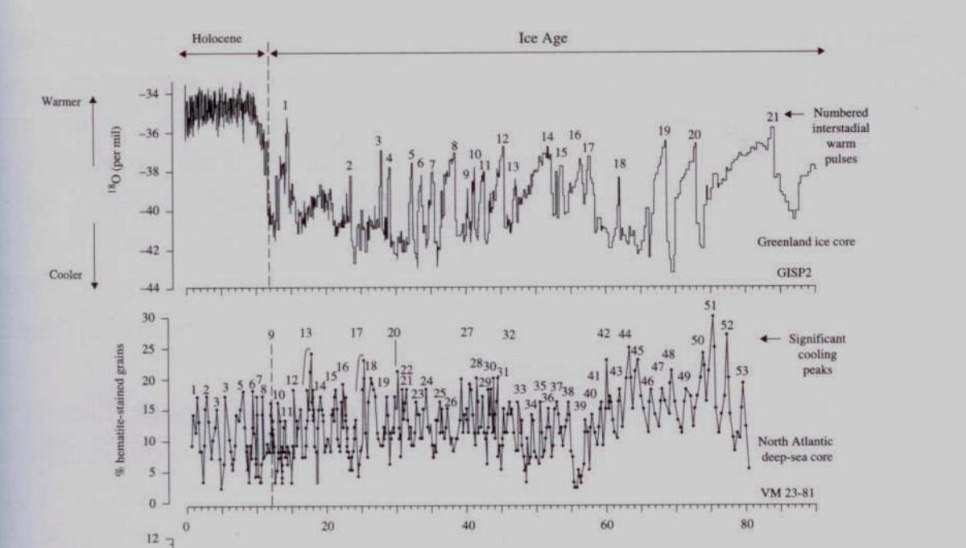Figure 1. Cyclic (or pseudo) climate-event dating: ice rafting” events” from ocean sediment core samples, showing positive and negative relationships between the ¹⁸O and ¹⁶O isotope. (After Gerard Bond, 1999)
Mainly this is done to lend perspective to the coming graphs showing the total (pseudo-decadally averaged) solar insolation as superimposed over human civilization for the last 9,000 years. This view lends greater breadth to deep time, visually, brought to the present, as we lead up to the most recent grand solar s and the mysterious LIA; the LIA dwarfed by this grand view. This view, from glacial ice rafting events from that time, also introduces temperature isotopes that are vital for understanding climate change: Oxygen 16 and 18 (¹⁶O and ¹⁸O).
Figure 1 is based on Gerard Bond’s research on hematite stains, moving glaciers, and a tie to solar activity. It covers c. 90,000 years for at least four full Earth precessional periods leading up to the early Holocene, when the Earth was in deep ice age. But even in that deep ice age, there were at least 25 rapid climate fluctuations peaking the amplitude of climate on Earth upward. That is, there were warming peaks even in much colder, deep ice age times.
“Up and down” wave amplitudes are shown by small hematite rock grains (in Figure 1’s case) found in sea off the Northeast U.S. and Canadian coasts. Cate change is recorded well on The hematite was found like this: ice-rafted debris in ocean core samples came from melted icebergs that were broken off the tongues of glaciers These icebergs contained the small stones (rock grains) that fell to the ocean floor (becoming part of the sediment and so, collected by researchers as core samples) as a consequence of icebergs melting on their way south. Thus collected by taking ocean sediment cores, they were then isotopically dated. Delta counts of the Oxygen-18 isotope in the core samples, compared to the hematite stain grains, reveals a c. 1,500 (+/- 500) year “hop.” These would be, then, the recurring rapid climate fluctuations (25 or so) just mentioned, and these are highly debated as to their cause and prevalence.
The “hop” is the temperature change recorded by comparing the two proxy isotopes of temperature just spoken of. These two are Oxygen-18 and Oxygen-16. Then in this comparison, researchers obtain (like in Carbon-14, for DURATION) a deep Earth date, from a ratio, off a chart. In the case of Oxygen-18 and Oxygen-16 the time is stamped to the temperature. If the found ratio of ¹⁸O to ¹⁶O is HIGHER, it was COLDER then. If the found ratio of ¹⁸O to ¹⁶O is LOWER, it was WARMER then. In Figure 1, these WARM amplitude peaks are plotted upward.
In this theory, within a 90,000 year period, there seems to have been a warming rise recorded by these two isotopes regardless of whether or not a deep ice age was ongoing. The graph shows at least twenty of these “ Dansgaard-Oeschger cycles” prior to the deep ice age’s end 11,700 years B.P. (dark blue arrow) and that a steady rise in temperature hemispherically occurred rather quickly thereafter. It is a “whole new plateau,” so to speak, in globally averaged temperatures, as weak a proxy as “delta T” (Δ) measurement is. The Earth’s “mean” temperature must have risen, since the temperature isotope’s ratio roughly today is -34 ¹⁶O-¹⁸O, and at the end of the deep ice age, it was -40 (higher, in other words, and so, colder back then in at least regional or specific locations). Figure 1 reflects all this. The very last of the ice age fauna like Woolly Mammoth were on their way out. Neanderthal, our human cousin and possibly chief architect of survival in the cold of the deep ice age was long gone. We (Cro Magnon) had by this time long learned to read the shifting climates and are in fact the sole surviving human type. As humans we are hardly any longer the hot-weather type of proto-human/ape from which we evolved in the high tropical periods three million years or more ago in equatorial Africa; back when England was like the Philippines. It lends much accuracy to Steven M. Stanley’s aptly-titled book about us as being “children of the ice age.”
The red arrow in Figure 1 shows the current upward trend in temperature according to these isotopes of oxygen. The lower dip inside of this high rise (the light blue arrow) shows the end of the last cooler trend about the year 1880. Visually it is a small distance and indeed, in deep time, it is just a short distance as is plainly shown by the graph. But near ancestors report down to us from this time how noticeably snowier and colder; windier, rainier, and wetter it was just 100 to 130 years ago.
Eleven thousand years ago modern humans (Cro Magnon) had been around for c. 40,000 years. His cousin the Neanderthal, still in existence at Cro Magnon’s beginning, may have taught them (who are essentially us) how to survive in the cold. The ice fields and sheets started to recede in the U.S. Northeast (close to the Laurentian if not a part of it) to name one well-known location. It took a few thousand years for it to repopulate with fauna and flora remotely familiar to what we see there today. In fact the U.S. Northeast is still quite hilly and rock-till filled, with eskers and terminal and lateral moraines barely covered over with vegetation even in the summer, as any hiker in the northeastern U.S., for instance, can see. Predictably as one reaches Canada the moraines, eskers, etc., are more visible and in many cases higher overall, all flat plain aside. As shown in the top part of Figure 1, the amplitudes of the Holocene are very small and tightly knitted compared to those in the deeper part of the deep ice age. Still they show their up and down variations for the cooler and the warmer, us currently being in the warmer. The current “down” part of the ¹⁶O-¹⁸O ratio (and higher wave peak) means the water and air over us are, roughly speaking, warmer since 1880. In the vast scheme of things, that timeframe was cold; but not that cold inthe Northern Hemisphere, compared to now.
In the close up of Figure 1 (that is, Figure 2) we get a glimpse at the last 9,000 years of the Holocene and its tightly knit, up and down peaks of cold and warm periods before 10,000 years ago. The warmest times were far from the coolest ones in the Holocene, a few exceptions aside. The Holocene is indeed a whole new plateau of Earth climate behavior after 9,000 years B.P.
Around 3,000 years after the deep ice age’s end, there was a significant cooling period called the “8.2 kiloyear event” or, 8,200 years before present (or 6,200 BC). In Figure 2, the downward peaks are such that the 8.2 Kyr event is nearly as far downward as the much-more recent Little Ice Age (LIA). For the 8.2 Kyr event’s occurrence we look at oscillations in the ocean current system. An abrupt cold period occurred around 8,200 BP in the North Atlantic area. It lasted for about 300 years. In Greenland ice-core records it is characterized by a reduction in temperature greater than 1°C, a decrease in ice accumulation rate, increasing wind speeds, and a drop in atmospheric methane levels. A slowing down of the thermohaline circulation as a result of a
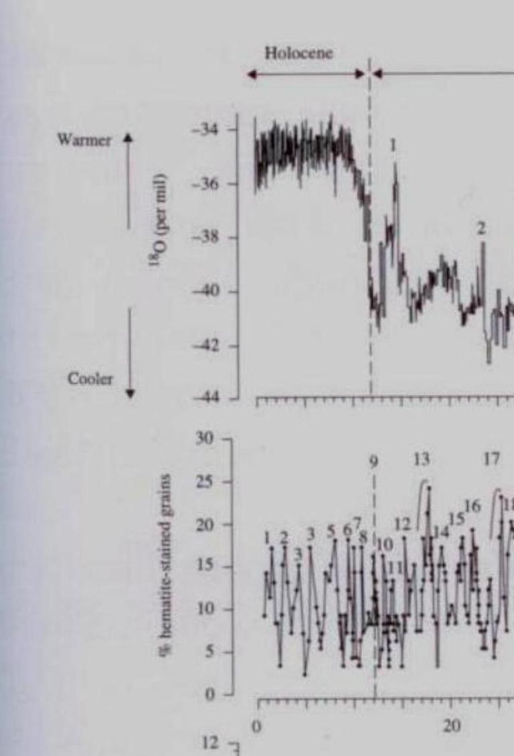Figure 2. Close up of Figure 1, showing the 8.2 Kyr event in relation to the Little Ice Age (LIA) and Younger Dryas (11.5 Kyr B.P.).
The 8.2 Kyr event, the Holocene Maximum, Henry’s Law, and today
The red arrow to the left, as shown earlier in this graph, is today. The red one to the right covers the time period of roughly 6-7,000 years BP, known as the Holocene Maximum. Observe that the ”warm amplitude peaks” are about the same as the present data for 18O and 16O ratio of the oxygen temperature isotope, and rather high up with less severe downward millenial ”down-peaks” overall.
The light blue arrow points to c. 9,000 year before present and refers to the c. 8,200 year BP cooling period. The deep blue arrow points at the Younger Dryas (c. 11.5 Kyrs B.P.)
This downward spike could account for the ice rafting events recorded by Bond and the hematite stains found, when large amounts of melting fresh water that was cold upset the saline balance in the water off the Laurentian in this timeframe (the Henry coefficient). Increased water temperature released much CO2. For all that, the peak upward right after this, about 7,000 years ago, is HIGHER than the red arrow on the left (today) with weaker downward amplitude. This is consistent with archeolgist William Richey’s ”warmer and drier New York State” c. 7,000 years ago, and most likely, much more floating CO2 and the attendant water vapor.
Little Ice Age?
Modern Maximumn?
freshwater perturbation has been proposed as the cause of the 8.2 kyr event. The thermohaline circulation slowdown resulted in a decrease of the northward heat transport in the North Atlantic Ocean, leading to pronounced cooling. The proglacial Laurentide Lakes in front of the Laurentide ice sheet were most likely the source of the freshwater surge into the salt sea. It seems as if melting ice caused a negative climate feedback in ocean circulation, resulting in Northern Hemispheric cooling for about 300 years.
A thousand years after the 8.2 Kyr event, or so Figure 2 intimates (and the pseudo-decadal graphs below shows) the Holocene Maximum (or, Climate Optimum) occurred. In upper state New York, the archaeologist William Ritchie reported C14 dating had marked the area as “warmer” than today, and perhaps even “somewhat drier,” and this is consistent with the approximately two degree Celsius Northern Hemispheric warming that was then ongoingat least this . It strongly suggests that the microclimate of New York State (and Southern Ontario, Canada) in this part of the Holocene timeframe received a westward-to-eastward invasion of species during the upper peak shown in the Bond graph (left red arrow in Figure 2). Ritchie hints that New York State’s climate and biome was more or less prairie-like:
Two species may record changes associated with the Climatic Optimum...The weather was presumed to be warmer and drier than at present, enabling prairie forms to extend their ranges eastward. This is believed to have been responsible for the prairie mole (Scalopus aquaticus) in an archaeofauna from Pennsylvania, 75 to 100 miles east of its present range.
Based on limited data, the Eastern Fox Squirrel (Sciurus niger) and Eastern Box Turtle (Terrapene carolina) also inhabited northern and northeastern New York and Southern Ontario at this time (they do not so any longer). Indeed, the very movement of the tree line, north, upwards of hundreds of miles near this period has been recorded using isotope reconstruction.
Arid areas like prairies (or, steppes) are attractive to nomadic or semi-nomadic human hunters due to its favoring by large herding herbivores, as shown below in the south-central Siberian steppe hunters of c. 850 B.C.
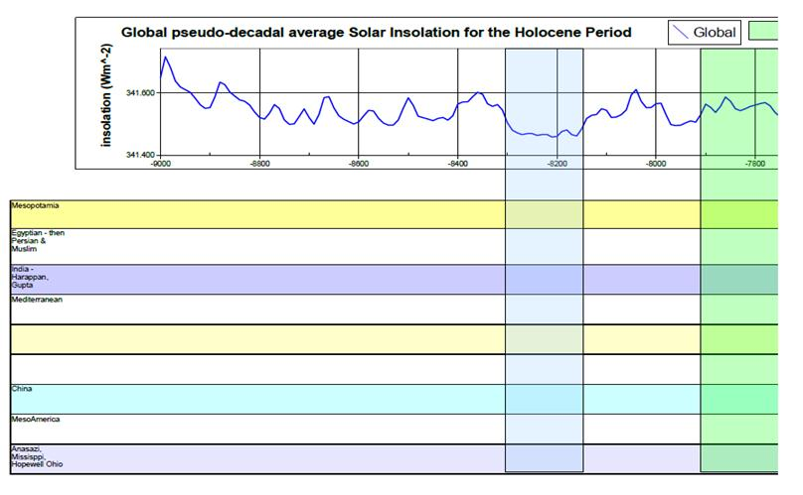
As in Siberia in 850 B.C., so in Northern New York State in c. 4,500 B.C. Palynological (fossil pollen) sampling around undisturbed Lamoka people burials in the warmer part of the Holocene “Climatic Optimum” revealed evidence of things that no longer live there. Even the racially-unidentifiable bones of the people themselves still exist, apparently aggressive hunters, and who may have made their way there in the same manner as the Vikings in a similar period of longer-term natural global warming: the Medieval Maximum – pnly much later.
8.2 Kiloyear event…6,200 BC (8,200 years B.P.)
Powerful regional effects of climate change vs. “global” averaging : three views
Regional effects are probably three to 10 times stronger, and often go in directions completely different from the mean global trend. Averaging them all out yields an overall weak global effect. The weakness of global temperature averaging, as academically useful as it is, is as scientifically suspect as proxy isotopic evidence.
Three regional examples of trends from strong local/regional climate-change effects in both cool and warm contexts gives us a striking view of the actual motor of climate change, in motion, howsoever measured or observed. One is cultural change and migration of peoples in or around 850 B.C., which coincided with an abrupt lowering of solar activity. The second is the poorly understood Little Ice Age (LIA) which always asks for interpretation and understanding, and a third, the effects of locally warmer weather due exactly to this lifting of the “LIA” on avian migration and settlement behavior.
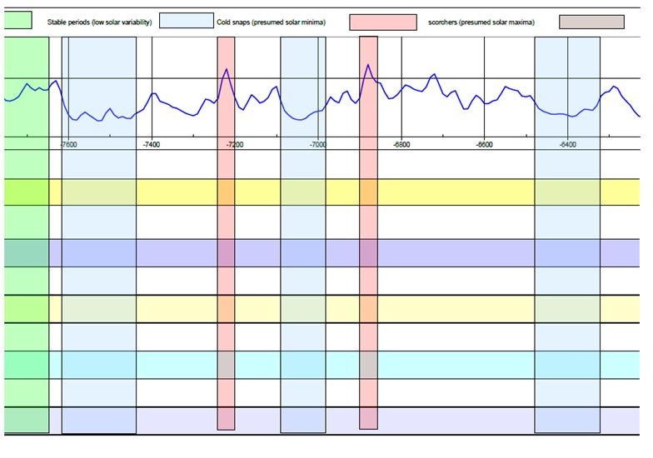
The Holocene “Climate Optimum”…this peak and the one on the left helped Northern Hemispheric treelines to expand north. Made the climate of upper state New York more midwestern: drier and possibly warmer.
One: “The 850 BC event”: lower solar activity with higher precipitation initiates a human crisis in The Netherlands and aridity in the tropics: changing populations, changing cultural behavior?
There was a degrading of weather that was noted in proxy data drawn from peat bogs in c. 850 BC in the Netherlands. Climate-related changes in precipitation and temperature are reflected in the changing species composition of the peat-forming vegetation.
Plant remains can be identified and, by using ecological information about peat-forming species, changes in species composition of sequences of peat samples can be interpreted as evidence for changing local hydrologic conditions linked to climate change. At the start of the abrupt climate shift (middle, see Figure 3 below) – and coincident with an abrupt decline of solar activity – the atmospheric circulation changed, leading to cooler and wetter climate conditions.
In lowland regions in the Netherlands for example, the climate shift caused a sudden, considerable rise of the groundwater table so that arable herding land was transformed into wetland, where peat growth started. Farming communities living in such lowland areas were forced to migrate because they could no longer produce sufficient plant and animal food.
The rise of the water table forced the farmers to migrate to well-drained areas in the northern Netherlands where salt marshes offered them new fertile land. (Phase two and three, middle and upper in Figure 3). The rise of inland water tables is attributed to increased precipitation.
Evidence from proxy data in this timeframe also suggests climate cooling events in France, Switzerland, Central Russia, and the Andes in South America, these latter due to palynological evidence revealing vegetation shifts consistent with global cooling. There is also evidence for dryness in Central Africa and Western India. Magny (2004) showed that over a period of several millennia the presence of lakeside villages in Southeastern France and adjacent Switzerland was strongly linked with lake levels and solar activity. Lakeside villages were present during periods of high levels of solar activity, as evidenced by reduced atmospheric C14. As C14 production is regulated by solar activity, periods of increased mire surface wetness and increased lake levels (peaks of 14C!) have been interpreted as evidence for solar forcing of climate change (the effects of sudden declines in solar activity). No lakeside villages occurred after 850 BC.
A link between the climate shift around 850 BC and the evidence for a subsequent increase in human population density has been made in Northwestern Europe. A climate crisis in the first instance caused environmental and social upheaval. A collapse of societies resulted in a weakening of the position of dominating groups, which brought about a change in the social structure of farming communities. This facilitated the introduction of a new technological complex, which again created further social change combined with a leap forward in production, food consumption, and population density. In this case there was apparently no catastrophic decline in human existence, but a major disruptive shift due to climate drivers for the cooler.
In south-central Siberia near this time archaeological evidence suggests an acceleration of cultural development and a sudden increase in density and geographic distribution of the nomadic Scythian population after 850 BC. van Geel et al (2004) hypothesized a relationship with an abrupt climatic shift towards increased humidity (equatorward relocation of mid-latitude storm tracks). The hypothesis is supported by pollen-analytic (palynological) evidence. Areas that initially may have been hostile semi-deserts changed into attractive steppe (that is, prairie) landscapes with a high biomass production and carrying capacity. Newly available steppe areas could be utilized by herbivores, making them attractive for nomadic tribes. The Central Asian horse-riding Scythian culture expanded, and an increased population density was a stimulus for westward migration towards southeastern Europe.
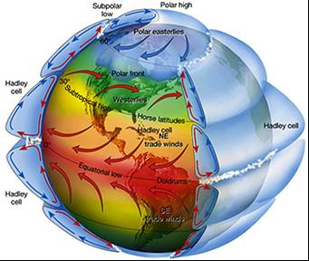
The Hadley Cell (Courtesy of Carleton University)
There is strong evidence for climate change in the Central African rain forest belt around 850 BC as well. Palynological studies point to a drastic change in the vegetation cover (from predominantly rain forest to a more open savannah landscape) as a consequence of dryness (aridity). A population of farmers migrated from the south into the area. The contrast between this change to dryness in central west Africa and the contemporary increase of precipitation in the temperate zones fits well with the hypothesis that, after a decline in solar activity, there was a decrease in the latitudinal extent of the Hadley Cell circulation and consequently, the monsoon decreased in intensity. Meanwhile, the mid-latitude storm tracks in the temperate zones were enhanced and moved in the direction of the equator.
A dryness crisis caused by a weak monsoon intensity in northwestern India after 850 BC also supports this hypothesis . Moving toward the Americas, massive glacier advance in the south-central Andes of Chile, probably resulting from an equatorward relocation of mid-latitude storm tracks (like in the Northern Hemisphere) forms part of a wealth of evidence for “worldwide” climate change around 850 BC for the cooler. Evidence from paleodata indicates that the climate shift around 850 BC occurred suddenly, probably within a decade, and (at least ) the 14C record points to a sudden, Maunder Minimum-like decrease of solar activity as the cause of this event (see the pseudo-decadal averaging chart for 1600 BC-400 BC below).
The theory with the close-up of this “850 BC event,” stepping back and taking a long view culturally, is noting solar “hibernations” and the rise and falls of civilisations, and loosely considers not just temperature, but perhaps more precipitation, and not just war. Plagues and other climate disruptors, such as heavy cloudiness as a negative feedback of say, albedo from heavy and persistent stratocumulus cloud buildup in key seasons that can reflect up to 90% of the Sun’s short-wavelength (visible light); attendant precipitation shifts, and the resultant droughts are others. Floods and the crop failures connected with these as well as with crop diseases, insect “plagues” (such as locust clouds), agrarian society economic failure (as seen in the well-documented “850 B.C. event” just related) and pandemics also factor in. These connect to each other in some cases, like in cause and effect, possibly as wars are prompted due in part to crop failures and famine-forced diseases that partly are the result of a weakened Sun wreacking havoc on crops and by proxy, markets. There is a feeling that the zones of huge agricultural productivity wander with the longer term solar cycles and even short-to-mid-long term pseudo cycles. As solar insolation decreases, big regional effects differ in nature. To quote Bill Howell, “There forms an intriguing dichotomy between ‘desertification’ versus ‘junglification’ in some respects to witness the rather sudden shifts from dryness to wetness, and the attendant changes in forces on humans.”
The end of the 850 BC event, however, seems to have been gradual (a time-transgressive passing of thresholds) so that, given present knowledge, it is not yet possible to pinpoint an end of the event. Changing climatic conditions at 850 BC may have been similar to climatic cooling shifts during the LIA.
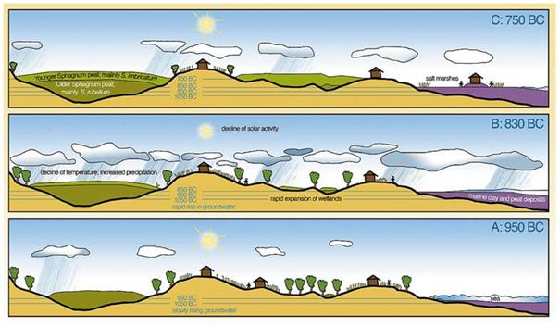Figure 3. Three views of climate change around 850 BC as revealed by increases in peat bog growth in The Netherlands. Phase A (base), warm and dry . Phase B (middle; c. 850-730 BC) cold and wet. Phase C (top) a return to warmth (After Beer & van Geel, 2008)
Two: The “Little Ice Age” (LIA)
Sandwiched in between the Bond graphs (see Figure 2) in tight amplitudes, barely visible, from the mid-1500s to the end of the 1800s is the phenomenon labeled such that it confuses most who stumble upon the subject. That would be the anomalous LIA, caused either solely by the Sun / albedo etc., solely by geophysical events (volcanoes) or is purely an ocean (hydrological) phenomenon. It may be caused a little by all of these and it defies a neat, cyclical cubbyhole. In any case, as shown in Figure 2, it cannot possibly be confused with a deep ice age.
The term “Little Ice Age” was coined by a journalist, probably in the 1930s according to U.S. Geological Survey scientist F.E Matthes (in 1940) as he described glacial re-expansion in a post-Pleistocene context on page 398 of an AGU report:
They (the glaciers) have re-expanded since then to the limits from which they are even now receding, and as their re-expansion has been of considerable magnitude, to judge from certain specific cases, there appears to be a warrant for the assertion that the present age is witnessing a mild recrudescence of glacial conditions – that it is, as a clever journalist has suggested, a separate “little ice age.”
What nags at the understanding of the LIA, other than the confusing label, is its locus in the range of two well-known solar minima: the Spörer (possibly a grand episode) and the Maunder. (definitely a grand solar episode). If separate from any solar activity, the LIA certainly worsened the climate conditions in the Northern Hemisphere at the time, and is fairly well recorded as such. We can see that from the familiar Eddy graph of 14C per mille and the red curve below. In any case, the LIA’s end coincides with solar insolation increases overall since Solar Cycle 11 or so, and could be one of the contributory effects to a warmer Twentieth Century, very much so after c. 1924.

Exacerbating the effects of prolonged solar minima was the coincidence of two closely-occuring grand minima episodes, one after the other. This is covered elsewhere in detail. Weather in Europe had already been “generationally different” from what Spörer and Maunder Minimum-living old timers recalled, which fell into what some think was the coldest year in c. eight thousands, culminating at the end of the year 1683, once called the “hardest” freeze (of the Thames River in England) in “postglacial times,” (that is, prior to c. 10,000 years BP). But from the Bond graph, it looks closer to c. 8,000 years before the year 1683 AD.
Three: Local shorter term warming since 1880 (post-LIA) in the altered permanent residency of migratory birds northward
We now do a hyper-convergent thing and make a tie-in to the science of ornithology in this largely anthropomorphic examination of climate steered events. Rather than think this a digression, it is a convergence from other branches of science used to lend weight to that branch of science attempting to understand natural local shorter term Earth warming or cooling (solar astrophysics-geophysics). The following explanation purports to show that species of birds – as warmblooded as mammals if not more so – have moved permanently northward since the end of the LIA, and which is a regional – if not hemispheric – phenomenon.
A never ending anedotal series of litanies on how much colder it was in the “old days” in the U.S. Northeast (roughly 100 years ago) and somewhat earlier wends its ways through popular literature. But some of it is more accurate than supposed. A scientific book on Massachusetts birdlife as it applied to state agriculture in 1905 backs this up. It was carefully assembled by numbers of good observers reporting to a professional bird biologist (E.H. Forbush) and relates later times for spring arrivals of many species, and earlier migrations of them south and west in the fall back then, compared to notes and data in modern field guides. Some species common in Massachusetts today were rare there, in 1905 (like the Tufted Titmouse [Parus bicolor] and Cardinal [Cardinal cardinalis]) or never occurring (like the soft-footed Mourning Dove [Zenadoura macroura] which became a year-round resident in Massachusetts in the 1940s) and the House (or Mexican) Finch (Carpodacus mexicanus). The Mexican Finch arrived in the U.S. from the south about 1940 into Texas and was spread from Long Island c. 1950. It has been a common summer and fall bird in Massachusetts for some years now. Many birds listed as seasonal in the 1905 book are now year round residents there today. It must have been cooler locally before c. 1900 in Massachusetts compared to after that time (c. 1950). Resource abundance must have brought them northward on wings, the possible help of human relocation notwithstanding, and warmer years making them year-round residents in the high north.
Another issue in this physical transformation could be the relative strength of the magnetic field. This northward migration of passerines must have been ongoing since the 1860s if not earlier. Perhaps strengths and weaknesses in Earth’s magnetic field signal the passerines to fly farther afield north or south, depending on the signal strength they receive in their olfactory (breathing) glands. In any case, their increased migrations northward for longer periods starting happening before the intense and widespread use of fossil fuels among an Earth population of less than two billion humans (pre-1940). Industrial waste emanation before 1940 worldwide is a null factor in global climate alteration. (After 1940 is an entirely different matter.)
Pseudo-decadal averaging solar insolation : zeroing in on short term climate effects
An overview of civilization rises and falls matched to variations in solar insolation from 1,600 BP to present
How does one characterize "periods, phases or states" of a chaotic system (such as solar variability) on another chaotic system – the “system” of the Earth’s climate? This question is one of intense interest in the field of solar science, and increasingly so in geophysics and in aeronautics and space research. It even has ramifications for the study of human demographics and conflict issues, this latter referred to as peace studies.
The following tables show averaged peaks (341.600 Wm²) in solar insolation and dips (341.400 Wm²) from 1,600 years ago to present. The tables bear some study and serious consideration as regards society, sickness, war, etc., and the Sun’s relative strength. (Though droughts, plague and war etc. occur along with the mapped out solar insolation we do not imply that the Sun is the sole cause of the listed droughts, plagues, and wars.) The two-way arrows show the rises of various civilizations, to their respective terminus points and petering out into newer or lapse into take-over by other civilizations. The color-coding reveals, from the top down, the Mesopotamian, Egyptian (Persian-Muslim), Indian (Harrapan or Marappan, Gupta) Mediterranean, European, Chinese, and Mesoamerican/Anasazi-Mississippian-Woodland societies on many of the world’s very-peopled landmasses.
The green blocks up and down and left to right are periods of presumed maxima and the white/blue areas to either sides, presumed minima, regardless of their strengths or whether or not they were grand episodes. The rose-colored areas represent extremely hot periods. The blue gray areas represent severe droughts.
Several things stand out in a cursory inspection of the graphs. One is a confluence of arrows (loosely interpreted as population disruption or change or both) in areas between 800 BC (and the 800 BC Minimum) heading into the weaker maxima periods found around 600 to nearly 400 BC. From the work of van Geel and colleagues gone over earlier in this chapter, it is amply clear that in such minima, there was considerable civilization disturbance (as he and colleagues outline well) in the Netherlands and elsewhere.
In the 800 BC timeframe the Phoenician and Etruscan civilizations transform into the earliest parts of the Roman Empire, this famous empire in full swing by 509 BC. The rise in European population falls off after the Roman Empire’s fall c. 300 years AD. In the relatively warm period stretching from c. 550 AD – 850 AD, Charlemagne encouraged the rise of feudalism and it can be said that this labyrinthine system of vassal and sub-vassaldom was popular enough to take root and help propel (from about AD 700) at least mid-Europe’s population from c. 23,000,000 to upwards of 73,000,000 humans by the year AD 1250 (through the Oort Minimum) and into the Medieval Maxumum. This rise is the first such major reversal in human population growth since late Roman Empire times in this Northern Hemispheric sector (at least). For it had been sinking steadily in that sector up till then.
The locus of this upward surge seems also to have been in what is today western Germany, north, and west to the Netherlands, then south to northern Italy and along the Rhine River. History textbooks relate that reasons for this period of massive population growth of c. 10 million persons per century for five centuries in a row remain “obscure.” That the rise coincided with massive agricultural production in west-central Europe, southward along the Rhine (prompting that very political yet mild growth, feudal and manorial life) is of course, not so surprising. But, what should also not be so very surprising is that agricultural yield and population growth at this critical juncture, both coincide with the Medieval Maximum which was very kind, climatically-speaking, to Western Europe. Curiously, North America, in the 550 AD-600 AD period, and again in ,100-1250 AD timeframe, is burned up by drought at least in the North American west.
1600 BC – 400 BC (slide window)

In the 400 BC Minimum to nearly 200 BC, the Persian Seleucid civilization is taken over by the aggressive and world-changing Roman civilization. Eastward, the Maurya Dynasty in India dies out into the Gupta, and, following a weirdly even pattern from thence on, Chinese dynasties routinely die out, and subsequently re-form, in each solar minimum. This odd pattern begins with the Chinese post-Zhou interregnum (403-221 BC), goes into the Chinese so-called “Dark Ages” of 220 BC-581 AD (the 200 AD Minimum) all the way to the start of the Sui Dynasty (581 AD – 618 AD) to the Tang Dynasty’s demise nearing the Oort Minimum and the beginning of the Mongol Empire, including the Yuan Dynasty, to the Ming Dynasty’s beginning in the Spörer Minimum. The Ming dies out in the even worse (LIA-aggravated?) Maunder Minimum, whence it becomes the Qing (Ch’ing) Dynasty. The human suffering in the Chinese / mainland Asian context and framework in this particular period is well outlined elsewhere and bears reconsideration in light of this pseudo-decadal solar insolation data by Howell.
Not to be outdone, it seems, the Mesoamerican experiences show a similar pattern to the Chinese, in that the Hopewell people of the Mesoamerican Ohio Valley peter out in the 200 AD Minimum, the Anasazi (U.S. southwest/northern Mexican) civilizations rise at the very end of the Oort Minimum and die in the Wolf Minimum, and what Spain and Portugal wrought in this part of the world (to include, most prominently, the Aztecs) is well-known and documented, the Spanish tide itself dying out in or around the Dalton Minimum.
400 BC – c. 1300 AD (slide window)
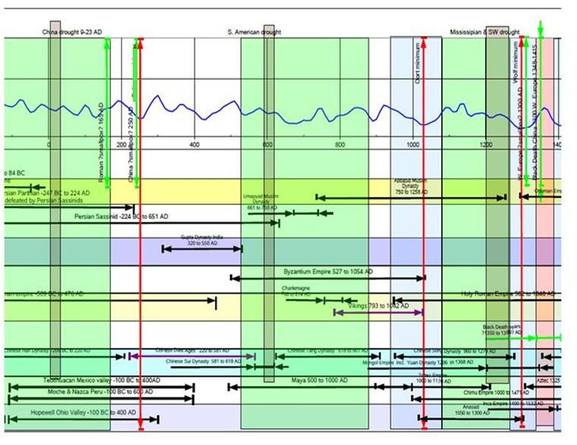
Taken on average, the amounts of arrows ending at a blocked line are about equal, whether or not we are looking at climate optimum (green) periods or the white and blue (climatically cooler, drier, windier) across the 1,600 BC – present timeframe. But a skew becomes apparent if we look at those civilizations from the northern Mediterranean upward to Northern Europe, including middle China and North America, versus the more southerly to Southern Hemispheric-occurring civilizations.

c. 1300 AD – c. 1950 AD (slide window)
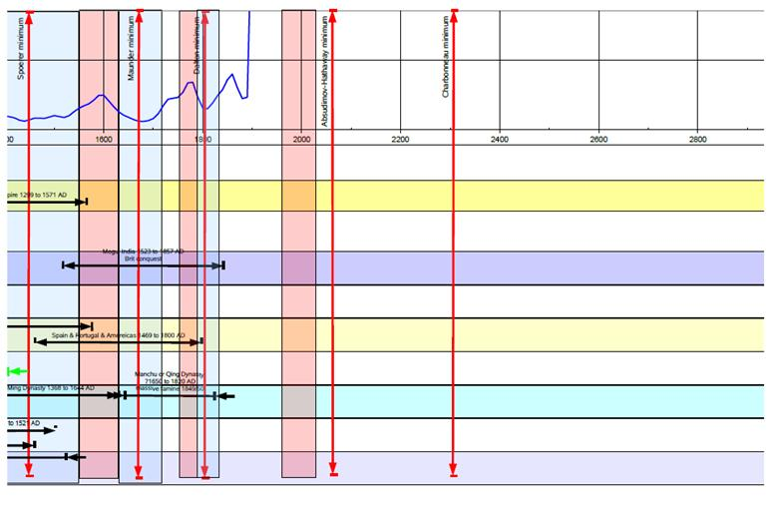
Solar minima and recurrence of civilization collapse, Northern Hemisphere relative to the Southern Hemisphere

1400 BC Minimum | 1 of 3 in the Northern Hemisphere
800 BC Minimum | 1 of 3 in the Northern Hemisphere
400 BCMinumum | 3 of 6 in Northern Hemisphere
200 AD Minimum | 5 of 6 in the Northern Hemisphere
Oort Minimum | All 4 in the Northern Hemisphere
Wolf-Spörer-Maunder Minima | 5 of 7 in the Northern Hemisphere
 | 30 total: majority in N. Hemisphere (19 out of 30)

When talking of drought, on the other hand, another pattern emerges:
Recurrence of civilization collapse in drought periods, not minima-dependent, Northern Hemisphere relative to the Southern Hemisphere

Aegean Drought | 2 of 6 in the Northern Hemisphere
“600 BC” drought | 1 in 6 in the Northern Hemisphere
China Drought | 1 in 3 in the Northern Hemisphere
S.American Drought | 3 of 6 in the Northern Hemisphere
Mississippian and S.W. U.S Drought (1200s) | 2 of 3 in the Northern Hemisphere
 | 24 total: majority in the Southern Hemisphere (15 out of 24)

Conflict and climate: statistical studies in a very recent context (1950 AD – 2004 AD)
Societal “rise and fall” – a blanket term for a myriad amount of human demographic fluctuations punctuated often by conflict, and characterised by regime shifts, changes in resource-achieving and maintaining methods and gambits, and so on – is a topic of social and political science as well as peace research. These “hard” sciences (harder than astrophysics in their grappling with unfathomable, quickly-shifting complexities which answer to few physical “laws”) make their ways to the stage of climate change via the back door of the environmental sciences, which in turn, rises up to meet geophysics and solar astrophysics at the confluence point of a rabidly-discussed topic: the strength of the El Nino Southern Oscillation (ENSO) and its effect on climate: regionally created, but hemispherically and even globally far reaching.
A recent statistical study has shown a correlation between increased conflict and climate change. (The methods used are summarized here. ) The introduction to the research letter in the same issue of Nature describes the study in layman’s terms, best:
Hsiang and colleagues’ study proceeded in two steps. In the first step, the authors used historical climate data to divide the countries of the world into two groups: 93 ‘teleconnected’ countries which have strong ENSO-related climate effects, including Australia, Ghana, Laos, Sudan and Trinidad; and 82 non-teleconnected ones that don’t experience these effects, such as Afghanistan, Greece, Latvia, Sweden and Tunisia…In the second step, they used statistical models to see whether the rate of outbreak of civil conflict each year from 1950 to 2004 correlated with an annual index of ENSO for the two groups.
The result was as follows, according to the author who analyzed the research letter:
The analysis identified a statistically significant relationship between the rate of outbreak of conflicts and ENSO among the countries in the teleconnected group, but not among the others. In the teleconnected group, the rate of conflict increased from an estimated 3% in La Niña [that is, cooler water surface ] years to an estimated 6% in El Niño years [that is, warmer water surface years].
The paper’s authors identified what they term Annual Conflict Risk (or ACR). They concluded that:
using data from 1950 to 2004, we show that the probability of new civil conflicts arising throughout the tropics doubles during El Nino [“warmer event”] years relative to La Nina [“cooler event”] years. This result, which indicates that ENSO may have had a role in 21% of all civil conflicts since 1950, is the first demonstration that the stability of modern societies relates strongly to the global climate.
What social and political scientists – in or out of peace studies – see in this data as cause and effect in human societies is up to them.
A tie between cyclonic activity – which ENSO very definitely is – and solar rotation is 102 year old information. E.W. Maunder noted this tie in a paper outlining data collected by British watch stations in their now-extinct empire and connecting these to solar rotation. In addition, he posited a connection between solar “stream lines,” sunspots, and cyclonic activity.
That the El Nino Southern Oscillation (ENSO) – a primary component of global climate – is perhaps one of the strongest “motors” of it and is a powerful factor in Indian Ocean monsoons, among others, is no mystery. “The coordinated El Niño/Southern Oscillation phenomenon (ENSO) is the strongest source of natural variability in the global climate system.” Its spread and affects, worldwide, out of the lower Pacific Ocean, was the main theme of that study tying societal conflict to ENSO intensity.
El Nino is the warmer apparition of this massive cyclonic eruption in the southern Pacific Ocean. La Nina is the cooler variant, affecting surface sea temperature. Taken together, these two comprise “ENSO.” This odd warming (El Niño) or cooling (La Niña) of surface water in the eastern equatorial Pacific occurs at irregular intervals between 2 and 7 years in conjunction with ENSO. ENSO is “a massive see-sawing of atmospheric pressure between the southeastern and the western tropical Pacific.” El Niño was seen as the appearance of unusually warm water in the Pacific Ocean starting near the beginning of the year and in Spanish might refer to the Christ child (Jesus) since the phenomenon arrives around Christmas (December 25). La Niña means The Little Girl. La Niña and means "a cold event" or period. El Niño on the other hand is known as "a warm event."
The late Theodor Landscheidt pointed out (1999) that “Small Finger Cycles” (or SFCs) of 7.5 years are associated with Southern Oscillation (SOI) extreme patterns between 1951 and 1998:
After the Big Finger Cycle [BFS - which are shorter than the 11 year Schwabe Cycles] of 1968 they …are closely correlated with negative extrema (El Niños [warm]) and before 1968, with positive extrema (La Niñas [cold]). Initial phases of Special Small Finger Cycles (SFS g) are also indicated, but only tentatively and only after 1968. Before 1968 they do not show the usual reversed pattern, or better, there is no consistent pattern at all. This speaks against the dependability of this factor, at least in the period 1951 - 1998. This all the more so as the two cases where there is a coincidence with El Niños can as well be explained by 0.382 year distance within subcycles of the sunspot cycle.
Objections to the solar link in climate change
The Hsiang paper shows a conflict rise due to global climate change trends from ENSO. If this is accepted, then by proxy, actions of the Sun also influence ENSO’s severity in light of the heightened cyclonic rate-to-solar-rotation/ENSO data gathered so long ago. As the Hsiang study’s sponsor out it, “bitterly cold winter weather contributed to the failure of France’s invasion of Russia in 1812. Hsiang et al now report that global climate can be a cause of war.”
That Nature can steer us so takes us back to the original thesis of this chapter, and to this book’s aim, in general. The objection to Nature being at least a contributory cause of war in any dynamic – for the warmer or the colder – is now being eaten away by quantitative analysis from the fields of conflict studies and peace research (with its handmaiden of political science). That this should drive physical scientists harder in their search for cause and effect from natural causes in climate change, is lauded as much as those from purely human-issued sources of climate change.
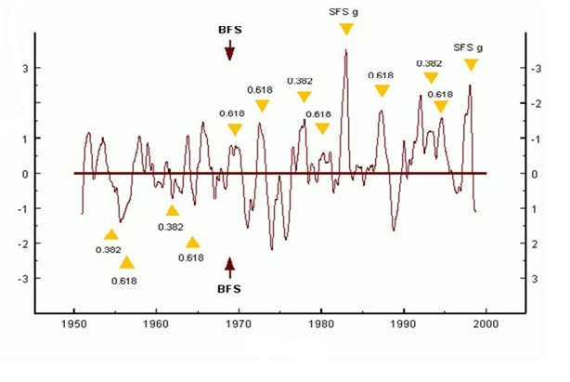Figure 4. Smaller “finger” cycles of solar activity are common from 1950 until 1968. After that, and a “big finger” imprint, they are more common. Sunspot cycles, then, had apparently been the “bearers” of increased El Nino – “warmer events” – since 1968. Whatever is happening after 2009 in this regard, however, is a mystery. (After Landscheidt [1999])
That the Sun (as part of Nature) conspires implicitly in this arrangement of death and destruction (again, generally) is still suspect of course. Landscheidt comments on this objection:
Taken together, the lines of evidence presented… leave little doubt that the relationship between phases …within solar cycles and ENSO events is real. Nonetheless, it is to be expected that sceptics will point at the lack of detailed cause and effect arguments and properly quantified physical mechanisms. Seen in a historical light, such objections are not valid. The lack of elaborate theory does not impair the heuristic importance of the results. You cannot achieve everything at the same time. Epistemologically, the stage of gathering data, establishing morphological relations, and setting up working hypotheses necessarily precedes the stage of elaborated theories. How can we solidly connect solar activity with climatic change as long as neither of these fields rests on a solid theoretical foundation? An accepted full theory of solar activity does not yet exist. What we have is only the hope of a future theory. According to P. V. Foukal the mechanism that causes the solar magnetic cycle remains poorly understood, although it has been the focus of intense research during the past half century. There is a lot of literature about aw-dynamos, but they are coping with incompatibilities of observation with theory, and they do not offer any explanation of longer solar cycles like the Gleissberg cycle that modulates the amplitudes of the 11-year cycle.
Perhaps, then, the insights leant to this dilemma regarding mechanisms for grand s assists in achieving that long-sought after “accepted full theory of solar activity?”
For this, a long, detailed look is taken at what is physically involved in the Sun-earth connection from a top-down perspective, outlining much of what is known in this regard so far.

My apologies to Edward Gibbon, author of The Rise and Fall of the Roman Empire
This entire paragraph is gratis Bill Howell (2011, personal communication).
Hsiang, S. (2010)
Earth’s axial tilt, which gives us new pole-star orientations every c. 20,000 years.
Wiersma A.P. & Renssen H., ”Model-data comparison for the 8.2 ka BP event: confirmation of a forcing mechanism by catastrophic drainage of Laurentide Lakes.” Quaternary Science Reviews, (2006) 25, 62– 88.
Clarke G., Leverington D., Teller J. & Dyke A., ”Superlakes, megafloods, and abrupt climate change.” Science, (2003) 301, 922–923.
Ritchie, William A:, The Archaeology of New York State (Purple Mountain Press, 1994; reprinted from Bantam/Doubleday, 1965) p. 42. The C14 evidence is derived from pollen samples found at particular undisturbed stratigraphic levels around campsites of the “Lamoka” peoples in New York State. The bones are so deteriorated they could not be racially indentifed but a “European” presence not unlike that found at L’Anse Aux Meadows could have been here as early as c. 4,500 B.C.
Quoted by Ritchie (p. 57) from Guilday, J.E., ”Prehistoric record of Scalopus from western Pennsylvania,” J, of Mammology, Vol. 42, # 1, pp 117-18, Lawrence, Kansas (1961)
Ibid, Ritchie p. 57
The Ennadai in the Laurentian Shield in my co-authored book, The Maunder Minimum and the Variable Sun-earth Connection, p. 215
It is thought that the Medieval Maximum temperature averaged out was nearly a degree warmer than it was at the 20th Century’s end, making it at least one degree higher added to the one degree rise, the warmth probably unevenly spread. Given the primitive state of meteorological and Earth science reconstructing micro climates in antiquity cannot be indentified and measured accurately. The Vikings made settlements in Nova Scotia then and had been – much like the war-scarred bones of the Brewerton Period people revealed thousands of years previously – attacked by the ”natives.” This perhaps contributed to their abandonment of L'Anse Aux Meadows, Newfoundland.
The ”850 BC event” is gratis Bas van Geel (personal communication)
Ibid Beer J., and van Geel (2008)
van Geel B., Buurman J. & Waterbolk H.T. ”Archaeological and palaeoecological indications of an abrupt climate change in The Netherlands, and evidence for climatological teleconnections around 2650 BP.” Journal of Quaternary Science, (1996) 11(6), 451–460.
Magny M., Holocene climate variability as reflected by mid-European lake level fluctuations and its probable impact on prehistoric human settlements.” Quaternary International, (2004) 113, 65–79.
By wiggle-matching 14C measurements, high precision calendar age chronologies for peat sequences can be generated (Blaauw et al. 2003), which show that mire surface wetness increased together with rapid increases of atmospheric production of 14C during the early Holocene, the Sub-boreal–Sub-atlantic transition: a sharp increase of 14C production and evidence for wetter conditions and the LIA (also Wolf, Spörer, Maunder, and Dalton minima of solar activity).
van Geel, B. and Berglund, B.E., 2000. A causal link between a climatic deterioration around 850 cal BC and a subsequent rise in human population density in NW-Europe?, Terra Nostra 2000/7: 126-130
van Geel B., Bokovenko N.A., Burova N.D., et al. ”Climate change and the expansion of the Scythian culture after 850 BC: a hypothesis.” Journal of Archaeological Science 31(12), (2004) 1735–1742.
van Geel B., van der Plicht J., Kilian M.R., et al. ”The sharp rise of Δ14C ca. 800 cal BC: possible causes, related climatic teleconnections and the impact on human environments.” Radiocarbon, 40(No. 1), (1998) 535–550.
Van Geel B. & Renssen H., ”Abrupt climate change around 2650 BP in North-West Europe: evidence for climatic teleconnections and a tentative explanation.” In: Water, Environment and Society in Times of Climatic Change (Eds A.S. Issar & N. Brown) (1998), pp. 21–41. Kluwer Academic Publishers, Dordrecht.
Van Geel B., Shinde V. & Yasuda Y., ”Solar forcing of climate change and a monsoon-related cultural shift in western India around 800 cal. yrs BC.” In: Monsoon and Civilization (Eds Y. Yasuda & V. Shinde), (2004) pp. 275–279. Roli Books, New Delhi.
Van Geel B., Heusser C.J., Renssen H. & Schuurmans C.J.E., ”Climatic change in Chile at around 2700 BP and global evidence for solar forcing: a hypothesis.” The Holocene, 10(5), (2000) 659–664.
10Be and others are also ”counters” as we have seen.
Mauquoy D., van Geel B., Blaauw M. & van der Plicht J., ”Evidence from northwest European bogs shows ’Little Ice Age’ climatic changes driven by variations in solar activity.” The Holocene, 12(1), (2002) 1– 6.
Matthes, F.E., ”Committee on Glaciers, 1939-40.” Transactions, American Geophysical Union, 1940 pp. 396-406
Ibid, Soon, W., and Yaskell, S.H., The Maunder Minimum and the Variable Sun,” (WSP:2003) ???????arth Connection
Ibid, Soon, W., and Yaskell, S.H.
Forbush, E.H., Useful Birds and Their Protection Mass. State Board of Agriculture Publication (Wright & Potter: 1905). He was as professional a biologist as you could get then.
Peterson, R.T., Birds of Eastern and Central North America (Houghton Mifflin: 2002)
Sibley, D.A., The Sibley Field Guide to Birds of Eastern North America (Knopf : 2003)
It is also interesting to note that passerines are now known to have an organ that can detect the Earth’s magnetic field for navigation. Bobolinks (or, Ricebirds) Dolichonyx ozivorous, common in the U.S. east, have Iron Oxide around their olfactory glands and in bristles extending from naval cavities. ”Closely proximal nerves fire in response to changes in magnetism to provide the exquisite sensitivity necessary for navigation by the Earth’s magnetic field.” (”Close Up Science,” Valley News, Vermont, July 25, 2011)
Additionally, can passerine motion teach us something about wind dynamics we do not know about? Italian theoretical physicist Giorgio Parisi tried to explain a wide-scale flocking behavior called a ”murmuration” performed by a common trans-Northern Hemispheric bird, the Starling (Sturnus vulgaris). It mimics wind motion and velocities. According to writer Brandon Keim on Parisi, ”the math equations that best describe starling movement are borrowed from the literature of criticality, of crystal formation and avalanches -- systems poised on the brink, capable of near-instantaneous transformation. They call it scale-free correlation, and it means that no matter how big the flock, If any one bird turned and changed speed, so would all the others." (The Atlantic:2011)
Valdes, Bonham-Carter , Time Dependent Neural Network Models For Detecting Changes Of State In Earth and Planetary Processes
Based on Laskar et al, and Solanki, Tapiping. Laskar solar insolation results assume 1368 Wm^-2. (1) Likely error that the insolation curve is shifted 85-years to left due to misinterpretation of Solanki's data table. (2) The sunspot variances as shown through insolation have been exaggerated to show what the Hale 11-year half-cycle peaks and troughs would look like (no galactic ray-cloud impact). This would skew energy perspectives, but may give an idea of shorter-term shocks as experienced by civilizations. Perhaps the temperatures are mostly influenced by GLOBAL irradiance iariations (and leveraging such as galactic rays-clouds, water vapor-clouds, ice albedo, ocean absorbance, etc.), whereas crops are also greatly affected by seasonal variations
Harrison, J.B., and Sullivan, R.E., A Short History of Western Civilization, Vol. 1: to 1776 4th Ed. (Knopf: 1971) pp 208-209 for these figures and analyses. These in turn were drawn perhaps from Georges Duby, Rural Economy and Country Life in the Medieval West (Harvest)
Ibid, Soon-Yaskell (2003)
These minina are potentially all of a “grand” type but this is not certain.
Hsiang, S.M., Meng, K.C., Cane, M.A., “Civil conflicts are associated with the global climate,” Research Letter , Nature, Vol 476, 25 August, 2011 pp 438-441
“Pixels with surface temperatures significantly and positively correlated with NINO3 for at least 3 months out of the year are coded ‘teleconnected’; remaining pixels are coded ‘weakly affected’. Countries are coded teleconnected (weakly affected) if more than 50% of the population in 2000 inhabited teleconnected (weakly affected) pixels. Group-level time-series regressions (Table 1, models 1–4) use a continuous variable for ACR; we drop 1989 because it is a 3s outlier, presumably because of the end of the Cold War. Group-level standard errors are robust to unknown forms of heteroscedasticity. Country level longitudinal regressions (models 5 and 6) are linear probability models for conflict onset with standard errors that are robust to unknown forms of spatial correlation over distances no more than 5000 km, serial correlation over periods no more than 5 years and heteroscedasticity21. We estimate the number of conflicts associated with ENSO by assuming all conflicts in the weakly affected group were unaffected and a baselineACRof3% for the teleconnected group would have remained unchanged in the absence of ENSO variations. We then project the observed sequence of NINO3 realizations onto our linear conflict model dACR/dNINO350.0081) and find 48.2 conflicts (21%) were associated with ENSO.” (Ibid Hsiang et al, p 440)
Solow, A.R., ”Climate for Conflict,” Nature, Vol 476, 25 August, 2011 pp 406-7
Ibid, Solow
Parenthetical inserts by this author
Maunder, E.W., “Notes on the Cyclones of the Indian Ocean,” Monthly Notices of the Royal Astronomical Society (MNRAS) November, 1909. pp 46-62.
It is also tied to solar activity. See Theodor Landscheidt’s published papers, for example, Landscheidt, T. (2000 a): Solar forcing of El Niño and La Niña. European Space Agency (ESA) Special Publication 463, 135-140. Also earlier, and published online (and so, more controversial): ”Solar Activity Controls El Niño and La Niña,” Schroeter Institute for Research in Cycles of Solar Activity Nova Scotia, Canada (1999)
Philander, S. G. H., El Niño, La Niña, and the Southern Oscillation. San Diego, Academic Press, 1990, as quoted in Landscheidt (1999)
Landscheidt (1999)
Ibid, Solow p 406
Ibid Landscheidt, T. (1999)
Italics by this author
Ibid
Foukal, P. V., ”The variable sun.” Scientific American, February 1990, 34-41.

