/home/bill/Howell - history timelines/War_occurences 1000-2000 AD, initial data versus ifft comparison.odt
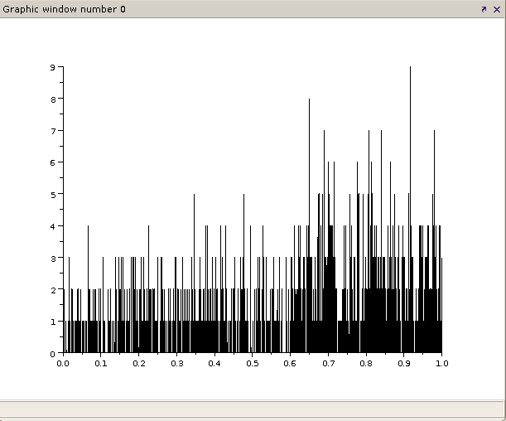
Initial data.. plot2d(f,x); // Plot original data

Data reconstructed from fft by using ifft, multiply normalized x by standard deviation:
y2 = ifft(x_ft)*x_stdev;
plot2d(f,y2,rect=[0,0,1.0,9])); // Plot inverse fft as reconstructed data
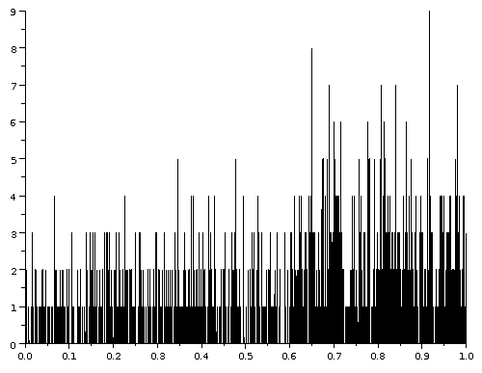

Fourier power spectrum
x_n = x / nanstdev(x); // Normalize to variance of 1 Matlab version
x_ft = fft(x_n); // Transform and pad to length ne
sp = x_ft.*conj(x_ft); // Compute spectral density curve. sp is complex and contains real and imag parts
f = linspace(1,ne,ne)/ne; // Generate sampling frequencies (f = 1 is the duration of the series!) for sp,
// Matlab was f = flt_intgen(ne)/ne, where presumably flt_intgen is a list of integers 1...ne
p = 1/f; // Cycle periods in original units (...usually have to set stacksize('max')?...)
// ...is this causing a divide by zero problem with stack? (shouldn't - f starts with 1.0)
plot2d(f,x_ft);
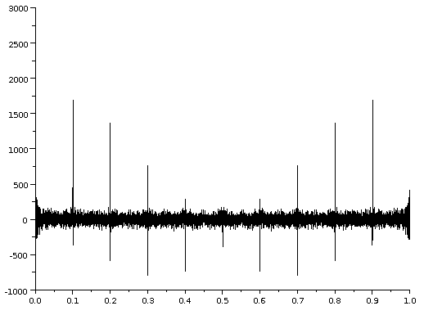

Why spikes at each integral of 0.1 “frequency” (1 = 1 ky)?
plot2d(f(1:ne/2),abs(x_ft(1:ne/2)));
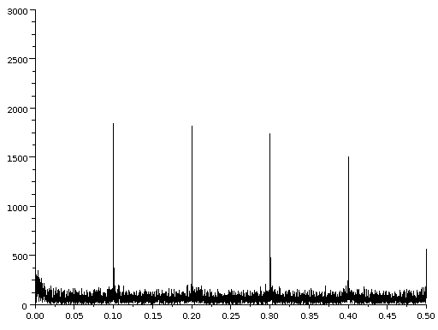

Power spectra "discrete output"

Hardware Reduction in Higher Order MASH Digital Delta-Sigma ...
File Format: PDF/Adobe Acrobat
Power (dB). Fig. 4. Simulated discrete output power spectrum for a conventional 16-bit. MASH 1-1-1-1 DDSM; the input is 6553. The smooth curve is S4 (4). 10 ...
ieeexplore.ieee.org
ieeexplore.ieee.org/iel5/5579765/5587092/05587175.pdf?arnumber...
clipped from Google - 1/2012
Stochastic resonance and the benefit of noise in nonlinear systems
File Format: PDF/Adobe Acrobat
of the output power spectral density in periodic SR is depicted in Fig. 3A. The SR effect is ..... discrete output y of the channel according to s + η < −θ ⇒ y = −1, ...
www.istia.univ-angers.fr
www.istia.univ-angers.fr/~chapeau/papers/congres/jura.pdf
clipped from Google - 1/2012
A Nested Digital Delta-Sigma Modulator Architecture for Fractional ...
File Format: PDF/Adobe Acrobat
Power (dB). Fig. 6. Simulated discrete output power spectrum for a conventional 19-bit. MASH 1-1-1 DDSM; the input is 157287. The smooth curve is S3 (17).
ieeexplore.ieee.org
ieeexplore.ieee.org/iel5/5579765/5587092/05587184.pdf?arnumber...
clipped from Google - 1/2012
319 Stochastic Analysis of a Class of Linear Time-quantized Control ...
File Format: PDF/Adobe Acrobat
x*(t) =Discrete output signal of sampler. oo(t)= Dirac delta function. s= Laplace complex variable. Z= EsT. T = Sampling period. S,(s) =Power spectral density of ...
www.tandfonline.com
www.tandfonline.com/doi/abs/10.1080/00207216408937709
clipped from Google - 1/2012
Sampling and Sampled-Data Systems
File Format: PDF/Adobe Acrobat
S, with sampling period h, analog input signal y and discrete output sequence ψ, i.e., ψ[k] = y(kh) for ..... hence W is called the power spectral density matrix of w.
www.seas.upenn.edu
www.seas.upenn.edu/~jeromel/teaching/NECS.../notes/3.../3_sampling.pdf
clipped from Google - 1/2012
Filtering of discrete time series by symmetric least-squares operators
File Format: PDF/Adobe Acrobat
Power-spectral analysis which provides information about the frequency ... a discrete input into a discrete output is generally characterized by a finite sequence ...
www.springerlink.com
www.springerlink.com/index/v4g9h55m12417215.pdf
clipped from Google - 1/2012
A Broad-band Power Spectrum Analyzer Based On Twin-channel ...
File Format: PDF/Adobe Acrobat
Abstract— This paper describes a power spectrum analyzer .... The estimated th power spectral component of the input ... identifies a generic discrete output of ...
ieeexplore.ieee.org
ieeexplore.ieee.org/iel4/19/16119/00746609.pdf?arnumber=746609

Francois Chapeau-Blondeau 2000 “Stochastic resonance and the benefit of noise in nonlinear systems” Laboratoire d’Ing´enierie des Syst`emes Automatis´es (LISA), Universit´e d’Angers, France pp. 137-155 ; M. Planat, ed., Lecture Notes in Physics, Vol. 550, Springer (Berlin) 2000 http://www.istia.univ-angers.fr/~chapeau/papers/congres/jura.pdf

endpage

Wiener–Khinchin theorem
http://en.wikipedia.org/wiki/Wiener%E2%80%93Khinchin_theorem

The Wiener–Khinchin theorem (also known as the Wiener–Khintchine theorem and sometimes as the Wiener–Khinchin–Einstein theorem or the Khinchin–Kolmogorov theorem) states that the power spectral density of a wide–sense stationary random process is the Fourier transform of the corresponding autocorrelation function.[1][2][3][4]

History
Norbert Wiener first published the result in 1930, Khinchin independently later in 1934. Einstein had anticipated the idea in a brief two-page memo in 1914.[5]

Continuous case
For the continuous case:
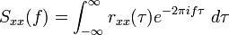

where

is the autocorrelation function (also called autocovariance) defined in terms of statistical expectation, and where is the power spectral density of the function . Note that the autocorrelation function is defined in terms of the expected value of a product, and that the Fourier transform of does not exist in general, because stationary random functions are not square integrable.
The asterisk denotes complex conjugate, and can be omitted if the random process is real-valued.

Discrete case

For the discrete case:
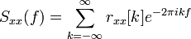

where

and where is the power spectral density of the function with discrete values . Being a sampled and discrete-time sequence, the spectral density is periodic in the frequency domain.

Application
The theorem is useful for analyzing linear time-invariant systems, LTI systems, when the inputs and outputs are not square integrable, so their Fourier transforms do not exist. A corollary is that the Fourier transform of the autocorrelation function of the output of an LTI system is equal to the product of the Fourier transform of the autocorrelation function of the input of the system times the squared magnitude of the Fourier transform of the system impulse response.[6] This works even when the Fourier transforms of the input and output signals do not exist because these signals are not square integrable, so the system inputs and outputs cannot be directly related by the Fourier transform of the impulse response.
Since the Fourier transform of the autocorrelation function of a signal is the power spectrum of the signal, this corollary is equivalent to saying that the power spectrum of the output is equal to the power spectrum of the input times the power transfer function.
This corollary is used in the parametric method for power spectrum estimation.

Discrepancy of definition
By the definitions involving infinite integrals in the articles on spectral density and autocorrelation, the Wiener–Khinchin theorem is a simple Fourier transform pair, trivially provable for any square integrable function, i.e. for functions whose Fourier transforms exist. More usefully, and historically, the theorem applies to wide-sense-stationary random processes, signals whose Fourier transforms do not exist, using the definition of autocorrelation function in terms of expected value rather than an infinite integral. This trivialization of the Wiener–Khinchin theorem is commonplace in modern technical literature, and obscures the contributions of Aleksandr Yakovlevich Khinchin, Norbert Wiener, and Andrey Kolmogorov.

Notes
- ^ Dennis Ward Ricker (2003). Echo Signal Processing. Springer. ISBN 140207395X. http://books.google.com/books?id=NF2Tmty9nugC&pg=PA23&dq=%22power+spectral+density%22+%22energy+spectral+density%22&lr=&as_brr=3&ei=HZMvSPSWFZyStwPWsfyBAw&sig=1ZZcHwxXkErvNXtAHv21ijTXoP8#PPA23,M1.
- ^ Leon W. Couch II (2001). Digital and Analog Communications Systems (sixth ed. ed.). Prentice Hall, New Jersey. pp. 406–409. ISBN 0135225833.
- ^ Krzysztof Iniewski (2007). Wireless Technologies: Circuits, Systems, and Devices. CRC Press. ISBN 0849379962. http://books.google.com/books?id=JJXrpazX9FkC&pg=PA390&dq=Wiener-Khinchin-Einstein&ei=1SxlSPGhB4jgsQPr5b3lDw&sig=ACfU3U2Phnk-zwJi57XrvNmdfosyg55FVA.
- ^ Joseph W. Goodman (1985). Statistical Optics. Wiley-Interscience. ISBN 0471015024.
- ^ Jerison, David; Singer, Isadore Manuel; Stroock, Daniel W. (1997). The Legacy of Norbert Wiener: A Centennial Symposium (Proceedings of Symposia in Pure Mathematics). American Mathematical Society. p. 95. ISBN 0821804154.
- ^ Shlomo Engelberg (2007). Random signals and noise: a mathematical introduction. CRC Press. p. 130. ISBN 9780849375545. http://books.google.com/books?id=Zl51JGnoww4C&pg=PA130.

// fft_discrete_war script - Wiener–Khinchin theorem.sci - discrete fast Fourier transform of war

nlags = 600; // 60 years (= 600 *0.1y)
ns = 2 * nlags - 1; // one less than twice the lags? I don't understad yet! must match sp dimension
f = linspace(1,ns,ns)/ns; // Generate sampling frequencies (f = 1 is the duration of the series!) for sp,
// Matlab was f = flt_intgen(ne)/ne, where presumably flt_intgen is a list of integers 1...ne
p = 1/f; // Cycle periods in original units (...usually have to set stacksize('max')?...)
// ...is this causing a divide by zero problem with stack? (shouldn't - f starts with 1.0)
npoints = 1; // pure guess
wtype = 're'; // no idea
sp = cspect(nlags,npoints,wtype,x_n)

// plot2d(f,sp); //
Hmmm... not much different from fft!
Is this because “cspect” uses fft? I may have to force auto-correlation first?
But Scilab's description states that it IS doing it right -> autocorrr first, THEN fft:
“... The correlation method calculates the spectral estimate as the Fourier transform of a modified estimate of the auto/cross correlation function. ...”
I tried npoints = nlags = 600, but there was no noticeabe difference in the plot.
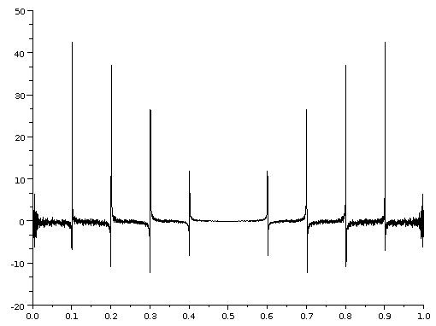

// fft_discrete_war script.sci - discrete fast Fourier transform of war
// Based on Matlab code from: Bjørn-Gustaf J. Brooks >110124
// "Earth Scientist’s Guide to Discrete-Time Power Spectrum Analysis"
// Center for Climatic Research, University of Wisconsin-Madison, Chapter 22
// http://www.intechopen.com/source/pdfs/14637/InTech-Earth_scientist_s_guide_to_discrete_time_power_spectrum_analysis.pdf
// www.BillHowell.ca
// 28Jan2012 initia code, play to learn SciLab functions, syntax etc

//Copy & paste to launch: exec("/home/bill/Howell - history timelines/fft_discrete_war script.sci");

// Initialize large stack for computations
stacksize(200000000);

// Use war_dates ONLY from 1000 AD to presentdue to stacksize limitations
exec("/home/bill/Howell - history timelines/war_occurrences, scilab ready 1000-2000 AD.sci");

// Use war_dates ONLY from 50 AD to present
// exec("/home/bill/Howell - history timelines/war_occurrences, scilab ready 50-2000 AD.sci");
// Full series - for later!
// exec("/home/bill/Howell - history timelines/war_occurrences, scilab ready.sci");

// to get a column of data:
x = war_dates(:,2);
tt = size(x); // 49991. 1.
ne = tt(1); // signal length ne, after padding by zeros
t = (linspace(1,ne,ne)/ne)'; // Generate sampling frequencies for sp,
// Matlab was f = flt_intgen(ne)/ne, where presumably flt_intgen is a list of integers 1...ne

// Matlab to Scilab conversion by:
// mfile2sci("/home/bill/Howell - history timelines/fft_discrete_war script raw.mat","/home/bill/Howell - history timelines")
// not used for now - done by hand!

// Procedure 1 General procedure for detrending a series by a polynomial curve of order N. The
// diversity data in Figure 1A was detrended by a polynomial of N = 3 to produce Figure 1C.
// Series x is comprised of nterms measured at increments of t.
// input : data series, {(tk, xk)} k=1...nterms
// output: data series of residuals, {rk} k=1...nterms

// For the war_dates, a log transform may help "somewhat linearize" the data, and account for growing populations.
// My own graph "Howell 120115 Wars & battles of history.png" shows the benefit of that.
// Actually, it looks like a sawtooth ramp (linear rise, then drops) from -800 to 0 BC, and again from 50 AD to present.
// Prior to 600-800 BC, it's very sparse and a real mess
// Initial analysis: only for 50 AD to present,

// [a,b,sig] = ??reglin(lsq, x); // Matlab expression p = poly_fit(t,x,N), Scilab nonliner: p = leastsq(fun, x0); Linear regression - [a,b,sig]=reglin(x,y)
// pv = ???(p,t); // Matlab expression pv = poly_val(p,t)
// r = x - pv;

// I haven't tried to de-trend the war series yet

// Procedure 2 General FFT procedure for Matlab, Octave, Python. Given the series x of discrete
// values xk the function fft is used to compute its complex conjugate meanwhile ‘stretching’
// the signal to length ne, provided that ne > nterms.
// input: time series, {xk} k=1...nterms
// output: x_ft (complex conjugate with Real & Imaginary parts),
// sp (spectral power),
// f (frequency),
// p (period)

x_stdev = nanstdev(x); // ...will use this later
x_n = x / x_stdev; // Normalize to variance of 1 Matlab version
x_ft = fft(x_n); // Transform and pad to length ne
sp = x_ft.*conj(x_ft); // Compute spectral density curve. sp is complex and contains real and imag parts
f = linspace(1,ne,ne)/ne; // Generate sampling frequencies (f = 1 is the duration of the series!) for sp,
// Matlab was f = flt_intgen(ne)/ne, where presumably flt_intgen is a list of integers 1...ne
p = 1/f; // Cycle periods in original units (...usually have to set stacksize('max')?...)
// ...is this causing a divide by zero problem with stack? (shouldn't - f starts with 1.0)

// 28Jan2012 - I am getting spikes every f=0.1 (every tenth of the frequency range). What does this mean - looks like a screw-up!!
// plot2d(f(1:ne/2),abs(x_ft(1:ne/2))); // Power spectrum results - only plot half of freq? (mirror images)
// plot2d(f,x_ft); // Power spectrum results - plot ALL of freq!
// plot2d(f,x_ft); // Power spectrum results - plot ALL of freq!
// plot2d(f,sp); //
// plot2d(f,x);
// y2 = ifft(x_ft)*x_stdev; // Inverse fft to regenerate estimate of the data
// plot2d(f,y2,rect=[0,0,1.0,9])); // Plot inverse (then copy / paste to document / close)
// plot2d(f,x); // Plot reconstructed data - paste to same doc for comparison

// Procedure 3 General procedure for determining the phase shift and computing the sine wave
// corresponding to the period and phase of the cycle of interest. This procedure uses the
// imaginary data at index k to compute the phase shift (ps) for constructing the sine wave.
// input: {x_ft} i=1...nterms (complex conjugate);
// p (period);
// t (time increments in physical units);
// a (sine wave amplitude in physical units)
// output: ps_k, p_k

k = 900; // index of reference point of zero phase shift
ps = atan(x_ft(k)); // phase shift
a = 10; // arbitrary magnitude to show up on a plot with wars?
sw = a * sin(2 * %pi / p(k) * t + ps); // the phase shifted sine wave Matlab original: sw = a * sin(2 * (%pi/p) * t + ps);

// 28Jan2012 - phase related plot
// plot2d(f,sw,rect=[0,-10,0.01,10]); //

