Geopolymeric Casting of stone?
from: John Temple 2011 “Egyptian Dawn: Exposing the real truth behind ancient Egypt” Arrow Books (earlier publication 2010 in Great Britain by Century Random House) 514pp
quick note by Bill Howell, 21Dec2011

French chemist Joseph Davidovits has apparently developed & patented some “geopolymeric” chemistry to make “cast stone”, which may have been used to construct the pyramids (apart from the ?Marble casing?, most of which has been removed to construct buildings in Cairo?). This would solve the “move the big stones” problem, and explain fits between rocks that a razor blade can’t be put between.

http://www.geopolymer.org/
http://www.davidovits.info/

I am not familiar with concrete/ ceramics etc. – so I have no idea of how realistic this is. Sounds crazy to me, and in a sense the same book does refer to stone being cut from quarries (more [granite, marble, alabaster] than the stones of the pyramids.

IF it is correct, at least in principle, then:
- was it applied in Mesopotamia and MesoAmerica as well? The images of extremely tight fits between very large stones in INCA ruins come to mind.
- Was “flour” silica (extremely fine sand) important? I assume that the bulk of the rock was normal sand, with silica-like polymers – and normal sand
- Clay is mentioned, but not specifically as part of the formulation (mainly for pottery). But is it involved?
- How are the “artificial stone” house coverings made? (eg Rona, Home Depot)
- Kind of reminds me of geodes, mineralisation of faults etc.
- We have sand and clay in the Tar Sands tailings. Can we build giant pyramids there too? <grin>, Stupid question, I know, but it might solve the tailings problem as well as result in weatherproof buildings in the North, to which you could hitch your dirigible…

John Temple also refers to the technique of ?Optical Chemi-Luminescence? (OCL) As a means of determining the date at which a stone was put into a pyramid! I had heard of similar techniques for pottery, and Stephen Wolfe of the GSC some years ago had explained his dating of the last time at which sand dunes in Saskatchewan had move. Stephen hasn’t seen Temple’s book, but feels that it’s quite likely that date determination would be possible with OCL.

By 31Dec2011, as a promise several months ago to 3 authors of a new book, I need to do 5 days of work on alternate chronologies of history and a first pass analysis of 6,00 years of war, so I won’t be looking into this “geopolymeric” question anytime soon

endpage
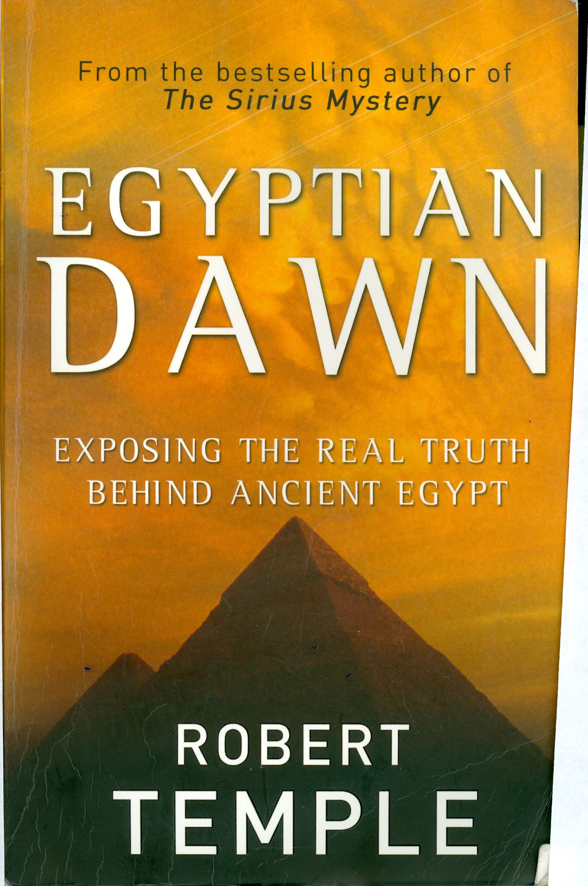

endpage
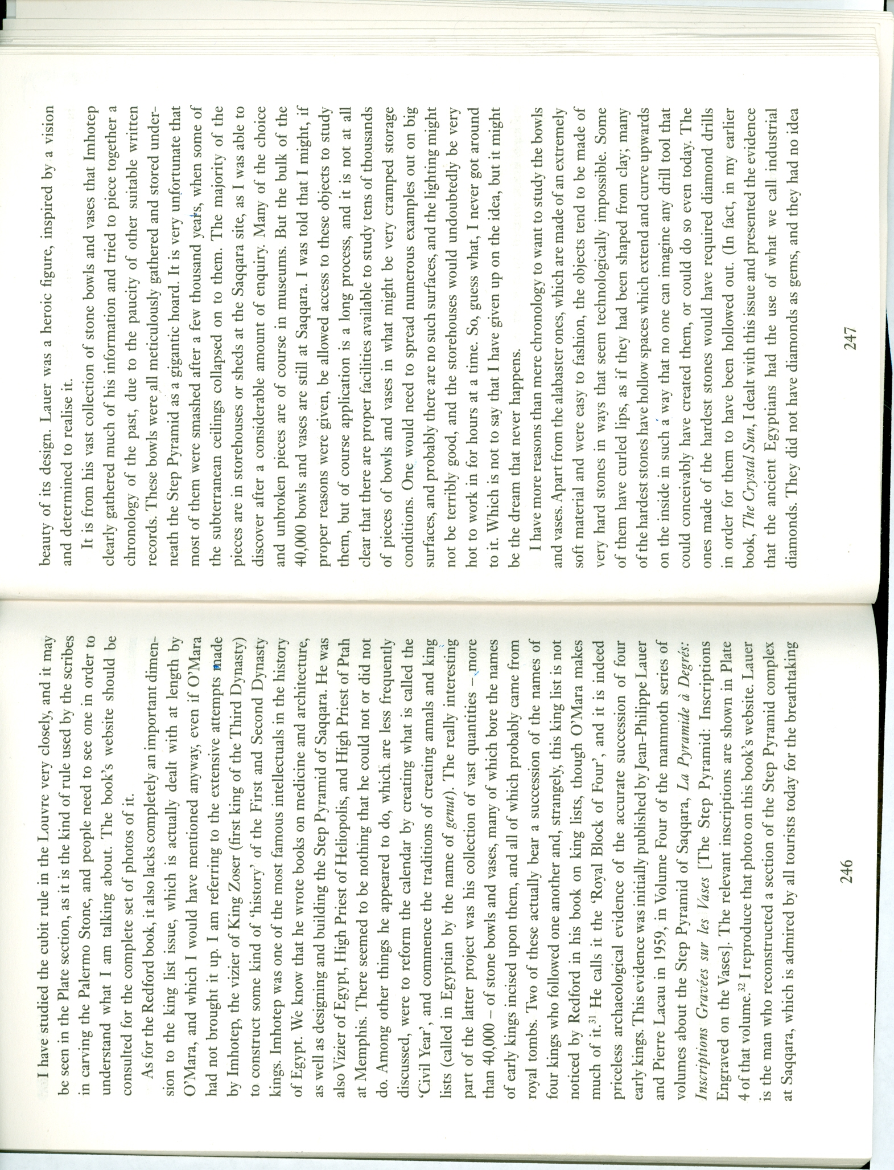

endpage

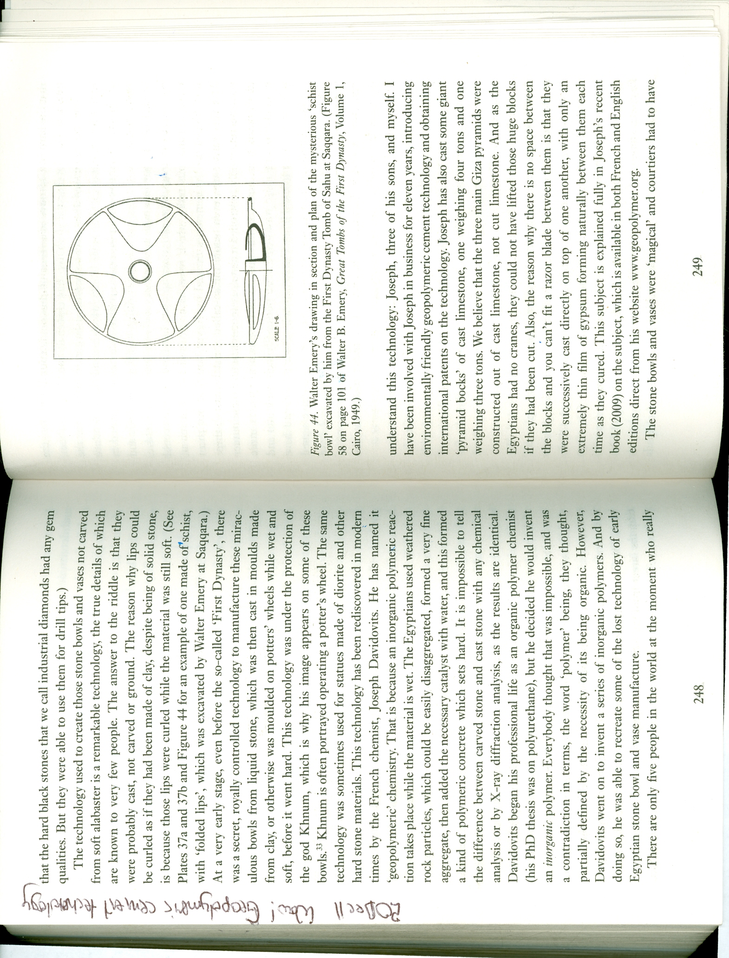
endpage
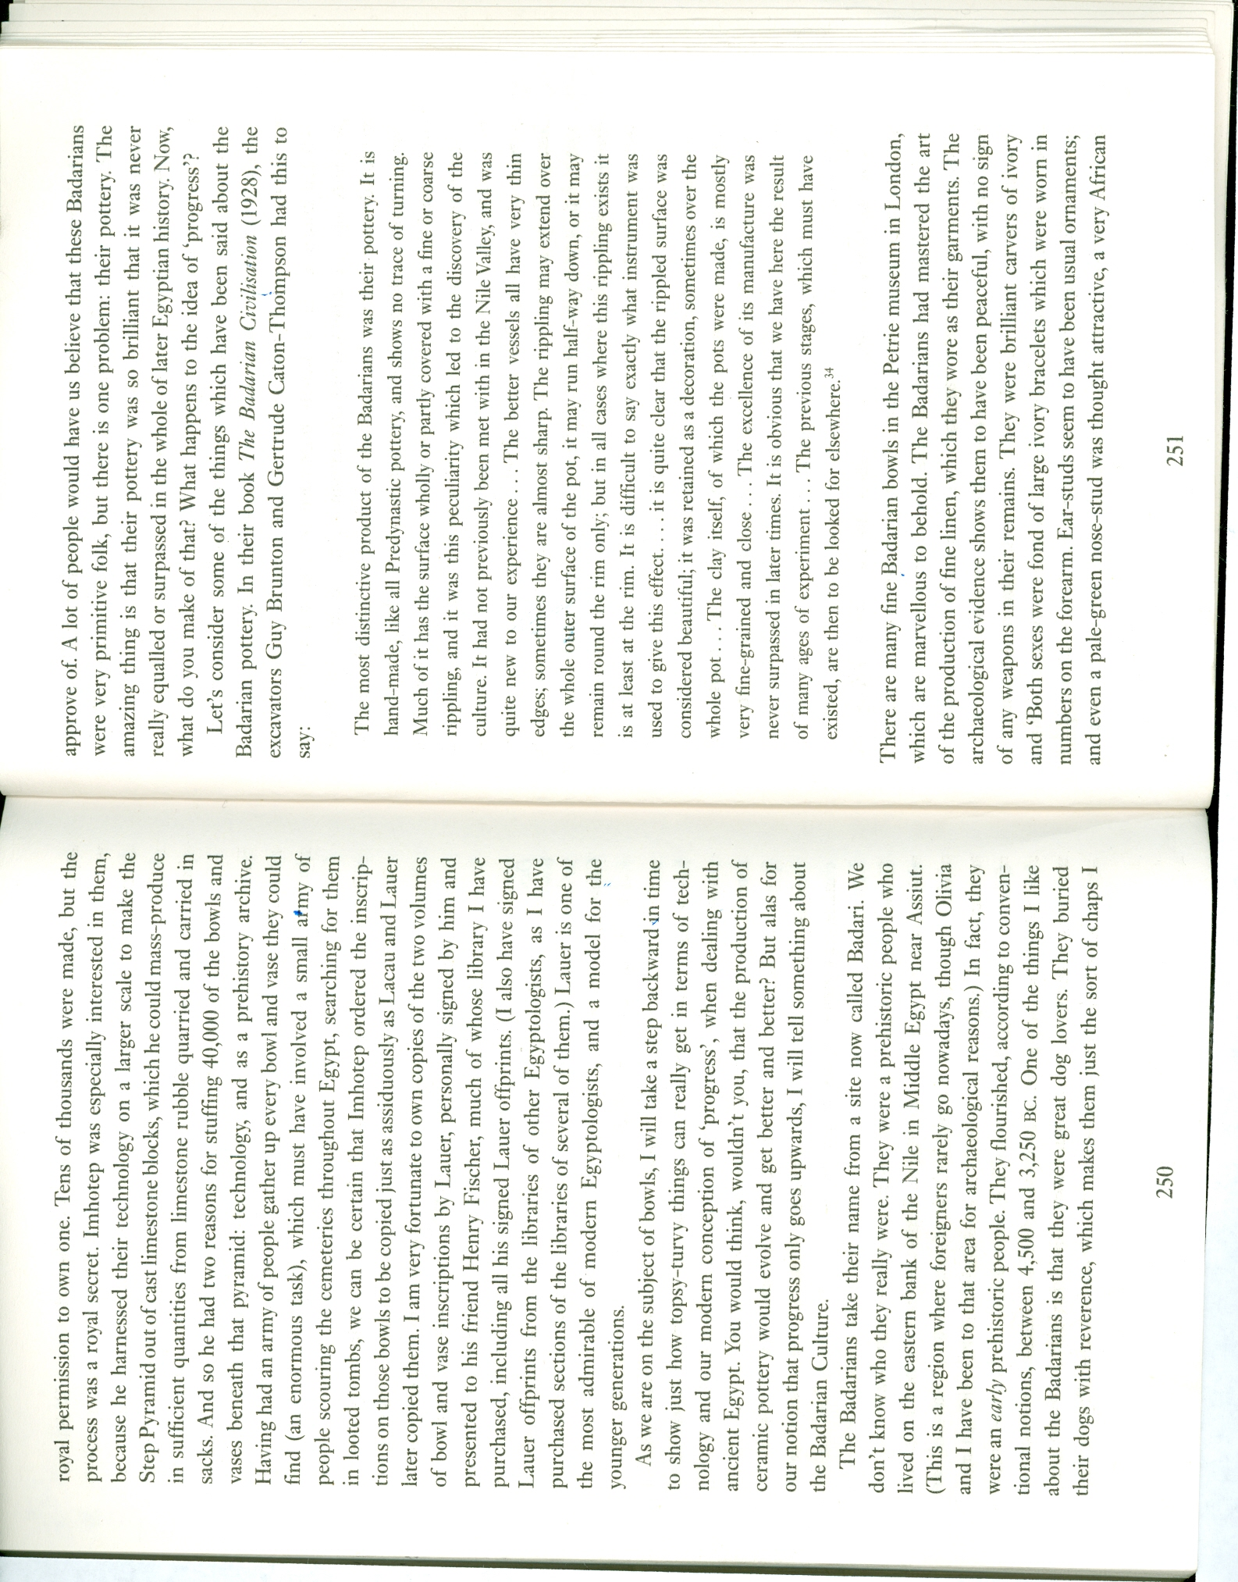
enddoc

