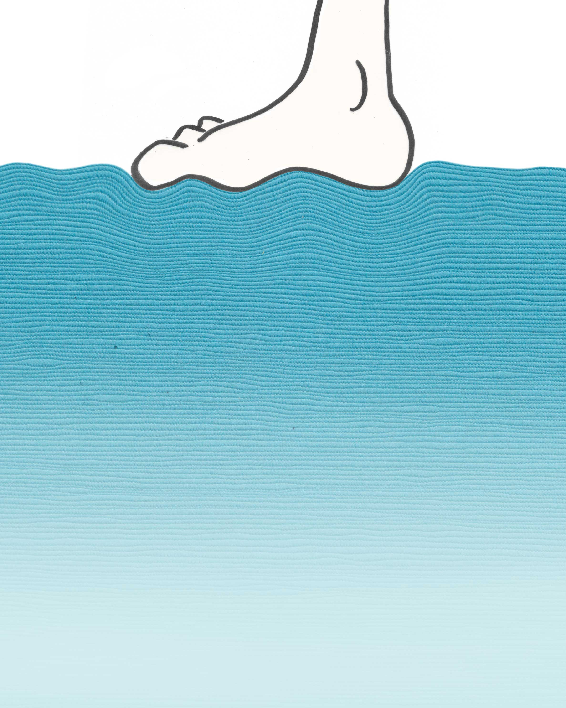
Chapter 16
Water Trampolines: Layering at the Water’s Surface
Skipping rocks across the water’s surface was once a teenage ritual. In my own pubescent days a subtle competition prevailed among the rock skippers — a test of manhood whose outcome might determine how successful you’d be in luring girls to your domain. Those who could bounce stones farthest surely qualified as the alpha males.
Why should those rocks bounce? Rocks can certainly bounce off trampolines, but the water surface would seem a far cry from an elastic sheet. Water is a viscous liquid. Rocks shouldn’t easily bounce. On the other hand, when water interfaces with air, special features appear: EZ mosaics cover the surface and project appreciably downward into the water (see Fig. 15.11). Thus, surface water differs from bulk water, raising the question whether those surface features might be aberrant enough to explain the bouncing of rocks.
This chapter explores the water’s surface. It reveals some surprising mechanical features, which help clarify phenomena ranging from walking on water to why ships float — the latter moving us a small step beyond Archimedes.
Surface Water Differs from Bulk Water
Finnish ski jumpers like to train year round. Ample snow accommodates their needs in winter, but summers present a challenge. The resourceful Finnish skiers nevertheless improvise: they ski on plastic tracks strategically situated so the skiers can land in water.
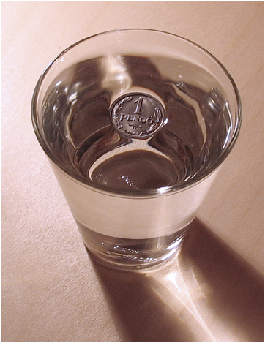
The water, however, is not as accommodating as one might expect. Landing ski jumpers are prone to bone fracture unless the surface has been pre-softened through vigorous bubbling. The bubbles continually break through the surface, diminishing the surface tension and permitting the skiers to land with impunity. Novice high divers often employ a similar strategy; few of them break their bones.
It should come as no surprise that water’s surface is stiff, for it is widely known that water has high surface tension. High surface tension is one of water’s known anomalies. The tension is high enough to float dense objects, ranging from steel pins to old Hungarian coins (Fig. 16.1).
Figure 16.1. Evidence of water’s high surface tension.

-- Box: Walking on Water
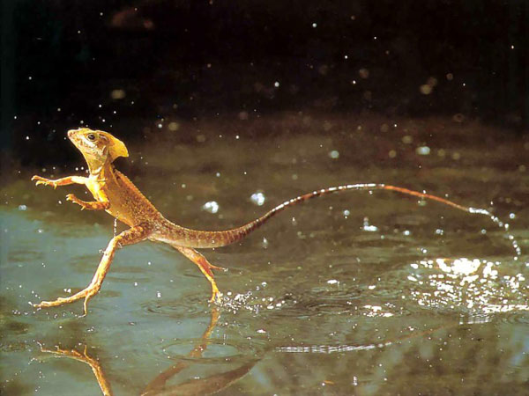
Water can support live creatures, ranging from water striders to South American lizards. Stunning videos show Costa Rican lizards scampering across pond surfaces (web ref 1). Because they can walk on water, those creatures are called Jesus Christ lizards. This phenomenon makes it clear that natural water surfaces may be considerably stiffer than one might suppose.
---
Prevailing science attributes water’s high surface tension to extra hydrogen bonding. Surface water molecules have no binding partners above; hence, they can bond more abundantly to their neighbors. Those extra bonds increase the stiffness, yielding the high surface tension.
The surface layer in question would be less than one nanometer thick. To appreciate this degree of thinness, think of a one-millimeter slice of salami. Slice it into a thousand slivers; then slice one of those slivers another thousand times — if you can. How a layer one-tenth the thickness of a cell membrane could make the difference between breaking one’s neck and not breaking one’s neck seems less than obvious.
Cropped from: http://mudfooted.com/jesus-christ-lizard-walks-on-water/
Something more significant than a few extra bonds must account for water’s unusual surface properties.
EZ-like Zones at the Air-Water Interface
Something significant is indeed present at the surface: a mosaic. The mosaic penetrates downward from the surface, creating a net-like layer of appreciable thickness (Chapter 15). That net-like layer cannot help but impact the surface’s mechanical features.
We first stumbled upon the sub-surface feature fortuitously — before we could even dream of using an infrared camera to explore its properties. In chambers containing water and microspheres we noticed a suspicious sub-surface layer: a microsphere-free zone that lined the water’s upper surface.
We saw it first in beakers. The suspension inside the beaker was uniformly cloudy because the microspheres scatter light. Soon, however, a clear, microsphere-free zone emerged at the upper surface. The zone remained in evidence for some time. What impressed visitors more than the clear zone was the clear vertical cylinder that emerged near the cloudy suspension’s midline (Fig. 9.11); but it was the clear plate-like zone at the top that gave way to form the cylinder (Ovchinnikova and Pollack, 2009).
The clear zone showed up again in another type of chamber. That chamber comprised two parallel glass slides sealed around three edges to hold water. It resembled a tank for skinny fishes (Fig. 16.2). Again, stable clear zones could be seen under at least some conditions. The suspension looked uniformly cloudy at first; but within tens of minutes a microsphere-free zone would develop at the top. That clear zone persisted for about a day, after which all microspheres sedimented to the bottom.
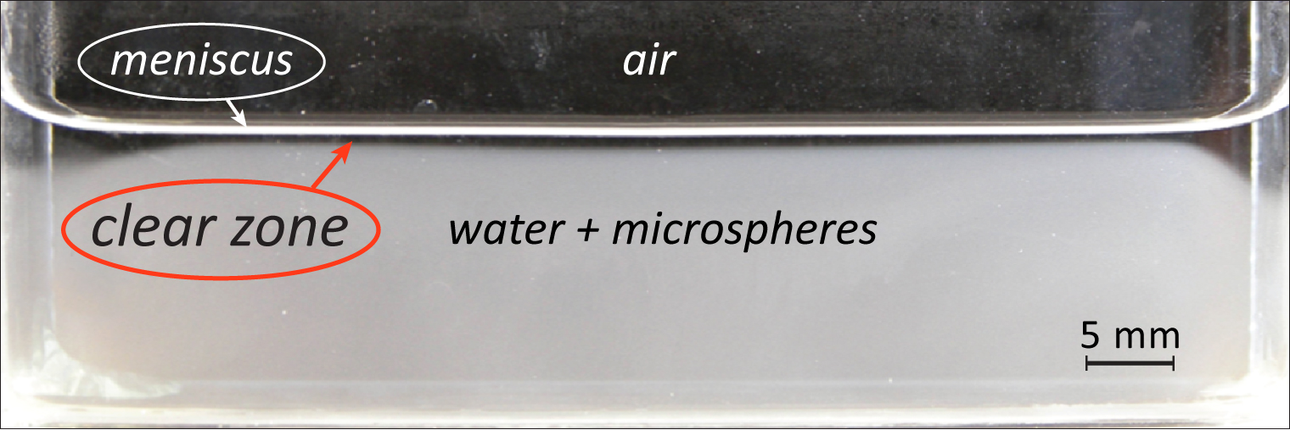
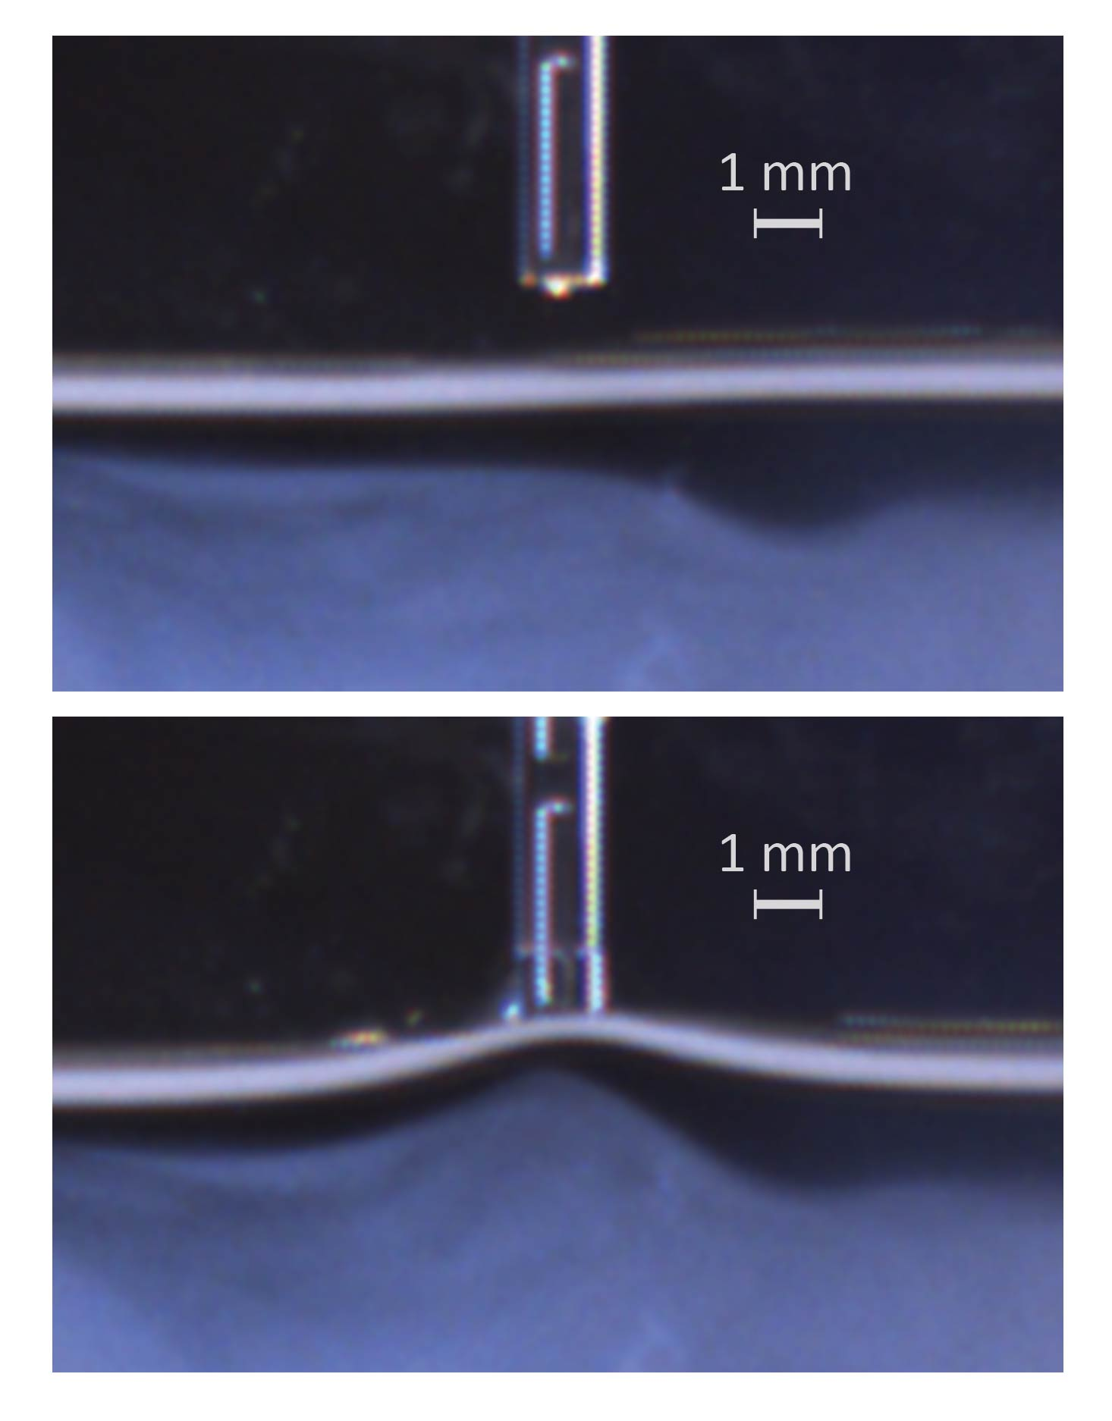
Thus, surface clear zones in cylindrical and rectangular chambers were identified well before we understood that they might correspond to the mosaics. The clear zones struck us immediately as EZs of some kind, for they excluded microspheres; and we quickly determined that the EZ’s characteristic negative potential was present at the top. If those clear zones indeed comprised EZ material, then they might easily be stiff enough to support steel pins and Hungarian coins.
Figure 16.2. Clear zone appearing near the top of a microsphere suspension. Chamber is built of two parallel glass slides, sealed at left, right and bottom.
We confirmed the high stiffness (Fig. 16.3). To do this we advanced a vertically oriented glass probe slowly toward the water surface. At some point the surface lunged upward (perhaps because of induced charge) to meet the probe. During this mechanical perturbation the clear zone just beneath the probe hardly changed thickness; nor did the thickness change as the probe was shifted from side to side. The clear zone behaved like a cohesive band running across the surface. Being millions of molecular layers thick, that band should support fairly weighty objects.
Figure 16. 3. Glass probe lowered to touch the top surface of water. Thickness of zone is hardly altered by the mechanical perturbation.
The structures observed here from the side evidently correspond to those seen from above in the previous chapter. Neither view gives the full picture. Together they provide a comprehensive view of what exists immediately beneath the water’s surface and that is sketched in Figure 16.4.
The previous chapter’s observations on the other hand were obtained mainly in warm water; they left some uncertainty about what might happen at room temperature. The clear zones above were seen at room temperature. Hence, we can surmise that the room-temperature surface features are at least qualitatively similar to those seen at elevated temperature: mosaics cover the surface and they extend appreciably into the water.
These mosaics are built mainly of clustered vesicles. In the laboratory, however, the mosaic’s outer boundary may lie just inside a container wall; the wall could nucleate standard EZ material, which would then merge seamlessly with the vesicle mosaic. In fact, some vesicles could transform themselves into standard EZ material by the zippering mechanism (Chapter 14). The mosaic would then be a mix — standard and vesicle EZs, whose relative content would depend on ambient conditions.
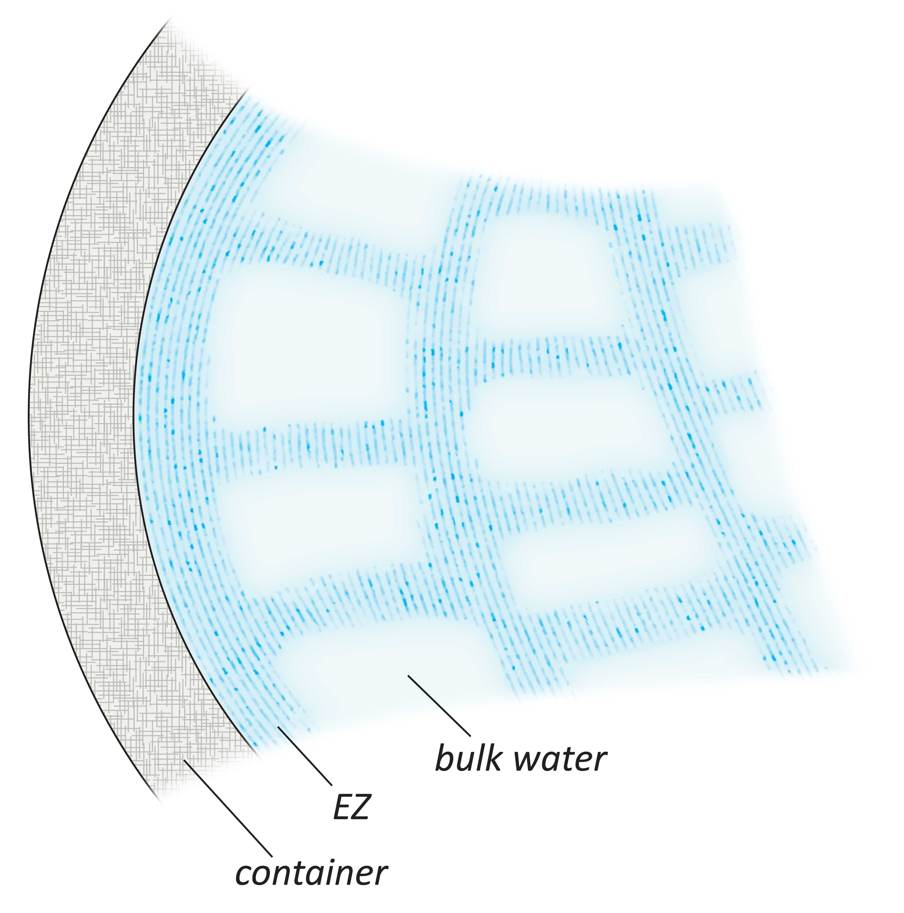
Also dependent on ambient conditions is the fractional coverage (Fig. 16.4). In theory, the openings could largely fill in: The extent of coverage should rest on vesicle concentration — a balance between vesicle production, vesicle absorption onto the matrix, and vesicle loss through evaporation. At room temperature, surfaces could quite possibly be filled with EZ material.
Quantitative uncertainties notwithstanding, the net-like mosaic should stiffen the surface, explaining the resistance encountered by high divers. Actually, it is not the stiffness alone that is the issue: When skiers or high divers land, the water needs to get out of the way. It must accelerate against inertia. The net-like layer hampers that acceleration by holding those molecules in place.
Figure 16.4. Top view of mosaic surface structure.
Thicker Surface Zones in Open Waters?
The observations described above were made in laboratory settings. Conditions may differ in deep bodies of natural water endlessly exposed to radiant energy. There, the surface mosaics’ fractional coverage and vertical extent are not necessarily the same as in laboratory beakers. Indeed, evidence implies that those surface structures might extend substantially deeper.
One hint of increased depth comes from the reports of competitive freedivers. Holding their breath sometimes for up to eight or nine minutes (!), these divers can descend to depths of 100 meters or more before resurfacing. The divers consistently report a physical transition at a depth of 15 to 20 meters. Above that depth the body seems almost neutrally buoyant, whereas below it, the body is said to sink like a stone.
The situation seems analogous to the pin in the glass of water: the pin may float on the top zone, but when forcibly submerged to a point beneath that zone, it sinks easily. This transition point lies millimeters from the top. In the case of freedivers, the transition point seems to lie some tens of meters beneath the surface.
A second hint of increased mosaic depth comes from naval engineers dealing with sonar. Sound directed downward ordinarily penetrates to the bottom of the sea. But if the sound is directed obliquely, then it bounces off a discontinuity somewhere beneath the surface and never makes it to the bottom. The same happens from beneath: sound directed obliquely upward may never reach the top. The discontinuity seems to lie at a variable depth. In the shallower waters near coastlines the depth is similar to what the free-divers report. tens of meters; in the deeper waters of the oceans, the interface reportedly occurs at depths of several hundred meters or more. The source of the discontinuity is not settled, but could represent the mosaic’s lower boundary.
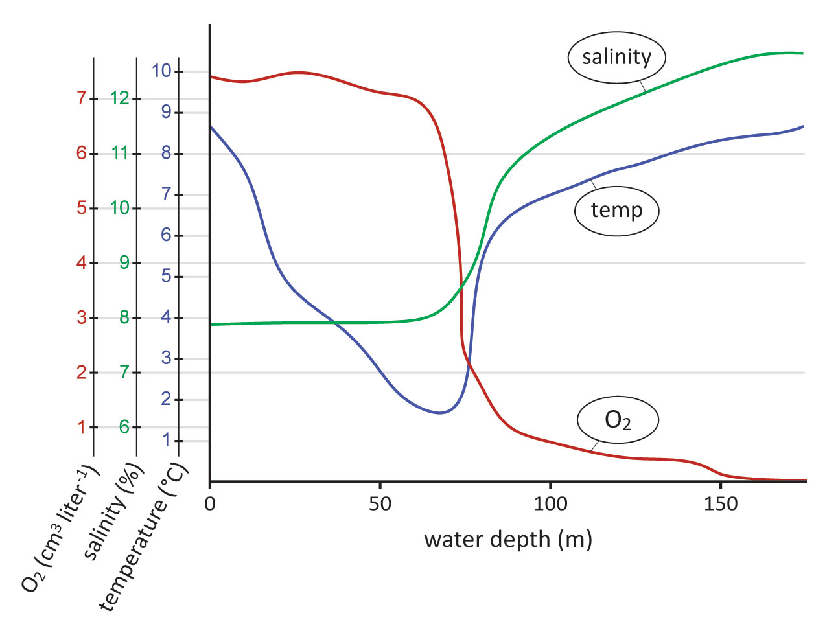
A third relevant observation comes from a shipboard study (Mopper and Lindroth, 1982). Measurements carried out in the Baltic Sea once again revealed the presence of a vertical discontinuity. From the surface downward to about 60 meters the investigators found a practically constant oxygen level, which then fell off sharply to a very much lower level. The falloff occurred within a 10-meter window (Fig. 16.5). The high oxygen content at the top supports the presence of EZ material, for EZs are densely packed with oxygen (Chapter 4). Moreover, the upper zone contained a salt concentration less than half the value seen farther down. Since EZs exclude salt, the low salt concentration in the upper zone is also consistent with an EZ presence.
A particularly intriguing finding of that study was on the distribution of amino acids. As the sun bore down during the day, the dissolved amino acid concentration progressively diminished in the top zone, while it increased below. Amino acids were evidently shifted downward. If sunlight increases surface structuring, then the downward shift of excluded material is anticipated. That shift should reverse as the sun begins to set, as was observed. Evidently, the quantity of excluded material waxed and waned with the sun, as expected from EZ material.
Figure 16.5. Vertical profiles in the ocean. Temperature, dissolved oxygen, and salinity profiles, measured at Baltic Sea station, 26 May, 1979. From Mopper and Lindroth, 1982.
This collection of evidence leads us to speculate that extensive regions of the sea’s upper zone may be EZ-like. In the laboratory such EZ-like zones extend down by millimeters, occasionally centimeters; in the sea they may extend downward by tens of meters near shorelines, and perhaps hundreds of meters farther out to sea. The depth is not surprising given the abundance radiant energy and oxygen, and of course the countless millennia available for assuredly attaining a steady state.
Although deep, these upper zones are likely to be discontinuous, even beyond the small fenestrations of Figure 16.4. The sea is continually shifted by tides and lashed by winds; hence, EZ-containing structures are likely to suffer multiple fractures. Moreover, the upper zone is penetrated by all manner of creatures. Hence, that zone may exist as a structural patchwork rather than a continuous network. Nevertheless, the thick, net-like structure should inevitably stiffen the water’s surface.
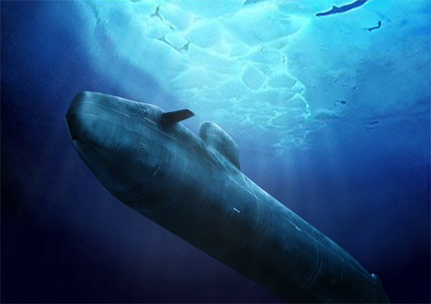
--- BOX: Submarine Detection
EZ material lying beneath the water surface creates a thick surface plate. That plate should be deformable. —as evident in Figure 16.3. Thus, mechanical perturbations originating beneath the plate could deflect the plate, and those deflections might be detectable from above. Indeed, infrared lasers have detected water-surface bulges, known as Bernoulli humps, arising from submarines passing beneath (Web ref 2)
complimentslikecupcakes.blogspot.com
--

Tsunamis
With a thick layer of EZ material lining the water surface, certain physical phenomena become easier to understand — the most notable of which are wave phenomena.
Waves pervade the ocean surface. The framework for understanding those waves builds on the presumption that oceans consist of bulk water alone; surface zones get scant consideration. Within that viscosity-dominated framework, explanations build on phenomena such as Stokes drifts, frequency dispersions, phase drifts, Boussinesq equations, and other seemingly arcane phenomena; and, they include different approaches for different depths. The resulting models are almost intractable; they require simplifications for achieving even modest understanding.
By contrast, waves in elastic media are common. Their physical description is straightforward enough that even I can understand. If the thick surface zone could be modeled as an elastic sheet, then propagating wave phenomena might be easily explainable. That model seems reasonable: all that’s needed is for the laterally strained net to return to its initial configuration when released. The mosaic net should do that.
In this interpretive vein it is worthwhile to consider the extreme example: tsunami waves. These towering and oft-devastating waves may circumnavigate the earth several times before dissipating. Envisioning such sustained propagation within the framework of a viscous liquid is not easy; the waves should quickly damp out. On the other hand, propagation is a lot easier to fathom in the context of a stiff elastic sheet: perturbations can propagate swiftly over long distances. If the water surface is a stiff elastic sheet, then this principle may explain why tsunamis can propagate as far as they do.
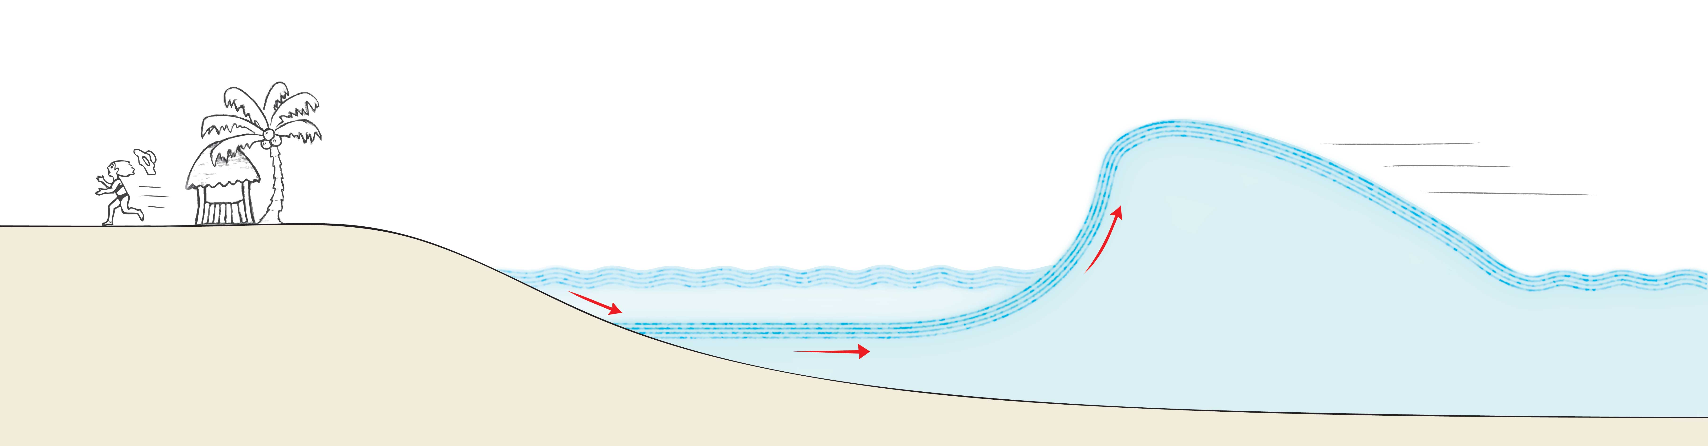
The continuous sheet model may also resolve the mystery of why the sea recedes from land just prior to the tsunami’s onshore arrival. The wave constitutes an upward swell. An upward deflection of a continuous sheet will draw the sheet inward from the periphery. In the case of the tsunami wave the upswell will pull the sheet’s edge seaward, explaining the sea’s pre-inundation withdrawal (Figure 16.6).
An additional expectation: the sizzle. As the upper sheet pulls seaward, some of the bulk water lying beneath the sheet may remain in place. That water should be rich with protons — just as any water juxtaposed next to an EZ sheet would be rich with protons. Thus, a bed of positively charged hydronium ions may remain in place as the water recedes. Those hydronium ions should repel one another, spraying upward into the air like a fizzy drink just opened. This repulsive spray may explain the oft-reported sizzle.
Figure 16.6. Tsunami dynamics with a surface elastic sheet. An upswell will draw the elastic sheet seaward, as observed.

Water Surface Fragility
The elastic sheet model may be a useful expedient for understanding waves, but it falls short of an accurate representation of the water surface. The surface is made up mainly of packed vesicles. This packed material may suffice for explaining surface elasticity, but what about surface fragility? The surface must be fragile: only if it’s fragile could fish pass through.
Fragility can be understood in terms of thixotropy. What is thixotropy? One of those tongue-twisting words you may have encountered but perhaps can’t define or even pronounce, thixotropy refers to a material character. Thixotropic materials nudged gently will return elastically to their initial configuration; however, if you nudge them enough, then they begin to flow. Think of egg white.
Egg white actually provides a good example for explaining the fragility of which we speak. Egg white is filled with ordered water (Pollack, 2001), now more definitively described as EZ water. Like other EZ water, egg white massively excludes. To demonstrate, expose egg white to food coloring: provided the gooey albumin is left undisturbed, those dyes will remain excluded (Cameron, 2010). Thus, thixotropic egg white is full of material that excludes.
EZ material behaves thixotropically because of the electrostatic nature of its bonds. Think of the vesicle array. Opposite charges hold the vesicles together. The array can accommodate small deformations without those bonds giving way; it behaves elastically. However, if you tug on the array enough to break the electrostatic bonds, then the array will fracture, and vesicle material will flow. Such fracture may explain the surface material’s fragility — why swimmers and fish can pass through without very much difficulty.
Thixotropy can also explain why coins may float when eased gently onto the water surface, but will sink if placed carelessly. Careless shear may fracture the surface structure and thereby allow for easy penetration; the object drops through. Scrupulous placement can avert this kind of surface disruption, permitting the object to remain floating on the surface.
The same principle holds for ships. Moving ships induce major shear. This shear immediately breaks up the surface structure and allows the ship to move on. The shear is less pronounced beside and beneath the ship; there, the EZ structure may remain intact, but strained.
Watching a ship pass through near-coastal waters can bear witness to this disruption phenomenon. The most obvious aftermath of passage is the wake, which moves in a predictably angled fashion behind the ship; you can feel the waves if you sit in a rowboat nearby. The subtler aftermath is the change of surface structure — the long trail-like print left behind by the passing ship (Fig. 16.7). You can identify the print because the print’s surface features differ from those of the water around it. The print may persist long after the ship has passed, often for as much as 15 to 30 minutes.
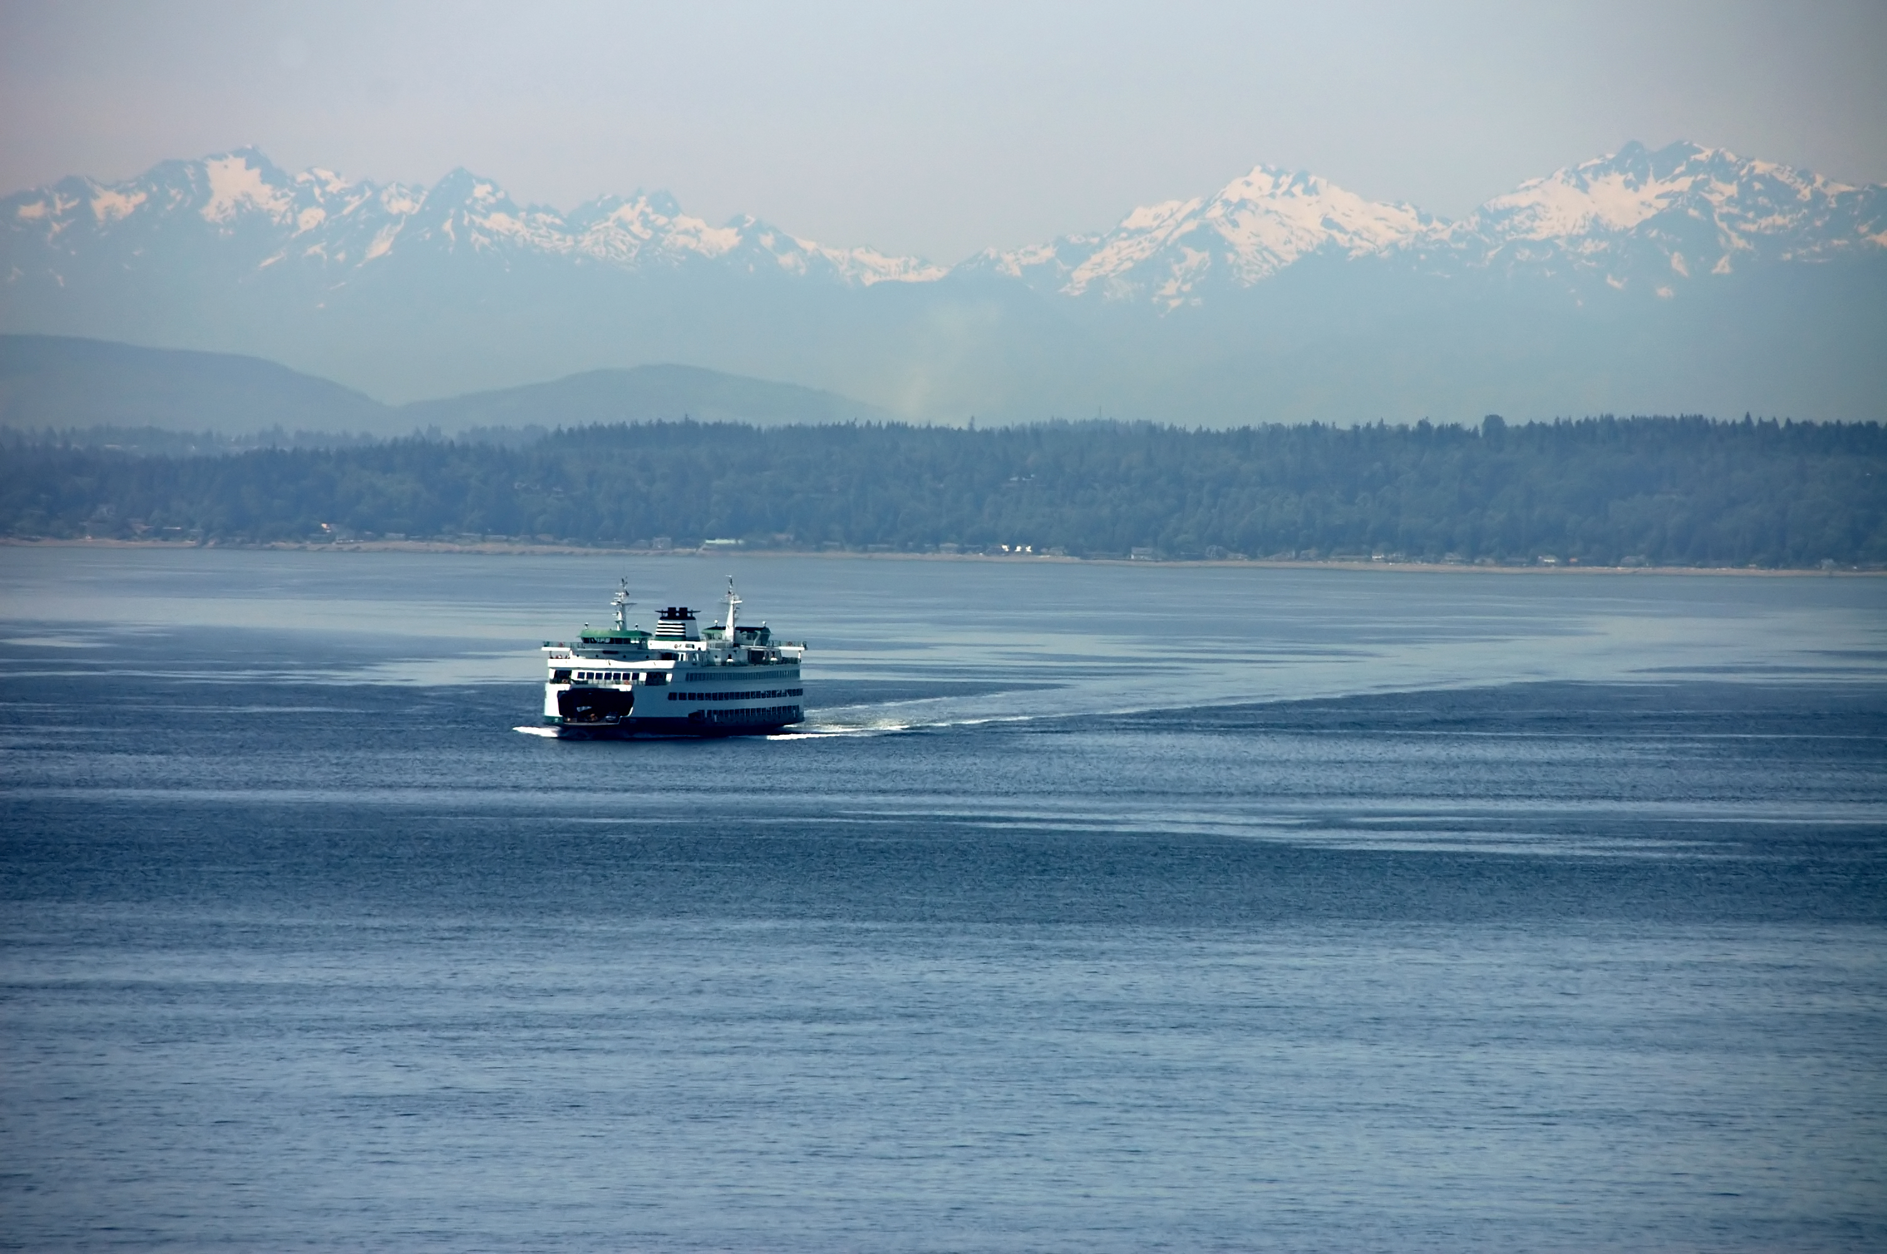
I hadn’t noticed this phenomenon until my colleague Michael Raghunath pointed it out to me. Now I see it consistently. The trail typically seems calmer than the water beyond. Calmness makes sense if the surface structure has broken up, for the capacity to sustain waves should thereby vanish. Eventually the flat trail disappears. The tens of minutes required for its disappearance presumably represent the time required for the surface to restructure and become indistinguishable from the rest.
Figure 16.7. Ferry in Puget Sound approaching Seattle. Note the long-lasting trail behind. Courtesy, Michael Raghunath.
Thus, the water surface may be globally elastic, but it is locally fragile; the surface can easily break up. The feature underlying this behavior is thixotropy — hard to pronounce but significant for understanding what happens at the water surface.
Cruise Ships, Bathtubs, and Archimedes
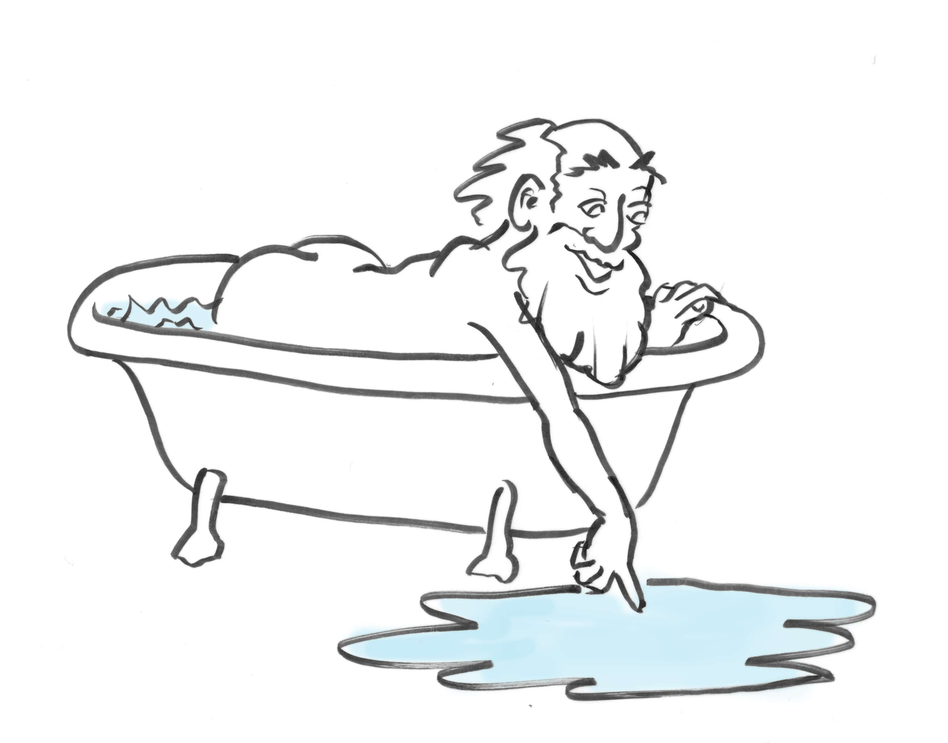
All of this brings us to Archimedes, who long ago considered water surfaces. Immersing his mass into a bathtub, Archimedes watched the water rise and had an epiphany: the upward force on partially submersed objects must equal the weight of the water displaced. It’s a simple principle, used to this day to explain why ships float.
While the concept makes sense, there may be more to it than meets the eye. First think of a model ship sitting on a spongy base. The balance of forces is simple: the boat pushes down, while the slightly dented base pushes up with equal and opposite force (Fig. 16.8). The reason the sponge can push up is that the sponge’s molecules manage to hold together despite the denting force. Molecular cohesion allows the sponge to push back. Cohesion matters.
Now set the ship on the water instead of the sponge. The force balance ought to be similar: the boat pushing down and the water pushing up. But how exactly does the water push up? If the water molecules beneath were not cohesive, then the weight of the ship might split the water like Moses split the Red Sea; the boat would quickly sink. Thus, at least part of the story of the floating ship must involve molecular cohesiveness.
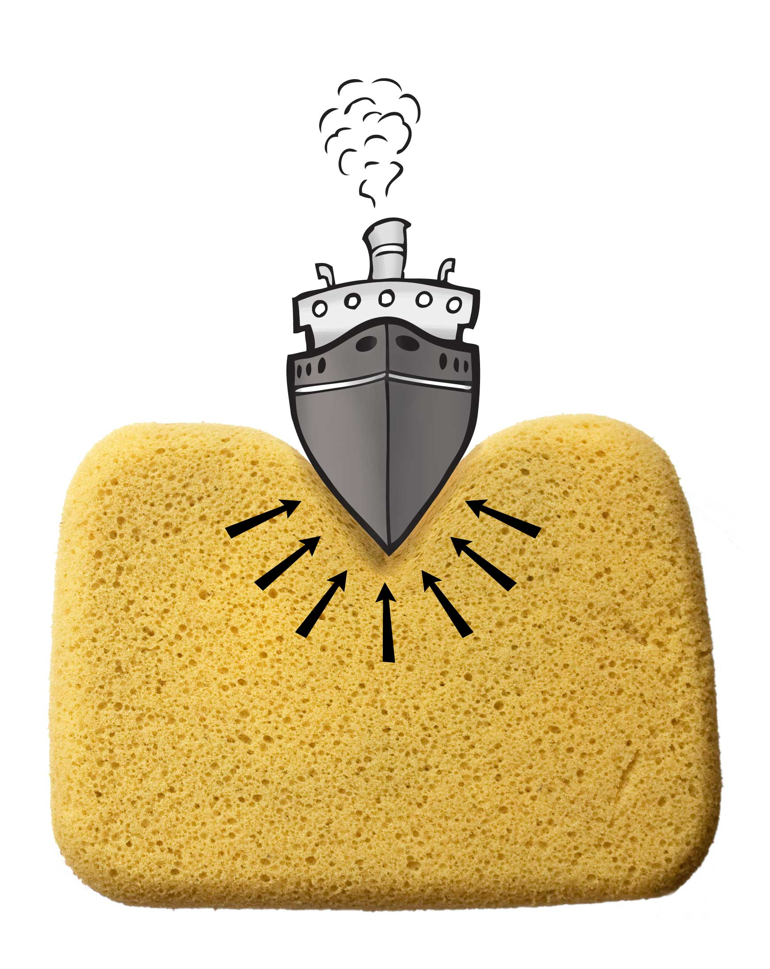
Readers familiar with the physics of flotation will recall that the standard explanation does not involve cohesiveness. It involves pressure. The weight of the water above a point creates pressure at that point. The pressure pushes in every direction, including upward. The farther down you go, the higher is that pressure. Therefore, if a boat were to sink deeper, it would experience higher pressure — until a vertical force balance is reached. There the boat should sit. Nothing more is required; no specific mention of cohesiveness.
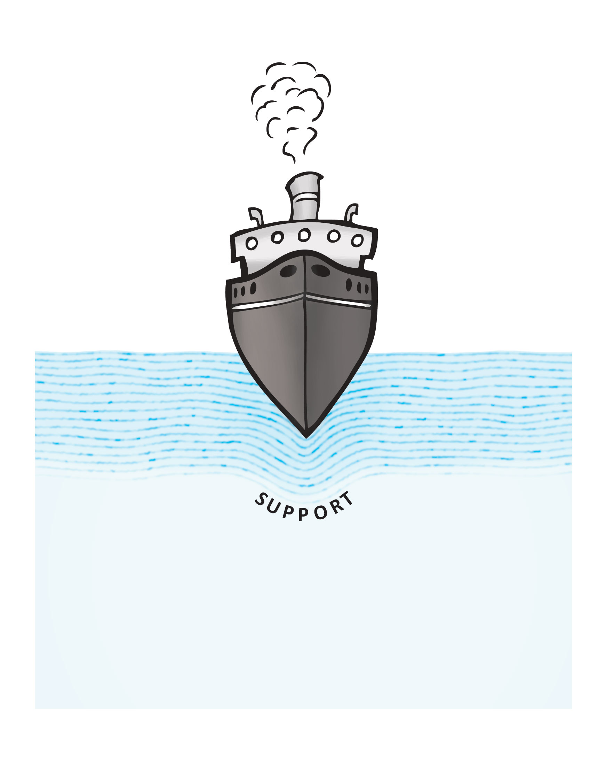
Do pressure and cohesiveness provide different explanations? The pressure-based explanation considers the pressure to be the same in all directions. Up, down, or sideways — it doesn’t really matter. This rests on the implicit presumption that the water’s properties are the same in all directions. However, that’s not necessarily true: while the boat may shear through the layers above, the layers below are only moderately distorted and may remain intact. If so, then the ship is cradled by elastic mosaic structures (Fig. 16.9). Strained yet largely intact, these layers should create upward thrust in much the same way as a trampoline creates upward thrust.
Figure 16.8. Cohesion prevents the boat from sinking.
Thus, Archimedes may have been only partially correct. Surely pressure pushes the boat up. However, the magnitude of the pushing force rests not only on depth but also on the cohesiveness of the EZ net lying below the boat’s hull. To the extent that the net remains intact and strained, it may provide upward thrust.
EZ surface structures may help us understand not only how ships float but also how they might sink. Consider regions notorious for ships that mysteriously sink en masse. The Bermuda Triangle is the most famous, but there are others. During certain epochs, many ships have mysteriously sunk in those zones, far more than can be explained by chance (Gaddis, 1965). Following the most notorious Bermuda Triangle losses, military surveillance records report that no ship debris could be recovered, implying that the ships had sunk directly to the ocean floor — hapless ships gone straight down (Fig. 16.10).
Figure 16.9. EZ layers provide cohesion and upward thrust, which helps keep the ship afloat.
These sinkings might be explained by undersea discharges. Thermal vents and methane deposits become periodically active, releasing bubbles that could easily disrupt the fragile surface structure. Indeed, pilots searching for the mysteriously lost ships have reported a locally strange looking ocean surface. One tugboat captain who barely escaped sinking reports the surface to be foamy and choppy, while the sea around was perfectly flat (Web ref 16.3). Thus, whatever happens involves the surface. In the same way as underwater bubbling allows high divers to descend easily, possibly natural bubbling lets the ships sink just as easily.
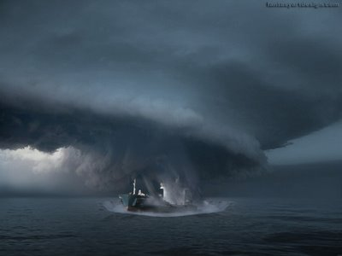
Intrigued by the extensive documentation of these losses, several have attempted to determine experimentally whether bubbling could actually cause sinking. It seems that it can. An amusing video demonstrates the sinking in a small chamber (Web ref 16.4), while a more serious BBC video documents speedboat sinking in shallow waters (Web ref 16.5). Bubbles can evidently sink the boat. While these demonstrations may not match the academic standards to which many of us have grown accustomed, they provide highly suggestive visual evidence.
Figure 16.10. Caught mysteriously in the clutches of the Bermuda triangle? http://lunaticg.blogspot.com/2009/01/bermuda-triangle-from-pound-to-dollar.html [ref at end]
To be prudent, you might check with local hydrologists before embarking on your next Caribbean cruise.
Capillary Action
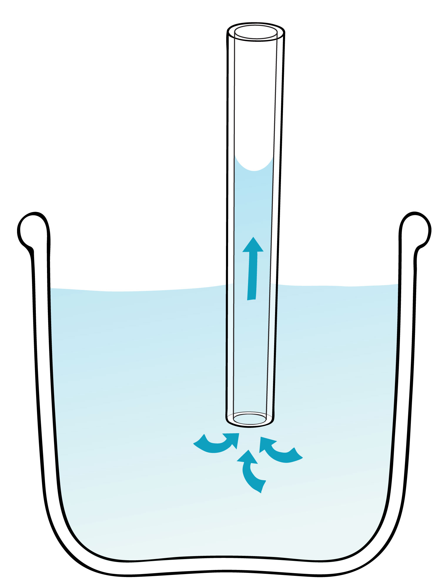
Place a wet teabag on a paper napkin and observe. Before long, much of the napkin will become wet. The water can even climb upward. Creeping phenomena such as this are often referred to as “capillary action.”
Capillary action is more rigorously demonstrated in narrow tubes, or “capillaries.” (That’s how the phenomenon got its name). When a vertically oriented quartz capillary tube is inserted into a container of water, the water inside the tube will quickly rise to a level higher than that of the surrounding water (Fig. 16.11). The water seems to defy gravity.
Why does the water rise?
Classical explanations are not helpful; they focus on the end result of the rise — the upper meniscus — and not on the rise itself. The meniscus is presumed stuck onto the capillary wall, weighed down by the column of water hanging beneath. That hanging load confers curvature onto the meniscus. In terms of force balance, the upward component of meniscus surface tension balances the weight of the hanging column (Fig. 16.12).
Figure 16.11. Example of capillary action.
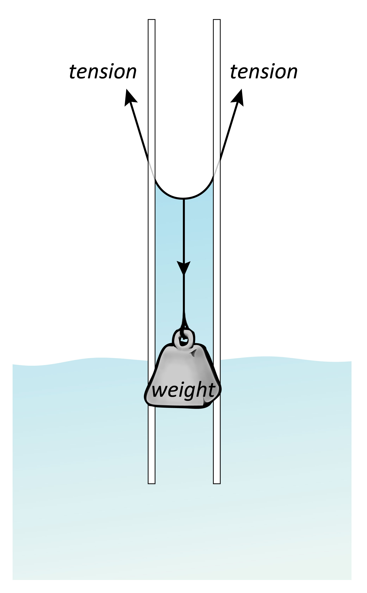
Implicit in this explanation is the presumption that the column of water hangs without any interaction with the surrounding wall. We know to be untrue: water interacts strongly with the hydrophilic walls the commonly make up these tubes. Nevertheless, the concept of force balance has proved convenient as an explanatory expedient. Students like it. Nevertheless, the concept fails to address the more fundamental issue: why does the column rise? That force is left unspecified, although the idea of “surface energy” is often vaguely invoked.
To identify the rise force, think of the surface mosaic that lines the water’s surface. Since the mosaic is charged, some kind of charged-based force is a good bet — either pulling from above or pushing from below. There are good reasons suggest both.
Consider the scenario above the meniscus (Fig. 16.13). If the tube’s inner walls contain any EZ layers at all, then those EZs will generate protons; the protons should lie exposed to the central axis of the tube. The protons’ positive charges are key, for they can draw the negatively charged vesicles upward.
Figure 16.12. Force balance. Upward component of surface tension balances the weight of the water column suspended beneath.
The inner walls should always contain at least some EZ layers. Vesicles from the atmosphere attract to any hydrophilic substance, including the hydrophilic walls. As they stick, the vesicles may then zipper into standard EZs plus protons — as we’ve seen before (Fig. 14.8). The protons will always lie facing the center of the tube. So the positive charges needed for the upward draw should always be present, at least to some extent.
That upward draw should quickly grow. Once some rising vesicles cling, zippering will create more inward facing positive charges. This will enhance the drawing force, pulling more vesicles that will in turn zipper to create even more positive charge, etc. The draw is inevitable: Once the rise begins in earnest, it should quickly go to completion. The full height should be reached when the upward drawing force balances the downward pull of the water.
The upward draw may be thought of is an enhancer of evaporation. An evaporative event takes place when the mosaic’s negative charge increases above a threshold; then part of the mosaic array rises. Placing positive charge above that negative array should accelerate the rise, effectively enhancing evaporation. The positive charge effectively pulls evaporating water — like pulling spaghetti strands from the water.
Meanwhile, positive charge from below may exert an upward push. Consider the section of tube beneath the meniscus. In that water-filled section, a rapidly growing annular EZ will build core protons (Fig. 16.13, lower panel). Those protons will cling to any sites with negative charge — which include the EZ generating the protons, and the vesicle mosaic lying above. The EZ’s inner face should thus be rich with protons, as should the water immediately beneath the vesicle array. These separated clusters of positive charge should generate a repulsive force that pushes the array upward.
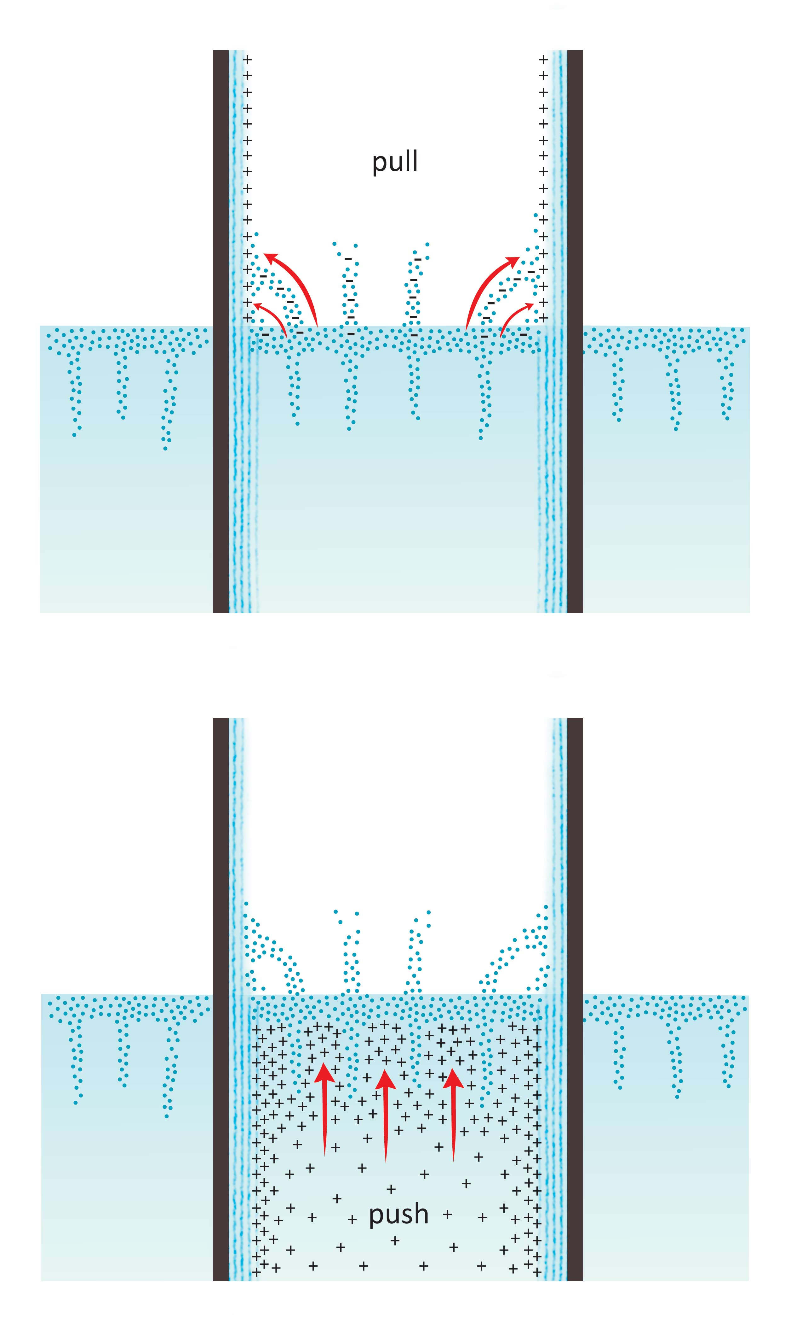
The driving forces are therefore symmetrical. An electrostatic force from above pulls the array upward, while an electrostatic force from below pushes the array upward. Both upward forces originate from the positive charges produced from the capillary’s inner EZ annuli.
Do these charge-based mechanisms fit with experimental evidence?
First consider the nature of the meniscus. Since the meniscus derives from EZ material, it should exclude. The meniscus should be particle free. Indeed, when menisci build from water containing suspended particles, the particles are excluded. An example is shown above, in Figure 16.2.
Another prediction is that the capillary rise should be most prominent near the wall, for it is there that the pulling and pushing forces originate. In wide tubes, the rise force may impact only the periphery, creating an edge meniscus but no rise in the tube’s core. In narrower tubes, the rise forces may impact the entirety of the tube’s cross-section. That expectation is confirmed: near-wall menisci are consistently present, but full column rise is seen only in tubes that are sufficiently narrow.
Figure 16.13. Mechanism of capillary rise. Positive charges from above pull negative surface layer upward (top); and positive charges from below push upward on hydronium ions concentrated immediately beneath the surface layer. Both forces may drive the rise of water.
A related expectation is that narrower tubes will produce a greater rise. The rise rests on a balance between upward and downward forces. Rise force depends on capillary perimeter, while the weight force depends on capillary cross section. Thus, reducing the diameter impacts the upward pull less than the downward resist. Narrower columns should lift higher. That’s borne out by common experiences: thinner capillary tubes lift farther.
A third test of the hypothesis is to examine the effects of heating. Heating facilitates evaporation, and should therefore produce a faster rise. We confirmed that warm water rises two to three times faster than room temperature water.
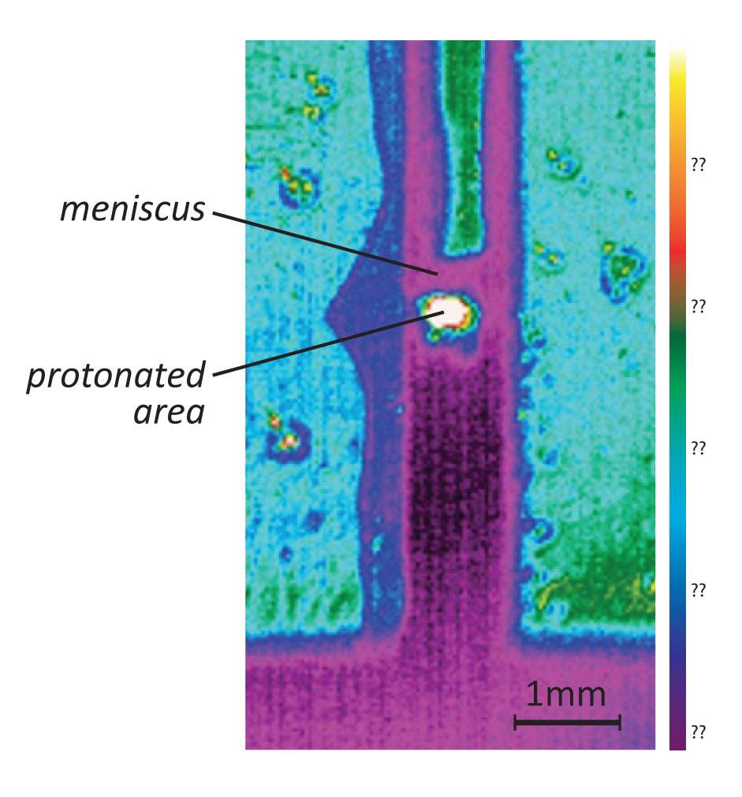
A fourth test relates to the pushing mechanism. That mechanism demands a high concentration of protons in the zone immediately beneath the surface mosaic. Free positive charges in high concentration ordinarily generate a strong infrared signal, as we’ve seen multiple times. We found the same here: strong infrared signals appear consistently beneath the surface array (Fig. 16.14).
A fifth expectation is the absence of any rise in hydrophobic tubes. The driving forces under consideration all derive from positive charges created as a result of EZ buildup. EZs do not exist next to hydrophobic surfaces; hence water should not rise in hydrophilic tubes and indeed it does not.
While additional tests seem necessary for evaluating and refining the proposed capillary drawing mechanism, a strong point is its commonality: the mechanism is similar to the one that draws water along napkins and that draws water osmotically. All are charge based. Thematic similarity is auspicious, for one might expect that all water-drawing phenomena might operate by the same class of mechanism. That simplification would be a satisfying outcome.
Figure 16.14. Infrared image of water rise in square capillary tube. Note hot spot just beneath meniscus.
Water Transport in Tall Trees
Capillary action is not restricted to quartz tubes and paper napkins alone; it occurs throughout nature. It is especially prominent in plants and trees, where water may rise even to the tops of 100-meter Redwood trees. Inside such trees, narrow xylem vessels run from roots to leaves, transporting the water ever upward.
The mechanism of vessel transport is actively debated. Most scientists think that some kind of capillary action draws the water upward. However, two issues have plagued that hypothesis. First, the “hanging column” is too heavy to be lifted more than about 10 meters; and second, the air pockets commonly found within xylem tubes should thwart the drawing process as they do in straws. Scientists struggle with those issues.
These obstacles are not necessarily at play in the capillary mechanism outlined in the section above. The column does not hang — it clings to the walls; and the presence of air pockets need not thwart the charge-based rise. The question is whether the proposed capillary mechanism really does operate in plants and trees. A key issue is whether xylem tubes contain exclusion zones, and the answer appears to be yes.
To find out about EZs in xylem tubes, I contacted my Australian friend Martin Canny, who has been the dean of the plant vascular field. Martin lives in Canberra. I recall a visit several years go when the Cannys were kind enough to put me up in their mother-in-law apartment downstairs. Martin mentioned the spiders. No need to worry about the Huntsman spider, he indicated dismissively — it’s huge and hairy but perfectly harmless. But do watch out for the little black ones with red spots; they lurk in nooks and crannies. Death from their venom may be quick, but it’s also agonizing. Needless to say, my three-day visit was practically sleepless.
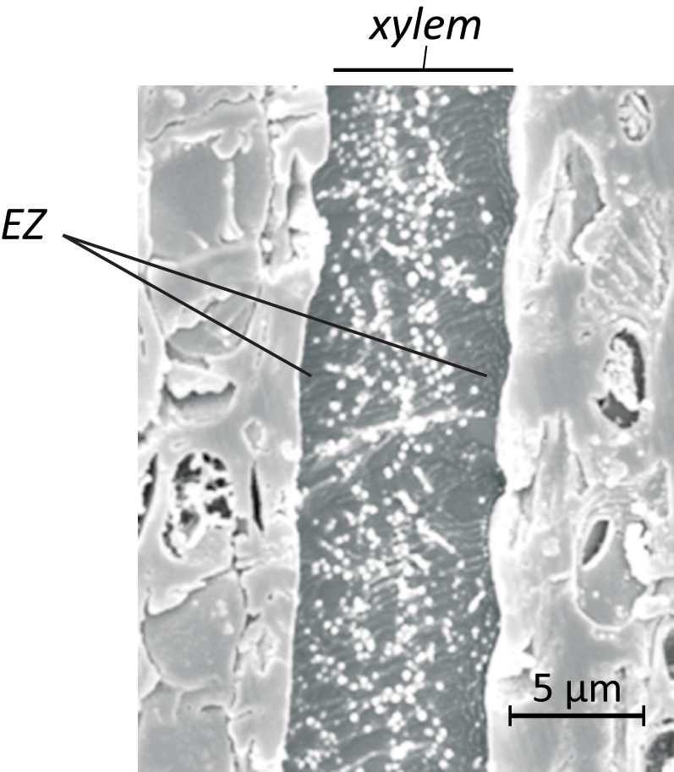
Nevertheless, we did have a chance to discuss capillary action, and Martin seemed curious about exclusion zones. Following my visit he went ahead and checked. He infused small ink particles into xylem tubes, quickly froze the specimens, and examined the frozen samples in an electron microscope. The results were positive (Figure 16.14). I’m not sure who was more excited, Martin or me, but the results confirmed that exclusion zones were present in those vessels.
This confirmation implied that we were on a positive track. If annular EZs are present in xylem tubes, then they presumably play some role in the tubes’ physiology. Annular EZs in Nafion tubes generate steady flow (Chapter 7); and flow is exactly what’s needed. Thus, flow inside the Nafion tube (or gel tube) could be a model of what happens in nature’s tubes.
Figure 16.14. Cryo scanning-electron microscope image of ink particles infused into xylem. Particles concentrate in center, and are excluded from zone near the walls. Courtesy Martin Canny.
In the Nafion flow model a key feature is the core proton content. Those protons drive the flow. The question is whether the fluid flowing inside the xylem is likewise full of protons. Standard textbooks confirm the sap’s low pH value, and modern methods narrow down those pH values. In maize seedlings for example, xylem pH ranges between 4 and 5, depending on conditions (Wegner and Zimmermann, 2004). Hence, the xylem fluid contains the required protons.
Given the annular EZ and core protons, xylem tubes seem very much like Nafion tubes. It would not be a giant leap to suggest that the drivers of flow are the same. We may commonly refer to that flow as capillary action, but really we speak of proton-driven flow.
For plants, the main issue is replacing the water lost through evaporation. Water evaporates from the leaves. As it does, the xylem may become transiently dry near the top, except for a few residual EZ layers. Those EZ layers would then be the responsible protagonists; they must draw the water upward from below. They may do so by the same mechanism that draws water upward in the narrow quartz capillary tubes. That’s all that’s necessary for keeping the leaves hydrated.
Height should not be a limiting issue for this mechanism. Nature is clever: it employs narrow tubes, which can pull water to great heights. The upper vessels of trees are of micrometer scale. The tubes farther down are wider, but still much narrower than standard quartz capillary tubes. Further, those tubes are commonly invested with meshes of hydrophilic polymer strands, which effectively narrow the tubes. EZs cling to all of these many surfaces; and positively charged bulk water clings to those EZs. These attachments bear much of the column’s weight. With abundant load bearing capacity and effectively narrow tubes, water should experience no difficulty rising to great heights — even possibly under the right circumstances all the way to the moon.
The energetics seem worthy of comment. The upward flow requires energy, just as pumping water to an elevated storage tank requires energy. The source is familiar: incident radiant energy. In the same way that radiant energy fuels the flow of water inside hydrophilic tubes, the same radiant energy should also fuel the flow through xylem tubes.

Given the rather direct contribution of radiant energy, you can understand why xylem flow might be seasonal. Flow begins as spring approaches — just when ambient radiant energy begins picking up. The flow increases as summer approaches, slows down in autumn, and shuts off in winter. Induced by the shutdown of radiant fuel supply — that flow shutdown may explain why autumn leaves dry out and fall gently to the earth.
http://www.owips.com/category/nature/ --
Floating Water Droplets
Finally, we return to water surfaces, asking what happens when those surfaces receive nature’s showering of gifts: raindrops. Intuition suggests that the drops will instantly coalesce with the body of water below. However, if both the water surface and the droplet surface contain EZs, then coalescence is not necessarily instantaneous.
I first learned of delayed coalescence when a colleague told me of his experience sailing just after a rainfall. Water would settle onto the boat’s gunwales. When the boat heeled to the side, droplets would often fall from the gunwales onto the lake below. As often as not, those droplets would float for some time before dissolving. Once you’ve seen those droplets you look everywhere for their presence. In rainstorms they can seem surreal — clear marbles floating on the water’s surface.
Delayed droplet coalescence turns out to be a recognized phenomenon, studied on and off for a century. Few people seem aware of it. Confident that further study might divulge more of water’s closely guarded secrets, we carried out a detailed investigation of the phenomenon using high-speed video (Klyuzhin et al., 2010). The results were confirmatory: As long as conditions were properly set and the droplets were released from heights of less than 10 mm above the water, the droplets consistently floated on the water surface before dissolving (Fig. 16.15).
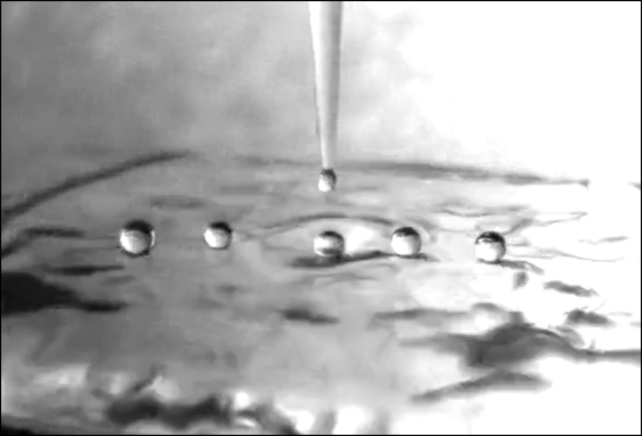
Even further, when the droplets happened to roll or slide sideways, coalescence took much longer — up to tens of seconds. The delay presumably results from the additional time needed to breach the droplet’s EZ shell. If the droplet rolls, then the disruption point continuously shifts; the breach process must begin anew. Dissolution therefore requires more time.
Figure 16.15. Water droplets falling onto water. Under appropriate conditions, droplets can persist for some time before coalescing with the water below.
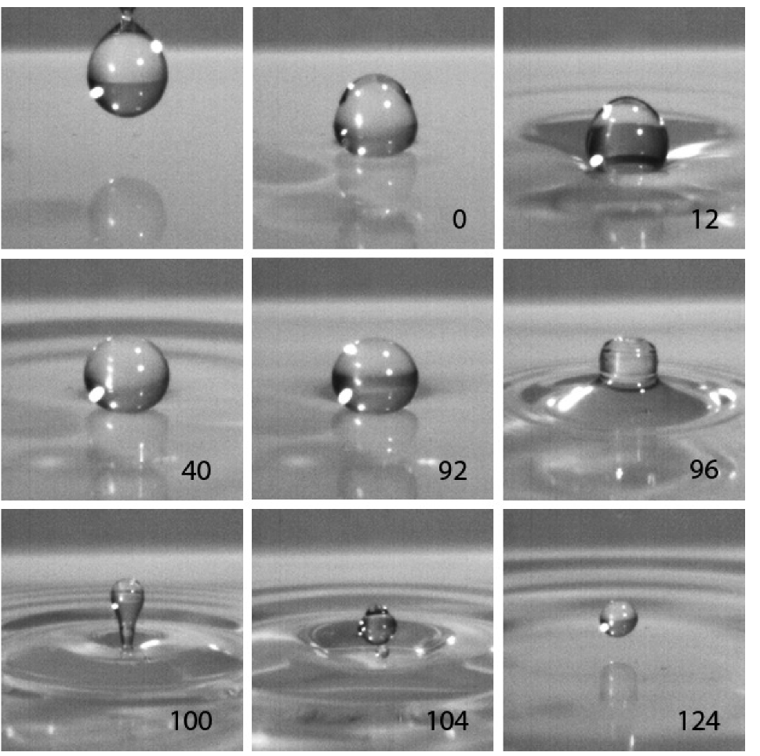
Actual dissolution involves more than just a single pop (Klyuzhin et al., 2010). The action occurs in a series of five or six orgasmic squirts, each one ejecting some of the droplet’s contents into the water beneath. Some of those downward squirts are powerful enough to induce waves in the water, and even to drive the residual droplet upward (Fig. 16.16).
Some panels of Figure 16.16 may look familiar. Images similar to these are often reproduced in books, magazines, and websites. Now you know where they come from. The characteristic salsa remains enigmatic — a challenge for the reader. Possibly, the initial squirt relieves much of the droplet’s internal pressure. If the resealed droplet contains residual positive charge, then the sequence may repeat. Only after multiple squirts would the droplet then empty, adding the proverbial drop in the ocean.
Figure 16.16. Several stages of water droplet dissolution in water. Numbers indicate time from onset, in milliseconds. From Klyuzhin et al., 2010.
Summary
EZ-containing structures build just beneath the water surface. These mosaic structures consist mainly of aggregated vesicles with standard EZ material. In the laboratory the mosaic structures may project down from the surface by millimeters or centimeters; in open waters with ample incident radiation they may reach down by tens, or even hundreds, of meters.
The presence of sub-surface boundary layers raises many questions, some of which are addressed here. These questions are conventionally framed in terms of water’s “high” surface tension, but surface-tension estimates are commonly made in situations with little or no exposure to radiant energy or air; so the measured values may be gross underestimates of the natural values.
Indeed, interfacial tensions in natural bodies of water may be extremely high — high enough to support small lizards and help support large ships. The agent creating that tension is the sub-surface mosaic. Its presence helps explain many observable phenomena: persisting ship trails, sustained tsunami waves, capillary flows in trees, and persisting water droplets on water surfaces.
In short, the vesicle mosaics help explain much of what happens on the surface of water. Whether those mosaics can help you figure out how to walk on water is doubtful — although we’re told that it has happened before.

References

Cameron I (2010): Dye Exclusion and Other Physical Properties of Hen Egg White WATER (2) 83 – 96.
Gaddis, V. (1965) Invisible Horizons: True Mysteries of the Sea. Chilton Books, Phila.
Klyuzhin IS, Ienna, F, Roeder, B, Wexler, A, and Pollack, GH (2010): Persisting water droplets on water surfaces. J. Phys. Chem. B 114, 14020–14027
Mopper K and Lindroth P (1982): Diel and depth variations in dissolved free amino acids and ammonium in the Baltic Sea determined by shipboard HPLC analysis. Limnol. Oceanogr. 27(2): 336-347.
Ovchinnikova K and Pollack GH (2009): Cylindrical phase separation in colloidal suspensions. Phys. Rev. E 79 (3) 036117.
Pollack GH (2001), Cells, Gels, and the Engines of Life. Ebner and Sons, Seattle.
Wegner LH and Zimmermann U (2004): Bicarbonate-Induced Alkalinization of the Xylem Sap in Intact Maize Seedlings as Measured in Situ with a Novel Xylem pH Probe. Plant Physiol. 136(3): 3469–3477.

Web ref 16.1: http://www.youtube.com/watch?v=45yabrnryXk
Web ref 16.2: <http://oai.dtic.mil/oai/oai?verb=getRecord&metadataPrefix=html&identifier=ADB228588.>
Web ref 16.3: <http://www.bermuda-triangle.org/html/don_henry.html>.
Web ref 16.4 http://www.youtube.com/watch?v=yf1n00LW1XI&feature=related.
Web ref 16.5. http://www.youtube.com/watch?v=DkIIMEVnNDg

