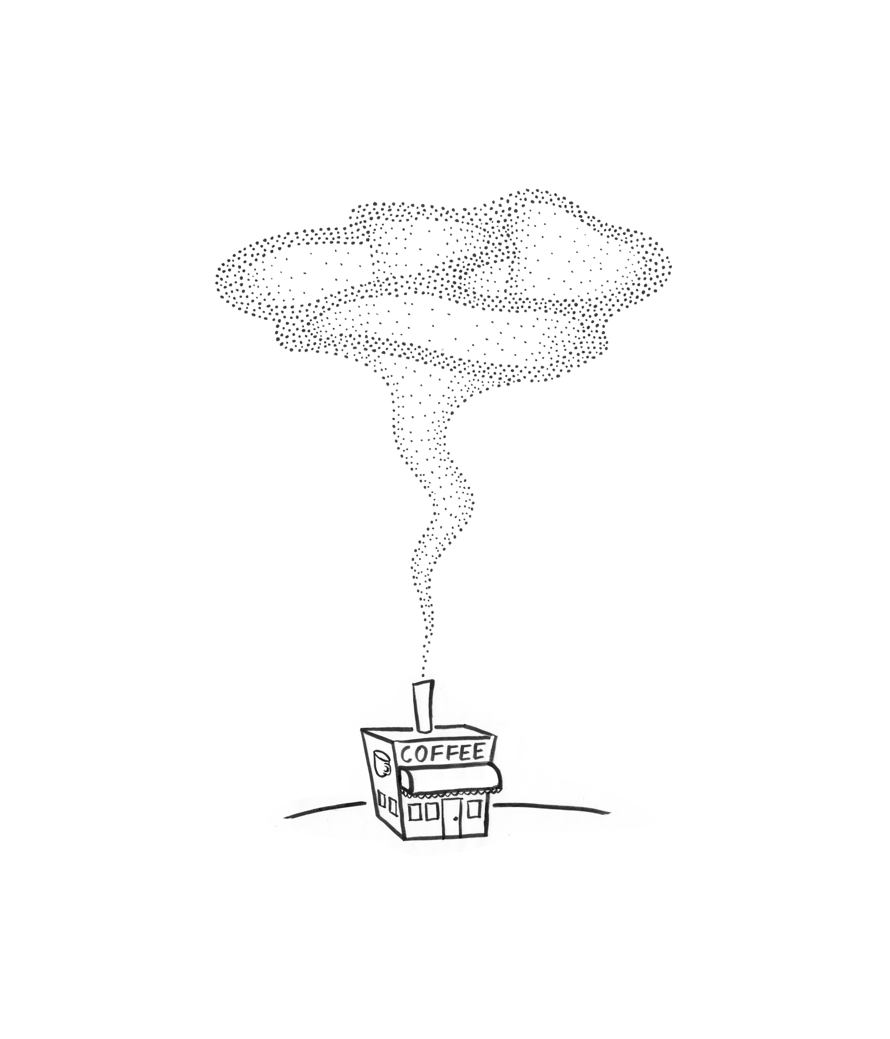
Chapter 15
Clouds from Coffee: The Remarkable Nature of Evaporation
Starbucks did not brew the first cup of coffee. The honor, according to legend, belongs to a 13th century Ethiopian goat herder named Kaldi. Kaldi noticed one day that his goats seemed uncharacteristically energized. They had just nibbled on some bright red berries. Ever curious, Kaldi chewed on a few of those berries himself and quickly confirmed their potent energizing effect.
With some pride, Kaldi brought a few berries to the local Muslim holy man, who registered his immediate disapproval by casting them angrily into the fire. He was displeased. But the aroma billowing from those roasting berries proved enticing, so Kaldi surreptitiously rescued some embers and brought them home. He ground the embers, dissolved the grounds in hot water, and voila! — the world’s first cup of coffee.
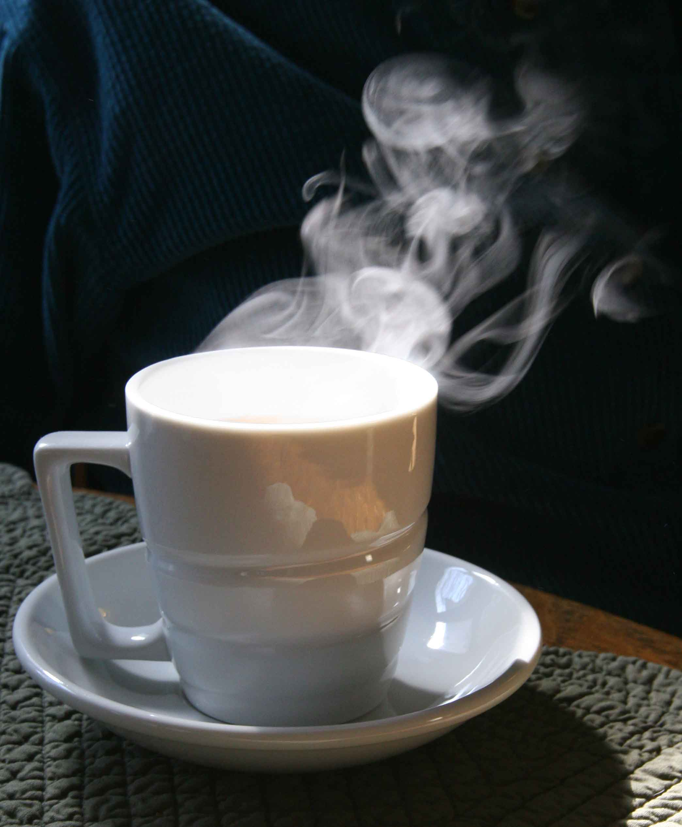
Hot coffee impacts all of our senses, including our visual senses (Fig. 15.1). Vapors unfurl like cobras from the snake charmer’s basket. The image of Figure 15.1 will not surprise you — but it should because conventional thinking might lead you to think that the vapor ought not to be visible.
Visibility depends on the scattering of light. The coffee vapor is visible because the vesicles that comprise the vapor scatter the incoming light; your eye detects that light. The amount of light scattered depends on vesicle size: to scatter appreciably, vesicle diameter must be at least the wavelength of the incident light, or half a micrometer. Hence, each of the many vapor vesicles must comprise some thousand billion water molecules.
Figure 15.1. Vapor rises in a series of puffs and thin streams.
There’s more. If you look at the image of Figure 15.1, you will notice that the vapor does not rise uniformly; the main feature is a series of “puffs” ascending one after another. It is as though the surface belches vapor puffs one at a time, each puff comprising numerous vesicles, and each vesicle packed with astronomical numbers of water molecules.
Also emerging from the liquid are narrow streams of vapor (visible on the right of Figure 15.1. The streams look like strands of spaghetti pulled from the liquid, maintaining their integrity as they rise. Since the strands are visible they must comprise many light-scattering elements, perhaps strings of water-packed vesicles.
It is not only from hot coffee that you can see distinct patterns of rising vapor. A student of mine noticed similar patterns at an Asian outdoor bath. Puffs of vapor rose directly from the warm water, ascending one after another in rapid succession. Much the same can be seen by examining most any hot drink: discrete, cloud-like puffs rise in succession, with not very much happening in the interval between.
Conventional wisdom tells us that water evaporates one molecule at a time: a random “kick” of kinetic energy releases the surface molecule from the liquid. Many such molecules could conceivably “condense” into clouds as they rise into the cooler air above. However, no easy explanation emerges as to why those scattered molecules should condense immediately as they leave the water, and why the condensation appears in the form of discrete puffs, rather that a single long continuous cloud.
We therefore examine evaporation with fresh eyes. We ask: what is the clouds’ anatomy? Do those clouds arise from cloud-like patterns inside the water? If so, why do the clouds rise in succession rather than continuously? What happens to the cloud material after the cloud disperses?
In short, what is the nature of evaporation?
The Anatomy of Rising Vapor
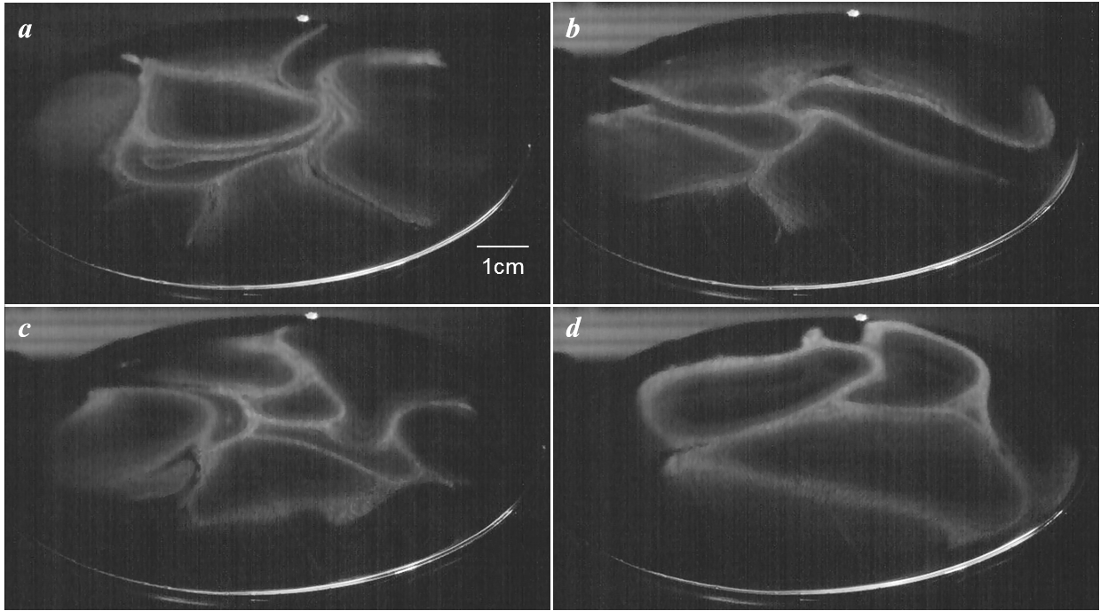
To study the vapor we used a laser. A prism fanned the laser beam into a horizontal sheet, and the sheet was positioned immediately above containers of warmed water — as close as possible without touching. That way we could capture video images of the rising vapor just as the vapor emerged from the water (Ienna et al., 2011).
I recall the brash young undergraduate waltzing into my office to show me what he had found. I was bowled over. His video frames showed that the emerging clouds were not solid; their cross-sections were mosaic-like (Fig. 15.2). Ringed structures fused with other ringed structures to form pretzel-like mosaics that carried the water. The rest was vapor free — hollow.
Figure 15.2. Examples of vapor rising from warmed water. The white rings represent high concentrations of vesicles, forming the visible vapor.
Although the pretzel figures seemed planar, successive frames revealed otherwise. A pretzel seen in one frame would persist with only subtle variation over multiple frames, usually for a period of one or two seconds. Then the pretzel would disappear. Hence, the pretzels have vertical dimension. The rising vapor cloud is perhaps best described as a vertical array of contiguous tubes, whose cross sections are pretzel-like.
--- Box: Dolphin Rings
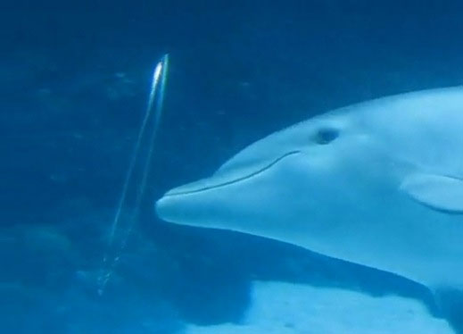
Ring-like vapor structures are not without precedent. Dolphins exhale them. The dolphins toy endlessly with those vapor rings, seemingly for amusement. When the rings finally break up, they break into myriad tiny vesicles.
Charming videos capture the fun (Web ref. 1).
---
Suffering inevitable distortion from convection, the rising tubular structure may morph into what is casually seen as a cloud. Sometimes, dark hole(s) in the cloud can still be discerned (e.g., see lower cloud of Figure 15.2).
Totally unexpected, we found that the tubes rose from limited regions of the surface. One region might belch a cloud or unleash a strand, while regions immediately adjacent might produce nothing at all — no detectable evaporation. Thus, evaporation is a series of localized discharge events.
We found these observations astonishing. We had understood that the vapor must comprise vesicles of substantial size in order to be visible; and we felt we knew the vesicles’ structure (Chapter 14). However, the images implied something more. Those vesicles seemed to self-organize into large tubes as they emerged from the water. The tubes could evidently hold together as they rose into the air, although ultimately dispersing as the visible vapor dissipated well above the water.
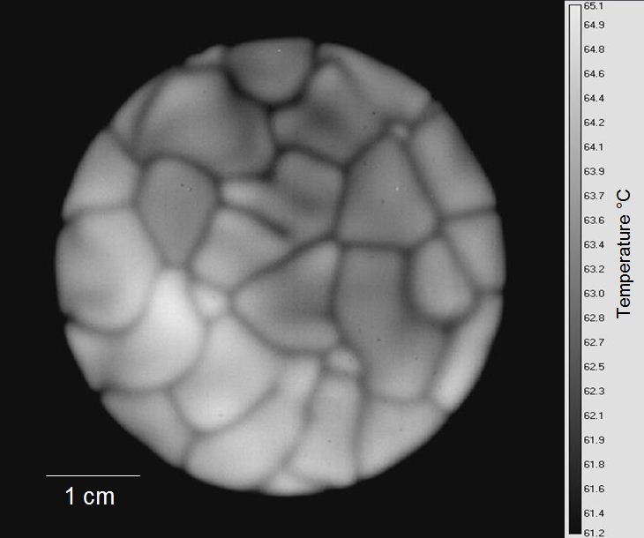
These distinct vapor patterns cannot arise magically. Since the patterns emerge from the water, you’d think that the water might contain patterns that spawn the vapor patterns. Do such water patterns exist?
Spatial Patterns in Liquids
The surface of warm water looks flat and featureless. However, infrared images tell a different story: they reveal ring-like mosaic structures not unlike those of the vapor. An example is shown in Figure 15.3.
The dark boundaries in the water resemble the light boundaries of the vapor. If several contiguous dark boundary rings were to rise from the liquid, they could conceivably produce the vapor patterns. Some of the dark boundary rings are miniscule (e.g., upper right); if the miniscule rings were to rise up, they could create the vapor’s spaghetti-like strands. Thus, the essence of the vapor pattern appears in the water.
Figure 15.3. Infrared image of dish of warm water, taken from above. Equivalent temperature scale at right.
These water patterns are present at all temperatures (Fig. 15.4). At higher water temperatures the cells are smaller, more dynamic, and more abundant. If the water patterns give rise to the vapor patterns, then this difference makes sense: it is consistent with the relatively higher evaporation rate seen at those higher temperatures.
The Origin of Mosaic Patterns in Water
What might create the mosaic patterns in water?
The patterns shown above were observed using an infrared camera. With infrared imaging, darker means less infrared energy radiated. Hence, the boundaries radiate less infrared energy. One might say the boundaries are “cooler.”
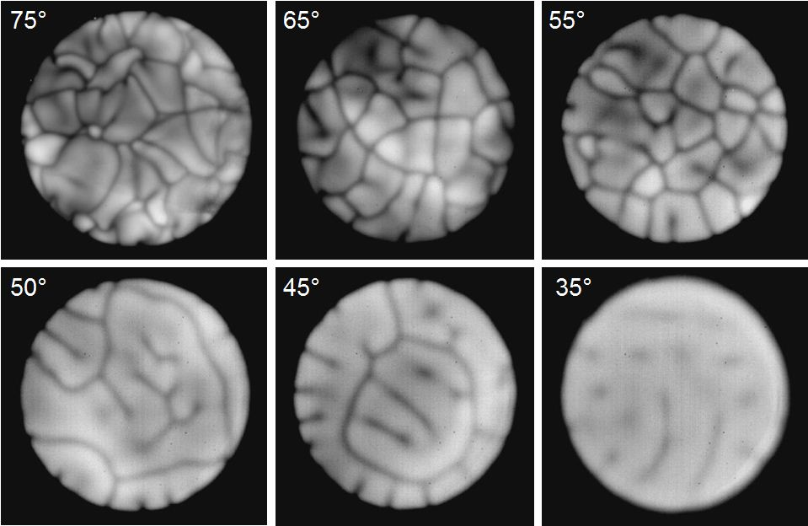
Indeed, the conventional interpretation of infrared images is based on temperature. So standard has become that interpretation that camera manufacturers provide handy temperature scales, such as the one seen on the right side of Figure 15.3. According to that scale the boundary temperature in that figure would be 62 °C, while the lighter interior zones would be 64 to 65 °C. The reference scale makes for a convenient interpretation — but one that may mislead.
Patterns such as those in Figures 15.3 and 15.4 are well known to aficionados; they are called Rayleigh-Bénard cells. These cells have been explored in many liquids, and also to a limited extent in water (Ivanitskii et al., 2006).
Figure 15.4. Infrared camera recordings of surface patterns, obtained from water at a series of temperatures.
According to the conventional interpretation these cells represent sharp temperature differences. The argument goes as follows: Heated water at the bottom of the container should be less dense than the water above; therefore, the bottom water should rise. When the rising water reaches the top and evaporates, nearby water molecules cool — evaporation is a cooling process. The cooled water has higher density, which prompts it to fall. Falling takes place at the periphery of each cell, creating the cool (dark) boundary rings. Thus, the conventional interpretation provides a reasonable framework for understanding, and indeed, the required up-down flows can be seen.
However, that interpretive framework is not the only one possible, especially given the ambiguities attendant with the use of temperature (Chapter 10). A plausible alternative is based on molecular order. The boundaries might radiate less because the boundary material is more ordered. Charges would then move relatively less, and less charge movement would produce less infrared radiation.
In support of this alternative, please recall Figure 3.10. The EZ was darker than the adjacent bulk water because its ordered structure generated less infrared energy. The same could apply here. The dark mosaic boundary might be EZ material, radiating less infrared because of its liquid-crystalline stability.
To determine which option holds more promise we adopted a simple strategy. We checked whether the mosaic patterns could be seen with ordinary visible light. Visible-light cameras create images based on optical features, not thermal features. (Actually, temperature does slightly impact water’s optical properties, but the impact is negligibly small over the relevant span of several degrees.) If we could see the mosaic pattern with our naked eye, or capture it with an ordinary camera, then temperature differences would be an unlikely explanation. The EZ-material option would be more likely.
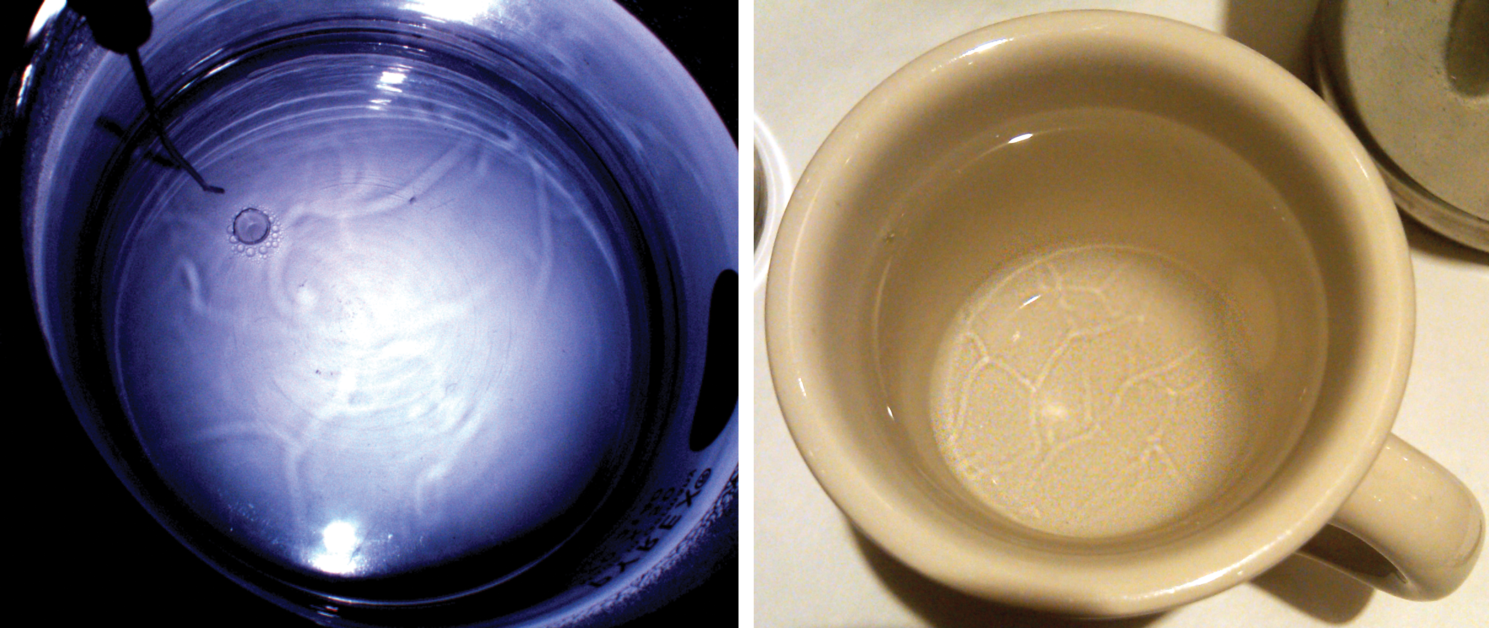
The images of Figure 15.5 confirm that the patterns are perfectly detectable with visible light. The patterns may not be as distinct as those obtained with the infrared camera, but they are discernible. You can see them with your eye or record them with an ordinary camera. Thus, the boundaries comprise something whose optical features differ from those of bulk water.
Figure 15.5. Mosaic pattern in a pot of warm water (left) and in a cup of warm water (right), seen by ordinary visible-light imaging.
Even clearer boundary detection is illustrated in Figure 15.6. A pan of warm water was illuminated with ordinary visible light, incident at very low angle. Contrast is achieved because of the light scattered from surface vesicles, which evidently concentrate differently in the lighter vs. the darker regions. Mosaic patterns obtained this way are identical to those obtained simultaneously with infrared imaging (Ienna et al., 2011). The pan in the figure contains nothing more than warm water, imaged with visible light.
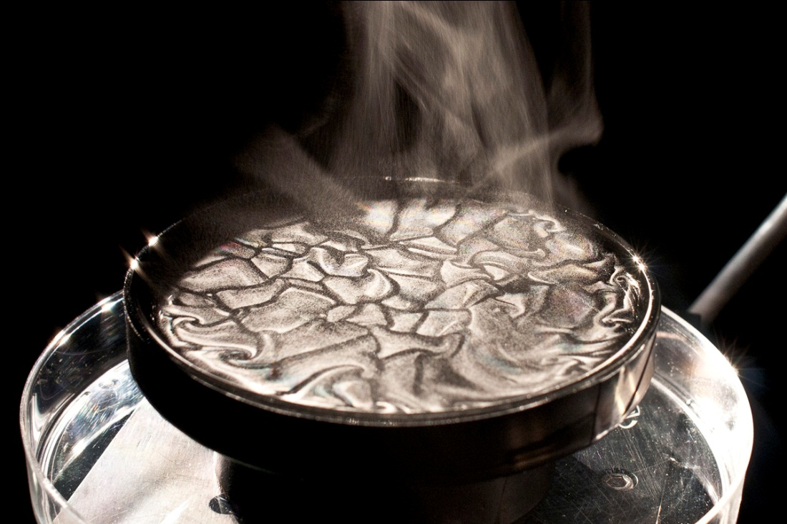
The boundaries visible in all these images evidently comprise something whose properties differ from those of bulk water, and a good candidate would be the EZ. The EZ’s optical properties differ in at least two ways. First, light absorption: not only does the EZ absorb preferentially at 270 nm, but also at other wavelengths as well (Chai et al., 2008). Second, the EZ’s refractive index is higher than that of bulk water, by approximately 10% (Tychinsky, 2011; Bunkin, 2012). These differences are easily large enough to produce optical contrast.
Figure 15.6. Mosaic pattern seen using low-angle visible light.
While the EZ interpretation fits nicely, a loose end remains. Remember those vertical flows that were key to the conventional interpretation? They remain present. Do those flows fit with the new interpretive framework; and if so, what role might they play?
EZ Material and Characteristic Flows
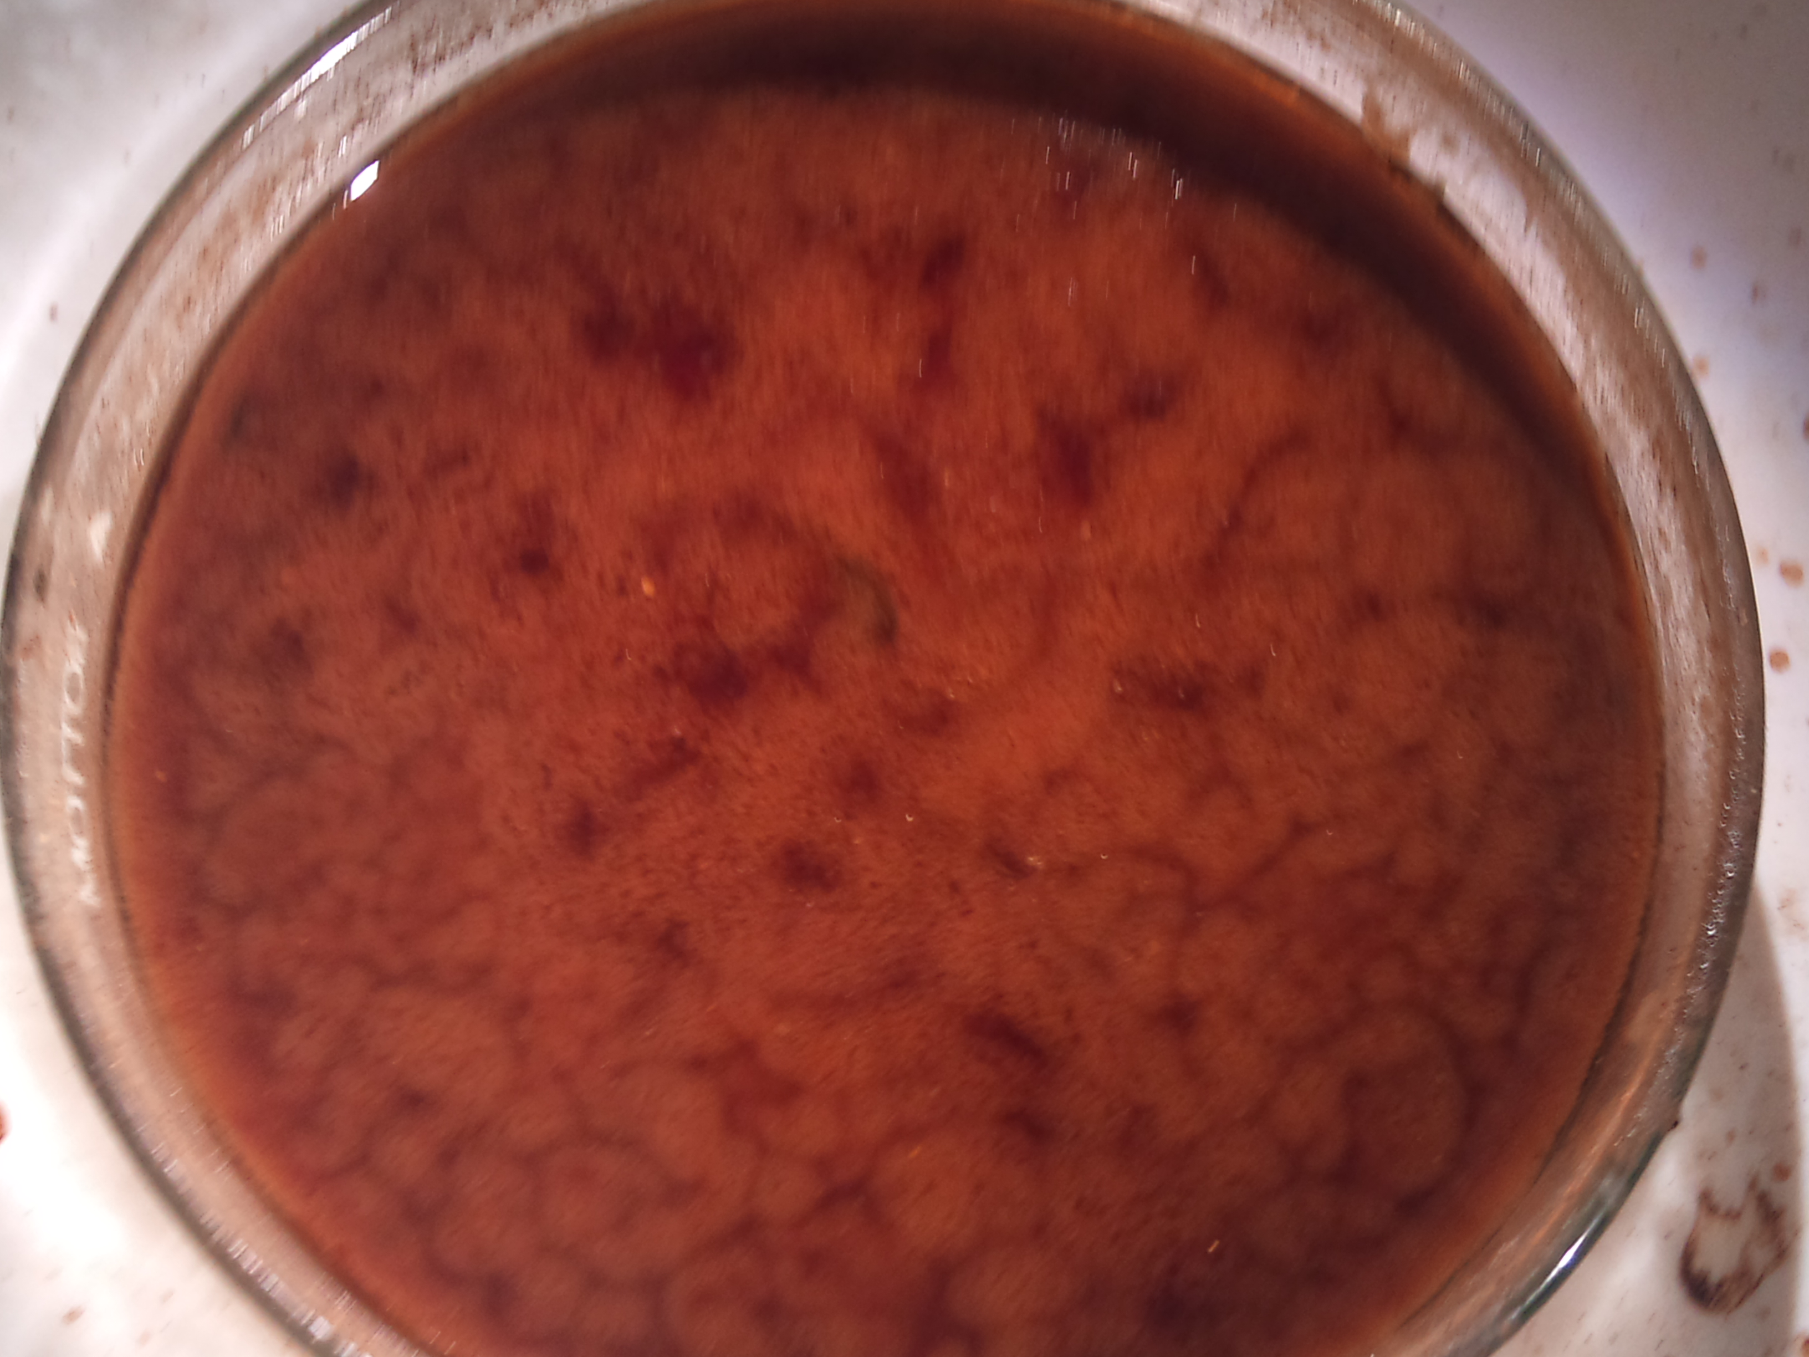
To obtain some hints about the vertical flows, we looked at mosaic patterns visible in various water-containing liquids, including soups. Warm miso soup is ideal; it shows mosaic boundary lines similar to those in the figures above. Please see Figure 15.7.
Observing mosaic patterns in miso soup became a preoccupation in our laboratory. Everyone began looking. Close inspection revealed two salient features: First, the boundary lines were more transparent than the units they enclose; those boundary lines apparently exclude soup particles, which then remain lodged within the cells. This exclusionary feature lent immediate strength to the notion that the boundary comprises some kind of EZ material.
Figure 15.7. Warm miso soup. Mosaic pattern is detectable.
The second observable feature was that the soup particles constantly flow. The particles flow upward within each cell and downward near that cell’s periphery — like circulating mini-fountains internalized within each cell. The mosaic boundaries do not participate; they merely enclose each fountain. So, the classically anticipated up-down flows are indeed present; but those flows do not involve the boundaries.
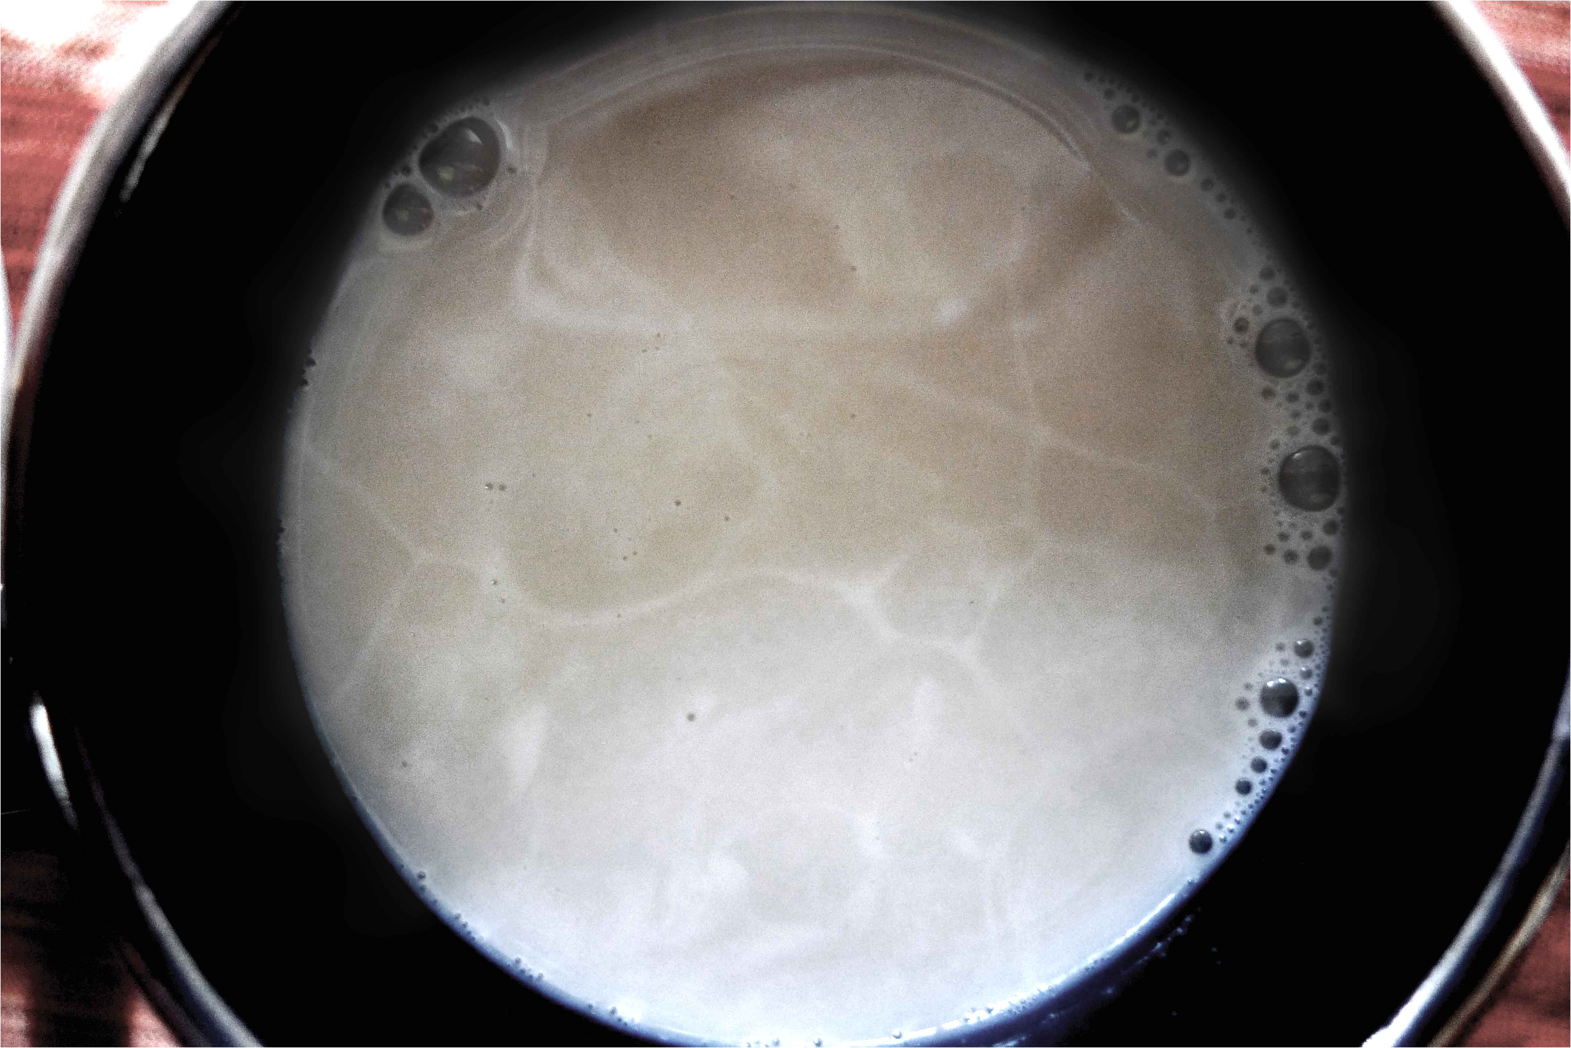
In fact, the boundaries can be seen even when flow is absent. Figure 15.8 shows a 50:50 mixture of pure milk and almond milk, each component taken fresh from the refrigerator and mixed. The pattern is extremely stable. No up-down flow could be detected, even in multiple attempts. Hence, up-down flow is not an obligatory feature of mosaic formation, at least in the soups. It is a secondary feature, appearing most prominently at higher temperatures.
The soups satisfied our hunger for sustenance and our thirst for understanding. They revealed that the mosaics were primary. Their optical clarity implied that the constituent material really does exclude, as EZ material should. That lent confidence. The up-down flows seemed secondary; yet their prominence implied a role of significance, particularly at the warmer temperatures where evaporation is most prominent. The first step seemed to be to figure out what kind of EZ material might create those mosaic boundaries, the flows next.
Figure 15.8. Mosaic pattern visible in cold mixture of milk (1% butterfat) and almond milk.
Composition of the Water Mosaic Boundaries
One option for building the water mosaic is standard EZ material — the kind that ordinarily lines hydrophilic surfaces. That option seems logical, almost reflexive. However, standard EZ material does not ordinarily form ring-like structures anything like those observed. So we hold that option in reserve.
A second option is a water mosaic built of vesicles — the same as implied earlier for the vapor mosaic. Enveloped by EZ shells, vesicles could exploit the like-likes-like mechanism to self-assemble into large ensembles, even networks. Those networks would exclude. The raw materials required for construction should be available: warm water contains many vesicles (Chapter 14); and extremely warm water, where mosaics are most concentrated, contains multitudes of vesicles. Hence, the vesicle option seems more promising.
In fact, the vesicle makeup is more than conjectural, for individual vesicles are discernible in the mosaic. Figure 15.9a, shows the early stages of mosaic formation in warm water; the vesicles are resolvable. The vesicles are also evident in Figure 15.9b, which shows warm water just drawn from an ordinary tap. In both instances the ring-like mosaic boundaries seem to be built of vesicles.
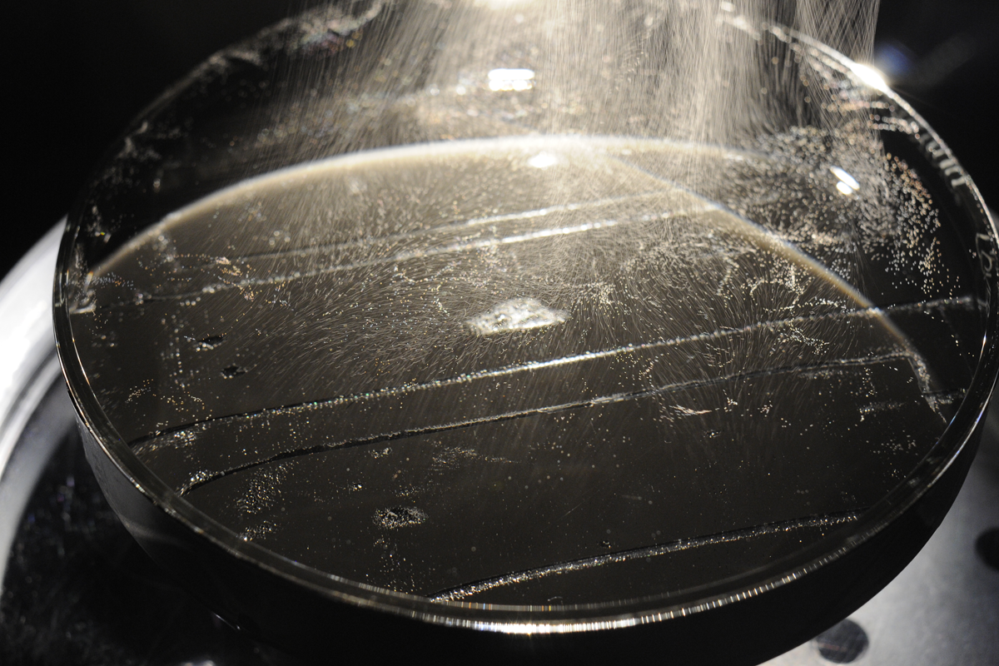
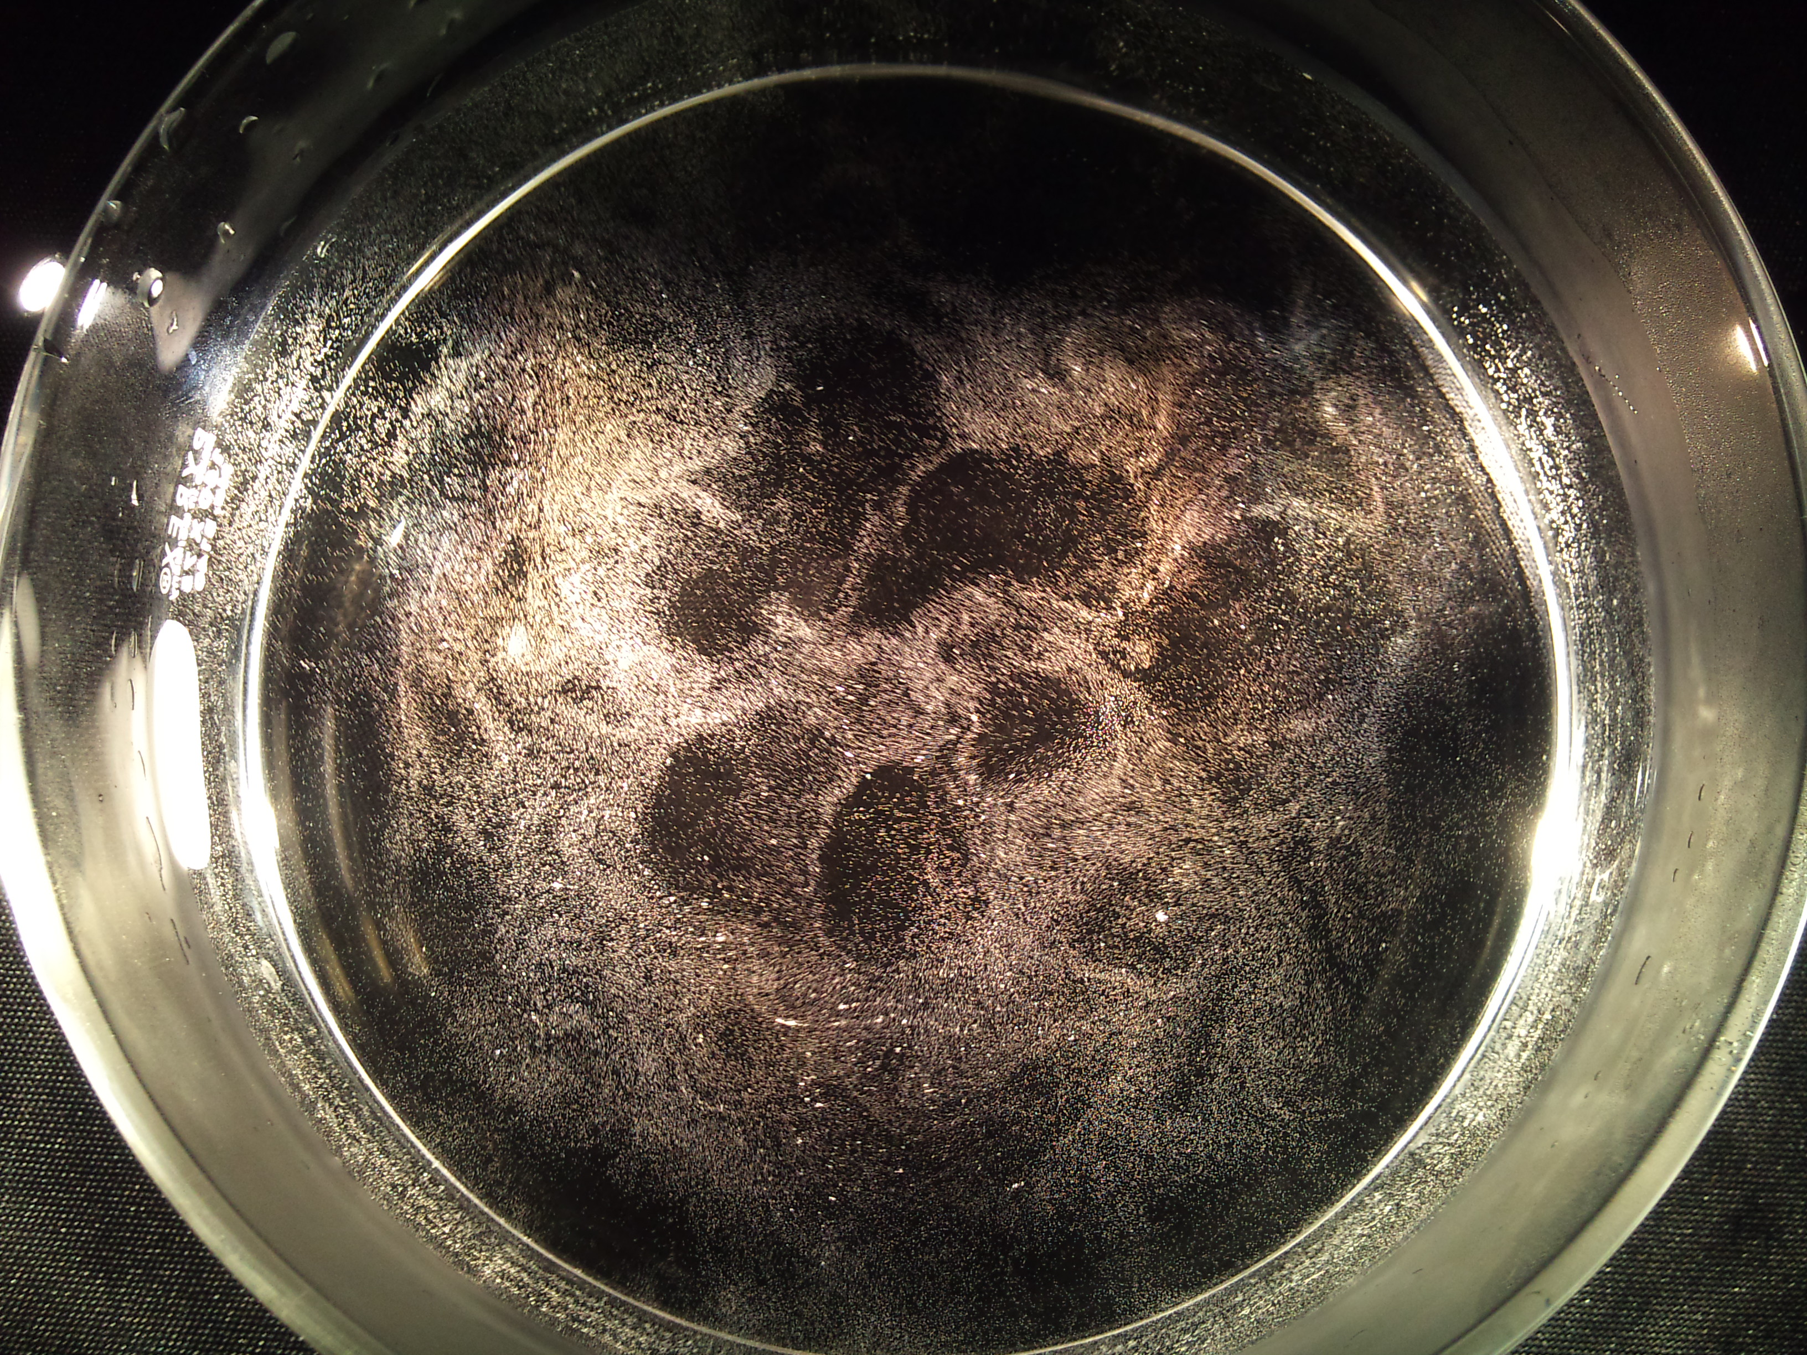
The vapor is likewise built of vesicles, as suggested earlier. Commonly referred to as aerosol droplets, the vesicles scatter light and confer visibility on the vapor. Figure 15.10 confirms that the vapor rings are indeed built of vesicles.
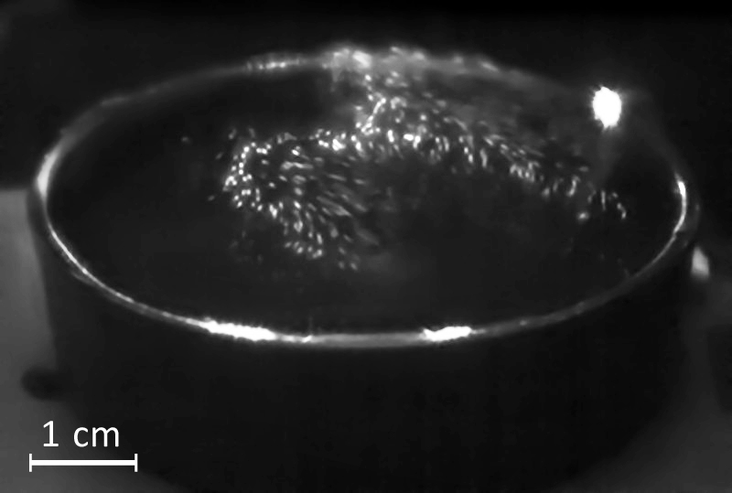
Thus, liquid mosaic rings and vapor mosaic rings are similarly structured: both comprise vesicles arrayed into patterns. It does not take a rocket scientist to deduce that the patterned arrays in the water might rise to produce the similarly patterned arrays in the vapor. Videos confirm that rise: the videos show sheets of vesicles emerging from the water mosaic boundaries to form the vapor mosaic boundaries (Ienna et al., 2011).
Figure 15.9. Incipient mosaic patterns. (a) Warm water poured into a container. Close inspection shows that the mosaic rings are built of individual vesicles. [From Federico Ienna]. (b) Tap water, 60 °C, run slowly into a bowl. Black cloth placed beneath the bowl to enhance contrast. Vesicles accumulate at boundaries, leaving the cells relatively empty. [From ZiYao Wang]

Figure 15.10. Vapor above warm water. Illumination is set to reveal the vapor’s vesicular nature.
Deep Mosaic Structures and Circulation
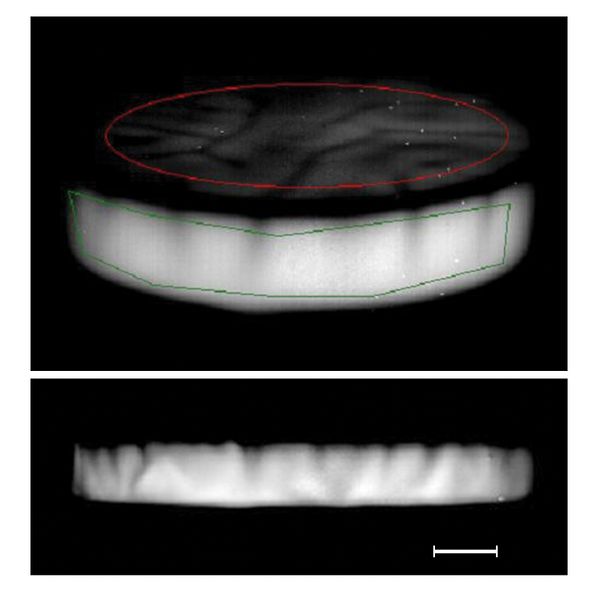
The evaporative rise must involve more than just a single mosaic plane rising from the water. Recall that the vapor mosaic has considerable vertical extent. The liquid mosaic ought to have vertical extent as well, for only then could one structure give rise to the other. Figure 15.11 confirms that expectation. The dark boundary lines of the water mosaic run downward from the surface. Thus, the liquid mosaic structure has considerable vertical extent.
In evaporating water those vertical lines are fairly dynamic. They may bend or undulate, particularly toward the bottom as though the bottoms project rather freely from the top. Videos show abundant material constantly flowing downward along the lines. That material is almost certainly vesiclular: since the vessel contains water alone, some form of water must be responsible, and the only reasonable choice is vesicles — which are abundantly present in warm water.
Figure 15.11. Oblique and side views of warm water obtained with an infrared camera. Downward projecting lines are evident. Scale bar, 1 cm.
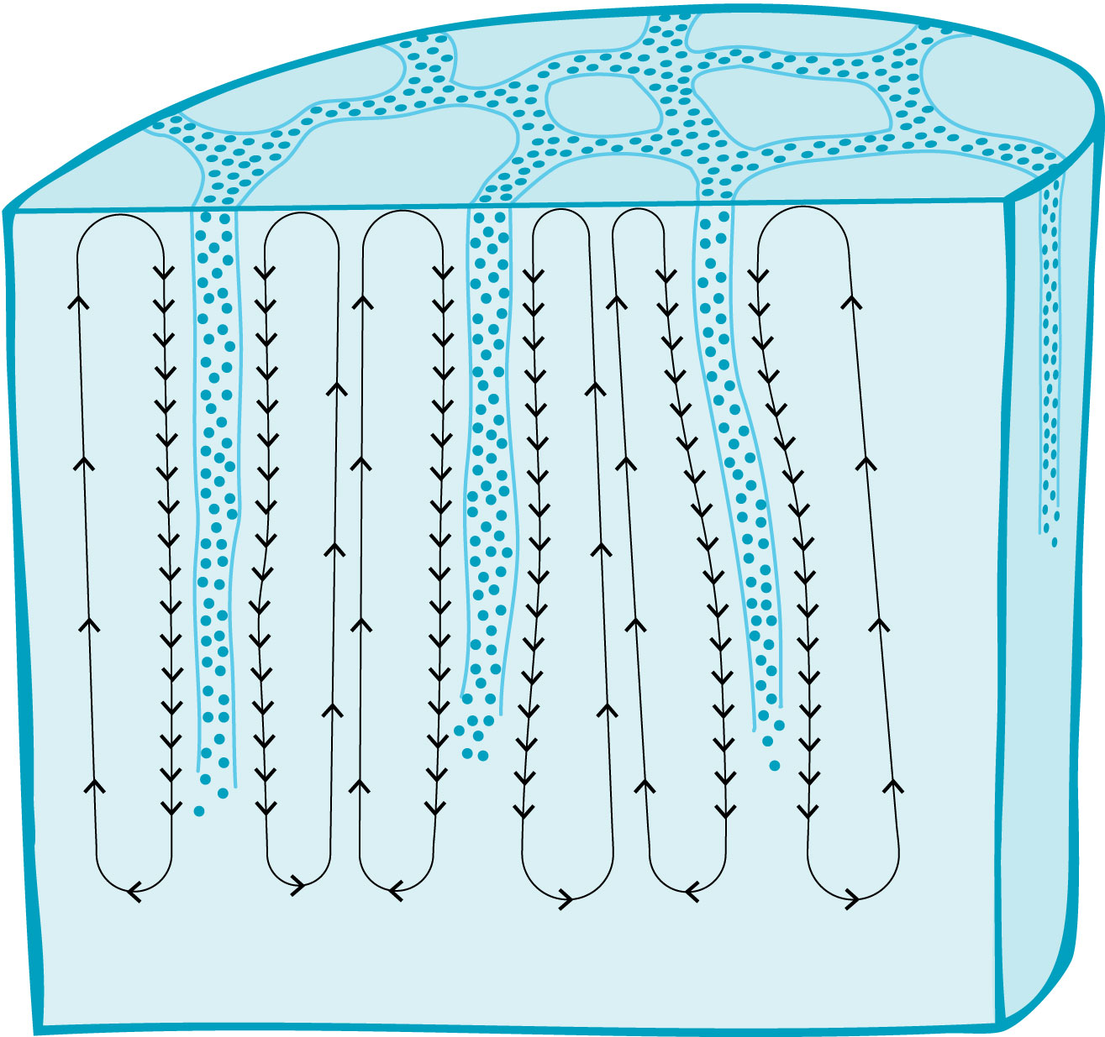
The miso soup observations reveal the pattern of vesicle flow (Fig. 15.12). Vesicles nucleated at or near the bottom of the container will inevitably get caught in the flow. Those vesicles will therefore rise upward within each mosaic cell and return downward next to the boundary walls — as in the miso soup. The downward flow is particularly evident because the vesicles concentrate near the boundaries, attracted to the existing vesicle array by the like-likes-like mechanism.
Those downward flowing vesicles presumably replenish the mosaic. Mosaic material is continually lost as vapor, and must be replaced. The downward flowing vesicles can do the job by linking to the residual framework, The like-likes-like mechanism provides the attractive force. With adequate replenishment, the mosaic maintains itself and evaporation can continue unabated.
Figure 15.12. Circulatory flows observed in warm water. Downward flows are concentrated next to the mosaic boundaries.
The vertical flows make sense also from an energetic perspective. The water had initially become warm because of the radiant energy it had absorbed. That absorbed energy put the water far out of equilibrium with the environment. To return toward equilibrium, the water has to lose energy, either through radiation or by doing work. The flows accomplish both. In order to flow, molecules must overcome molecular friction; this requires energy expenditure, expressed as work. The flow may also generate radiant energy because the vesicular charges move rapidly through the water. Hence, the flows are vehicles through which the water’s excess energy is released — another example demonstrating water’s role as an energy transducer.
There are two main points here. The first is that the water mosaic is indeed a three-dimensional structure, just like the vapor mosaic. Both are vertically oriented tubular structures. The second is that the vertically oriented tubules are renewable. As tubular complexes rise up to form the vapor, they are quickly replenished with freshly manufactured vesicles. This permits evaporative events to continue.
The Evaporative Event
What, then, triggers each evaporative event?
The question of trigger begs the question of what drives evaporation. Since water evaporates most rapidly when it receives ample sunshine or heat, radiant energy absorption might be a good candidate. Radiant energy builds vesicle EZs. If the EZ buildup adds interior protons, then mounting pressure may expand the vesicles, turning their liquid interiors to vapor (Chapter 14). With that density reduction, the tubules may rise up into the air, creating the multi-tubular figures seen in the evaporating vapor.
At first glance, density reduction would seem adequate to propel the rise: vapor-filled vesicles have lower density than liquid vesicles. However, interior density reduction cannot be the full story, for the vesicle also has a shell to consider. The shell consists of dense EZ material, denser even than liquid water. So vapor interior notwithstanding, mean vesicle density could easily remain higher than that of air. On the basis of density alone, then, the vesicles might not necessarily rise. Something more certain seems necessary for propelling the rise.
For a clue, think of those vesicles that rise high up to eventually form clouds. Cloud vesicles — often called aerosol droplets — are filled with water. Those clouds can be weighty. An atmospheric science colleague estimates cloud weight not in kilograms but in elephants, which are easier to fathom. Total droplet weight in a large cumulonimbus cloud can be 15 million elephants. That’s a lot of elephants to keep suspended in the sky (and a lot of shit to watch out for).
Those hapless elephants do eventually plummet to the earth. Rain happens. Thus, cloud vesicles respond to orders of some kind, orders seemingly based on something beyond just density. Some alterable force keeps the elephants high in the sky to prevent them from falling. That same force might help lift the vesicles.
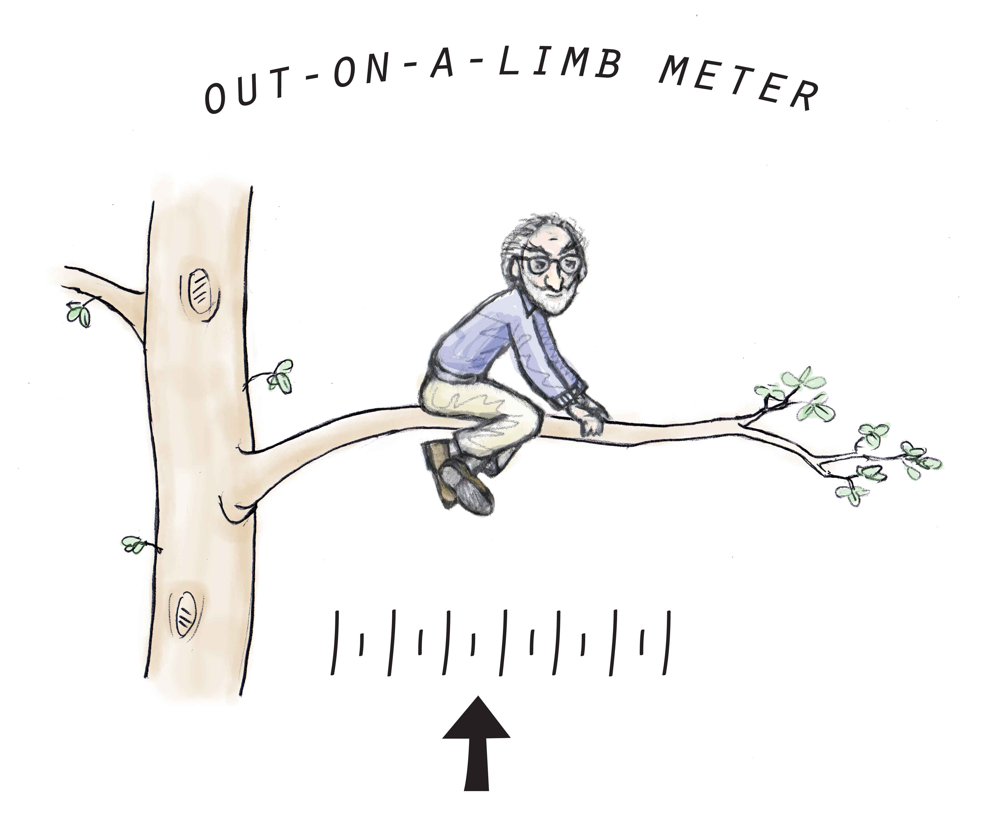
I would speculate that that lifting force may be electrostatic, i.e., charge based. You may recollect from Chapter 14 that vesicles carry a net negative charge. Negative charge by itself is not sufficient for explaining lift; however the earth bears negative charge as well (see Chapter 5). Those two negative charges create a repulsive force. In theory, this vertically oriented repulsive force could help propel the evaporative rise (Fig. 15.13).
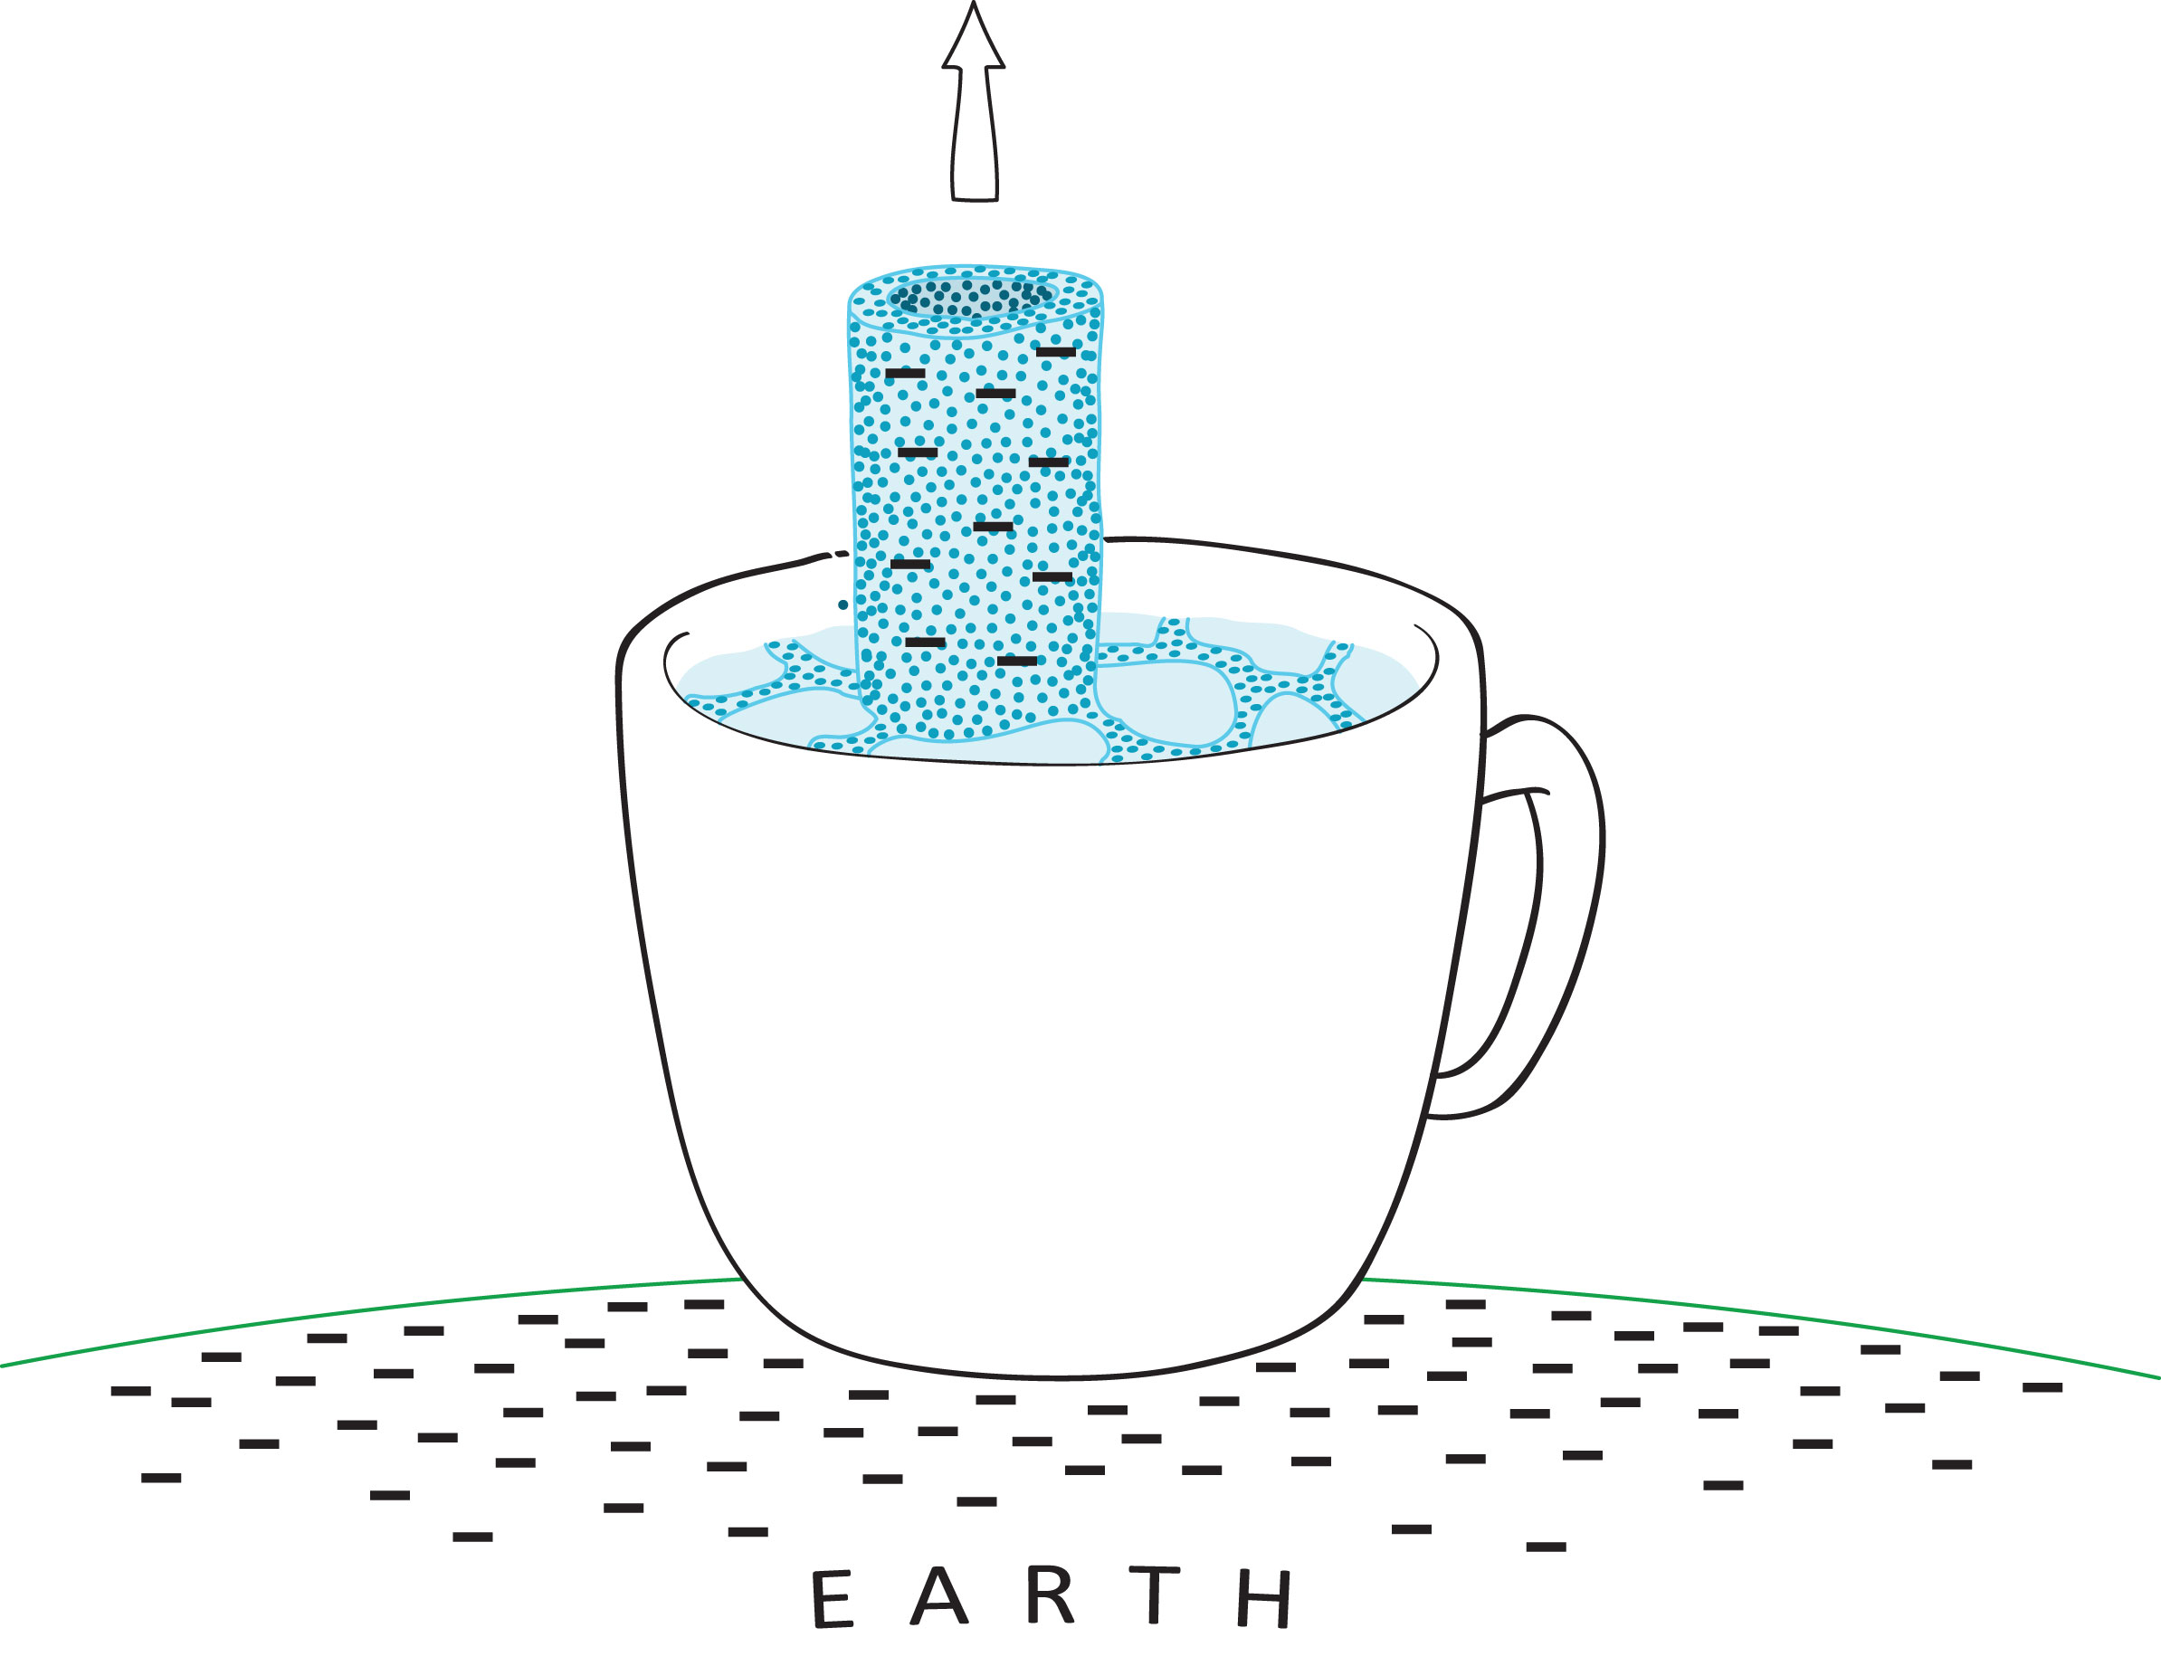
A familiar example of this kind of levitational force is associated with waterfalls. As the water hits the bottom it creates a mist of droplets that rise upward, forming a cloud. The cloud can sometimes rise above the top of the falls (Fig. 15.14). Since the droplets cannot mechanically rebound to those heights, some kind of levitational force is implied, and a good possibility is negative charge repulsion. Such repulsive force may be the same as the force that suspends the elephants — and perhaps also the same as the force that propels the tubular structures upward. Those tubular structures merely need to acquire enough negative charge to trigger the rise.
Figure 15.13. Negatively charged vesicles are repelled from the surface of the earth.
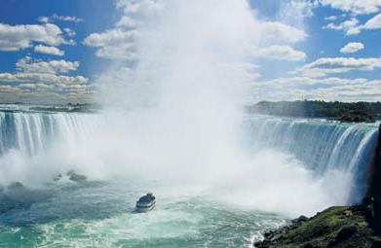
With this mechanism we can appreciate why the rise is practically explosive. The sun’s radiant energy creates vesicles, which then self-assemble into mosaic tubes. The tubes bear net negative charge because constituent vesicles are negative. Protons lying between vesicles mitigate the negativity; however, those like-like-like attractors are merely spot welds contributing only modest amounts of positive charge. Net negativity remains. As tubules adsorb more and more vesicles the tubules’ net negativity increases. When the internal charge exceeds a threshold, the tubule structure literally tears itself apart at the weakest point. The top section then rises upward — repelled from the negative residual structure below and also from the negative Earth.
Figure 15.14. Niagara Falls. Note the ever-present cloud of water droplets rising upward. From web-ref 2.

The evaporative event is therefore catastrophic; it occurs because of a charge-based instability. Once the unstable threshold is crossed, the vapor appears as a discrete event — one of those puffs that you may see above your hot coffee.
Completing the Evaporative Cycle.
The vapor clouds may appear, but they ultimately disappear. Watching the vapor over a cup of hot coffee reveals that the puffs eventually vanish into the air. We might rightly ask why and how they vanish.
Two possible explanations come to mind: the vesicle aggregate might break up; or the vesicles themselves might break up. Individual vesicle breakup is conceivable, but a reason for any such breakup is not obvious; more likely they remain intact. Aggregate breakup is simpler to envision because the positive charge linkages are rather labile, and could easily disperse in the air. The vesicles would then be freed — but intact.
Suspended in the air, those freed vesicles should disperse. The dispersed vesicles would escape detection: vesicles do scatter light, but if widely enough dispersed, then the amount of light scattered would be modest. Humid air would tell a different story. High concentrations of vesicles would scatter light appreciably, explaining the oft-seen summer-humidity haze. Distance vision is compromised simply because concentrated vesicles scatter too much light. It’s like seeing through a thin cloud.
Which brings the next point: those dispersed vesicles stand ready to form clouds. All they need do is re-aggregate. The re-aggregation process need not be complicated — I believe it requires nothing more than positive charge — but in the interest of brevity I will leave that discussion for another venue.
The point is that vesicles provide a simple vehicle of continuity. The vesicles form in water. They then transition from liquid water, to vapor, to clouds, and ultimately to rainfall as the vesicles fuse with one another to create droplets and return back to the Earth. Thus, vesicle dynamics may be a central feature of the water cycle, and hence a central feature of weather.
---
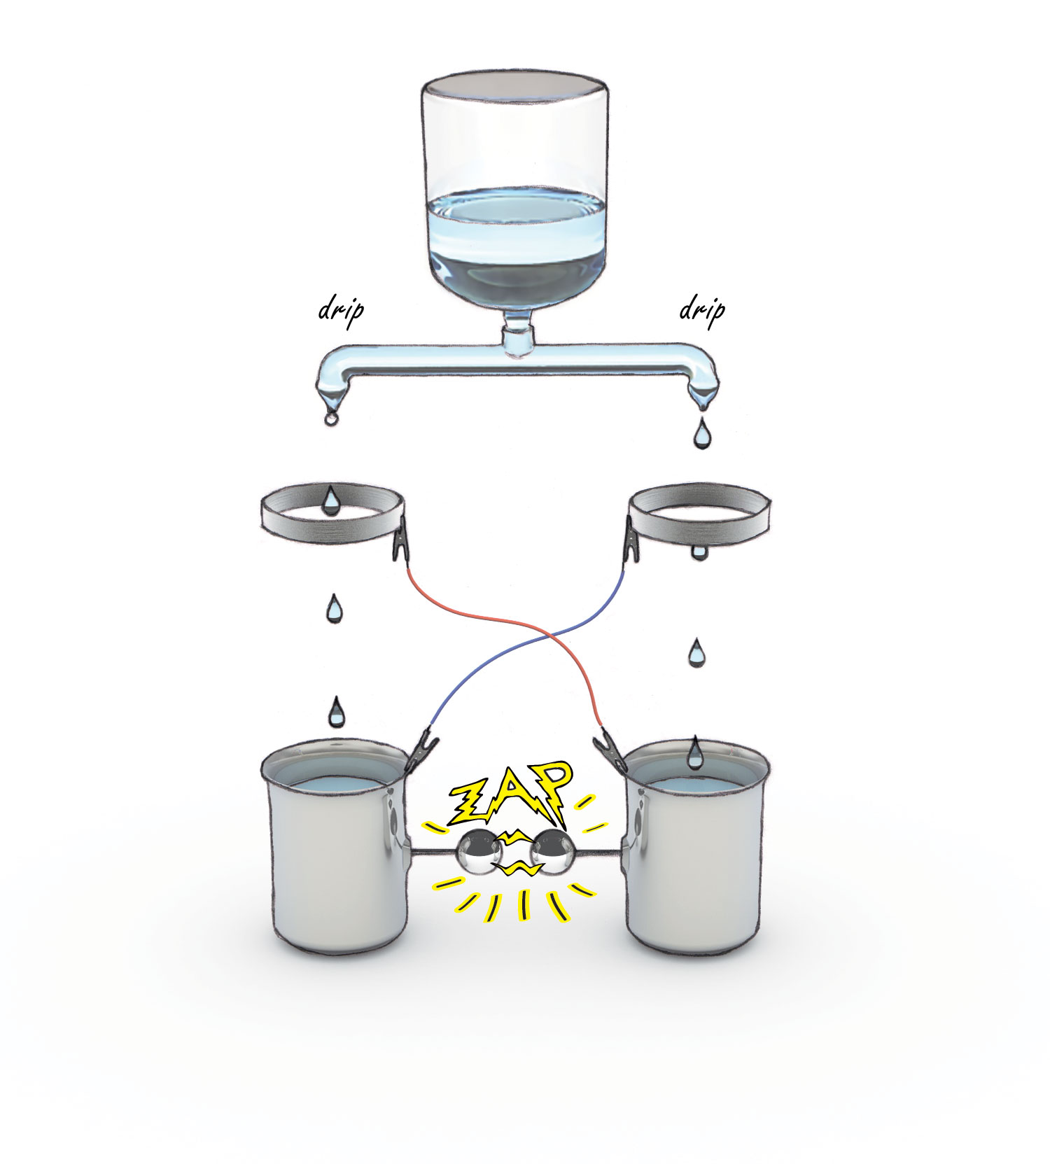
BOX: Vesicle charge and the Kelvin Water-Dropper
Zap! An electrical discharge between two containers of water, both filled from same source. Weird — but that’s the Kelvin water dropper demonstration (Chapter 1).
The discharge bespeaks the falling droplets’ ability to carry charge. Here’s how the discharge works. Suppose the first falling droplet happens to contain a trace of charge, let’s say negative. If that droplet falls into the left bucket, then the left bucket will contain a trace of negative charge.
Now in the Kelvin experiment all buckets and rings are metallic. They conduct. If the left container acquires negative charge, then the right ring will also be negatively charged (see diagram). The right ring’s negative charge — here’s the key — will induce equal and opposite charge on the water just above. The tip of that column of water, about to drop, will therefore be positively charged. When the drop falls into the right bucket, that bucket will contain trace positive charge.
The right bucket’s positive charge will in turn confer positivity to the left ring, which induces negativity in the water column just above. So the next droplet to fall on the left will bear negative charge.
Thus, every drop falling into the left bucket will contribute negative charge while every droplet falling into the right bucket will contribute positive charge. As charge builds in each bucket and hence each ring, the induction effect will become increasingly strong. Eventually the buckets become so highly charged that discharge is inevitable. The buckets then discharge onto one another.
Apart from the impressive zap, a subtle sideshow is the droplets’ dynamic behavior. The descending droplets sense the charge on the buckets below. As bucket charge increases, the falling droplets begin deflecting away and even upward, often missing the target bucket altogether. In other words, the charge effect is anything but feeble; from the Kelvin demonstration it’s clear that charge effects can be strong enough to defy gravity.
This point may be of significance when considering why small vesicles rising from coffee can remain suspended in the air. Electrical forces can be impressive.
---
Bug Screens and Air Flow
As tempting as it may be to end this chapter here, I am nevertheless drawn to consider what happens to those evaporated vesicles dispersed throughout the air. Those vesicles may condense into clouds on occasion. In most circumstances, however, you’d guess that the vesicles would remain suspended and independent of one another, floating aimlessly in the air like children’s bubbles.
That scenario seems unlikely. Some kind of interaction with the air seems probable for at least two reasons. First, the unitary vesicle is charged; charged vesicles will inevitably seek out opposite charges wherever they might lodge, and the air contains plenty of charges. Second, air molecules themselves show signs of linkage, which could easily involve the vesicles. It is this latter linkage possibility that I want to consider for a moment because it is unanticipated.
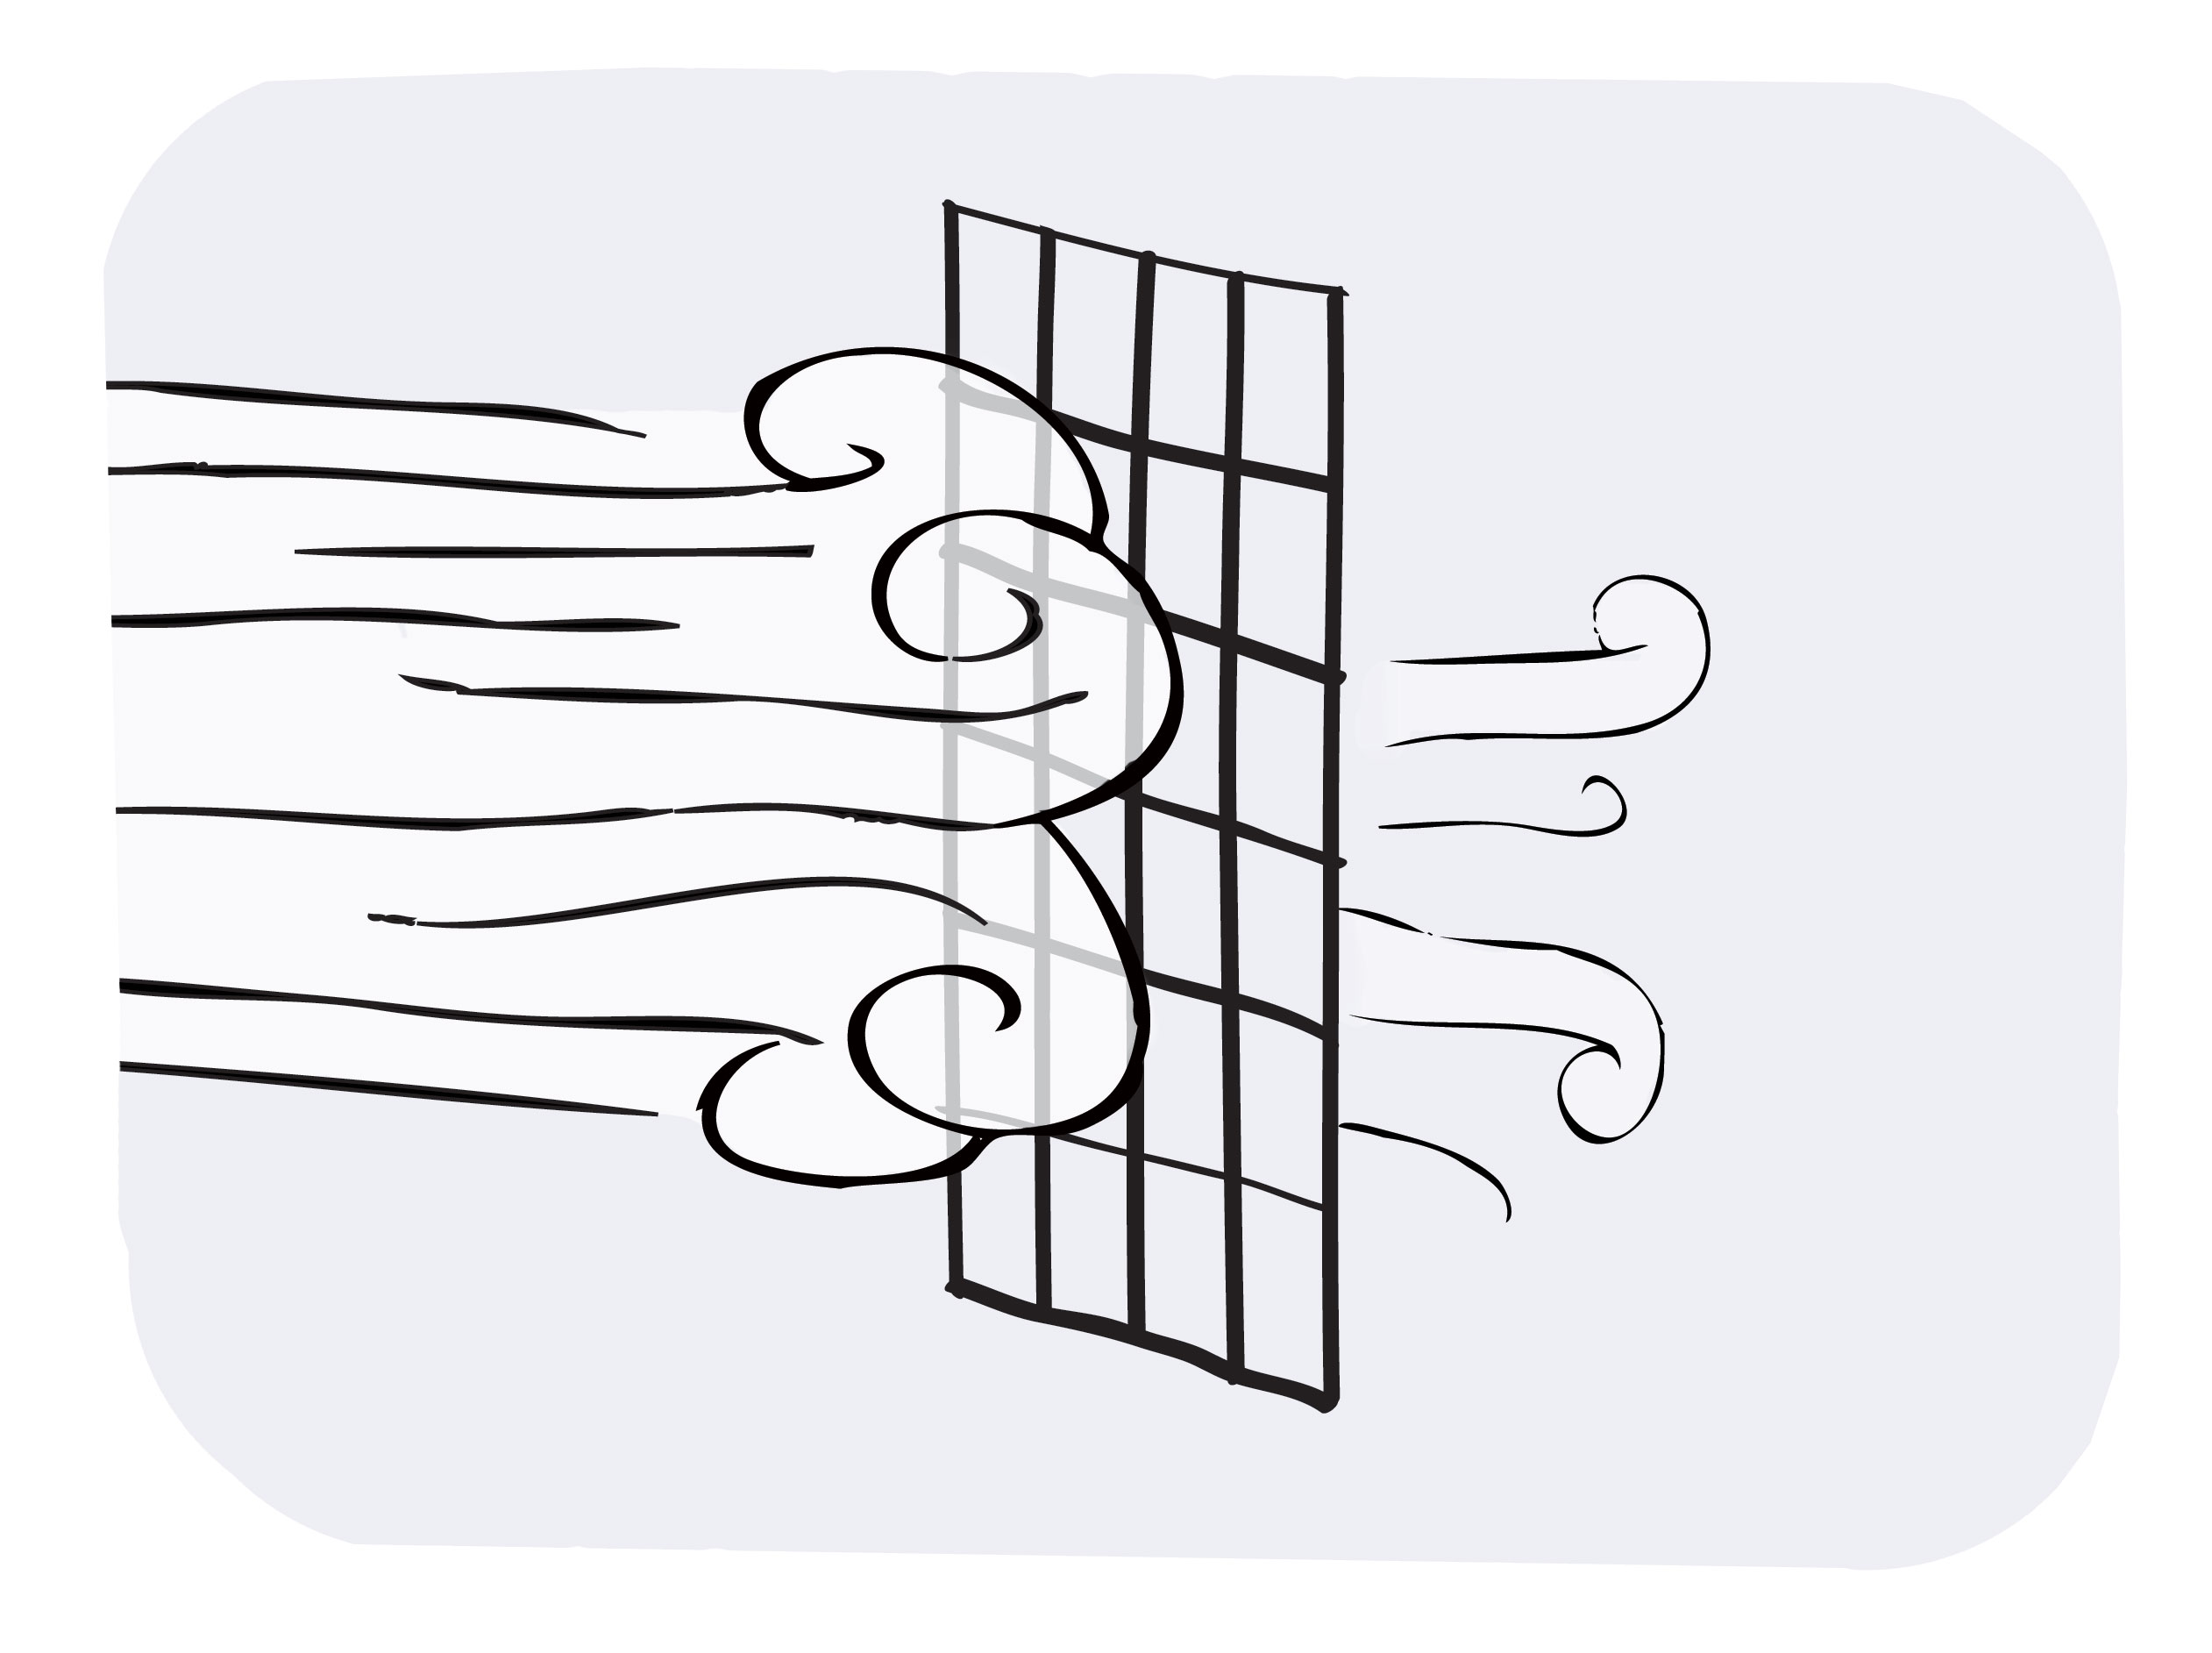
To demonstrate said linkages, try the following experiment (Fig. 15.15). On a humid day, take notice of the breeze wafting pleasantly into an open window of your home. Now slip a bug screen into the window frame, and note the decrease of wind speed. Several colleagues had told me of this phenomenon. In my own experience at home, the speed on the leeward side dropped substantially. A crude sensor showed a speed diminution of about two times. You expect some drop in speed because the screening material partially blocks the air passage; but the material in my bug screen covers only 10 to 15 percent of the area, whereas the speed easily fell by half. Something more seemed to be going on.
Let me put the scenario into a more quantitative perspective. Air molecules are measured in nanometers, while the screen openings are measured in millimeters. That’s a linear ratio of a million times.
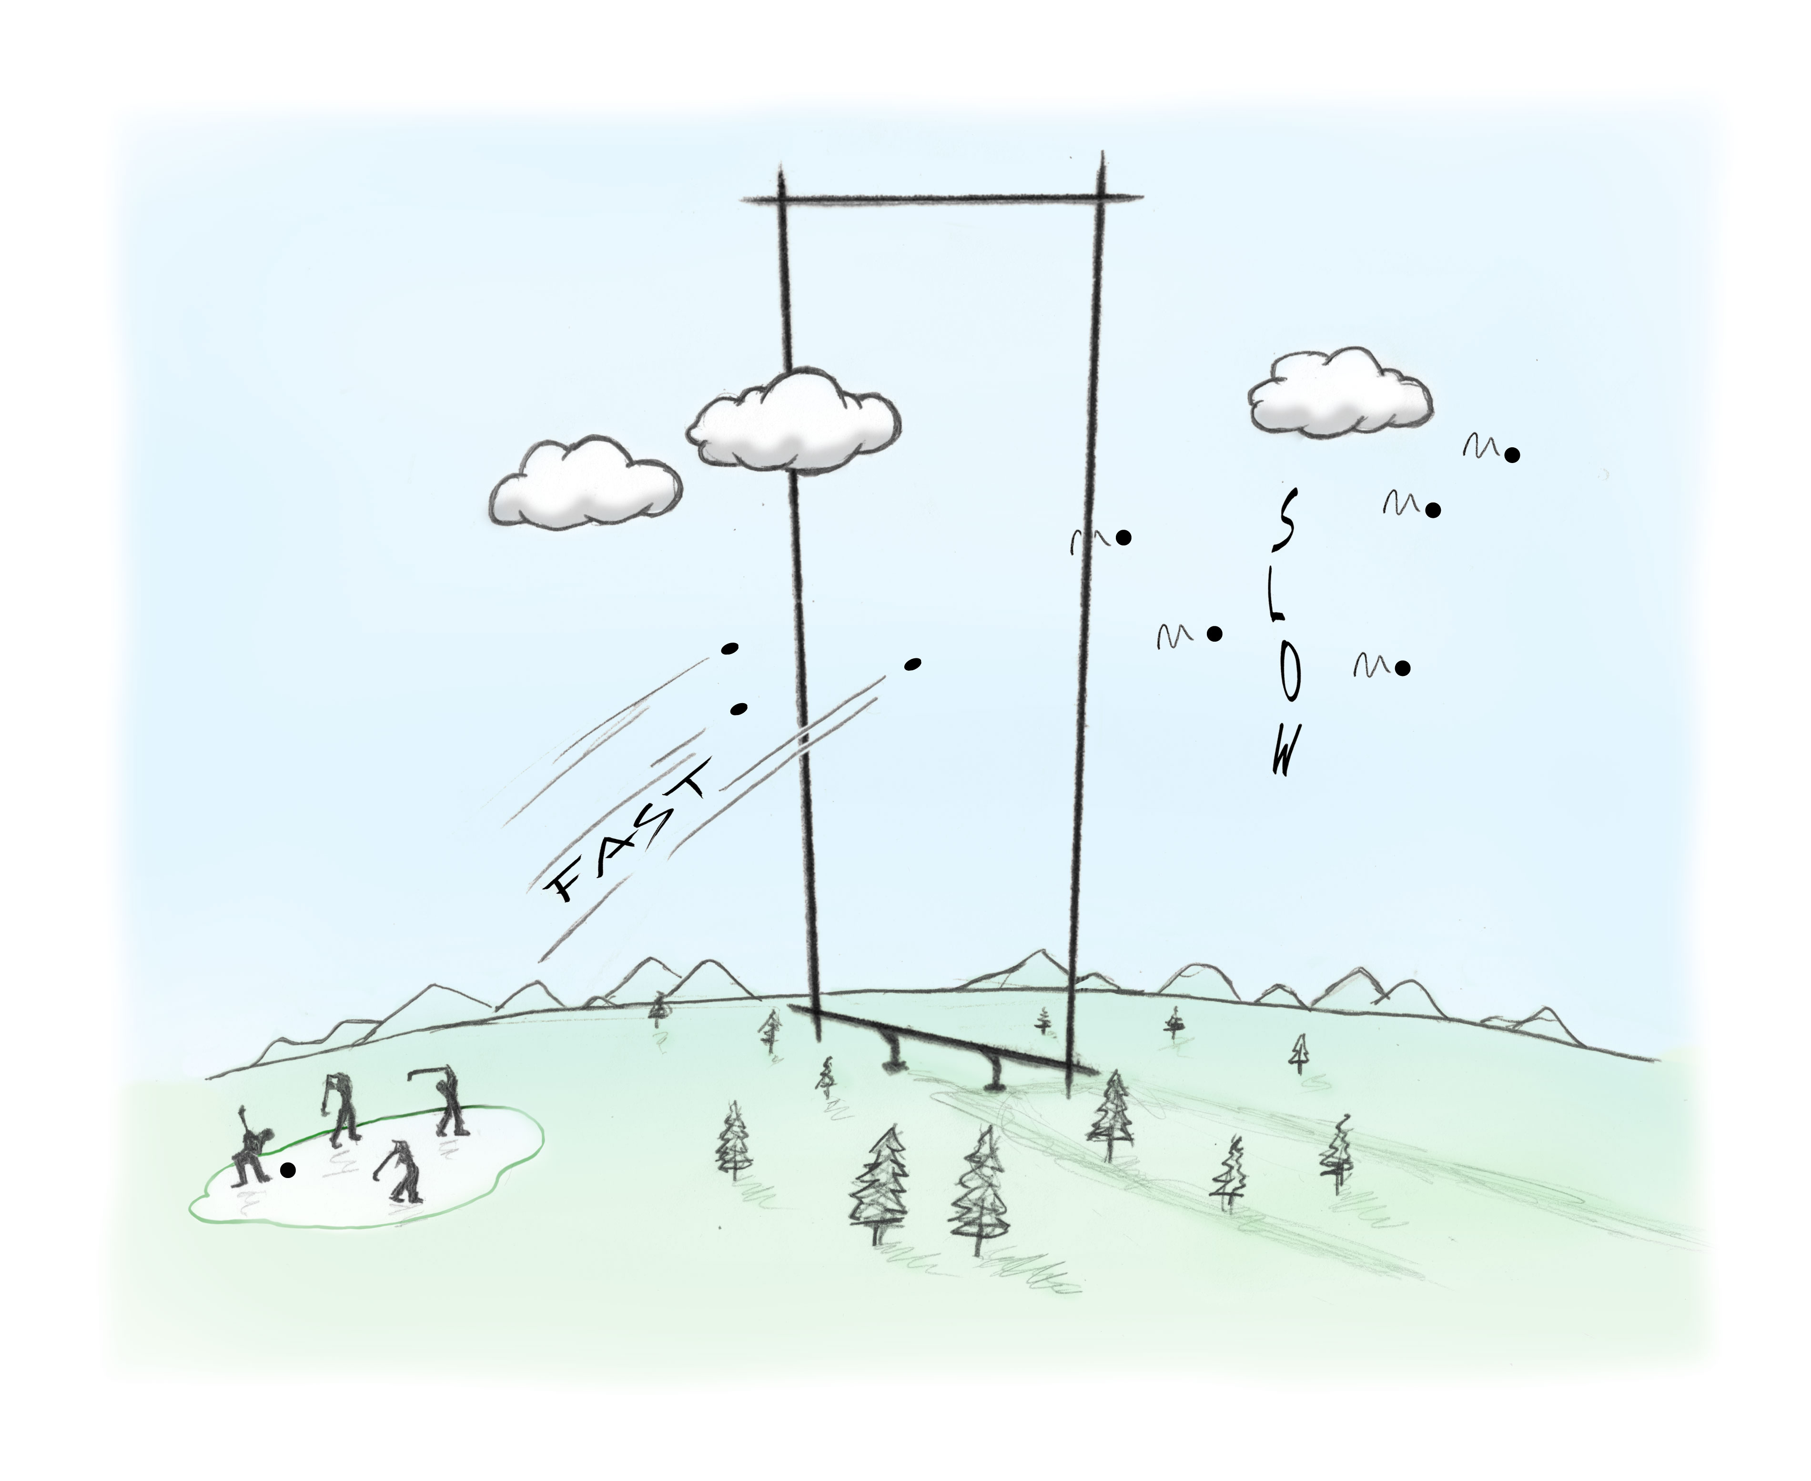
To appreciate the difference of scale, imagine a bug screen whose unit openings are the size of a mountain. Cut out one of those units and stand it vertically on edge (Fig. 15.16). Now drive golf balls through the opening. You notice that merely having that screen boundary in place is sufficient to slow down all the balls passing through. Remove the screen boundary and the velocity returns to normal. As weird as that may seem, it’s analogous to what happens as the air molecules pass through the bug screen. The size ratio is similar.
Figure 15.15. Ordinary window screens reduce moist air flow more than anticipated.
Figure 15.16. Bug-screen analogy. Even though the boundary is massively large, its presence slows down the golf balls.
Turbulence and eddies may play some role in retarding the flow, but the speed diminution seems too impressive to be explained away so easily. Something else seems to be going on. A possible explanation is unconventional: suppose the air molecules were linked to one another, forming a loose net. Then, any molecule(s) hitting the screen material would slow down all the rest of the molecules.
Of course, air molecules should be unlinked in theory: molecular independence is the very definition of a gas — at least an ideal gas. However, the screen result demands and explanation, and some kind of linkages seem worth exploring. Could some evaporated entity create the implied linkages?
Linkages in the Air?
Evaporative entities include both the vesicles and proton glue that rises along with the vesicles. If the vesicles disperse, then the protons might disperse as well. Those protons initially seemed an attractive linkage candidate: their positive charge could link electronegative sites on nitrogen and oxygen molecules in the air. This seemed promising. However, proton linkages could only create molecular pairs. Multiple pairs don’t suffice; the bug screen results imply extensive linkages.
Dwelling on those possible proton linkages nevertheless brought to mind a long-known paradox that suddenly seemed freshly relevant. That paradox is the constant nitrogen-to-oxygen ratio. By volume, dry air contains 78.09% nitrogen and 20.95% oxygen. The ratio is 3.727. While concentrations of trace gases like argon and carbon dioxide can vary widely from place to place and time to time, the ratio of oxygen to nitrogen remains stubbornly constant — to four significant figures (Web ref 3). That’s an awfully constant ratio.
This constancy seems to hold irrespective of where you are — in the city, on a farm, or even atop a mountain. Even in locales like wintry Siberia where photosynthesis surely contributes far less oxygen than in the jungles of the Amazon, still the ratio holds fast. In fact, the ratio remains so invariant that atmospheric scientists are working assiduously to develop instruments that push measurement precision from four significant digits to five significant digits; that might facilitate the search for even trivial oxygen differences.
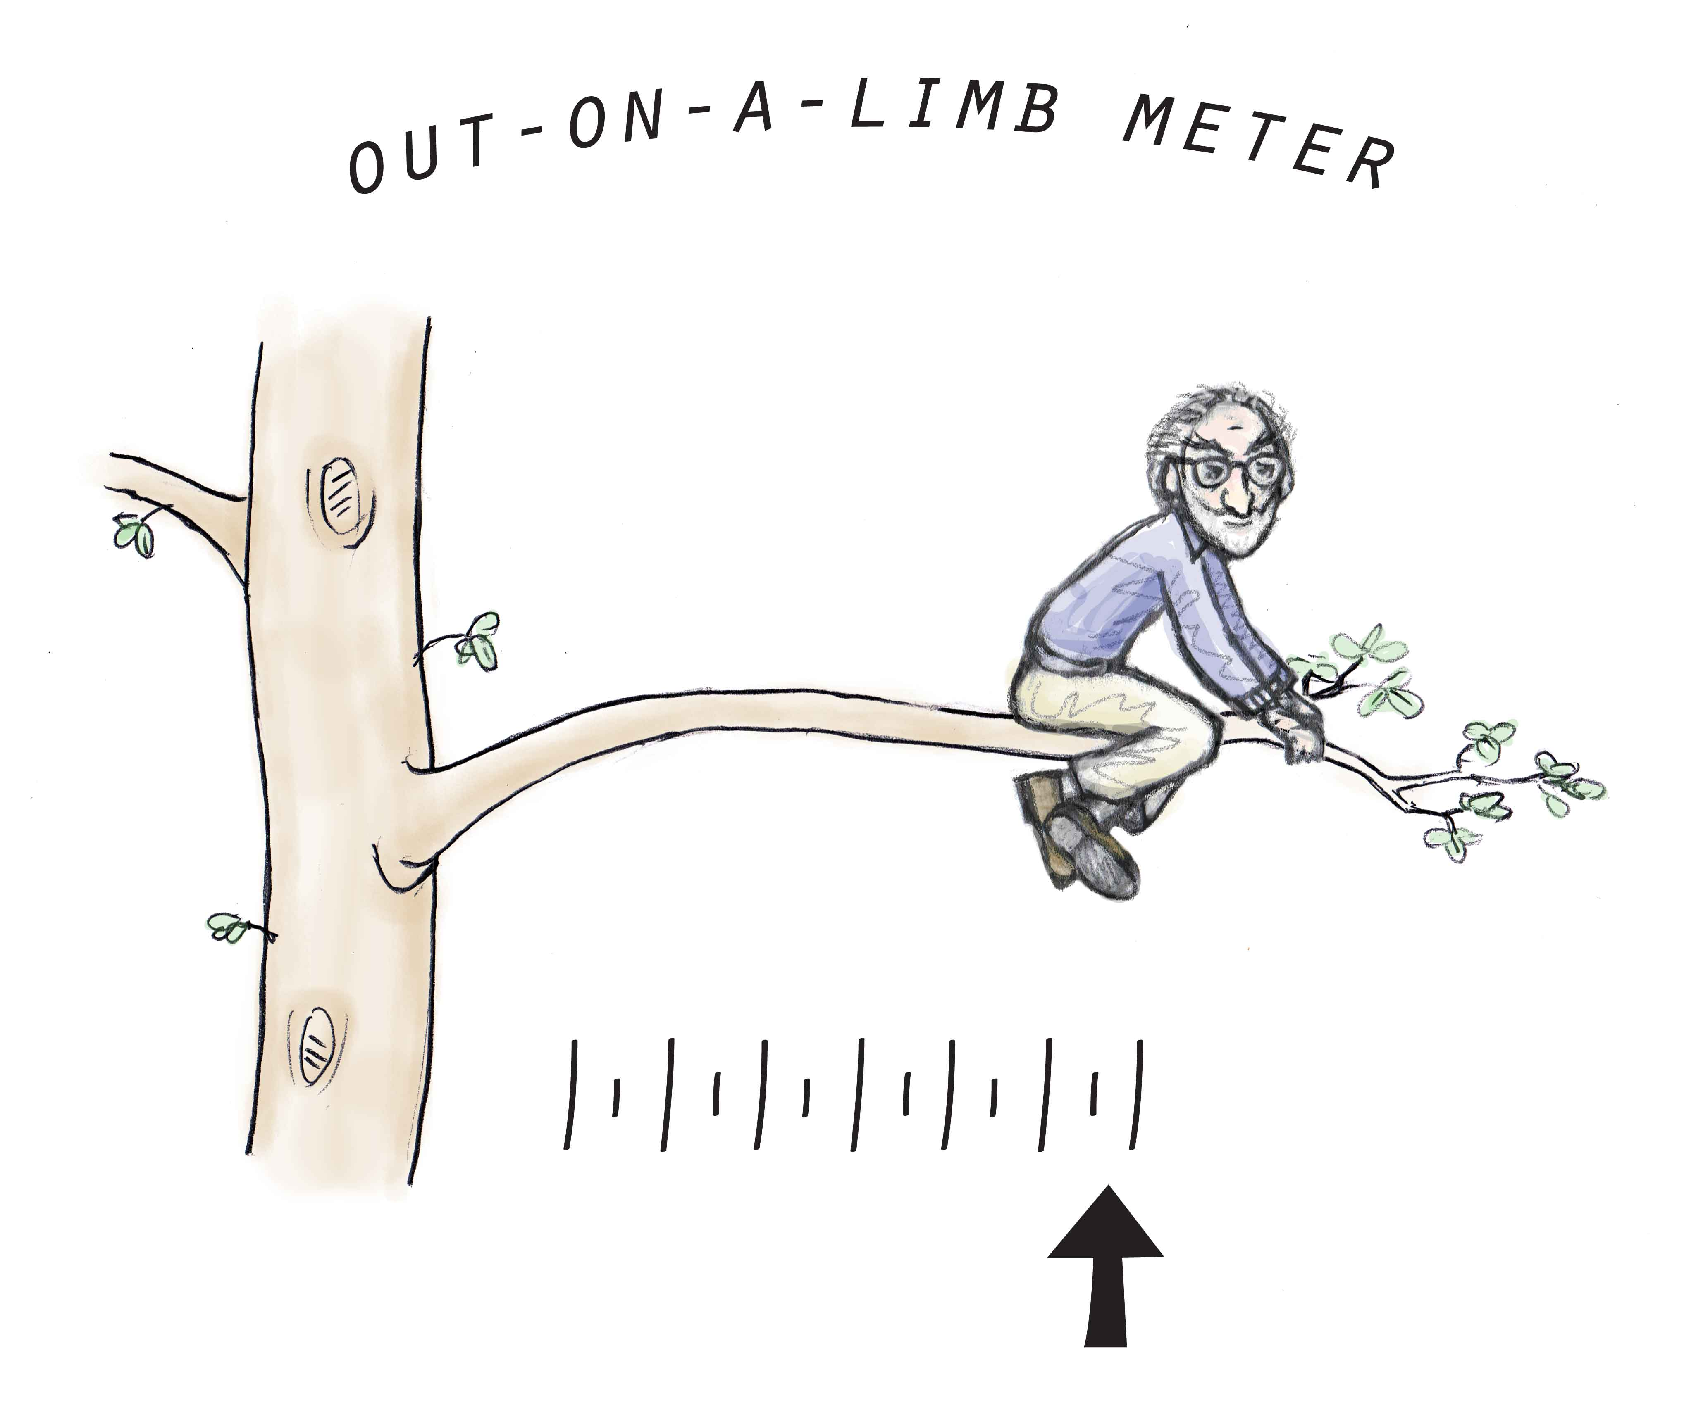
A possible explanation for this unexpected constancy is that these gases’ earthly turnover is trivial relative to overall atmospheric content. In other words, the vast oxygen-generating flora covering the Earth might not really matter. That is certainly possible, although not easy to understand if the oxygen really did come from the flora to begin with.
Another possible explanation — and here I go far out on the limb of speculation — is that nitrogen and oxygen form stoichiometric complexes — i.e., complexes containing fixed ratios of oxygen to nitrogen. Complexes of that sort are known as gas clathrates. Gas clathrates typically contain fixed numbers of gas molecules trapped within cages of water. In the present case the complexes would contain fixed numbers of nitrogen and oxygen molecules, electronegative entities held together by positive protons.
How many molecules? Gas clathrates commonly contain up to dozens of molecules. In air, the nitrogen to oxygen is near 4:1 by volume; if the molecule ratio were exactly 4:1, then the clathrate might contain only five molecules (Fig. 15.17). Other integer ratios would yield larger numbers with different arrangements, but the essence would remain the same: stoichiometric complexes of nitrogen and oxygen. Furthermore, if the probability of complex formation were high, then virtually all of the air’s nitrogen and oxygen molecules could be complexed; the nitrogen-to-oxygen ratio would then remain invariant over space and time, as observed.
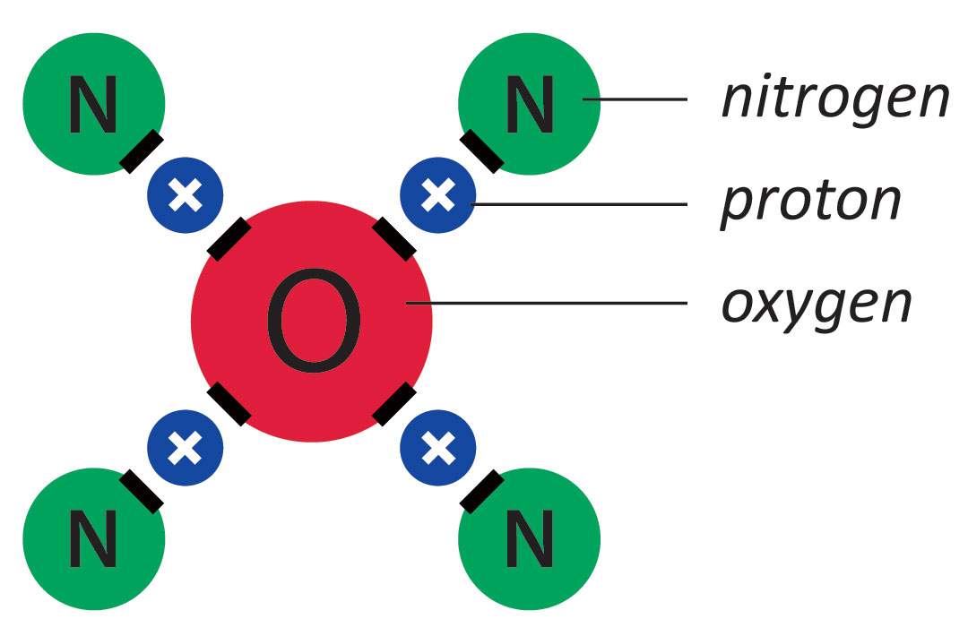
The clathrate hypothesis has the advantage of defining a role for the atmosphere’s positive charge. Scientists know of this charge, but don’t know its origin or role. Its origin could lie in the protons freed during evaporation; and its role could be to create molecular linkages.
Although those protons might explain the gas ratio constancy, they don’t solve the problem we need to solve: extensive linkages. Here the second evaporative entity might come into play: the vesicles. Negatively charged vesicles always seek positivity. The most abundant sources of atmospheric positivity are the nitrogen molecules’ exposed ends — the clathrates’ outer edges. Vesicles latching onto those sites could nucleate extensive linkages (Fig. 15.18).
Figure 15.17. Possible gas linkages. Protons might link electronegative sites on oxygen and nitrogen, creating stoichiometric linkages such as the one shown. The actual number of molecules would be larger.
While said linkages are speculative, and require serious experimental followup, they could easily explain the screen results. Such linkages would be rather weak — weak enough perhaps to escape casual detection. Yet they could be strong enough to explain why the humid air that scatters light is commonly described as “thick” and “heavy.” The many vesicle linkages present in humid air would explain why that air brings the most screen retardation.
Atmospheric Conductivity and Friction
Beyond solving the bug-screen problem, the proposed linkages might help explain certain paradoxical but seemingly unrelated phenomena. I’ll consider two of them. The first is atmosphere’s remarkable ability to transmit electronic signals.
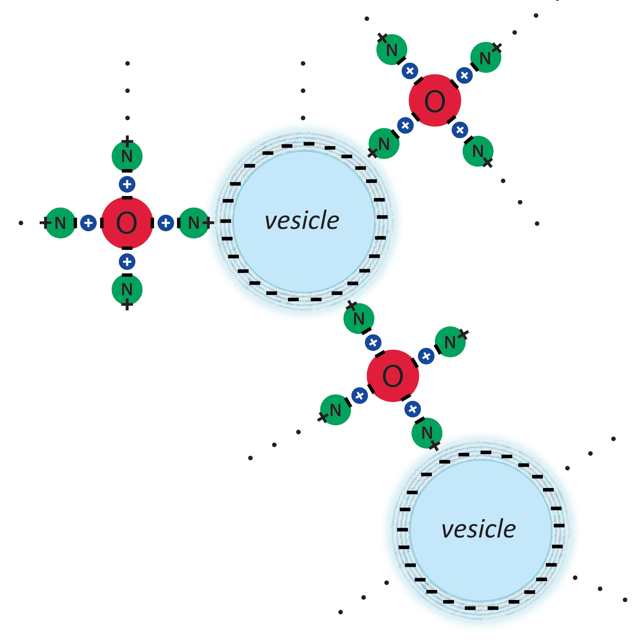
As a child, I wondered how radio waves generated in Australia could reach all the way Brooklyn. Those distant signals could be picked up by my radio and my friend’s radio next door. Somehow, energy radiated from the other side of the world filled the local atmosphere; the radio waves seemed everywhere. Even if those waves maintained strength by bouncing multiple times off the ionosphere and the Earth, still I could not understand how it could persist in strength over such immense distances.
Even more impressive, my primitive crystal radio could perform almost as well. It too could pick up radio signals sent from huge distances. Yet, it had no battery. Those distant-traveling signals themselves must have contained enough energy not only to emerge cleanly from my crystal detector but also to power my headphones. Incredible! To my knowledge no satisfying explanation for this feat has ever emerged.
Figure 15.18. Vesicles might loosely link oxygen-nitrogen complexes to form a continuous structure.
Whether the putative air-molecule linkages might solve the electromagnetic transmission problem remains speculative — even more so than the linkages’ existence. However, such linkages could provide a kind of electrical continuity. A signal sent from Australia might travel along those atmospheric “wires” in much the same way as signals travel along copper wires. The signals could travel virtually everywhere. Losses would be anticipated, but since radiant energy continuously feeds the vesicles, those vesicles could serve as signal amplification nodes, boosting the signals everywhere. In that case, plenty of signal could be available to power even passive crystal receivers.
While in a speculative vein, I’d go a step further to suggest that these linkages might resolve another unrelated atmospheric conundrum: why the atmosphere moves in lockstep with the Earth. Consider this: The Earth spins relentlessly around its own axis. Relative to the universe’s reference frame, you are whizzing around at 1,500 km per hour, twice the speed of a jet plane. The air around you evidently moves the same — for if it did not, then you’d feel an eternally howling wind (Fig. 15.19).
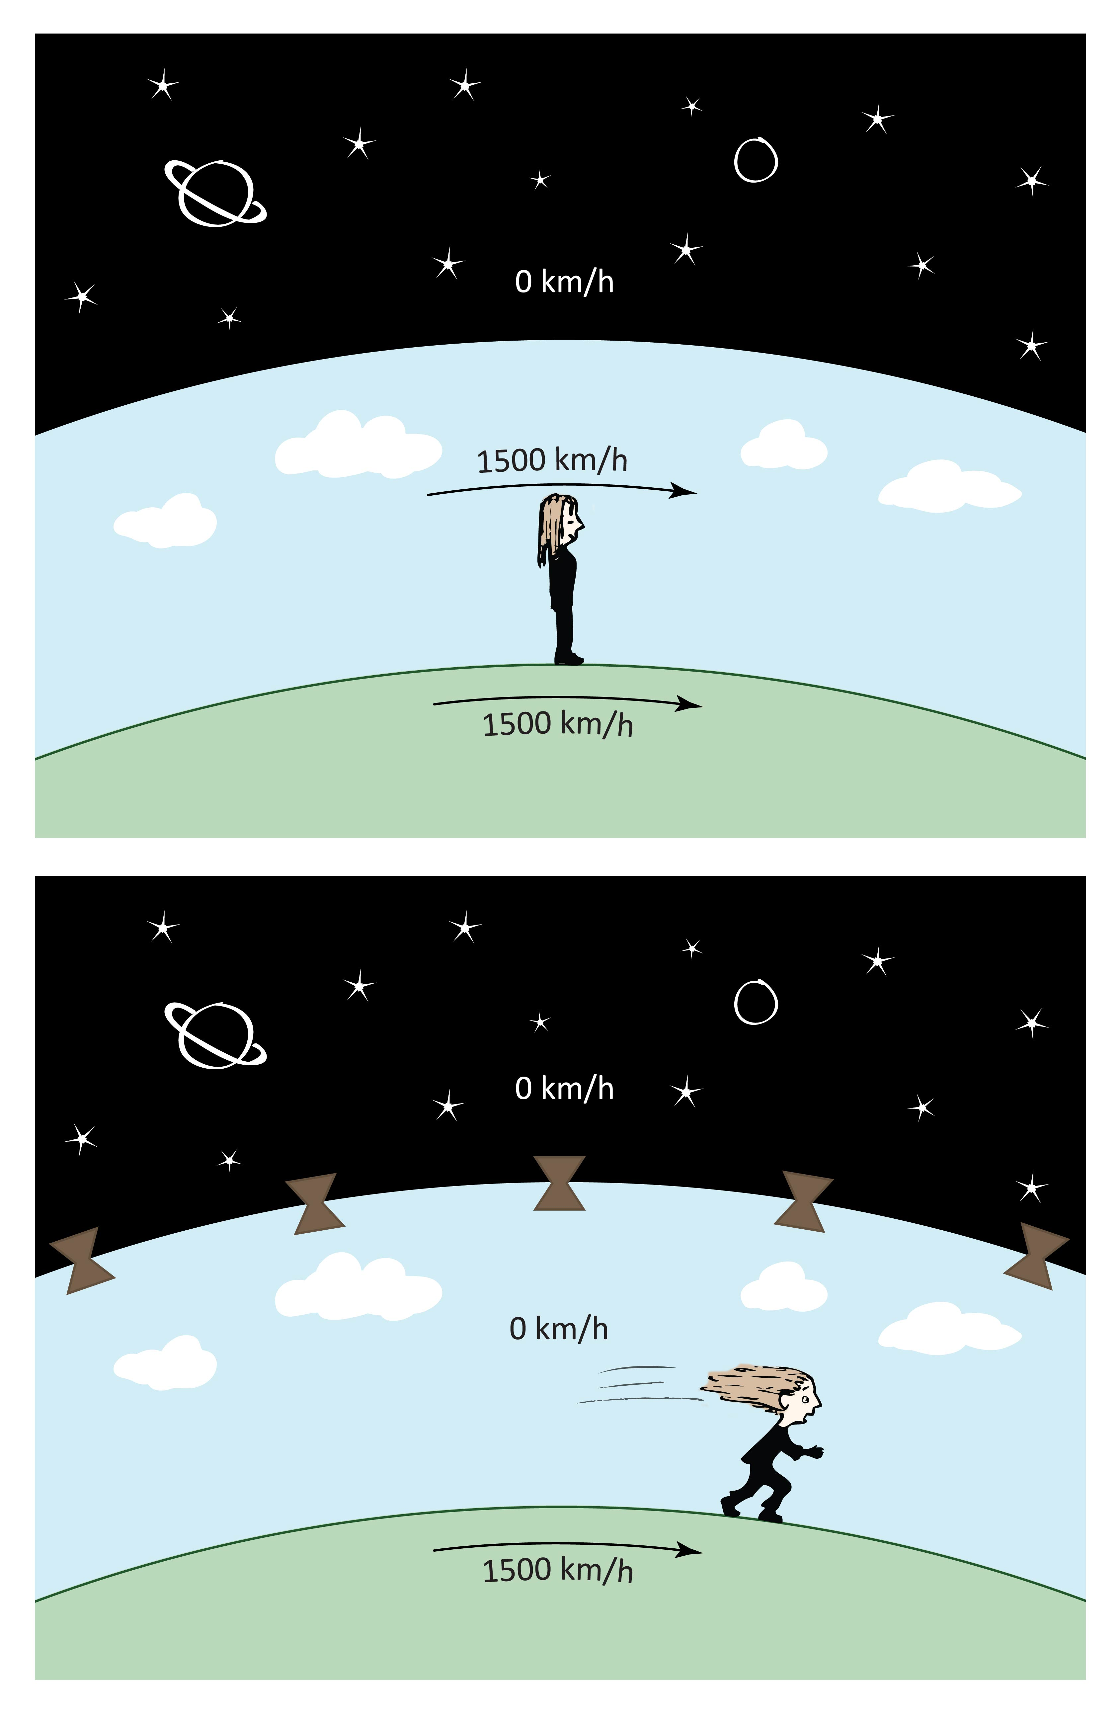
To explain why the air moves in lockstep with the Earth you might argue that that’s just the way it is. When the Earth was conceived, the air spun right along with the Earth; and because of the air’s momentum its speed might persist undiminished — just like that of the Earth. However, that explanation doesn’t work. Variable upper winds show that air velocities can change practically by the minute. Frictional losses and accelerative factors must therefore outweigh any supposed inertial continuity.
An alternative explanation for the lockstep movement is mechanical coupling: the atmosphere remains coupled to the earth by friction. Tall buildings, rolling hills and protruding mountains might drag the near-surface air along with the Earth. That explanation seems more promising, but what about the air molecules situated far above? Without some kind of vertical linkage, upper air molecules would experience little or no drag; they’d remain part of the cosmos. To an earth observer, those upper air molecules would whiz at supersonic speeds in the direction opposite the Earth’s rotation. That never happens.
Figure 15.19. Earth-atmosphere coupling. The atmosphere moves together with the Earth’s surface (top). In the absence of coupling between air molecules, the atmosphere might not move much at all (bottom). A tall earthbound observer would detect an east-to-west wind of high velocity all the time.
Air and Earth must therefore be coupled, even fairly high into the atmosphere. The two entities must spin as a unit. Such coupling seems difficult to explain unless air molecules are at least loosely linked to one another. Then, as lower molecules move with the Earth, so will the upper ones. Coupling is fortunate; otherwise we might face the hellish vision of eternally howling winds. Imagine a commuter flight from Chicago to New York!
Coupling of air molecules may also help explain why air has as much friction as it does. Think of meteors burning as they pass into the atmosphere; think of planes consuming as much fuel as they do; and think of someone (else) jumping from a tall building and reaching a terminal velocity. All of these phenomena result from air friction, which in turn results from connectedness.
Naturally, there’s more to air-earth coupling than just linkages and friction. I don’t want to digress even further from the topic of evaporation, but I simply cannot leave the issue of coupling without mentioning the obvious: the earth is negative and the atmosphere is positive. They attract. Whether the attractive force is substantial enough to couple the two entities is a question left for future discussion; I believe it could be a dominant factor, even for explaining air pressure. That electrostatic attraction, along with the proposed intermolecular linkages, may be novel features dominating atmospheric dynamics.
The material of the last several sections is obviously highly speculative; it was presented mainly to raise questions rather than to answer them. If those questions distracted too much from the chapter’s central theme of evaporation, then I’m guilty of gross distraction. The main point of the chapter is the surprising if not astonishing series of events surrounding the evaporative process. I hope that it’s now clear how the genie rises from the water.
Summary
Vesicles self assemble in water. They assemble by the like-likes-like mechanism, forming extensively networked structures. These structures resemble mosaics when viewed from above; however, the mosaics are actually mosaic tubes, extending deeply into the water. With sufficient radiant energy absorption, the tubes may acquire enough negative charge to rise individually or collectively. The rising structures are seen as puffs of vapor, emerging one after another from the water. Those puffs are the essential elements of evaporation.
A question is how those evaporative events relate to the vesicle-generating processes considered in the previous chapter. Temperature is key. With infrared (heat) input, vesicles form in abundance, flow vertically, and augment the tubular mosaics — which may then rise as vapor. With more energy input the vesicles form more rapidly and mosaics rise more rapidly. Hence, the more the energy input, the higher the rate of evaporation.
With highest infrared input, vesicle production may become so rapid that vesicles have little opportunity to join the mosaics. The vesicles may simply coalesce, transition to bubbles, and rise to the surface in the phenomenon we know as boiling. Boiling is the evaporative extreme; it is sufficiently chaotic that mosaic regularity is practically lost.
At the other end of the heating spectrum lies room temperature. There, evaporative processes can be presumed to occur as described in this chapter, but at reduced rate. On the other hand, the room temperature condition implies a kind of stability. That stability brings other interesting features, which will be detailed in the next chapter.
References
Web Ref 1: < http://www.youtube.com/watch?v=bT-fctr32pE>
Web Ref 2: <http://touristattractionsgallery.com/niagara-is-the-largest-waterfall-in-the-world>.
Web Ref 3: <http://www.engineeringtoolbox.com/air-composition-d_212.html>

Bunkin N (2012) Refractive index of water and aqueous solutions in optical frequency range close to Nafion interface. (submitted).
Chai B, Zheng JM, Zhao Q, and Pollack GH (2008): Spectroscopic studies of solutes in aqueous solution. J. Phys. Chem.,A 112 2242-2247.
Ienna F, Yoo H and Pollack GH (2001): Spatially Resolved Evaporative Patterns from Water. arXiv:1112.2796v1 physics.flu-dyn.
Ivanitskii GR, Deev AA, Khizhnyak EP (2005) Water surface structures observed using infrared imaging Physics ± Uspekhi 48 (11) 1151 ± 1159.
Tychinsky V (2011). High Electric Susceptibility is the Signature of Structured Water in Water-Containing Objects. WATER 3: 95 – 99.

