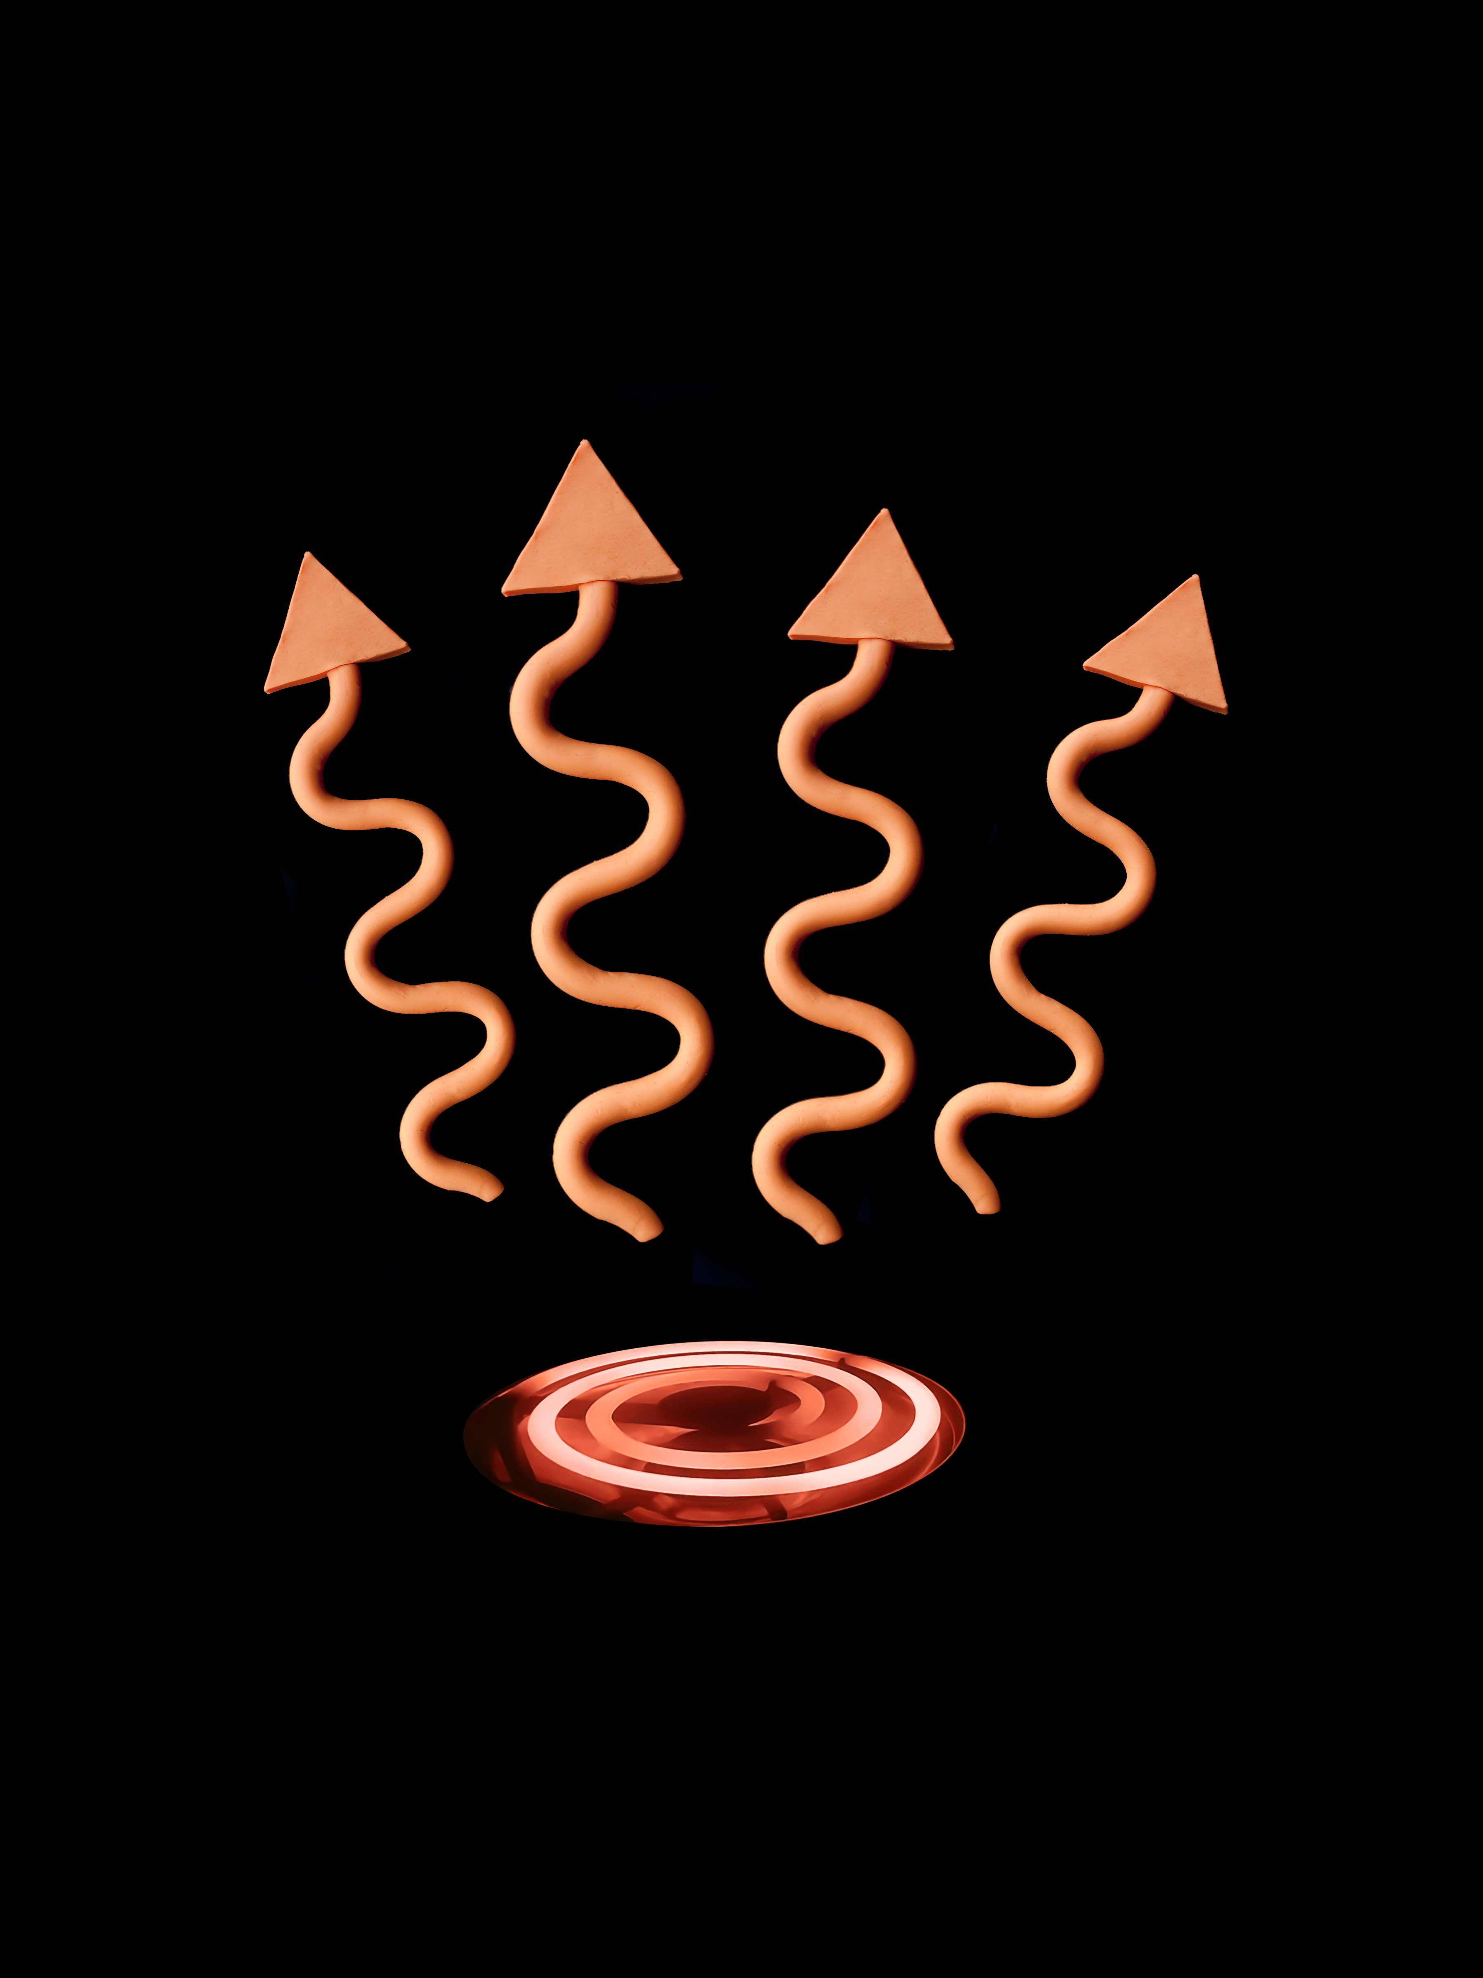
Chapter 10
Heat and Temperature: Throwing New Light on Thermal Darkness
While lunching in a charming island restaurant near Seattle, a colleague’s passing comment caught my interest. The comment referred to temperature. My colleague said that if you took a container of water and vigorously swished it around to form a vortex, the water would get cooler. “No way!” I exclaimed. Swishing generates friction. Everyone knows that friction induces heating, not cooling. He had to be wrong.
Vortices are natural phenomena. They can be seen in rivers and streams, as well as in bathtub drains and flushing toilets. A popular demonstration is shown in Figure 10.1.
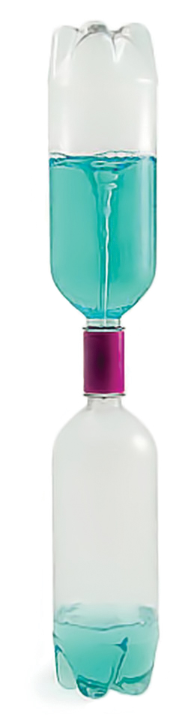
My colleague turned out to be right after all. I followed up our lunchtime conversation by asking one of my students to repeat the experiment. He indicated that he’d already vortexed laboratory water many times, and confirmed that it got cooler. The same for a New Zealand colleague, who vowed to determine how much cooler it could get, but never made it beyond a 4 °C drop.
How can we understand why water cools when vortexed?
You’d think we could grasp the essentials by being properly rigorous in dealing with heat and temperature. Rigor usually helps. However, that’s not always certain in the thermodynamic realm. An example came in the previous chapter. It had been long supposed that Brownian motion was driven by heat, but scrupulous treatment by renowned physicists never managed to yield a fully satisfying understanding. Something remained amiss.
Heat and temperature (also entropy) are terms central to practically every energetic consideration. Yet, the definitions of those terms are surprisingly vague, as we shall see. Using those terms in casual conversation may be fine; for building foundations of understanding, however, vaguely defined terms can prove hazardous. They can imply that something ought to be hotter when in fact it’s cooler.
Figure 10.1. Common demonstration of water vortex.
Because of this risk, we employ a more rigorous quantity: radiant energy. Radiant energy relates to temperature and heat, but it carries the advantage of being uniquely defined. On the other hand, the language of radiant energy is less familiar to most, and I hope you will bear with me through the short “tutorial” that begins this chapter. Once the rudiments are established, I believe the language can communicate a rich body of understanding. Small pains may yield big gains.
The Origin of Radiant Energy
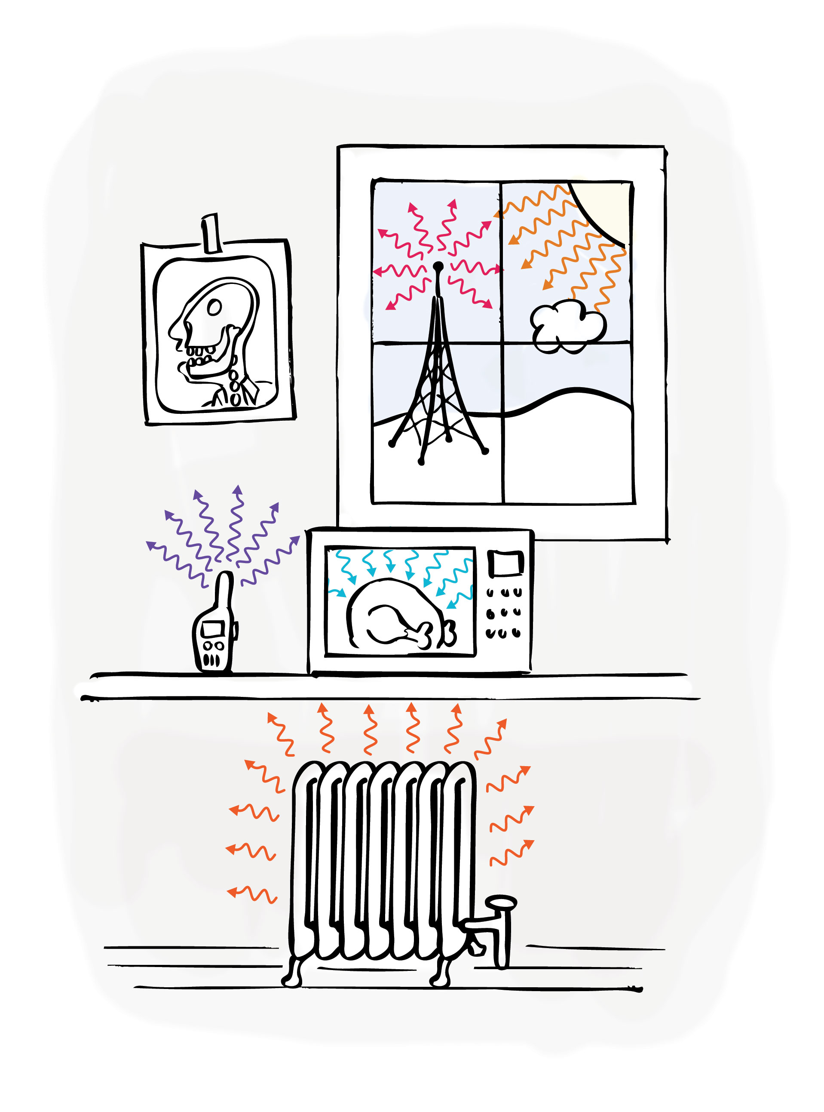
Radiant energy is electromagnetic energy. It may contain any of a range of different wavelengths, each of which exhibits different characteristics (Fig. 10.2): light waves can be optically detected; microwaves can cook our food; radio waves can help us communicate; X-rays can produce images; and infrared waves can keep us warm. These features seem so different from one another that it’s easy to forget that the waves all belong to a single electromagnetic spectrum. The waves are variants on a common theme.
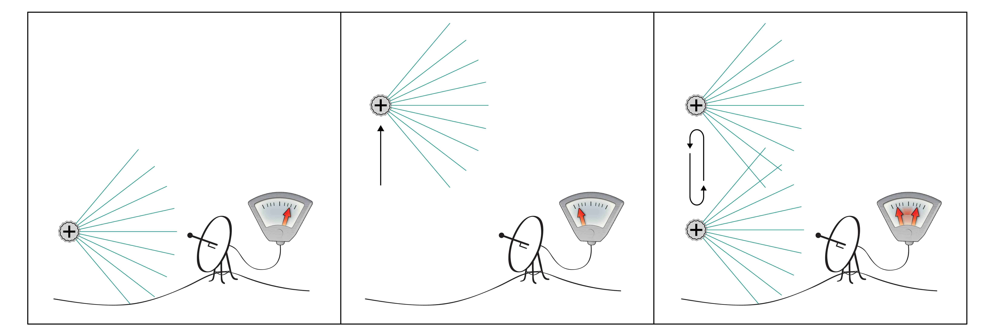
To understand the workings of radiant energy you need to understand how the waves originate: always by charge movements. The concept is schematized in Figure 10.3. A static charge creates a static electric field. That field extends over space, and if you (or your sensor) are situated close enough, you may sense the electric field (left panel). If the charge starts to move, then your relationship to the field changes (middle). You will sense the change, although it may take some time depending on how quickly the information can propagate through the intervening medium. Similarly, back-and-forth charge accelerations will create a back-and-forth field oscillation (right), which again you will sense after a brief time. You are now sensing a propagating electromagnetic wave.
Figure 10.2 Various sources of radiant energy. Radiant energy .encompasses a broad distribuiton of wavelengths.
Figure 10.3. Electromagnetic wave generation (simplified). Back-and-forth acceleration of charge creates an oscillating electric field, which may be picked up by a sensor.
Any charge oscillation can serve as the generator. The charge can be an electron, a proton, a nucleus, or even some larger charge-bearing entity. All qualify. And the displacement can range from miniscule, as within an atom, to colossal as in a large radiating antenna. The generating process, however, is always the same: charges oscillating back and forth.
Interaction of Waves with Materials
Now consider what happens when an electromagnetic wave impinges on a material. Materials contain charges. Fields exert forces on those charges; hence, the incoming wave will displace whatever charge it encounters. If the incoming wave is periodic, then those charges should oscillate with corresponding periodicity. Effectively, a charge oscillation induces another charge oscillation. The process continues.
Just how it continues depends on the medium through which the wave passes. If the medium is the same all over then the wave’s principal features will remain invariant, although the wave might suffer some decay. If the medium is not uniform, then the oscillation’s character will vary as it passes through. For example, it might propagate more quickly through one region than another. Quicker propagation means a longer distance traveled over the time interval between amplitude peaks, which means longer wavelength. So wavelengths can change as the wave travels.
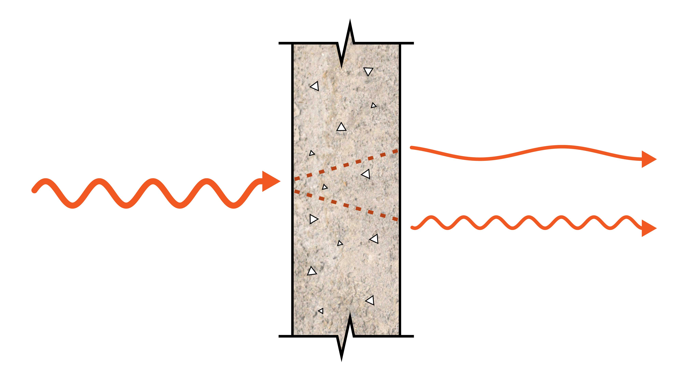
A subtle but important feature of wave propagation is that each receiver becomes the next propagator. The movement of the receiver’s charge becomes the generator of the subsequent wave; and so on. Many features can change during this passage. An incident wave of wavelength, say, 10-µm might re-radiate at, say, 5 µm or 20 µm, depending on the medium’s character. Thus, waves passing through complex media can re-radiate at longer and/or shorter wavelengths (so-called Stokes and anti-Stokes shifts); see Figure 10.4.
An example of such a shift is fluorescence. Incident light of some wavelength shifts the material’s electrons to a higher energy level; when they drop back down, they radiate light at a longer wavelength. Thus, incident blue light may produce emitted red light. The material is said to fluoresce red.
Figure 10.4. Electromagnetic radiation passing through a complex medium. The character of the radiation may change. Total output energy need not equal input energy if the medium stores energy and uses it for work production.
Spectral shifts also occur at infrared wavelengths. A familiar example is your house. Sunlight strikes the bricks outside. The bricks absorb the energy, heat up, and radiate to the interior walls, which in turn radiate into the room — so you feel warm. The inner walls might radiate at wavelengths and amplitudes entirely different from those of the incoming sunlight.
These examples illustrate a fundamental dynamic: Radiation entering the system drives charge movement, which generates electromagnetic waves, which drive charge movement, etc. Finally, the waves exit the system, but only after having suffered multiple wavelength and amplitude shifts, and having perhaps powered some work in the process (Chapter 7). So, radiant emission depends not only on what enters the system, but also on the character of the medium.
Radiant Emission
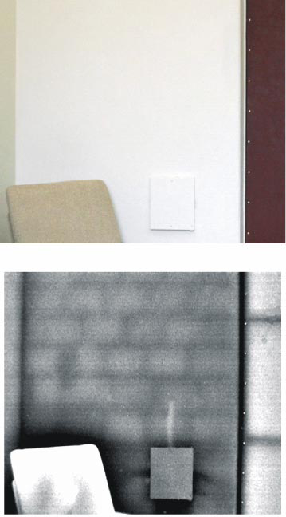
How then can an understanding of a material’s emissive character help us understand what’s going on, particularly within water?
Emissive character is generally expressed in a shorthand term called “emissivity.” Objects with higher emissivity radiate more energy than objects with lower emissivity, even if situated in the same physical environment. They seem more energized. If the emission lies within the infrared wavelength range, then an infrared camera will depict them as brighter than nearby objects with lower emissivity.
An example is shown in Figure 10.5. The standard visible light image of an office wall (top) shows only rudimentary detail. The infrared image (bottom) shows more of the underlying structure. The image is evidently rich with detail, some of which derives from emissivity differences.
Figure 10.5. Interior wall in a room situated just off a corridor. Observed with visible light (top); and with infrared light (bottom). The infrared image reveals details of the wall’s internal structure. From Ivanitskii et al. 2005.
A more telling example is a landscape image with clouds (Fig. 10.6). Notice that regions of clouds generate more radiant energy than some landscape areas far beneath. That seems paradoxical: the air is frigid at cloud altitude; therefore, the scenario resembles a freezer contaiing an oven. By conventional thinking a sharp temperature gradient sustains itself over time, which seems oddly awkward. By radiant energy thinking, the cloud’s emissive character is simply higher than that of the surround; the cloud’s moving charges generate lots of infrared energy. The cloud looks “hotter,” but really its charges are bouncing around more.
This more “back to basics” interpretation shows how reliance on familiar concepts such as temperature and heat can easily mislead. Surely the cloud sitting in the frigid sky is not hot.
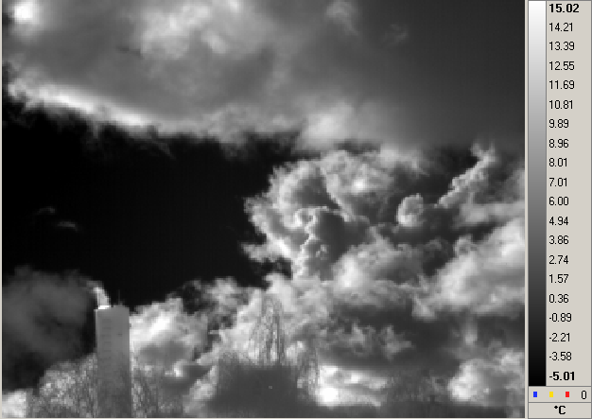
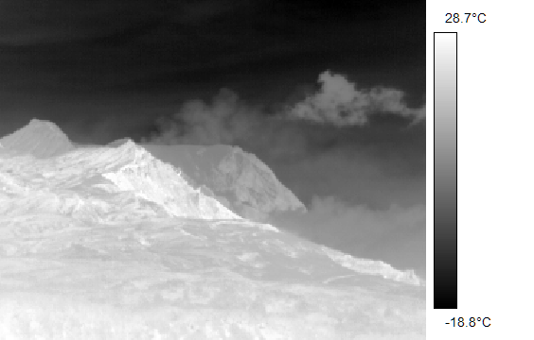
The most relevant image is one you’ve already seen: infrared radiation from the water near the Nafion surface. Please take another look at Figure 3.10. A key feature is that EZ water radiates less than the bulk water. Since the respective water zones had remained long juxtaposed, any physical difference between zones should have equilibrated by the time the image was obtained; yet the exclusion zone remained darker. That means the EZ radiates less. If the darkness doesn’t arise from a lower temperature, then it presumably arises from a lower emissivity than bulk water.
Figure 10.6. Infrared images, obtained at wavelength range 9 – 12 µm. Left: Aerial image from plane. Despite its location well above 2,000 meters in a “cold” environment, the upper cloud appears about as “hot” as some lowland areas. Courtesy Michael Ramsey. Right: View from office window. Ground temperature approximately 0°C. Smokestack and treetops visible at bottom. Distant cloud regions appear hotter than 15 °C despite surrounding air temperature estimated at minus 20 °C. Courtesy Eugene Khijniak.
Why should the EZ emit less radiant energy than bulk water? Think about charge movements in the respective zones. In the EZ, charges are fixed in a lattice; they may jump from one lattice point to another, but for the most part they lodge in place. In the adjacent bulk water zone. the charges are free: they move continuously with abandon. Since moving charges generate radiant energy, the bulk-water region should appear brighter. Thus, the bulk water looks “hotter” than the EZ, but really its charges are moving around more actively.
So, brightness and darkness in an infrared image do not necessarily imply higher or lower temperature; more fundamentally they reflect the intensity of charge movement. Referring to brighter objects such as clouds as having “higher temperature” may be permissible in casual conversation, but brightness is really a reflection of charge movement. Materials with charges buzzing around are said to be more emissive than those without, but at the core, more emission is a reflection of more charge movement.
That is perhaps this chapter’s most central message: Radiant emission reflects the intensity of charge movement. If we stick to this fundamental linkage, we should not go too far astray in our subsequent search for understanding.
What Exactly Are Temperature and Heat?
The message so far has been to avoid the reflexive temptation to think in terms of temperature and heat. A word or two about why those terms confuse seems in order.
Heat, temperature and radiant energy certainly relate to one another, but how they relate is not immediately obvious — at least it had not been obvious to me at the outset. I must admit that for some time this issue had me stumped. Finally some clarity emerged, and I believe those emergent clarifications can be helpful.
Incident radiant energy is absorbed, transformed, and then re-radiated. In the case of water the most relevant wavelengths lie in infrared region of the spectrum. The reason lies in water’s structure: Water’s charges reside at a certain characteristic spacing, which means that whenever water’s charges oscillate, they prefer to do so at corresponding characteristic frequencies. At those frequencies, or wavelengths, radiation will be preferentially absorbed, and also preferentially radiated.
In water, those wavelengths happen to lie mainly in the infrared region of the spectrum, particularly in the window of 3 µm to 15 µm. Outside that narrow window, radiation is absorbed less and radiated less. In considering water, then, those are the wavelengths that seem to matter. The rest hardly count at all.
How do those absorbed/radiated wavelengths relate to heat? More fundamentally, what is heat?
Unfortunately, no single definition prevails. Most often but not always, heating is described as the transfer of energy from one physical body to another, exclusive of any work performed on that body. You can’t raise a boulder to the top of a mountain and call it heating; however, you can supply radiant energy to a body and label it as heating. The amount of heat will depend on the wavelength and the nature of the target substance. In principle, the more radiant energy you supply, the more will be the heating.
We can now appreciate why heating and infrared (specifically the 3 – 15 µm wavelength window) often come practically in the same breath. Water absorbs this radiation; it therefore “heats up.”
However, we need to bear in mind that water absorbs not just at infrared wavelengths, but also to some extent at all wavelengths of the electromagnetic spectrum. Even visible light can heat water if you provide enough of it. And the microwave energy in your oven produces a lot of heating. So, infrared absorption is not the same as heating. Nor can we be certain that heated water radiates only at infrared wavelengths; indeed, water can generate also at visible wavelengths (Chapter 7). Because of this vagueness, it is only with the greatest of caution that we dare employ the term heat.
When water “heats up” from infrared or other absorbed energy, we say that its temperature increases. Again, we need to know: what exactly is temperature? Unfortunately, no unique definition exists. Some discipline-dependent examples include the following: the degree or intensity of heat present; the ability of a substance to transfer heat energy to another substance; a measure of the average kinetic energy of the atoms or molecules of a substance; a reflection of particle motion arising out of translation, vibration, or excitation of an electron energy level; and in a gas, it’s the probability distribution of the energy of motion of gas particles. Thus, temperature is not uniquely defined.
Even the well-known temperature end points don’t help bring a unique definition. Water is said to freeze at 0 °C and boil at 100 °C. You’d think these would constitute handy markers helpful in pinning down temperature’s real meaning. But they do not, for water can freeze at temperatures much lower than 0 °C and can vaporize at temperatures above and sometimes below 100 °C (Chang, 2011). We relegate these variants to anomalies, but can we be sure they are not simply manifestations of definitional ambiguity? Temperature seems just as ambiguous as heat.
Further confounding these definitional ambiguities is a more general problem. In systems out of equilibrium, thermodynamicists warn that empirical measures may disagree on which of any two bodies is hotter. Translated into plain English this means that no material body has a well-defined temperature. This is a profound problem. Resolving the issue is a major goal of the non-equilibrium thermodynamics field, and until it is resolved, the lingering ambiguity poses a confounding issue for the rest of us. We simply don’t know what temperature and heat mean.
You can now understand why I’ve refrained as much as possible from using those familiar terms. In everyday conversation the use of heat and temperature are unavoidable, and probably just fine. For scientific discussion, squishy definitions inevitably lead to squishy conclusions, and possibly even to erroneous ones. Vortexing and Brownian motion may be good examples of how they mislead.
Real understanding, on the other hand, has a better chance to emerge by sticking to physically definable terms. One of them is radiant energy. Let’s see if the concept of radiant energy can help bring sensible answers to lingering questions.
Cooling, Heating and Radiant Energy
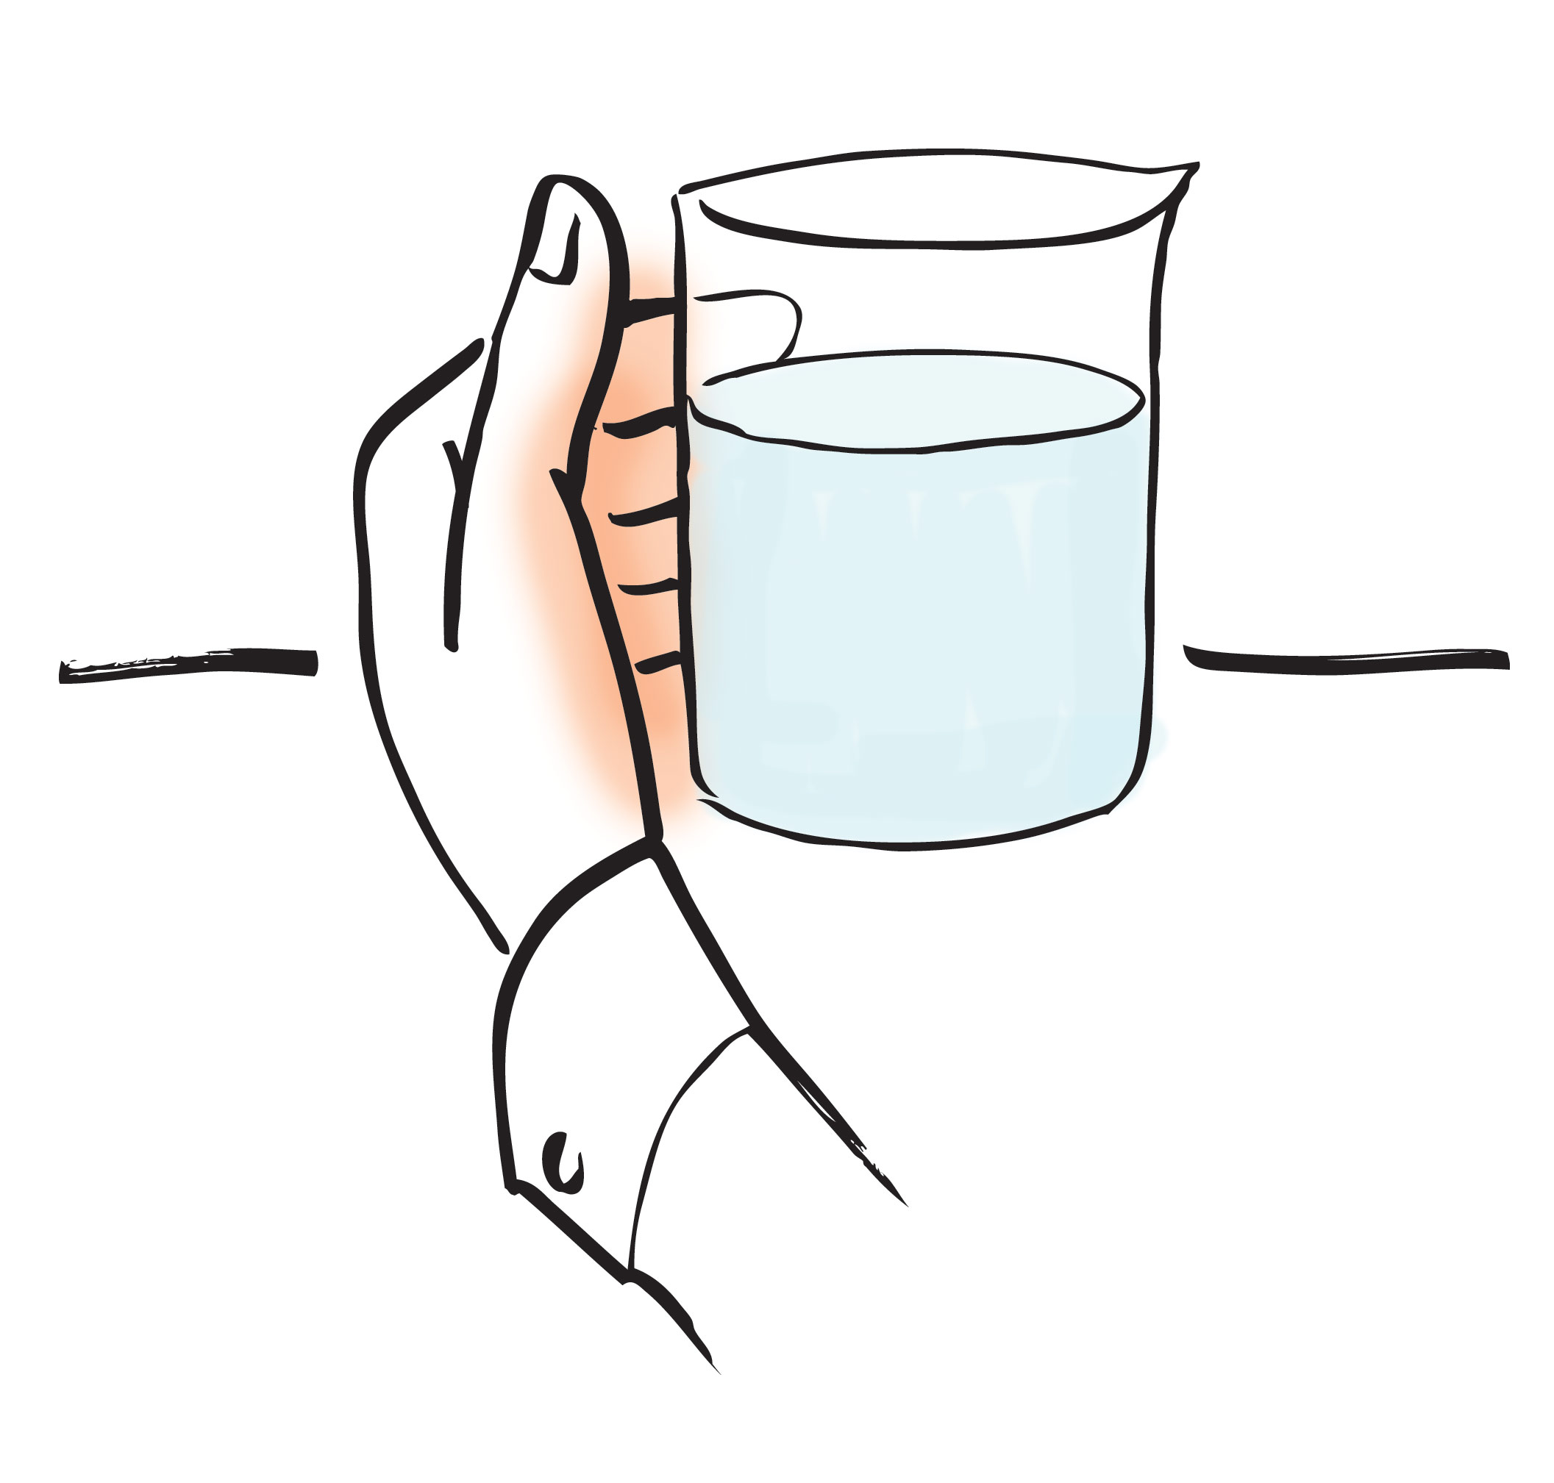
When your hand encircles a container of water it absorbs radiant energy emitted by the water. If the water generates a lot of infrared energy, you interpret it as warmth; if there’s not much infrared generated, then you sense coolness. Your hand senses the radiation emitted, relays it to your brain, and hey —something feels hot or cold (Fig. 10.7).
Thermometers sense much the same. They employ either of two sensing modes: radiative or conductive. Although common understanding implies that those modes differ, I believe they are more similar than different. Let me explain.
Radiative thermometers register the amount of radiant infrared energy received. That is much like what your hand senses. So far, so good.
Figure 10. 7. Your hand senses the amount of radiant energy coming from the water.
Conductive thermometers, by contrast, are said to “conduct” heat. The hard steel bulb of a mercury thermometer “conducts” heat from outside, through the steel, and eventually into the column of mercury. The mercury expands in response, letting you read a scale corresponding to temperature. The mechanism operates through contact: water’s “thermal vibrations” transfer directly into the steel, which causes vibration of the steel’s electrons, which causes more distant steel electrons to vibrate, etc. Vibrations of charge propagate through the steel and eventually to the mercury.
Propagation of this kind seems similar to the propagation of an electromagnetic wave. Charge vibrations propagate through a medium in both instances. If that is so, then conductive thermometers sense similarly to radiative thermometers: Both absorb radiant energy and scale it to temperature according to a predetermined conversion table.
Essentially, your hand does the same. If your hand loosely encircles the water container, then it senses the emerging radiant energy. If it grasps tightly, then it does the same, but the sensation will be more intense because propagation to your hand is more direct. All of these sensing methods detect radiant infrared energy arising from charge oscillations. When we sense that the water is hotter, what we really mean is that the water is emitting more radiant energy.
By sticking with radiant energy and avoiding the pitfalls attendant with heat and temperature, we can now press on. A potentially useful expedient lies under the umbrella of radiant energy: the difference between EZ water and bulk-water. EZ water generates relatively little radiant infrared, while bulk water generates more. Armed with this distinction, we can tackle some issues that have befuddled scientists and have confused the dickens out of the rest of us. We consider two of them: mixing and vortexing.
----
Box: Does Radiant Energy Contain Information?
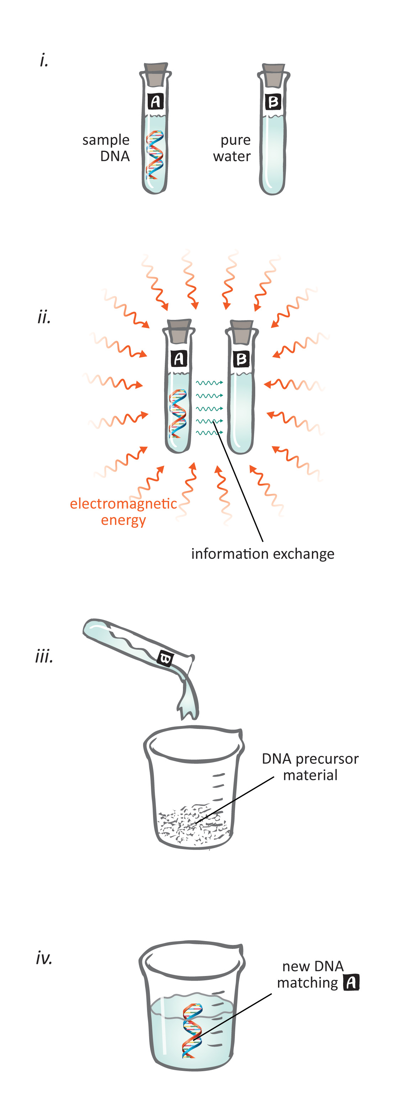
Water emits radiant energy. Most of that energy comes from bulk water, but the EZ emits energy as well. The wavelengths depend on structure. While EZ structure has a generic aspect, the nucleator’s unique surface-charge distribution creates variants of that generic EZ structure (see Chapter 4); hence, the radiated energy should contain material-specific information. Thus, energy radiated from EZ water may contain information in the same way that energy radiated from a TV-station antenna contains information.
A question is what happens to this information when water absorbs the radiated energy. We might expect immediate blurring and loss. However, if some of the energy’s vibratory modes induce EZ structural variants, then some information could be retained. Any such retention would amount to nothing less than structural information electromagnetically communicated — a kind of water-based Internet.
Stunning reports from Nobelist Luc Montagnier have lent credence to this kind of information transmission (see Figure). Montagnier claims to have successfully transmitted DNA-structural signals to water. He first created an aqueous suspension of sample DNA. The suspension was placed in a sealed flask next to a similarly sealed flask of water. The flasks stood next to one another for an extended period, while both were exposed to generic electromagnetic energy.
The flask of “informed” water was then removed and combined with the raw materials required for DNA synthesis. This procedure created new DNA. The DNA sequence was not random: it was the same as the sample DNA that had sat nearby the water. Even though the two flasks had been well sealed and never in physical contact, the information evidently passed from one flask to the other (Montagnier et al., 2010).
Initial responses to Montagnier’s report have been mainly skeptical. However, some scientists, persuaded by reports of electromagnetic transmission phenomena dating back to the work of Gurwitsch (1943) almost a century ago to the more recent work of Jacques Benveniste (Thomas et al., 2006), have begun following up. It will be interesting to keep an eye on what develops from these experiments.
---
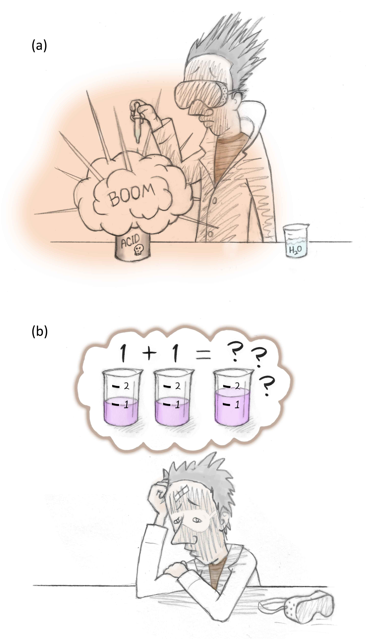
(i) The Case of the Suspicious Heat and Missing Volume
A perplexing issue is what happens when substances mix with water. Beyond dissolution, you might expect that nothing particularly interesting will happen. However, serious consequences can ensue. Adding just a few drops of water to sulfuric acid can produce enough heat to induce boiling, spitting, and even an explosion (Fig. 10.8a).
That’s not the only counter-intuitive result. When liquids mix with water the final volume doesn’t always equal the sum of the two initial volumes: it can be higher, but more commonly it is lower (Fig. 10.8b). In extreme cases the volume shortfall can be as much as 20%. Solids mixed with water can behave similarly: A large number of sodium hydroxide pellets needs to be dropped into a flask of water before the volume climbs back up to the original water volume.
Chemists know these phenomena well. According to prevailing theory, the burst of heat arises from thermal contributions from each of the several sub-processes underlying solvation; their sum yields the “heat of hydration.” The volume change arises differently: it depends on whether the mixing of molecules produces a better or worse intermolecular fit.
Figure 10.8. Mixing substances with water can bring unexpected consequences.
While these explanations seem straightforward enough, there is something of an ad hoc nature to them, with no easy way to verify whether they are correct or not. The relevant heat contributions, for example, are commonly surmised from the experiments themselves, rather than from independent observations. And, determining how molecules fit together is not an exact science. Hence, the correctness of these explanations remains uncertain.
When I began looking into these two phenomena I was struck by an unexpected correlation: heat evolution and volume change seemed to occur in a linked fashion: Whenever there was heat evolution, there also seemed to be shrinkage; and in cases when heat was absorbed, there’d be expansion. I wondered whether thermal and volume changes might therefore have a common origin.
The player that had not previously been considered was the familiar one: the EZ. Mixing a soluble substance with water seemed likely to change EZ content in one way or the other: If the substance were initially dehydrated, then adding water might promote EZ buildup — for EZ buildup is the very basis for dissolution (see Fig. 8.12). On the other hand, if the substance were pre-hydrated with abundant EZ water, then adding water might reverse the concentrating process that gave rise to the original EZ buildup. So, mixing substances with water could increase or decrease EZ content. This had to be a relevant clue.
OK, suppose mixing brought an EZ increase. How might this impact temperature and volume?
(i) As EZs build, protons are released. Moving charges generate radiant energy; hence, the mixture should “heat up.”
(ii) The mixture should also shrink. EZ density exceeds that of bulk water (see Chapters 3 and 4); hence, a shift from bulk to EZ water should diminish the volume.
EZ growth, then, can theoretically explain the concomitant heating and shrinking. The proposal seemed on track. The missing link, however, was whether EZ buildup really accompanies heating and shrinking . So we set up experiments to answer that question.
Resolving the Volume/Heat Enigma
We first sought some reassurance. Heating and shrinkage seemed linked, but we had to be certain. So we examined an array of seven heat-generating dissolutions. In all cases the heat-shrinkage linkage were confirmed. (One shrinkage result proved technically challenging, but others had already confirmed the shrinkage). The shrinkage typically took place within tens of seconds, and so did maximum heat evolution. So the two phenomena tracked nicely, as we had suspected.
Next, we tested whether EZs were generated. In all cases the mixture showed the standard EZ signature: a 270-nm absorption peak. The peak could sometimes be shifted in one or the other direction by 10 – 25 nm; sometimes two sub-peaks could show up instead the single peak; and some peaks could be weaker or stronger than others; but in all cases the expected peaks were clearly discernible. A representative example is shown in Figure 10.9.
So the results were promising. They affirmed that whenever there was heating and shrinkage there was also EZ buildup. It appeared that we were on track — at least for mixtures producing heating and shrinkage.
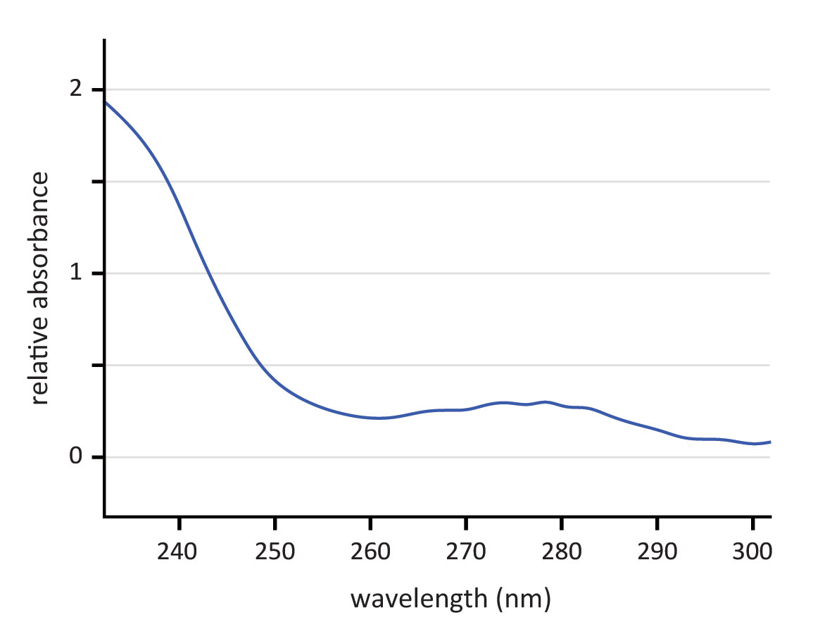
The flip side of the mixing coin is cooling and expansion, the less common outcome. To pursue that variant, we focused on a well-recognized example: the mixing of ammonium persulfate with water. Ammonium persulfate comes in powdered crystals. When the crystals mix with equal parts with water, the volume expands. We confirmed the expansion, although the percentage cannot be reliably assessed without overcoming the challenge of measuring the volume of material within the volume of powder. The temperature, on the other hand, was easy to track; it dropped by 8 °C. Hence, mixing behaved as anticipated.
Powder crystals such as ammonium persulfate form most commonly as a like-likes-like extreme: radiant energy from heating (or some procedural equivalent) builds EZs around each molecule. This buildup creates abundant likes and unlikes, which lock the molecules together into stable crystalline form even when dried (Chapter 8, box). Although the powder crystals do not contain water, they contain substantial EZ water.
Figure 10.9. UV-Vis spectrometer recording of 50:50 mixture of HCl and water.
Dropping crystals of that nature into water should reverse the buildup process. The charges holding the crystal together should dissipate; and, absent the driving energy responsible for EZ buildup, the EZs should revert to a more standard size.
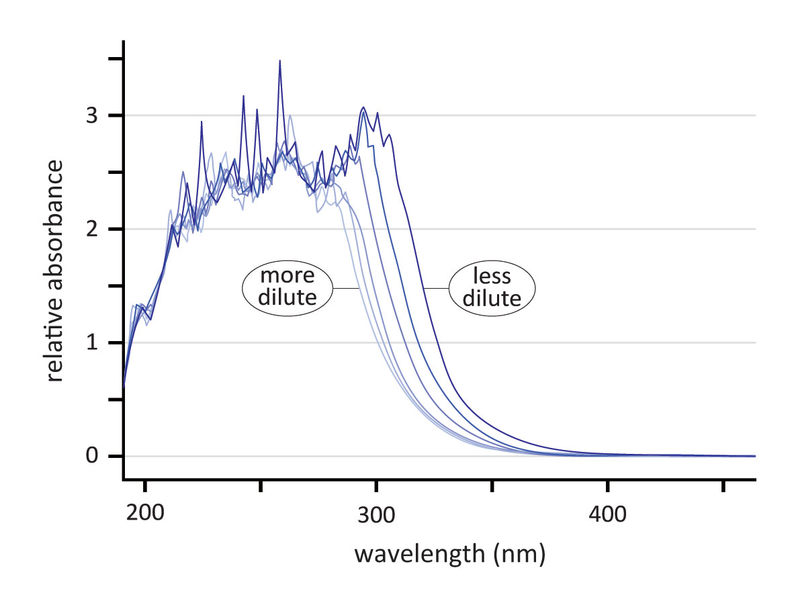
From these expectations, we can predict thermal and volume features: As EZ water converts to lower-density bulk water, the volume should increase. That fits. And dropping those charged EZs into water should constrain otherwise mobile water molecules nearby, diminishing radiant energy output and thereby reducing the measured temperature.
With those expectations in place, we embarked on our tests. Did the mixture really contain ample EZ initially, and did that EZ content diminish with dilution? Figure10.10 confirms that expectaton. Initially, the 270-nm peak was robust, with substantial area beneath the broad peak. With dilution, the peak progressively narrowed. It narrowed with time after dilution, and also with successive dilutions.
Figure 10.10. Ammonium persulfate dissolved in water. With increasing dilution (right to left), the area beneath the absorption peak diminishes.
Hence, the EZ paradigm seems to suffice. It suffices not only for heating/shrinkage but also for cooling/expansion. A single player seems able to account for all features. If follow-up studies lend support in a more quantitative way, then this will resolve the heat/volume anomaly. It will then be clear why the innocent act of dribbling a few drops of water into a vat of sulfuric acid can have such explosive consequences.
--
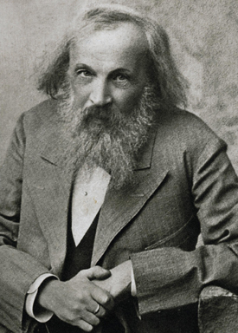
BOX [situated about four paragraphs above]: Vodka and Viscosity Dmitry Mendeleev, the Russian scientist who brought us the periodic table, also studied the mixing of ethanol and water. Like many mixtures, this one produces heat and shrinkage. Mendeleev noted another attribute: an increase of viscosity — by as much as three times. The reason is unclear, although EZs are viscous (see Fig. 3.13), so high viscosity could arise from EZ formation. Further, ethanol forms EZs much like water (Chai and Pollack, 2010); therefore, a mix of the two liquids could produce intermingling EZs with elevated viscosity.
While that’s speculation, what’s beyond speculation is the practical result of Mendeleev’s discovery: Because the highest viscosity was found with a 40:60 ethanol-to-water ratio, Mendeleev opined that ratio as ideal for making vodka; and that’s the ratio used to this day. The high viscosity lends the drink a satisfying “body,” enough perhaps to explain why Russians consume so much of it.
Dmitry Mendeleev, 1834-1907. Copyright??
-----
BOX: Concrete
Following the standard recipe, you add water to the concrete mix, stir arduously, pour, and let the mixture set for a day or two. As the concrete hardens it gives off heat. Why so?
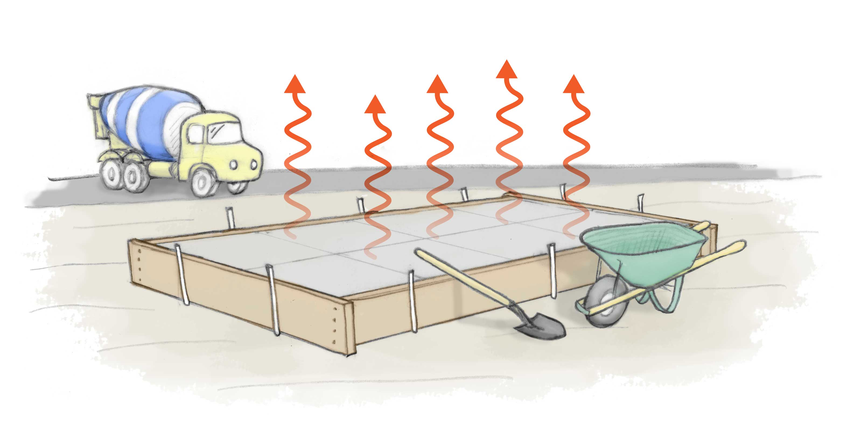
Adding water to the concrete mix creates workable putty that is much like wet sand. The putty-like consistency arises in the usual way: EZs build around the newly wetted particles, releasing protons, which then mediate the like-like-likes attraction. With this attraction the particles begin to cling. They cling with yoghurt-like consistency at first, and more firmly as EZ-based attractive forces continuously grow.
An expected accompaniment is heat. With progressive EZ growth, protons are continuously released. The proton movements generate abundant radiant energy, which is sensed as heat.
Meanwhile, that radiant energy brings the process to completion. The radiant energy promotes further EZ growth, more released protons, and therefore increasingly stronger attractions. That’s ultimately what makes the concrete hard throughout.
------
(ii) Why Vortexing Induces Cooling
We next consider the second paradoxical phenomenon: vortex-induced cooling. Why should vortexed water feel cooler than non-vortexed water?
A hint comes from the work of the legendary Austrian naturalist Viktor Schauberger. Life-long observations convinced Schauberger that vortices lent a special “vitality” to water. Thus, water taken from fast-running, vortex-filled streams was considered more “alive” than stagnant water, which Schauberger considered dead. Living water is the kind that Vladimir Voeikov might use for producing his abundantly tall plants (see Chapter 7).
Schauberger followed in the footsteps of another legendary Austrian, Rudolph Steiner, who engaged himself in diverse spheres of endeavor including agriculture. Steiner invented the biodynamic farming technique, whose central feature is water vortexing. Farmers to this day tout his fertilizer-free, vortexed water approach as producing crop yields of stunning abundance.
From this background we might surmise that the hidden secret of vortexing could lie in the buildup of EZs: That would explain the water’s so-called vitality, for EZ buildup separates charges and separated charges constitute potential energy. In terms of vitality, potential energy can’t hurt.
EZ presence could explain the cooling as well. If vortexing shifts some bulk water to EZ water, and the EZ fraction radiates less, then the water should feel cooler. The released protons could counter this cooling effect; however, the large volume of water offers ample dilution opportunity; hence, that heating contribution should be relatively minor. The net result of vortexing ought to be cooling.
All problems are solved if vortexing really does indeed build EZs. We confirmed that this was so. In preliminary experiments we examined vortexed water and confirmed an absorption peak at 270 nm (Fig. 10.11).
Why vortexing induces EZ buildup is not mysterious if you recall that EZ water contains relatively more oxygen than bulk water. The swirling action puts water into continuous contact with oxygen, both from the air above and from bubbles trapped beneath; thus, water continuously mixes with air. Oxygen abundance, chemists might say, should drive the equilibrium in the direction of EZ buildup.
Friction may also promote EZ buildup. Water swirling against air creates friction. Friction inevitably induces negative charge (see Chapter 9), which in turn promotes EZs buildup (Fig. 5.7).
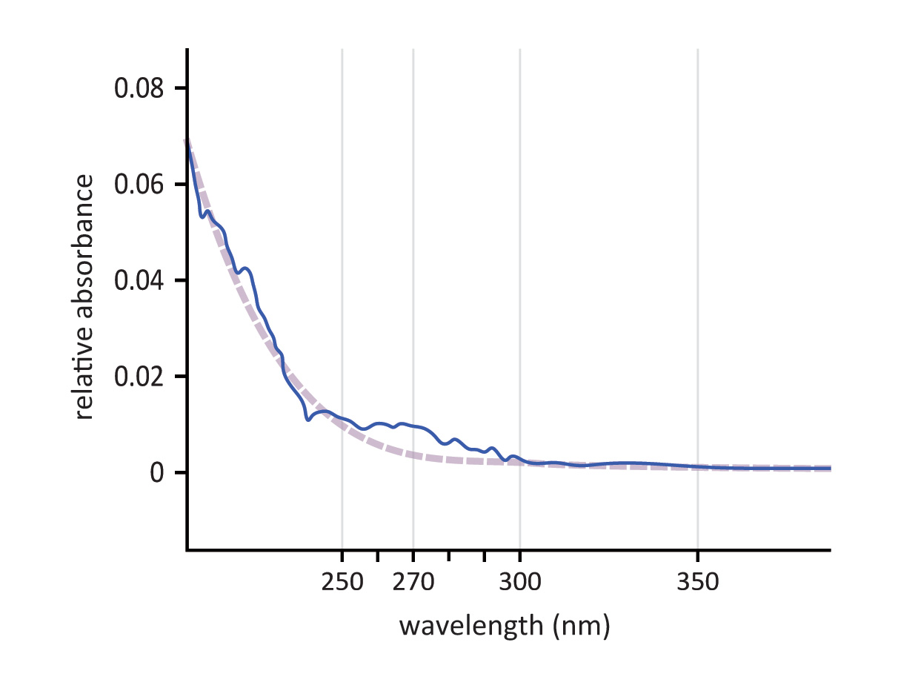
Given the EZ buildup, it becomes clear why vortexed water becomes cooler: the newly present EZs generate less radiant energy than the bulk water from which those EZs were built. If you could imagine the extreme in which all bulk water turns to EZ water, then the liquid should feel like something close to ice.
Resolving this paradox and the one prior help highlight the chapter’s main point: understanding water’s thermal features requires a step back to fundamentals. At the very core of those fundamentals is the movement of charge. More charge movement generates more radiant energy, which — if you’ll excuse the colloquial lingo — makes the substance seem hotter.
Figure 10.11. Spectral measurements of vortexed water. Preliminary observations show EZ growth.
Adhering to these fundamentals has helped resolve several anomalies, and will serve us well as we explore other natural phenomena not easy to comprehend at the moment, but aching to be understood.
Summary
Water’s thermal features have remained riddled with anomalies and paradoxes. To resolve these paradoxes we stepped away from standard approaches based on heat and temperature, and retreated to more fundamental approaches.
The most central of those approaches was the use of radiant energy. Radiant energy originates from charge movements. Back-and-forth displacements give rise to electromagnetic waves, which propagate through materials and often emerge with different character. In the case of water, the most prominent wavelengths lie in the infrared range. Because of the water molecule’s atomic structure, water radiates a lot of infrared and also absorbs a lot of infrared. Thus, infrared wavelengths take on a particular relevance when dealing with water.
A second feature of the approach was to recognize the contribution of exclusion-zones. EZ buildup generates protons, whose movements generate plenty of infrared energy. This energy is sensed as heat. Once the EZ buildup subsides, what counts more for thermal considerations is how much EZ water is present and how constrained are nearby water molecules. Both factors diminish infrared output, which translates into cooling.
These EZ-based features help explain why mixing substances with water can lead to heat transients and volume changes. Mixing can create EZ-based protons, whose movements generate infrared energy; this radiated energy is sensed as heating. The newly formed EZ is denser than bulk water; this density increase creates shrinkage. Heat evolution and shrinkage therefore appear together.
The EZ paradigm also helped resolve the paradox that opened this chapter: why vortexed water feels cooler. Vortexing generates EZs. The increased EZ fraction results in relatively less infrared output, and this makes the water feel cooler.
All of these determinations arose through considerations of radiant energy. We avoided using heat or temperature. While these latter terms may be handy for everyday use, their definitional ambiguity makes them unreliable vehicles for attaining scientific understanding. For that purpose, adhering to well-defined foundational concepts inevitably leads to firmer understanding — as we will continue to see as we explore water’s common everyday behaviors.

References – Chapter 10
Ivanitskii GR, Deev AA and Khizhnyak EP (2005). Water surface structures observed using infrared imaging. Phusics – Uspekhi 48(11) 1151-1159.
Chai B and Pollack GH (2010). Solute-free Interfacial Zones in Polar Liquids. J Phys. Chem B 114: 5371-5375.

Montagnier L, Aissa J, Del Giudice E, Lavallee C, Tedeschi A and Vitiello G (2011) DNA waves and water. J. Phys: Conf. Series vol. 306, 2011 (on line). http://dx.doi.org/10.1088/1742-6596/306/1/012007.
Gurwitsch AG, Gurwitsch LD (1943). Twenty Years of Mitogenetic Radiation: Emergence, Development, and Perspectives. Uspekhi Sovremennoi Biologii 16:305-334. (English translation: 21st Century Science and Technology. Fall, 1999;12( 3): 41-53).
Chang H (2011). The Myth of the Boiling Point. http://www.hps.cam.ac.uk/people/chang/boiling/
Thomas Y, Kahhak L, Aissa J. The physical nature of the biological signal, a puzzling phenomenon: the critical role of Jacques Benveniste. in: Pollack GH, Cameron IL, Wheatley DN editors. Water and the Cell. Dordrecht: Springer, 2006. p. 325–340.

