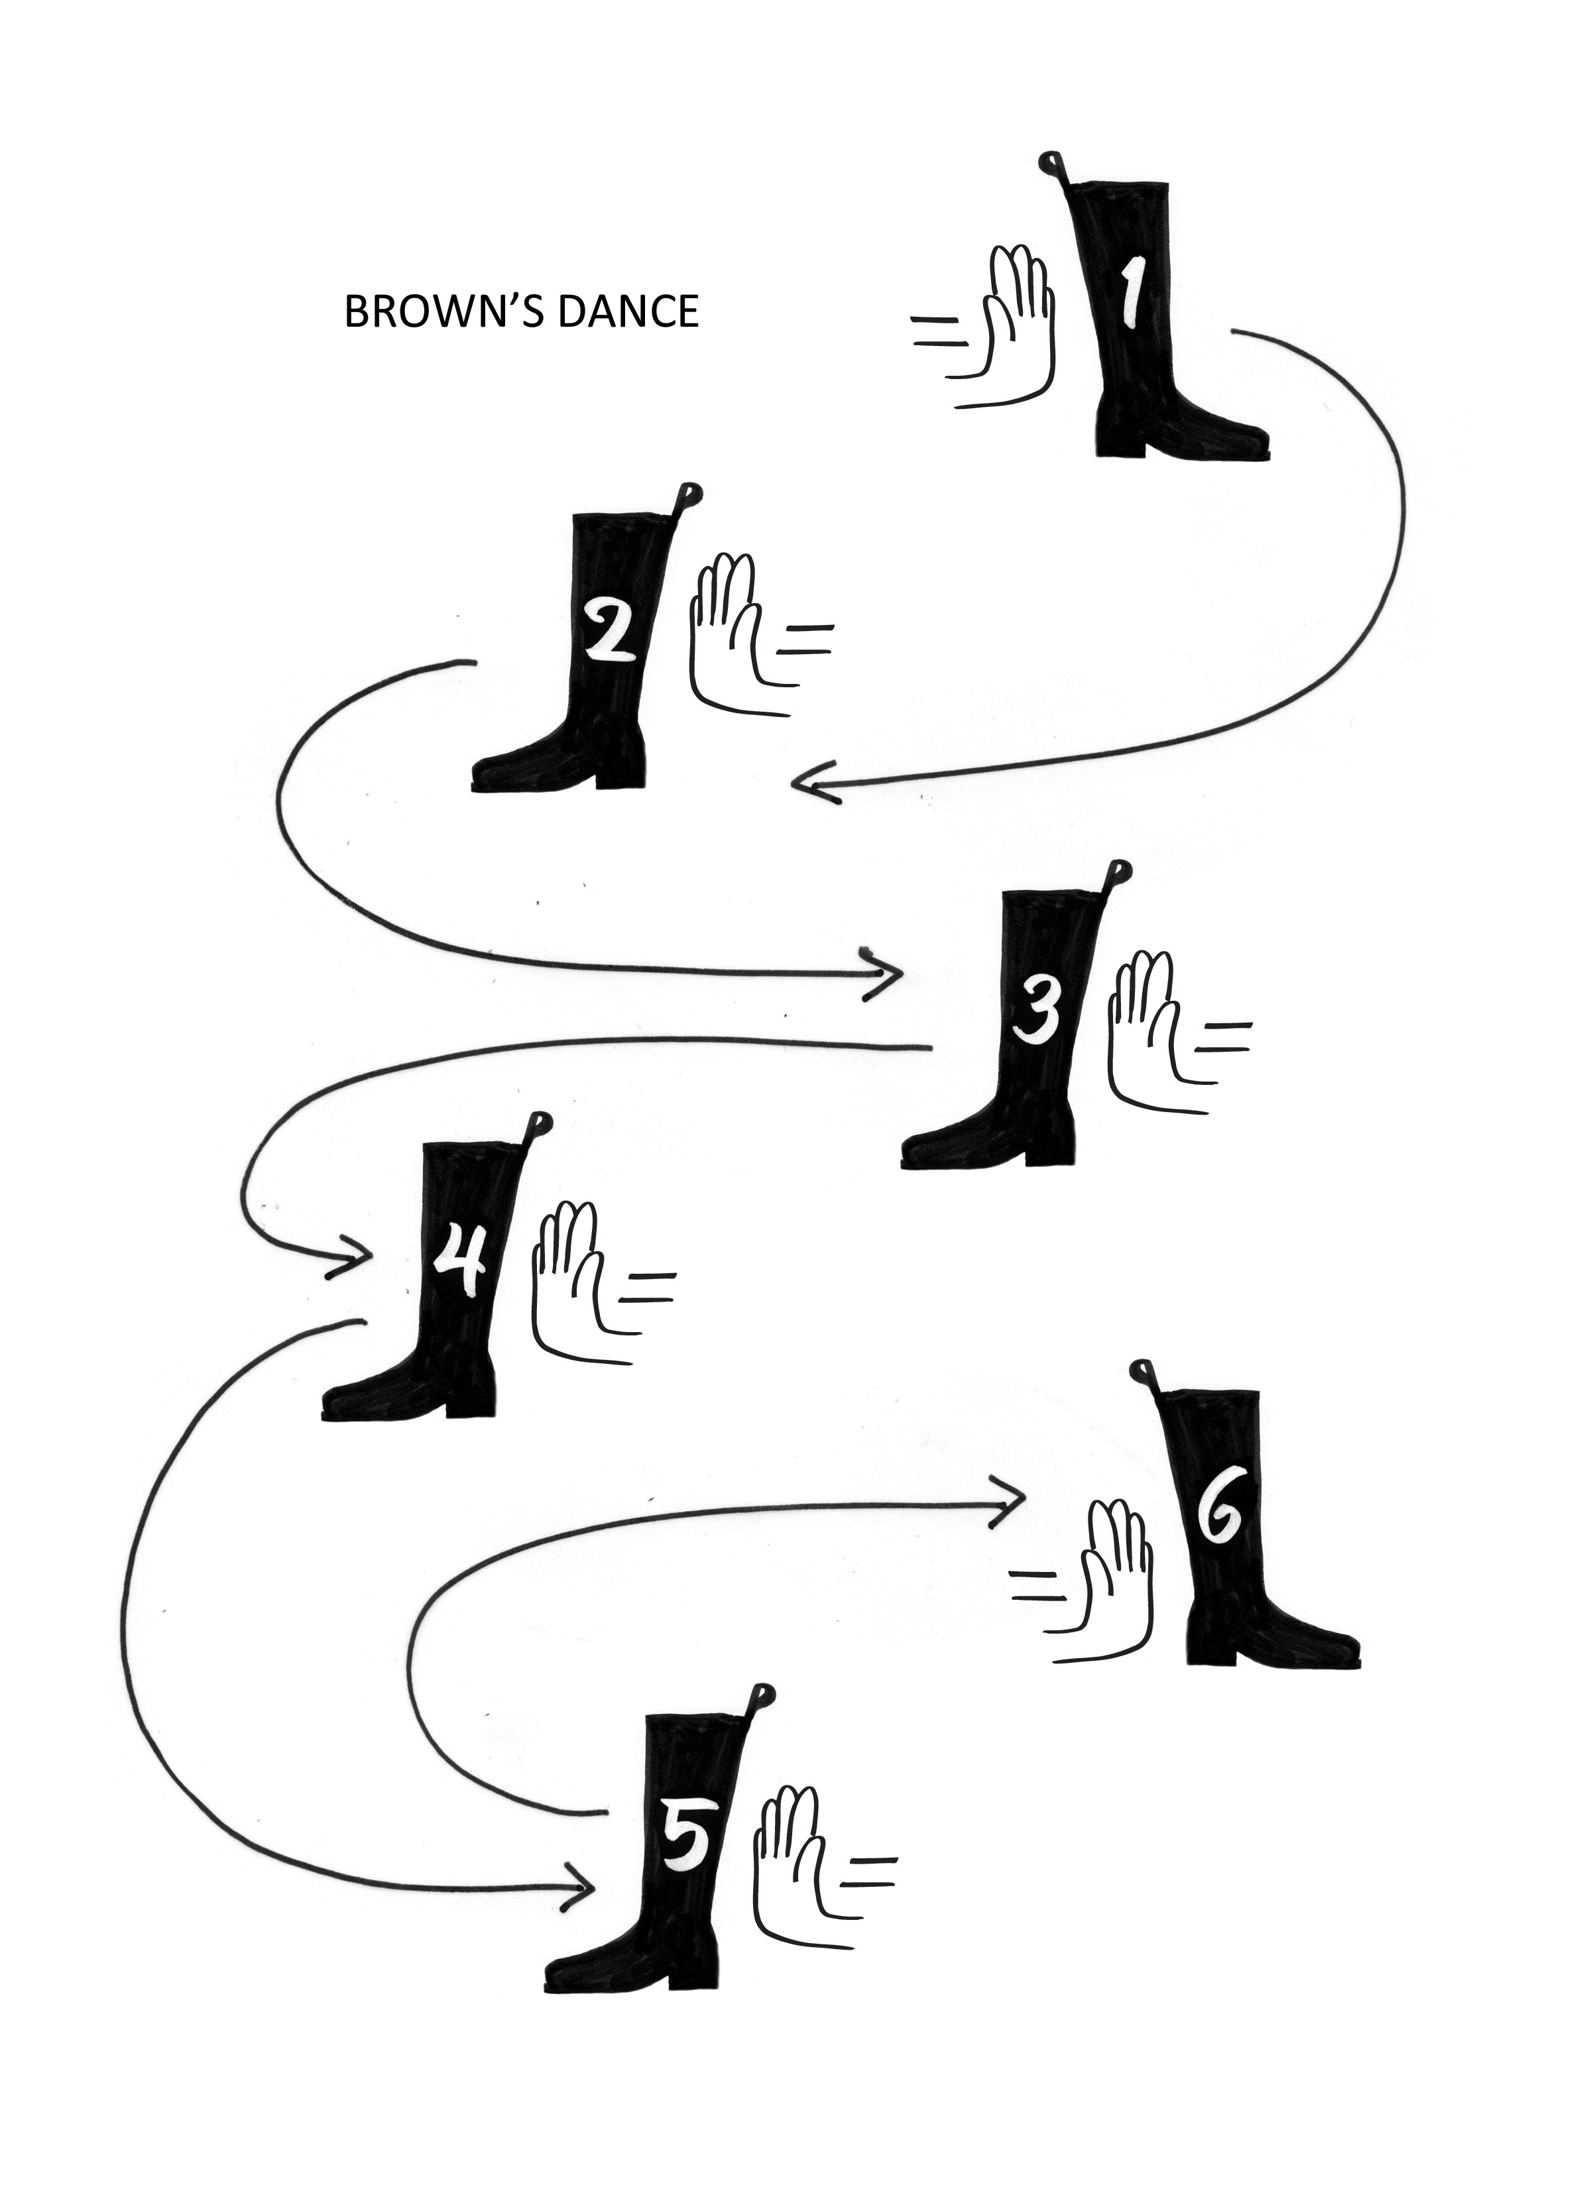
Chapter 9
Brown’s Dance: Energy-Driven Movements
Early in the nineteenth century, the Scottish botanist Robert Brown (Fig. 9.1) noticed something odd. After dropping some grains of pollen into a container of water, Brown observed a kind of jittery motion: instead of sitting lifelessly in the water, the grains danced around endlessly. Brown soon found that this motion was characteristic not only of pollen, but also of spores, dust, and even tiny window-glass fragments.
This jittery dance became known as Brownian motion, even though reports of similar motion came a half-century prior. Brown’s main contribution was to demonstrate that it was not just biological entities that partook of this seemingly self-animated motion but also non-biological entities. In other words, Brownian motion was a universal feature of nature.
What fuels these Brownian dancers? Why should inert particles move endlessly to and fro when “perpetual motion” is supposed to be impossible? A common understanding of this peculiar motion has long prevailed, but that understanding has not dealt with the pool of radiant energy absorbed from the environment; that energy will bring a new (and perhaps simpler) understanding of this motion’s origin.
Brownian Motion According to Einstein
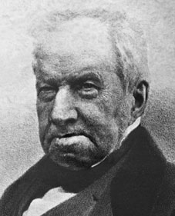
Brown’s observations initially confounded physicists. Generating motion evidently requires energy, and the source of that energy had not been clear. It appeared that the energy from the surroundings was not the culprit, for beaker of water sitting in a room for some time was presumed to be in full equilibrium with the environment; it was not receiving any energy. For years physicists scratched their collective heads, but no satisfying answer came forth.
Then came Einstein. In the seminal year of 1905, Einstein produced groundbreaking works on three different subjects: special relativity, the photoelectric effect, and Brownian motion. It was a good year. Einstein’s explanation for Brownian motion did not require a constant input of driving energy. It rested instead on an ever-present internal energy that was there as a consequence of temperature.
Figure 9.1 Robert Brown (1773 - 1858).
Einstein considered the mechanics of the motion as deriving largely from two phenomena: osmosis and friction. Osmosis is the phenomenon in which water moves toward solutes or particles. The concentration of water always wants to even out. Einstein took this inherent drive of water molecules as the motion’s generator.
To appreciate how this might happen, imagine some particles sitting in water. An individual particle may be considered to have a high mass concentration but no water. Because of the natural osmotic drive, the water molecules always want to move toward the particle. As a result, they will occasionally bump into the particle, which will move as a result.
Any such movement needs to overcome friction. Einstein recognized that. To account for such viscous resistance, he applied the standard friction equation, known as Stokes’ law of friction. He set the driving force of osmosis equal to the resistive force of friction and thereby articulated what has become the modern understanding of Brownian motion.
This simple sketch belies the sophistication of Einstein’s analysis. Einstein dealt not only with the origin of the movement but also with its nature. He likened the movements of water molecules to the movements of gas molecules. Gas molecules, according to a kinetic theory well articulated by that time, bounce around randomly; they do so as a consequence of their temperature. Temperature was considered the source of energy for their movement.
Thus, Einstein sought to extend that gas theory to liquids. By considering liquid molecules analogous to gas molecules, he could envision the water molecules bouncing randomly to and fro, occasionally striking suspended particles and pushing them to and fro (Fig. 9.2).
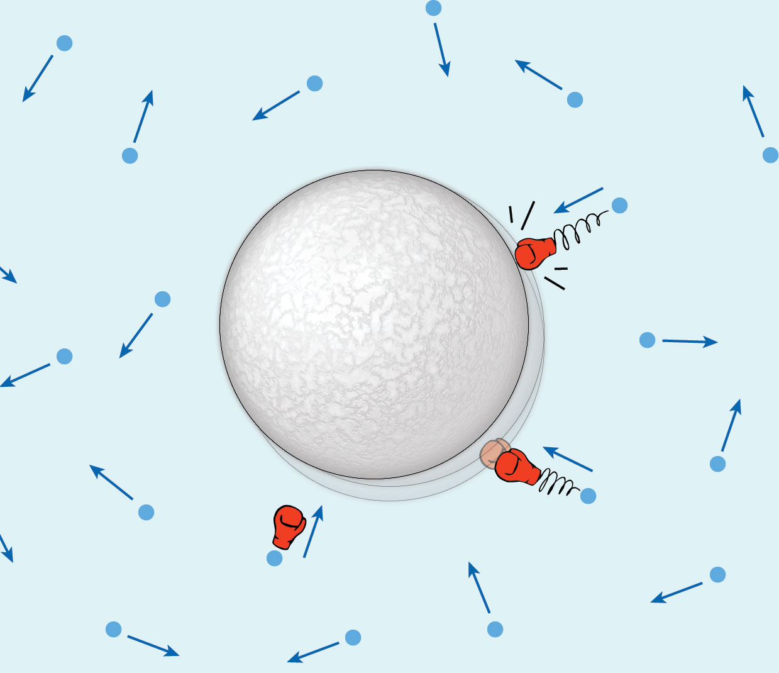
Of course, the hit of a single water molecule will not produce very much motion. The mass of a water molecule is roughly 10,000 million times smaller than the micron-sized particle to be moved. So the punch will be feeble. My friend Emilio Del Guidice likens this punch to the crash of a mosquito onto the windshield of a trailer truck — the truck will not seriously deviate from its course. To move the truck you’d need a lot of crashing mosquitoes.
At any rate, by using the kinetic theory of gases Einstein arrived at an equation describing Brownian dynamics (see box). That equation predicts the value of particle displacement (actually mean square particle displacement} over time.
Figure 9.2. Origin of Brownian motion, according to Einstein. Water molecules continually bombard the particle with mechanical energy.
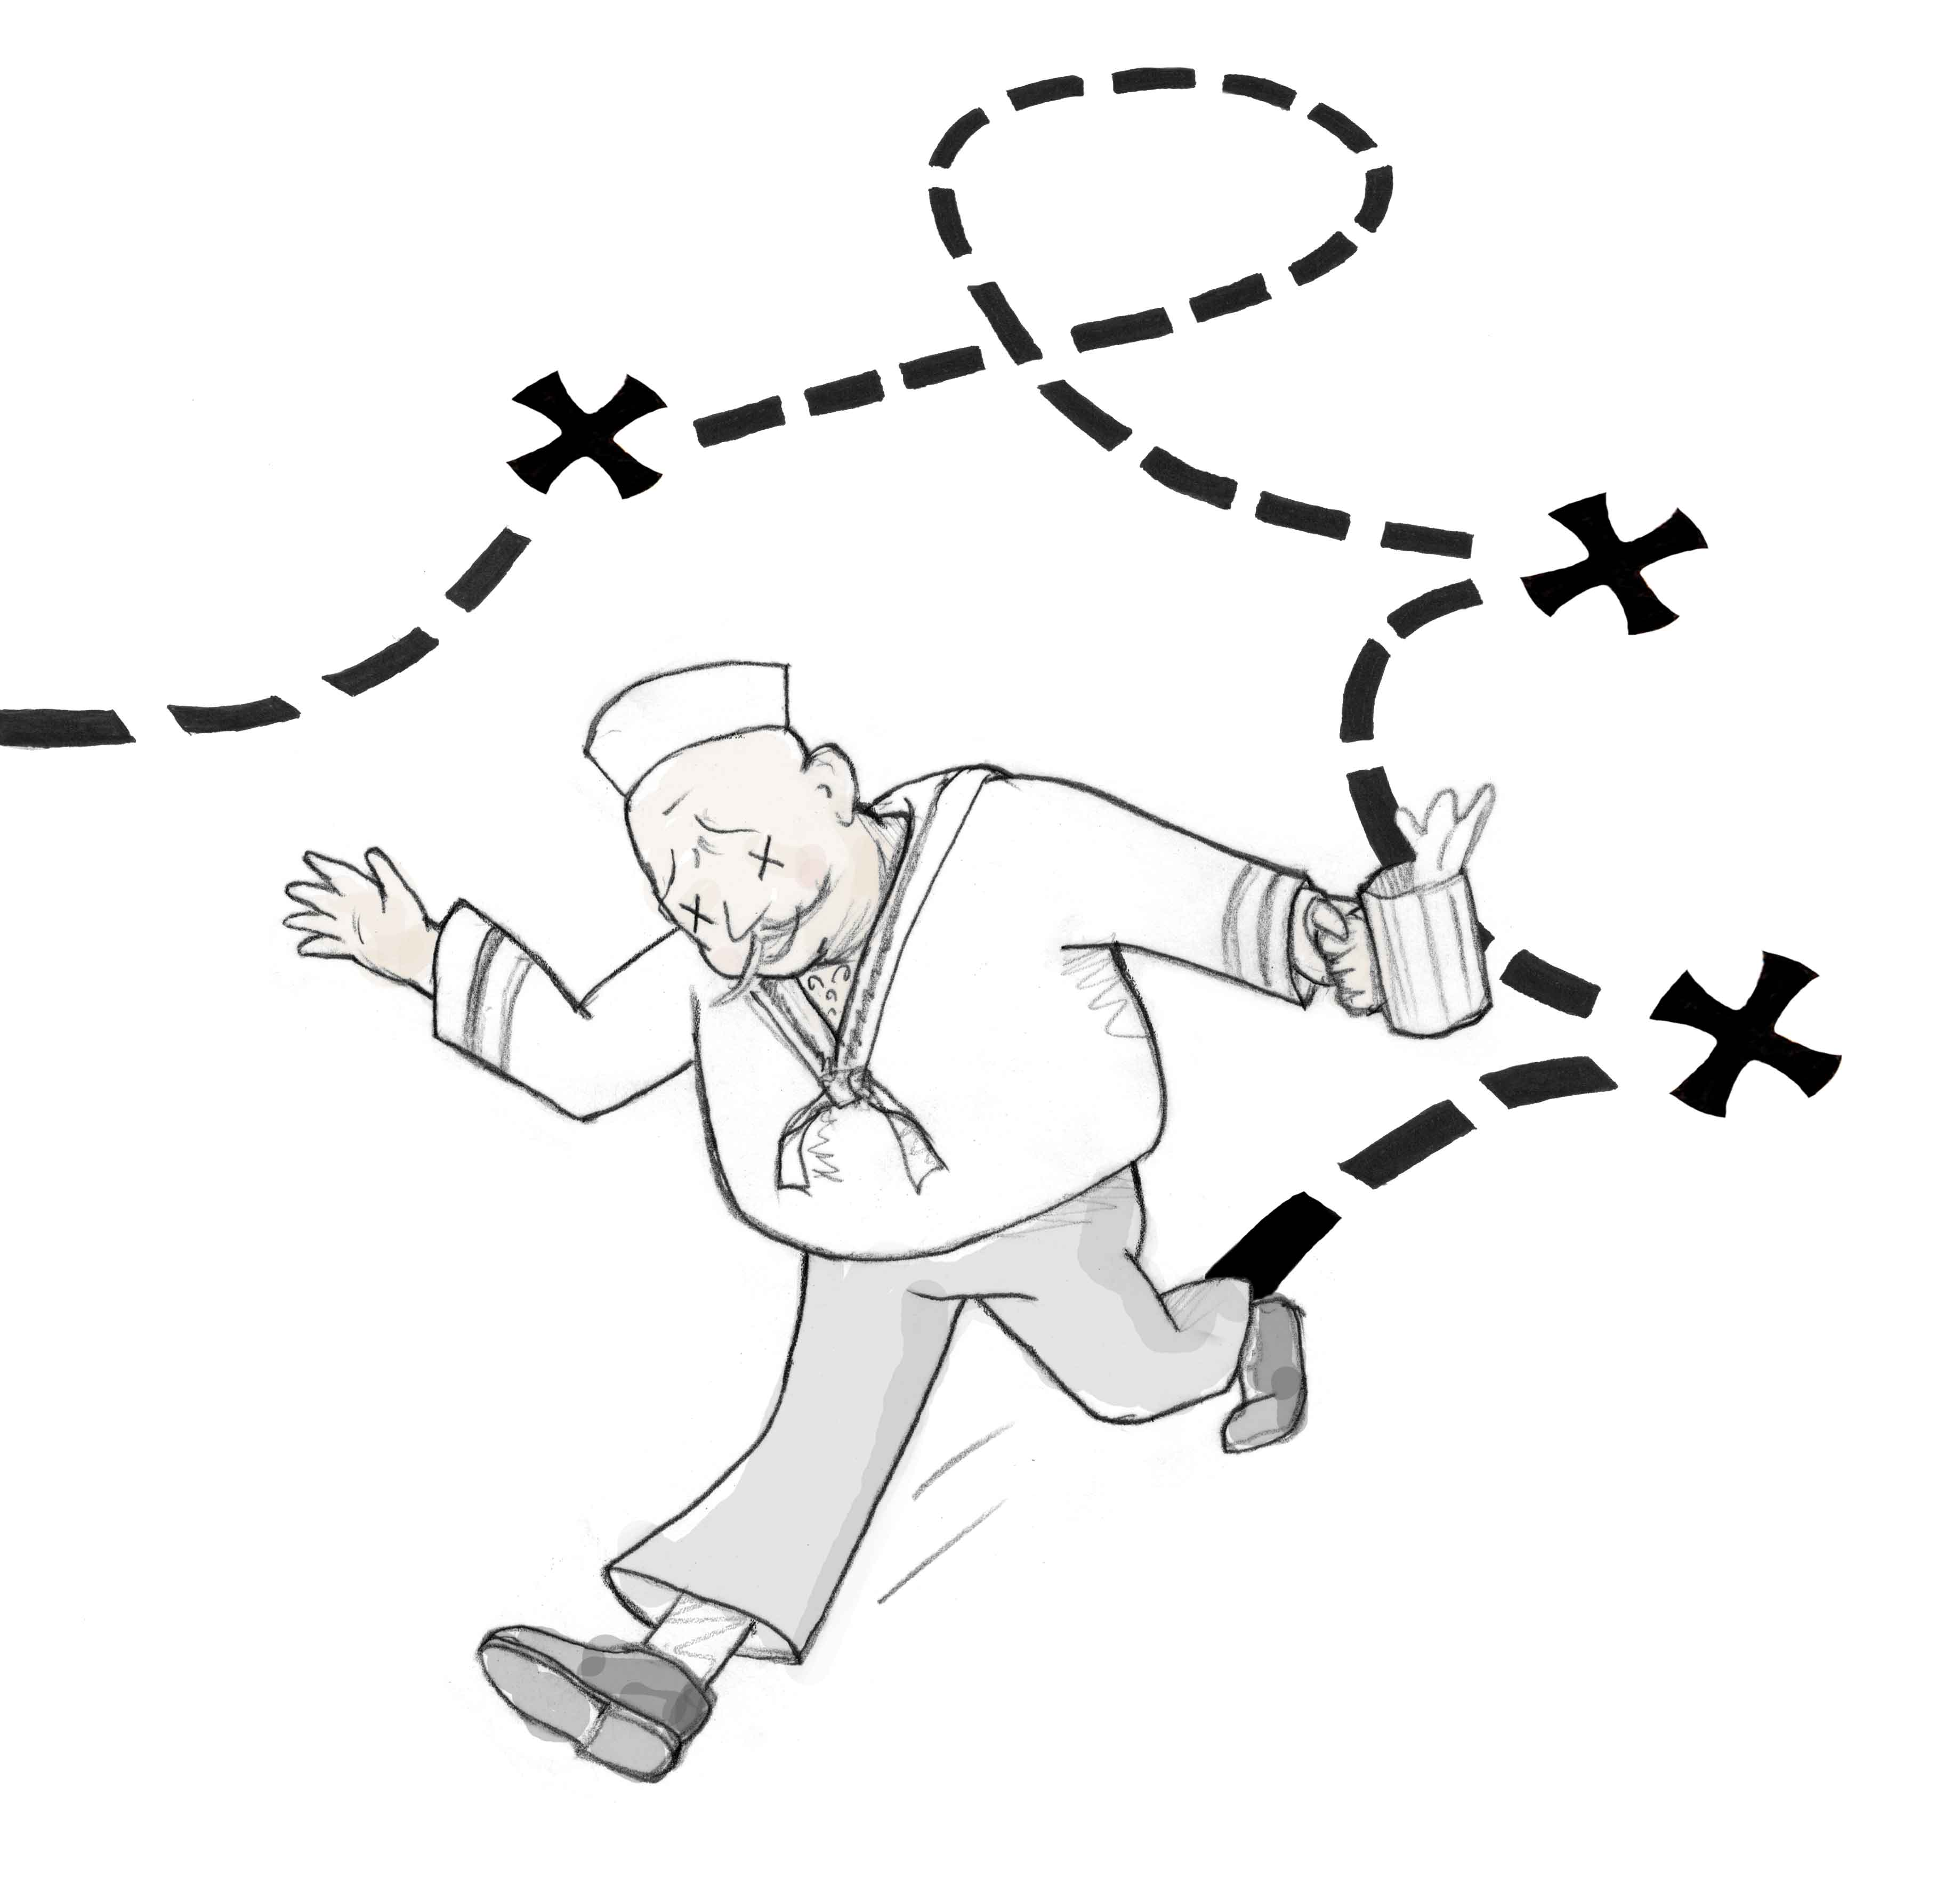
With this formal theory, Einstein described what might happen to the single particle suspended in a bath of water molecules. The water molecules, he opined, should undergo random gas-like motions. Sometimes those moving molecules would hit the particle. Because the hits would come at random instants, the particle will suffer random displacements, which might resemble the walk of a drunken sailor (Fig. 9.3).
Einstein’s theory led to the concept of “thermal” motion. According to his formulation, a particle’s Brownian excursions in a liquid should depend on temperature. At absolute zero temperature no motion should be present; as the temperature increases, the excursions should increase progressively. On the basis of this temperature dependence Einstein could refer to the motion as “heat motion” or “thermal motion.” Thus, physicists have come to take this motion as temperature’s inevitable manifestation: atoms and molecules dance as a consequence of their temperature.
Figure 9.3. Brownian motion, described as the walk of a drunken sailor.
While scientists broadly accept Einstein’s analysis, that was by no means true initially. A historical account by Brush (1968) provides a readable account of the early resistance to Einstein’s theory. Physicists were skeptical because of questionable theoretical leaps. Stokes’ law, for example, had been advanced for describing friction in macroscopic systems such as pendulums swinging through air; but Einstein assumed that it could also apply to the microscopic entities involved in Brownian motion. In addition, some physicists thought that the effects of bumping water molecules could not be powerful enough to explain the observed movements (crashing mosquitoes) unless the water motions were coordinated. Other physicists raised concerns about mutually exclusive assumptions: osmotic theory implied that the water molecules should smash into the surface and bounce off; but Stokes’ law implied that they had to remain adjacent to the particle in order to create the friction. These issues troubled contemporary physicists.
Box

Einstein’s original equation described the diffusion constant, D, of a particle in a fluid:

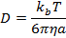
where k_{b} is Boltzmann’s constant, T is the absolute temperature, is the fluid viscosity, and a is the particle radius.

From the value of D, one can calculate the displacement, x, over time as:

where is the mean square distance traveled, and t is time.
Another troublesome issue for many scientists was Einstein’s general approach. It rested on an abstract form of statistical mechanics of gases whose basis some physicists found difficult to follow. Many found his analysis obscure, and were more impressed by a later exposition from the Polish physicist Marian Smoluchowski.
To compound these theoretical difficulties, certain experimental observations contradicted the Einstein’s predictions. Contemporaries such as Svedberg and Henri found displacements four to seven times those predicted from his formulation. They were not shy about trumpeting those disagreements.
Nevertheless, as Einstein’s stature grew, resistance to his theory gradually melted away. Within several decades his theoretical formulation became universally accepted. By now, the concept of thermal motion has risen in prominence to become one of the most fundamental attributes of nature. Every atom, molecule, or particle is thought to undergo this thermal dance, and out of such dancing has come our contemporary understanding of much of modern condensed matter physics. It is why kT, the product of Boltzmann’s constant and absolute temperature, appears so often in standard equations of chemistry and physics. It would be no overstatement to say that the concept of thermal motion has become practically as fundamental as Newton’s laws of motion or the atomic theory of matter.
Concerning Issues
With the early reservations of Einstein’s contemporaries long forgotten, it is natural to presume that everything is fine in Brownland, and that agreement is now universal. However, that is not the case. The theory fails to match modern experimental observations in at least three situations: (i) when salt is added to the water; (ii) when particle concentrations are relatively high; and (iii) when a light is turned on.
Regarding (i), Brownian excursions were measured at a series of salt concentrations (Okubo, 1989a). Adding salt increased the excursions; i.e., it intensified the jitters. Einstein’s analysis offers no direct explanation for why the presence of salt might cause water molecules to bash into particles more energetically.
Nor does Einstein’s analysis anticipate any influence of particle concentration (ii) At high concentrations, however, the motions of neighboring spheres often become cooperative: when one moves, others nearby will often move in the same direction (Weeks et al., 2000). Such synchronous behavior is also seen in colloid crystals (Ise et al., 1990) and at high particle concentrations with added salt (Okubo, 1989b). Thus, high particle concentrations introduce a feature not expected classically: the local synchronization of Brownian excursions.
Synchronization is a nettlesome problem because the theory anticipates random motions. There should be no coordination among particles. A possible escape might be that classical theory doesn’t apply here: if the particle concentration grew high enough to squeeze out most of the water, then no molecules would be on hand for hitting the particles; so Einstein’s formulation might no longer apply. But concentrations rarely grew so high: In the studies cited just above, the spacing between particles was typically on the micrometer scale, equal to a lineup of thousands of water molecules; hence, plenty of bouncers should have been on hand to do the job. The conflict is not swept away.
Synchrony is not the only type of non-random behavior observed. At high particle concentration Weeks and Weitz (2002) detected a “hopping” motion. A particle would remain within an almost stationary locus for some time; then it would hop to a new locus, where once again it would suffer only minor random displacements. It was as though the particle had jumped from one cage to another. This caged pattern was observed also in biological contexts (Bursac et al., 2005). This pattern constitutes yet another deviation from the theory’s expectation: a direct proportionality between mean-square distance traveled and time.
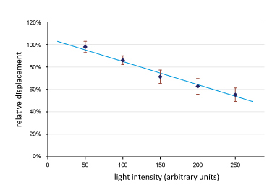
Regarding (iii), another conflict comes from the effects of light. Added light diminishes Brownian excursions. Although century-old studies by Gouy had denied any such effect, more recent experiments using modern instruments have revealed a definite effect of light, which depends both on wavelength and intensity (Bhalerao et al., 2010). Adding modest amounts of light could diminish particle excursions by as much as 50% of controls (Fig 9.4).
These effects could be of secondary concern if they were mediated indirectly, perhaps through light-induced changes in temperature. However, that seems unlikely. Absorbed light should increase the temperature; but according to Einstein’s formulation temperature increase should produce larger particle excursions, not the smaller ones observed. At any rate, the increase amounted to less than 1 °C. So, temperature increase seems an unlikely vehicle for escape. The light-mediated effect has no obvious explanation within the classical formulation. On the other hand, it is striking enough to demand explanation, and we will deal with the explanation shortly.
Fig. 9.4. Microsphere displacements measured over a fixed period of time at different incident light intensities. Higher intensities diminish displacements.
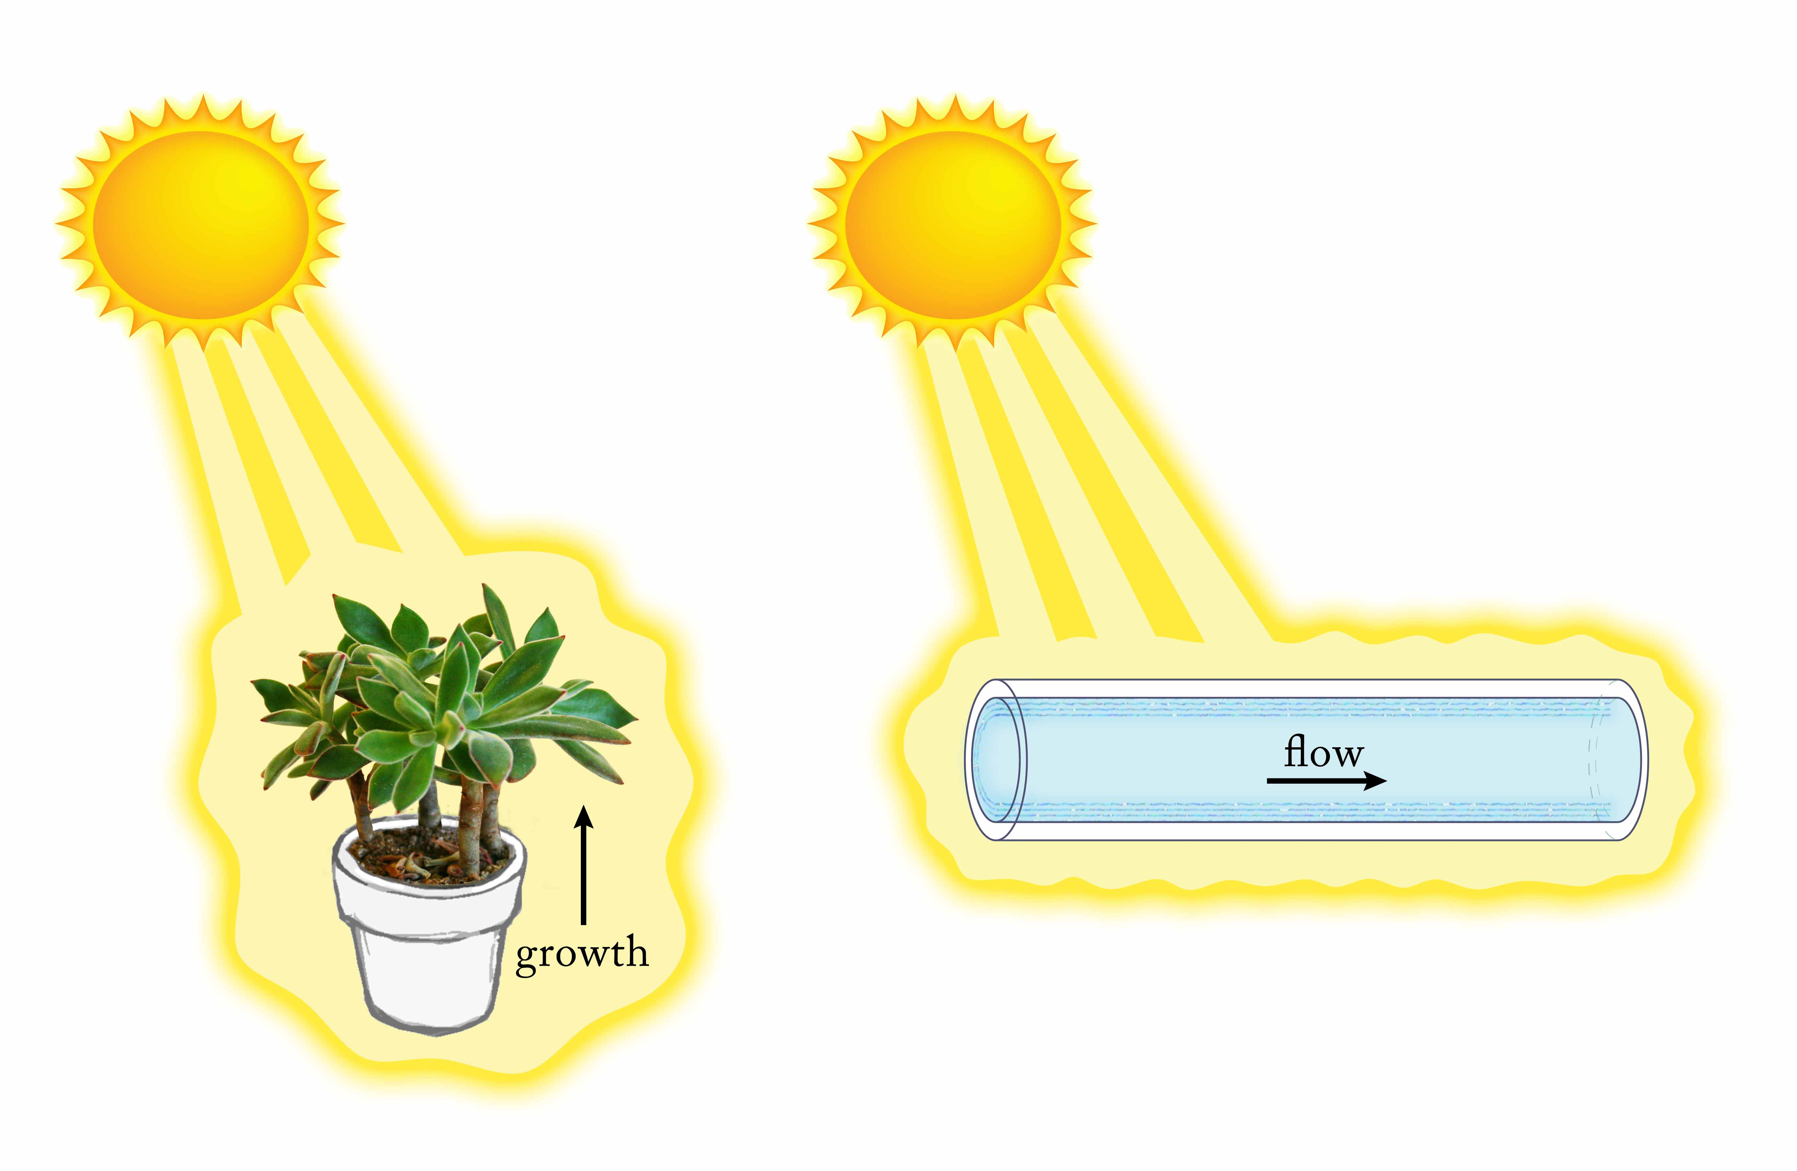
Apart from the three conflicts just considered, a fourth potential problem is the uncertain nature of the actual driving force. Einstein suggested osmosis because osmosis was presumed to be a fundamental feature of nature — on the same level for example as the attraction between positive and negative charges. However, that presumption is uncertain: the osmotic mechanism has remained under debate for years, without any real resolution. Chapter 11 offers evidence that the osmotic drive is not at all fundamental; it arises from the separation of charge attendant with EZ buildup, which creates an electrical potential that drives the osmotic water flow. If that hypothesis is sound — please wait for Chapter 11 to judge the evidence — then the most central underpinning of the classical theory would collapse.
Figure 9.5. Radiant energy produces work in plants and in water; the two processes are conceptually similar. By processing energy, both operate out of equilibrium.
In sum, while Einstein’s theory of Brownian motion is broadly accepted and evidently fits some experimental observations, it does not fit others. The failures imply that the theory is at best incomplete. Rather than just incomplete, I argue next that the theory is fundamentally inadequate — it fails to account for energy that may affect, or even drive, the observed motions.
More Brownian Issues: Are Aqueous Systems Ever at Equilibrium?
A central presumption of Einstein’s formulation is that the system is at equilibrium: So long as the ambient temperature remains steady, it neither gains nor loses energy. A pot of hot water would certainly lose energy to the environment, while a glass of cold water might gain some. But a covered vessel of water sitting in a room for some time should qualify as neither losing nor gaining energy. That’s what the classical theory presumes.
However, the previous chapters have shown otherwise. They’ve presented evidence showing that room-temperature water continually absorbs electromagnetic energy from the environment. The absorbed energy builds order and separates charge — creating potential energy that can produce many kinds of work. By mediating this energy conversion, the water operates like all common working machines: out of equilibrium.
Out-of-equilibrium behavior even characterizes even life’s most primitive water-based mechanism: photosynthesis (Fig. 9.5). In the photosynthetic mechanism incident photons drive physicochemical processes, including metabolism, growth, and various flows. Absorbed energy continually power work output, which means that the system is out of equilibrium.
Hence, the classical presumption of equilibrium conflicts with the evidence. In both water and plants (the latter consisting mainly of water) input energy produces work in much the same way as fuel powers your car. All of those systems operate far from equilibrium. If indeed they lie out of equilibrium, then any understanding of Brownian motion built on the presumption that they lie in equilibrium must be considered suspect.
This issue is a serious one; it presents yet another fundamental challenge to the classical understanding of Brownian motion.
The Energy Driving Brownian Motions
If the energetic driver of Brownian motion is not internal heat as classical theory predicts, then what is the energetic driver?
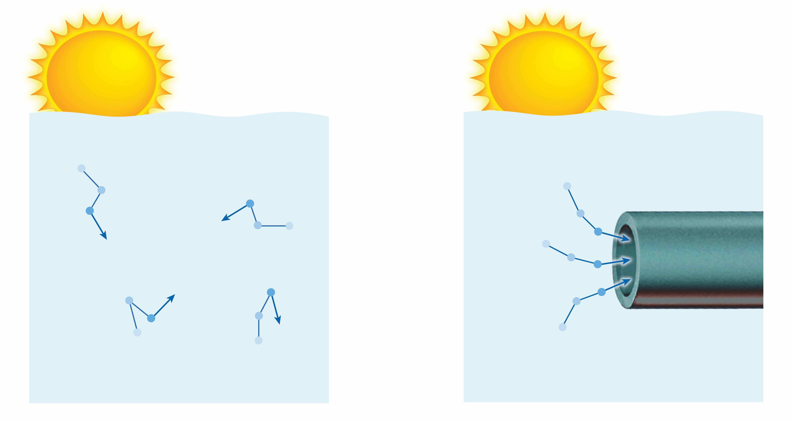
Consider incident electromagnetic energy. If that energy drives the myriad processes already noted, then might it not also drive Brownian motions? These motions constitute small-scale work: Each particle moves through a viscous medium, and such movements require driving energy. You can’t get something for nothing.
The energy requirement is similar for fluid flow through the hydrophilic tube, except that the latter motions are directed, not random. The tubular “director” coordinates the individual motions to produce useful work. If electromagnetic energy drives that work, then it follows that it must power the individual motions that sum to produce the work. All such motions should arise as products of incident electromagnetic energy (Fig. 9.6).
Figure 9.6. Incident energy generates motions. The motions can be random in the absence of a director (left); or coordinated and work producing in the presence of a director (right).
The idea of an electromagnetic energy driver of Brownian motion may seem radical but it has precedent. Several 19th century physicists thought that electromagnetic energy might drive the motion indirectly by inducing heat. Later, the father of quantum mechanics, Max Planck, thought similarly: he entertained the notion that electromagnetic interactions could drive random molecular motions. When that line of reasoning failed to yield the rich dividends envisioned, he finally moved in other directions. Nonetheless, the idea of an electromagnetic driver had remained high on Planck’s agenda for some 20 years.
Hence, the notion that Brownian motions might be externally driven is not as radical as it might seem. Fresh evidence from previous chapters now lends support: The fact that incident electromagnetic energy drives all kinds of work implies that it might drive Brownian motion work as well. Think of it: Absorption of electromagnetic energy occurs continually. Without some kind of relief, that energy buildup would eventually create an explosion. The Brownian work might therefore be viewed as a kind of relief outlet: a way to continuously release all of that pent up energy. In other words, Brownian motion is a direct manifestation of absorbed energy.
You might think of the water as a simple transducer, converting input electromagnetic energy into output Brownian work.
The Force Driving Brownian Motions
The considerations above help us understand Brownian energetics, but they tell us nothing about the immediate driver. What force pushes the particles to and fro?
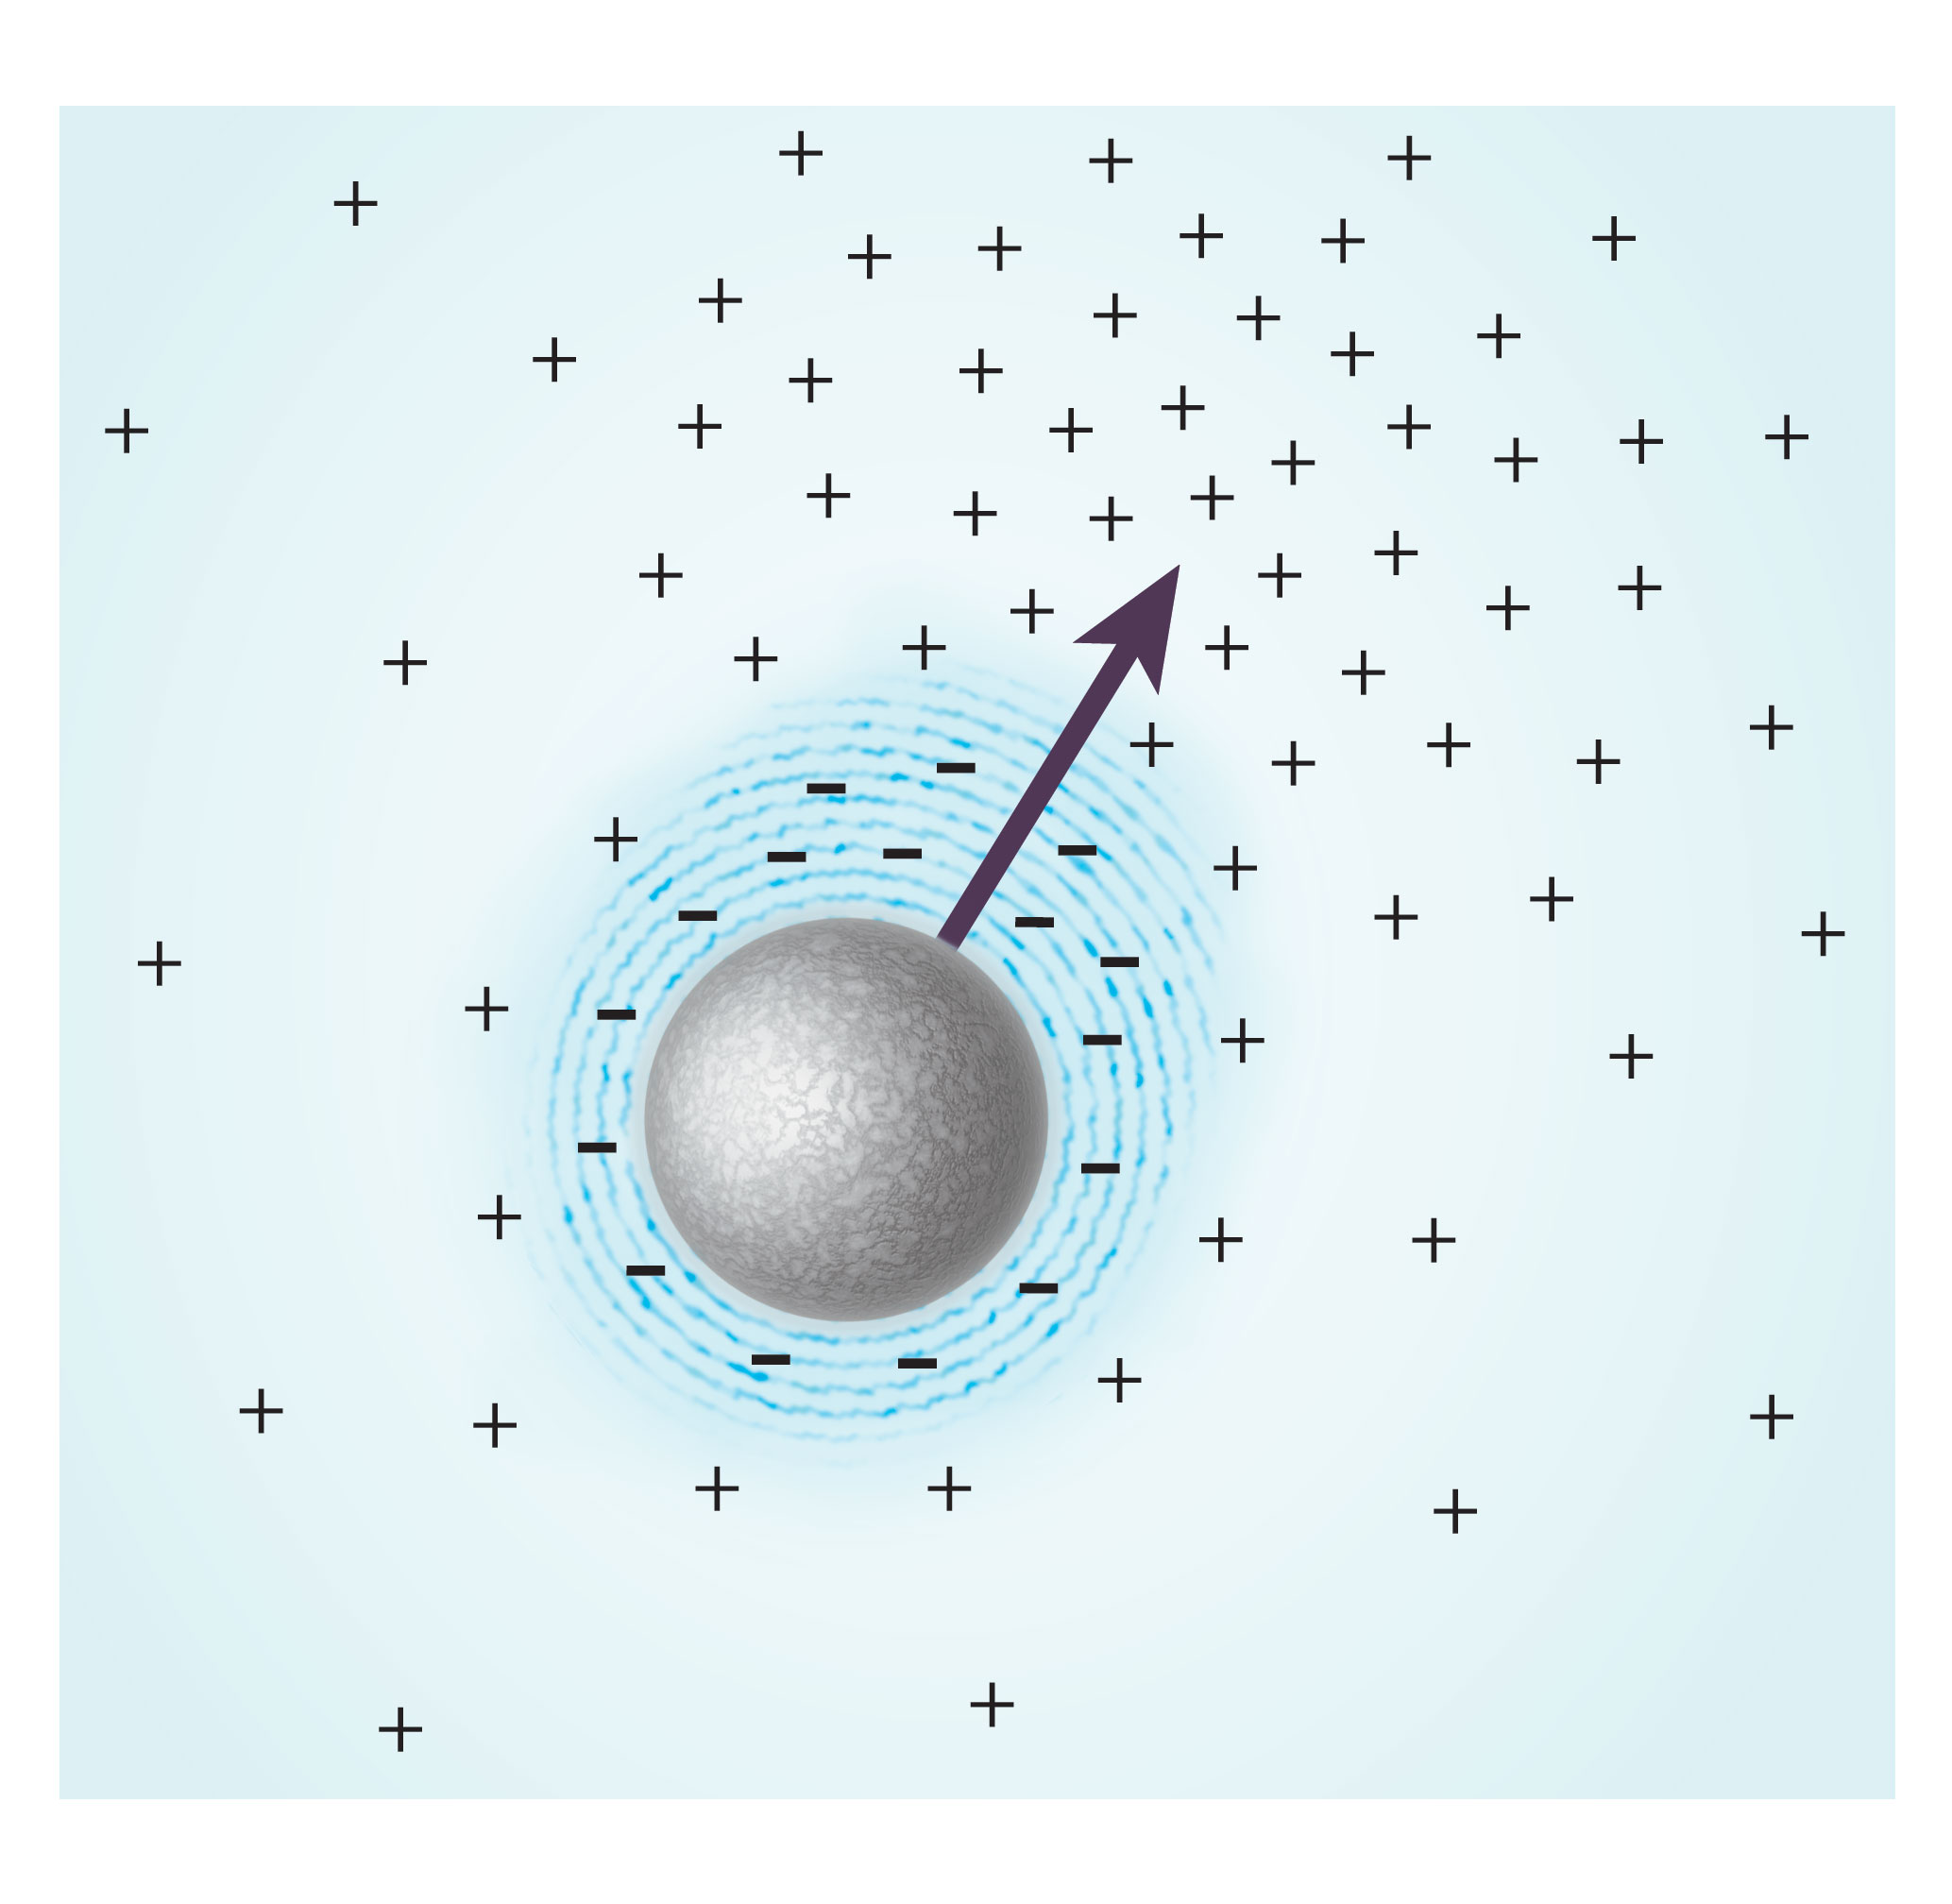
Logic implies some involvement of the exclusion zone. If the incident energy builds exclusion zones, then some feature of the EZ ought to be responsible for orchestrating the action. The EZ has two principal features: order and charge separation. Charge separation seems a candidate worth exploring, for charges can generate substantial forces, which could then drive the Brownian jitterbug.
To see how this might happen, imagine a single microsphere suspended in water. If energy were uniformly incident from all directions, then the microsphere’s exclusion zone should be uniform; it ought to be a perfect shell. However, absolute uniformity is unachievable in practical circumstances; therefore, the non-uniform incident energy will build a correspondingly non-uniform EZ shell with a correspondingly non-uniform distribution of charges; see Figure 9.7.
Figure 9.7. More intense incident light (from upper right) should yield an asymmetric charge distribution and, hence, a net electrostatic force in the direction of the light.
Now, which way would the suspended microsphere of Figure 9.7 want to move? Remember that the entity under consideration is not the microsphere alone but microsphere plus clinging EZ; it is a compound particle, which is quite negative overall. In theory it could move in any direction, but being inert, dumb and negatively charged, it will inevitably move in the direction of highest local positivity. In the figure, that is toward the upper right.
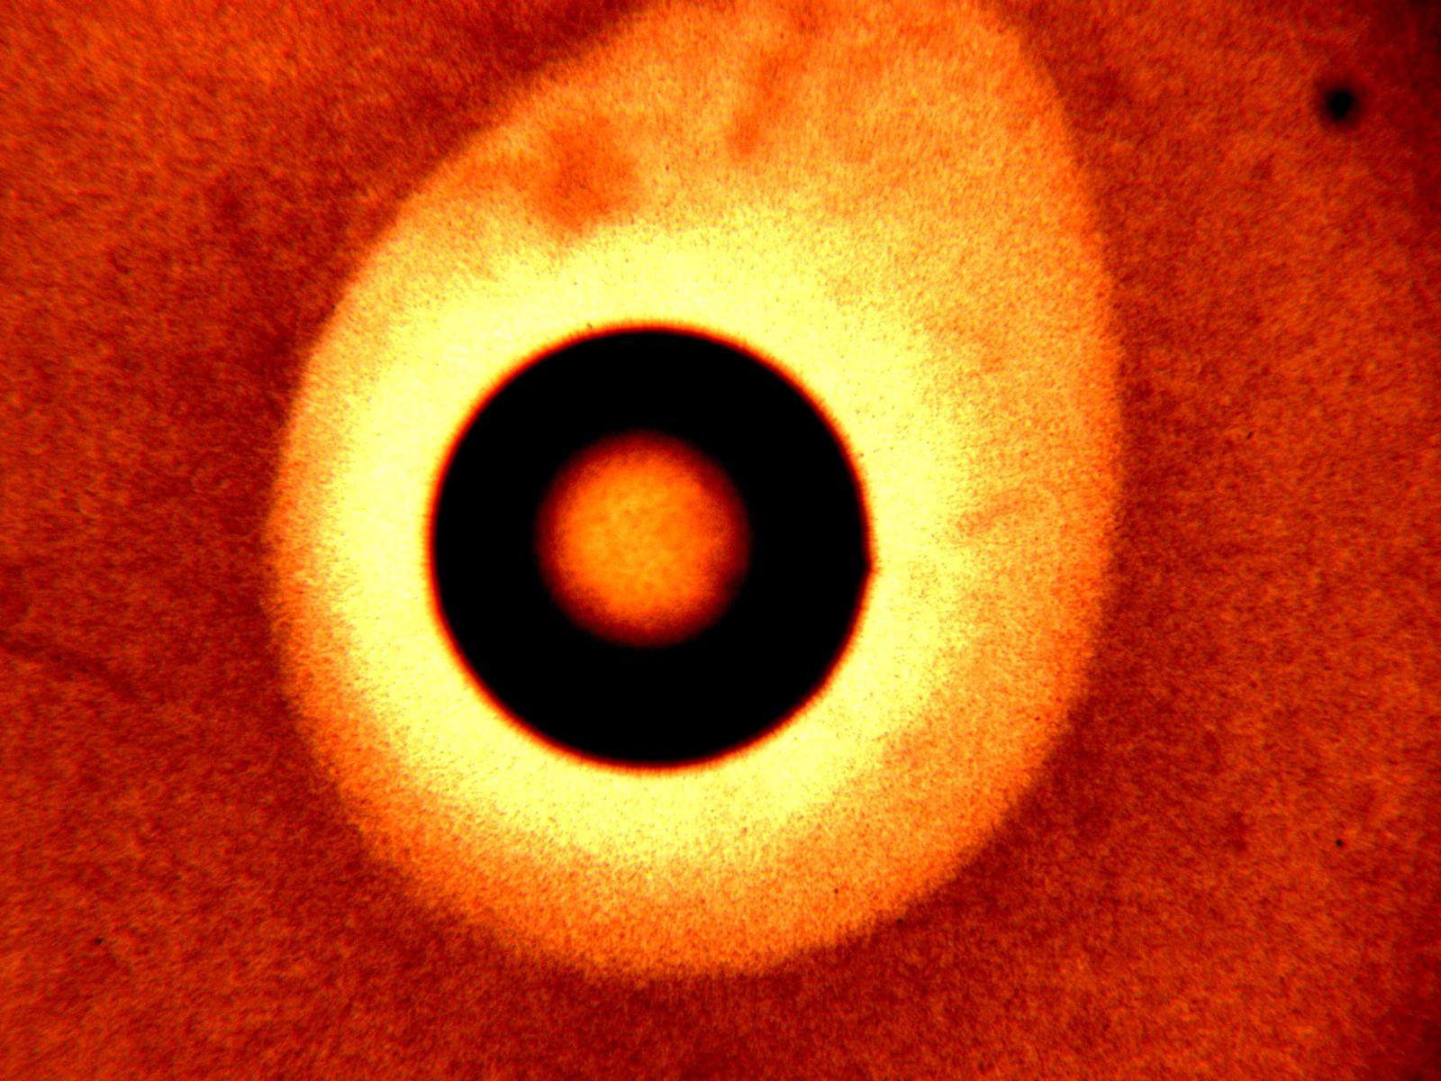
We confirmed such positive-directed movement experimentally. A long, silver ribbon assembly was positioned horizontally in an experimental chamber, the ribbon’s lateral edges oriented at top and bottom. The ribbon was cantilevered from one end. On a flat face near the free end, a piece of Nafion was bonded. When the assembly was exposed to water, the EZ grew around the piece of Nafion in all directions except toward the face of the ribbon, whose mass effectively blocked EZ growth. Hence the EZ was asymmetric, as was the associated region of positivity. The lever bent impressively sideways on exposure to water, toward the region of high positivity. Hence the positivity-directed movement anticipated in Figure 9.7 really does take place.
We tried modeling the light-induced asymmetry of Figure 9.7 and got a positive result. Figure 9.8 shows a gel bead approximately 0.5 mm in diameter sitting on the floor of a chamber. The exclusion zone is ordinarily uniform around the bead; however, when we shone extra light from one direction, the EZ grew larger on that side. Hence the asymmetry needed for charge-directed movement is physically realizable.
Such positive-directed movement may be thought of as a single Brownian excursion. It is mediated by simple attraction. For creating the attraction all that’s needed is some non-uniformity of incident light energy, a condition that is practically inevitable. Put another way, the Brownian excursion amounts to a movement toward the highest intensity of light, or more generally toward the highest intensity of incident electromagnetic energy.
Figure 9.8. Asymmetric exclusion zone around a gel bead, resulting from incident light coming from top right.
Do Particles Really Move Toward Light?
If this attraction-to-light principle genuinely operates, you’d expect that suspended particles should always move toward the light. The attraction should be consistently seen. Although not widely appreciated, the attraction is indeed seen in diverse contexts, and I’ll show you some examples to illustrate.
We first saw evidence of this attraction in the previous chapter, although the evidence was subtle. The agent responsible for the like-likes-like attraction was incident light. The light separates the charge that mediates the underlying attraction. Regions with more incident light must therefore experience more like-likes-like coalescence. That is tantamount to saying that the microspheres are drawn toward regions with the most incident light.
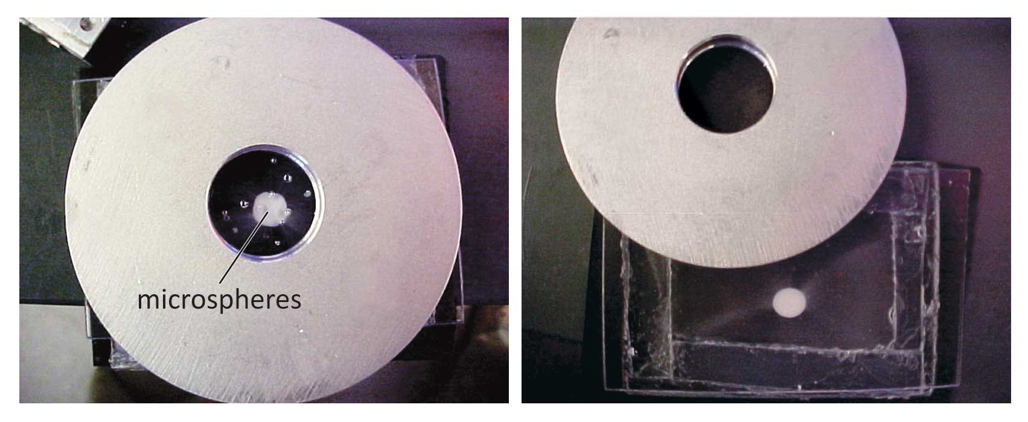
A second and more direct piece of evidence comes from experiments in which incident light was restricted. We passed a beam of light through a pinhole and into a suspension of microspheres. The microspheres eventually concentrated in the narrowly illuminated zone. They evidently gravitated toward the light (Fig. 9.9).
Figure 9.9. Light-induced attraction of microspheres. Light shines through hole in aluminum mask. After some time, microspheres in the chamber beneath the mask gather at center of hole.
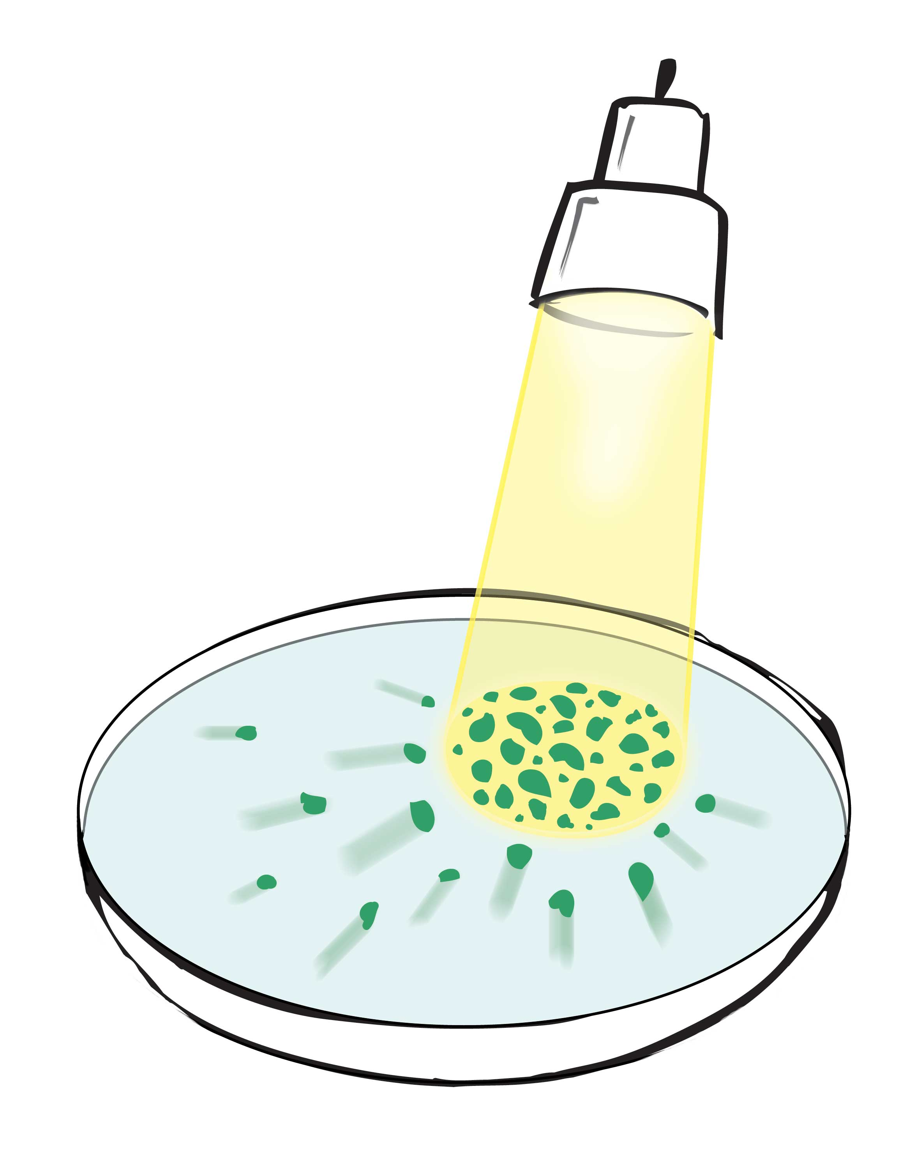
Bacteria do much the same (Fig. 9.10). They move toward near-infrared light in the same way as microspheres move toward the light passing through the pinhole. It has been thought that the movement arises from some kind of infrared sensor lodged within the bacterial cell (Albrecht-Buehler, 2005). This is certainly possible, but the movement closely resembles the movement of microspheres. In both cases the direction is toward the light.
A third example: Do you remember the microsphere-free cylinder running vertically down the middle of the beaker? That was one of the Chapter-1 anomalies we sought to resolve. The microspheres were initially distributed uniformly. After some time they moved toward the beaker’s periphery, leaving a vertically oriented cylinder devoid of microspheres. Figure 9.11 shows an example. We found that the light impinging on the beaker from all around drew the microspheres toward the beaker’s periphery. The microspheres moved toward the light.
Figure 9.10. Bacterial cells and particles move toward the point of highest light intensity.
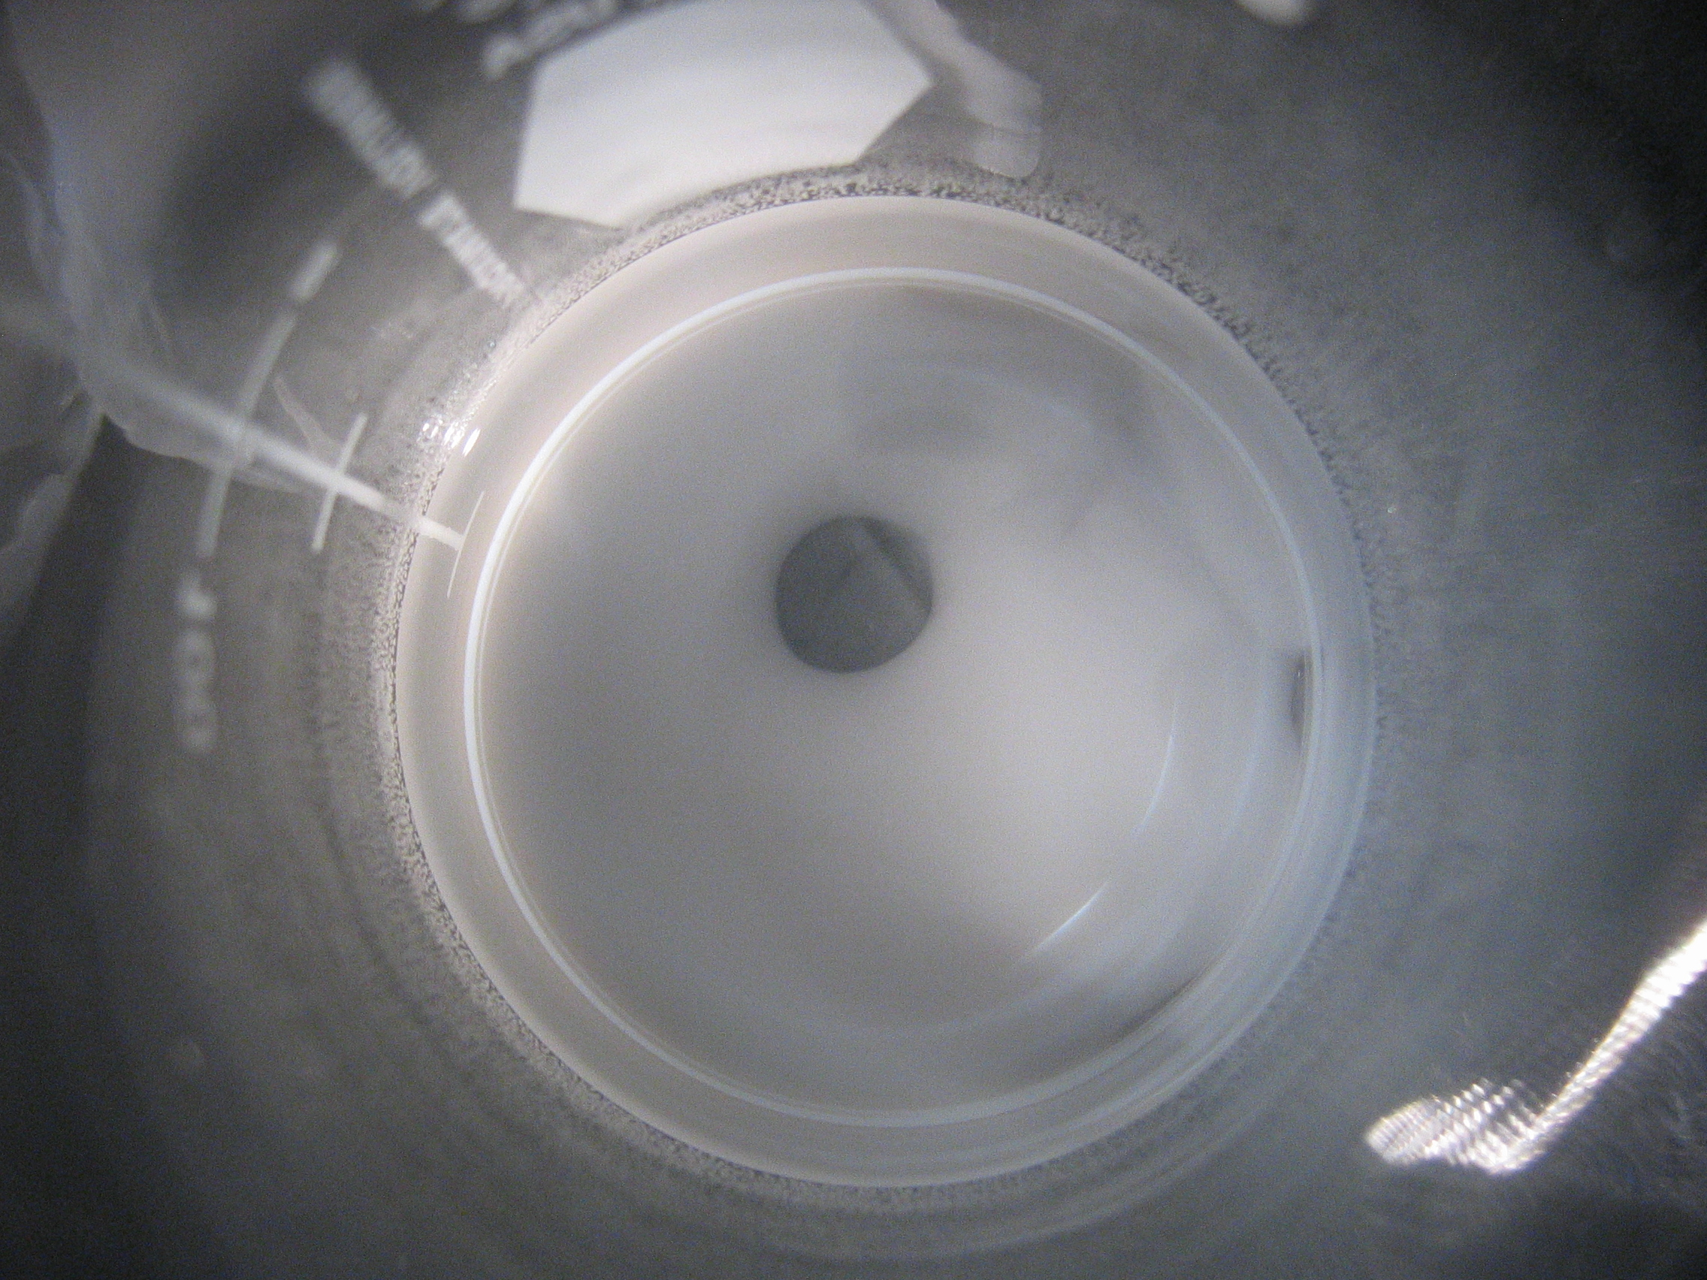
Once the cylinder formed, then shining additional light from one side drew the microspheres rapidly toward that side. The accumulation displaced the cylinder progressively toward the darker side of the beaker, where it ultimately collapsed into nothingness. All of this happened within a minute or so (Ovchinnikova and Pollack, 2009).
Figure 9.11. Microsphere-free zone in a beaker (viewed from above). Running from top to bottom, the clear zone appears near the center of the aqueous microsphere suspension.
We saw similar light-mediated displacements in other configurations. In very long cylindrical chambers, exclusion zones that originated from one end would narrow down and continue to grow in stalagmite fashion toward the far end of the chamber (see Fig. 3.5). Over time, these spaghetti-like projections often extended all the way to the other end of the meter-ling chamber. Out of curiosity we examined them with a flashlight or laser beam. Each time, the microspheres moved toward the applied light. This shifted the microsphere-free EZ strand away from the light, as shown in Figure 9.12.
A fourth example is a phenomenon we observed in ordinary microsphere suspensions. Microspheres eventually settle to the bottom of the chamber, forming a sedimentary layer. We noticed, however, that shining a light from above retarded the settling, whereas shining a light from below accelerated it. Again, the microspheres were drawn toward the light.
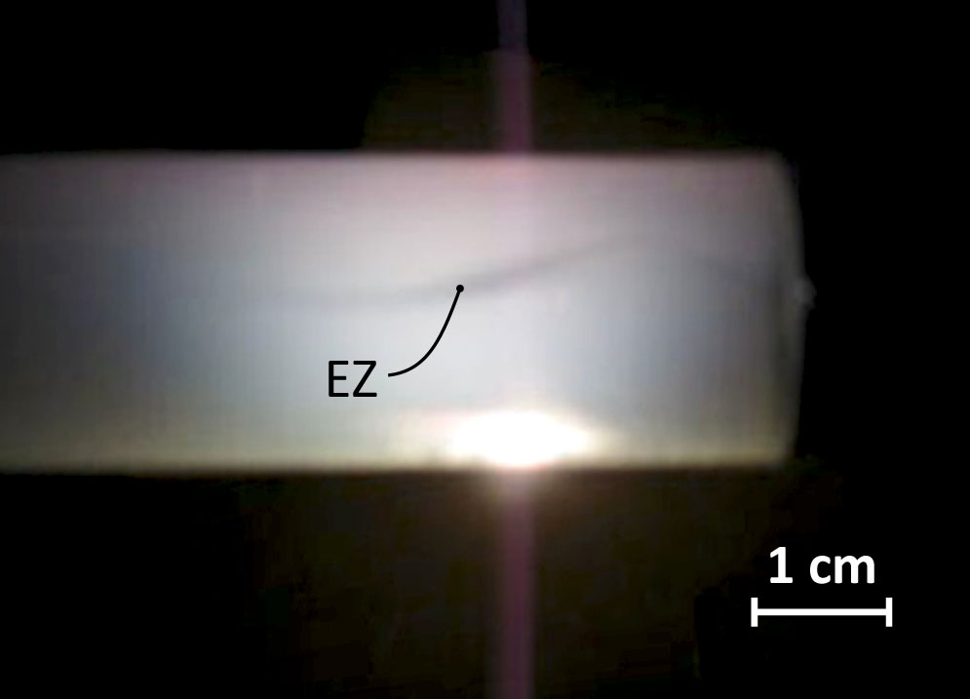
Particle attraction to light is in fact the basis of a widely exploited experimental tool called optical tweezers. Biophysicists use this technique to move particles from poi nt to point. You merely shine an intense light such as that from a laser beam onto a particle or cell, move the light beam, and voila: the illuminated object will follow. The illuminated entity always seeks the point of highest light intensity. Effectively, the particle is “trapped” in the beam of light.
This Star Wars phenomenon is commonly ascribed to a so-called “radiation pressure,” but the mechanism shown in Figure 9.7 provides a simple alternative explanation. The mechanism would work not only for the lower intensities characteristic of the experiments described just above, but also for the higher intensities used for optical tweezers. The higher the intensity, the tighter will be the trapping. Otherwise, the principles could be the same for all light intensities.
Figure 9.12. Light-induced deflection of microsphere-free zone. This EZ projects from a nucleating surface positioned off to the left. Light beam projects from bottom to top. Microspheres drawn toward the light causes the EZ to shift oppositely.
The examples above leave little doubt that suspended particles move toward light. Multiple contexts demonstrate the attraction. This confirms that we are not whistling in the dark: the hypothesized driving force is real. It could constitute the immediate driving force for Brownian motion.
Ensemble Dynamics
The remaining issue is just how those light-driven displacements create the seemingly random motions characteristic of the ensemble. Up to now all considerations have focused on the single particle. Incident light creates an asymmetric charge distribution, which draws the particle toward the light.
When multiple particles populate the water, the scenario grows more complex (Figure 9.13). One microsphere’s EZ liberates positive charges, which may attract neighboring microspheres. Those negatively charged microspheres move in response. Their movements may in turn block or unblock light pathways to still other microspheres, and so on. Movement directions and magnitudes are therefore unpredictable. To complicate matters further, we found recently that EZ size depends on local positive ion concentration; hence, positive ions liberated from one EZ may impact the size and charge distribution of another. The scenario grows hugely messy.
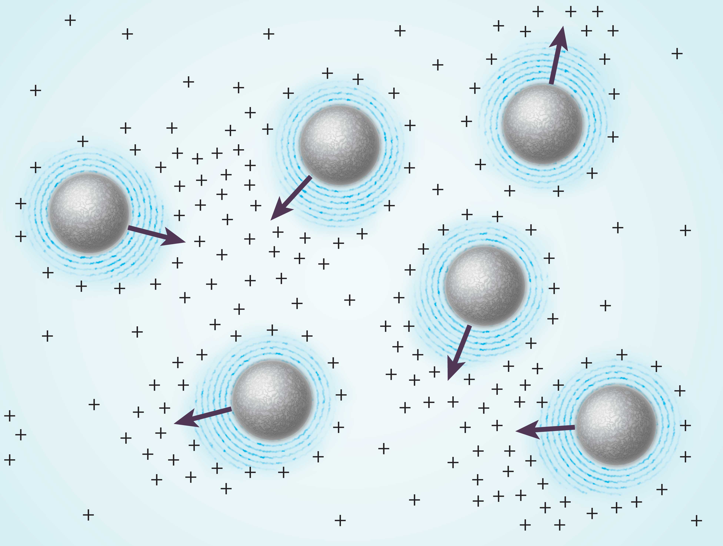
The bottom line is that individual displacements are effectively unpredictable, although a slow natural drift toward the light should be an inevitable component. On the other hand, if we are on target, then local dynamics might not be completely random: since the movement of one particle impacts the movement of its neighbors, displacements of neighboring particles should be loosely coupled. The coupling should be most evident when particles are sufficiently concentrated that one microsphere feels the charge of another. And as we’ve seen, that situation is exactly when coupling is experimentally evident.
Figure 9.13. Positive-charge distributions surrounding microspheres in suspension. Arrows denote anticipated directions of movement of negative particles toward positive-charge maxima. Directions will continually change as particles move.
Merits of the Light-Driven Mechanism
The ultimate question is whether the proposed Brownian mechanism has better explanatory power than the classical one. The classical formulation does work (with the important exceptions noted above); otherwise it would not have survived as long as it has.
The classical formulation contains three variables (see box): fluid viscosity, temperature, and particle size. From the way those variables are arranged in the equation, Brownian excursions should diminish if you do any of the following: increase fluid viscosity; reduce fluid temperature or, increase particle size. All of these expectations are experimentally confirmed. The classical model scores favorably.
On the other hand, the new formulation yields similar expectations. To wit:
• Viscosity: Higher viscosity will always dampen the jitters. That expectation should apply irrespective of the nature of driver. It fits here as well.
• Temperature: We found experimentally that increasing the water temperature diminishes EZ size. This was confirmed over a wide range, from 0 °C to 30 °C. This reduces the effective bulk of the microsphere, creating a more agile mass that can move farther in a given window of time.
• Particle size. As above, bulkier particles should jitter less than smaller ones. While this expectation follows in almost any theoretical formulation, it is confirmed here in a model-specific way: in the current formulation bulkiness is achievable either by increasing particle size or by increasing EZ size. The latter could be accomplished by adding light, which brought the anticipated quieting effect (Fig. 9.4). This amounts to fingerprint-like support for the theoretical formulation.
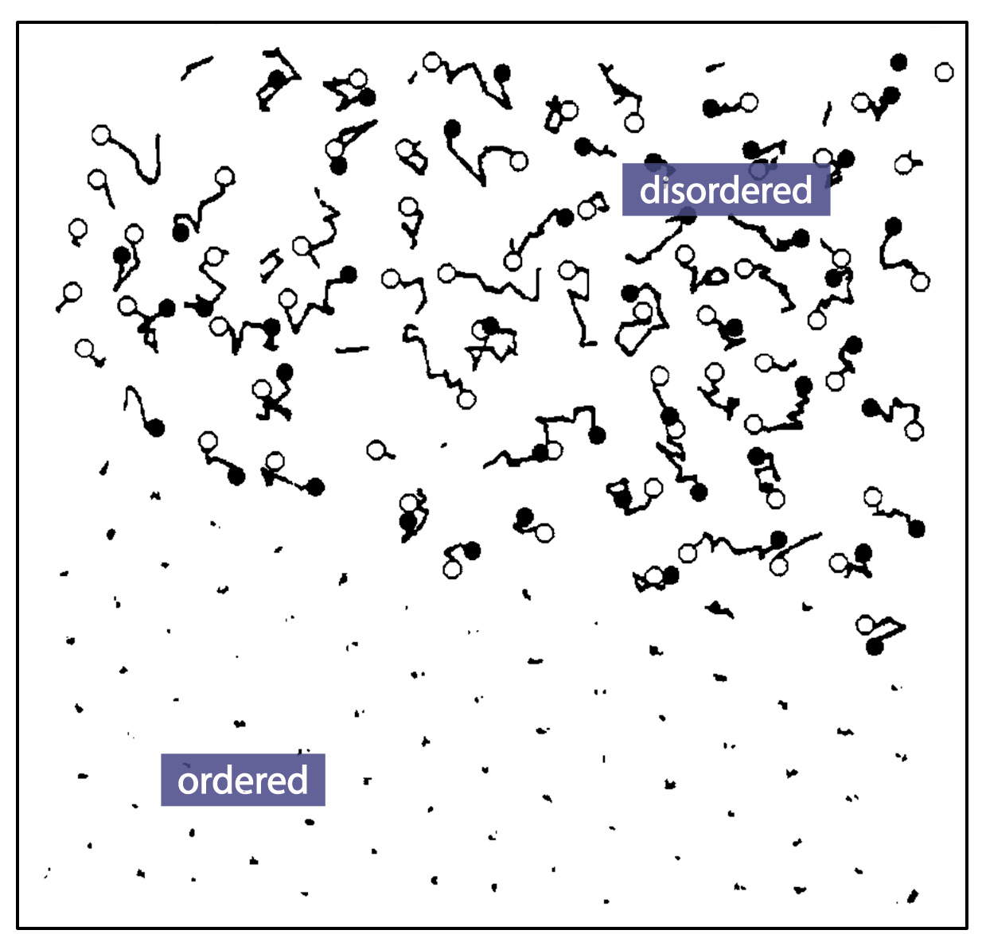
Beyond accommodating those three basic expectations, the EZ mechanism also explains the curiously striking finding that when microspheres become part of a colloidal array they practically cease to move. A microsphere lying just outside the array will jitter with the usual dynamics, but once it joins the array it will practically slow to a standstill (Fig. 9.14). This standstill does not happen because neighboring microspheres constrain them, for the neighbors can be situated as far as several micrometers away; many water molecules lie in between them.
Why then do the crystal microspheres come to a virtual halt? According to the like-likes-like mechanism the crystal’s stability lies in the fact that strong attractive and repulsive forces firmly balance one another. In the face of these dense charges, the ordered microspheres become relatively immune to any charge fluctuations arising outside the array; hence, few Brownian fluctuations should occur. A microsphere even slightly removed from the array, however, will experience the usual impact of external charge fluctuations and exhibit the usual Brownian motions. Thus, a possible explanation for this striking observation lies naturally within the newer formulation.
Fig. 9.14. Traces of particle movement over a period of time, both within the ordered region (lower left) and outside the ordered region (upper right). from Dosho et al. (1993).
Another notable feature of Brownian motion is that it is seen in liquids other than water. The proposed mechanism does not fail: light-generated exclusion zones appear in many polar solvents (Chai and Pollack, 2010); they are not restricted to water. Hence, the proposed formulation anticipates Brownian motions in those liquids as well as water.
The EZ mechanism also explains the motion’s endlessness. You can put the beaker of water and microspheres away for a day — or a year — and (provided the microspheres don’t sediment to the bottom) the motions will continue unchanged. The particles just keep jittering. The jitter is endless because the driving energy is itself endless: so long as the sun continues to deliver electromagnetic energy to the earth, it will continue to drive those motions.
Implications
Lucretius's classic scientific poem On the Nature of Things (ca. 60 BCE) provides a memorable description of Brownian motion in dust particles:
"Observe what happens when sunbeams are admitted into a building and shed light on its shadowy places. You will see a multitude of tiny particles mingling in a multitude of ways ... . [T]heir dancing is an actual indication of underlying movements of matter that are hidden from our sight ... . It originates with the atoms, which move of themselves [i.e., spontaneously]. Then those small compound bodies that are least removed from the impetus of the atoms are set in motion by the impact of their invisible blows and in turn cannon against slightly larger bodies. So the movement mounts up from the atoms and gradually emerges to the level of our senses, so that those bodies are in motion that we see in sunbeams, moved by blows that remain invisible."
Lucretius presciently describes the contemporary view of the origin of Brownian motion. Every atom, every molecule, every particle, and every larger entity suffers random displacements. The smaller ones hit the bigger ones, driving them into motion. This was nicely put two millennia ago. Until the contribution of Einstein, however, we little understood the origin of these multilevel displacements. Einstein concluded that the heat contained within the system was the driving force. That heat produced motion, which produced heat, which produced motion, etc. The motion, it seemed, would continue endlessly, with no loss.
At the time of Einstein, however, it could not be conceived that a simple aqueous suspension could absorb ambient energy and put that energy to work. Even though this happens in plants all the time, it could not be imagined to happen in nonliving systems such as a bath of water. The evidence presented above shows that it can and does happen.
Thus, absorbed radiant energy is used to perform mechanical work. If conditions are right, e.g., if a hydrophilic tube is present to help constrain the motions, then the work can be useful. If no such director is present, then the absorbed energy’s impact does not simply vanish; it is expressed as uncoordinated mechanical displacements. Nothing much is accomplished except for some incoherent Brownian jittering.
If this paradigm for Brownian motion is adequate, then many physical phenomena might need re-thinking. The common terminology for Brownian motion is “thermal motion.” Thermal motion is presumed to occur in every atom and every molecule. It has been thought until now that these motions are driven by internal energy, i.e., by virtue of temperature. If they are instead driven by external energy, then a very different paradigm emerges with very different consequences.
BOX. Why does dust undergo Brownian motion?

Dust comprises mostly flakes of skin and hair. Both are negatively charged; hence, they repel one another. Additional repulsive charge builds as the dust passes through the air. This happens in the same way as air from a hair dryer builds charge (and fluff) on your hair. The faster the relative movement of the air, the higher will be the negative charge and hence the repulsion.
The atmosphere, on the other hand, contains positive charge, which can neutralize the dust’s negative charge. Neutralization takes a while because air molecules need time to gather round the particle; hence, neutralization is most pronounced if the particle moves slowly or not at all. So the particle’s speed counts, both for charge buildup and for charge neutralization. Net charge will therefore be highly dynamic, giving rise to the Brownian air dance.
You might also wonder why the moving dust particles seem to float as they dance. Denser than air, they should be pulled steadily toward the earth by gravitation; but they float. At play here may be the earth’s net negative charge — an attribute well established but little recognized. The earth’s negative charge repels the dust’s negative charge; hence, the particles stay afloat. They continue their endless dance, rarely settling because of repulsion from the earth, and never touching because of their repulsion from one another.
One important distinction between the two formulations lies in the influence of what is nearby (Fig. 9.15). In Einstein’s formulation, particle movements depend only on the blows of nearby water molecules; any particles lying beyond those water molecules don’t count much. In the EZ formulation, the opposite is true: neighboring particles generate charges whose fluctuations may be felt by the particle in question. Effects can be long-range. In this sense, the two proposals differ fundamentally, over and above their mechanical versus electrical origins.
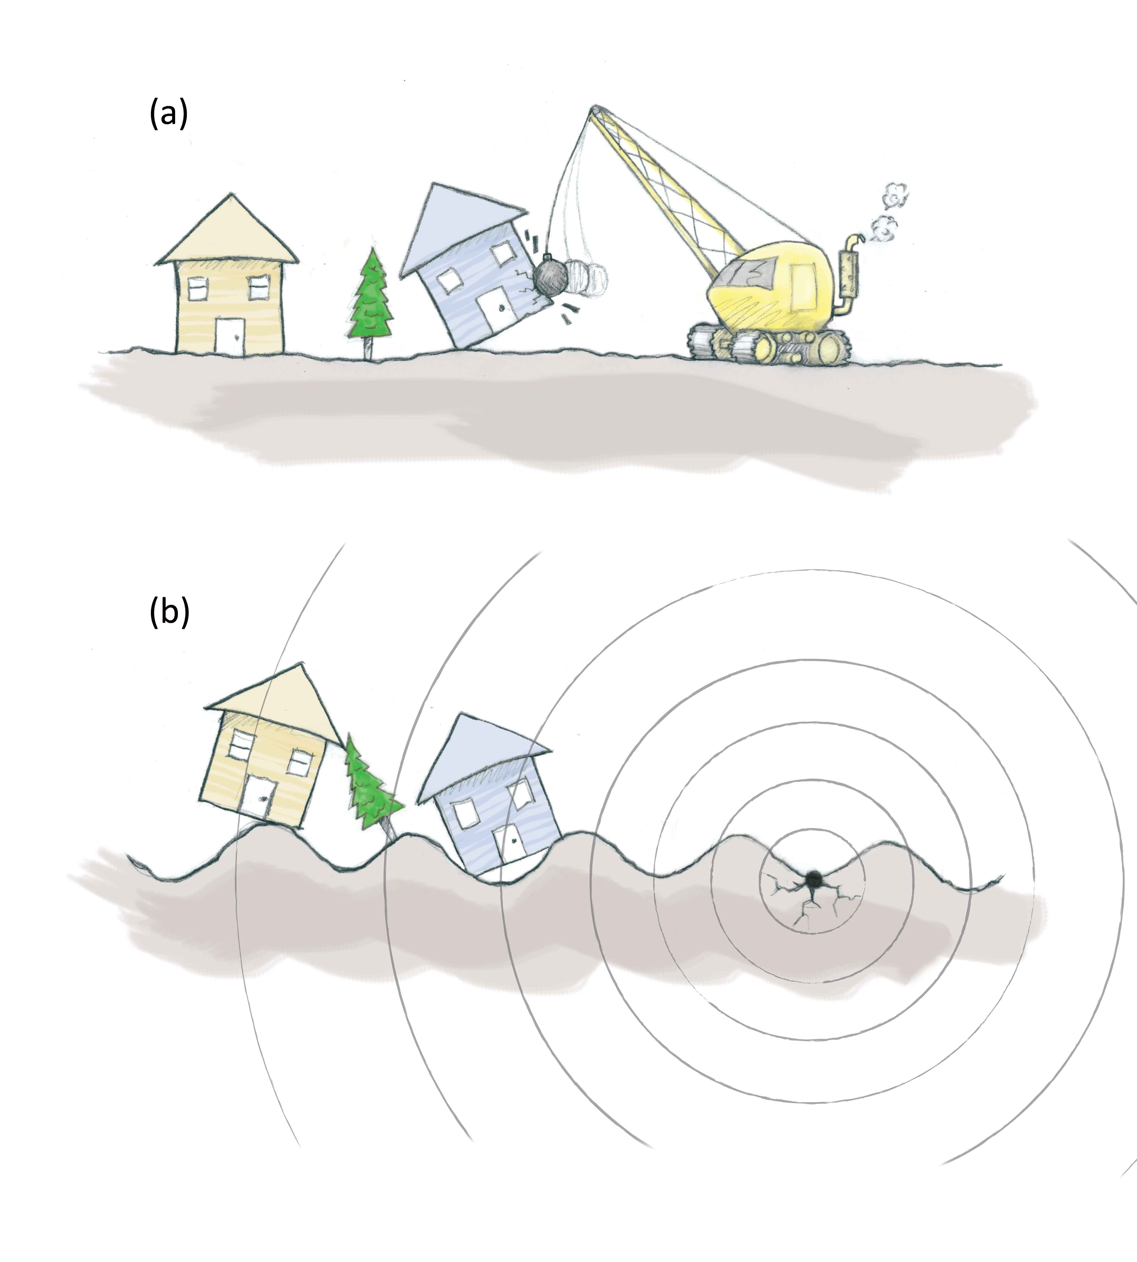
As a consequence of these distinctions, phenomena that seem anomalous within the Einstein paradigm are not necessarily anomalous within the EZ paradigm. I already mentioned the coupling of nearby particle displacements, and the near absence of particle displacements within the colloid crystal. Neither one fits in the classical paradigm, but fits naturally into the EZ paradigm. The salt-induced jitter also finds no easy explanation in the classical paradigm. In the new paradigm it may be a simple matter of size: salt diminishes EZ size (Zheng and Pollack, 2003); that diminishes effective particle size, allowing the particles to dance more actively. Thus, multiple phenomena difficult to reconcile with the classical paradigm find natural explanation within the EZ paradigm.
I don’t profess that the EZ formulation can necessarily explain all features of Brownian motion; but I believe it has a chance, because it contains a new feature: external energy input. This energy may play a profound role, not only in driving Brownian dynamics but also in governing other aqueous phenomena that now seem anomalous, or perhaps even befuddling. Those phenomena will come shortly.
Figure 9.15. (a) Einstein’s formulation emphasizes local influence. (b) The EZ formulation implies long-range influence.
Before going there, I feel a need to clear up a few relevant misconceptions. Did the concept of temperature-induced motion seem entirely clear as you read through this chapter? When I first learned (incorrectly, according to this chapter) that internal heat drove Brownian motions, I must admit to a sense of confusion: Even in reasonably well-insulated chambers, I couldn’t fathom why the motion should continue forever. Nor could I understand how exactly the heat drove the motion, although I understood that physicists acquiesce to this notion. Heat and temperature are terms we use freely, but I came to find that their meaning is not as straightforward as presumed. Understanding those concepts in an intuitively satisfying way requires some fresh consideration, and that comes in the next chapter.
Summary
According to conventional views, Brownian (thermal) motion is a reflection of the kinetic energy that arises out of temperature. This energy drives particles endlessly to and fro in random fashion. Although this theory is universally held, a surprising number of experimental observations do not fit, raising doubts as to its adequacy.
An alternative hypothesis suggests that the incident radiant energy absorbed by water drives these motions. The absorbed energy builds exclusion zones around the particles and thereby separates charge. The separated charges create forces that drive the particle movements. Although more work is needed to develop and test the model, broad consistency with experimental evidence lends some optimism. The model is intuitively straightforward: energy input drives energy output.

References Chapter 9

Albrecht-Buehler G (2005). A long-range attraction between aggregating 3T3 cells mediated by near-infrared light scattering. Proc Natl Acad Sci U S A. 102(14):5050-5055.
Bhalerao A and Pollack GH (2001), Light-induced effects on Brownian displacements. J Biophotnics 4(3) 172-177.
Brush SG (1968). A History of Random Processes. I. Brownian Movement from Brown to Perrin. Springer, Berlin/Heidelberg.
Bursac P, Lenormand G, Fabry B, Oliver M, Weitz DA, Viasnoff V, Butler JP and Fredberg JJ (2005). Cytoskeletal remodelling and slow dynamics in the living cell. Nature Materials 4: 557-561.

Chai B and Pollack GH (2010). Solute-Free Interfacial Zones in Polar Liquids. J. Phys. Chem. B 114: 5371–5375.

Dosho S, Ise N, Ito K, Iwai S, Kitano H, Matsuoka H Okumura H and Oneo T (1993). Recent Study of Polymer Latex Dispersions. Langmuir 9(2): 394-411.

Ise N, Matsuoka, H, Ito K and Yoshida H (1990): Inhomogeneity of Solute
Distribution in Ionic Systems. Faraday Discuss. Chem. Soc. 90, 153 – 162.
Okubo T (1989a). Brownian Movement of Deionized Colloidal Spheres in Gaslike Suspensions and the Importance of the Debye Screening Length. J Phys Chem 93: 4352-4354.
Okubo T (1989b). Microscopic observation of gas-like, liquid-like, and crystal-like distributions of deionized colloidal spheres and the importance of the Debye-screening length. J Chem Phys. 90(4): 2408 – 2415.

Ovchinnikova, K, Pollack GH (2009). Cylindrical phase separation in colloidal suspensions. Phys Rev E 79(3): 036117.
Weeks ER and Weitz DA (2002). Properties of Cage Rearrangements Observed near the Colloidal Glass Transition. Phys Rev Lett 89(9): 095704.
Weeks ER, Crocker JC Levitt AC, Schofield A and Weitz DA (2000) Imaging of structural relaxation near the colloidal glass transition. Science 287: 627-631.
Zheng J-M and Pollack GH (2003). Long range forces extending from polymer surfaces. Phys Rev E.: 68: 031408.

