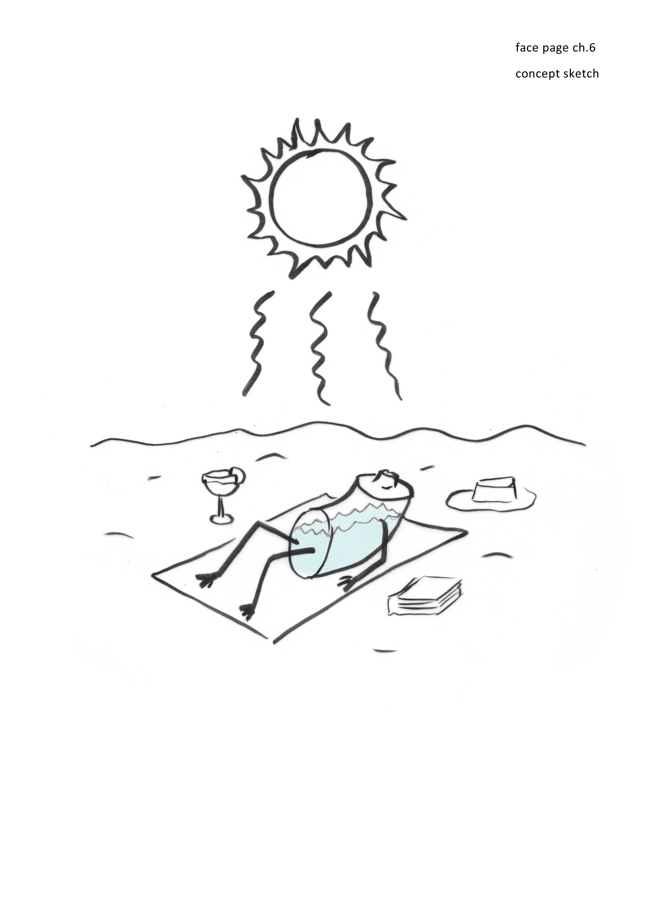
Chapter 6
Charging the Water Battery
It was Jim’s casual, easy-going nature that led us to strike gold — or at least to find the equivalent: a source of energy virtually free for the taking.
My postdoctoral fellow Jim Zheng and I had been scratching our heads trying to figure out what energy kept the EZ charged. No solution seemed to emerge. You had first to build the EZ; then you had to maintain its charge in the face of oppositely charged ions eager to annihilate the charge. Natural attrition had to be countered. Energy was needed not only for separating charge initially, but also for maintaining that separation in the face of natural attrition.
A lurking suspicion was that the culprit might be the “surface energy” present at material interfaces. The concept of surface energy never did seem entirely clear to me, and in any case it didn’t seem to fit: the exclusion zone is extensive — not just one or two molecular layers but as many as one or two million. Energy from the surface could reasonably build the first molecular layer that is intimate with the surface … but a million? How could something pinned onto a surface act at so vast a distance?
Furthermore, something had to maintain the charge separation once it was established. Maintenance seemed inexplicable without invoking some kind of continuous feed of energy to counter continuous attrition. But the source of this energy feed was not obvious at the time — at least not to us.
In retrospect, it should have been obvious. When I raised the question during an undergraduate class presentation, a hand shot up and, half as a question and half as a declarative statement, one student blurted out, “Light?” He was spot on. It came so easily to that student (whose talents we quickly exploited in our laboratory); but for us it took several years to figure out.
By the time of that class we had managed to ascertain that the responsible agent was light. Incident light supplied the energy. I should be clear: by “light” I mean not only the visible component of the electromagnetic spectrum but also the ultraviolet and especially infrared components. The vehicle of energy supply was radiant electromagnetic energy — which the water absorbs and uses for building the EZ and maintaining the attendant charge separation.
The first hint of this revelation, as I mentioned, came from Jim. It came during one of his experiments, as he succumbed to an ordinary human need. Laboratories are like other human workplaces: as evening approaches and hunger pangs grow pervasive, dinner bells sometimes seem to chime almost audibly and people will occasionally skip the usual cleanup step. That happened one evening to Jim. He simply left the chamber on the microscope stage, turned off the microscope lamp, and ambled home for dinner.
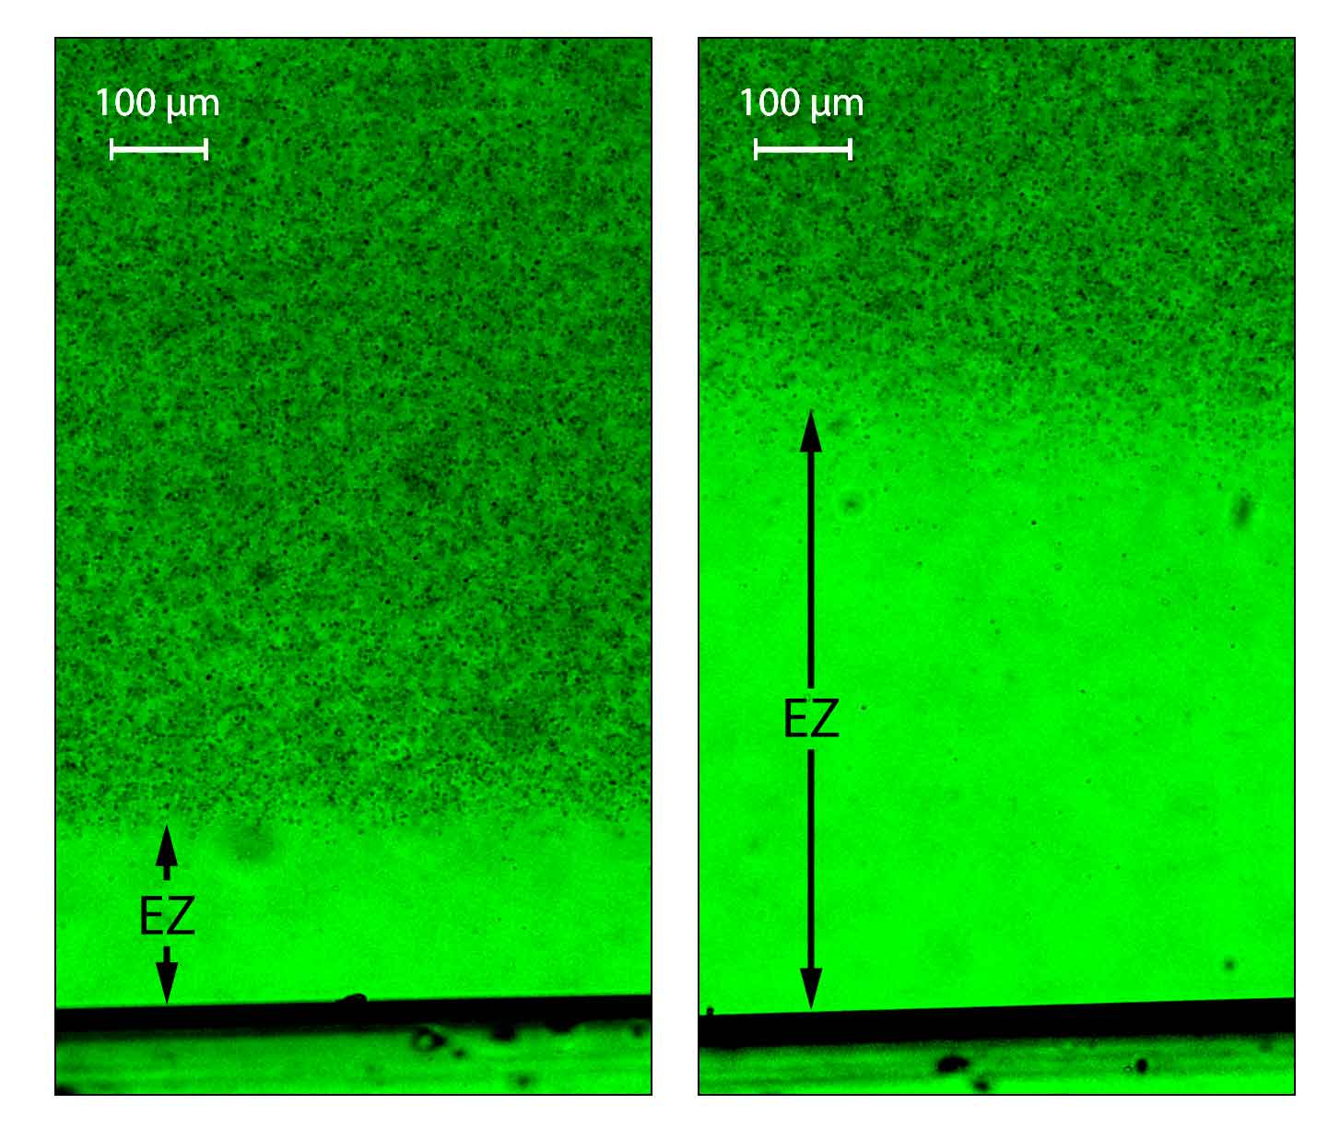
When he returned in the morning and turned on the microscope lamp to see the exclusion zone, it had diminished to half of its former size. Within just a minute or two of watching, he would recount, the EZ returned all the way to its former size. It grew quickly. It was as though the microscope lamp could reinvigorate the exclusion zone. Something about light seemed to matter (Fig. 6.1).
Light as Fuel
Figure 6.1 Example of exclusion zone adjacent to Nafion. Left: control. Right: following a several minute exposure to light.
To explain this mysterious effect we first considered a common bugaboo: a light-induced temperature increase. Incident light could heat the chamber and perhaps create the expansion. We quickly concluded that this was unlikely: the EZ’s rapid growth had begun immediately after the light was switched on — well before the water in the chamber could have heated appreciably. Furthermore, subsequent experiments confirmed that even after the minutes of exposure to light that gave substantial expansion, the temperature rose by only a trivial amount (Chai et al., 2009). Apparently, it was a non-thermal effect of light: photons of light somehow imparted their energy to grow the EZ.
This was an exciting moment. It implied that the incident light from the sun could supply the energy needed for building order and separating charge; the environment itself could do the job. Imagine: energy from sunlight could power the water battery in much the same way that it powers photosynthesis. Wow!
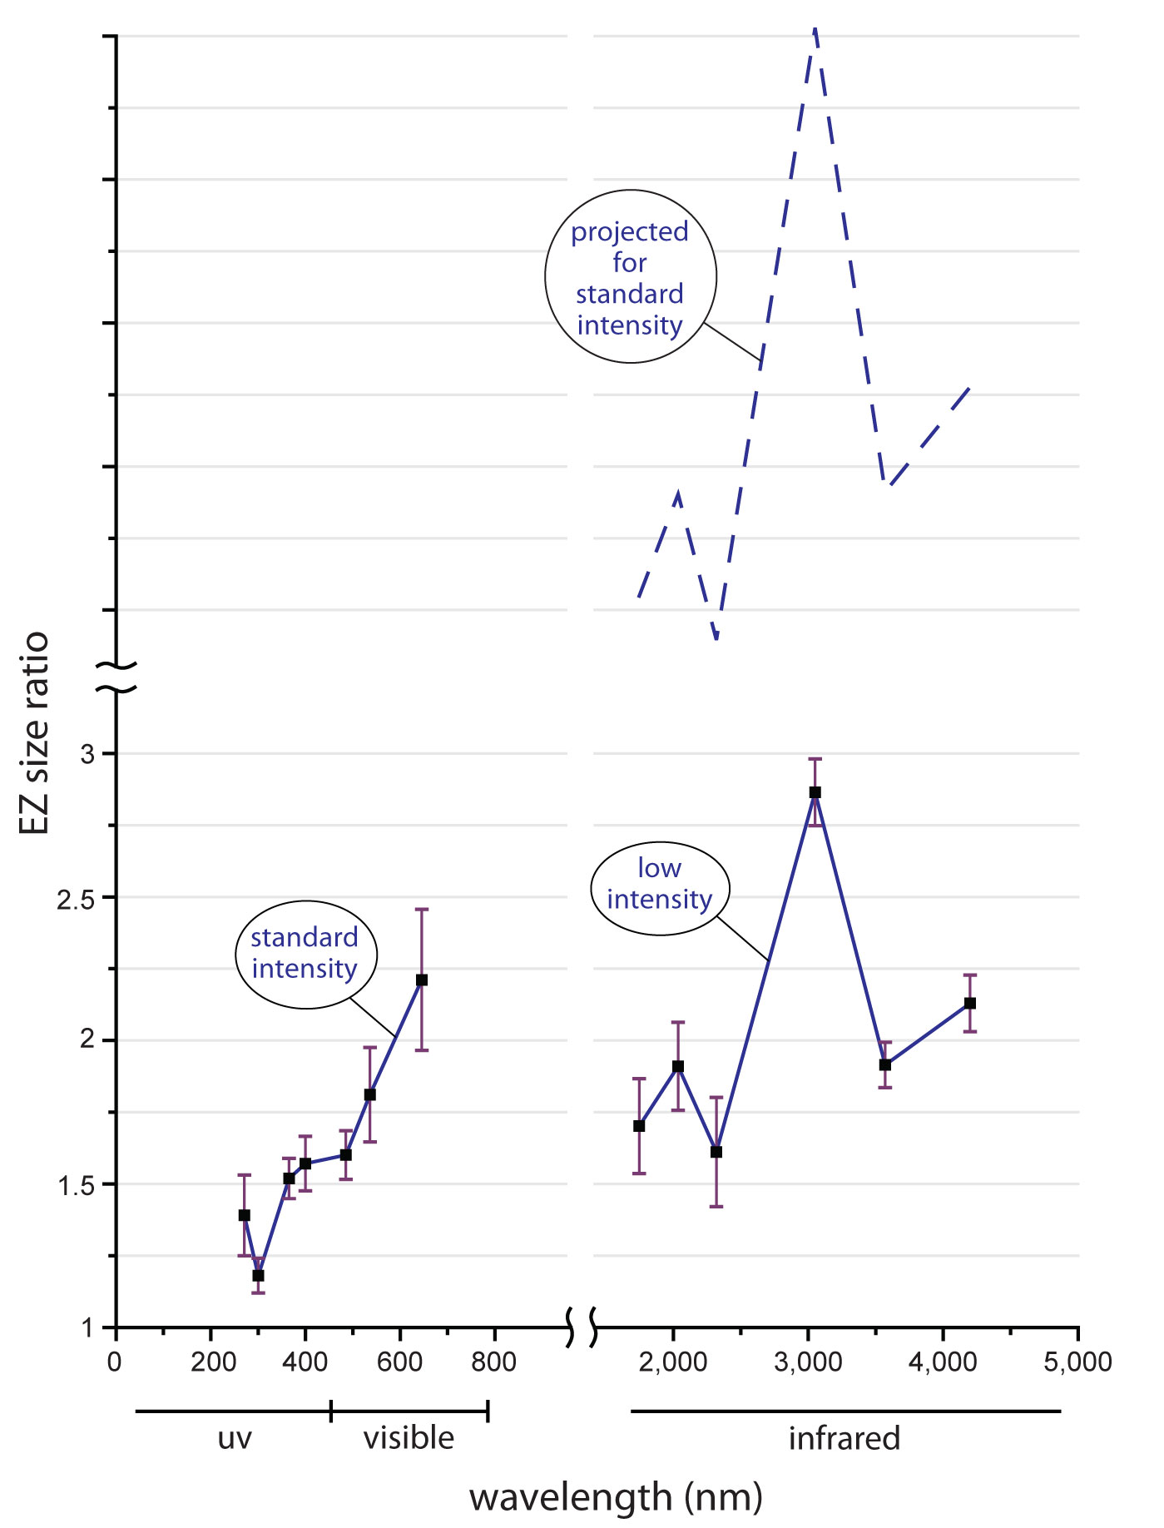
Descending from the clouds of excitement, we asked the obvious question: what wavelengths of light were responsible for powering EZ growth? Ordinary microscope lamps generate a broad range of wavelengths; they include visible light as well as ultraviolet and infrared light. We wondered whether certain wavelengths might work more effectively than others.
To explore this issue, we reduced the microscope lamp intensity to the point where we could just barely see the EZ. For the main source of light we used light-emitting diodes. They emit light at specific wavelengths ranging from the ultraviolet through the visible to the infrared. We used one at a time. The incident light was directed onto an experimental chamber, with a sheet of Nafion next to water. The water contained microspheres, which allowed us to measure exclusion-zone size. The idea was to see how effectively each of those wavelengths could expand the exclusion zone.
Figure 6.2. Effect of light wavelength on exclusion-zone size. Reference value of EZ size, 1.0, was obtained in the absence of additional incident light. Data points show EZ-expansion at the end of 5-minute exposure to incident light at different wavelengths. For technical reasons data on the right graph were obtained with lower-than-standard intensity. Standard intensity might have elevated the graph as indicated by the dashed curve. [maybe, for clarity, add numbers on top of ordinate: 50, 51, 52, on big tic marks] [maybe “sub-standard” intensity instead of “low” – b/c “standard” and “low” were not clear. [ROYGBIV on “visible” zone of abscissa? Some visual representation of uv and IR?]
The results confirmed that wavelength did matter (Chai et al., 2009). Figure 6.2 shows what happened to the size of the exclusion zone after a five-minute exposure to light at each of a series of wavelengths. The incident light was not intense: it was weak enough that the chamber temperature never rose by more than 1 °C during the five-minute exposure. The vertical axis shows the expansion — a ratio of 2, for example, indicates a light-induced doubling of EZ size.
The figures shows that all wavelengths drive EZ expansion, but some are more effective than others. Ultraviolet is least effective; visible light is more effective; and infrared is the most effective, particularly 3 µm. At first, this result surprised us. Later we realized that this wavelength is the one most strongly absorbed by water. Hence, the most strongly absorbed wavelength is the one most effective for driving EZ growth — a rather satisfying correlation.
We also found that longer exposures and higher intensity could expand the EZ far more. The figure above was obtained using five-minute exposures. With longer exposures at the same intensity we could easily realize 5 to 10 times expansion.
I should explain the mysterious dashed curve at the top of Figure 6.2. It arose from a technical issue. The infrared sources available for these experiments were relatively feeble: they produced 600 times less intensity than the visible and UV sources. Thus, the right hand graph is lower than it would have been had the infrared light sources been up to par. An estimate of where the curve might have been if all light sources had the same intensity is given by the dashed curve above. It is the one that should be considered.
You can see from the figure that infrared wavelengths dominate — hugely. They are far more effective than visible or ultraviolet wavelengths for building EZs.
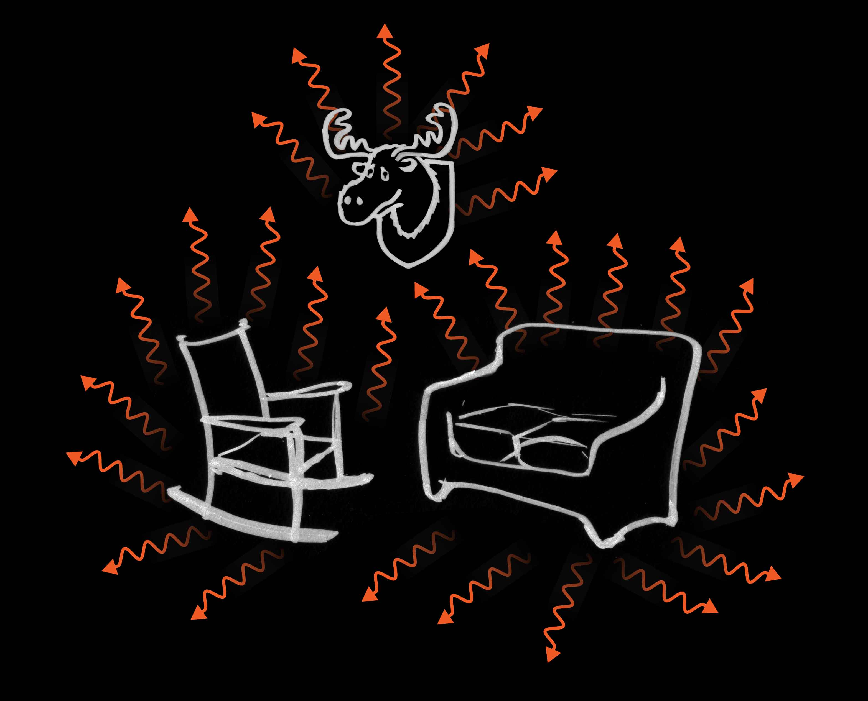
Think of what this implies (Fig. 6.3). In contrast to visible light, which can disappear when you flip the switch, infrared is almost always present. Infrared cameras and scopes have no problem capturing nighttime images, ranging from army tanks to giant bulldozers — and people. Even your home emits. The bricks absorb radiant energy from the sun and re-emit at different wavelengths; hence, the inside walls of your room emit plenty of infrared energy, whether the lights are on or off. Infrared, or “IR” energy is all over the place — and that energy is what builds the EZ most effectively.
IR energy was likely the critical factor in that overnight experiment. When Jim casually turned off the microscope lamp in the evening, it reduced the IR, which in turn diminished the size of the exclusion zone. When he turned it back on the next morning, he restored the IR and the EZ promptly grew to the former day’s size.
Figure 6.3. Even in the dark, infrared energy is freely available.
We also tried purposefully to reduce the infrared energy to see what happens. We did this by inserting chambers with fully developed EZs into a dewar, similar to a large coffee thermos with good vaccum insulation and an external reflector. A 15 to 30 minute insertion diminished to EZ to about half its former size. So the infrared effect works either way: more infrared expands the EZ, while less infrared diminishes it.
For powering exclusion-zone construction, then, infrared light is supremely effective. Other wavelengths contribute, but the IR contribution predominates. And infrared is widely available: unless you happen to reside in climates where the temperature approaches absolute zero (minus 273 °C) or put yourself into a giant dewar, plenty of infrared energy is available for driving EZ growth. It is nature’s gift — free for the taking.
Incident Energy Dissociates Water Molecules
How could light energy build the exclusion zone?
Apart from allowing us to detect images, light achieves many wondrous things. It achieves them because its photon energy readily converts into other forms of energy. Examples: incident light of one wavelength converts to light of another wavelength to produce fluorescence; light energy powers the vibrational energy that drives Brownian motions (Chapter 9); when incident on semiconductors, light releases electrons to generate the photoelectric effect; light can also catalyze reactions, and in photosynthesis it can separate charge.
Given this versatility, it is reasonable to think that light could also drive the charge-separation process under consideration here. This would be merely another in a series of light-induced transformations — nothing particularly surprising. Establishing the mechanism underlying such transformation, however, is the challenge. Simple logic helps.
A clue is that EZ buildup can come from energy sources other than just light. One of them is ultrasound. We found that ultrasound energy similar to that used for imaging embryos can drive exclusion-zone growth. During application of 7.5-MHz ultrasound, the exclusion zone typically narrows, probably as a result of mechanical shear: molecules rubbing past one another. When we turned off the ultrasound, the exclusion zone immediately enjoyed a stunning regrowth — it could transiently grow to more than five or six times its initial size before ultimately returning to its pre-exposure size. Evidently, the acoustic energy created something in the water that could go on to produce EZ growth, much the same as incident light produced EZ growth.
We found that audible sound energy did much the same. Certain frequencies brought EZ expansion. Radio-frequency energy also seemed also to increase EZ size. Although these latter two observations remain preliminary at this writing, they seem consistent enough that they are probably real.
Hence, several distinct forms of energy can build exclusion zones. They include electromagnetic (light) energy of various wavelengths, and sound energy of varying wavelengths. What can this energy diversity imply?
It might imply that the energy doesn’t directly split the water molecule into the positive and negative components ultimately seen. Any such splitting would likely arise from a narrowly defined wavelength band, which would specifically tear apart the water molecule through some kind of resonance; it would shake the molecule apart. Instead of a narrow band, we observe effectiveness over a diversity of wavelengths. That doesn’t fit direct resonant splitting. Further to this point, infrared photons have low energy compared to, say, ultraviolet photons. Their energy is low enough that they are considered unable to split the water molecule directly. Yet they are the most effective EZ builders; so their efficacy must lie elsewhere.
It appears that incident energy produces a subtler effect than direct water-molecule breakup; more likely it merely enables the breakup. The separation of charge would then take place at a later stage.
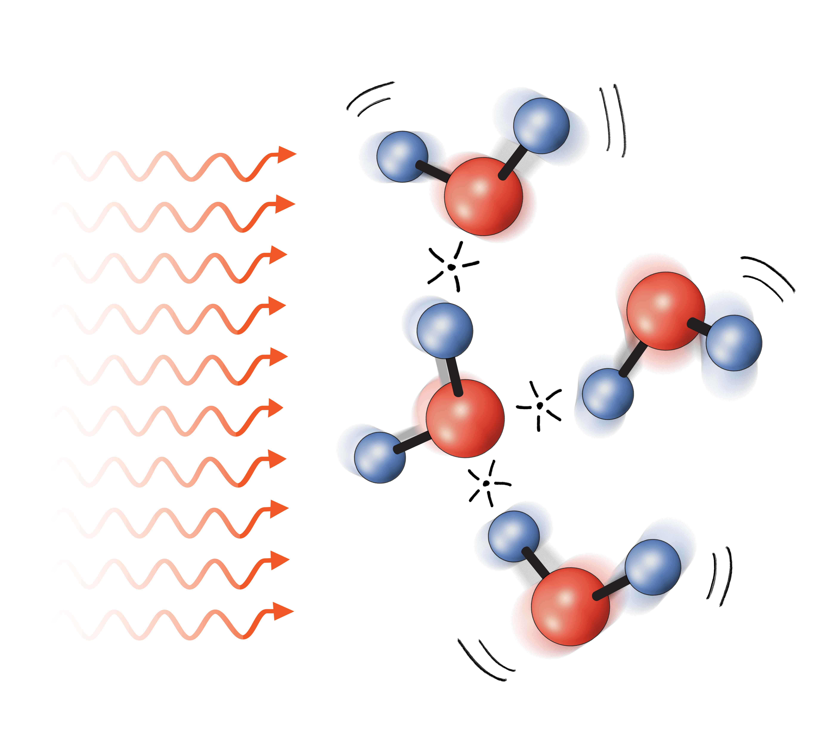
That subtler effect might be the separation of one water molecule from another (Fig. 6.4). The absorbed energy would loosen the inter-molecular connections, a feat that could be accomplished by a diversity of energies. Exactly what those connections are like remains uncertain, for bulk water’s structure itself remains uncertain. However, one certainty is that constituent molecules stick to one another; otherwise water would not be a liquid but a gas. Some scientists argue for transient intermolecular links, while others argue for ordered clusters, which might then link with one another because of quantum mechanical effects (see Chapter 2). Either way, incident energy could weaken the links, freeing individual water molecules for new interactional opportunities.
Figure 6.4. Input energy dissociates water molecules from one another.
That would constitute step one.
Assembling the Exclusion Zone
Step two of the buildup process should involve some kind of assembly. Dissociated water molecules must assemble one by one onto the growing EZ lattice. Let us suppose that several honeycomb-sheet layers are already assembled and ask how freshly freed water molecules might assemble to build the next layer.
The water molecule contains negative and positive charges (Fig. 6.5). As the figure shows, those charges should draw naturally toward opposite charges on the lattice’s exposed surface. The molecule would then settle onto the lattice. One by one, the water molecules should settle in similar fashion and thereby grow the next honeycomb-sheet layer.
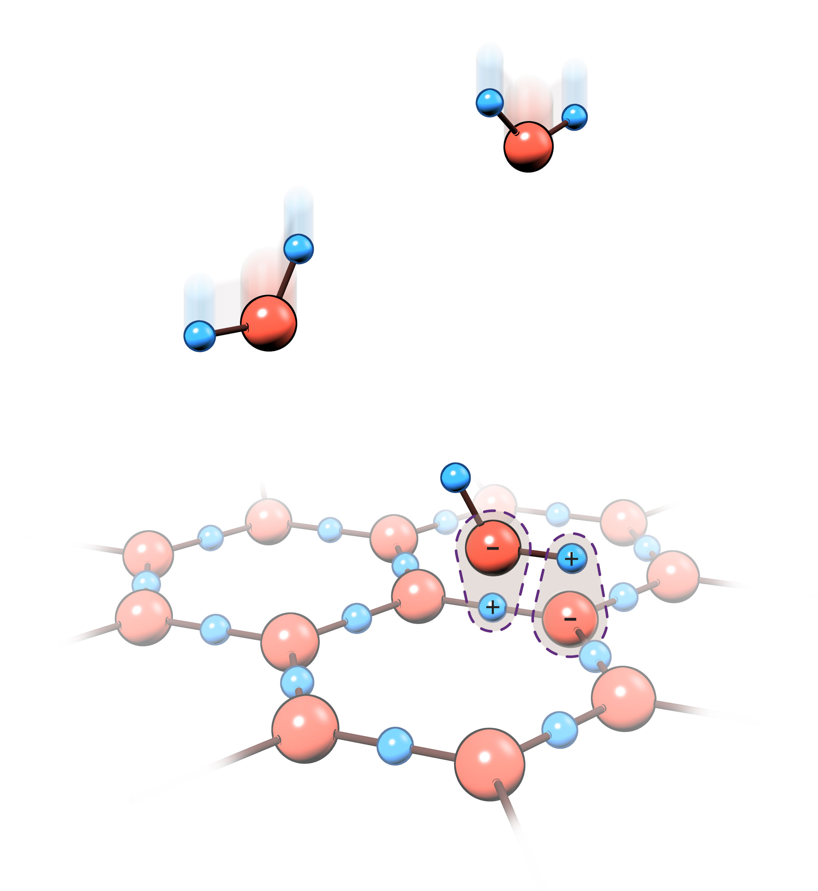
While this process may seem straightforward, an inconvenient problem arises: the dangling hydrogen atoms sticking out of the lattice. Figure 6.5 shows that once a water molecule joins the lattice, one of its hydrogen atoms dangles loosely outside. If it remains, then the next sheet cannot grow. Only if it dissociates can the growing process continue in the same fashion. For continued growth, the proton must be cleaved.
Cleavage is automatic, and to understand why, consider the water molecule’s electron clouds (Fig. 6.6). For the molecule lying in isolation, oxygen’s negative electron clouds point toward each hydrogen’s positive nucleus (a). Those so-called OH bonds keep the water molecule intact. This tidy scenario gives way as the water molecule builds onto the EZ lattice (b): the freshly settled molecule secures itself as oxygen’s electron cloud shifts toward the lattice. That is glue that helps bond the molecule to the lattice.
Figure 6.5. Building the exclusion zone. Freed water molecules draw toward the existing EZ surface as exposed EZ charges attract opposite charges on the water molecule. Following the attachment, a hydrogen atom dangles.
For the dangling hydrogen atom, that shift is immediately unsettling. The glue that formerly held it to the water molecule has vanished; it has shifted its allegiance to the lattice. You might say the dangling hydrogen has come unglued; it is cast off as a lonely proton {c}.
The castoff process can also be viewed in terms of energy change. As each newly settled water molecule falls into place, energy is released. This is because oppositely charged entities separated from one another have plenty of potential energy but as they merge that potential energy is released to the system. It is similar to separated magnets, which release potential energy as they come together. Here that released energy accomplishes something: it cleaves the dangling hydrogen.
So, whether you look through a structural lens or an energetic lens, the result is the same: proton cleavage. The lost proton carries positive charge, which is now separated from the negative EZ lattice. Effectively, the water molecule has split itself apart in order to grow the lattice.
By this mechanism free protons ought to build just beyond the EZ’s growing edge. That’s what is seen experimentally: as the lattice grows, protons accumulate at the far edge of the exclusion zone (see Fig. 5.3). Many of those protons diffuse toward the bulk because they repel one another. This diffusive action is important: if each and every proton were to remain right at the boundary, they would quickly clog the interface; bulk-water molecules could no longer gain access, and the EZ could not grow further.
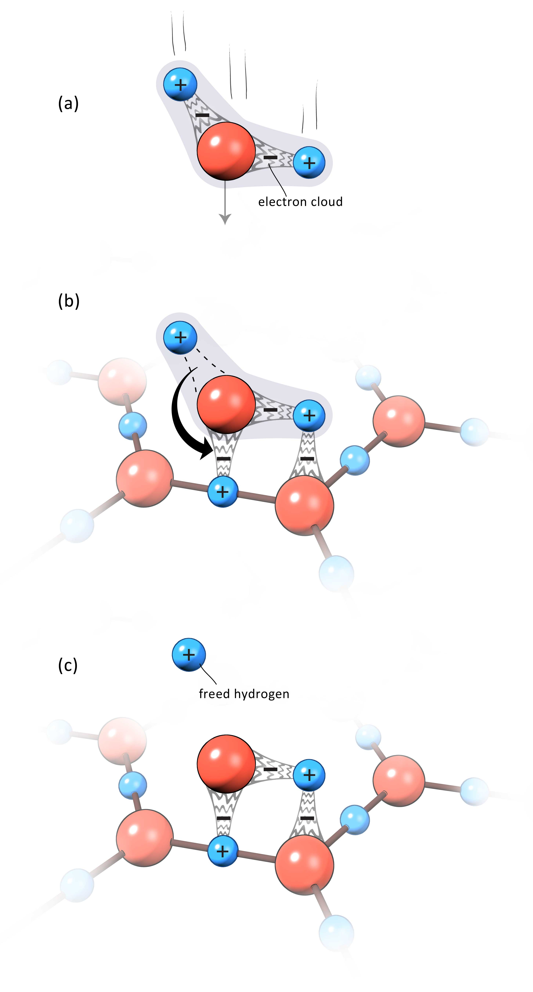
That’s not the full story. As I mentioned earlier, those protons are actually short-lived species. Being free agents with positive charge they will inevitably seek out anything looking electronegative — in much the same way that a teenage boy will seek out anything looking female: almost any candidate will do. For the positively charged proton the common attractor is the water-molecule’s electronegative oxygen. The proton will immediately latch on, creating an H₃O⁺. That so-called hydronium ion is nothing more than a positively charged water molecule — an entity that will have significant potential for explaining all kinds of water movements.
So the separation of proton charge is a secondary event. It takes place as the water molecule settles onto the growing EZ lattice. The absorbed energy does not bear direct responsibility for this event; it seems to loosen the bulk water structure so that individual molecules are freed to build onto the EZ lattice, forming its next layer. Latching onto the lattice shifts the water-oxygen’s electron cloud. This shift releases the dangling proton into the bulk, where it immediately forms a hydronium ion. That is when charge is separated. By these processes the exclusion zone continues to build and the water battery continues to charge.
Figure 6.6. Electron-cloud shifts as water bonds to lattice. The shift frees the dangling proton.
This buildup process does not continue forever; eventually it terminates. Some pole-like projections may continue to sprout from the EZ, but the main body of the EZ eventually attains some steady-state value.
A question is why. Why should EZ growth cease? And why, in some instances, should the EZ begin to shrink?
Exclusion Zone Disassembly
Here, as everywhere, the forces of nature are at work. Ordered structures left alone will eventually become disordered. This gain of entropy is a fundamental feature of thermodynamics. It’s kind of like your room: it can be messy in countless ways, but only one arrangement is neat and tidy. To get it that way requires energy (Figure 6.7). Unless you put in that energy continually, your room will inevitably become as messy as, well… mine.
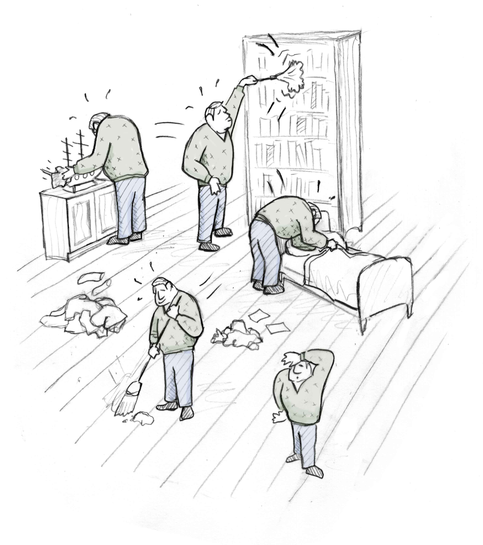
And so it is with the exclusion zone. Order cannot persist unless energy is continually supplied. The separated charges will slowly recombine and order will give way to disorder. The exclusion zone’s outer reaches will wear thin like an eroding beach. That’s what happened in that overnight experiment: the EZ narrowed because a major energetic input was switched off; when it was restored the next morning, the EZ grew back to its former size.
Figure 6.7. Building order requires energy input.
To understand what governs EZ size, then, we need to consider the balance between energy-dependent growth and the natural tendency to wither. When the two processes are in balance, EZ size attains a steady state. We already dealt with the first process, but the second has not yet been considered: How exactly does the EZ erode?
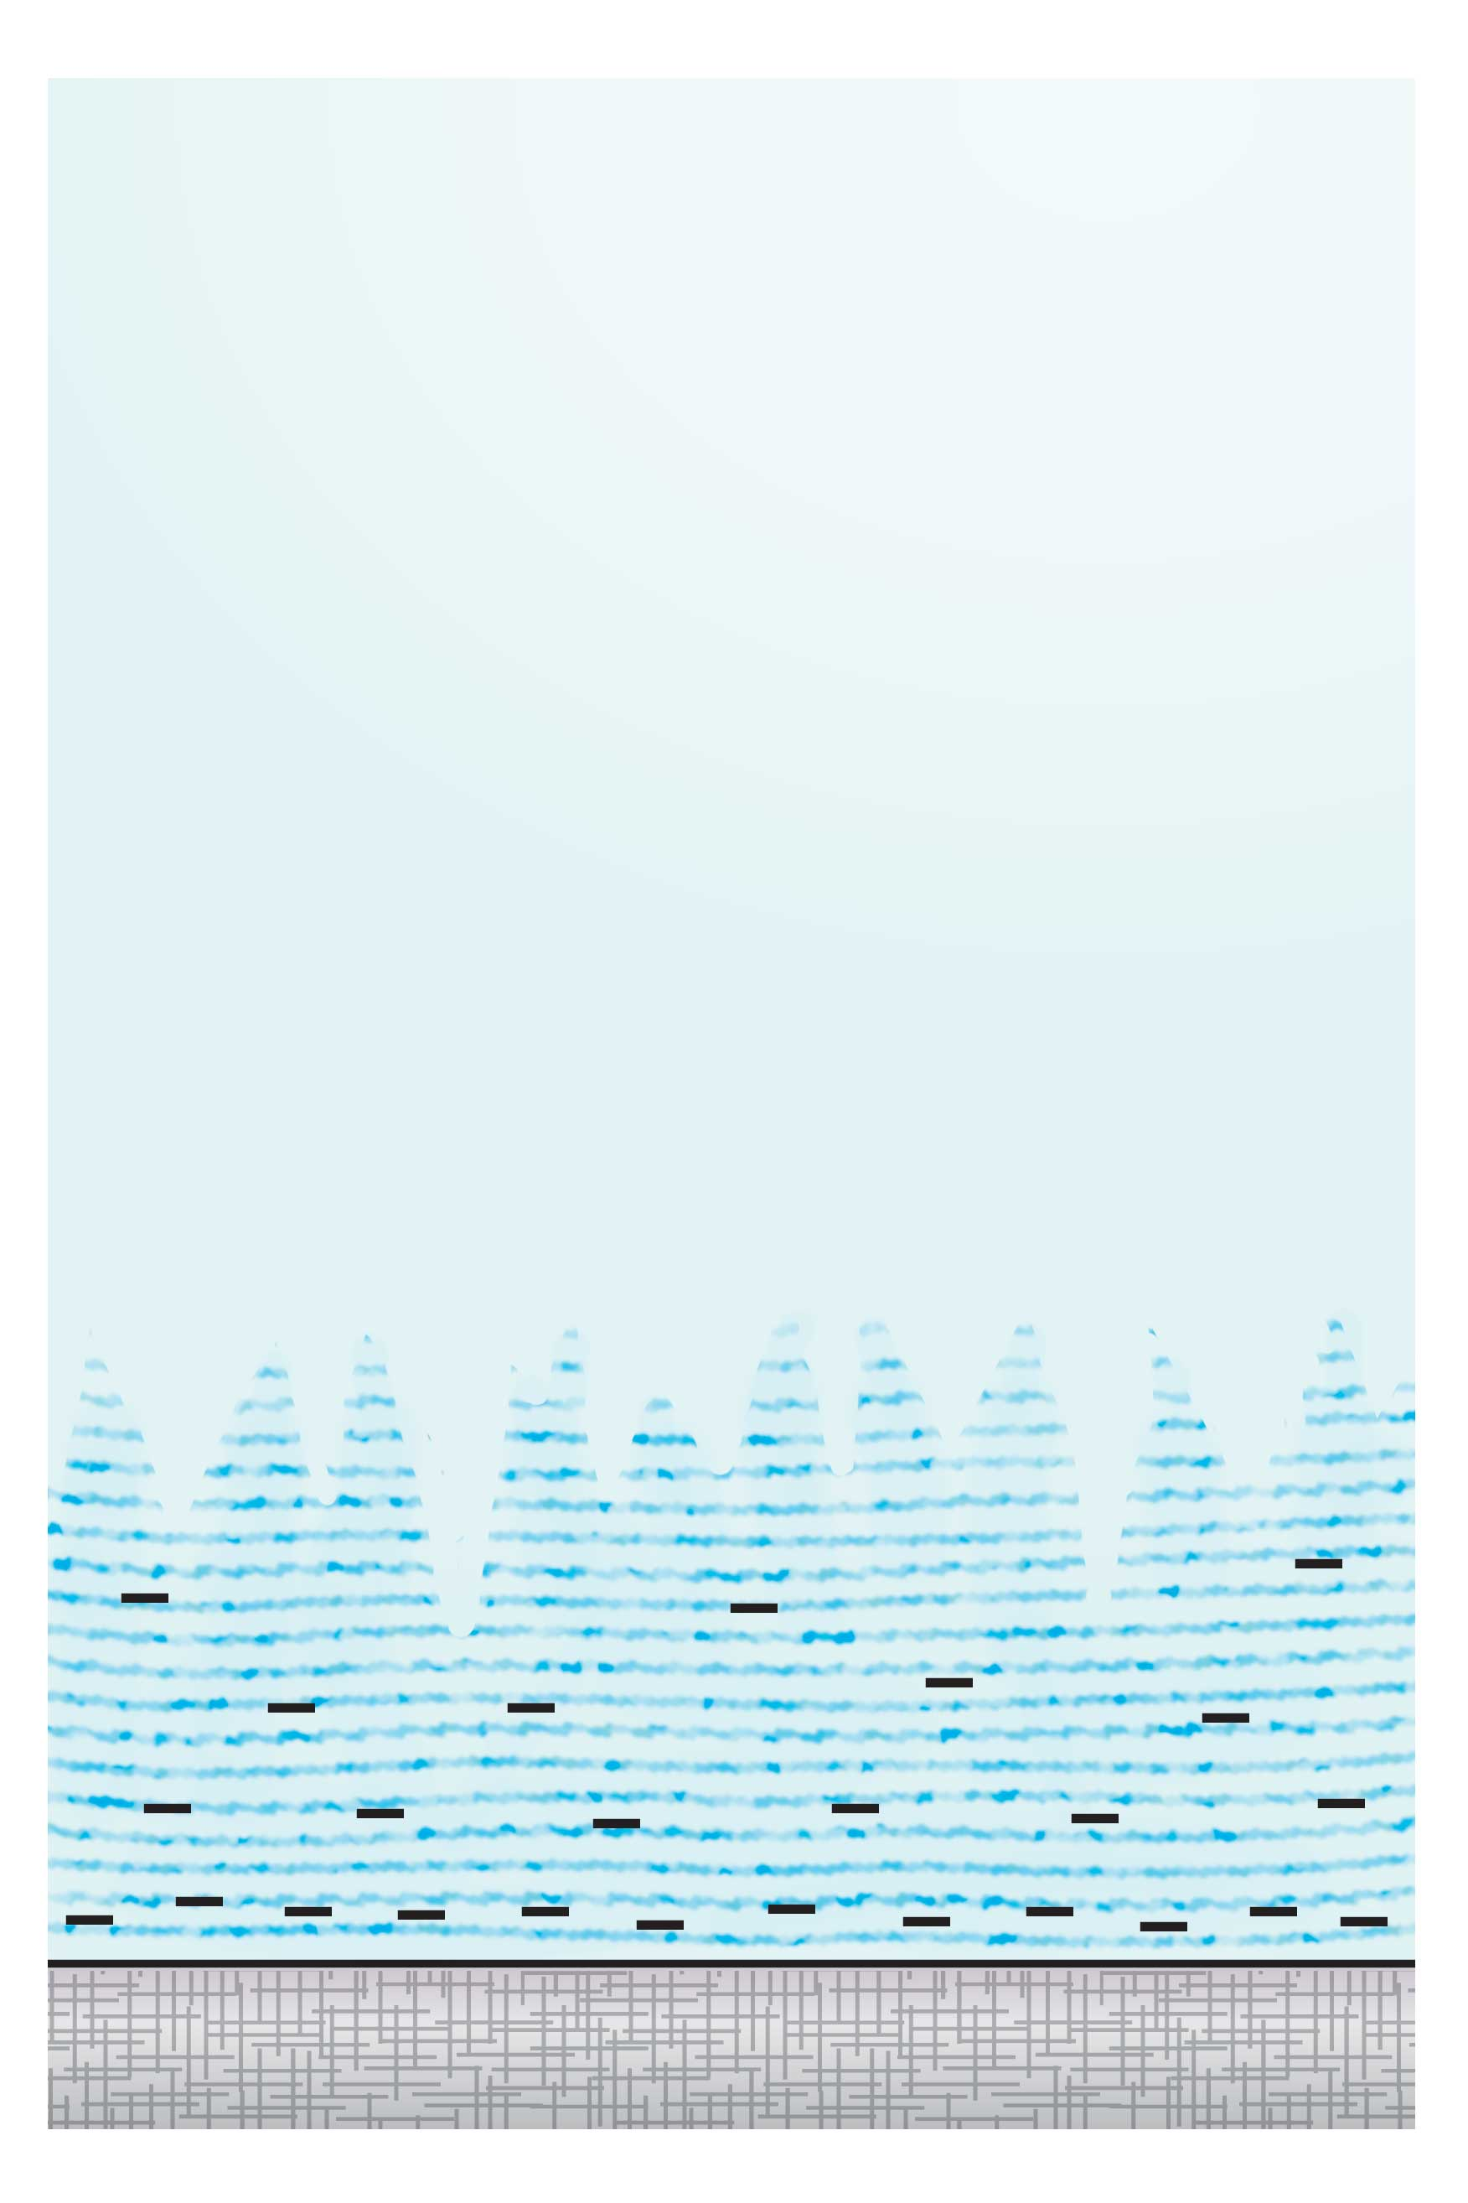
In order to answer the question we need to consider the outer reaches of the exclusion zone, where you might expect the attrition to take place. There, the EZ is almost certainly more open than in the more proximal regions nearer to the nucleating surface: The electrical potential is nearer to zero, which means there must be relatively fewer EZ charges, which in turn means that lattice-oxygen atoms are more sparsely distributed. Hence, the lattice at the far edge is relatively looser and more open (Fig. 6.8).
The loose lattice implies that molecules can penetrate — or have penetrated. The most eager candidates are hydronium ions, for their positive charge can find no greater satisfaction than to draw toward the negativity of the EZ’s inner reaches. So, hydronium ions invade the valleys in between the mountains.
This invasion has consequences. Having penetrated, these positive ions cannot survive long in the presence of nearby negatively charged oxygen atoms that line the mountainsides. The hydronium ions will be quickly captured. The result is a merger: an H₃O⁺ combining with a lattice-structural unit (OH⁻) yields two water molecules (Fig. 6.9).
Figure 6.8. Jagged outer reaches of the exclusion zone. Hydronium ions penetrate the valleys between the mountain peaks because of attraction to negative charges.
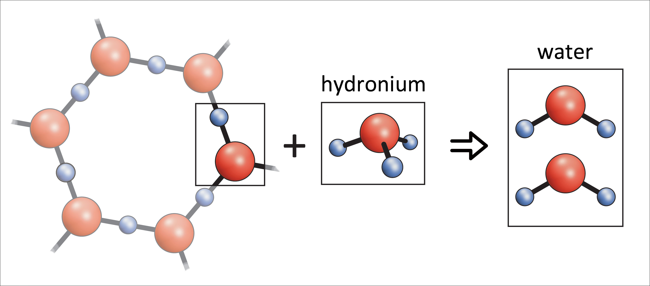
So we are back where we started: an element of the EZ lattice has returned to water, and the system has taken one step back toward where it began. The system, after all, is reversible. It reaches a steady-state size when creation and destruction are in balance, i.e., when energy-driven EZ production balances natural EZ attrition.
That balance can shift as ambient conditions change. In acidic water conditions for example bulk-water hydronium ions are in abundance; these positive ions should eagerly invade the EZ’s valleys and continually chip away at its mass, tilting the balance toward a smaller EZ. This is confirmed: acidic pH does diminish EZ size. Salts erode similarly: While the Cl– of NaCl can combine with bulk H₃O⁺ to yield HCl + H₂O, the positive Na⁺ can invade the lattice, extract a lattice OH– unit, and create NaOH. Again, the exclusion zone withers, and water returns to the bulk. Wherever the lattice is open, positive ions can enter and erode.
Figure 6.9. Natural erosion of exclusion zone. Combination of hydronium ion with one structural unit extracts the unit, resulting in two water molecules.
In sum, the exclusion zone retracts by a process that largely reverses the way it builds. It builds from water molecules, casting off protons, which immediately become hydronium ions. It retracts when those hydronium ions (or other positive charges) extract EZ units from the lattice to yield water (or other products). The balance point will depend on how much energy the system is receiving: more intense incident energy yields larger exclusion zones, while less intense incident energy yields smaller ones.
Free Radicals
No process is perfect, and that reality certainly applies to the EZ buildup-attrition dynamic. Central to that dynamic is the OH⁻ structural unit. The EZ builds by locking those OH⁻ units into the lattice one at a time, whereas it retracts by releasing those OH⁻ units one at a time to the bulk. The process is thus reversible — more-or-less. It is fully reversible if hydronium ions happen to be at hand to sop up each freed OH⁻; then neutral water will result and the system will be back where it started.
However, suppose hydronium ions are locally in short supply and therefore unavailable to do the job? That could happen, for example, if some remotely situated negatively charged site had drawn the hydroniums away. Then, the cycle cannot complete, for the lattice OH⁻ unit has no neutralizing partner. Likewise, completion may be thwarted if the EZ itself is perturbed: suppose some electron-hungry process has drawn off some of the EZ’s charge, leaving the released lattice unit devoid of its usual negativity. Again, the cycle can’t complete. Issues of this nature could upset the default situation.
In such cases, the reversible cycling scheme outlined above will not be so neat and tidy. Instead of water, the withering process will yield various alternative forms of oxygen, which will then populate the bulk. Their natures will depend on the nature of the deviation.
These alternative oxygen species are generally known as free radicals, or sometimes, because of their high reactivity, reactive oxygen species (ROS). The most common one is the superoxide radical, two oxygen atoms containing a single negative charge. Another is the OH radical, which bears no charge. Still another is H₂O₂ or hydrogen peroxide. All of them contain oxygen, and all of them can arise from exclusion-zone breakdown.
The high reactivity of these species can be a problem. High reactivity implies instant binding to many substances, which can potentially alter those substances. In living systems these reactions can induce toxicity: for example, the superoxide radical is virulent enough to be a potent microorganism killer. Unsurprisingly, nature makes every effort to scavenge these radicals in order to avert any such disasters. Thus, every cell in your body contains a scavenging enzyme called superoxide dismutase, or SOD. SOD quickly neutralizes the emerging superoxide radicals almost as rapidly as they form.
This enzyme’s omnipresence has remained something of an enigma. If free radicals are natural byproducts of EZ dynamics, however, then their ubiquity is understandable: since exclusion zones are practically everywhere, then SOD should be practically everywhere.
Life in the Depths
Recognizing the character of these energetic processes can help unravel some of nature’s mysteries, and I cannot resist mentioning just one of them here: why the bottom of the deep sea is host to creatures so numerous. At those depths, not only is dissolved oxygen absent, but so is light. You can’t breathe and you can’t photosynthesize. Life should be impossible, but paradoxically, life flourishes (Fig. 6.10). Each time a deep-sea sample is taken, more and more species are identified. Even bacteria that are obligatory photosynthesizers have no difficulty thriving in such environments, where light is absent (Beatty et al., 2005).
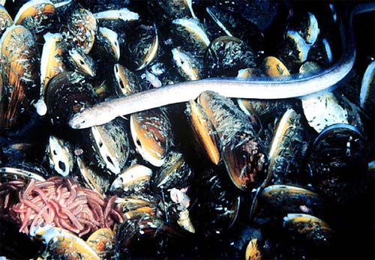
The energetic processes outlined here can help resolve this enigma. Although extreme depths certainly lack visible light, they suffer no shortage of infrared light. Infrared energy radiates from the earth itself and particularly from the ocean floor, where thermal vents radiate the enormous heat of the earth’s core. Infrared wavelengths build EZs and separate charge. Perhaps bacteria exploit this energy-supplying mechanism for life. After all, the mechanism bears much similarity to the initial steps of photosynthesis.
Furthermore, oxygen is not at all absent. The EZs that build from the infrared energy contain plenty of oxygen; so the oxygen can come from the EZ. My colleague Vladimir Voeikov refers repeatedly to this process as the “burning” of water. Dissolved oxygen may be absent, but as long as exclusion zones exist, ample oxygen is available for fueling life’s processes.
Figure 6.10. Life at the deep bottom. Brine pool eel, a creature of the deep sea floor, taken in the Gulf of California. Courtesy NOAA. Wikipedia commons. [500 x 347 pixels – no higher resolution available.]
So, despite the bleakness of the deep-sea environment, we can understand life’s abundance at those depths. There is plenty of energy and plenty of oxygen. On the other hand, this deep-sea discussion is meant only to whet your appetite. The underlying energetic processes are fundamental not only for deep-sea life, but also for very much of nature. In this section’s final chapter we will explore energy’s broader implications, some of which may surprise you.
Summary
The exclusion zone builds from light energy, particularly infrared. Even with the room lights turned off, plenty of infrared energy is available for doing the job. Acoustic energy can also suffice and perhaps radio-frequency energy as well. These energies appear to dissociate bulk-water molecules from one another, freeing them for upcoming construction jobs. Drawn toward the growing EZ, the freed molecules assemble onto the lattice. The end result is EZ expansion and attendant separation of charge. Thus, the interfacial battery gets charged.
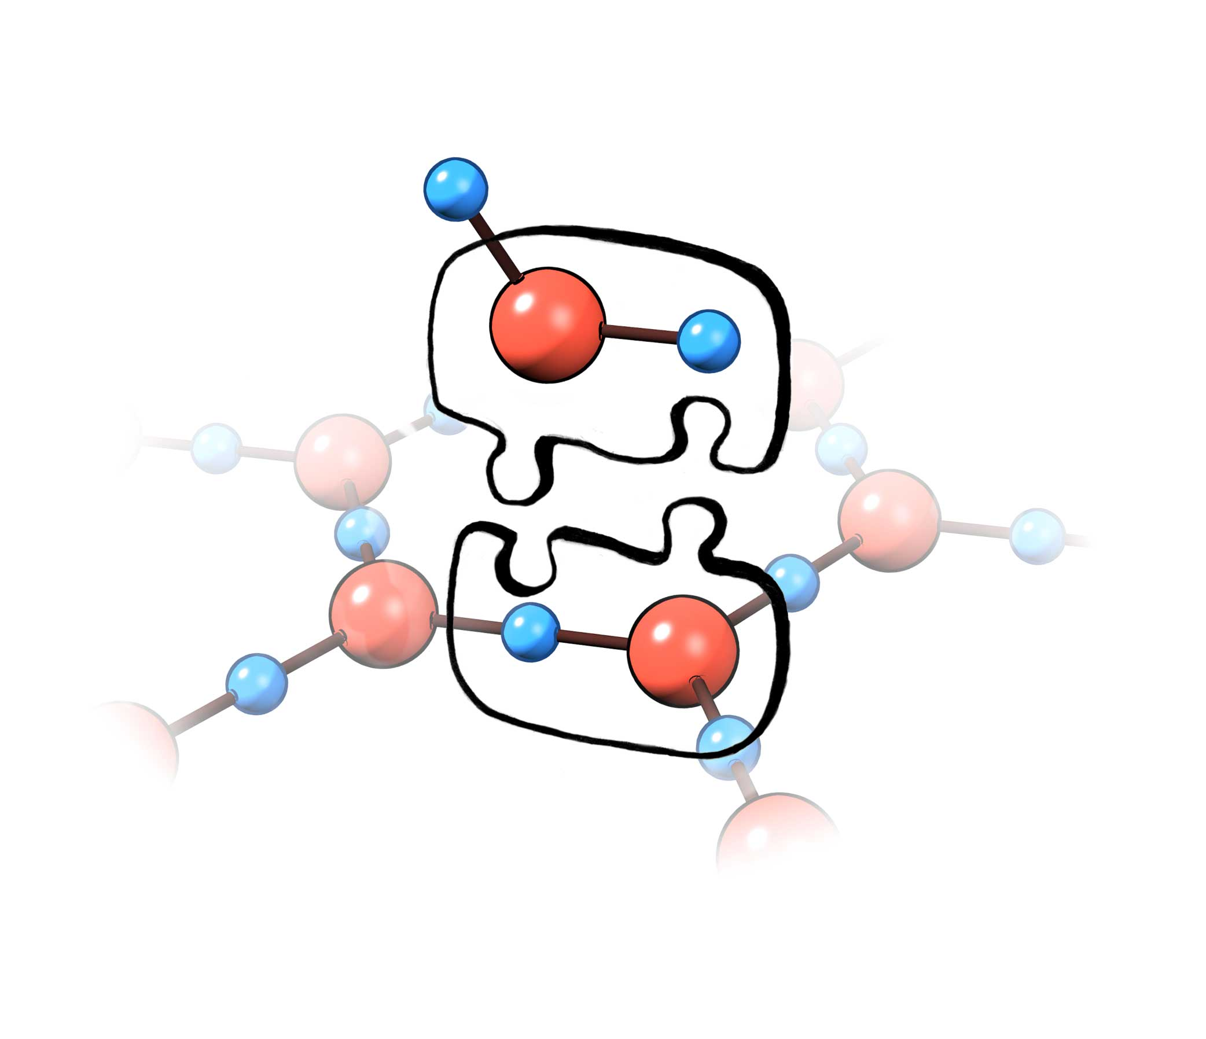
The assembly process resolves the previous chapter’s quandary of how EZ charges can pack so densely. Negative charges repel one another; hence, the EZ should rightly fly apart. However, shifted electron clouds glue each new element onto the growing lattice, preserving lattice integrity. You can liken the electron clouds to the nob interlocks that hold puzzle pieces together (Fig. 6.11). Net repulsions notwithstanding, the pieces remain firmly interlocked.
The EZ may begin to disassemble if the energy feed is inadequate. Absent enough energy, separated charges will inevitably trickle back into the lattice. When that happens the EZ will wither;.elements of the EZ matrix will revert to the very same water molecules that bore responsibility for its buildup. This reverses the growth process and discharges the water battery.
When conditions for reversal are not ideal, oxygen radicals can form instead of water. Those radicals can be nasty. Biological systems take special measures to avert their destructive power: abundant enzymes sop up these radicals as fast as they form. Nature, after all, specializes in self-preservation.
Figure 6.11. Adding elements to the lattice. Repulsion notwithstanding, elements remain locked together by the puzzle-piece interlocks.
Perhaps you’ve wondered what happens to all the energy that the EZ stores. Does the EZ finally go up in smoke? Or, does something more interesting and measured take place? The next chapter addresses the question whether a jar of water can do work.

References Chapter 6
Chai B, Yoo H. and Pollack GH (2009). Effect of Radiant Energy on Near-Surface Water. J. Phys. Chem B 113: 13953-13958.
Zheng JM and Pollack GH (2006). Solute exclusion and potential distribution near hydrophilic surfaces. in Water and the Cell, ed. GH Pollack, I Cameron, and DN Wheatley, Springer, pp. 165 – 174.
Beatty JT, Overmann J, Lince MT, Manske, AK, Lang AS, Blankenship RE, Van Dover CL, Martinson TA and Plumley FG (2005). An obligately photosynthetic bacterial anaerobe from a deep-sea hydrothermal vent. PNAS 102(26): 9306 – 9310.

