SECTION II
THE HIDDEN LIFE OF WATER

The previous section showed that near-surface water differs from bulk water. Next we explore the nature of that difference. We identify the structure of the near-surface exclusion zone, and pinpoint features that will be foundational for all that follows.

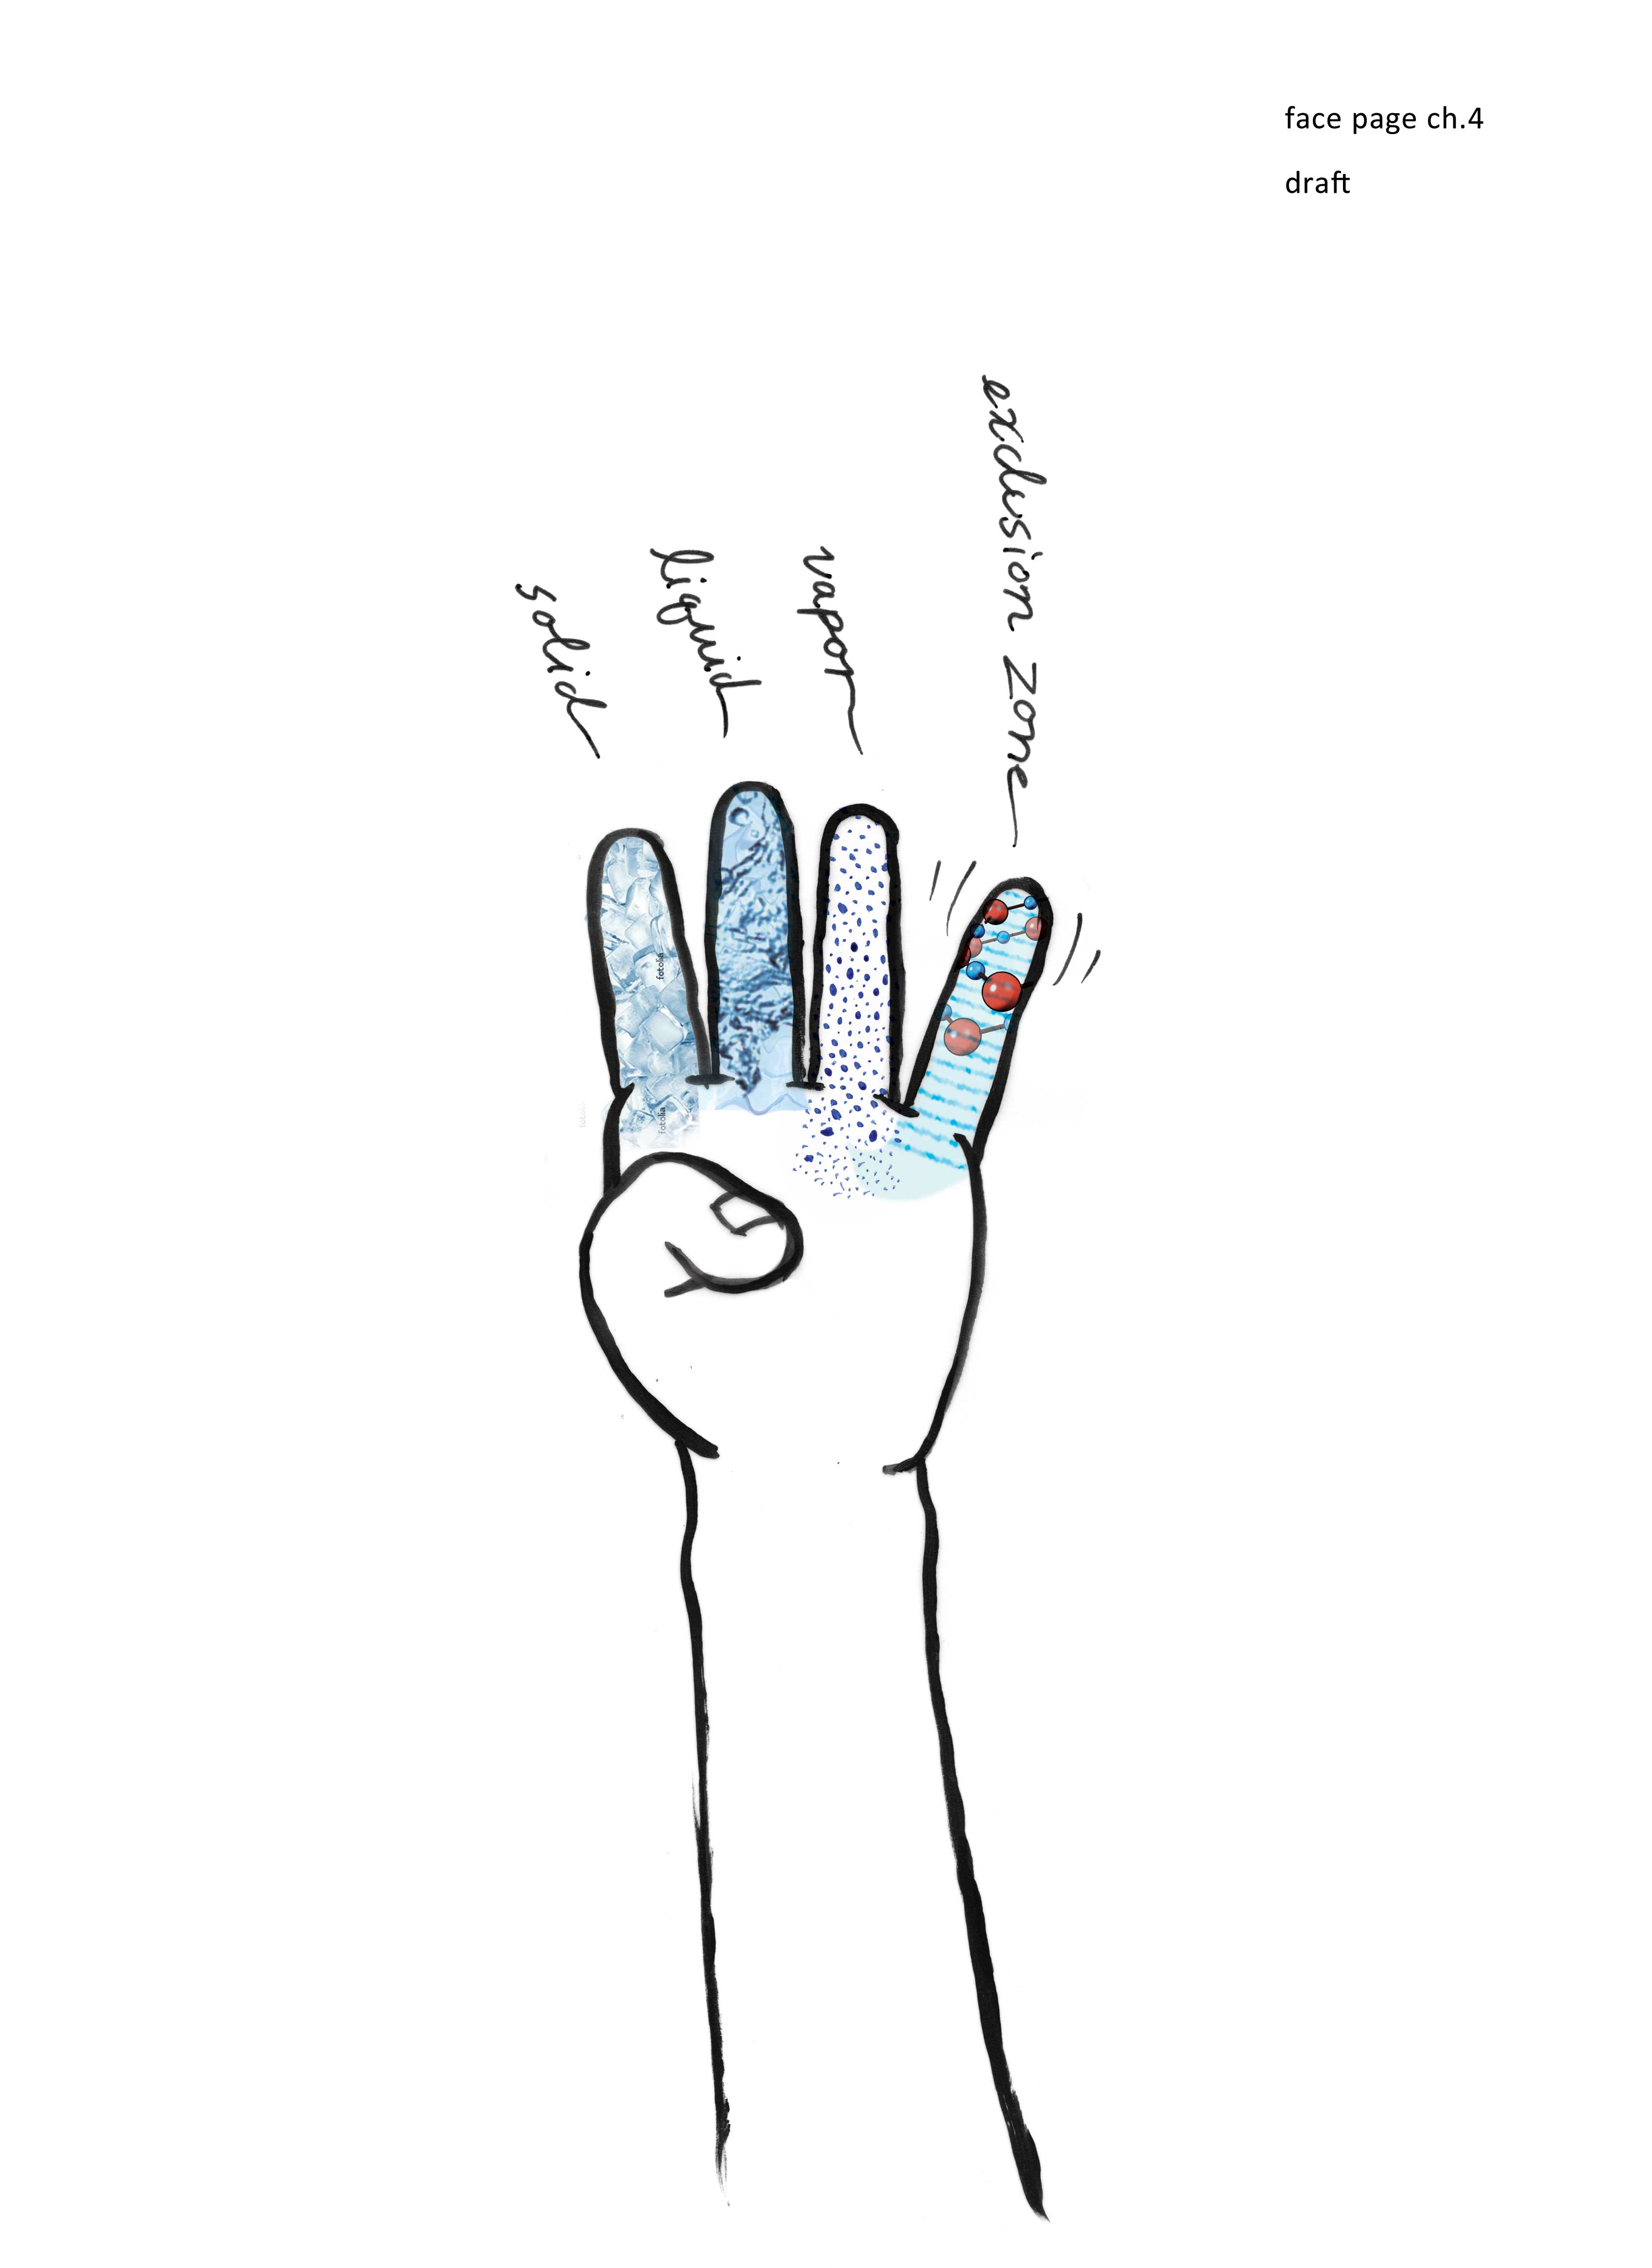
Chapter 4
A Fourth Phase of Water?
As a college freshman in the dark ages of 1957, I recall the stir created by the launch of the world’s first space satellite. Sputnik was a stunning achievement. It was also a Soviet coup that caught the US off guard, which felt ominous during that tense Cold War era. The US government responded by galvanizing support; it pledged huge financial resources for funding scientific research and engineering development. Sputnik had been an embarrassment, the likes of which could not be allowed to happen again.
But it seemed to happen again only one decade later. This time the embarrassment came from something less lofty than a satellite: it came from the science of water. The Russians had struck again with the discovery of what appeared to be a new phase of water. They had put some water into narrow capillary tubes and found that its properties changed dramatically. The water no longer behaved like a liquid; nor was it a solid either. It looked for a while like a genuinely new phase of water.
Elementary chemistry teaches us that water has three phases (or states): solid, liquid, and gas. The Russian finding implied a fourth phase. I would not dwell on this finding if I didn’t believe it warranted some consideration. From the previous chapter you will recall that the water next to common hydrophilic surfaces took on different properties: it was more viscous, more stable, and more ordered than bulk water. These features do not exactly match what the Russians claimed to have found in their narrow capillary tubes, but close enough to raise suspicion that the Russians’ findings might just hold some embedded grain of truth.

Revisiting the Polywater Debacle
The story began, as I mentioned several chapters back, when an obscure Russian scientist named Nikolai Fedyakin discovered that under certain conditions water could become unexpectedly stable; it became difficult to freeze and difficult to vaporize. It also seemed denser and more viscous than bulk water. Excited by these unusual findings, Fedyakin took his results to the Soviet Union’s most prominent physical chemist, Boris Derjaguin (Fig. 4.1), who was impressed enough to launch a cadre of lieutenants into hot pursuit.
Derjaguin appreciated that capillary tubes were not the only possible interfaces with water. Anything touching water creates an interface — from the glass that holds drinking water, to the proteins lying inside the cell. These interfaces, in turn, create “interfacial water” with seemingly stable features. Derjaguin understood the stakes: unraveling this single phenomenon might hold the key to understanding a good deal of nature. Therefore, he explored the phenomenon meticulously. To assure its purity, the water was first allowed to evaporate and subsequently condensed inside of scrupulously cleaned glass capillary tubes. It was this seemingly pure water that exhibited such remarkable stability.
Although Derjaguin’s work had become well known to the Russian community by the mid-1960s, only later did westerners begin to take notice. Follow-up studies soon began throughout the US and Great Britain. Everyone became interested in this special kind of water.
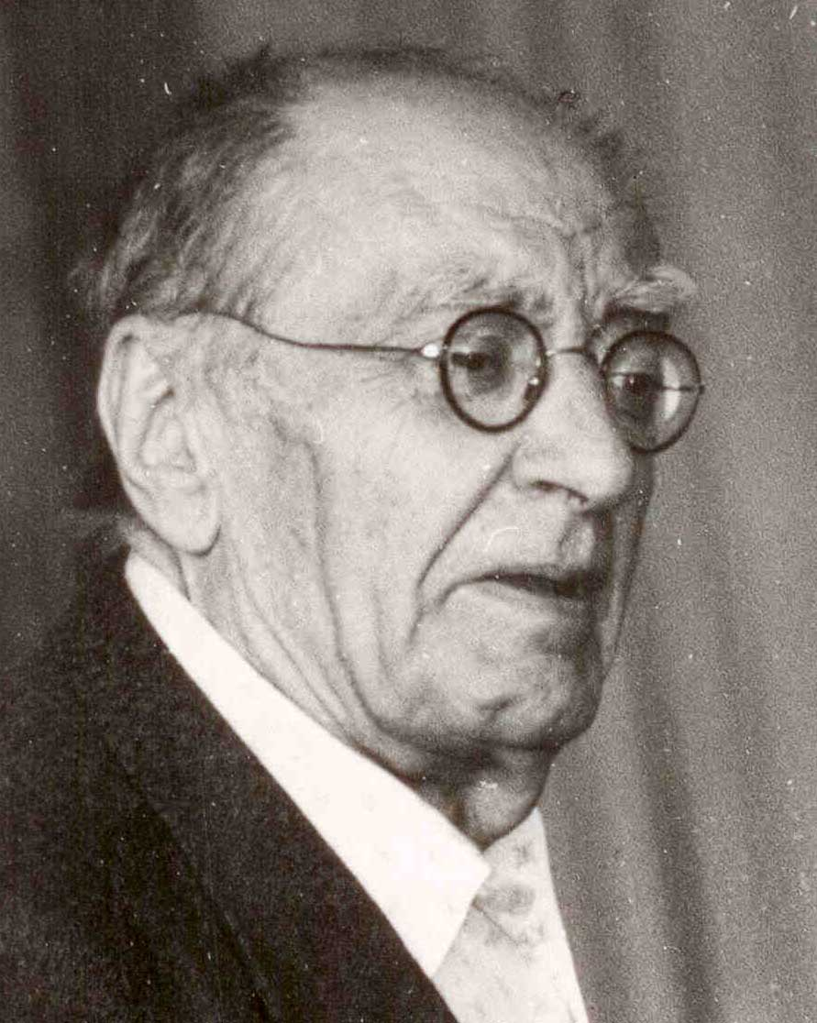
Even the press took notice. With inevitable sensationalization, it aroused concern by fabricating a theory that, throwing a thimbleful of this stuff into the ocean might act like a seed crystal, polymerizing all the earth’s water supply into one massive blob and rendering it useless for consumption. And so, we die.
As a result of this kind of unusually purple cold-war prose, it came as some relief when this “polywater” was shown to be an experimental goof. Repeating the experiments, Western scientists found that the water contained traces of silica, presumably leached from the walls of the enveloping quartz capillary tube. Hence, it was impure. Although water in a large beaker could hardly be presumed to contain meaningful concentrations of the container material, here the scientists were dealing with extremely narrow tubes with surface-to-volume ratio high enough that the silica concentration inside the water could increase beyond trivial levels; indeed, it was above the detection threshold. Some silica apparently dissolved in the water, and with revelation of that contamination, the Soviets had egg (or perhaps silica) on their faces.
Figure 4.1. Boris Derjaguin, pioneering Russian chemist.
Later, another western scientist took glee in reporting that polywater-like features were observed when salt was added to their preparations of pure water, implying that the Russian results might have arisen from Soviet summer sweat. Guffaws could be heard the world around.
Derjaguin himself sealed the coffin of polymeric water with a published recant. Several years following the reports of contamination, Derjaguin conceded that his water had indeed been impure. With this public concession the world’s water supply could be deemed safe after all, rescued from the impending threat of polymeric solidification. Case closed. Debunking polywater had become America’s response to the coup of Sputnik. This time, the joke was on the Russians.
Although the story of this famous incident has made its way into multiple books, the inside story of the episode has yet to be told. Here are a few relevant tidbits. While traveling in Russia recently I had the pleasure of chatting with the director of a famous biophysical institute, who had been good friends with Derjaguin. They had lived in neighboring flats. He told me that the two of them had enjoyed conversations almost daily, and assured me that right up to the time of his death, Derjaguin felt certain that trace contamination was not a decisive issue, despite his published retraction. I heard much the same later from another prominent Russian scientist who had been one of Derjaguin’s last protégés. Publicly, Derjaguin professed error, but privately he felt certain that he had been on the right track.
Why would a scientist concede a sin he had not committed? One can speculate on the embarrassment suffered by the proud Soviet government with the appearance of sloppy technique. Kept on a short leash by a totalitarian regime, Derjaguin might have been pressured to retract; that act would shift the guilt away from the regime and onto the individual. Blame Derjaguin, not the Soviets.
Political pressure was certainly in evidence on the other side as well. Fearful of Soviet dominance following the Sputnik coup, western scientists were definitely on the defensive. Sweat-in-the-water must have given them a hefty ego boost.
In his book, Polywater, Felix Franks details the events surrounding this famous incident that set the political stage for the emerging science. Franks does not question the authenticity of Derjaguin’s retraction. Nevertheless, one can sense the backdrop of political forces on both sides that might have influenced the outcome. This political subtext leaves one with an uneasy feeling about just what is true and what is not.
My own intuition is that both sides were right. Over the years that I have studied water it has become apparent that obtaining absolutely pure water is next to impossible: No matter the precautions taken, some contamination is unavoidable because water is a universal solvent; it can dissolve practically anything. Hence, Derjaguin’s water probably did contain traces of silica and perhaps also traces of salt. The critics might have been on target.
On the other hand, that’s where the story becomes interesting. In Derjaguin’s experiments only the water was questioned and not the correctness of the observations made using that water. Let us suppose that Derjaguin’s water had been impure, as charged. Then the issue reduces to this: in the presence of contaminants, why does water take on the interesting features that it does?
Fedyakin, Derjaguin, and even many western scientists detailed those interesting features in numerous published papers. Why not consider those features? I do not advocate contamination, but only that trace contaminants need not automatically disqualify any further exploration. Why throw out the baby with the bathwater?
We keep these considerations in mind as we move on to explore the nature of exclusion-zone water. Like polywater, exclusion-zone water resides near surfaces. Is this similarity more than fortuitous?
Possible Structures of Near-Surface Water
When exclusion-zone water was first identified, many suspected it might be the same as polywater — not in any constructive sense but in the sense that it might have arisen from a similar experimental error. One prominent physical chemist suggested this possibility to me rather directly, claiming that all he really wanted to do was to save us from the ignominious fate of polywater.
We responded by adding contaminants to the water. We wanted to see whether contaminants built our exclusion zone in the same way that they were asserted to build polywater. We found the opposite: practically anything we added to the water diminished the size of the exclusion zone instead of expanding it. The purest water correlated with the largest exclusion zone.
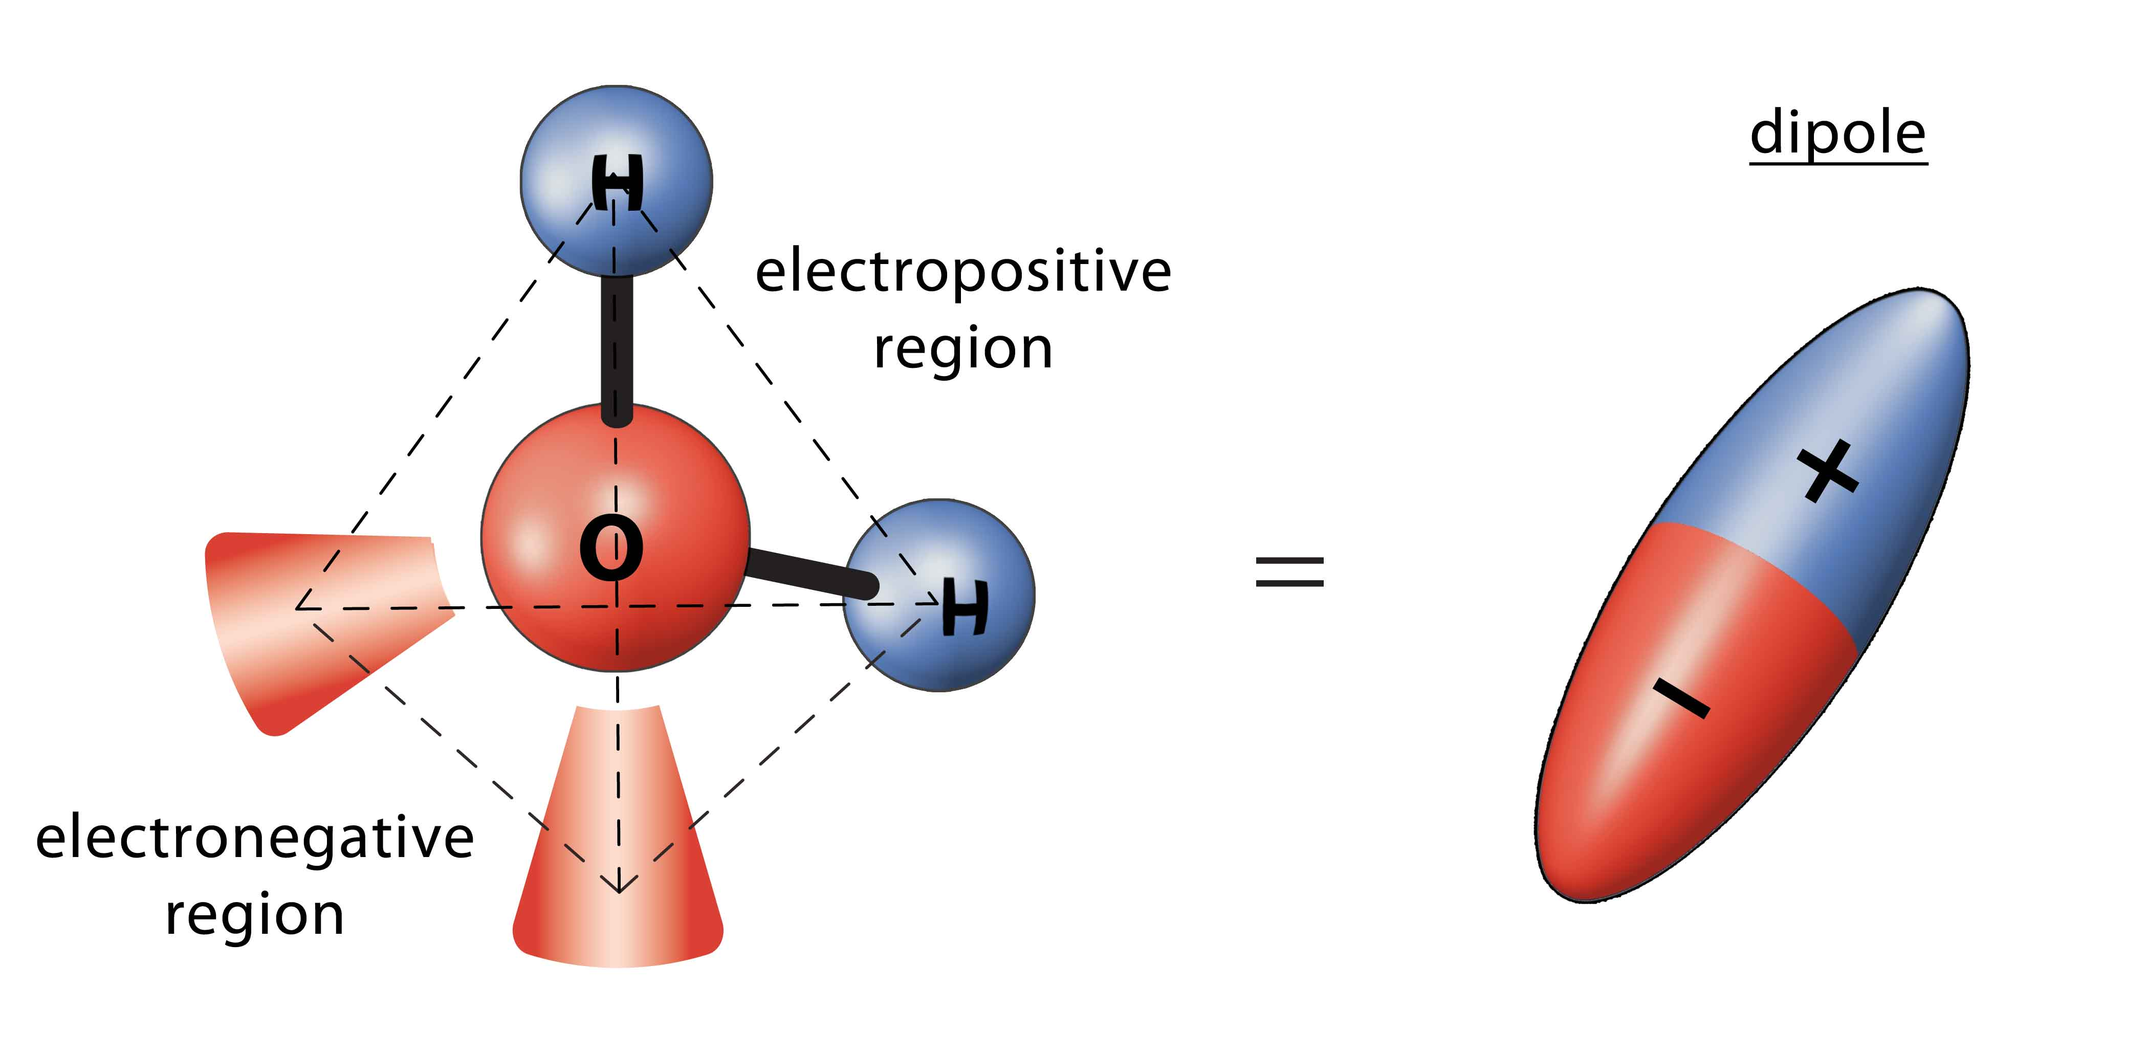
That result told us one of two things: either exclusion-zone water was not the same as polywater because it behaved differently; or if it was the same, then the attacks on polywater might have been motivated by issues beyond science, for the contaminants did the opposite of what was suggested. At any rate, the polywater specter did not throw a monkey wrench into our works, and we felt justified in exploring exclusion-zone water on its own terms.
Figure 4.2. Textbook structure of the water molecule (left), showing cones of negativity and the region of positivity, creating a tetrahedral shape. The separated charges are commonly represented by a simple dipole (right).
The name “exclusion-zone,” by the way, originated with my Australian friend John Watterson, who also suggested the “EZ” abbreviation. I am not sure that those monikers are optimum, now that we know that the exclusion zone does more than just exclude, but EZ does have an easy ring to it, and the term seems to have stuck.
The central question was the exclusion zone’s molecular structure. We felt it had to differ from that of bulk water, for EZ water was observed to be more stable, more viscous, and more ordered. But what was that structure?
Stacked Dipolar Water
The most obvious candidate was a simple ordered stack of water molecules, and we consider that first. Stacking is possible because the water molecule is a dipole: it comprises an electrochemically negative oxygen atom at one end and two electropositive hydrogen atoms at the other (Figure 4.2). Because of that charge separation, dipoles have a natural tendency to stack; hence, it seemed reasonable to consider the exclusion zone’s ordered structure in terms of dipole stacking.
A model is shown in Figure 4.3.
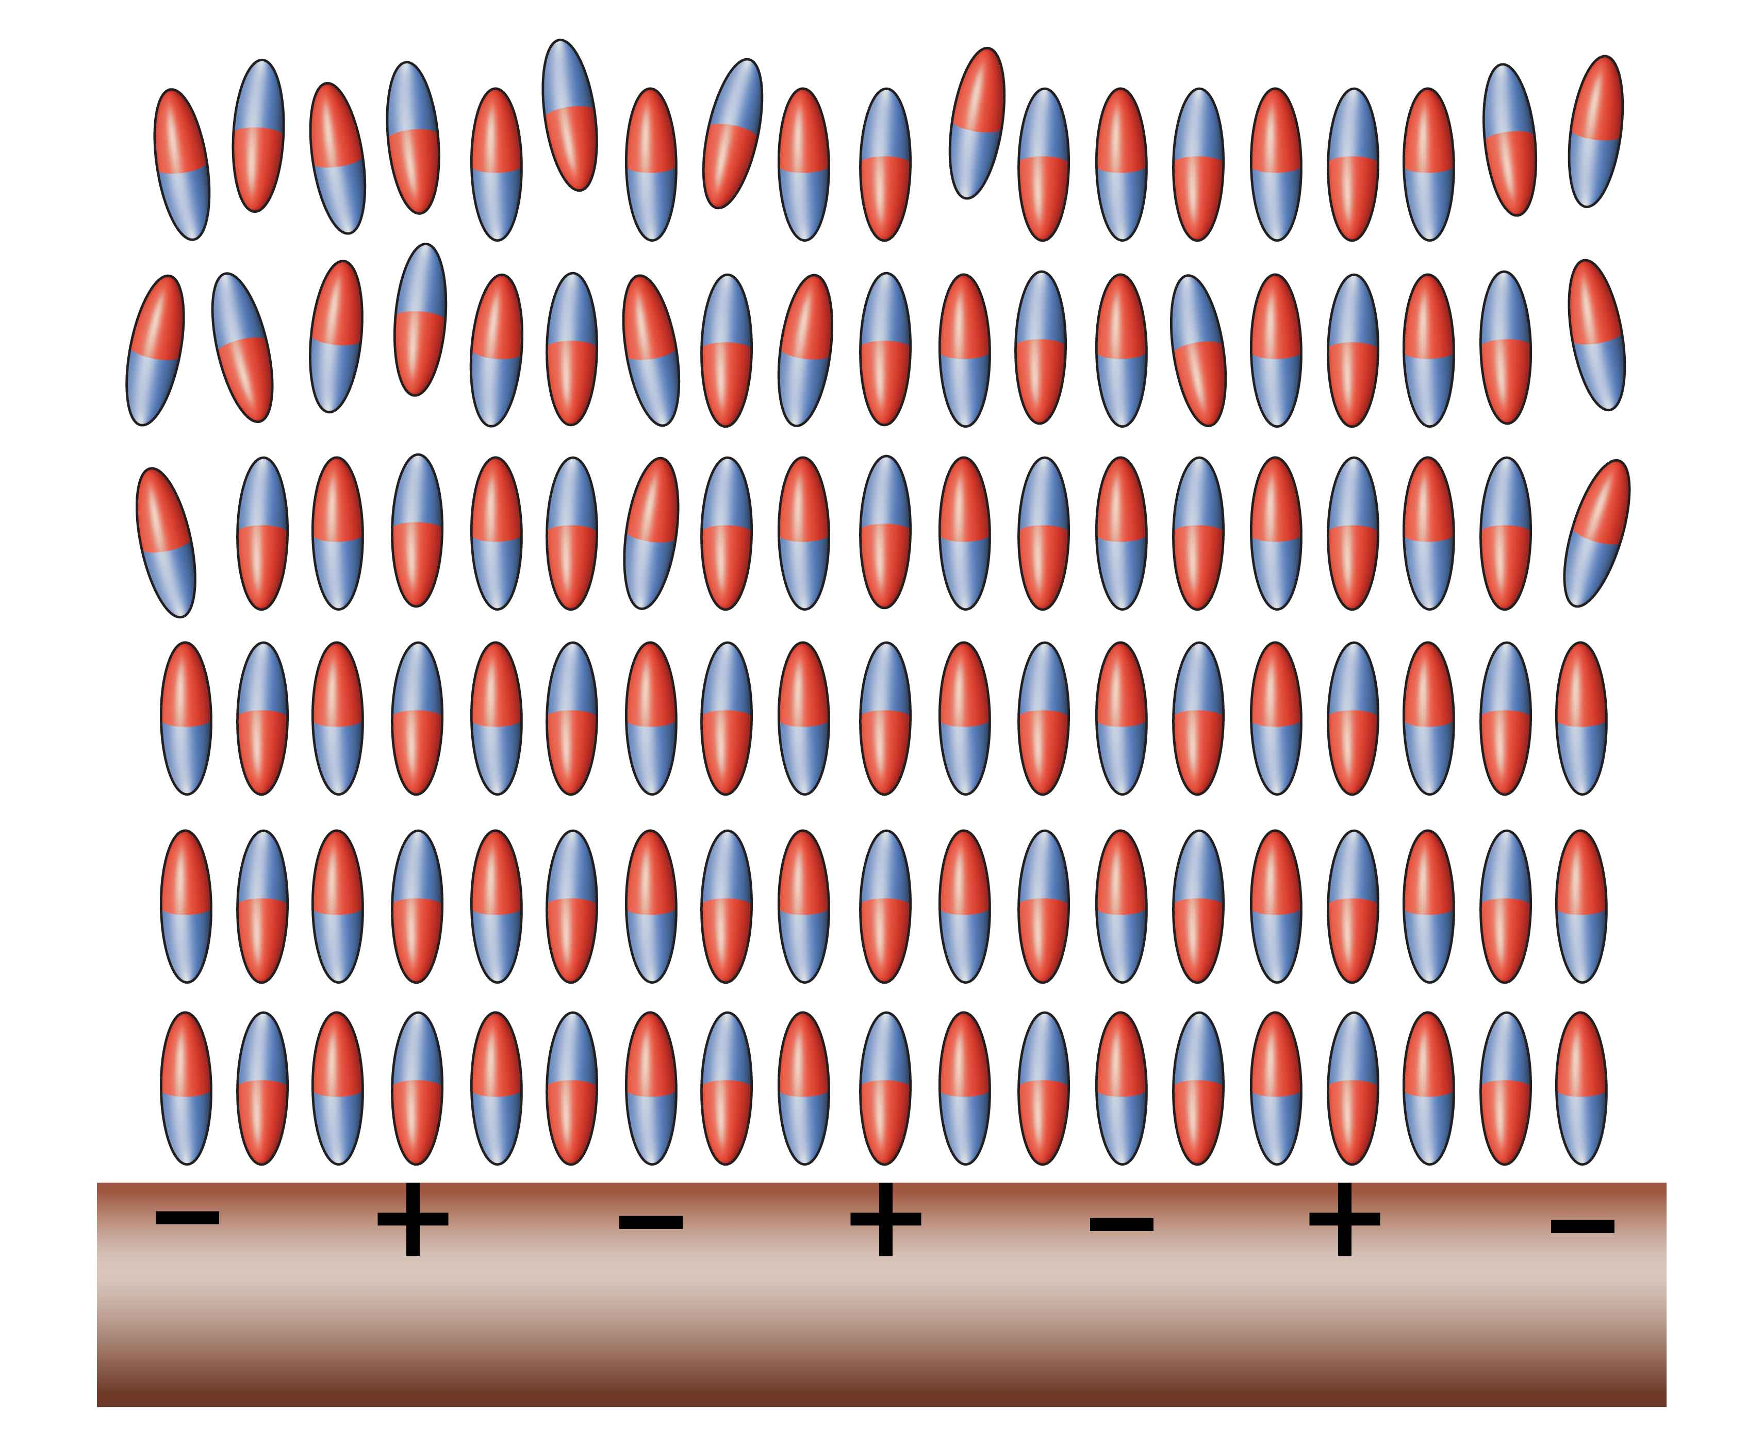
The stacked dipole configuration would seem the practically inevitable solution to our problem. Beginning at the nucleating surface, water dipoles would stack one upon another, projecting farther and farther from the surface until the disruptive forces of thermal (Brownian) motion limit further ordered growth. How far such an ordered crystal might build depends on various assumptions. Most chemists would argue for no more than a few molecular layers, while others argue for an almost unlimited stacking (Ling, 2003; Roy et al., 2005).
Figure 4.3. Stacked dipole model of water ordering. Some loss of order might occur with increasing distance from the surface because of thermally induced motions.
The stacked dipole model’s most fervent advocate has been the world-class scientist Gilbert Ling. Ling built a comprehensive theory of cell function on the basis of ordered water, implicitly presuming the dipolar arrangement (Ling, 1992). His cell-function theory has seemed so compelling to me that even in relatively recent writings I could find no reason to question its dipolar basis (Pollack, 2001). In fact, that arrangement had seemed the only plausible option.
On the other hand, we now have reasons to reconsider. Although the stacked dipole model may apply in certain circumstances, newer evidence implies that it cannot represent the general case. That evidence centers on the fact that the exclusion zone is charged (evidence in a moment), whereas dipoles have no net charge. Models without charge cannot explain zones with charge.
So let us consider an alternative structural candidate that does bear charge. Like the stacked dipolar model, this structure is ordered; but the ordering is of a non-dipolar nature.

Crystalline Water
A good way to deduce structure is to look for precedent. If exclusion arises from water’s ordered nature, then looking for some known example of an ordered water structure seems a logical way to begin.
The obvious candidate is ice, whose structure is certainly well ordered. Another of ice’s handy features is that it excludes. As ice grows, it excludes molecules or particles present in the water, creating a crystal largely free of debris. So the ice structure is a candidate worthy of exploration: it is ordered, and it excludes — just like the EZ. Could the ice structure hold clues for exclusion-zone structure?
The planes of ice are built of oxygen and hydrogen atoms arranged in hexagonal units (Fig. 4.4). Multiple units create the familiar honeycomb sheets. The sheets above and below are linked by simple interposed protons, which bond respective oxygen atoms and create the solid structure that is ice. The protons confer rigidity. Every other oxygen in the hexagon is not bonded. Those unbonded oxygens, being electronegative, repel one another, creating the slight pucker evident in each planar sheet. The main point, however, is that the inter-planar proton linkages confer rigidity.
The exclusion zone, on the other hand, is not rigid; it behaves as a highly viscous liquid. So the ice structure itself does not suffice, as we might have presumed. However, a minor tweak makes a difference. The structure needs fluidity, not rigidity. Liquids commonly gain their fluidity if constituent planes are able to slip past one another. For the exclusion zone, then, a premise worth considering is a stack of ice-crystal planes devoid of those rigidifying inter-planar proton linkages. With the linkages absent, the planes could slide past one another, accounting for the zone’s liquidity.
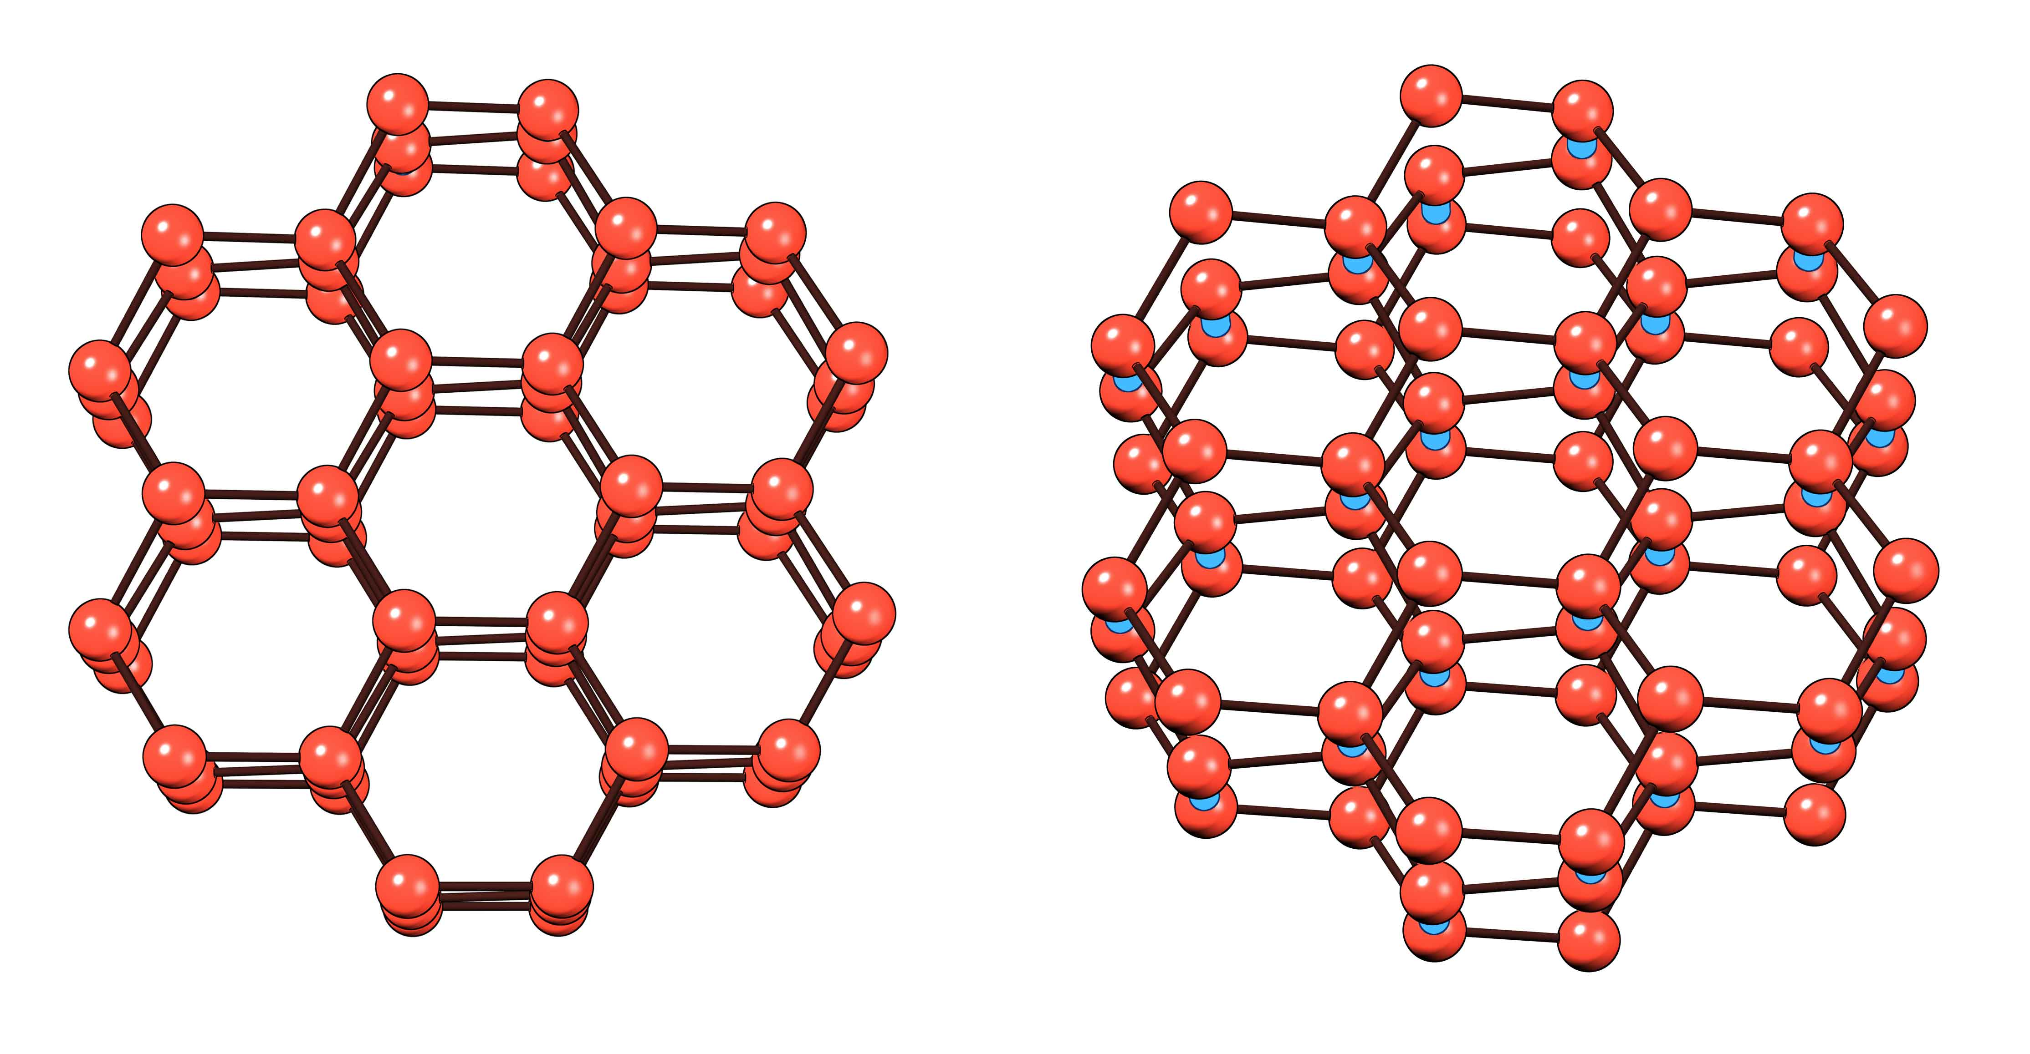
Suppose, then, that those proton links were sparse, or perhaps even absent. Individual planes could shear past one another, conferring the required liquidity. However, the structure still needs to hang together, so the planes must be weakly linked. With weak linkages, which I’ll explain in a moment, the water’s mechanical behavior would be semi-solid when left alone, but able to flow in response to shear: something like gelatinous egg white.
Figure 4.4. Structural model of common ice viewed from two different angles. Oxygen atoms are red. Hydrogen atoms (not shown) lie midway along the lines connecting the oxygens. Note (right) that interplanar protons (blue) link every other oxygen. They create a pucker, which makes the arrangement of atoms seem less planar and more tetrahedral.
Now let us return to the earlier question: why should we consider any such ice-like model to be more likely than the stacked dipole model? Does some critical distinguishing feature lurk beneath the surface?
The Issue of Charge
Some readers may recognize that the ice-like model has a problem — or so it seems. Removing the inter-planar protons extracts positive charges from something initially neutral; the overall structure then becomes negative. The posited structure would then imply net EZ negativity; and, because the exclusion zone is large, it would imply a substantial zone of net negativity.
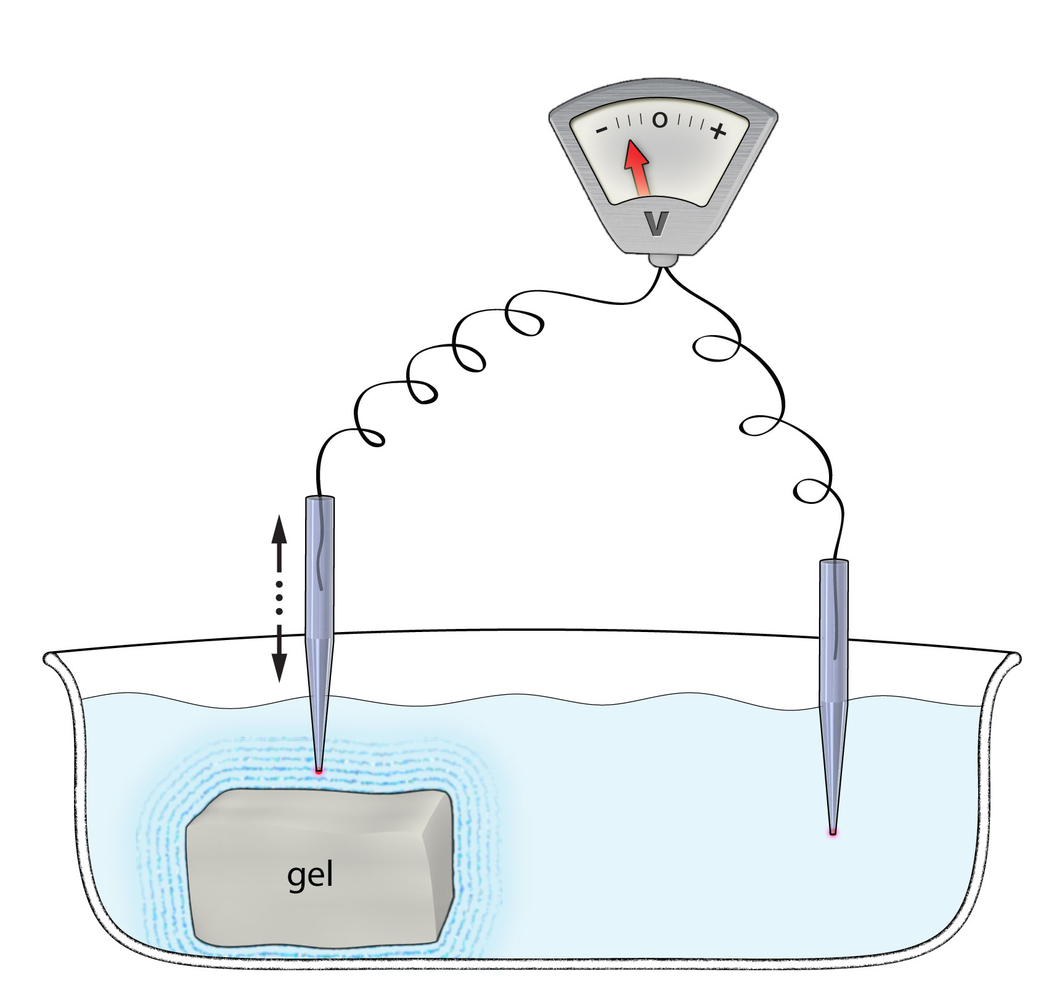
Considering such negativity unlikely, we set out experimentally to disqualify this model. After all, any such negatively charged zone could be as much as a half-millimeter wide, and expecting to find such a vast zone of negatively seemed improbable. The dipole model implied zero net charge, and every bit of our scientific experience suggested that an uncharged region was more likely than a charged one. So we expected that we could readily prove the model wrong.
Figure 4.5. Experimental setup used for measuring the electrical properties of the exclusion zone. Reference electrode at right.
We designed a straightforward experimental setup (Fig. 4.5). With ample experience measuring electrical potentials in living cells, we could easily set up an experiment to do likewise in and around gels. We used microelectrodes, which, as their name implies, taper to a very fine tip, facilitating micron-scale spatial resolution. One such electrode was planted remotely as a reference. With the other electrode driven by a motor to positions progressively closer to the gel surface, it was possible to chart the near-surface electrical potential. We could thereby determine whether the exclusion zone was negatively charged.
To our great surprise, we found that it was indeed negatively charged.
Figure 4.6 shows representative results. With the probe electrode positioned initially in bulk water, and therefore well beyond the exclusion zone, the potential difference was zero. That was expected. As the probe advanced closer to the interface, it began to report negative potentials, the magnitude increasing with proximity to the surface. Immediately outside the gel, the magnitude of the negative potential, approximately 120 mV, remained steady even as the probe continued to advance inside the gel. With Nafion replacing the gel, the near-surface potential magnitude rose to negative 200 mV. For both specimens the negative potentials extended rather far from the interface: to approximately 200 µm for the gel, and to 500 µm or more for Nafion. In other words, the exclusion zones had negative potential.
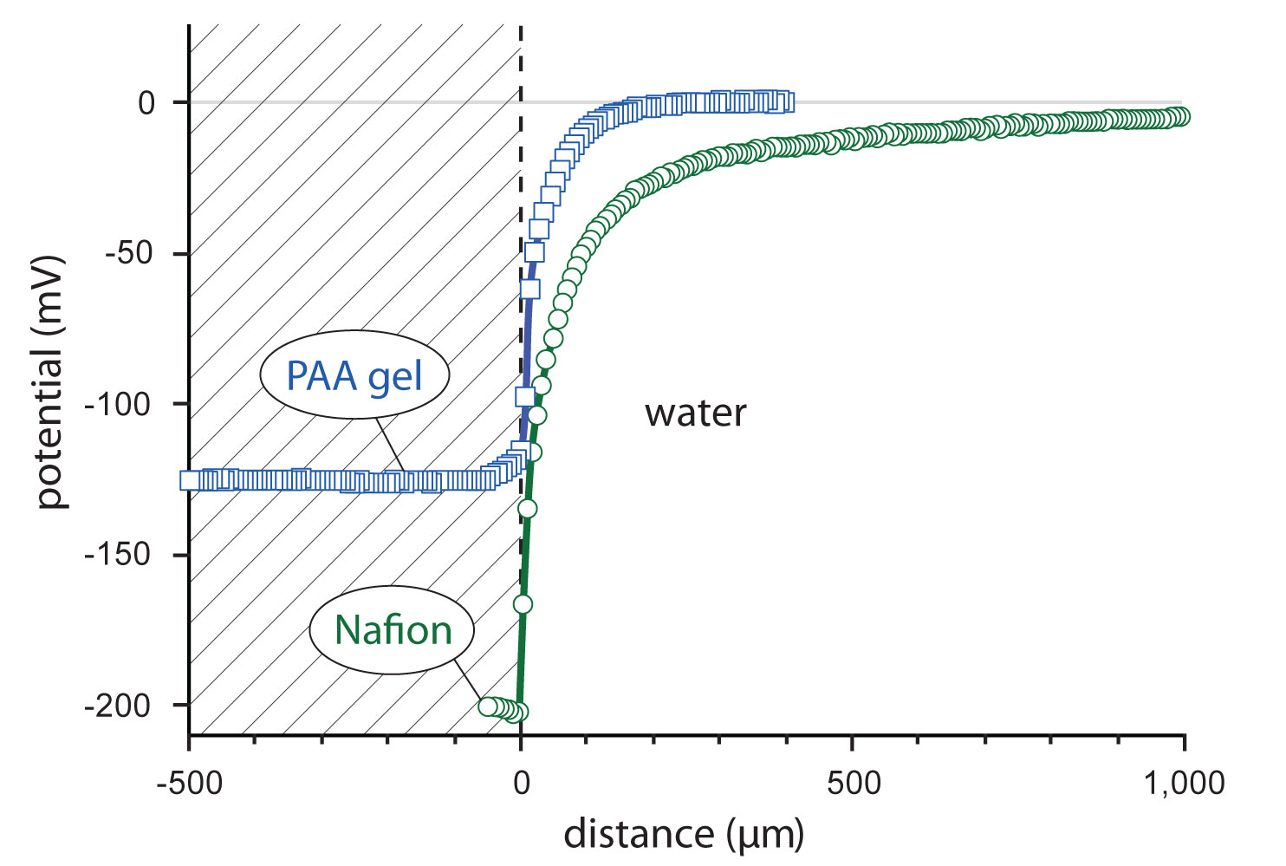
This result was the opposite of what we had expected. The fact that the entire exclusion zone showed negative potential lent credence to the ice-sheet model, whereas the dipole model had no net charge and was therefore disqualified. It seemed we were making progress. We were excited — except for one possible snafu that my colleagues were not shy about suggesting.
Figure 4.6. Electrical potentials measured in the vicinity of a polyacrylic acid gel (blue), and a Nafion sheet (green). The zone of negativity correlates with the width of the EZ, which differs in the two cases. [show EZ regions for clarity]
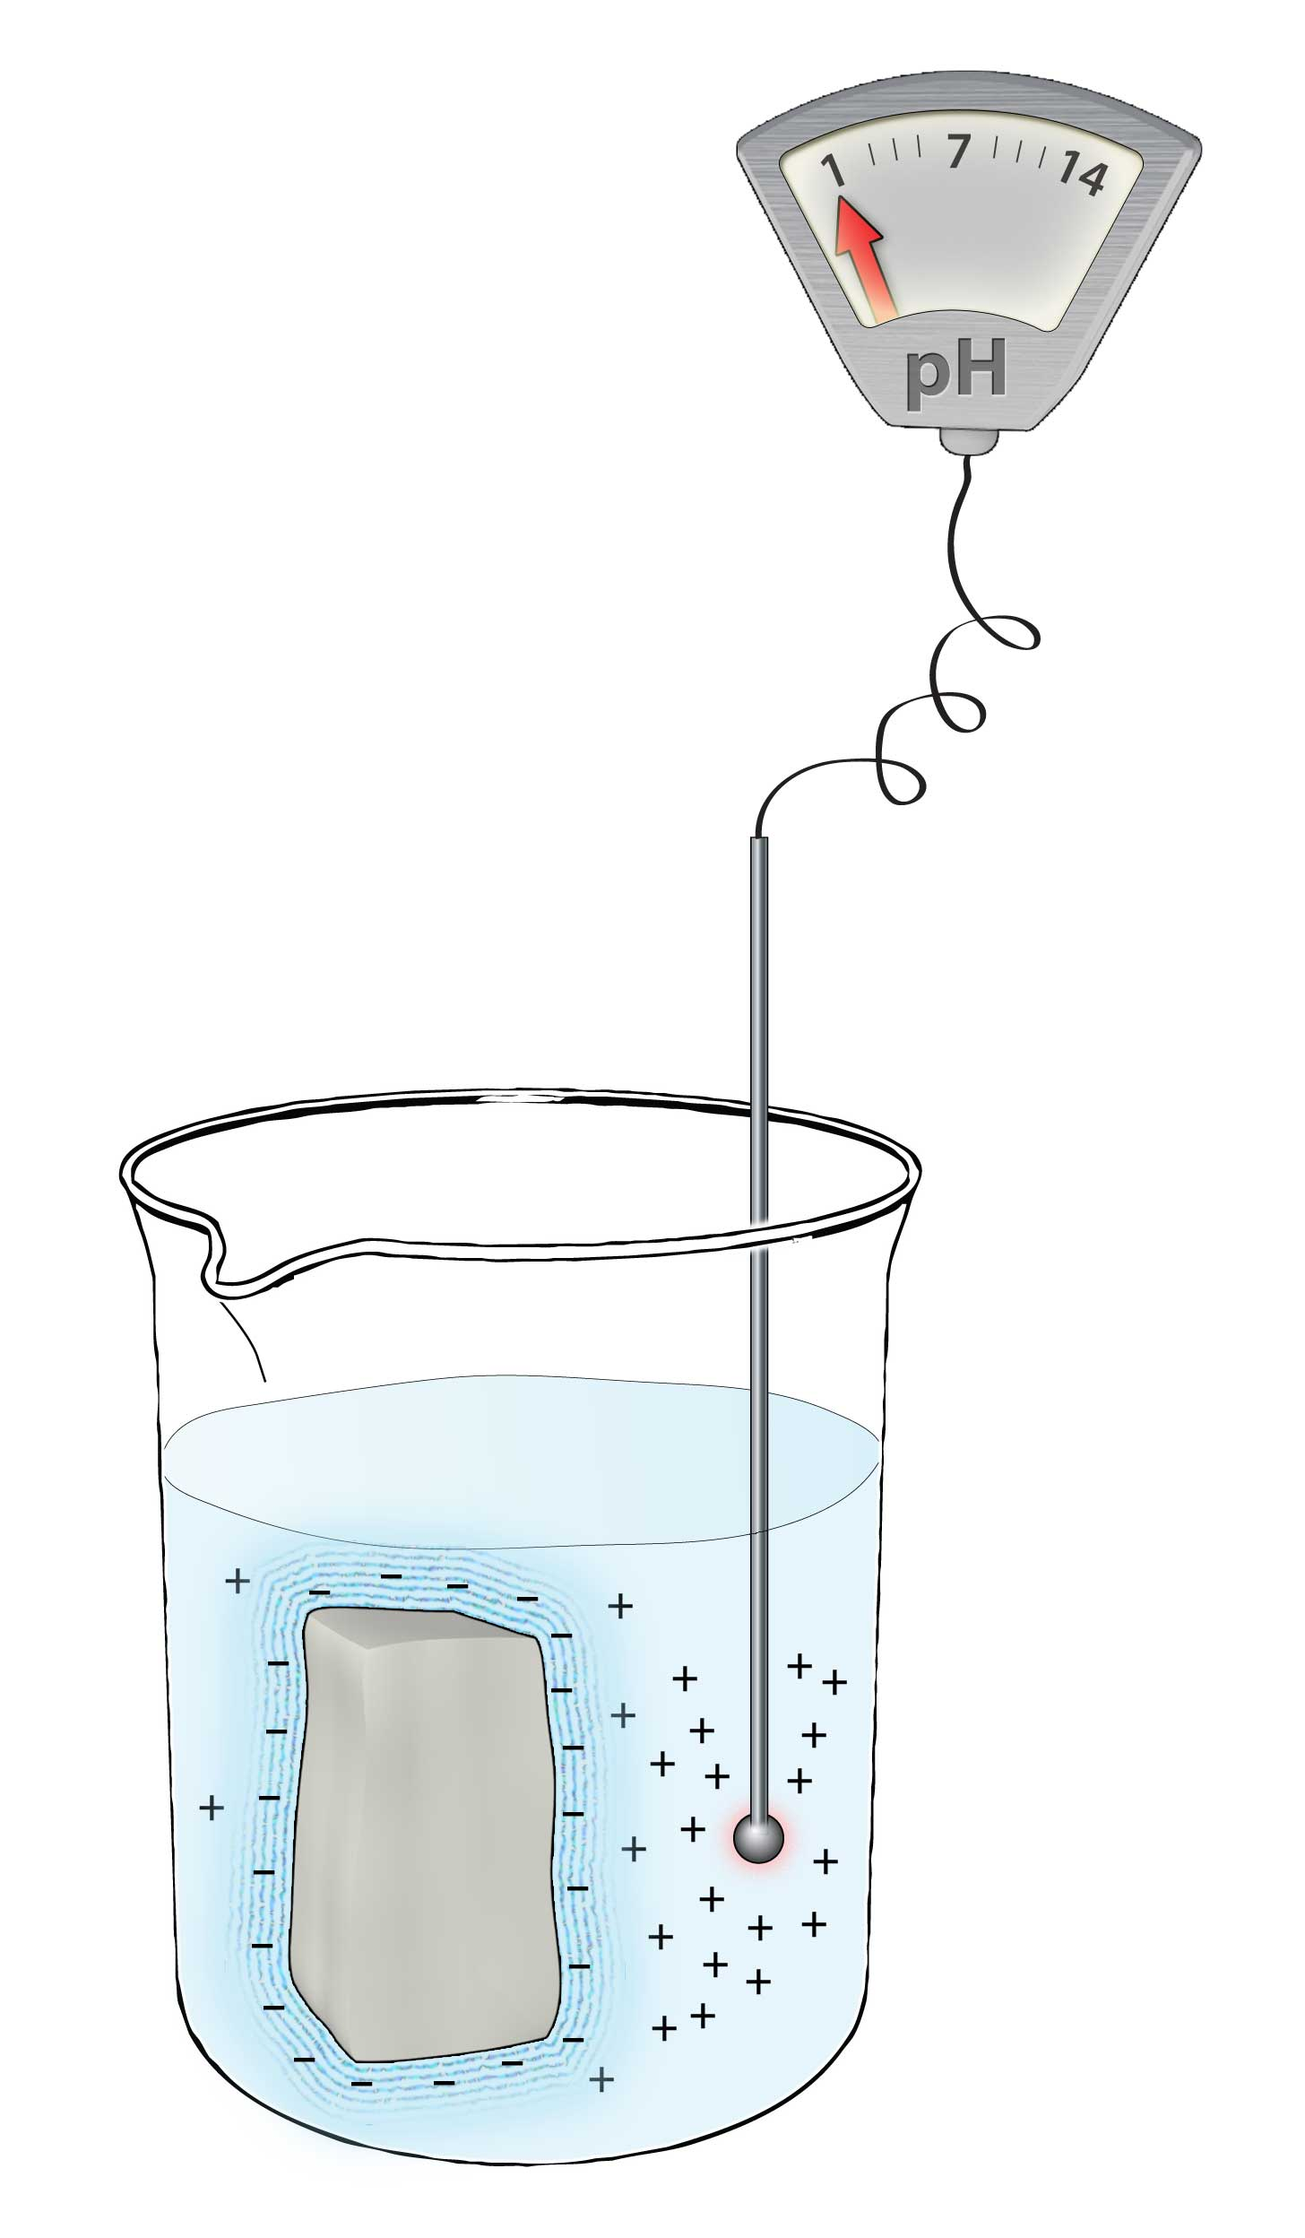
Although someone trained as an electrical engineer should have been more savvy, my colleagues reminded me that a negative potential could arise merely from the sample’s negative surface charge. If the surface were charged, then the effect of that charge might be felt at some distance into the water. The negative EZ potential could have arisen merely from the charge’s long-range impact, and needn’t reflect any net charge contained within the exclusion zone. Ouch!
The obvious test was to see whether we could find a corresponding positive charge elsewhere. If the EZ were genuinely negative throughout, then surely corresponding positive charges should exist somewhere, because starting with neutral water and winding up with something negative makes no sense. Further, because everything originated from water, the positive charges would likely occur in the form of protons. In other words, somewhere, we ought to find a zone filled with protons — a zone of low pH.
To test this, we inserted a bulky gel into a beaker of water (Fig. 4.7). Exclusion zones immediately began building. A pH probe was then positioned in the water beyond the EZ. The pH values dropped substantially, sometimes to values as low as 2, or even 1, indicating huge concentrations of protons in the water beyond the exclusion zone. So, the expected protons were indeed present.
Figure 4.7. Measuring the pH of water next to an immersed gel. The gel occupies an appreciable fraction of the water volume.
The experiment confirmed that the observed negative potential did not arise as a long-range effect of charge on the material surface; it resulted from negative charge distributed throughout the exclusion zone, compensated by an opposite and presumably equal (proton) charge lying in the water beyond. The system overall seemed just as neutral as the water that was dumped into the beaker, but the charges had apparently separated as the exclusion zone built up.
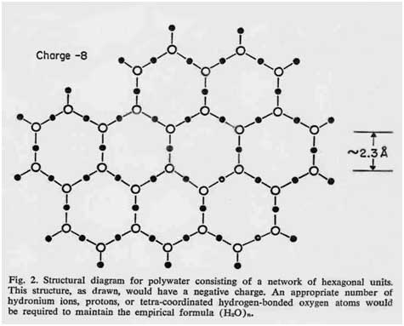
So the near-surface exclusion zone was indeed negative, as the ice-sheet model anticipated. This news seemed both good and bad. It was bad news because it implied the inadequacy of Ling’s stacked dipole model, which I had endorsed in my 2001 book. Dipole models do not contain net charge. I had evidently erred. On the other hand, it was good news because the ice-sheet model seemed even more promising: it could account for both the region’s semi-liquid nature and also for its negative charge. Best of all, it had good precedent; it was not magically pulled from a hat.
Figure 4.8. Molecular structure of polywater, proposed by Lippincott et al. (1969). Oxygen molecules denoted by open circles, hydrogens solid. Sheets stack to yield volumetric structure. [REMOVE THEIR CAPTION]
Would it surprise you to learn that decades ago somebody else had proposed the very same model? In a lead article in the journal Science published in 1969, prominent chemists from the University of Maryland hypothesized practically the same structure — for polywater (Fig. 4.8).
I said we’d return to the ill-fated issue of polywater and here we are. Because polywater was discredited only several months after publication of that article, nobody took the trouble to pursue the proposed structure; any and all attempts to deduce the nature of this special kind of water were laid to rest. Now, that structure gains fresh relevance. What had these scientists learned before negative publicity brought a sudden stop to this field’s progress?

Crystalline Water Revisited
Like the ice-like structure considered several sections back, the polywater structure envisions a stack of honeycomb sheets made up of hydrogen and oxygen atoms. The authors of that fateful Science article had deduced this structure from a broad range of amassed physicochemical data. The structure of Figure 4.8 fit the experimental data best.
Upon reading that Science paper, several aspects struck a resonant chord. First, it reminded me that nature likes hexagonal structures. You see them abundantly throughout the domain of organic chemistry. You see them also in graphite, where one honeycomb (graphene) sheet can slide easily over another, producing the low friction. Hexagonal sheets are common, and therefore natural options to consider.
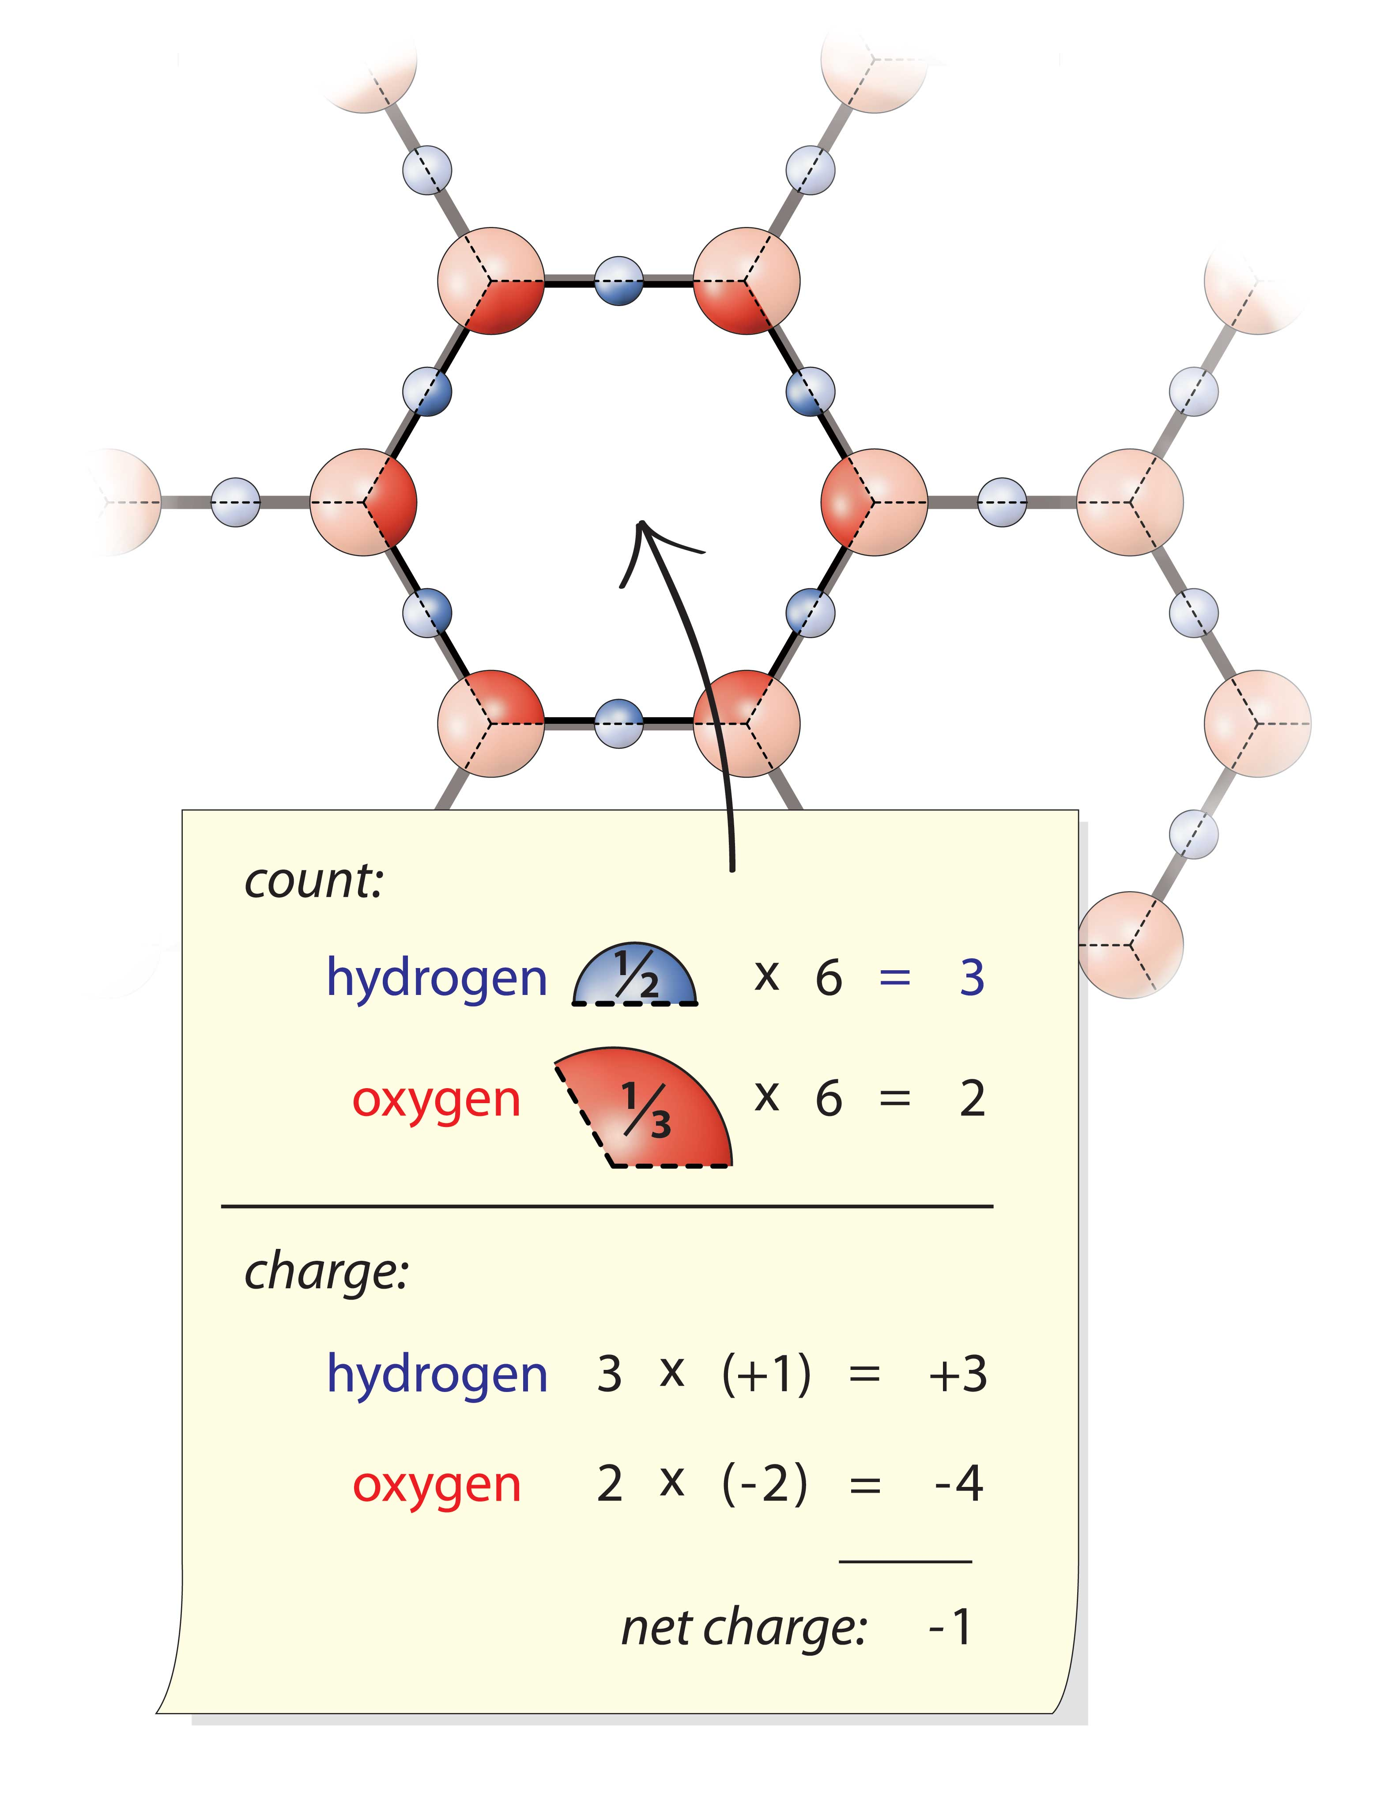
Second, the authors provocatively state that the substance in question is not water. It is built of oxygen and hydrogen to be sure, but their arrangement in a hexagonal lattice bears little resemblance to their arrangement in the water molecule. This new substance, they asserted, “should not be considered to be or even called water, any more than the properties of the polymer polyethylene can be directly correlated to the properties of the gas ethylene.” Clearly, this entity was not water.
A third feature really made me stand up and take notice: the ratio of hydrogen atoms to oxygen atoms. As everyone knows, these elements have a 2:1 ratio in bulk water. In this planar structure, however, they have a ratio of 3:2. This feature may not be immediately obvious, but you can make the count in a simplified way if you wish (Fig. 4.9). The ratio of hydrogen to oxygen is 3:2 (or 1.5:1), not 2:1, and the net charge of each hexagon is -1.
This numerology matters because the familiar 2:1 ratio confers neutrality. Two electropositive hydrogen atoms balance one electronegative oxygen atom, so the water molecule is neutral. The lattice, on the other hand, has an unbalanced ratio. Having only 1.5 positive charges present instead of the usual two leaves the hexagon with one negative charge.
Figure 4.9. Computation of the net charge of each hexagonal unit. To make the count, represent each atom as a sliceable pie; then count all the pie fractions lying within a given hexagon, taking care to remember that the oxygen pie’s charge is minus two while the hydrogen’s is plus one. The resulting ratio of hydrogen to oxygen is 3:2 and the net charge is -1.
The authors made special note of this feature on the upper left corner of their figure (see Fig. 4.8), but paid scant attention to its potential significance. In a matter-of-fact way they presumed that positive charges lodged in between the negatively charged planes would probably neutralize most of this charge. The model’s essential point was that the planes themselves were negatively charged.
The Lippincott model is essentially identical to the model put forth here. It derives from physicochemical reasoning, while the proposed model rests on precedent and logic. Both routes lead to the same honeycomb-sheet model, with a hydrogen-to-oxygen ratio of 1.5:1, not 2:1.
This is not the first time this seemingly odd ratio has been detected. An experimental report in a prominent physics journal created a stir with a finding of this very ratio: when protons and neutrons hit water molecules, the scattering pattern implied H_{1.5}O, not H₂O (web ref. 4.1; Chatzidimitriou-Dreismann et al., 1997). Hence, the seemingly odd ratio implicit in these models has actually been detected.
The key feature for both models is the hexagonal configuration. A question is whether such hexameric figures have ever been observed, and the answer is yes. Researchers have identified water hexamers next to diverse surfaces, including metals (Henderson, 2002), protein subunits (McGeoch and McGeoch, 2008), and quartz (Ostroverkhov et al., 2008). Near-surface hexamers have also been found in supercooled water (Micaelides and Morgenstern, 2007). And, next to mica, adsorbed water showed a preponderance of 120° angles, which was interpreted as evidence for hexagonal patterns (Xu et al., 2010). Hence, hexagonally structured water evidently exists next to many surfaces.
Yet another of these models’ anticipated features is light absorption in the ultraviolet region. Absoprtion at approximately 270 nm wavelength is envisaged in situations In which electrons are delocalized. Generally, this occurs in aromatic structures. Also, hexagonal oxygen-containing “crown-ether” structures similar to the structure under consideration absorb at these wavelengths. The confirmed EZ absorption at 270 nm (Fig. 3.8) thus provides additional evidence in support of these hexagonal structures.
Hence, we press on. Hexamers are detectable, UV absorption is confirmed, and two independent sets of considerations lead to the same hexagonal model. This collection of evidence provides impetus to consider the model more seriously.
Building with Legos
In exploring the model’s potential explanatory power, we must first determine how the honeycomb sheets stack to form an exclusion zone. After all, the EZ is a three-dimensional entity, not a plane. To realize depth, the sheets must somehow stack. It’s also necessary to understand how the initial layer is formed, and we’ll get to that soon. Let us first deal with the more generic issue: how one sheet builds upon another.
The simplest stacking model puts the hexagons of each plane in register with the hexagons of the adjacent plane. All hexagons are aligned. You could look down the stack of hexagons and see all the way through.
This in-register arrangement is attractively simple, but it has a problem: it is impossible. To appreciate why, look back at Figure 4.4, left panel, which shows an example of planes in register. Suppose you remove the inter-planar protons that glue the planes together (shown more clearly in the right panel). Removing this glue juxtaposes negatively charged oxygen atoms in one plane next to negatively charged oxygen atoms in the next plane. This creates inter-planar repulsions, which are explosive: the structure would immediately fly apart.
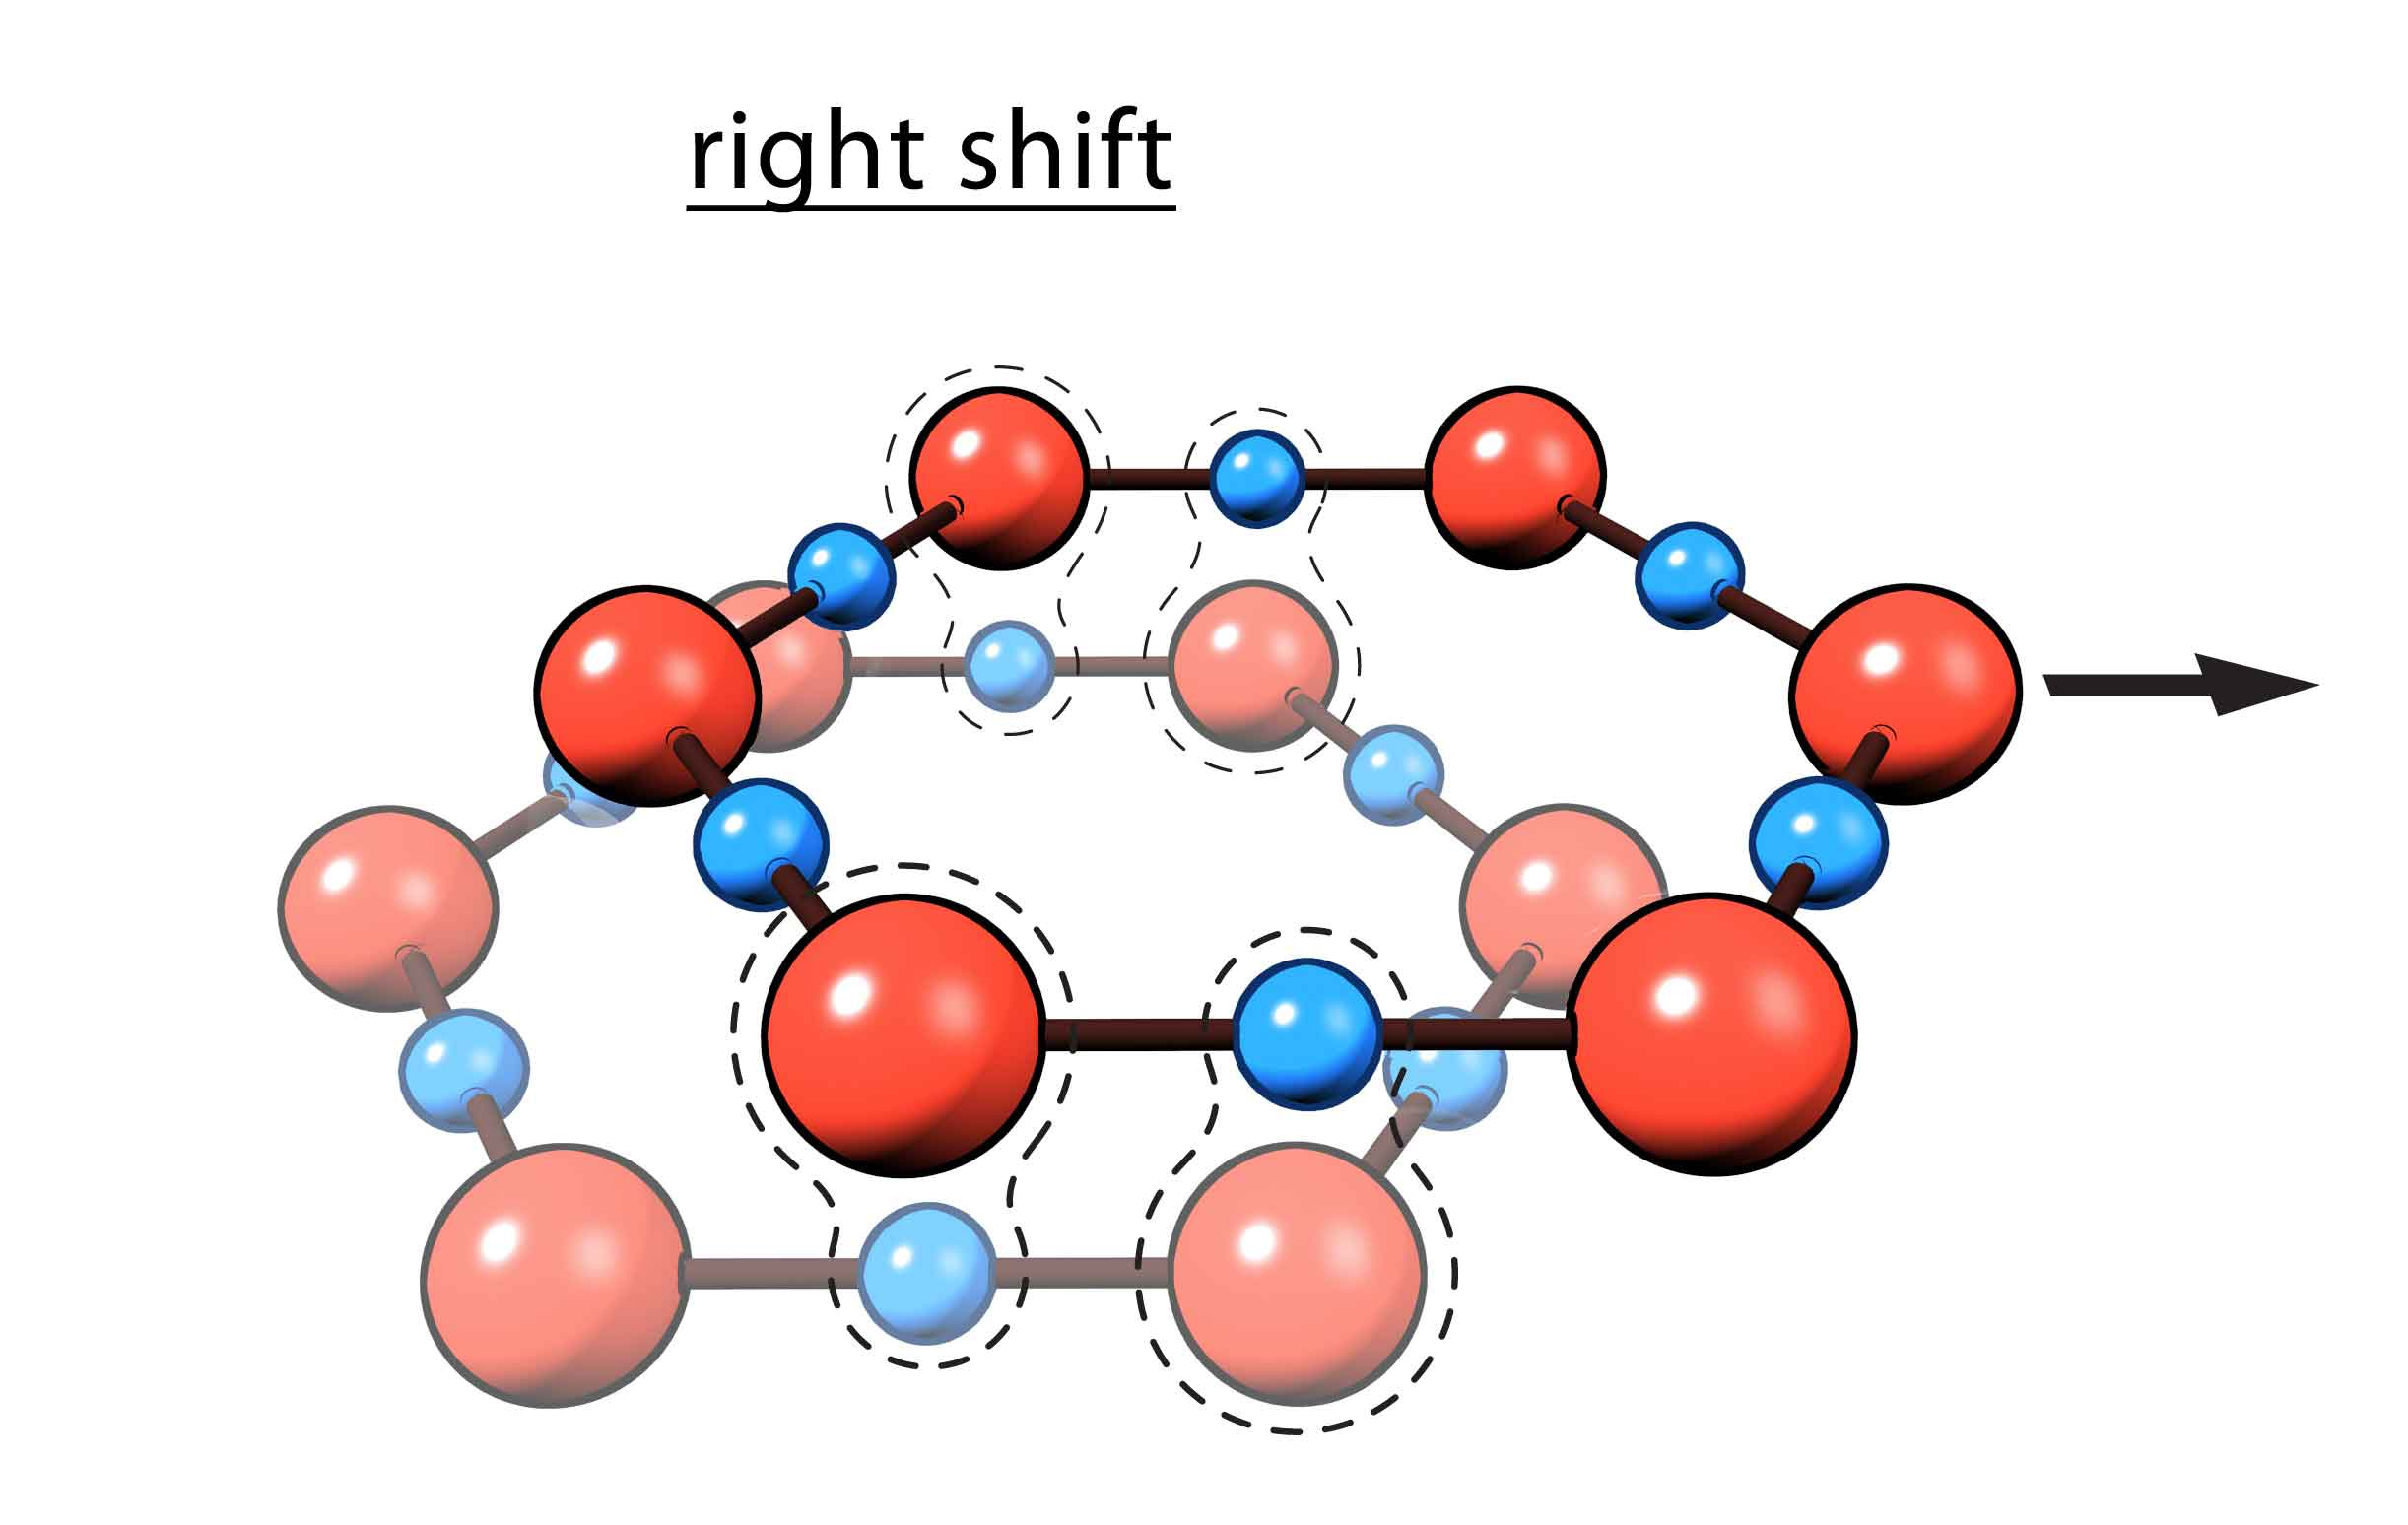
A more natural way for the planes to hold together is by shifting them out of register (Fig. 4.10). If successive planes were shifted so that the negatives of one plane lay opposite the positives of the next, then the planes could stick by attraction. They wouldn’t be rigidly stuck, like ice; they would be more weakly held, allowing the kind of shear-induced flow we might expect from viscous EZ material — something like egg white.
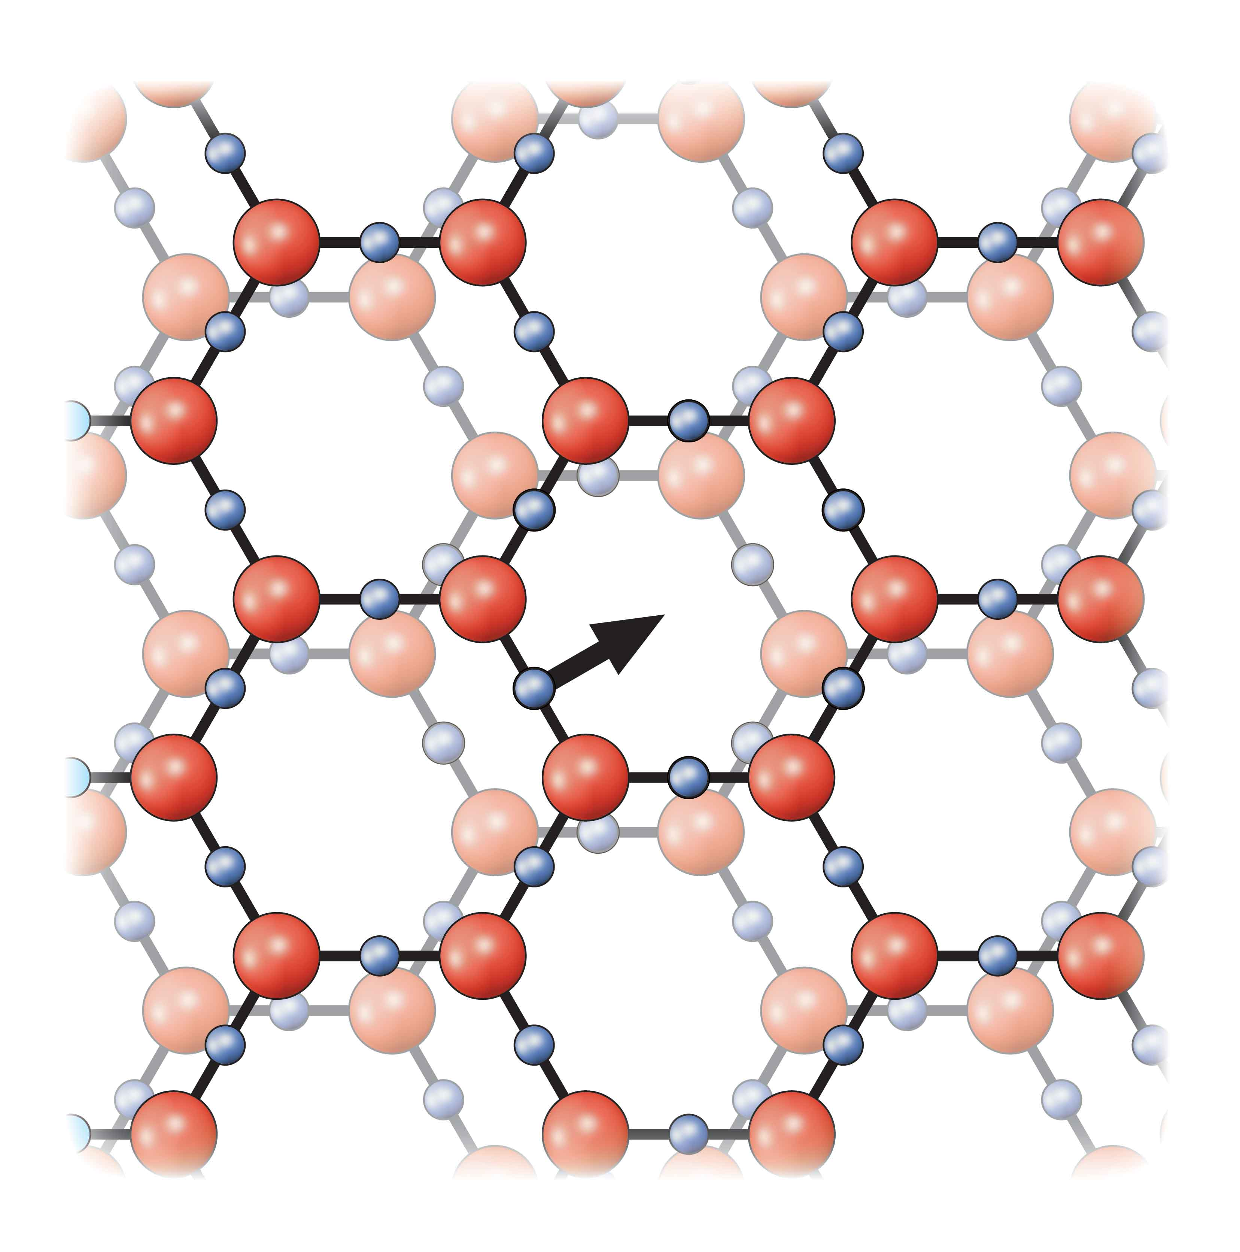
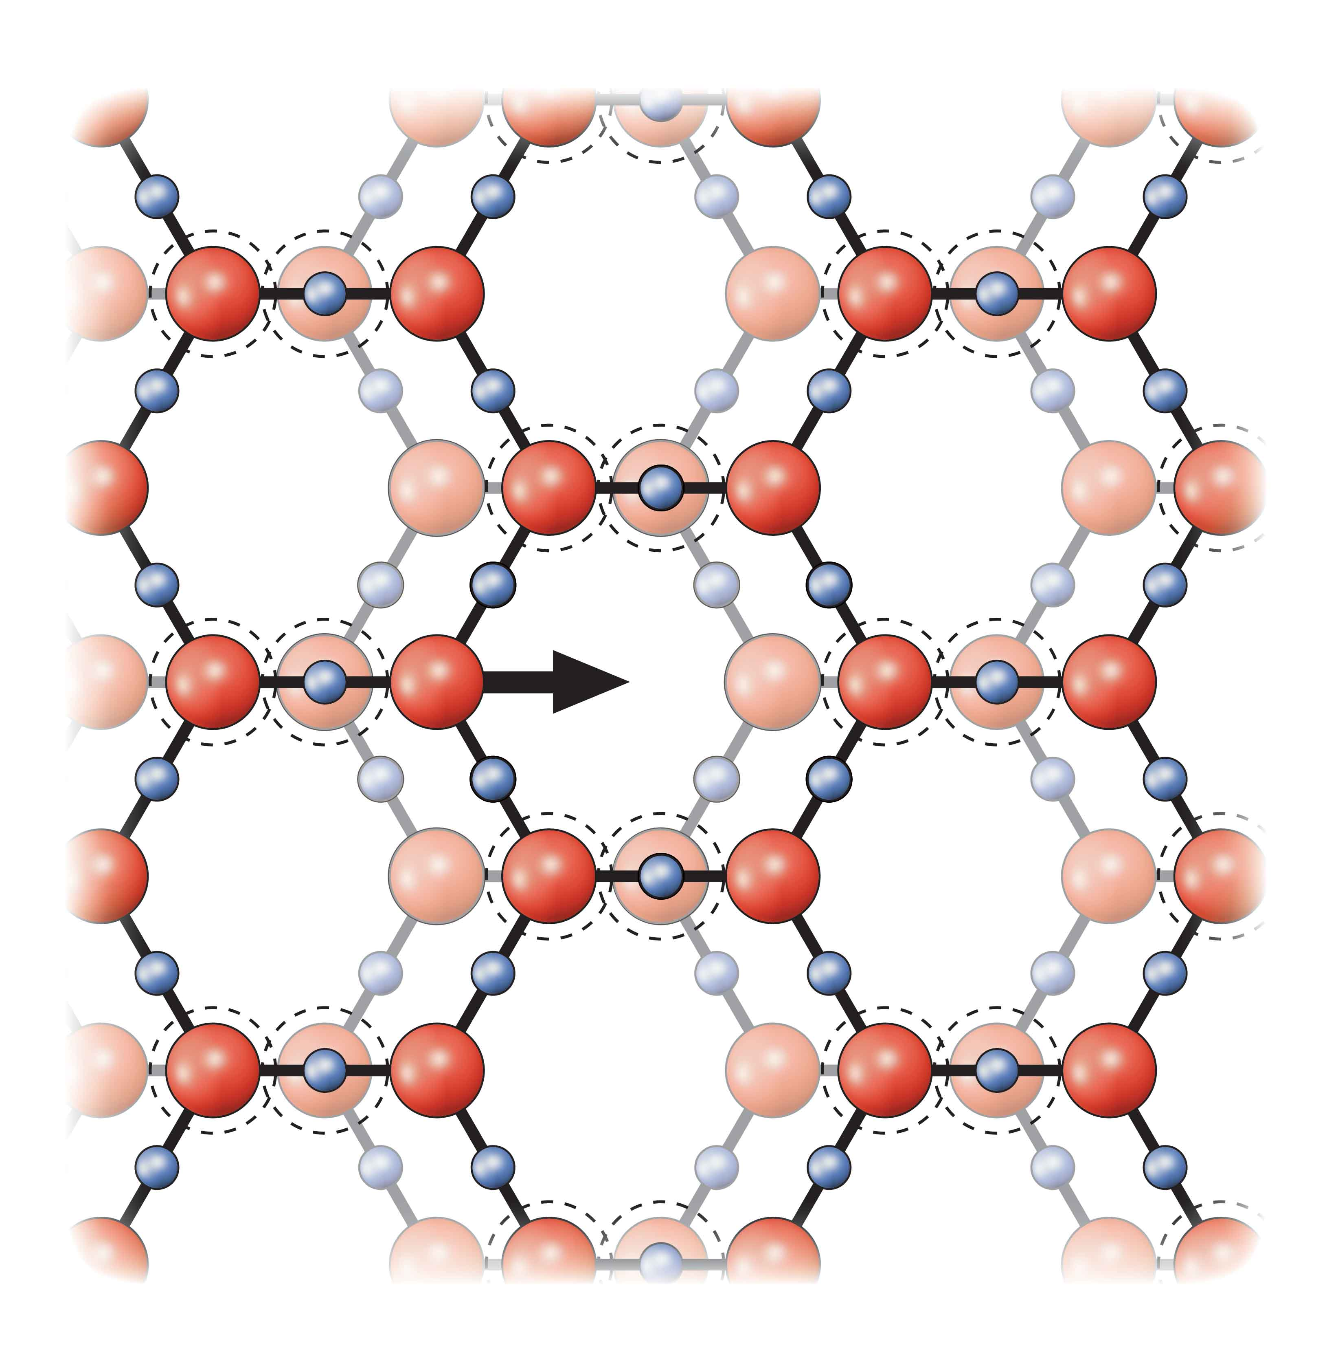
Regular shift is theoretically achievable in either of two ways, but only one of them can do the job (Fig. 4.11). The first involves shift in the direction perpendicular to a hexagonal strut (panel a); the second involves shifting along a line parallel to a strut (panel b). In the first model, no degree of shift leads to any regular apposition of opposite charges, and hence no stickiness. In the second, shifting by half the oxygen-oxygen spacing brings many opposite charges into apposition: one third of all planar charges stick, offering ample potential for cohesion. Repulsions also exist between contiguous planes’ nearby atoms, but computations show that they are insignificant relative to the attractions. The attractive forces win out. So the second model yields a stable structure.
Figure 4.11. Possible plane-stacking arrangements involving linear shifts. Only the shift on the right yields a stable structure with overlapping opposite charges. [LABEL a and b]
Figure 4.10. Shifting one plane relative to another puts opposite charges next to one another, creating attractions. [delete “right shift” and delete arrow]
Variants on the stacking theme lead to interesting entities. For example, successive planes of Figure 4.11b are shifted rightward; but they could just as easily shift leftward. With these options you could build a left-tilted or right-tilted edifice. These variants could perhaps explain the mirror-image molecular constructs mentioned in Chapter 2.
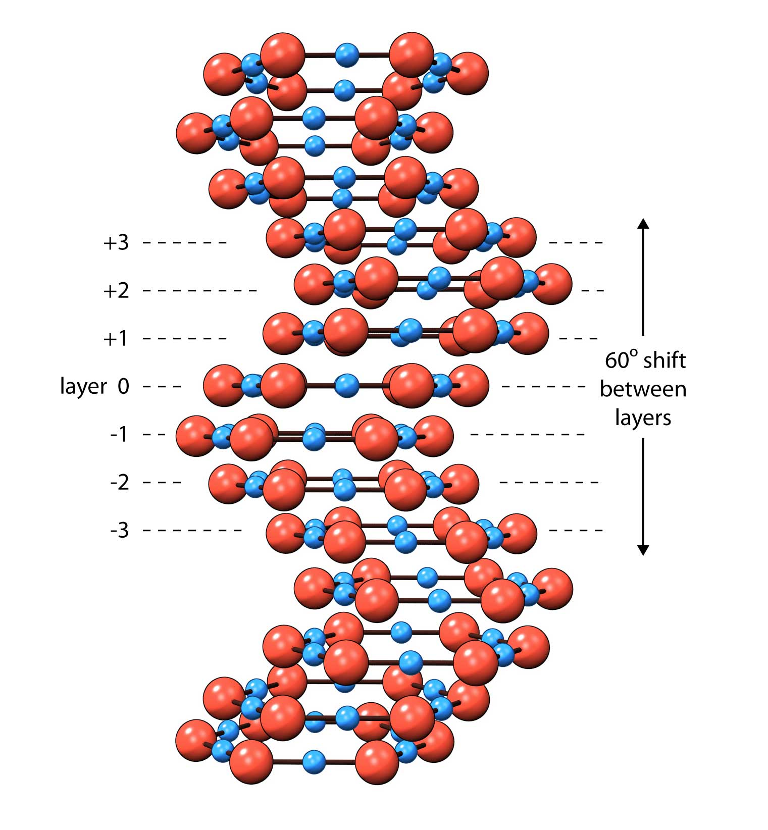
In fact, the shift direction need not be restricted to left - right; it could occur in any of the six strut directions, leading to endless stacking possibilities. For example, we can easily realize helical arrangements (Fig. 4.12): start with a base plane, shift the next plane above in the direction along a strut, the next plane 60° to that, the next an additional 60°, etc. The helical pitch unit would then comprise six planes. Almost any larger pitch is theoretically realizable, even irregular pitches. This feature may be particularly important for biology, where EZ water needs to interface with the numerous helically wound proteins and nucleic acids. The model suffices.
Figure 4.12. Shifting successive planes by 60° yields a helical structure.
In sum, pouring water onto a hydrophilic surface nucleates EZ growth (Fig. 4.13). The EZ honeycomb layers build from this raw material, stacking one upon another. The out-of register stacking creates an ultra-tight lattice through which few substances can penetrate; hence, solutes are massively excluded.
The Initial Layer
How does the construction process begin? Although this issue is largely unstudied, some conjectures are possible. Hydrophilic surfaces generally contain oxygen atoms, and a possibility is that surface-oxygen molecules form a template. If enough oxygens match the hexagonal pattern of the EZ sheet, then the template itself could be thought of as the initial layer. Additional EZ layers would then build onto that template layer.
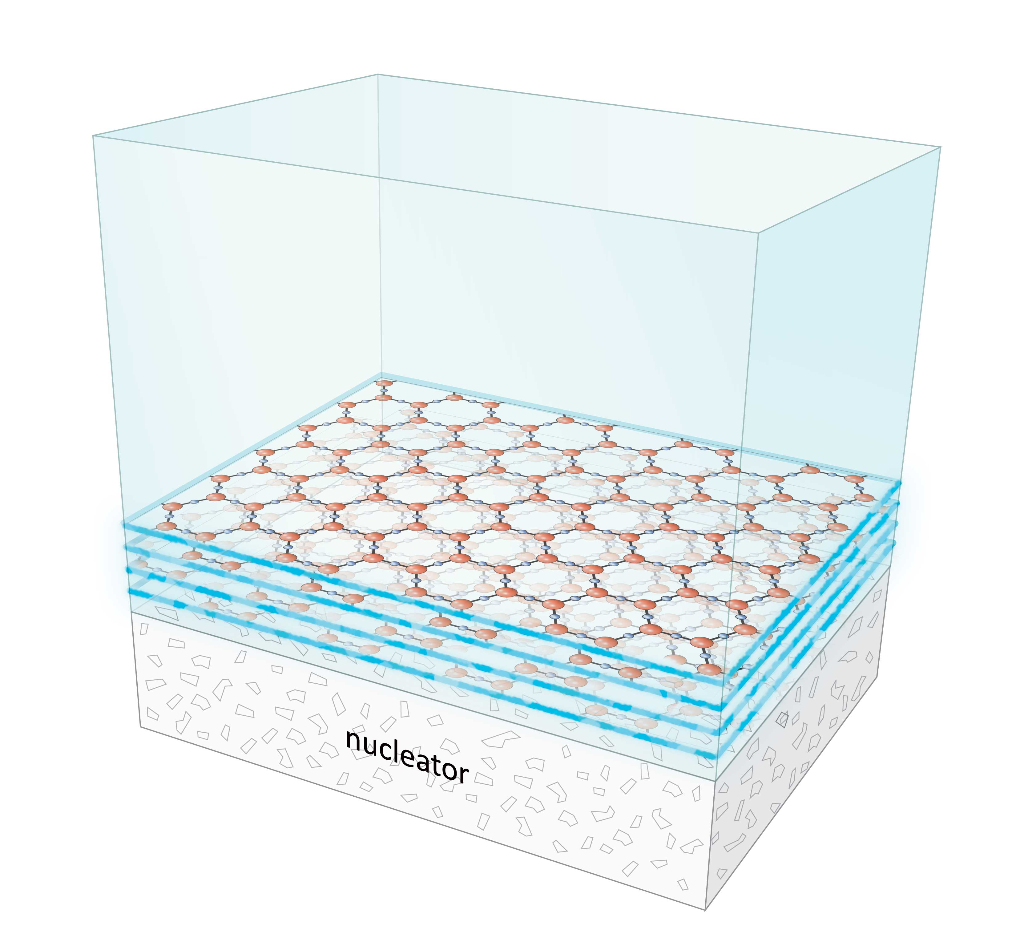
Of course no surface provides a perfect match. Different surfaces have different atomic arrangements; and, different negatively charged atoms sometimes replace oxygen. Some surfaces might therefore be less adept at nucleating EZ layers; they would be considered less hydrophilic.
A subtle implication is that the nucleator imparts information to the EZ layers. A patch of missing oxygens on the template, for example, implies a corresponding miss on the first EZ layer, and so on. The missing patch could project through many layers. If so, then the EZ would contain information about the nature of the nucleating surface. To the extent that the EZ is stable over time, that information could be retained.
Another implication is that for EZ growth nucleation, all that’s needed is the template, i.e., a single molecular layer. Nucleator thickness is irrelevant. That explains why EZs can grow even from single monolayers (Fig. 3.7).
Figure 4.13. Buildup of honeycomb planes from bulk water. Hydrophilic surface nucleates EZ growth, which progresses layer by layer.
Materials that contain no surface charges, or offer no match to the standard honeycomb pattern, should have little or no capacity to template EZ growth. Such surfaces would be classified as hydrophobic, or water hating. They fail to draw water molecules tightly to their surfaces to nucleate EZ construction. Charged surfaces, on the other hand, should be fully capable; they easily nucleate EZ growth.
Limits to EZ Growth
Here’s a problem. The electrical potential is not constant from layer to layer; it falls off with distance from the nucleating surface (Fig. 4.6). This is an issue because identical EZ planes should yield identical electrical potentials; the potential distribution should be uniform. To account for the observed falloff of potential, the planar charge must diminish with distance from the nucleating surface.
The simplest way of realizing this diminishing charge is by eliminating oxygen atoms; the more oxygen atoms removed from a plane, the less the overall negativity. Figure 4.14 shows that limited removal is tolerable: so long as the number of removed oxygens is not excessive, the planar lattice can still hang together. Even removing every other oxygen does not necessarily compromise the lattice, bearing in mind that contacts with the planes above and below promote stability.
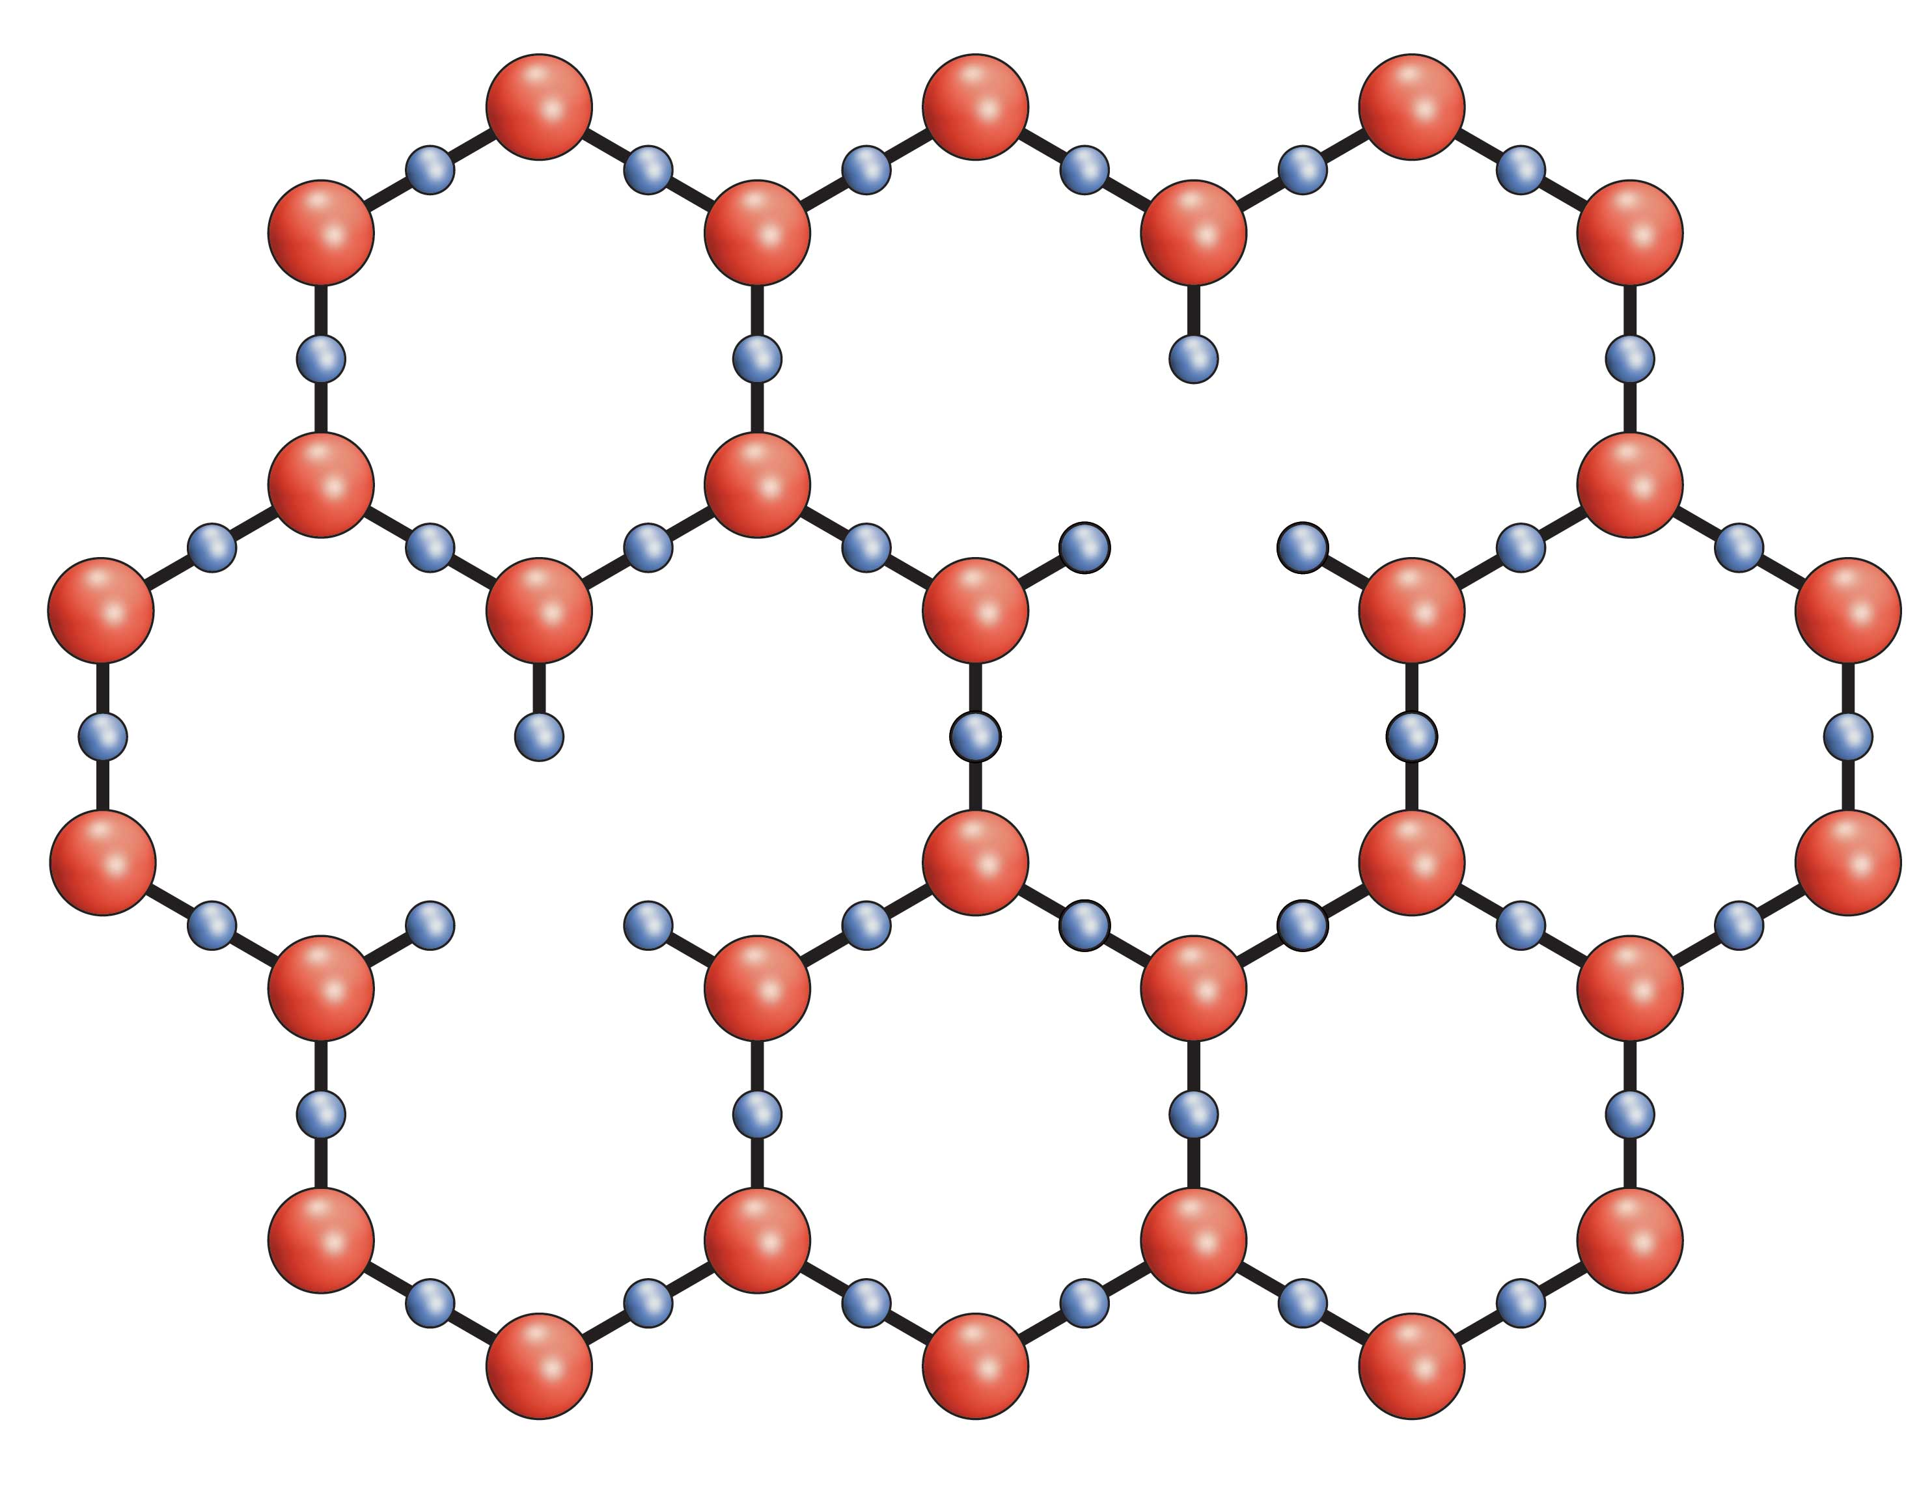
Hence, a mechanism is available for realizing the decreasing negative potential. The oxygen “defects” would increase with distance from the nucleating surface, making more distant planes less negative. These distant planes should nevertheless retain some semblance of hexagonal character.
Essentially, we have arrived at the second of the proposed Lippincott structures that seemed to fit the evidence: similar to the first (Fig. 4.8) but less regular. The two models are effectively extremes of a continuum: highest regularity near the nucleating surface, and lowest regularity farthest from that surface. The decreasing regularity explains the decreasing electrical potential.
Figure 4.14. Diminishing planar charge. The example shows how oxygen atoms can be removed from the hexagonal lattice without impairing structural integrity.
A way of realizing the progressive oxygen loss is through erosion. The negativity of the lattice strongly motivates positively charged ions such as hydroniums to penetrate; they can hardly resist the draw. The tightness of the EZ lattice ordinarily prevents their entry; however, openings such as those schematized in Figure 4.14 create possible invasion points. Alternatively, protons breaking free from the hydronium ions could penetrate through the center of the hexagonal ring. Either way, the penetrating positive ions would then locally neutralize the negative lattice. In fact, if those hydronium ions combine with lattice oxygens, they would form water, effectively eroding the lattice at distal points and inserting water molecules in their place.
The extent to which erosion takes place could determine exclusion-zone size. For extremely hydrophilic surfaces with few defects, erosion should be limited; for less hydrophilic surfaces with more defects, positive ions can enter more easily, erode the lattice, and compromise EZ size. This may explain why less hydrophilic materials generate smaller exclusion zones.
The presence of lattice defects is reminiscent of semiconductors, where crystal-lattice defects lead to structures with excess electrons or excess holes, referred to respectively as n-type or p-type. The structure we are contemplating is more like the n-type, with excess electrons borne by oxygen atoms. Thus, some semiconductor-like features are anticipated, and in due course we will see that such features are present. For now, the message is that the lattice defects provide a mechanism for governing EZ size.
Positively Charged Exclusion Zones?
The attentive reader may have spotted a curious anomaly in the section above. Plucking a few oxygens from the lattice certainly diminishes negativity; the more you eliminate, the less negative becomes the lattice. In fact, plucking every other oxygen would shift the net charge beyond zero, all the way to positive. You can go through the exercise yourself and verify that the net positive charge per hexagonal unit would be +1, compared to -1 for the standard lattice.
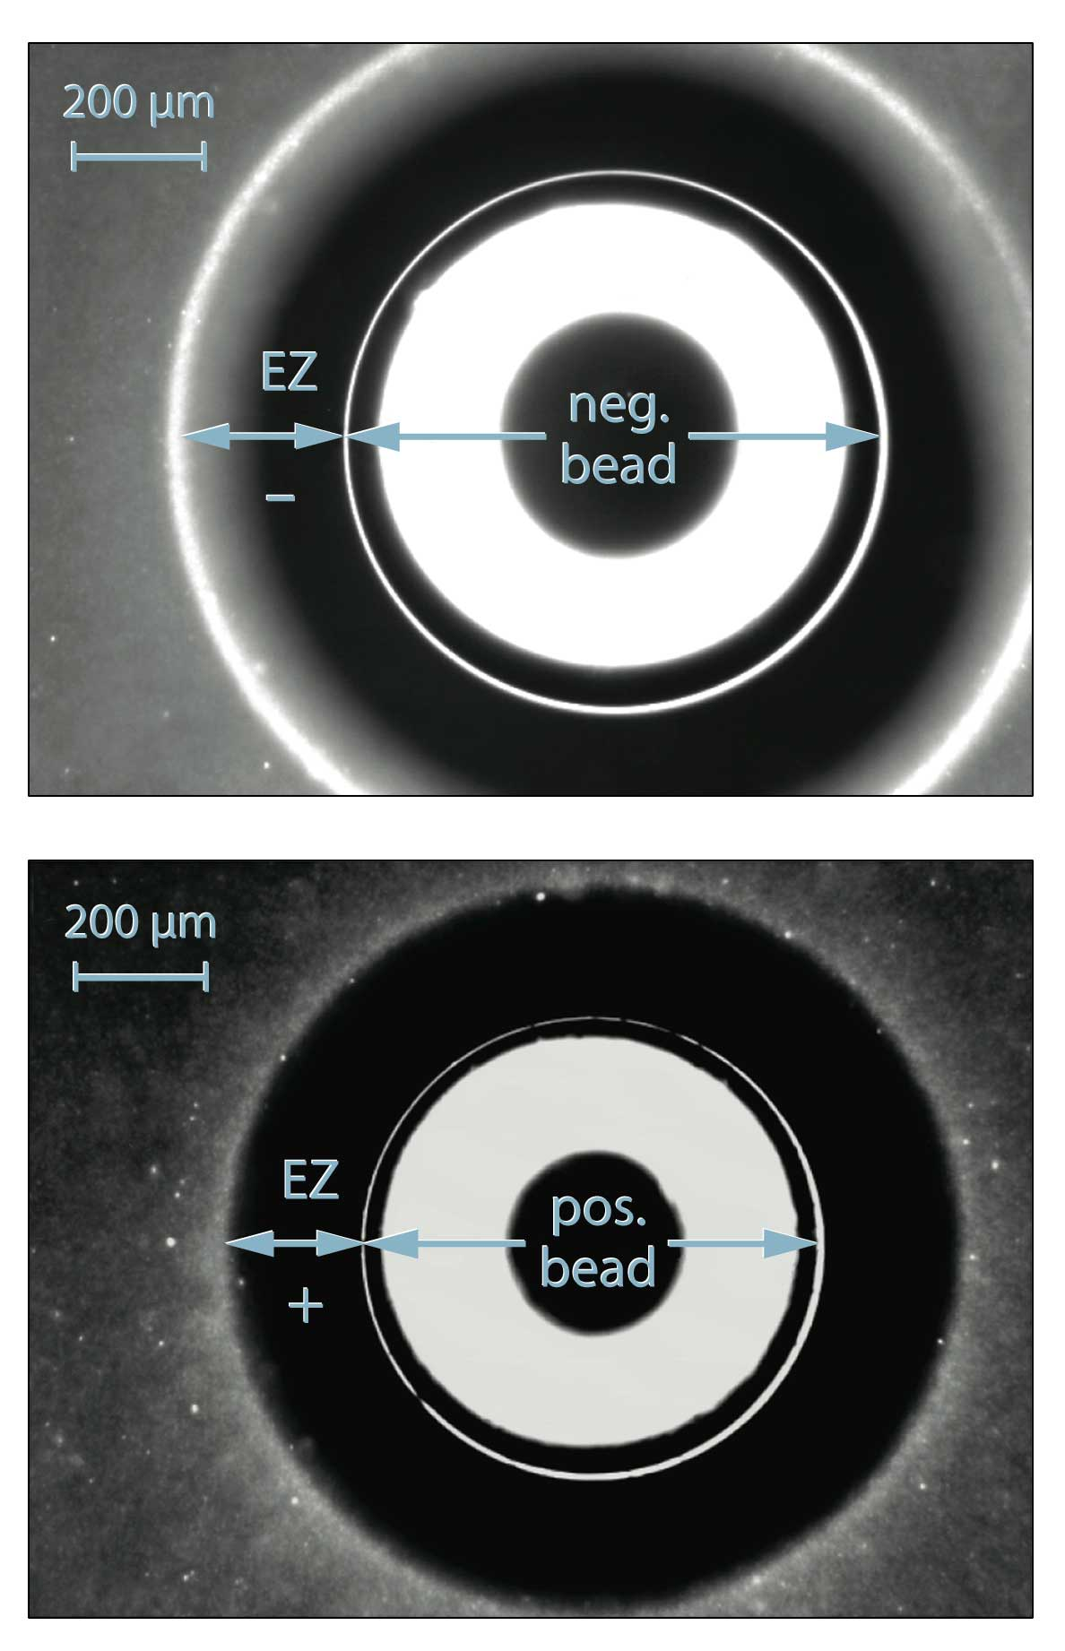
At first blush, this feature seems curious, as it implies the possible existence of positively charged exclusion zones; so far, we have mentioned only negative ones. Yet, if the proposed honeycomb-layer framework is adequate, we might expect to find positively charged exclusion zones as well; their structural framework would remain the same except that they would have far fewer oxygen atoms.
And, indeed, such positive zones exist, although they are less common than the negative ones. We could find them next to certain polymers and metals. An example is the exclusion zone next to an ion-exchange gel bead. Commonly used for physical separations, these half-millimeter beads come in two varieties: anionic and cationic. Both types show exclusion zones (Figure 4.15), but the EZ next to cationic beads have positive charge.
Figure 4.15. Exclusion zones (EZ) surround both negatively charged and positively charged beads.
Evidence for positive charge is shown in Figure 4.16. The figure demonstrates that the electrical potential distributions next to the cationic and anionic beads are practically mirror images of one another. One is the standard negative type, whereas the other shows a correspondingly positive potential. The regions outside the positive exclusion zones show higher pH instead of the usual lower pH seen with the negative EZs.
Thus, the positive exclusion zones seem more-or-less the inverse of the negatively charged ones. Both potential distributions are theoretically realizable through variation of the number of planar oxygen atoms with distance, possibly through the encroachment of oppositely charged ions.
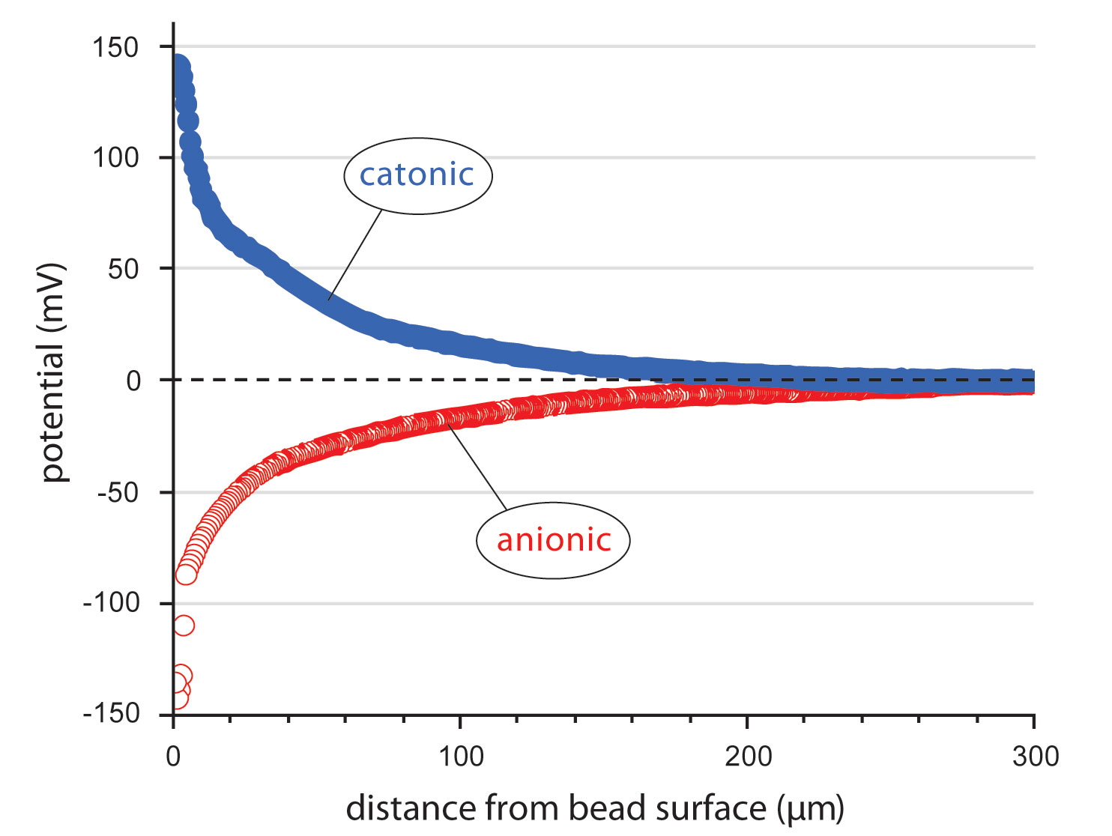
If many missing oxygens account for the positive EZs, then you might expect the positive ones to be relatively more fragile, for the lattice is weaker. Fragility is confirmed. Positive EZs are quirkier excluders, which can break up relatively easily with minor mechanical perturbation. As a result, colleagues in the laboratory hesitate to study them; nevertheless, they do exist.
The proposed structural framework is evidently versatile enough to accommodate both types of exclusion zones, negatively charged and positively charged. Separate structures are not needed. This is an appealing attribute in terms of nature’s anticipated simplicity.
Figure 4.16. Electrical potentials recorded next to cationic and anionic beads.
A Fourth Phase of Water and Why Some Chemists Suffer Apoplectic Fits
In reflecting on this structural model, we cannot overestimate the significance of one feature: the similarity to ice. On the other hand, the EZ structure is most definitely not ice; nor is it water. It is a unique species different from ice or water. Thus, if we consider ice as a “phase” of water, then it is reasonable to consider the EZ as another of water’s phases — perhaps the long sought “fourth phase” of water suggested a century ago by the physical chemist Sir William Hardy.
To qualify as a phase (sometimes referred to as a “state”), the structure should not only be unique, but also it should be spatially bounded and it should exist in some quantity. These features are evidently true for water’s three classical states, and they are also true for the EZ substance, for exclusion zones are bounded, and they can sometimes project to as much as a full meter (see Fig. 3.5). They can also occupy large regions within colloidal crystals (see Chapter 8). Hence, the EZ would seem extensive enough to qualify.
On the other hand, alluding to the EZ’s extensiveness can occasionally throw otherwise sober chemists into fits. How could any structure built of water molecules extend millions of layers from the nucleating surface? Educated to think that the disruptive effects of thermal (Brownian) motion will limit ordering to a few molecular layers at most, some chemists are prone to view the concept of long-range order as a nonstarter; it simply cannot happen.
However, we are not proposing a structure composed of stacked water dipoles, but stacked planes. Chemists might view a stack of dipoles as similar to a stack of bricks, made wobbly by the disruptive effects of thermal motion (Fig. 4.18, left). These disruptive effects are additive, so the stack cannot grow very high before faltering. We are instead positing a stack of planes (Fig. 4.18, right). Each plane is extensive, and we know that the more extensive the structure, the lower the thermal agitation. So the disruptive effects should be far less pronounced than in the stacked dipole model. One might therefore hope that this planar model would prove less likely to provoke chemists into reflexive fits of outrage.
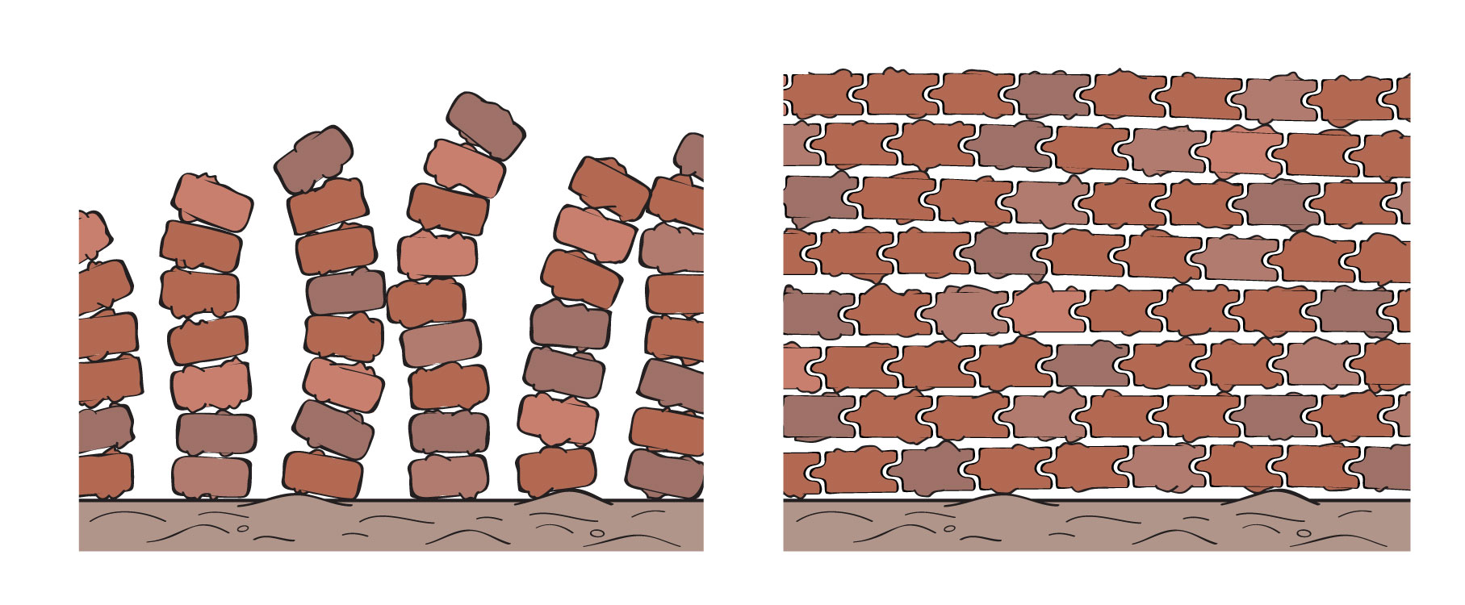
In an altogether different vein, this structural model also helps us appreciate why gels retain water (Fig. 1.1). Even gels whose water content amounts to 99.9% of total mass can hold their water. The reason? Inside the gel, numerous hydrophilic surfaces of the solid matrix extensively order the contiguous water, converting it to EZ. The EZ planes stick to the nucleating surfaces as well as to one another; hence, your gelatin dessert remains deliciously hydrated.
Figure 4.18. Stacked dipole model leads to wobbling and disorder (left); however, disorder is minimized when elements are interconnected to form extensive planar structures (right).
Finally, the proposed structure makes clear why exclusion zones exclude. They exclude because the only way solutes can enter is through the hexagonal openings, and those openings are small. The impediment is even more formidable than just those openings: Because successive planes are out of register, the columns through which the solutes would need to pass are narrower than the hexagonal openings themselves (Fig. 4.13). The lattice is extremely tight, and therefore highly exclusive.
Only protons would seem small enough to penetrate through those narrow openings. Later (Chapter 16) we will see how proton penetration may be critical to the formation of ice. Perhaps you can surmise how this might work by noting the subtle differences between EZ and ice structures. On the other hand, protons ordinarily don’t exist as distinct entities; they stick to water molecules to form hydronium ions, which are much bulkier than protons and hence excluded.
It appears that all solutes are excluded — at least from the full lattice in which oxygen-defect openings are few or absent. Because positive ions are excluded from the negative lattice, the electrical potential difference is sustained. That’s why we can measure a sustained potential difference. The charge separation persists because the tight lattice excludes even opposite charges.
---
The charge separation between the EZ and the zone beyond will impact much of what follows. The separation constitutes a battery, whose character will be pivotal for practically all phenomena involving water.

Summary
In formulating a structural model of the exclusion-zone material, we first considered stacked dipoles. While simple, logical, and historically grounded, dipoles remain stubbornly neutral; they cannot account for the exclusion zone’s net charge. Hence, the dipole model failed. We found the sheet model more promising, with its honeycomb patterns out of register with one another. This model could account for the EZ’s net charge; and, it had the advantage of precedent because of its similarity to ice.
In this stacked sheet model, local charge depends on the density of electronegative oxygen atoms. Thus, local electrical potential can range from extremely negative to zero, and all the way to the positive values characteristic of some exclusion zones. The basic structural framework is versatile enough to account for all types of exclusion zone.
Exclusion zones seem both extensive enough and distinct enough from bulk water to qualify as a separate phase. This fourth phase is only beginning to be recognized. Its elucidation holds promise of finally leading the way to the long-sought understanding of practically everything that water touches.

References Chapter 4
Felix Franks, Polywater, MIT Press, 1981.
Ling, G.N., (2003). A new theoretical foundation for the polarized-oriented multilayer theory of cell water and for inanimate systems demonstrating long-range dynamic structureing of water molecules. Physiol. Chem Phys. & Med. NMR. 35: 91-130.
Roy, R., Tiller, W. A., Bell, I., and Hoover, M. R. (2005). The structure of liquid water; novel insights from materials research; potential relevance to homeopathy. Mat. Res. Innovat. 9-4 93-124 1066-7857.
Ling, GN (1992). A Revolution in the Physiology of the Living Cell. Krieger Publ. Co, Malabar FL.
Chatzidimitriou-Dreismann CA, Abdul Redah T, Streffer RMF and Mayers J. (1997). Anomalous Deep Inelastic Neutron Scattering from Liquid H₂O-D₂O: Evidence of Nuclear Quantum Entanglement. Phys Rev Lett. 79(15): 2839 – 2842.
Henderson MA (2002). The interaction of water with solid surfaces: Fundamental aspects revisited. Surface Science Reports 46: 1- 308.
McGeoch JEM and McGeoch MW (2008) Entrapment of water by subunit c of ATP synthase. Interface (Roy. Soc.) 5(20): 311 – 3XX.
Ji N, Ostroverkhov V, Tian CS, Shen YR (2008). Characterization of Vibrational Resonances of Water-Vapor Interfaces by Phase-Sensitive Sum-Frequency Spectroscopy, Phys Rev Lett 100, 096102.
Lippincott et al Science 1969
Michaelides A and Morgenstern K (2007). TITLE Nature Mater. 597 – XXXX.
Pollack GH (2001) Cells, Gels and the Engines of Life. Ebner and Sons, Seattle.
Xu, K, Cao P, and Heath JR (2010). Graphene Visualizes the First
Water Adlayers on Mica at Ambient Conditions. Science 329: 1188 – 1191.
Web reference 4.1 <http://www.aip.org/enews/physnews/2003/split/648-1.html>

MENTION: (MODEL AGREES WITH HIGHER DENSITY OF EZ, MENTIONED IN PREVIOUS CHAPTER)

