SECTION I
WATER RIDDLES: FORGING THE PATHWAY
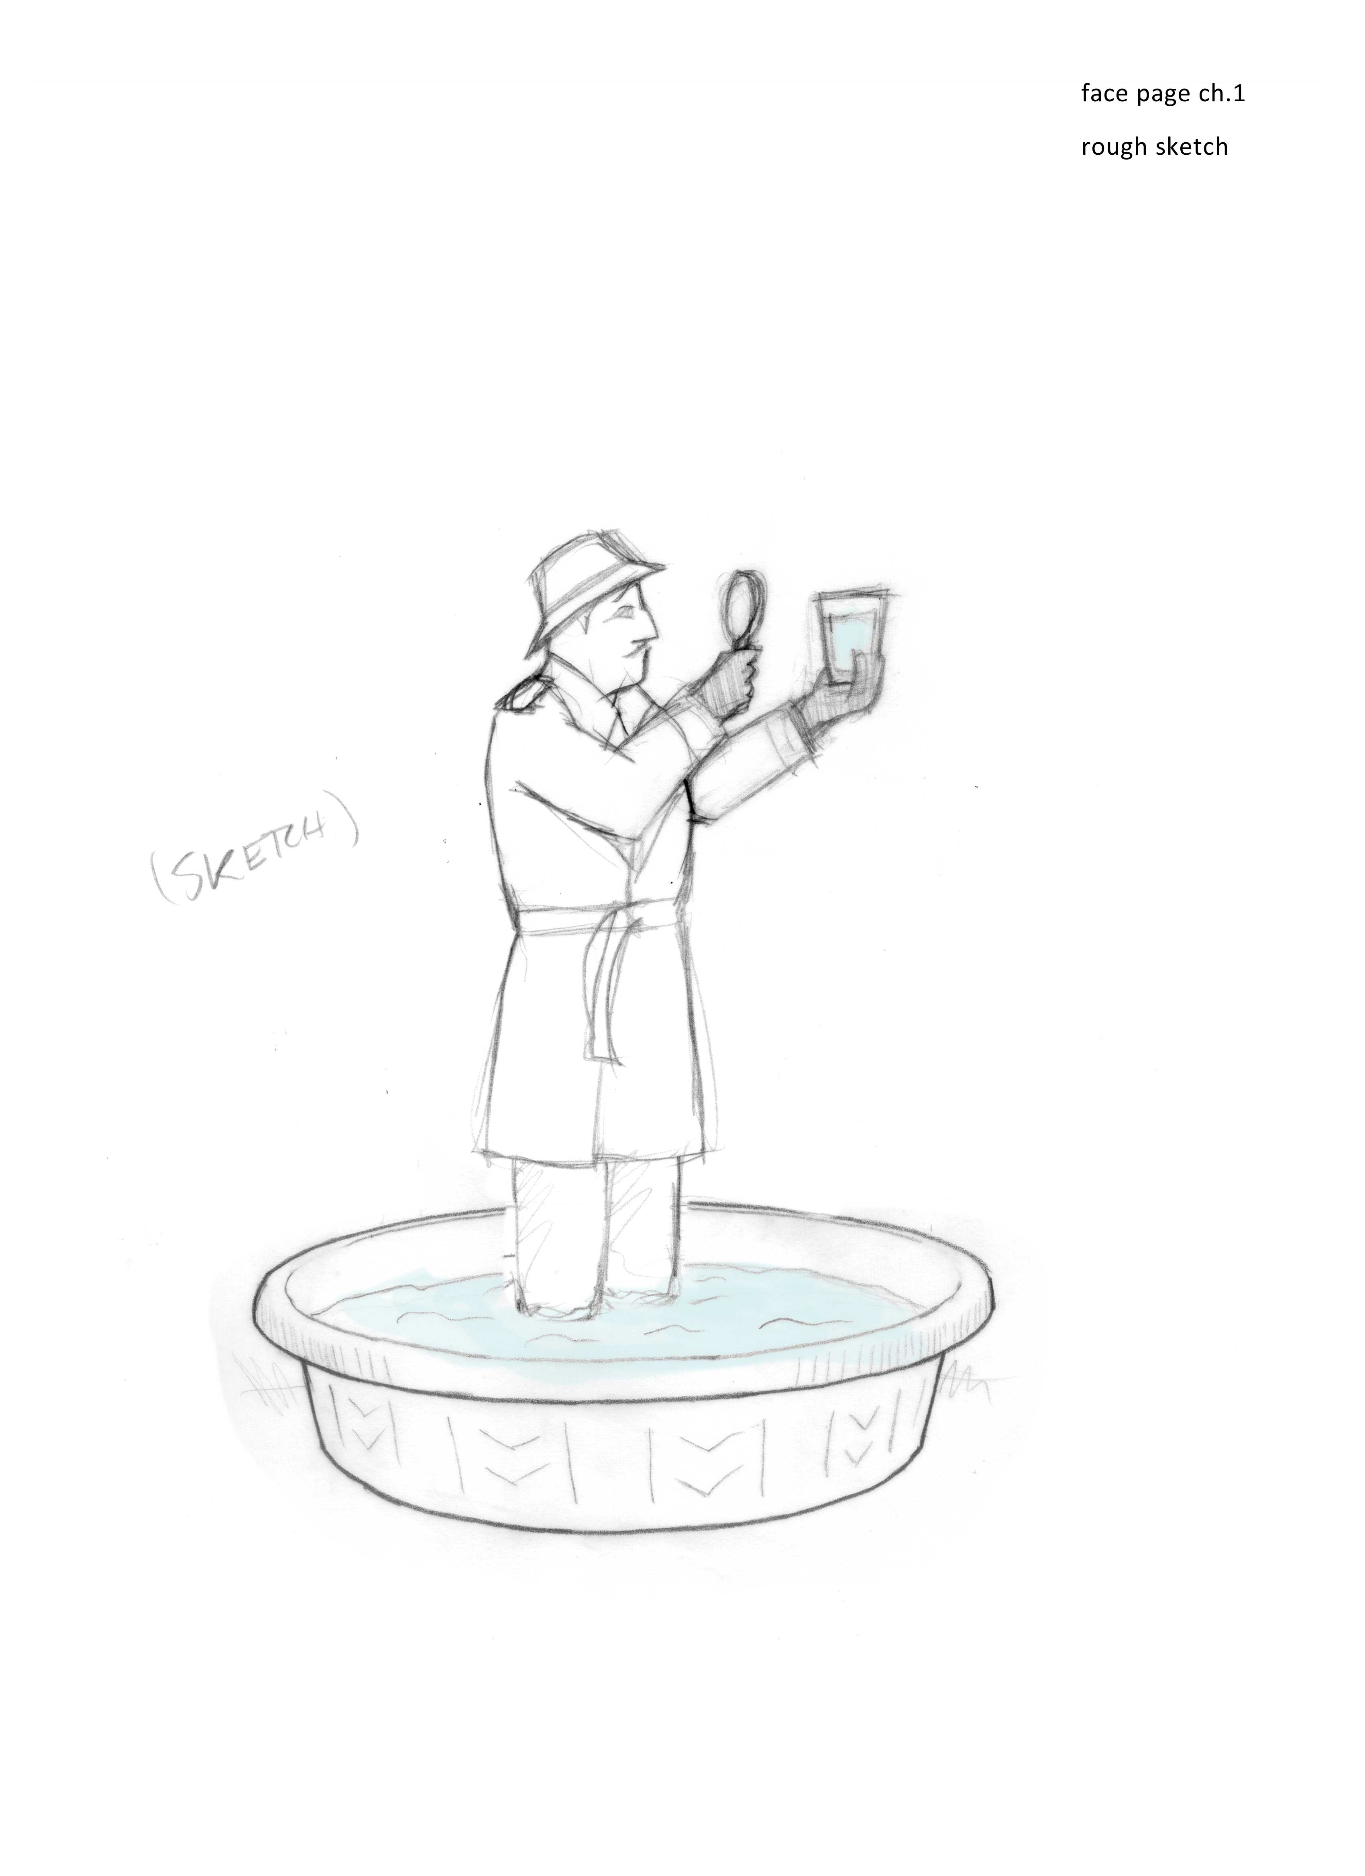
Chapter 1
Surrounded by Mysteries

Beaker in hand, two students ran down the hall to show me something unexpected. But I was preoccupied. By the time I could take a look, the phenomenon had vanished. Yet it was no fluke. When the phenomenon appeared again the next day, it became clear why the students had reacted with such excitement: they had witnessed a feature of water that defied explanation.
I’ll describe their observation in a few moments — along with others that collectively demonstrate how little we understand about the planet’s most ubiquitous substance. Water covers much of the earth. It also pervades the skies, and it fills our cells. In fact, the diminutive size of the molecule means that it takes very many of them to fill our cell’s two-thirds volume fraction; more than 99% of our molecules are H₂O.
Despite their huge number, do we really understand how they behave?
To test our understanding I will present a collection of every-day scenarios and challenge you to explain them. If you can, then you needn’t read much further — you could more profitably spend your time writing your own book on water. If the explanations are elusive, and you find no rescue from accessible sources, then please view the scenarios as more than just unexplainable curiosities. They contain important clues that we will use as foundations for building understanding.
I’ll begin with familiar observations that might befuddle you. I’ll then move on to a few laboratory-based oddities, which may at first seem like parlor tricks designed to amuse, but have been confirmed again and again by scientists, and hold important clues for understanding. Let’s see how you fare.
Everyday Mysteries
Here are fifteen common observations that demand explanation:

• Wet sand vs. dry sand. When stepping into dry sand you sink deeply, but the wet sand near the water’s edge is firm: you hardly sink at all. In fact, wet sand is so firm that you can use it for building sturdy castles that protect from invading flotillas. How does water glue together those sand particles? See Chapter 8.
• Wet glass plates. Glass plates positioned face-to-face require no effort to pull apart, but separating wet plates can require a pair of horses. Why? See Chapter X.
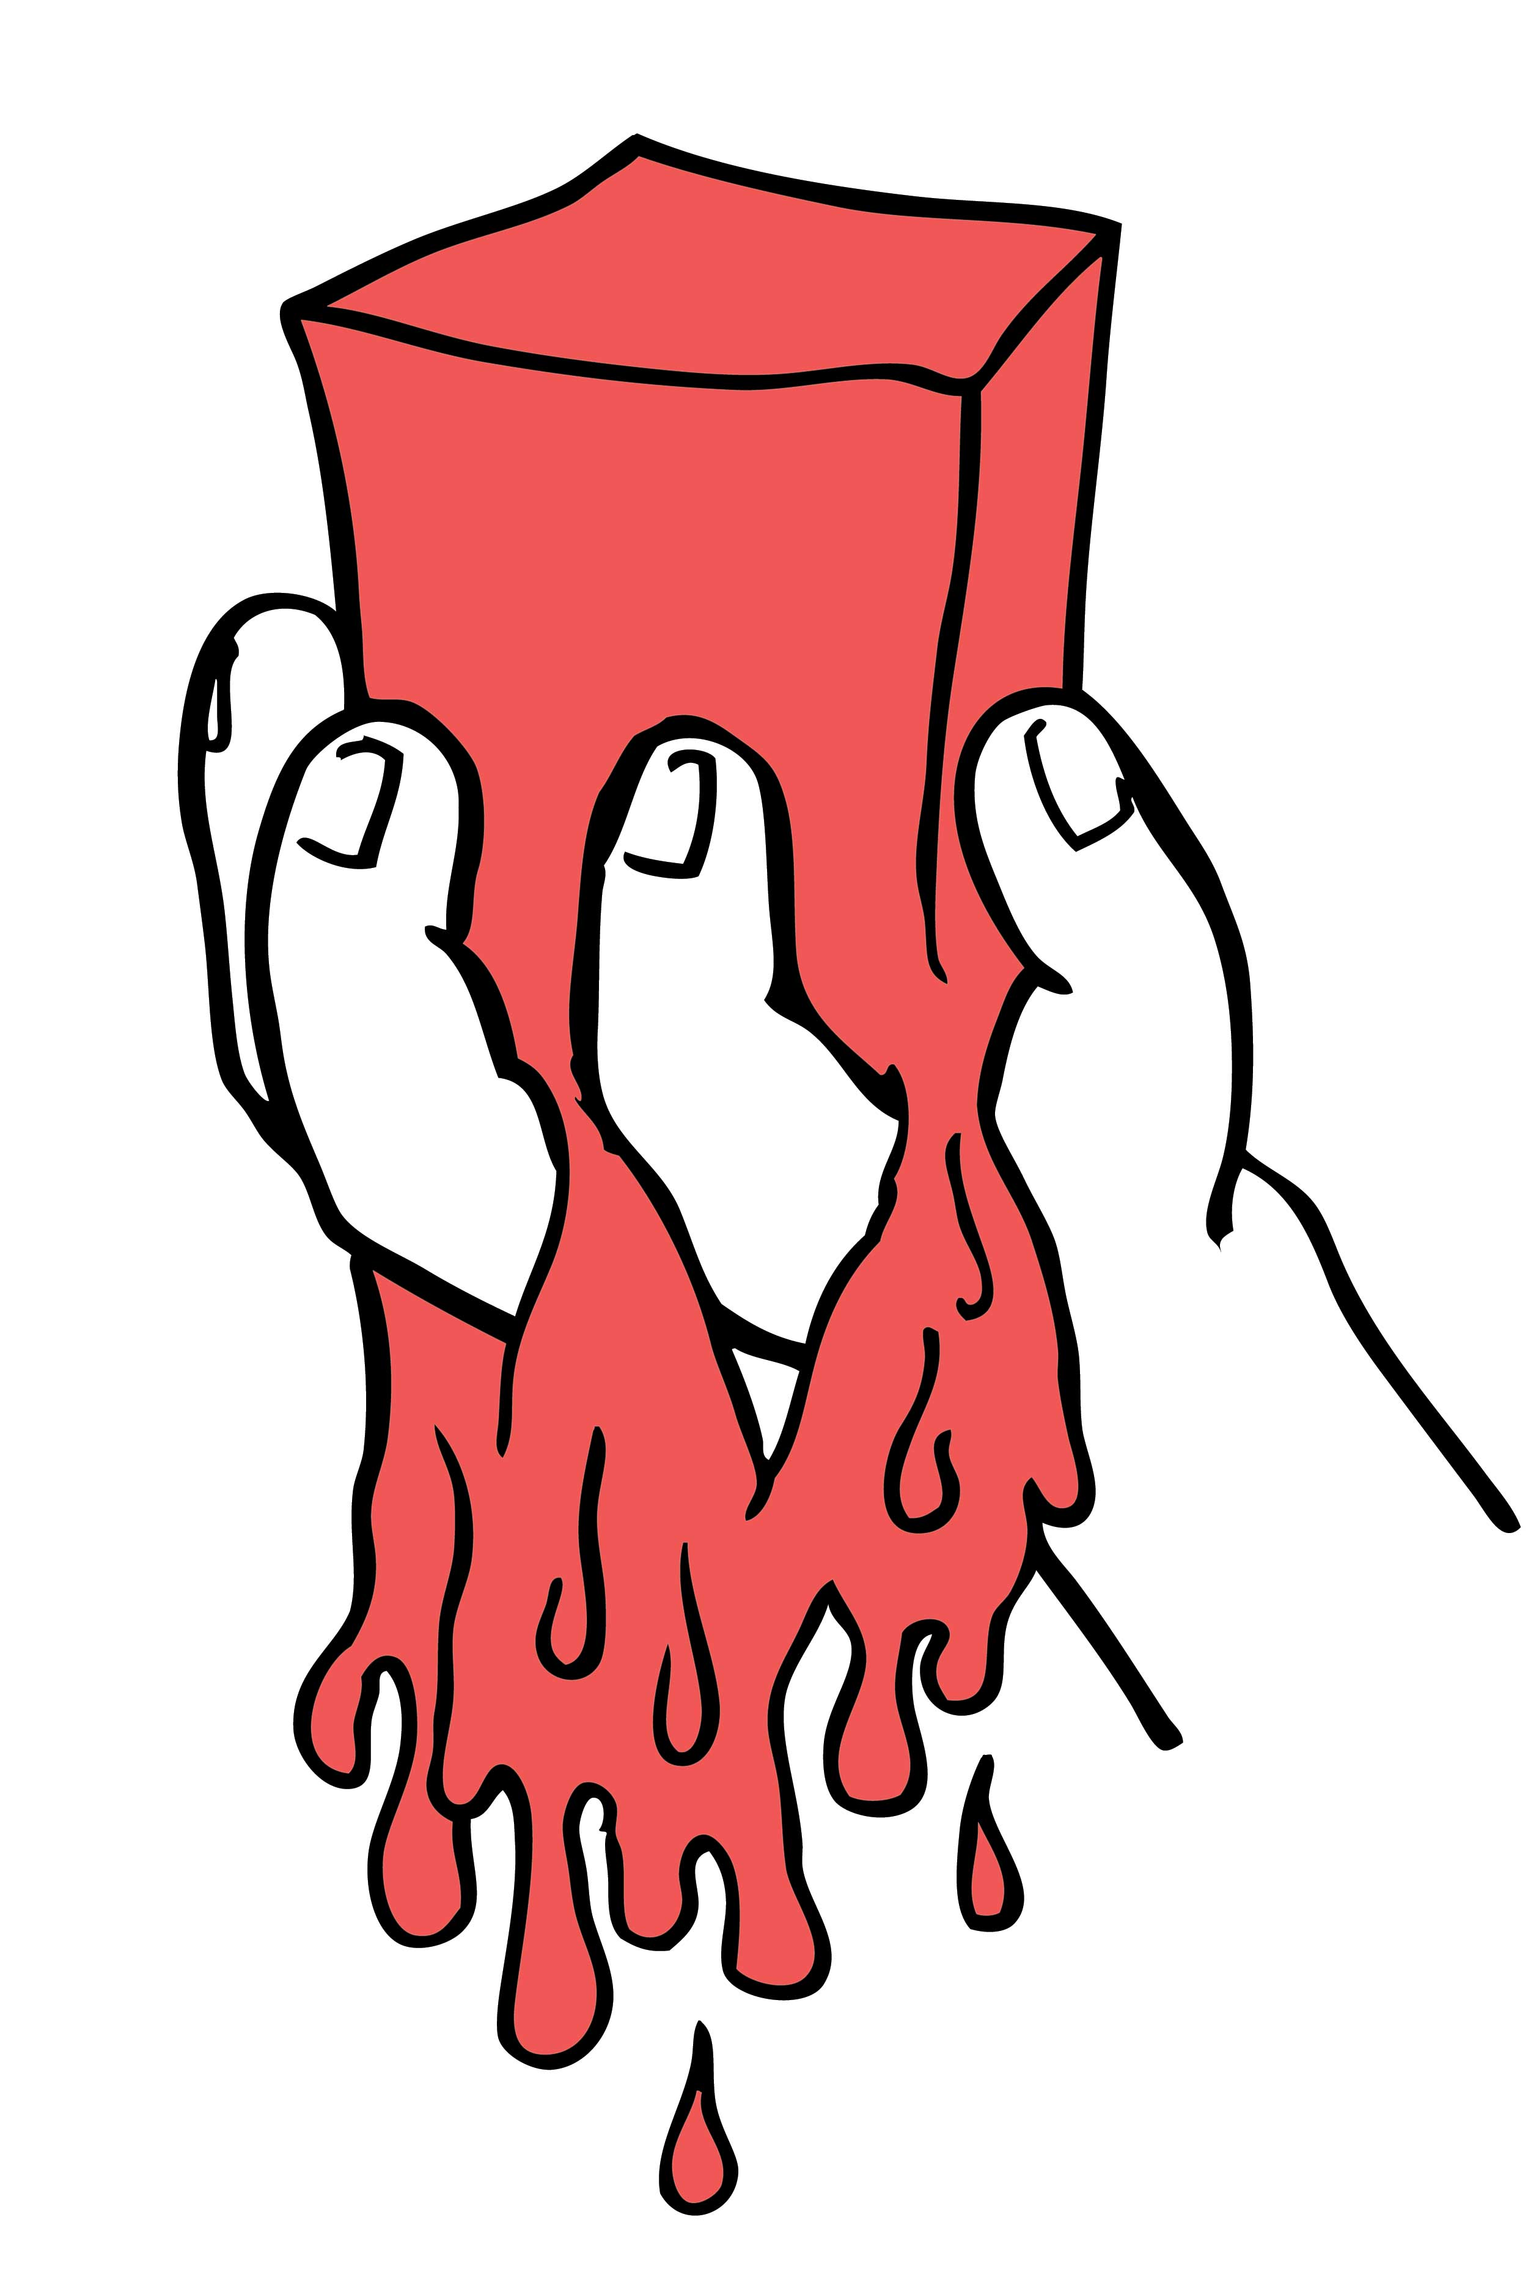
• Gelatin desserts. Gelatin desserts comprise 95% water. The question is why all that water doesn’t just dribble out. In fact, there is no dribbling, even from gels whose water content is 99.9% (Osada and Gong, 1993). That’s practically all water, with only a bare trace of solids. Why doesn’t all that water leak out (Fig. 1.1)? Please see Chapter 4.
• Slipperiness of ice. Solid materials don’t easily slide past one another — think of your shoes planted on a hilly street. Friction keeps you from sliding. Yet, if the hill is icy, then great care must be exercised to keep you from falling on your face. Why does ice behave so differently from ordinary solids? Why is it slippery? See Chapter X.
• Shower curtains. When the shower is turned on, the curtain often draws inward. This inward pull is commonly ascribed to the Bernoulli effect: the lowering of pressure within the curtained zone arising from the fast flow. However, that explanation leaves a collateral phenomenon unexplained: the curtain sticks to your wet legs. What feature of the shower spray explains both the inward pull and the curtain’s stickiness? Please see Chapter X.
Figure 1.1. What keeps the water from dribbling out of the Jell-O?
• Leftovers. Grandma’s homemade food often tastes delicious. However, the leftovers sometimes taste even better. It doesn’t matter whether it’s bean soup or beef stew — most food tastes better when reheated a day later. The foods’ common ingredient is water. Is some time-dependent feature of the water responsible for the improved taste? See Chapter X.
• Freezing warm water. In his middle-school cooking class, a precocious African student named Erasto Mpemba observed something odd. He found that adding warm water to his powdered ice-cream mix produced his frozen dessert faster than when he added cold water. This paradox has become famously known as the “Mpemba effect.” How is it that warm water can freeze more rapidly than cold water? Please see Chapter X.
• Breaking concrete. Perhaps you’ve noticed concrete sidewalks cracked by upwelling tree roots. How is it possible that plant roots can build enough pressure to crack slabs of concrete? See Chapter X.
• Rising water. Drawn from the tree’s roots, water flows upward through narrow channels. It quenches the leaves’ thirst. To draw the water upward, the top of the column supposedly exerts an upward force. But the column of water can be pretty heavy, especially those of 100-meter-tall Redwood trees. The columns should therefore break, like strings carrying too-heavy weights. That’s a problem: once a column breaks it can no longer draw from the roots. How does nature avert this debacle? See Chapter X.
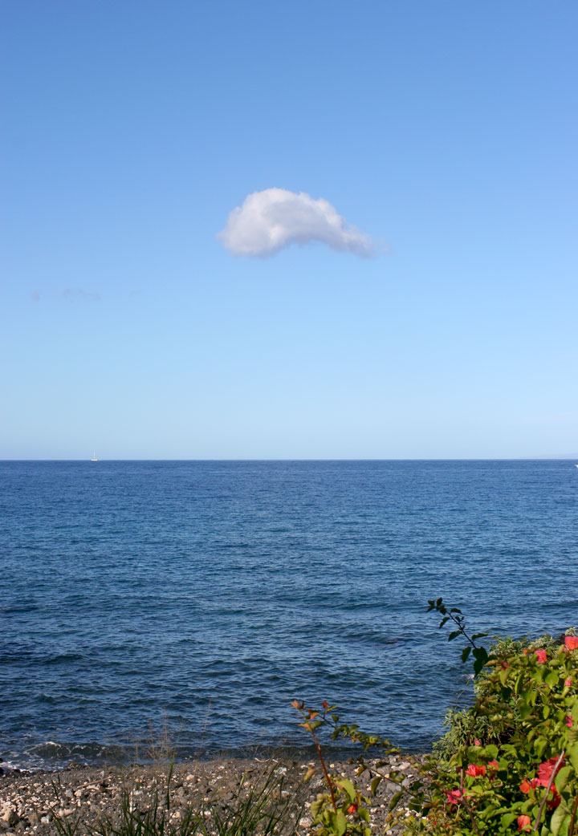
• Walking on water. Perhaps you’ve seen videos of the “Jesus Christ” lizard walking on the pond’s surface. It scampers across from one end to the other. What is it about the water (or about the lizards) that makes possible this seemingly biblical feat? Please see Chapter X.
• Isolated puffy white clouds. From vast uninterrupted reaches of the ocean’s water, vapor rises toward the sky. The vapor is everywhere. Yet clouds will often form as localized entities, punctuating the otherwise clear sky (Fig. 1.2). What force directs the rising water vapor towards those specific sites? Please see Chapter 8.
• Drying on clotheslines. If you urgently need clean underwear, you might hang your wet laundry in a place that’s sunny. Laundry dries faster that way. Why should the sun’s rays so dramatically enhance evaporation, even if the sunny area isn’t much warmer? See Chapter X.
• Ice floats. Most substances expand when heated, and contract when cooled. Water does the same. However, once the water has cooled enough to turn to ice it greatly expands. That’s why ice floats. Why is ice so much less dense than water? Please see Chapter X.
Figure 1.2. What directs the rising water vapor to specific locations?
• Capillary action. A drop of water spreads over a dry napkin. The water ordinarily spreads sideways; however, if the napkin is hung in the vertical plane it can also spread upwards. We ascribe these movements to capillary action, but this begs the question of force. What force pulls water upward in defiance of gravity? Please see Chapter X.
• Charged balloons. Rub a balloon on your hair and then move it toward a gently running stream of water coming from a faucet. The stream will deflect sharply toward the balloon. Why does a charged object bend a stream of water? See Chapter X.

Mysteries from the Laboratory
I next consider some simple laboratory observations, beginning with the one witnessed by those students running down the hall.

(i) The Mystery of the Migrating Microspheres
The students had done a simple experiment. They merely dumped a bunch of tiny spheres, or “microspheres,” into a beaker of water. They shook the suspension to ensure proper mixing, covered the beaker to minimize evaporation, and then went home for a good night’s sleep. Next morning, they returned to examine the result.
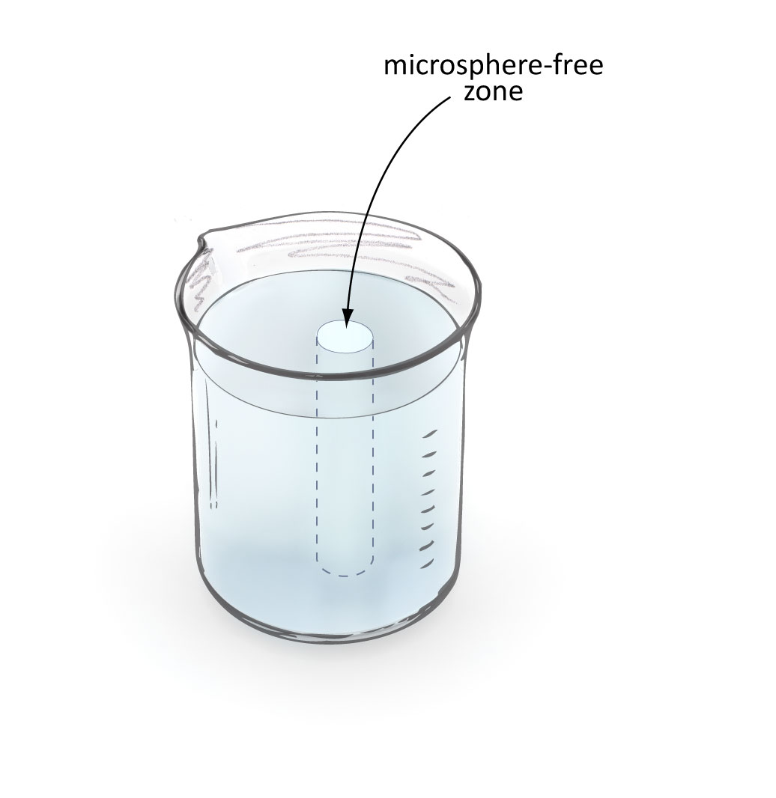
By conventional thinking, nothing much should have happened except maybe some settling at the bottom. All of the microspheres carry the same electrical charge so repulsive forces might have spread the spheres uniformly throughout the beaker’s volume. The suspension should have looked uniformly cloudy — as if you’d poured some droplets of milk into a container of water and shaken it vigorously.
The suspension did look cloudy — for the most part. Near the center-line, the students saw a clear cylinder running from top to bottom (Fig. 1.3). The cylinder’s clarity meant that it contained no microspheres. It was as though some mysterious force had driven the microspheres out of a central core and toward the beaker’s periphery. If you’ve ever seen 2001: A Space Odyssey, and the astonishment of the ape-humans first seeing the perfect monolith, you have some sense of just how our jaws dropped. This was something to behold.
So long as the initial conditions remained within a defined window, the cylinders appeared consistently; we could produce them again and again (Ovchinnikova and Pollack, 2009). They never ceased to amaze us. The question: What drives this counterintuitive migration of the spheres from the center? Please see Chapter 9.
Figure 1.3. Central clear zone in microsphere suspension, shown in artistic rendition. Why does the microsphere-free cylinder appear spontaneously?
(ii) The Bridge Made of Water
Another laboratory phenomenon is the so-called “water bridge.” This is a bridge built of water — if you can imagine. Although the water bridge is a century-old curiosity, Elmar Fuchs and his colleagues pioneered a modern incarnation that has aroused considerable interest worldwide.
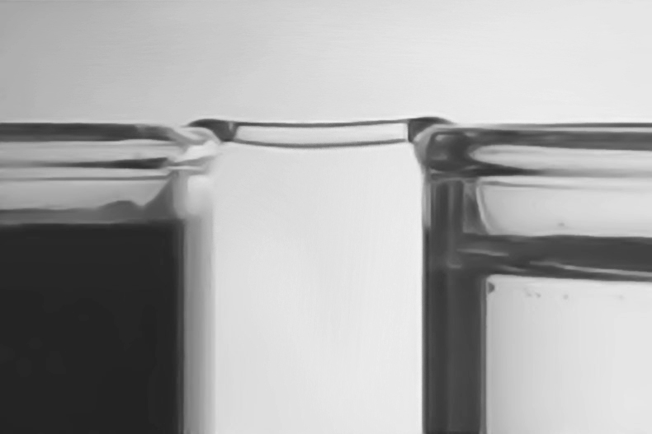
The demonstration requires two glass beakers filled almost to their brims with water. The beakers are initially placed side-by-side, lips touching. An electrode immersed in each beaker imposes a potential difference on the order of 10 kV. Immediately, water in one beaker jumps to the rim and bridges across to the other. Once it does, the two beakers are slowly separated. But the bridge doesn’t break; it continues to elongate, spanning the gap between beakers even when the lips separate by as much as several centimeters (Fig. 1.4).
Astonishingly, the water-bridge hardly droops; it exhibits an almost ice-like rigidity. The ice-like rigidity exists even though the experiment is carried out at room temperature.
Figure 1.4. The water-bridge. A bridge made of water spans the gap between two water-filled beakers. What sustains the bridge?
I caution you to resist the temptation to repeat this high-voltage experiment unless you consider yourself immune from electrocution. Better to watch a video of this eye-popping phenomenon (web ref. 1.1). The question: what sustains the bridge made of water? Please see Chapter X.
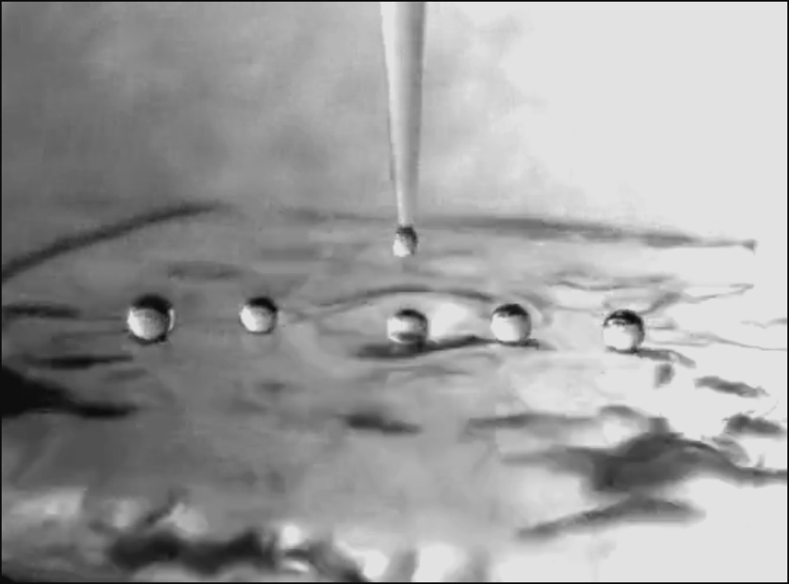
(iii) The Floating Water Droplet
If you release a series of water droplets from a narrow tube positioned just above a dish of water, the droplets will often fail to dissolve instantly; they will float for a period before dissolving (Fig. 1.5). If they happen to roll on the water surface, then they may sustain themselves for periods up to tens of seconds. Even more paradoxically, dissolution does not occur as a unitary event; the droplet dissolves in a succession of volume reductions involving multiple squirts of water into the pool beneath (Klyuzhin et al., 2010). It resembles a programmed dance.
Figure 1.5. Water droplets persist on water surface for some time. Why?
Floating water droplets can be seen in nature if you know where and when to look. A good time is just after a rainfall, when water drips from a ledge onto a puddle or from a sailboat’s gunwales onto the lake beneath. Sometimes they can be seen as raindrops directly hit ground water. The droplets will often persist for many seconds. The obvious question: If water mixes naturally with water, what feature might delay coalescence? Please see Chapter X.
(iv) Lord Kelvin’s Discharge
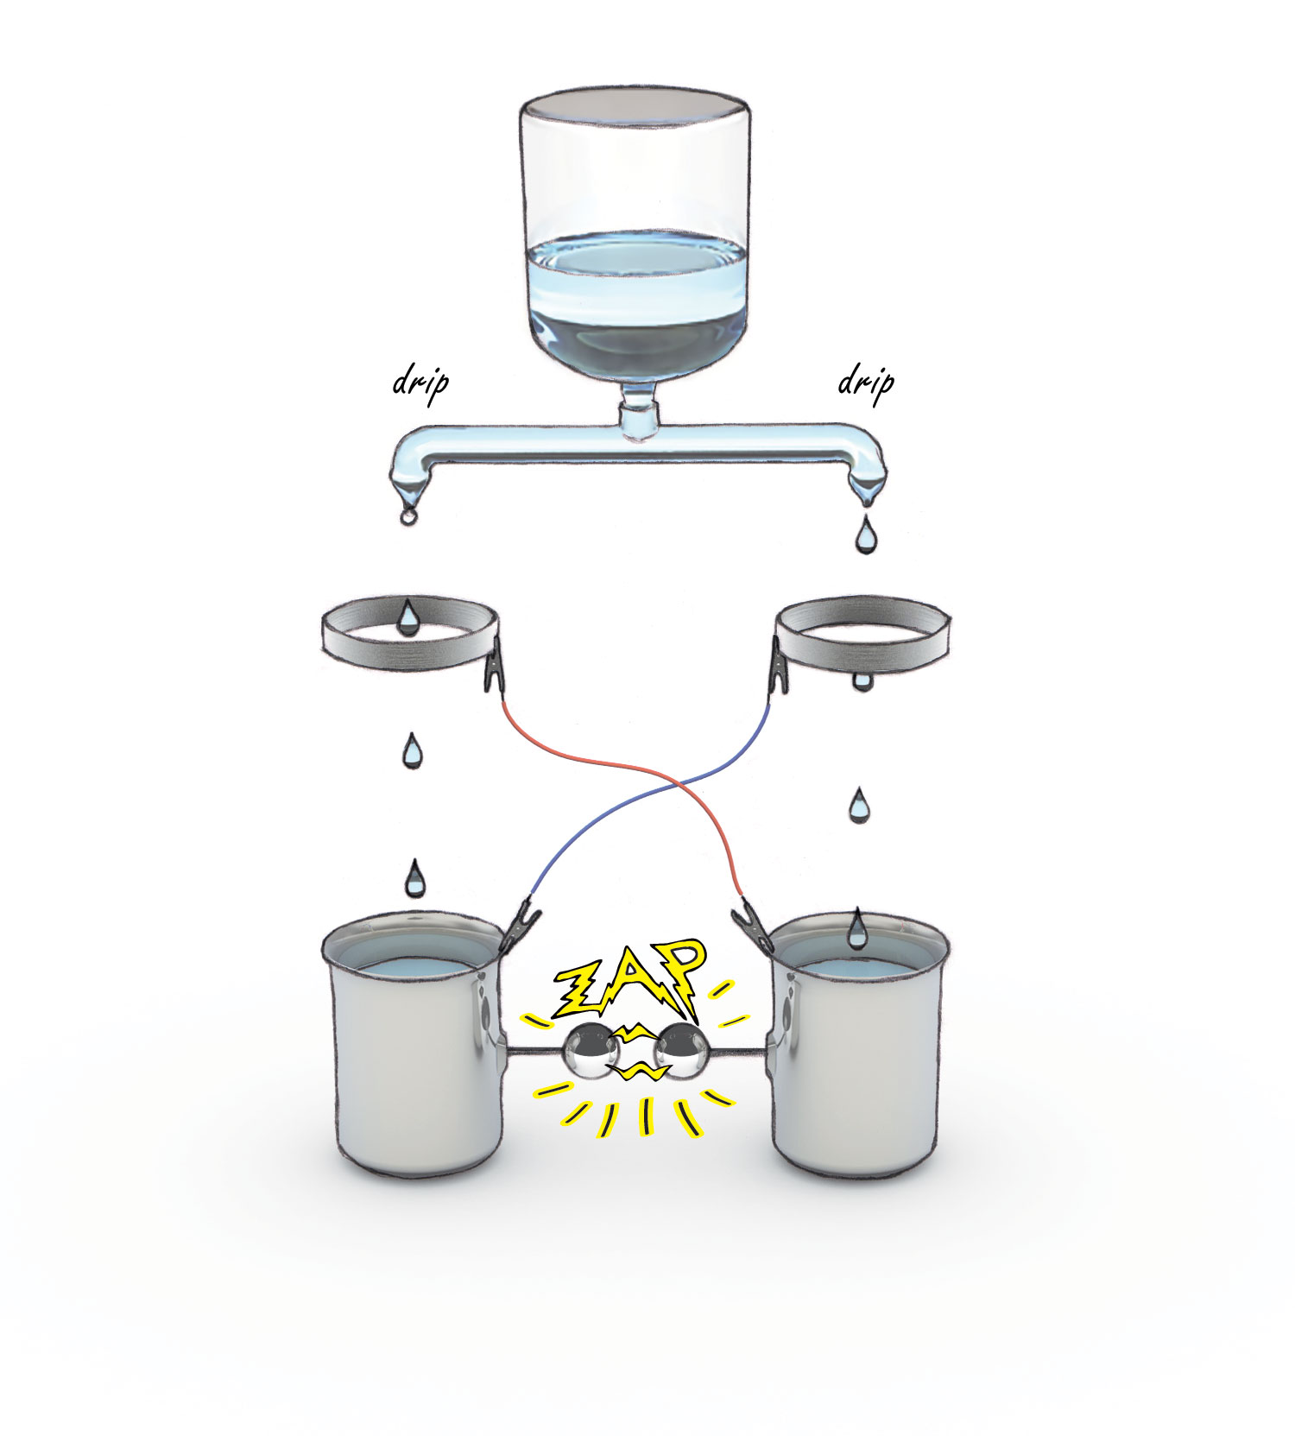
Finally, Fig. 1.6 shows the setup for another head-scratching observation. Water from an upside down bottle or an ordinary tap is split into two branches. Droplets fall from each branch, passing through metal rings and into metallic containers. Electrical cross-connections exist between the metal rings and the metal containers, as shown. Metal spheres project from each container through metallic posts, leaving a several millimeter air gap between spheres.
Originally conceived by Lord Kelvin, this experiment produces a surprising result. After a few minutes of falling droplets, you begin hearing a crackling noise. Then, suddenly, you witness a flash of lighting accompanied by a crack of sound.
Figure 1.6. The Kelvin water-dropper demonstration. When water levels rise sufficiently, the cups discharge onto one another. Why does this happen?
This kind of electrical discharge could only occur if a large potential difference builds between the two containers. Depending on the gap size, it can easily be on the order of 100,000 volts. Yet, this massive charge separation builds from a single source of water.
Although you can build one of these devices at home, observing the discharge on video is simpler. Perhaps the best example is the one produced by Professor Walter Lewin (web ref 1,2), who demonstrates the discharge to awe-struck MIT freshmen, and invites them to explain why as their homework assignment. Can you explain this massive charge separation? Please see Chapter X.

Lessons from these Mysteries
The phenomena presented in the foregoing sections defy easy explanation. All involve water in one form or another. More accurately they involve water’s social behavior, i.e., how individual molecules behave in a crowd of other water molecules. It seems clear that this social behavior lies beyond simple comprehension; otherwise those demonstrations should be easily understandable. I doubt they are.
Social behavior is the purview of social scientists. A psychiatrist once told me that in order to understand human behavior you should learn from oddballs and weirdos; their behavioral extremes provide clues for understanding the subtler behaviors of the rest of the population. I think that the same reasoning applies to water. The social behaviors embodied in many of the foregoing scenarios are extreme; as such, they provide clues for understanding the more “normal” behaviors of water. They teach us valuable lessons.
So, rather than brushing aside these phenomena as unexplainable anomalies, we will use them to advantage — we will exploit them as clues for figuring out how water molecules interact. Especially as we reach the middle chapters you’ll see a lot of that exploitation.
Meanwhile, we need a starting point for building our understanding. The next chapter offers some perspective on what we know about water, what we don’t know, and why we know a lot less than we ought to. The explanation might surprise you.

References
Ovchinnikova, K, Pollack GH (2009). Cylindrical phase separation in colloidal suspensions. Phys. Rev. E. 79(3), 036117.
Osada, Y, and Gong, J (1993). Stimuli-responsive polymer gels and their application to chemomechanical systems. Prog. Polym. Sci., 18, 187–226.
Klyuzhin, IS, Ienna, F, Roeder, B, Wexler, A and Pollack GH (2010). Persisting water droplets on water surfaces J. Phys. Chem. B, 114, 14020–14027.
Web reference 1.1: http://www.youtube.com/watch?v=FhBn1ozht-E
Web reference 1.2: <http://www.youtube.com/watch?v=oY1eyLEo8_A&feature=related>

